Olist E-Commerce Analytics: SQL to Power BI
End-to-end analytics project | PostgreSQL, Power BI, DAX | Brazilian marketplace data (currency: R$)
1. Executive Summary
This project turns the public Olist e-commerce dataset (nine relational tables, 112,650 order items, 98,666 orders and 3,095 sellers) into a five-page Power BI dashboard. It covers the complete analytics pipeline: loading raw CSV files into PostgreSQL, enforcing a relational model with primary and foreign keys, shaping the data into BI-ready SQL views, building a DAX measure library, and presenting sales, product, delivery and payment performance for decision-makers.
Headline results
- The marketplace generated R$13.59M in item revenue plus R$2.25M in freight, at an average order value of R$137.75.
- Delivery is largely reliable: 6.8% of delivered orders (6,534 of 96,478) arrived after the estimated date, so 93.2% were on time.
- Credit cards dominate payments (75.4% of orders), and about two thirds of credit card orders are paid in installments.
- Freight adds about R$16.6 for every R$100 of product value, a meaningful cost burden on customers.
2. Business Problem and Objectives
An online marketplace needs a single, trustworthy view of how the business is performing. This project was built to answer four groups of questions:
- Sales: How are revenue and order volume trending, and how does this period compare with the same period last year?
- Products and satisfaction: Which categories drive revenue and orders, and how do customers rate them?
- Delivery: How reliable is delivery, where are the delays, and how does the shipping route (same state versus cross state) affect delivery time, freight cost and lateness?
- Sellers and payments: How do customers pay, and how is revenue spread across sellers and regions?
The objective was one governed data model and one dashboard that moves from executive KPIs to operational drill-downs.
3. Data and Data Model
The source is the public Olist dataset, supplied as nine CSV files. Each was loaded into its own PostgreSQL table with an explicit primary key and foreign keys that mirror the real business relationships.
Table | Grain (one row per) | Role
customers_data | customer_id | Customer city, state and unique customer id
orders_data | order | Status and purchase, approval, carrier, delivery and estimated dates
order_items_data | order item (order_id + order_item_id) | Price, freight, product and seller
order_payments_data | payment (order_id + payment_sequential) | Payment type, installments, value
order_reviews_data | review | Review score and comments
products_data | product | Category and physical dimensions
sellers_data | seller | Seller city and state
product_category_name_translation | category | Portuguese to English category names
geolocations_data | zip prefix | Latitude and longitude reference
Foreign keys: orders reference customers; order items reference orders, products and sellers; payments reference orders; reviews reference orders. These constraints guarantee that no item, payment or review can exist without a valid parent order.
4. Data Engineering in PostgreSQL
4.1 Loading the data: problems found and how they were solved
Importing the files was not a single click. Each problem below had a specific cause and fix, and together they show why raw data should be profiled before it is loaded.
Problem | Cause | Fix
Date values rejected or misread | Source dates use month/day/year; PostgreSQL expected another order | Set datestyle to MDY at database level so every session and import wizard inherits it
Import rejected for the category translation file | The file has a .csv extension but is tab-separated | Import with a tab delimiter instead of a comma
Encoding error on the reviews file | Accented Portuguese characters saved in a Windows code page, not UTF-8 | Set client encoding to match the file before importing
Duplicate key errors on items and payments | One order can contain several items and several payment rows, so order_id is not unique | Use composite primary keys: (order_id, order_item_id) and (order_id, payment_sequential)
Rows doubled after a repeated import | The same file was loaded twice | Truncate before reloading; the primary key now acts as a safety net against accidental duplicates
Server-side copy could not find the file | Server-side COPY reads files as the database service account, not the logged-in user | Use the client-side psql copy command with the exact file path
4.2 BI-ready SQL views
Rather than loading nine normalised tables into Power BI and rebuilding joins there, the business logic was placed in four SQL views. This keeps transformations in one auditable place and lets the dashboard import a single flat fact table.
- bi_dim_product: attaches the English category name (falling back to the Portuguese name when no translation exists) and computes product volume from dimensions.
- bi_dim_latest_review: keeps only the most recent review per order using DISTINCT ON, because some orders have more than one review.
- bi_payments_order: collapses payments to one row per order, holding total payment value, maximum installments and the primary payment type (the type that carried the largest amount).
- bi_fact_order: one row per order with purchase date and month, delivery days (purchase to delivery, delivered orders only), an is_late flag, and customer city and state. An order is late when it is delivered and the actual delivery date is after the estimated date.
- bi_fact_sales: the item-grain fact table that joins items to the order, product, latest review, order-level payments and seller attributes. This is the one table imported into Power BI.
4.3 Controlling grain: the most important design decision
A fact table must have a clear grain. Here the grain is one row per order item. Payments and reviews, however, exist at order level, and one order can have several payment rows (this affects 2,961 of 99,440 orders in the payments file).
Joining the raw payments table directly to order items multiplied rows: 112,650 items became 117,604 rows, with 3,284 duplicated item keys, and the summed payment value was overstated by roughly 27%. The final design therefore collapses payments and reviews to one row per order before joining, so the fact table keeps exactly one row per order item.
A related point remains: order-level attributes such as payment value and installments are repeated on every item row of the same order. Measures that aggregate them must count each order once (see Appendix B). Item-level attributes such as price and freight can be summed normally.
5. Analytics Layer: DAX Measures
Because the fact table is item grain, order-based measures use DISTINCTCOUNT on order_id so that multi-item orders are never counted more than once.
Group | Measures
Sales | Total Revenue, Total Order, Total Customer, AOV, Item Sold, Item per Order, Total Freight Value
Delivery | Order Delivered, Late Orders, Late Delivery %, On Time %, Avg Delivery Days
Time intelligence | Revenue LY, Revenue YTD, Rolling 30D Revenue, YoY %
Sellers and payments | Total Sellers, Revenue per Seller, Avg Freight per Item, Total Payment, Payment Installments
Reviews | Positive Reviews %, Negative Review %, Review Bucket (calculated column)
Calculated columns and tables | Route Type (same state or cross state), Country, Dim_Date calendar table
Key definitions
- Late Delivery % = late delivered orders divided by delivered orders. Cancelled, unavailable and in-transit orders are excluded from the denominator, so the rate is not diluted.
- Route Type compares seller state with customer state, classifying each item as Same state, Cross state or Unknown.
- Dim_Date is a dedicated calendar table generated from the first to last purchase date. It powers year-over-year, year-to-date and rolling-window measures.
6. Dashboard Walkthrough
The report has six pages that move from a high-level summary to specific operational questions.
Page: overview (Excutive dashboard).
Purpose: One screen business health check.
Visual: KPI cards (Total revenue, Total order, total customers, AOV, GMV, YOY%) revenue trend with yoy % , order and revenue by month, sales by category.
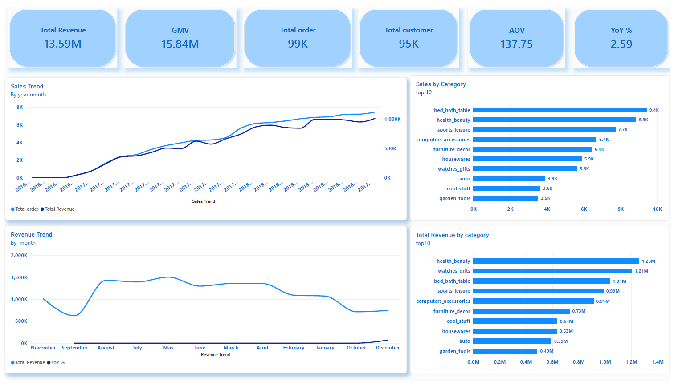

Page: Sales Trend
Purpose: Growth & seasonality.
Visual: Revenue YTD ( year to date) Vs last year, rolling 30 days revenue vs last year matrix of month by category and revenue, order and AOV.
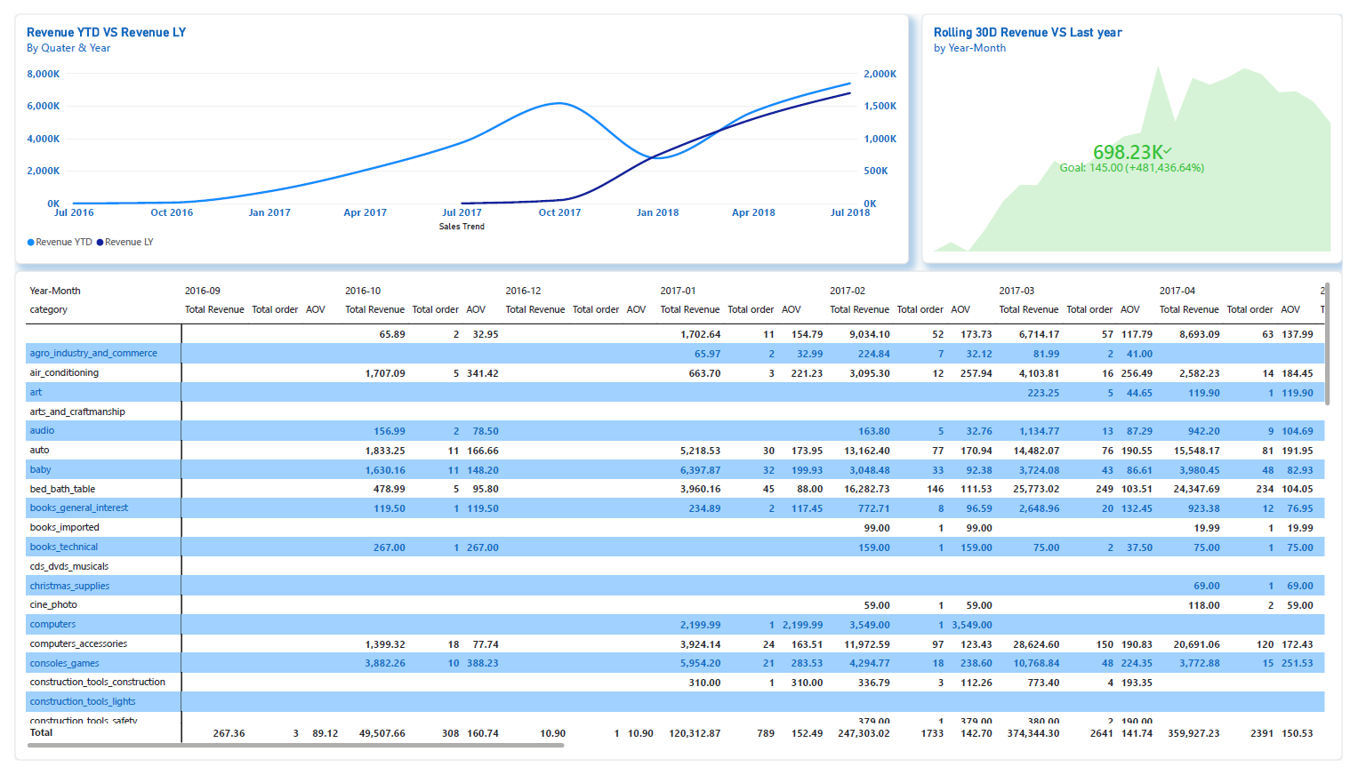

Page: category and product.
Purpose: product mix and customer sentiments.
Visual: positive verses negative review split, review sentiment by category (100% stacked) treemap of category by order and AOV, month by category matrix.
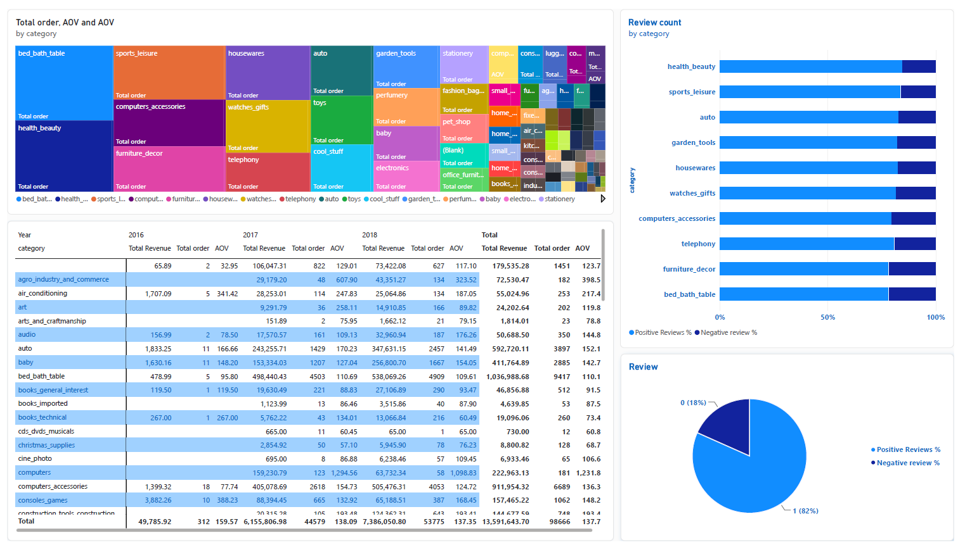

Page: Delivery and logistics.
Purpose: Delivery reliability.
Visual: field map of late delivery % by customer state, monthly late delivery % by average delivery days, late versus on time delivery, late order by delivery bucket.
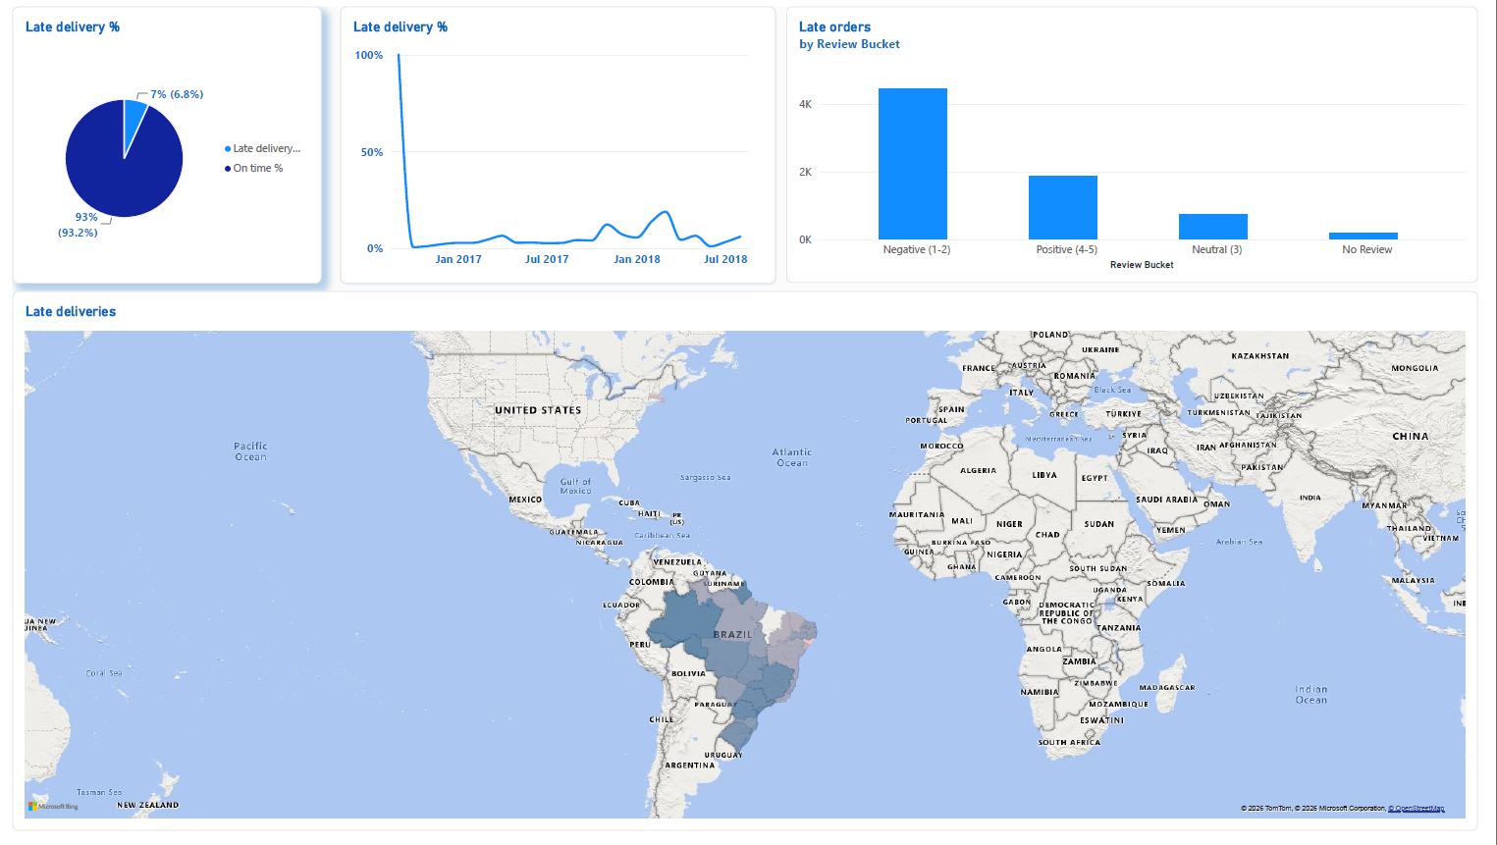

Page: sellers and payment.
Purpose: coast root and payment behaviour .
Visual: same state versus cross state camparison ( late %, delivery days, freight per item, share of orders), seller map(revenue per seller), freight map by customer state, payment funnel by type, installments and values.
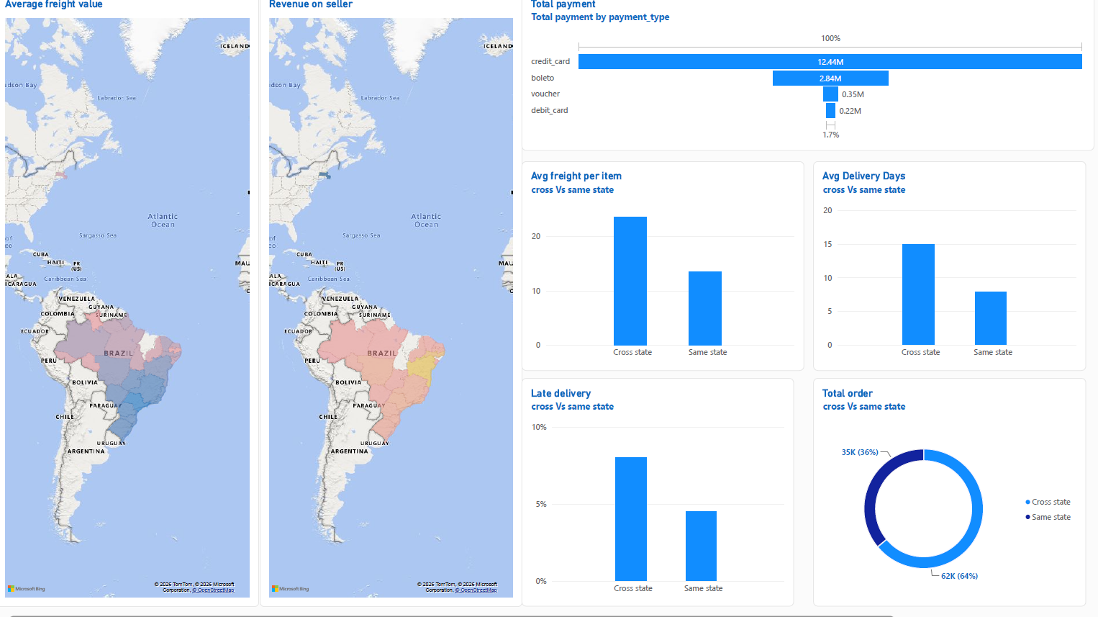

Page: Insight and Recommendations.
Purpose: Sales and basket, delivery, payment and freight, recommendation, footnote.
Visual: text data ( not visual) .
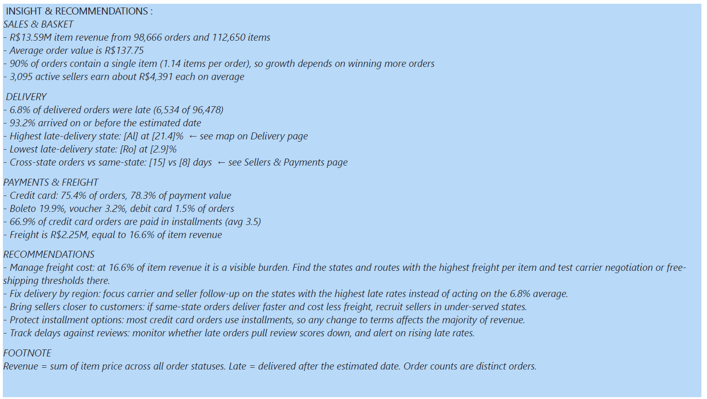

7. Key Findings
All figures below were calculated from the order items and payments source data and match the dashboard definitions.
7.1 Scale and value
Metric | Value
Orders with items | 98,666
Order items sold | 112,650
Items per order | 1.14 (9.9% of orders contain more than one item)
Item revenue (sum of price) | R$13.59M
Freight charged | R$2.25M (16.6% of item revenue)
Item value plus freight | R$15.84M
Average order value | R$137.75
Active sellers | 3,095
Distinct products | 32,951
Revenue per seller | about R$4,391
Most orders are single-item purchases, so growth depends mainly on winning more orders rather than increasing basket size.
7.2 Delivery performance
6.8% of delivered orders were late (6,534 of 96,478), and 93.2% arrived on or before the estimated date. At marketplace level this is a healthy result, which means the useful analysis lies in where delays concentrate. The Delivery and Logistics page breaks lateness down by state and by month, and the Sellers and Payments page compares same-state and cross-state routes on lateness, delivery time and freight.
7.3 Payment behaviour
Payment type | Share of orders | Share of payment value
Credit card | 75.4% | 78.3%
Boleto (bank slip) | 19.9% | 17.9%
Voucher | 3.2% | 2.4%
Debit card | 1.5% | 1.4%
Share of orders uses each order's primary payment type (the type carrying the largest amount). Credit card orders average 3.5 installments, and 66.9% of them are paid in more than one installment. Installment financing is therefore central to how customers buy.
7.4 Freight burden
Freight equals 16.6% of product revenue, so a customer pays roughly R$16.6 in shipping for every R$100 of goods. Because freight is charged per item and varies by distance, it is a lever worth tracking by region and by route type, which is why the dashboard includes freight per item by state and by route.
8. Analytical Decisions and Data Quality Notes
- Latest review only: an order with several reviews is represented by its most recent one, so review metrics are not inflated by repeat reviews.
- One payment row per order in the fact table: the primary payment type is chosen by the largest amount, a documented and repeatable rule.
- Delivered-only delivery metrics: delivery days and the late flag are calculated only for delivered orders with valid dates.
- Order counts use DISTINCTCOUNT: this prevents multi-item orders from being counted once per item.
- Honest interpretation: route type and lateness show association, not proof of cause. Distance, carrier and seller quality can all contribute.
9. Recommendations
- Manage freight cost actively. At 16.6% of item revenue, freight is a visible cost for customers. Use the freight-by-state and route-type views to find the regions and routes where shipping is most expensive, then test carrier negotiation or free-shipping thresholds there.
- Target delivery improvement by region. Use the late delivery map to focus carrier and seller follow-up on the states with the highest late rates, rather than acting on the 6.8% average.
- Keep installment options. With most credit card orders paid in installments, any change to installment terms would affect the majority of revenue.
- Bring sellers closer to customers. The same-state versus cross-state comparison shows whether local fulfilment shortens delivery and lowers freight. If it does, recruiting sellers in under-served states is a practical lever.
- Monitor delays alongside satisfaction. The late-orders-by-review view lets the business track whether late deliveries are pulling review scores down.
10. Limitations and Next Steps
- Total Revenue sums item price across all order statuses, so it includes cancelled and unavailable orders. A delivered-only revenue measure would be stricter.
- The data is historical (2016 to 2018), and the earliest and latest months are typically partial, so year-over-year comparisons are only reliable for periods that are complete in both years.
- Delay analysis does not yet separate seller handling time from carrier transit time. Adding the carrier handover date would split the delivery journey into those two stages and point to who should fix the delay.
- Next steps: publish to the Power BI service with scheduled refresh, add a delivered-only revenue view, and add seller scorecards with a minimum-order threshold.
Appendix A: Key SQL
Order-level payment view
CREATE OR REPLACE VIEW bi_payments_order AS
SELECT
op.order_id,
SUM(op.payment_value) AS order_payment_value,
MAX(op.payment_installments) AS order_payment_installments,
(ARRAY_AGG(op.payment_type ORDER BY op.payment_value DESC NULLS LAST))[1] AS order_payment_type
FROM order_payments_data AS op
GROUP BY op.order_id;
Delivery days and late flag (inside bi_fact_order)
CASE WHEN o.order_status = 'delivered'
AND o.order_purchase_timestamp IS NOT NULL
AND o.order_delivered_customer_date IS NOT NULL
THEN o.order_delivered_customer_date::date - o.order_purchase_timestamp::date
END AS delivery_days,
CASE WHEN o.order_status = 'delivered'
AND o.order_delivered_customer_date IS NOT NULL
AND o.order_estimated_delivery_date IS NOT NULL
AND o.order_delivered_customer_date::date > o.order_estimated_delivery_date::date
THEN 1 ELSE 0
END AS is_late
Payment join in the item-grain fact (inside bi_fact_sales)
p.order_payment_type AS payment_type,
p.order_payment_installments AS payment_installments,
p.order_payment_value AS payment_value,
...
LEFT JOIN bi_payments_order AS p ON p.order_id = oi.order_id
Appendix B: Core DAX
Total Revenue = SUM(bi_fact_sales[price])
Total Order = DISTINCTCOUNT(bi_fact_sales[order_id])
AOV = DIVIDE([Total Revenue], [Total Order])

Order Delivered =
CALCULATE([Total Order], bi_fact_sales[order_status] = "delivered")

Late Orders =
CALCULATE(
[Total Order],
bi_fact_sales[order_status] = "delivered",
bi_fact_sales[is_late] = 1
)

Late Delivery % = DIVIDE([Late Orders], [Order Delivered])
On Time % = DIVIDE([Order Delivered] - [Late Orders], [Order Delivered])

-- one value per order, not per item
Avg Delivery Days =
AVERAGEX(VALUES(bi_fact_sales[order_id]),
CALCULATE(MAX(bi_fact_sales[delivery_days])))

Total Payment =
SUMX(VALUES(bi_fact_sales[order_id]),
CALCULATE(MAX(bi_fact_sales[payment_value])))

Revenue LY = CALCULATE([Total Revenue], SAMEPERIODLASTYEAR(Dim_Date[Date]))
YoY % = DIVIDE([Total Revenue] - [Revenue LY], [Revenue LY])

Route Type =
IF(ISBLANK(bi_fact_sales[seller_state]) || ISBLANK(bi_fact_sales[customer_state]),
"Unknown",
IF(bi_fact_sales[seller_state] = bi_fact_sales[customer_state],
"Same state", "Cross state"))

