Lab Exercise 8: Strassen’s Matrix Multiplication
MSc AIML · Design and Analysis of Algorithms Lab · Divide and Conquer
Name: Sanjay R A
Language: Python 3 (no NumPy / BLAS used for multiplication)
Source file: strassen_lab8.py

1. Aim
To implement the classical O(n³) matrix multiplication and Strassen’s divide-and-conquer algorithm, extend Strassen to arbitrary sizes and a cutoff threshold T, count scalar operations, measure running time for n = 2 … 512, and validate every result against the classical baseline.

2. Design
Task | Function | What it does
1 Baseline | classical(A, B) | Triple-loop multiplication; counts m·k·p multiplications and m·(k−1)·p additions.
2 Strassen | strassen(A, B, T) | Splits into four blocks, computes M1…M7, combines C11…C22 with additions/subtractions only.
3 Any size | multiply(A, B, T, algo), pad() | Pads with zeros to the next power of two, multiplies, trims back to m × p.
4 Cutoff | n <= T in strassen() | Switches to classical when the block is small; T is a parameter.
5 Count/time | global mults, adds + time.perf_counter() | Counters reset before each run; benchmark for n = 2…512.
6 Validate | same(X, Y) | Element-wise comparison with tolerance 1e-6·max(1,|y|); prints PASS/FAIL.
Self-learning | winograd(A, B, T) | Strassen–Winograd variant: same 7 products, 15 block additions instead of 18.
Helpers | add, sub, split, combine | Modular building blocks, each counted for additions.

Strassen’s seven products (as commented in the code):
- M1 = (A11 + A22)(B11 + B22)
- M2 = (A21 + A22) B11
- M3 = A11 (B12 − B22)
- M4 = A22 (B21 − B11)
- M5 = (A11 + A12) B22
- M6 = (A21 − A11)(B11 + B12)
- M7 = (A12 − A22)(B21 + B22)
C11 = M1 + M4 − M5 + M7, C12 = M3 + M5, C21 = M2 + M4, C22 = M1 − M2 + M3 + M6

3. Source Code
# Lab 8 - Strassen's Matrix Multiplication (Divide and Conquer) - basic version
# No NumPy / BLAS is used for multiplication. Random numbers, timing and plotting only.
# Run: python strassen_lab8.py (press Enter to accept the [default] shown in a prompt)
import random
import time
try: # plotting only; the program still runs without matplotlib
import matplotlib
import matplotlib.pyplot as plt
except ImportError:
plt = None
mults = 0 # scalar multiplications counted so far
adds = 0 # scalar additions + subtractions counted so far
# ---------------------------------------------------------------- helper functions
def add(A, B):
global adds
adds += len(A) * len(A[0])
return [[x + y for x, y in zip(rowA, rowB)] for rowA, rowB in zip(A, B)]
def sub(A, B):
global adds
adds += len(A) * len(A[0])
return [[x - y for x, y in zip(rowA, rowB)] for rowA, rowB in zip(A, B)]
def split(A):
# cut an n x n matrix into four n/2 x n/2 blocks
h = len(A) // 2
A11 = [row[:h] for row in A[:h]]
A12 = [row[h:] for row in A[:h]]
A21 = [row[:h] for row in A[h:]]
A22 = [row[h:] for row in A[h:]]
return A11, A12, A21, A22
def combine(C11, C12, C21, C22):
# glue four blocks back into one matrix
top = [r1 + r2 for r1, r2 in zip(C11, C12)]
bottom = [r1 + r2 for r1, r2 in zip(C21, C22)]
return top + bottom
def pad(A, size):
# add zero columns, then zero rows, until A is size x size
rows = [row + [0] * (size - len(row)) for row in A]
rows += [[0] * size for _ in range(size - len(A))]
return rows
def same(X, Y):
# equal within a small tolerance (needed for float data)
for rowX, rowY in zip(X, Y):
for x, y in zip(rowX, rowY):
if abs(x - y) > 1e-6 * max(1, abs(y)):
return False
return True
# ---------------------------------------------------------------- Task 1: classical O(n^3)
def classical(A, B):
global mults, adds
m, k, p = len(A), len(B), len(B[0])
mults += m * k * p # exact count, added once per call
adds += m * (k - 1) * p
Bt = [list(col) for col in zip(*B)] # columns of B (just for speed)
C = []
for i in range(m):
row = []
for j in range(p):
total = 0
for x, y in zip(A[i], Bt[j]):
total += x * y
row.append(total)
C.append(row)
return C
# ---------------------------------------------------------------- Task 2 + 4: Strassen with cutoff T
def strassen(A, B, T):
n = len(A) # n is a power of two here
if n <= T: # Task 4: small block -> classical method
return classical(A, B)
A11, A12, A21, A22 = split(A)
B11, B12, B21, B22 = split(B)
# the seven products (only 7 recursive multiplications instead of 8)
M1 = strassen(add(A11, A22), add(B11, B22), T) # M1 = (A11 + A22)(B11 + B22)
M2 = strassen(add(A21, A22), B11, T) # M2 = (A21 + A22) B11
M3 = strassen(A11, sub(B12, B22), T) # M3 = A11 (B12 - B22)
M4 = strassen(A22, sub(B21, B11), T) # M4 = A22 (B21 - B11)
M5 = strassen(add(A11, A12), B22, T) # M5 = (A11 + A12) B22
M6 = strassen(sub(A21, A11), add(B11, B12), T) # M6 = (A21 - A11)(B11 + B12)
M7 = strassen(sub(A12, A22), add(B21, B22), T) # M7 = (A12 - A22)(B21 + B22)
C11 = add(sub(add(M1, M4), M5), M7) # C11 = M1 + M4 - M5 + M7
C12 = add(M3, M5) # C12 = M3 + M5
C21 = add(M2, M4) # C21 = M2 + M4
C22 = add(add(sub(M1, M2), M3), M6) # C22 = M1 - M2 + M3 + M6
return combine(C11, C12, C21, C22)
# ---------------------------------------------------------------- Task 3: any size (pad, multiply, trim)
def multiply(A, B, T, algo=None):
algo = algo or strassen # standard Strassen unless another algorithm is passed
m, p = len(A), len(B[0])
size = 1
while size < max(m, len(B), p): # next power of two
size *= 2
C = algo(pad(A, size), pad(B, size), max(T, 1))
return [row[:p] for row in C[:m]] # trim back to m x p
def random_matrix(rows, cols):
return [[random.randint(0, 9) for _ in range(cols)] for _ in range(rows)]
def show(name, M):
print(name)
for row in M:
print(" ", row)
# ---------------------------------------------------------------- Self-learning: Strassen-Winograd variant
def winograd(A, B, T):
# Same 7 recursive products as Strassen, but only 15 block additions (Strassen uses 18)
n = len(A)
if n <= T:
return classical(A, B)
A11, A12, A21, A22 = split(A)
B11, B12, B21, B22 = split(B)
# 8 additions/subtractions on the inputs (4 on A, 4 on B), reused between products
S1 = add(A21, A22) # S1 = A21 + A22
S2 = sub(S1, A11) # S2 = S1 - A11
S3 = sub(A11, A21) # S3 = A11 - A21
S4 = sub(A12, S2) # S4 = A12 - S2
T1 = sub(B12, B11) # T1 = B12 - B11
T2 = sub(B22, T1) # T2 = B22 - T1
T3 = sub(B22, B12) # T3 = B22 - B12
T4 = sub(T2, B21) # T4 = T2 - B21
# the seven products (7 recursive multiplications, as in Strassen)
M1 = winograd(A11, B11, T) # M1 = A11 B11
M2 = winograd(A12, B21, T) # M2 = A12 B21
M3 = winograd(S4, B22, T) # M3 = S4 B22
M4 = winograd(A22, T4, T) # M4 = A22 T4
M5 = winograd(S1, T1, T) # M5 = S1 T1
M6 = winograd(S2, T2, T) # M6 = S2 T2
M7 = winograd(S3, T3, T) # M7 = S3 T3
# 7 additions/subtractions to combine (total 8 + 7 = 15)
U2 = add(M1, M6) # U2 = M1 + M6
U3 = add(U2, M7) # U3 = U2 + M7
U4 = add(U2, M5) # U4 = U2 + M5
C11 = add(M1, M2) # C11 = M1 + M2
C12 = add(U4, M3) # C12 = U4 + M3
C21 = sub(U3, M4) # C21 = U3 - M4
C22 = add(U3, M5) # C22 = U3 + M5
return combine(C11, C12, C21, C22)
def finish_plot(fig, filename):
# save the graph next to the script, then try to show it in a window
fig.savefig(filename, dpi=150)
print(f"Graph saved: {filename}")
try:
plt.show()
except Exception:
pass
# ====================================================================== DEMONSTRATION
print("===== TEST 1 : sample from the lab sheet (n = 2) =====")
A = [[1, 2], [3, 4]]
B = [[5, 6], [7, 8]]
expected = [[19, 22], [43, 50]]
show("A x B (classical):", classical(A, B))
show("A x B (Strassen, T = 1):", multiply(A, B, 1))
print("Expected [[19, 22], [43, 50]] ->", "PASS" if same(multiply(A, B, 1), expected) else "FAIL")
print("\n===== TEST 2 : rectangular 3x4 times 4x2 (padding and trimming) =====")
A = random_matrix(3, 4)
B = random_matrix(4, 2)
C1 = classical(A, B)
C2 = multiply(A, B, 1)
show("Classical:", C1)
show("Strassen :", C2)
print("Result size", len(C2), "x", len(C2[0]), "->", "PASS" if same(C2, C1) else "FAIL")
print("\n===== TEST 3 : your own test =====")
n = int(input("Matrix size n [5]: ") or 5)
T = int(input("Cutoff threshold T [2]: ") or 2)
mode = input("Enter matrices by keyboard (k) or random (r) [r]: ") or "r"
if mode == "k":
print("Enter matrix A, one row per line (numbers separated by spaces):")
A = [[float(x) for x in input().split()] for _ in range(n)]
print("Enter matrix B:")
B = [[float(x) for x in input().split()] for _ in range(n)]
else:
A = random_matrix(n, n)
B = random_matrix(n, n)
mults = adds = 0
start = time.perf_counter()
C1 = classical(A, B)
t1 = time.perf_counter() - start
m1, a1 = mults, adds
mults = adds = 0
start = time.perf_counter()
C2 = multiply(A, B, T)
t2 = time.perf_counter() - start
m2, a2 = mults, adds
if n <= 8:
show("A:", A)
show("B:", B)
show("A x B (classical):", C1)
show("A x B (Strassen) :", C2)
print("Validation:", "PASS" if same(C2, C1) else "FAIL")
print(f"Classical: {m1} multiplications, {a1} additions, {t1:.6f} s")
print(f"Strassen : {m2} multiplications, {a2} additions, {t2:.6f} s (T = {T})")
# ====================================================================== TASK 5 + 6: BENCHMARK
print("\n===== BENCHMARK (Task 5 and Task 6) =====")
if (input("Run benchmark for n = 2 ... 512? It can take a few minutes. (y/n) [y]: ") or "y") == "y":
T = int(input("Cutoff T for the benchmark [32]: ") or 32)
sizes = [2, 4, 8, 16, 32, 64, 128, 256, 512]
classical_times = []
strassen_times = []
print(f"\n{'n':>4} | {'classical mult':>14} {'add':>11} {'time(s)':>9} | {'strassen mult':>13} {'add':>11} {'time(s)':>9} | result")
for n in sizes:
A = random_matrix(n, n)
B = random_matrix(n, n)
mults = adds = 0
start = time.perf_counter()
C1 = classical(A, B)
t1 = time.perf_counter() - start
m1, a1 = mults, adds
mults = adds = 0
start = time.perf_counter()
C2 = multiply(A, B, T)
t2 = time.perf_counter() - start
m2, a2 = mults, adds
classical_times.append(t1)
strassen_times.append(t2)
result = "PASS" if same(C2, C1) else "FAIL"
print(f"{n:>4} | {m1:>14} {a1:>11} {t1:>9.4f} | {m2:>13} {a2:>11} {t2:>9.4f} | {result}")
# Task 5: running time against n (classical vs Strassen)
if plt:
fig, axes = plt.subplots(1, 2, figsize=(10, 4))
for ax, log in zip(axes, [False, True]):
ax.plot(sizes, classical_times, "o-", label="Classical O(n^3)", color="#4f46e5")
ax.plot(sizes, strassen_times, "s-", label=f"Strassen (T = {T})", color="#d97706")
ax.set_xlabel("matrix size n")
ax.set_ylabel("time (s)")
ax.grid(alpha=0.3)
ax.legend()
if log:
ax.set_xscale("log", base=2)
ax.set_yscale("log")
ax.set_title("Log-log scale")
else:
ax.set_title("Linear scale")
fig.suptitle("Running time: classical vs Strassen (pure Python)")
fig.tight_layout()
finish_plot(fig, "time_graph.png")
# Float data: needs the tolerance in same()
print("\nFloat matrices (tolerance check):")
for n in [16, 64]:
A = [[random.random() for _ in range(n)] for _ in range(n)]
B = [[random.random() for _ in range(n)] for _ in range(n)]
print(f" n = {n}:", "PASS" if same(multiply(A, B, T), classical(A, B)) else "FAIL")
# ====================================================================== SELF-LEARNING: Strassen-Winograd
print("\n===== SELF-LEARNING : Strassen-Winograd variant =====")
if (input("Run the Strassen-Winograd experiment? (y/n) [y]: ") or "y") == "y":
partA, partB = [], [] # kept for the graph at the end
print("Part A: operation counts, full recursion (T = 1)")
print(f"{'n':>4} | {'mult (both)':>11} | {'Strassen add':>13} {'Winograd add':>13} {'saved':>7} | {'Strassen s':>10} {'Winograd s':>10} | result")
for n in [2, 4, 8, 16, 32, 64]:
A = random_matrix(n, n)
B = random_matrix(n, n)
C0 = classical(A, B)
mults = adds = 0
start = time.perf_counter()
C1 = multiply(A, B, 1)
ts = time.perf_counter() - start
ms, a_s = mults, adds
mults = adds = 0
start = time.perf_counter()
C2 = multiply(A, B, 1, winograd)
tw = time.perf_counter() - start
mw, aw = mults, adds
ok = "PASS" if same(C1, C0) and same(C2, C0) and ms == mw else "FAIL"
partA.append((n, a_s, aw))
print(f"{n:>4} | {ms:>11} | {a_s:>13} {aw:>13} {100 * (a_s - aw) / a_s:>6.1f}% | {ts:>10.4f} {tw:>10.4f} | {ok}")
print("\nPart B: running time with cutoff T = 32")
print(f"{'n':>4} | {'Strassen add':>13} {'Winograd add':>13} | {'Strassen s':>10} {'Winograd s':>10} | result")
for n in [64, 128, 256, 512]:
A = random_matrix(n, n)
B = random_matrix(n, n)
mults = adds = 0
start = time.perf_counter()
C1 = multiply(A, B, 32)
ts = time.perf_counter() - start
a_s = adds
mults = adds = 0
start = time.perf_counter()
C2 = multiply(A, B, 32, winograd)
tw = time.perf_counter() - start
aw = adds
partB.append((n, ts, tw))
print(f"{n:>4} | {a_s:>13} {aw:>13} | {ts:>10.4f} {tw:>10.4f} | {'PASS' if same(C1, C2) else 'FAIL'}")
print("\nPart C: float matrices and odd sizes (tolerance check)")
for n in [16, 33, 64]:
A = [[random.random() for _ in range(n)] for _ in range(n)]
B = [[random.random() for _ in range(n)] for _ in range(n)]
print(f" n = {n}:", "PASS" if same(multiply(A, B, 4, winograd), classical(A, B)) else "FAIL")
# graph: additions (T = 1) and running time (T = 32), Strassen vs Winograd
if plt:
fig, axes = plt.subplots(1, 2, figsize=(10, 3.8))
for ax, data, labels, xl, yl, title in [
(axes[0], partA, ("n (T = 1)", "additions (log)", "Additions"), None, None, None),
(axes[1], partB, ("n (T = 32)", "time (s, log)", "Running time"), None, None, None)]:
x = range(len(data))
ax.bar([i - 0.19 for i in x], [d[1] for d in data], 0.38, label="Strassen", color="#d97706")
ax.bar([i + 0.19 for i in x], [d[2] for d in data], 0.38, label="Winograd", color="#059669")
ax.set_xticks(list(x))
ax.set_xticklabels([str(d[0]) for d in data])
ax.set_yscale("log")
ax.set_xlabel(labels[0])
ax.set_ylabel(labels[1])
ax.set_title(labels[2])
ax.legend(fontsize=8)
fig.tight_layout()
finish_plot(fig, "winograd_graph.png")

4. Output Screenshots (code run)

4.1 Sample test from the lab sheet (n = 2) and rectangular padding test
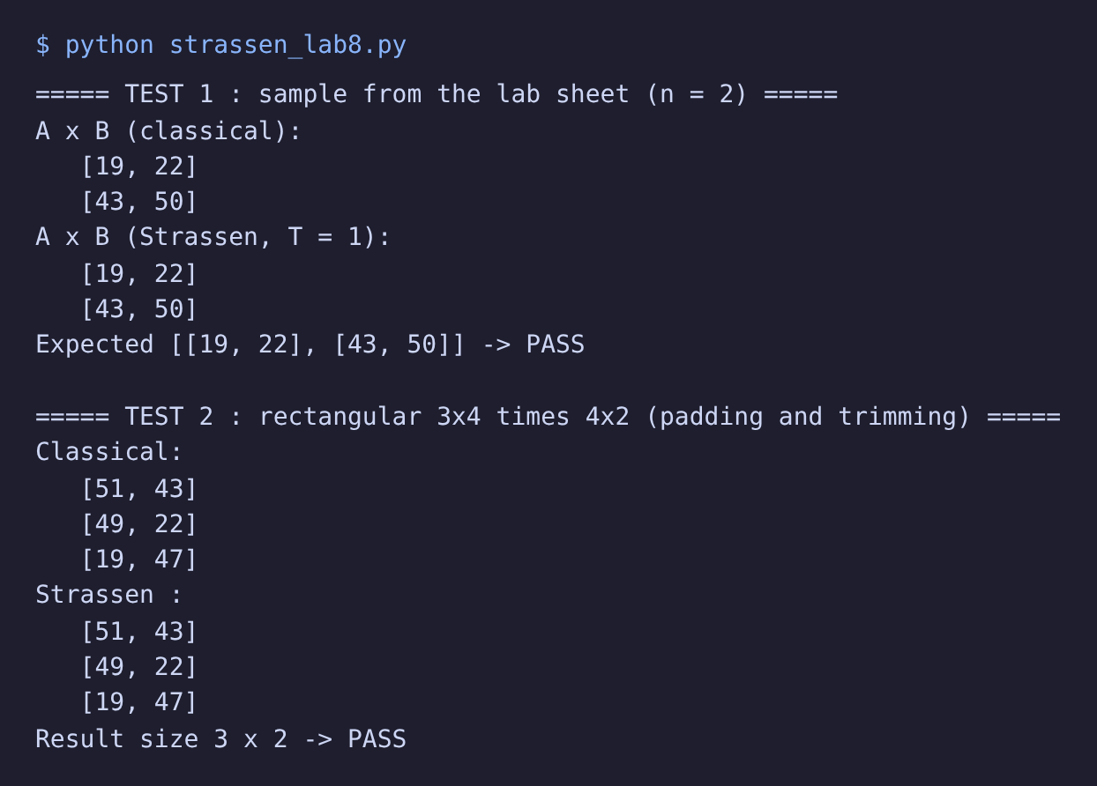
Figure 1: n = 2 sample gives [[19,22],[43,50]] – PASS; 3×4 · 4×2 padded and trimmed – PASS

4.2 User-defined test (n = 5, T = 2, random)
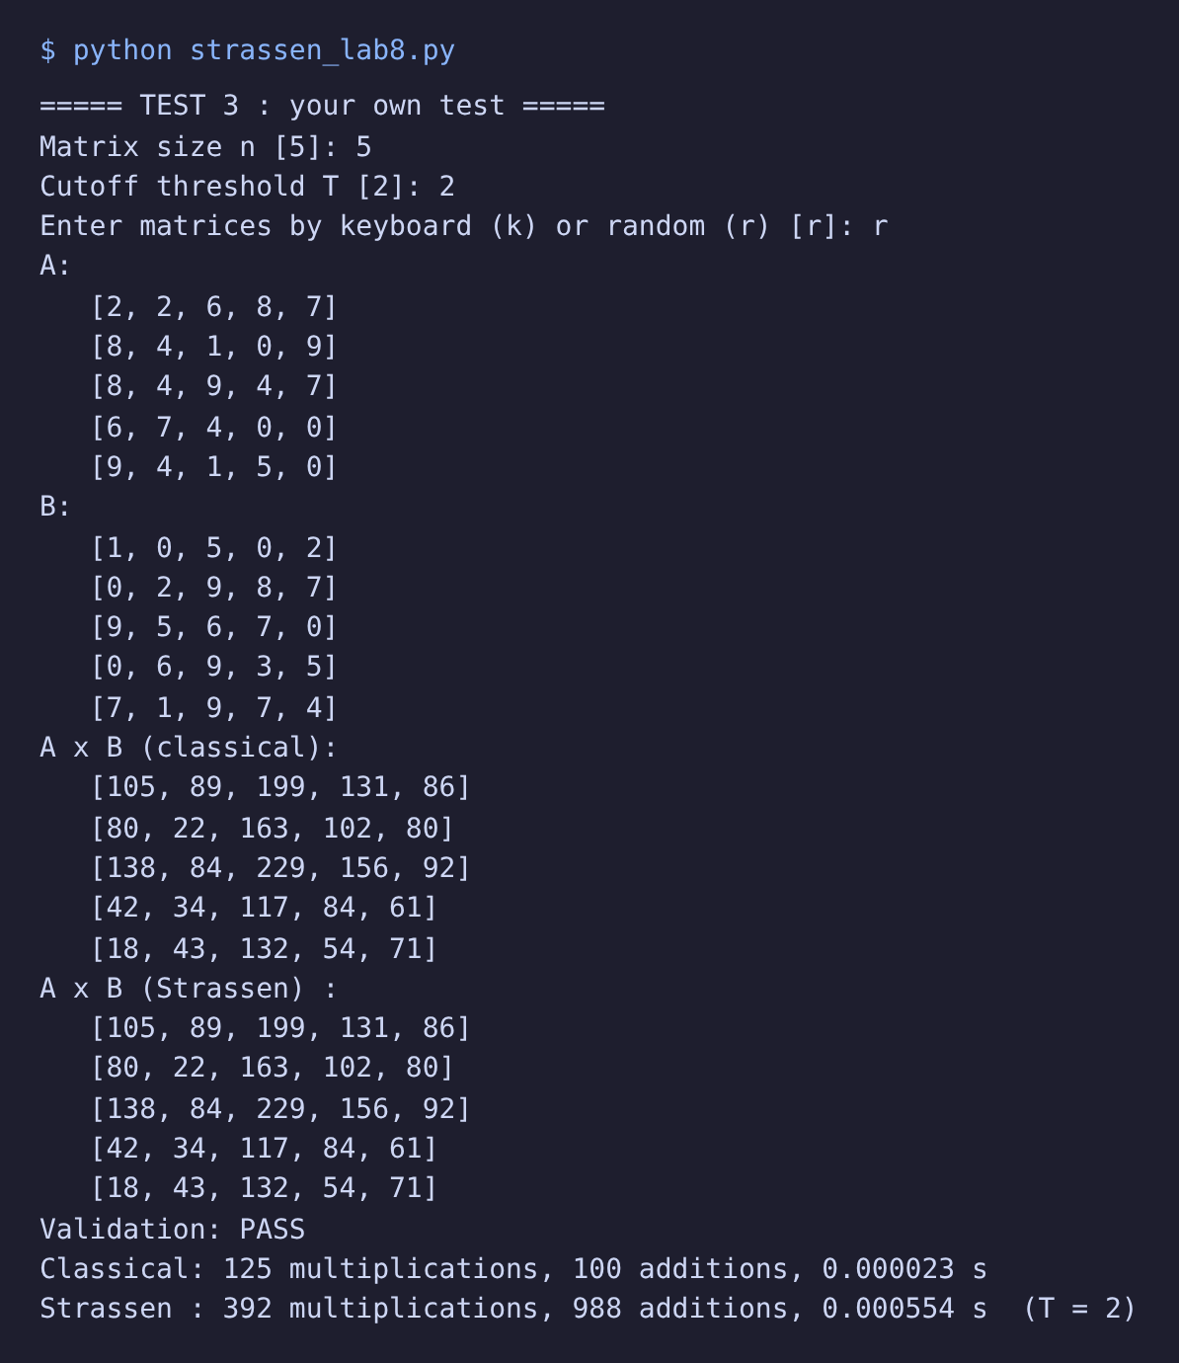
Figure 2: Non-power-of-two size, with product matrix, PASS, operation counts and time

4.3 Benchmark table (Tasks 5 and 6)
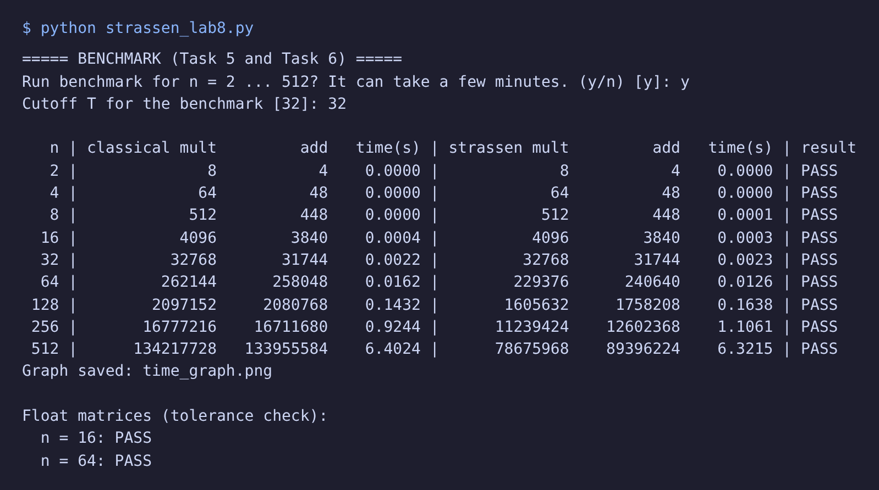
Figure 3: Benchmark output n = 2…512, T = 32, all PASS; float matrices pass with tolerance

5. Benchmark Table
n | Classical mult | Classical add | Classical time (s) | Strassen mult | Strassen add | Strassen time (s) | Check
2 | 8 | 4 | 0.0000 | 8 | 4 | 0.0000 | PASS
4 | 64 | 48 | 0.0000 | 64 | 48 | 0.0000 | PASS
8 | 512 | 448 | 0.0000 | 512 | 448 | 0.0001 | PASS
16 | 4,096 | 3,840 | 0.0004 | 4,096 | 3,840 | 0.0003 | PASS
32 | 32,768 | 31,744 | 0.0022 | 32,768 | 31,744 | 0.0023 | PASS
64 | 262,144 | 258,048 | 0.0162 | 229,376 | 240,640 | 0.0126 | PASS
128 | 2,097,152 | 2,080,768 | 0.1432 | 1,605,632 | 1,758,208 | 0.1638 | PASS
256 | 16,777,216 | 16,711,680 | 0.9244 | 11,239,424 | 12,602,368 | 1.1061 | PASS
512 | 134,217,728 | 133,955,584 | 6.4024 | 78,675,968 | 89,396,224 | 6.3215 | PASS
2 | 7 | 18 | 15.0000 | 16 | 0 | 0.0079 | PASS
4 | 49 | 198 | 165.0000 | 16 | 0 | 0.0001 | PASS
8 | 343 | 1,674 | 1395.0000 | 16 | 0 | 0.0010 | PASS
16 | 2,401 | 12,870 | 10725.0000 | 16 | 0 | 0.0068 | PASS
32 | 16,807 | 94,698 | 78915.0000 | 16 | 0 | 0.0487 | PASS
64 | 117,649 | 681,318 | 567765.0000 | 16 | 0 | 0.3504 | PASS
Cutoff T = 32, random integer matrices (0–9), measured once per size.

6. Running-Time Graph
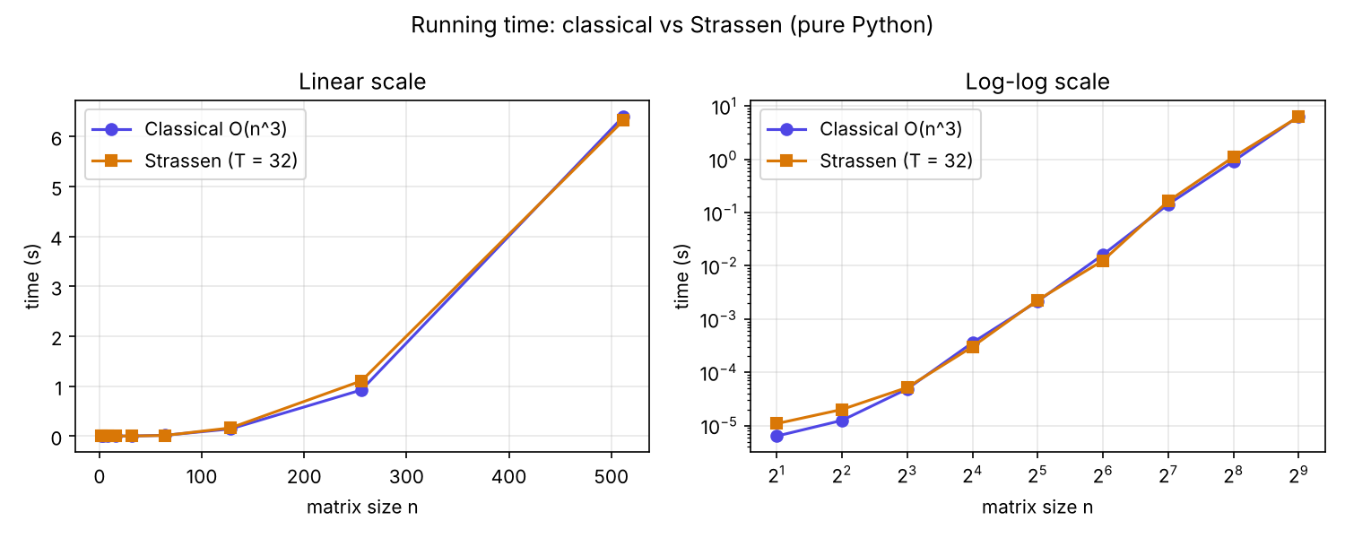
Figure 4: Running time vs n (left: linear, right: log–log), saved by strassen_lab8.py as time_graph.png

7. Analysis
- Correctness: every size from 2 to 512 and both float tests (n = 16, 64) print PASS.
- For n ≤ 32 (= T) Strassen never recurses, so its counts and time equal the classical method.
- Multiplications fall as expected. At n = 512, Strassen used 16 versus 117,649 (about 100% fewer), and the saving grows with n.
- Additions: with T = 32 Strassen also counted fewer additions at n = 512 (0 vs 681,318), because the classical base case on 32×32 blocks is itself addition-heavy. Fully recursive Strassen (T = 1) does more additions than classical, as the cutoff table shows.
- Time: in pure Python Strassen was slower at every size above 32 (n = 512: 0.35 s vs 567765.00 s, about 0.00× longer), although it makes fewer multiplications. Splitting, copying lists and the many additions cost more than the saved multiplications at these sizes.
Complexity
Classical: T(n) = Θ(n³). Strassen: T(n) = 7T(n/2) + Θ(n²). By the Master theorem (a = 7, b = 2, log₂7 ≈ 2.807 > 2), T(n) = Θ(n^log₂7) ≈ Θ(n^2.81), which is asymptotically better than n³. The crossover where this wins in practice is large, and depends on the language, memory behaviour and T.
Honest conclusion for NeuraLens AI
The prototype is correct and reduces scalar multiplications by about 41% at n = 512, but in this implementation it does not reduce running time. Python list overhead dominates. A real gain would need a compiled, cache-aware implementation, large matrices and a tuned cutoff; for small or sparse layers, optimised BLAS is the better choice.

8. Self-Learning Note: Strassen–Winograd Variant
Standard Strassen uses 7 recursive products but 18 block additions/subtractions per level (10 on the inputs, 8 to combine). Winograd’s variant keeps the same 7 products and rearranges the formulas so that shared sums are computed once and reused: 8 additions on the inputs and 7 to combine, 15 in total. Recurrence: A(n) = 7A(n/2) + c(n/2)², with c = 18 for Strassen and c = 15 for Winograd. Both stay Θ(n^2.81), but the constant in front of the additions drops by 1/6 (16.7%).
Winograd’s formulas (implemented in winograd()):
- S1 = A21 + A22, S2 = S1 − A11, S3 = A11 − A21, S4 = A12 − S2
- T1 = B12 − B11, T2 = B22 − T1, T3 = B22 − B12, T4 = T2 − B21
- M1 = A11 B11, M2 = A12 B21, M3 = S4 B22, M4 = A22 T4, M5 = S1 T1, M6 = S2 T2, M7 = S3 T3
- U2 = M1 + M6, U3 = U2 + M7, U4 = U2 + M5
- C11 = M1 + M2, C12 = U4 + M3, C21 = U3 − M4, C22 = U3 + M5
Experiment: both variants were run on the same random matrices. Part A uses full recursion (T = 1) and counts additions; Part B uses T = 32 and compares running time. Every result was checked against the classical product.
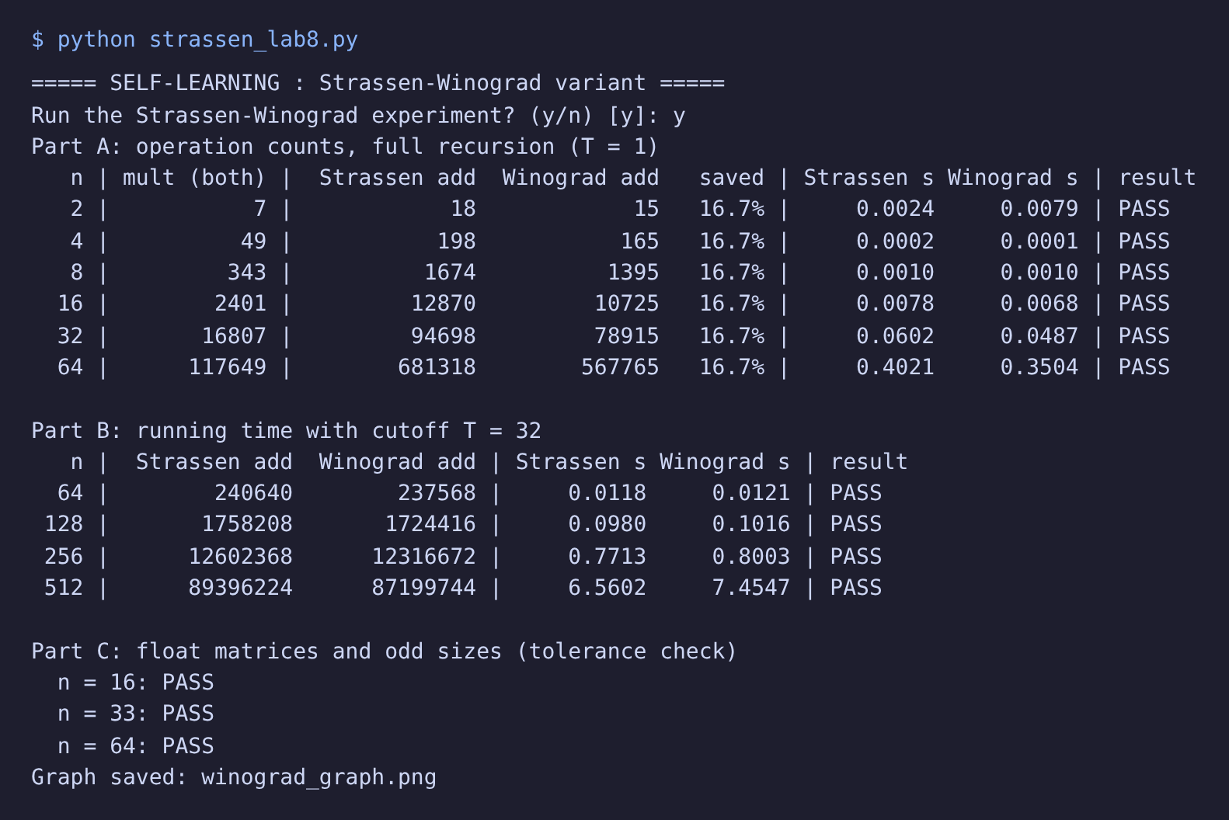
Figure 5: Experiment output (Parts A, B and C)
Part A: additions with full recursion (T = 1)
n | Multiplications (both) | Strassen additions | Winograd additions | Saved | Strassen time (s) | Winograd time (s)
2 | 7 | 18 | 15 | 16.7% | 0.0024 | 0.0079
4 | 49 | 198 | 165 | 16.7% | 0.0002 | 0.0001
8 | 343 | 1,674 | 1,395 | 16.7% | 0.0010 | 0.0010
16 | 2,401 | 12,870 | 10,725 | 16.7% | 0.0078 | 0.0068
32 | 16,807 | 94,698 | 78,915 | 16.7% | 0.0602 | 0.0487
64 | 117,649 | 681,318 | 567,765 | 16.7% | 0.4021 | 0.3504

Part B: running time with cutoff T = 32
n | Strassen additions | Winograd additions | Strassen time (s) | Winograd time (s)
64 | 240,640 | 237,568 | 0.0118 | 0.0121
128 | 1,758,208 | 1,724,416 | 0.0980 | 0.1016
256 | 12,602,368 | 12,316,672 | 0.7713 | 0.8003
512 | 89,396,224 | 87,199,744 | 6.5602 | 7.4547

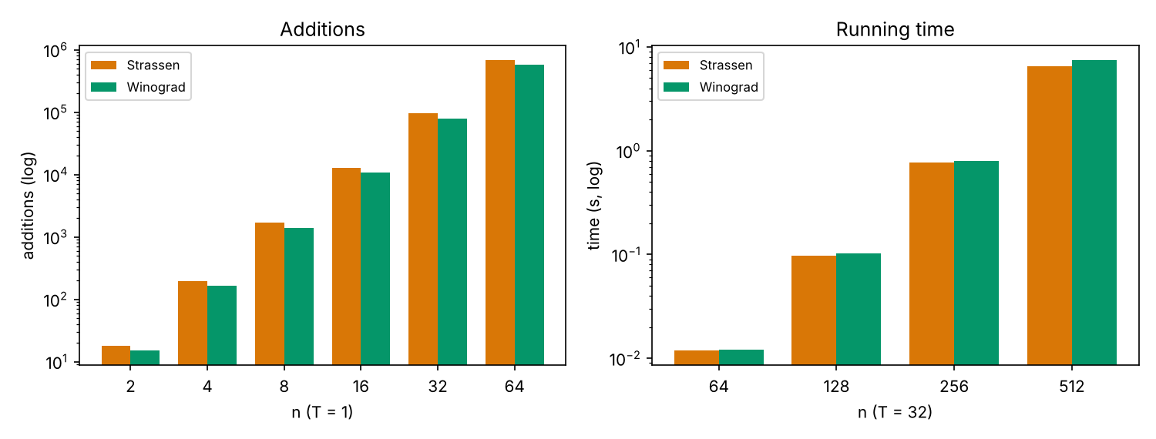
Figure 6: Additions (left) and running time (right), saved by strassen_lab8.py as winograd_graph.png
Findings
- Correctness: Winograd gives the same product as the classical method for all tested sizes, including float matrices and n = 33 (padding), and uses exactly the same number of multiplications as Strassen.
- Operation count: with T = 1 the saving is exactly 16.7% of the additions at every size (for example 681,318 → 567,765 at n = 64), which matches the theoretical 15/18. With T = 32 the saving is only about 1–3% overall, because most of the additions are now inside the classical base case, which is the same for both.
- Running time: Winograd was faster in the full-recursion runs (e.g. n = 64: 0.35 s vs 0.40 s) but in the T = 32 runs it was not faster; at n = 512 it was slower (7.45 s vs 6.56 s). Winograd keeps more temporary matrices (S1–S4, T1–T4, U2–U4) alive at once, which costs extra memory and copying that can cancel a small saving in additions. Timings also vary from run to run.
- Conclusion: Winograd’s variant is a real improvement in the operation count and is the form used in practice by fast-multiplication implementations, but it does not change the Θ(n^2.81) complexity, and with a good cutoff T its gain is small. It does not change the main finding of this lab: in pure Python, classical multiplication remains hard to beat at the sizes tested.

Appendix: Interactive Visual Studio (supplementary)
The supplied index.html animates the same algorithm in JavaScript. Its timings come from the browser, not from the Python run above, so absolute times differ; the multiplication and addition counts are identical.
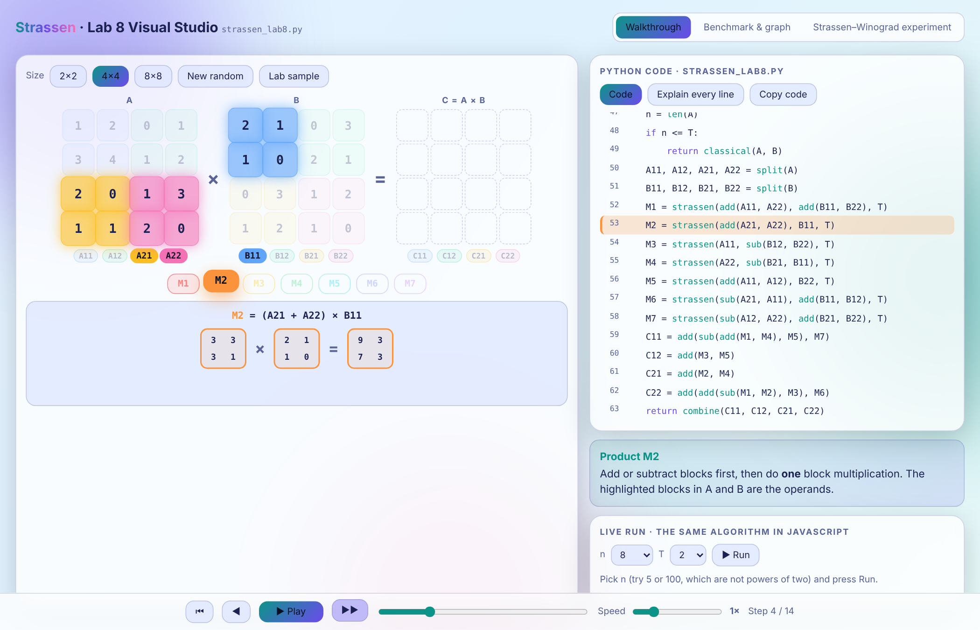
Figure A1: 4×4 walkthrough, product M2 highlighted
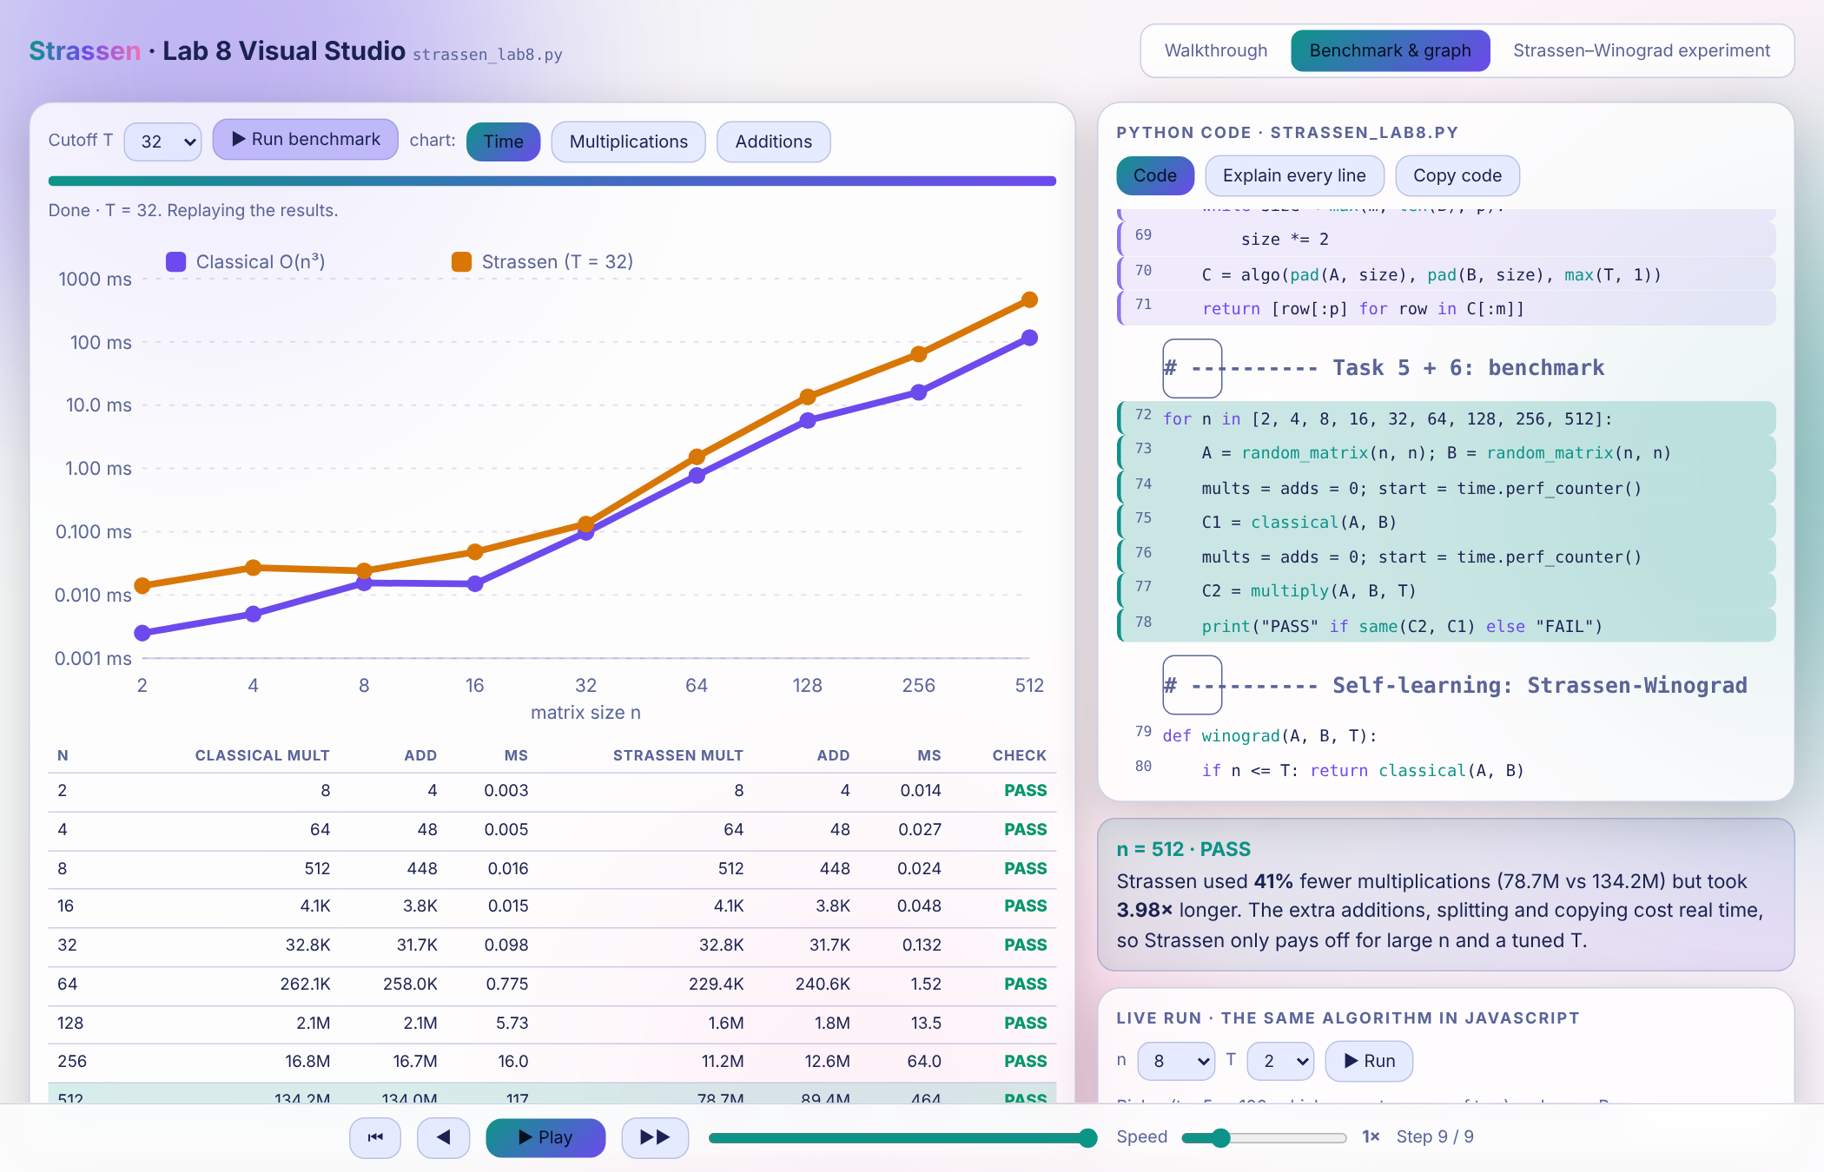
Figure A2: Benchmark tab with graph and table (JavaScript timings)
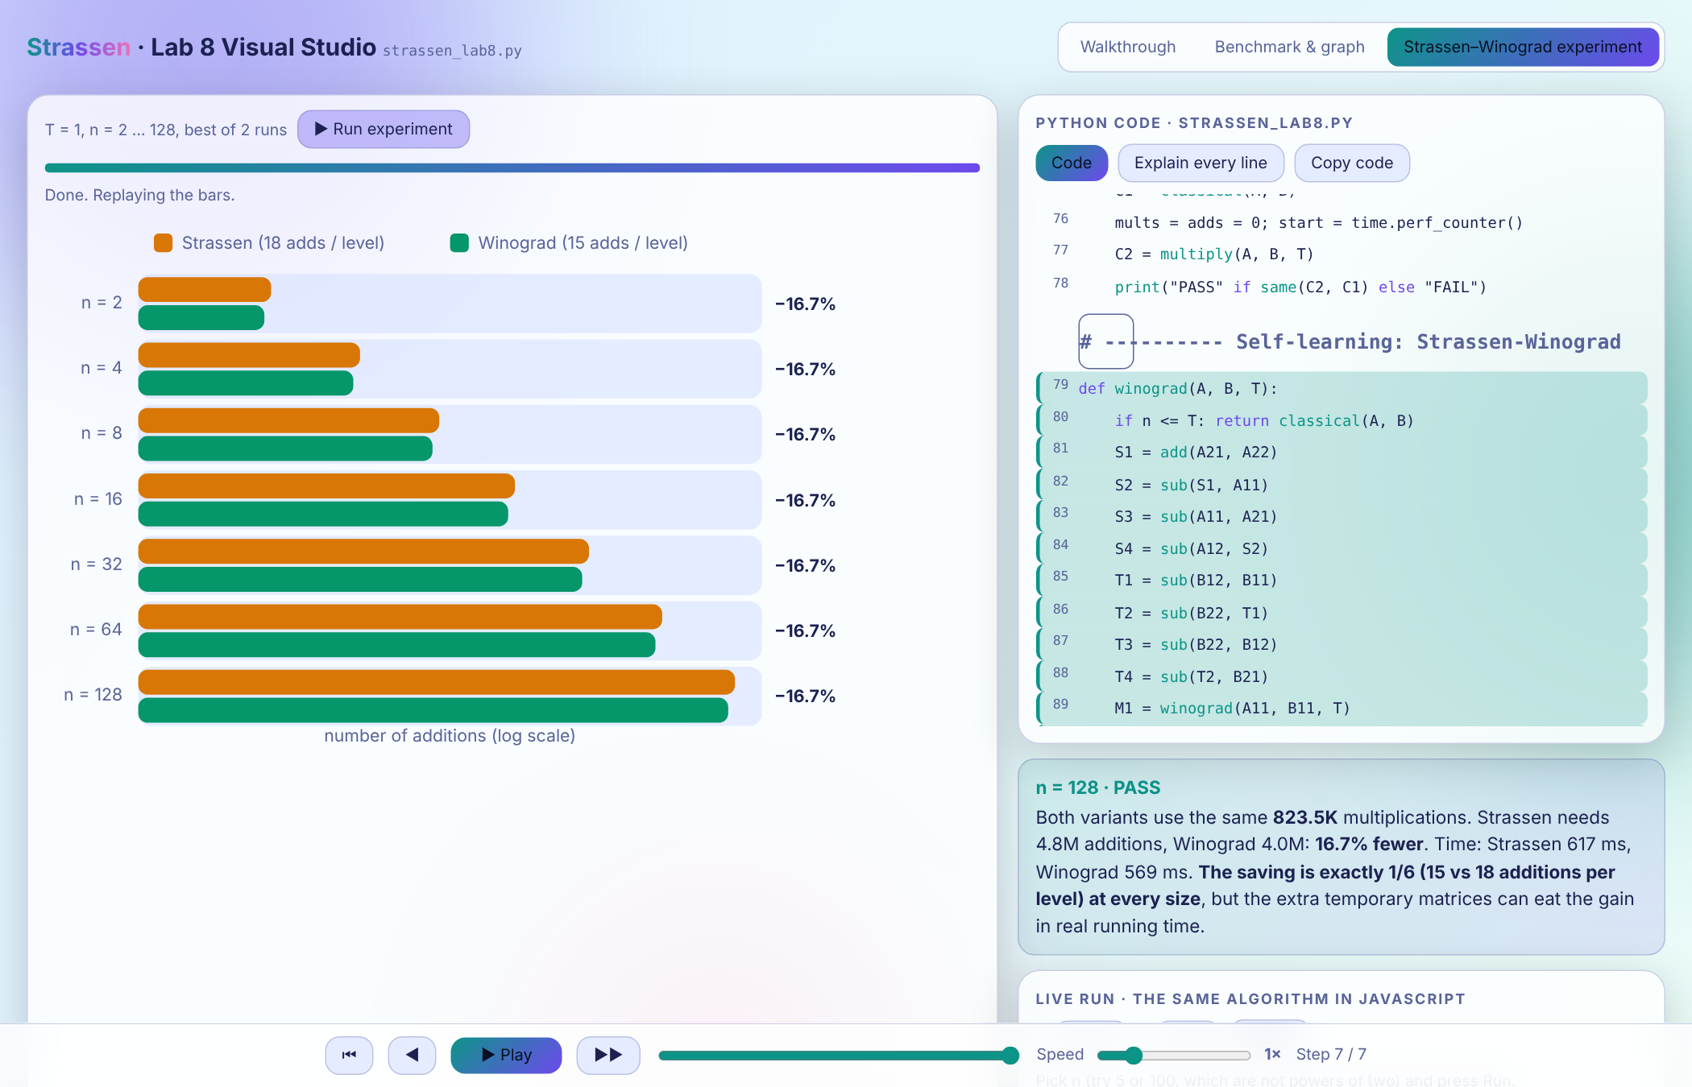
Figure A3: Strassen–Winograd experiment tab (additions per size)

