To
The Director of Public Instruction
Department of Higher Education
Government of West Bengal
Bikash Bhawan, Salt Lake
Kolkata-700091.

Sub: Submission of list cases of all suspension.

Sir,

Please find herewith the cases of all suspension.

Name of the suspended employee | Name of the Office / Institute with address | Suspended From | Reason for suspension | Any other detail
N/A | Bijanbari Degree College, Bijanbari | N/A | N/A | There are no cases of suspended employee’s in this college till date

Thanking You.

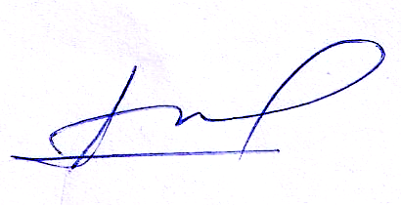

Principal
Bijanbari Degree College

