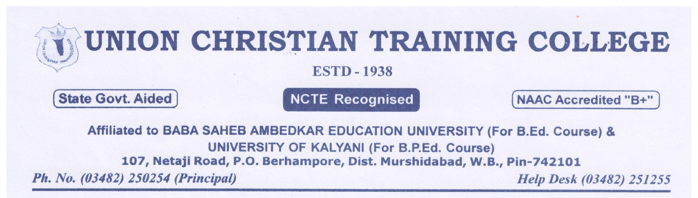

DATE:- 03/09/2024
REPORT ON SUSPENSION FOR INDEFINITE PERIOD

NAME OF THE SUSPENDED EMPLOYEE | NAME OF THE OFFICE/INSTITUTION WITH ADDRESS | SUSPENDED FROM | REASON FOR SUSPENSION | ANY OTHER DETAILS
NA | NA | NA | NA | NA

THERE IS NO SUCH GRIEVANCES IN OUR COLLEGE.

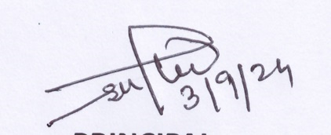
PRINCIPAL
DR. S.K.THAKUR

