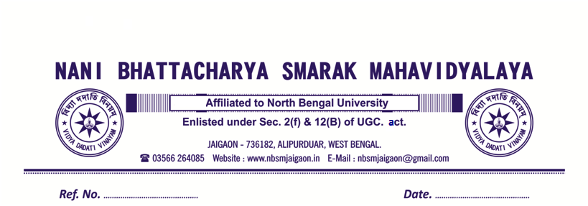

Present Status of Suspension case of Mr. David willam Xalxo, Peon, Non Teaching staff of Nani Bhattacharya Smarak Mahavidyalaya, Jaigaon

Name of the Suspended Employee | Name of the Office/Institution with Address | Suspended from | Reason for suspension | Any other details
Mr. David willam Xalxo | Nani Bhattacharya Smarak Mahavidyalaya, Jaigaon, Alipurduar.  PIN-736182 | 1:12:2008, | Irregular present in workplace | - As per Governing Body Resolution, dated 8:12:2008 item no Misc 8, salary of Mr. David willam Xalxo, Peon stop from December, 2008.  - As per Governing Body Resolution, dated 3:07:2015 item no 5, Mr. David willam Xalxo, Peon give a last chance to be continued in his service.

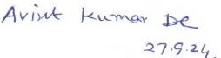

PRINCIPAL
N.B.S.Mahavidyalaya
