UNIVERSITY COLLEGE OF ENGINEERING KANCHIPURAM
Department of Computer Science and Engineering
B.E. (Computer Science and Engineering) — Batch 2023–2027

SwiftShip Tracker
AI-Powered Parcel Tracking Service Agent
Built on Salesforce Agentforce / Agent Builder
PROJECT TECHNICAL DOCUMENTATION

Team Leader | : | Sanjai G
Team Members | : | Thuyavan M, Mathan T, Akash S, Ranjith
Institution | : | University College of Engineering Kanchipuram
Department | : | B.E. Computer Science and Engineering
Academic Year | : | 2023 – 2027
Year of Study | : | Final Year
Technology Platform | : | Salesforce Agentforce / Agent Builder
Development Environment | : | Salesforce Developer Org

Table of Contents
1. Project Overview
2. Project Objectives
3. Project Scope
4. System Architecture
5. Technology Stack
6. Salesforce Environment Setup
7. Data Model
8. Agentforce Agent Configuration
9. Agent Topics
10. Agent Actions and Flows
11. Flow Diagrams
12. User Interaction Process
13. Implementation Process
14. Testing Strategy
15. Test Cases
16. Deployment and Validation
17. Maintenance, Monitoring and Troubleshooting
18. Maintenance Procedure
19. Security and Permissions
20. Error Handling
21. Limitations
22. Real-World Enterprise Deployment
23. Future Enhancements
24. Project Outcomes
25. Conclusion

1. Project Overview
SwiftShip Tracker is a prototype AI-powered parcel tracking service agent developed as a final-year academic project by students of the B.E. Computer Science and Engineering programme at the University College of Engineering Kanchipuram. The system is built using Salesforce Agentforce within a Salesforce Developer Org and demonstrates how modern AI agent technology can be applied to logistics and parcel delivery use cases.
The primary goal of SwiftShip Tracker is to enable users to interact with an intelligent conversational agent using plain English to retrieve real-time parcel, delivery, and customer information stored in Salesforce custom objects. Instead of navigating traditional portals or contacting human support agents, users can simply ask questions such as "Where is my parcel?" or "When will TRK001 arrive?" and receive accurate, data-driven responses.

1.1 Problem Statement
Parcel tracking in conventional systems is largely portal-driven, requiring users to navigate web pages, manually input tracking numbers, and interpret raw status updates. This creates friction, especially for non-technical users, and increases the burden on customer service teams who receive high volumes of tracking enquiries. There is a growing need for an intelligent, conversational interface that can understand natural-language queries, automatically retrieve the correct data, and communicate results in a user-friendly format.

1.2 Proposed Solution
SwiftShip Tracker addresses this problem by deploying a Salesforce Agentforce AI service agent configured with parcel-tracking-specific topics, instructions, and Salesforce Flow-based actions. The agent understands user intent, routes the request to the appropriate automated workflow, retrieves data from Salesforce custom objects, and generates a natural-language response — all without human intervention.

1.3 Role of Salesforce
Salesforce serves as the complete backend platform for this project. It hosts the custom data objects (Parcel, Customer, Delivery), the Flow-based automation for data retrieval, and the Agentforce agent configuration. All data is stored, managed, and accessed within Salesforce, ensuring a single, consistent source of truth for all tracking information.

1.4 Role of Agentforce
Agentforce is Salesforce's native AI agent framework. It provides the natural-language processing capability, topic routing mechanism, and action invocation layer that powers the SwiftShip Tracker agent. Agentforce allows the project team to configure the agent's behaviour through a no-code Agent Builder interface, making it accessible to developers without deep machine learning expertise.

1.5 Academic Context
This implementation is a functional prototype submitted as part of the final-year project requirement for the B.E. (Computer Science and Engineering) programme at the University College of Engineering Kanchipuram, academic batch 2023–2027. The project is designed to demonstrate competency in cloud platform development, AI agent configuration, data modelling, automation, and system testing. It is implemented and tested in a Salesforce Developer Org and is not deployed to a production environment.

2. Project Objectives
The SwiftShip Tracker project is designed to achieve the following objectives:
- Design and implement a functional AI-powered parcel tracking service agent using Salesforce Agentforce.
- Enable end-users to query parcel status, delivery details, and customer records using natural-language input.
- Create a structured Salesforce data model using custom objects for Parcel, Customer, and Delivery information.
- Configure Agentforce agent topics to accurately identify and classify user intent from conversational queries.
- Develop Salesforce Flows that retrieve parcel and delivery data based on user-supplied inputs such as tracking numbers.
- Map agent actions to Salesforce Flows to enable automated data retrieval without manual intervention.
- Configure agent instructions to ensure responses are accurate, contextual, and free from fabricated information.
- Implement structured error handling so the agent responds appropriately when data is missing, invalid, or unavailable.
- Validate all agent capabilities through a defined functional test plan executed within the Salesforce Developer Org.
- Document the complete implementation, maintenance, troubleshooting, and testing process for academic evaluation.
- Demonstrate the viability of Salesforce Agentforce as a platform for AI-powered customer service applications.

3. Project Scope

3.1 In Scope
- Salesforce Developer Org provisioning, setup, and configuration.
- Agentforce Agent Builder — agent creation, role definition, topic configuration, instructions, and action mapping.
- Salesforce custom objects: Customer, Parcel, and Delivery, including fields and lookup relationships.
- Salesforce Flow Builder — automated Flows for parcel status retrieval, delivery information retrieval, and customer parcel listing.
- Natural-language user interaction via the Agentforce conversational interface.
- Agent topic routing to correctly identify parcel-tracking, delivery-information, and customer-lookup intents.
- Error handling for invalid tracking numbers, missing records, and unsupported queries.
- Functional testing within the Developer Org covering valid, invalid, and edge-case scenarios.
- Technical documentation of architecture, data model, implementation steps, test cases, and maintenance procedures.

3.2 Out of Scope
- Deployment to a Salesforce production environment or customer-facing system.
- User Acceptance Testing (UAT) with real end-users or customers.
- Enterprise sandbox strategy and multi-environment deployment pipelines.
- Automated CI/CD pipeline for Salesforce metadata deployment.
- Integration with real-time external carrier or logistics APIs.
- Large-scale performance, load, or stress testing.
- Production monitoring infrastructure and enterprise logging systems.
- Mobile or native application development for the tracking interface.
These activities are outside the scope because the project is a prototype developed for academic evaluation. Enterprise deployment requires additional Salesforce environments, formal change management, security governance, and resources that are beyond the scope of a final-year undergraduate project.

4. System Architecture
The SwiftShip Tracker system follows a layered architecture in which user queries pass through the Agentforce AI processing layer, into Salesforce automation, and then into the Salesforce data layer. Results travel back through the same stack and are presented to the user as natural-language responses.

4.1 Architecture Flow
USER
Natural language parcel query submitted
▼
Agentforce AI Agent
Receives query, processes intent
▼
Topic Recognition Engine
Matches query to configured Agent Topic
▼
Agent Instructions
Applies rules, validates inputs, prompts if needed
▼
Agent Action
Determines which Salesforce Flow to invoke
▼
Salesforce Flow (Automation)
Executes query logic against Salesforce objects
▼
Salesforce Custom Objects
Parcel__c / Customer__c / Delivery__c
▼
Data Returned to Agent
Flow output passed back to Agentforce
▼
Natural Language Response
Formatted response delivered to user
▼
USER

4.2 Component Descriptions
Component | Description
User | End-user submitting parcel tracking queries via the Agentforce conversational interface.
Agentforce AI Agent | The SwiftShip Tracker agent configured in Salesforce Agent Builder. Manages the full conversation lifecycle.
Topic Recognition | Determines which configured Agent Topic matches the user's intent and routes the query accordingly.
Agent Instructions | Rules and behavioural guidelines defining how the agent should respond, retrieve information, and handle errors.
Agent Action | An Agentforce-defined action that is triggered by a topic and mapped to a Salesforce Flow.
Salesforce Flow | Auto-launched Flow that accepts agent inputs, queries custom objects, and returns results.
Salesforce Custom Objects | Parcel__c, Customer__c, and Delivery__c objects storing all tracking-relevant data.
Agent Response | Formatted natural-language answer generated by Agentforce and delivered to the user.

5. Technology Stack
Technology / Platform | Role in Project
Salesforce Platform | Core development environment hosting all objects, automation, and agent configuration.
Salesforce Developer Org | Free, isolated development environment used for building and testing this prototype.
Salesforce Agentforce | AI agent framework providing natural-language understanding, topic routing, and response generation.
Salesforce Agent Builder | No-code visual tool for configuring agents, topics, instructions, and action mappings.
Salesforce Flow Builder | Automation tool for creating Flows that retrieve parcel and delivery data from Salesforce objects.
Salesforce Custom Objects | Defines and stores Parcel, Customer, and Delivery data within Salesforce.
Salesforce Object Manager | Used to create and configure custom objects and their fields and relationships.
Natural Language AI (Agentforce) | Processes user queries to identify intent without keyword-matching or scripted menus.

6. Salesforce Environment Setup

6.1 Developer Org Provisioning
A Salesforce Developer Org was provisioned by registering at developer.salesforce.com. This free environment provides complete access to Salesforce features including custom objects, Flow Builder, and Agentforce, making it suitable for prototype development and testing.

6.2 Required Permissions and Configuration
Configuration Item | Requirement
User Profile | System Administrator (provides full access for development purposes).
Agentforce | Must be enabled in the org via Setup → Einstein / Agentforce configuration.
Flow Builder | Available by default to System Administrator. Required for creating retrieval Flows.
Object Manager | Used to create and configure Parcel, Customer, and Delivery custom objects.
Agent Builder | Accessible via Agentforce Setup once the feature is enabled.

6.3 Custom Object Setup
Three custom objects were created in the Developer Org to support the SwiftShip Tracker data model. Each object was configured with the required fields, data types, and lookup relationships through the Salesforce Object Manager.

6.4 Sample Data Population
Sample records were manually created for each custom object to support functional testing. These records include representative tracking numbers, parcel statuses, delivery dates, carrier names, and customer information. Sample data quantity is sufficient for prototype testing but does not represent production-scale volumes.

6.5 Flow Configuration
Salesforce Auto-launched Flows were created using Flow Builder. Each Flow accepts input variables (e.g., tracking number), queries the target custom object using a Get Records element, evaluates the result, and returns output variables to the calling agent action. Error paths were configured on each Flow to handle cases where no matching record is found.
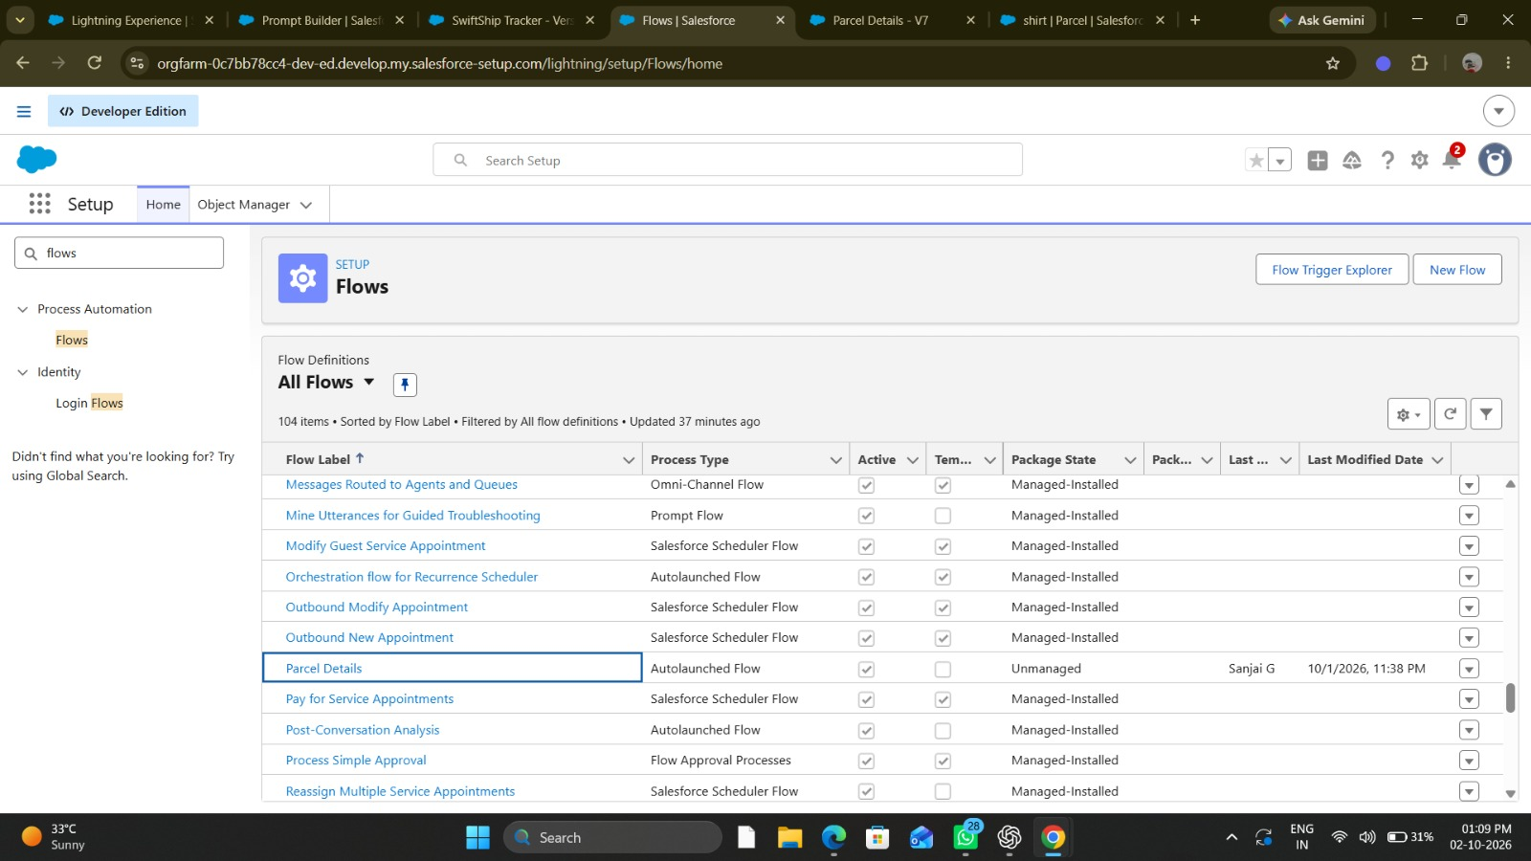
Figure: Salesforce Setup – Flows list showing the active "Parcel Details" Autolaunched Flow

6.6 Agent Configuration
The SwiftShip Tracker agent was created in Salesforce Agent Builder. The agent was configured with a defined role, behavioural instructions, topics, and mapped actions. Each action was linked to its corresponding Salesforce Flow to enable end-to-end data retrieval.

7. Data Model
The SwiftShip Tracker data model is built on three Salesforce custom objects that together capture all information required for parcel tracking: the customer who placed the shipment, the parcel being tracked, and the delivery event associated with it.

7.1 Customer Object (Customer__c)
Stores the profile and contact information of individuals or organisations whose parcels are being tracked.
Field Label | API Name (Example) | Field Type | Purpose
Customer Name | Name | Text | Full name of the customer.
Customer ID | Customer_ID__c | Text (Unique) | Unique business identifier for the customer.
Email Address | Email__c | Email | Primary email contact for the customer.
Phone Number | Phone__c | Phone | Primary phone contact for the customer.
Registration Date | Registration_Date__c | Date | Date the customer was registered in the system.
Address | Address__c | Text Area | Customer's primary postal address.

7.2 Parcel Object (Parcel__c)
Stores the core tracking information for each shipment, including the unique tracking number, current status, and origin/destination details.
Field Label | API Name (Example) | Field Type | Purpose
Parcel Name | Name | Text (Auto) | Auto-generated record identifier.
Tracking Number | Tracking_Number__c | Text (Unique) | Unique alphanumeric identifier used for tracking (e.g., TRK001).
Parcel Status | Parcel_Status__c | Picklist | Current status: Processing / In Transit / Out for Delivery / Delivered / Exception.
Origin City | Origin__c | Text | City or location from which the parcel was dispatched.
Destination City | Destination__c | Text | Target delivery city or location.
Description | Description__c | Text Area | Brief description of parcel contents.
Dispatch Date | Dispatch_Date__c | Date | Date the parcel was dispatched by the sender.
Customer (Lookup) | Customer__c | Lookup → Customer__c | Links the parcel to its associated customer record.

7.3 Delivery Object (Delivery__c)
Stores the delivery-specific information including carrier details, current location, estimated date, and actual delivery confirmation.
Field Label | API Name (Example) | Field Type | Purpose
Delivery Name | Name | Text (Auto) | Auto-generated record identifier.
Carrier Name | Carrier__c | Text | Name of the logistics carrier managing delivery.
Delivery Status | Delivery_Status__c | Picklist | Current delivery state: Scheduled / In Transit / Out for Delivery / Delivered / Failed Attempt.
Current Location | Current_Location__c | Text | Last recorded location of the parcel.
Estimated Delivery Date | Estimated_Delivery_Date__c | Date | Projected date of successful delivery.
Actual Delivery Date | Actual_Delivery_Date__c | Date | Confirmed date of successful delivery (populated on completion).
Delivery Notes | Delivery_Notes__c | Text Area | Additional information such as delivery instructions or exception notes.
Parcel (Lookup) | Parcel__c | Lookup → Parcel__c | Links the delivery record to its associated parcel.

7.4 Object Relationships
Customer → Parcel: One-to-Many. A single customer can be associated with multiple parcel records. The Parcel__c object holds a Lookup field (Customer__c) pointing to the Customer__c object.
Parcel → Delivery: One-to-One. Each parcel record has one associated delivery record. The Delivery__c object holds a Lookup field (Parcel__c) pointing to the Parcel__c object.

8. Agentforce Agent Configuration

8.1 Agent Creation
The SwiftShip Tracker agent was created using Salesforce Agent Builder within the Developer Org. Agent Builder is a no-code visual configuration interface within the Agentforce platform that allows developers and administrators to define an agent's identity, role, topics, instructions, and actions without writing custom AI code.
The agent was created by navigating to the Agentforce section within Salesforce Setup and selecting the option to create a new agent. The agent was named "SwiftShip Tracker" and configured with the role and instructions described below.

8.2 Agent Role Definition
The following role was configured for the SwiftShip Tracker agent:
"You are SwiftShip Tracker, an AI-powered parcel tracking service assistant. Your sole purpose is to help users retrieve accurate parcel status, delivery information, and customer parcel records from Salesforce. Always use the designated Salesforce actions to retrieve data. Never estimate, assume, or fabricate parcel information. If a parcel cannot be found, inform the user and ask them to verify their tracking number."

8.3 Agent Instructions
The following behavioural instructions were configured at the agent level to govern all interactions:
- Always ask the user for their tracking number before attempting to retrieve parcel information.
- Use the designated agent action to retrieve parcel data — do not generate or estimate responses from memory.
- If a parcel record is not found, respond clearly: "I could not find a parcel with tracking number [X]. Please verify the number and try again."
- If a Flow or action fails, respond: "Parcel information is temporarily unavailable. Please try again shortly or contact support."
- If the user asks a question unrelated to parcel tracking or delivery, respond: "I am a parcel tracking assistant and can only help with parcel and delivery queries."
- Always confirm the tracking number received from the user before proceeding.
- Return only data retrieved directly from Salesforce. Do not supplement or interpret results beyond what is returned by the action.
- If partial data is returned (e.g., parcel found but no related delivery record), provide the available information and note what is not available.

9. Agent Topics
Agent Topics are the classification units within Agentforce that define the categories of user requests the agent is trained to handle. When a user submits a query, Agentforce evaluates all configured topics and selects the best match based on the topic description and the user's input.
Each topic contains a name, a description, topic-level instructions, and one or more agent actions. The description is critical — it must clearly represent the type of user query that should trigger the topic.
Topic Name | Purpose | Example User Queries | Associated Action
Parcel Status Enquiry | Handles all requests to retrieve the current status of a parcel using a tracking number. | "Where is my parcel?" "Track parcel TRK001" "What is the status of my shipment?" | Get Parcel Status Action [Example]
Delivery Information Enquiry | Handles requests for delivery-specific information including carrier, estimated date, and current location. | "When will my parcel TRK002 arrive?" "Who is the carrier for TRK001?" "What is the delivery date?" | Get Delivery Information Action [Example]
Customer Parcel Listing | Handles requests to list all parcels associated with a customer. | "Show me all my parcels." "List my shipments." | Get Customer Parcels Action [Example]
Unrecognised / Out-of-Scope Query | Handles queries that do not match any parcel-tracking topic and returns a graceful redirect message. | "What is the weather today?" "Can you book a taxi?" | Handled via agent-level instructions — no specific action.

9.1 Topic Configuration Notes
- Topic descriptions must be specific enough to avoid overlap. If two topics have similar descriptions, Agentforce may route queries to the wrong topic.
- Topic-level instructions can be configured to supplement the agent-level instructions for that specific category of request.
- Topics should be tested with a variety of user phrasings to ensure robust recognition across different natural-language patterns.
- Topics that are not implemented should not be listed in the agent configuration as they may produce unexpected routing behaviour.

10. Agent Actions and Flows
Agent Actions are the mechanism by which Agentforce topics trigger Salesforce automation. Each action is defined in Agent Builder and mapped to a specific Salesforce Flow. When the agent determines the appropriate action based on the topic, it invokes the Flow, passes the required inputs, and receives the result for inclusion in the response.

10.1 Flow: Get Parcel Status
Attribute | Detail
Flow Name | Get_Parcel_Status_Flow [Example]
Flow Type | Auto-launched Flow
Purpose | Retrieves the current status of a parcel using the provided tracking number.
Input Variable | varTrackingNumber (Text) — the tracking number supplied by the user.
Processing | Uses a Get Records element to query Parcel__c where Tracking_Number__c equals varTrackingNumber.
Salesforce Object Queried | Parcel__c
Output Variables | varParcelStatus (Parcel_Status__c), varOrigin (Origin__c), varDestination (Destination__c), varCustomerName (related Customer Name).
Error Handling | If no record is found, output variable varErrorMessage is set to "Parcel not found." Flow terminates with the error output.
Agent Action Name | Get Parcel Status [Example]

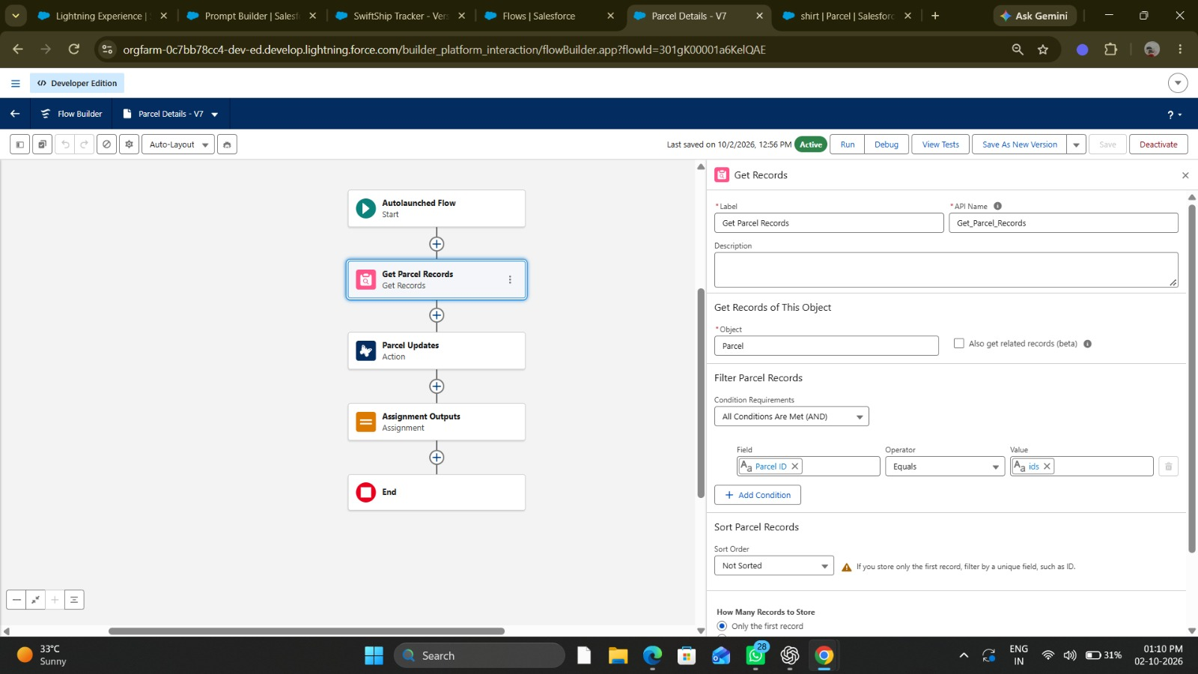
Figure: Flow Builder – "Parcel Details" flow with Get Parcel Records element (Parcel ID equals input ids)
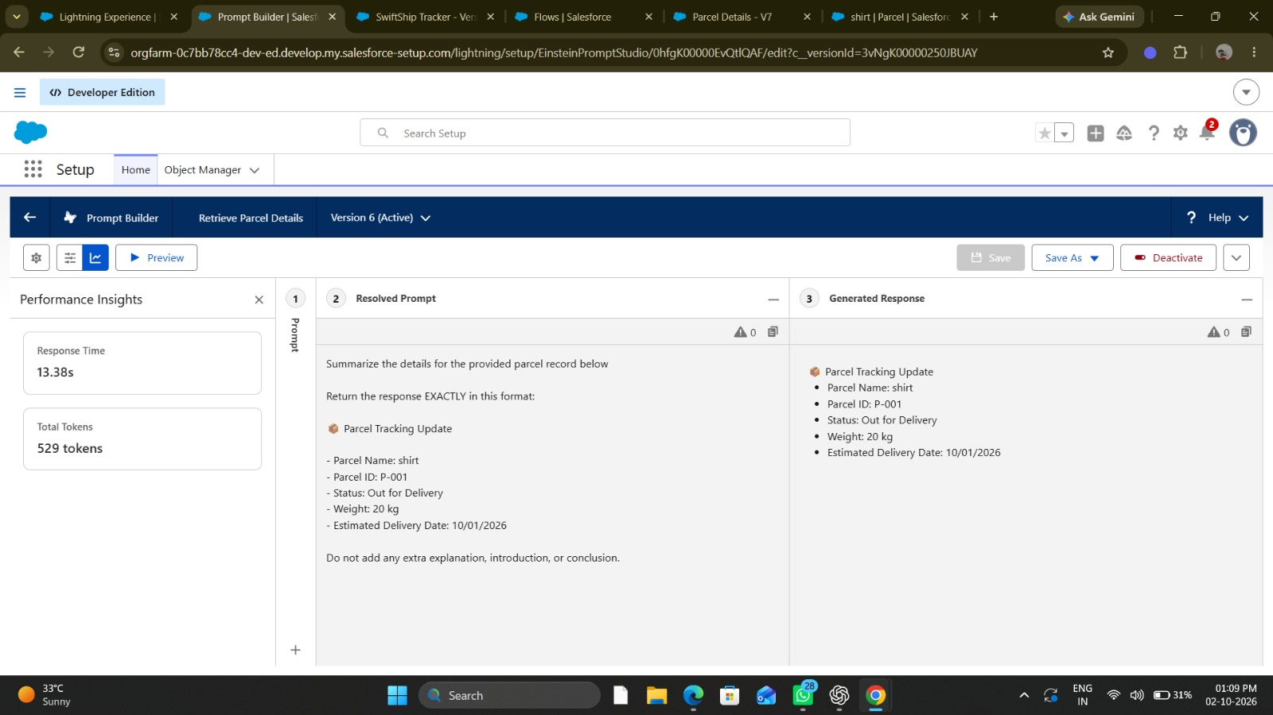
Figure: Prompt Builder – "Retrieve Parcel Details" template (Version 6, Active) with resolved prompt and generated response

10.2 Flow: Get Delivery Information
Attribute | Detail
Flow Name | Get_Delivery_Info_Flow [Example]
Flow Type | Auto-launched Flow
Purpose | Retrieves delivery details for a parcel using its tracking number.
Input Variable | varTrackingNumber (Text) — the tracking number supplied by the user.
Processing | Queries Parcel__c to locate the record, then traverses the relationship to retrieve the related Delivery__c record.
Salesforce Objects Queried | Parcel__c, Delivery__c
Output Variables | varCarrier, varEstimatedDeliveryDate, varActualDeliveryDate, varCurrentLocation, varDeliveryStatus.
Error Handling | If the parcel is not found or no related Delivery__c record exists, returns an appropriate error message variable.
Agent Action Name | Get Delivery Information [Example]

10.3 Flow: Get Customer Parcels
Attribute | Detail
Flow Name | Get_Customer_Parcels_Flow [Example]
Flow Type | Auto-launched Flow
Purpose | Retrieves a list of all parcels associated with a customer account.
Input Variable | varCustomerID (Text) or varCustomerName (Text).
Processing | Queries Customer__c to identify the customer, then retrieves all related Parcel__c records using the Lookup relationship.
Salesforce Objects Queried | Customer__c, Parcel__c
Output Variables | varParcelList — a collection of tracking numbers and their statuses.
Error Handling | If no customer record or no parcels are found, returns a "No parcels found" error message.
Agent Action Name | Get Customer Parcels [Example]

11. Flow Diagrams
This section illustrates the logical execution flow for each Salesforce Flow used by the SwiftShip Tracker agent. These diagrams represent the step-by-step processing that occurs when an agent action invokes a Flow.

11.1 Flow Diagram — Get Parcel Status Flow

START
▼
Receive Input: varTrackingNumber
Input variable passed from Agent Action
▼
Validate: Is varTrackingNumber empty?
Decision element
▼
YES → Set varErrorMessage = "Please provide a tracking number."
▼
Get Records: Query Parcel__c WHERE Tracking_Number__c = varTrackingNumber
Get Records element — retrieves first matching Parcel record
▼
Decision: Was a Parcel record found?
Check if Get Records returned a result
▼
NO → Set varErrorMessage = "Parcel not found. Please verify the tracking number."
▼
YES → Set Output Variables (Status, Origin, Destination, Customer)
Assigns output variable values from the retrieved Parcel record
▼
END — Return Output Variables to Agent Action

11.2 Flow Diagram — Get Delivery Information Flow

START
▼
Receive Input: varTrackingNumber
Input variable passed from Agent Action
▼
Get Records: Query Parcel__c WHERE Tracking_Number__c = varTrackingNumber
Retrieves the Parcel record to get the related Delivery ID
▼
Decision: Parcel record found?
▼
NO → Set varErrorMessage = "Parcel not found."
▼
YES → Get Records: Query Delivery__c WHERE Parcel__c = Parcel Record ID
Retrieves the related Delivery record using the Parcel Lookup
▼
Decision: Delivery record found?
▼
NO → Set varErrorMessage = "Delivery information not yet available for this parcel."
▼
YES → Set Output Variables (Carrier, ETA, Status, Location, Actual Date)
▼
END — Return Output Variables to Agent Action

11.3 Flow Diagram — Get Customer Parcels Flow

START
▼
Receive Input: varCustomerID or varCustomerName
Input variable passed from Agent Action
▼
Get Records: Query Customer__c WHERE Customer_ID__c = varCustomerID
Locates the customer record
▼
Decision: Customer record found?
▼
NO → Set varErrorMessage = "Customer not found. Please verify your details."
▼
YES → Get Records: Query Parcel__c WHERE Customer__c = Customer Record ID
Retrieves all Parcel records related to the customer
▼
Decision: Any parcels found?
▼
NO → Set varErrorMessage = "No parcels found for this customer."
▼
YES → Build Parcel List (Tracking Number + Status for each Parcel)
▼
END — Return Parcel List to Agent Action

11.4 Flow Colour Key
Colour | Meaning
Blue (EBF3FB) | Standard processing step — data retrieval, variable assignment.
Yellow (FFF3CD) | Decision element — conditional branching based on a true/false evaluation.
Red (FFE0E0) | Error path — sets error message and returns to agent without data.
Green (D4EDDA) | Success path — data retrieved successfully, output variables populated.
Grey-Blue (D9E2F3) | Flow start and end points.

12. User Interaction Process
The following documents the complete end-to-end interaction process when a user submits a parcel tracking query to the SwiftShip Tracker agent.

12.1 Interaction Steps
Step | Actor | Action
1 | User | Submits a natural-language parcel query via the Agentforce conversational interface.
2 | Agentforce | Receives the query and performs natural-language analysis to identify intent.
3 | Agentforce | Evaluates all configured Agent Topics and selects the best match.
4 | Agentforce | Applies the selected topic's instructions. If input data is missing (e.g., tracking number), prompts the user.
5 | User | Provides any additional information requested by the agent (e.g., tracking number).
6 | Agentforce | Invokes the Agent Action associated with the matched topic.
7 | Salesforce Flow | Executes the automation logic — queries the relevant Salesforce custom objects.
8 | Salesforce Data | Returns matching records (Parcel, Delivery, Customer) to the Flow.
9 | Salesforce Flow | Formats the output variables and returns them to the Agentforce agent action.
10 | Agentforce | Formats the retrieved data into a natural-language response using the agent instructions.
11 | User | Receives the natural-language response in the conversation interface.

12.2 Example Interactions
The following are illustrative example interactions. These are representative scenarios based on the configured agent behaviour. Actual responses depend on the data in the Developer Org and the agent configuration.

Example 1 — Valid Parcel Status Query
Role | Message
User | "Where is my parcel?"
Agent | "I can help you track your parcel. Please provide your parcel tracking number."
User | "TRK001"
Agent | "Your parcel with tracking number TRK001 is currently In Transit. It was dispatched from Chennai and is heading to Mumbai. Would you like delivery information for this parcel?"

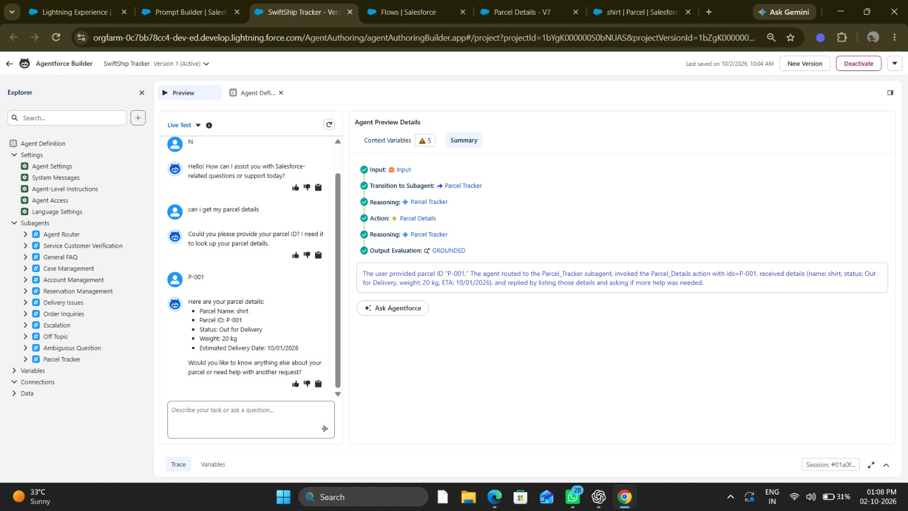
Figure: Agentforce Builder – live preview test of the SwiftShip Tracker agent retrieving parcel P-001 details
Example 2 — Delivery Date Query
Role | Message
User | "When will my parcel TRK002 be delivered?"
Agent | "Your parcel TRK002 is scheduled for delivery on 15 October 2026. It is currently with BlueDart Courier and was last recorded at Hyderabad Sorting Hub. The current delivery status is Out for Delivery."

Example 3 — Invalid / Non-Existent Tracking Number
Role | Message
User | "Track parcel TRK999"
Agent | "I was unable to find a parcel with tracking number TRK999. Please verify the tracking number and try again. If the problem continues, please contact our support team."

Example 4 — Unrelated Query
Role | Message
User | "What is the capital of India?"
Agent | "I am the SwiftShip Tracker assistant and I can only assist with parcel tracking and delivery queries. Please ask me about a parcel or shipment."

Example 5 — Customer Parcel Listing
Role | Message
User | "Show me all my parcels."
Agent | "Please provide your Customer ID so I can retrieve your parcel list."
User | "CUST001"
Agent | "I found 2 parcels associated with your account: 1. TRK001 — In Transit 2. TRK002 — Out for Delivery Would you like more details on any of these?"

13. Implementation Process
The SwiftShip Tracker prototype was implemented following the ten-step process described below. Each step was completed within the Salesforce Developer Org.
Step | Objective | Procedure | Expected Result
1 — Developer Org Setup | Provision and configure the development environment. | Register at developer.salesforce.com. Activate the org. Verify admin access. Enable Agentforce through Setup. | Accessible Developer Org with Agentforce enabled and admin credentials available.
2 — Custom Object Creation | Create the three core custom objects. | Navigate to Setup → Object Manager. Create Customer__c, Parcel__c, and Delivery__c with the fields defined in the data model. Set field types, uniqueness constraints, and required flags. | Three custom objects visible in Object Manager with correct fields configured.
3 — Relationship Configuration | Link objects through Lookup fields. | Add a Lookup field on Parcel__c pointing to Customer__c. Add a Lookup field on Delivery__c pointing to Parcel__c. | Relationships visible in Object Manager. Related lists appear on parent records.
4 — Sample Data Entry | Populate objects with representative test records. | Manually create at least 3 Customer records, 5 Parcel records with various statuses, and corresponding Delivery records. Link records through the Lookup fields. | Queryable, related test records available in all three objects.
5 — Flow Creation | Build Salesforce Flows for data retrieval. | Open Flow Builder. Create three Auto-launched Flows: Get_Parcel_Status_Flow, Get_Delivery_Info_Flow, Get_Customer_Parcels_Flow. Configure input variables, Get Records elements, Decision elements, and output variables. Add fault paths. | Flows execute successfully when tested in Flow Builder with valid and invalid inputs.
6 — Agent Creation | Create the SwiftShip Tracker agent in Agent Builder. | Navigate to Agentforce Setup. Create a new agent named SwiftShip Tracker. Enter the defined role description and agent-level instructions. | Agent visible in Agent Builder with role and instructions saved.
7 — Topic Configuration | Add topics to route user queries. | In Agent Builder, add three topics: Parcel Status Enquiry, Delivery Information Enquiry, Customer Parcel Listing. Write clear descriptions for each topic. Add topic-level instructions. | Topics saved and visible in the agent's topic list.
8 — Action Creation | Map topics to Salesforce Flows. | For each topic, create an Agent Action that references the corresponding Flow. Configure input and output variable mappings between the action and the Flow. | Actions created, linked to Flows, and visible in the agent configuration.
9 — Action-Flow Validation | Confirm action-to-Flow linkage. | Test each action individually in Agent Builder by providing sample inputs. Verify that the correct Flow is invoked and that output variables are returned as expected. | Each action successfully invokes its Flow and returns correct output.
10 — Functional Testing | Validate the complete end-to-end agent behaviour. | Use the Agent Builder test interface to submit queries covering all test scenarios. Record actual results against expected results in the test case table. | Agent correctly handles all valid, invalid, and edge-case query scenarios as defined in the test plan.

14. Testing Strategy
All testing for SwiftShip Tracker was performed within the Salesforce Developer Org. Testing was conducted by the project team using the Agentforce Agent Builder test interface and the Salesforce Agentforce conversation interface. The purpose is to validate that all agent components — topics, instructions, actions, Flows, and error handling — function as designed.

14.1 Testing Objectives
- Confirm that Agent Topics correctly identify user intent for all supported query types.
- Validate that Agent Actions successfully invoke the mapped Salesforce Flows.
- Verify that Salesforce Flows correctly retrieve data from Parcel, Customer, and Delivery objects.
- Confirm that the agent produces accurate, data-driven natural-language responses.
- Test agent behaviour when given invalid tracking numbers, missing records, or incomplete inputs.
- Validate graceful error handling when a Flow fails or data is unavailable.
- Confirm that the agent correctly rejects unrelated queries.
- Verify that the agent does not fabricate tracking information.

14.2 Test Environment
Parameter | Detail
Environment | Salesforce Developer Org
Testing Interface | Agentforce Agent Builder test console
Test Data | Manually created sample records in Parcel__c, Customer__c, and Delivery__c
Tester | Project team members
Test Period | [Enter Testing Date Range]

14.3 Testing Scope Limitations
Testing is limited to functional validation within the Developer Org using sample data. Performance testing, load testing, concurrent user simulation, and UAT with real users are outside the scope of this prototype. Test results reflect Developer Org behaviour only and may not represent production performance.

15. Test Cases
Test ID | Scenario | Input | Expected Result | Actual Result | Status
TC01 | Valid parcel tracking — correct status returned | "Track TRK001" | Agent returns parcel status, origin, and destination for TRK001. | [To be filled] | [Pass/Fail]
TC02 | Invalid tracking number format | "Track XXXABC!!!" | Agent informs user the tracking number is invalid and requests a valid one. | [To be filled] | [Pass/Fail]
TC03 | Parcel not found — non-existent tracking number | "Track TRK999" | Agent responds: "No parcel found with tracking number TRK999." | [To be filled] | [Pass/Fail]
TC04 | Unrelated query — out-of-scope topic | "What is the weather today?" | Agent responds it only handles parcel tracking queries. | [To be filled] | [Pass/Fail]
TC05 | Topic recognition — Parcel Status topic | "Where is my parcel?" | Agentforce routes query to Parcel Status Enquiry topic. | [To be filled] | [Pass/Fail]
TC06 | Topic recognition — Delivery Information topic | "When will my parcel arrive?" | Agentforce routes query to Delivery Information Enquiry topic. | [To be filled] | [Pass/Fail]
TC07 | Successful Flow execution | Valid tracking number with a Parcel record in the org. | Flow executes without error and returns parcel data. | [To be filled] | [Pass/Fail]
TC08 | Flow execution failure — no Fault Path output | Flow Fault Path triggered intentionally (e.g., permissions removed). | Agent responds with "Information temporarily unavailable." | [To be filled] | [Pass/Fail]
TC09 | Missing tracking number input | "I want to check my parcel" (no number given) | Agent asks user to provide the tracking number. | [To be filled] | [Pass/Fail]
TC10 | Delivery information retrieval | "When will TRK002 arrive?" | Agent returns carrier, estimated date, current location for TRK002. | [To be filled] | [Pass/Fail]
TC11 | Customer parcel listing — valid customer ID | "Show all my parcels" + Customer ID: CUST001 | Agent lists all parcels associated with CUST001 with their statuses. | [To be filled] | [Pass/Fail]
TC12 | Customer not found | "Show my parcels" + Customer ID: CUST999 | Agent responds: "No customer found with that ID." | [To be filled] | [Pass/Fail]
TC13 | Parcel with no related Delivery record | Tracking number of a Parcel record with no linked Delivery__c | Agent returns parcel information and notes delivery details are not yet available. | [To be filled] | [Pass/Fail]
TC14 | Delivered parcel status check | Tracking number of a Parcel with status "Delivered" | Agent returns: "Parcel [X] has been delivered on [Actual Delivery Date]." | [To be filled] | [Pass/Fail]
TC15 | Agent does not fabricate data | Ask for delivery ETA for a parcel with no Estimated Delivery Date | Agent returns available information only — does not generate an estimated date. | [To be filled] | [Pass/Fail]

16. Deployment and Validation
SwiftShip Tracker is implemented and validated entirely within a Salesforce Developer Org. This environment provides full Salesforce platform functionality for development, configuration, and functional testing in an isolated context.
Important: Real-world production testing, User Acceptance Testing (UAT), sandbox deployment, staging environments, and enterprise CI/CD automation were not performed as part of this project.

16.1 Validation Scope
Validation Area | Method | Status
Agent topic recognition | Manual testing via Agent Builder test console. | [Validated / To be validated]
Agent instructions compliance | Manual query testing covering all instruction rules. | [Validated / To be validated]
Salesforce Flow execution | Flow tested in Flow Builder and via agent action invocation. | [Validated / To be validated]
Data retrieval accuracy | Results compared against known sample records in the Developer Org. | [Validated / To be validated]
Error handling | Invalid inputs and missing records tested against all defined error scenarios. | [Validated / To be validated]
Agent response quality | Responses reviewed for accuracy, relevance, and compliance with instructions. | [Validated / To be validated]

16.2 Why Production Deployment Was Not Performed
- The Developer Org is an isolated standalone environment and is not connected to a production Salesforce org.
- Enterprise production deployment requires additional Salesforce environments (Full Sandbox, Partial Sandbox) and formal release management procedures.
- Production deployment would require a security review, governance approval, change management process, and performance validation with real customer data — activities beyond the scope of this academic prototype.
- The project's purpose is to demonstrate the functionality and design of an Agentforce-based solution, which is fully achievable within the Developer Org.

17. Maintenance, Monitoring and Troubleshooting
In the SwiftShip Tracker project, ongoing maintenance ensures that Parcel, Customer, and Delivery data remain accurate, synchronised, and up to date. Regular monitoring helps detect issues such as misrouted agent queries, failed Flow executions, incorrect responses, configuration errors, or performance delays. Proactive maintenance minimises the risk of service disruption and maintains the quality of user interactions.

17.1 Maintenance Activities
Activity | Frequency | Description
Data Validation | Weekly | Verify that Parcel, Customer, and Delivery records are accurate, complete, and correctly linked.
Flow Review | Monthly | Review Flow configurations to confirm they handle all current data patterns and edge cases.
Topic Refinement | As needed | Update topic descriptions and instructions when user queries are being misrouted.
Instruction Updates | As needed | Revise agent-level instructions when responses are inaccurate or incomplete.
Agent Configuration Review | Quarterly | Review the overall agent configuration including role, topics, and action mappings.
Permission Checks | Monthly | Confirm the agent's running profile has the necessary object, field, and Flow permissions.
Error Log Review | Weekly | Review Salesforce debug logs and Flow error records for failed executions.
Response Validation | Fortnightly | Test a sample of queries to confirm agent responses remain accurate and compliant.
Record Synchronisation | As needed | Correct any data inconsistencies between related Parcel, Customer, and Delivery records.

17.2 Troubleshooting Procedures

17.2.1 Misrouted Agent Query
Symptom: The agent invokes the wrong topic or action in response to a user query.
- Review the description of the incorrectly triggered topic and compare it with the user's query.
- Check whether another topic's description overlaps and may be a closer match.
- Refine topic descriptions to more precisely represent the intended query types they should capture.
- Add topic-level instructions to further guide the agent's interpretation within that topic.
- Re-test the affected query after making changes.

17.2.2 Flow Execution Failure
Symptom: The agent reports that tracking information is unavailable, or the Flow does not return expected results.
- Open the Flow in Flow Builder and review each element for configuration errors.
- Check that input variable names and types match what the agent action is passing.
- Verify that the record being queried exists in the Developer Org.
- Confirm field API names used in Get Records elements match the custom object's field definitions.
- Check the Fault Path — ensure it assigns an error message variable rather than silently terminating.
- Review Salesforce debug logs for the specific error message.

17.2.3 Incorrect Data Returned
Symptom: The agent returns data that does not match the expected parcel or delivery record.
- Verify the Salesforce record directly in the Developer Org to confirm the stored data is correct.
- Review the Flow's Get Records filter criteria to ensure the correct fields and comparison operators are used.
- Confirm that relationship traversal (Parcel → Delivery) uses the correct Lookup field.
- Check whether multiple records match the query and whether the correct record is being selected.

17.2.4 Agent Gives an Incorrect Response
Symptom: The agent returns a response that is factually wrong, fabricated, or inconsistent with the retrieved data.
- Review agent-level instructions — confirm that rules explicitly prevent the agent from generating estimates or assumptions.
- Confirm the agent action is returning the correct output variables from the Flow.
- Update the agent response instructions to specify exactly how the returned data should be presented.
- Re-test the query after updating the instructions.

17.2.5 Missing Parcel Information
Symptom: The agent reports a parcel cannot be found even though the record appears to exist in Salesforce.
- Verify the tracking number in the user's query exactly matches the value stored in Tracking_Number__c (case-sensitive).
- Open the Parcel record directly in the Developer Org and confirm the field value.
- Check the Flow's filter condition — confirm the comparison is using an exact match operator.
- Verify the agent's running profile has Read access on the Parcel__c object and Tracking_Number__c field.

18. Maintenance Procedure
The following repeatable maintenance cycle is recommended for the SwiftShip Tracker agent. This procedure should be executed on a regular basis or immediately when an issue is identified.

1. MONITOR
Review agent logs, Flow error records, and response quality
▼
2. IDENTIFY ISSUE
Classify: misrouted query / Flow failure / incorrect data / wrong response
▼
3. ANALYSE ROOT CAUSE
Use troubleshooting procedures in Section 17 to trace the issue
▼
4. UPDATE CONFIGURATION
Fix topic / Flow logic / data record / permissions / instructions
▼
5. TEST THE CHANGE
Re-run affected test cases in the Developer Org
▼
6. VALIDATE AGENT RESPONSE
Confirm the agent responds correctly after the fix
▼
7. DOCUMENT THE CHANGE
Record issue, root cause, fix applied, and test result
▼
8. CONTINUE MONITORING
Return to Step 1

19. Security and Permissions
Salesforce provides a comprehensive, multi-layered security architecture. Proper security configuration is essential to ensure that SwiftShip Tracker can retrieve the data it needs while preventing unauthorised access to sensitive customer and parcel information.
Security Layer | Configuration Required | Purpose
User Profile / Permission Set | Agent's running profile must have appropriate permissions. | Controls which Salesforce features and automation the agent can access.
Object-Level Security | Read permission on Customer__c, Parcel__c, Delivery__c. | Allows the Flow to query records on the relevant objects.
Field-Level Security | Read access on all fields used in Flows and returned by actions. | Ensures specific field values (e.g., Tracking_Number__c, Parcel_Status__c) are accessible.
Record-Level Access (OWD) | Organisation-Wide Defaults set appropriately (e.g., Public Read Only for prototype). | Controls which records within an object can be queried by the Flow.
Flow Access | Profile must have permission to run the Auto-launched Flows. | Allows the agent action to successfully invoke the Flows.
Agent Access | Agent Builder access restricted to project administrators. | Prevents unauthorised modification of agent configuration.
Data Privacy | Customer personal data (email, phone) returned only when necessary. | Reduces the risk of exposing sensitive customer information in agent responses.
Note: In a production environment, a formal security review using the principle of least privilege would be required. The Agentforce agent's running context should have only the minimum permissions required to execute its defined actions.

20. Error Handling
Robust error handling is a critical aspect of the SwiftShip Tracker agent. The agent is explicitly instructed never to fabricate parcel information. Every error scenario has a defined response that informs the user clearly while maintaining a professional and helpful tone.
Error Scenario | Cause | Expected Agent Response
Tracking number not provided | User requests parcel information without supplying a tracking number. | "Please provide your parcel tracking number so I can assist you."
Tracking number appears invalid | Input does not match the expected format (e.g., contains special characters, too short/long). | "The value you provided does not appear to be a valid tracking number. Please check and try again."
Parcel record not found | No Parcel__c record exists with the provided tracking number. | "I could not find a parcel with tracking number [X]. Please verify the tracking number and try again."
No related delivery record | Parcel record exists but no linked Delivery__c record is present. | "I found parcel [X], but delivery details are not yet available for this shipment."
Salesforce Flow execution fails | Flow encounters an unhandled fault or runtime error. | "Parcel tracking information is temporarily unavailable. Please try again or contact our support team."
Customer record not found | No Customer__c record matches the provided customer ID. | "I could not find a customer with the provided ID. Please verify your details."
No parcels for customer | Customer record found but no linked Parcel__c records. | "No parcels were found associated with your account."
Unsupported or unrelated query | User asks a question outside the agent's topic scope. | "I am the SwiftShip Tracker assistant and can only help with parcel and delivery queries."
All error responses must be retrieved from Flow output variables or triggered by agent instruction rules. The agent must not generate an error-recovery response by inference — if the situation is not explicitly handled, the agent should return the default "temporarily unavailable" response.

21. Limitations
The following limitations apply to the SwiftShip Tracker prototype. These are acknowledged honestly as part of the project's academic scope.
Limitation | Impact | Mitigation (Future)
Developer Org environment only | No production-scale validation. Different resource limits than a production org. | Progress through Salesforce sandbox environments toward production.
Sample data only — no real shipments | Test results based on manually created records, not real logistics data. | Integrate with real carrier systems or import live data for further testing.
No production deployment | The agent has not been validated under real customer conditions. | Complete enterprise deployment process as described in Section 22.
No real user testing | Agent usability and natural-language recognition quality based only on team testing. | Conduct formal UAT with representative end-users.
No performance testing | Concurrency, response time under load, and large-volume data handling not assessed. | Conduct load testing in a full sandbox environment.
No CI/CD pipeline | Deployment is manual. No automated change management or rollback capability. | Implement Salesforce DX-based CI/CD pipeline.
No external carrier integration | Tracking data is static within Salesforce. No real-time updates from logistics carriers. | Integrate with carrier APIs (DHL, FedEx, etc.) using Salesforce Integration features.
AI response quality limitation | Response accuracy depends on the precision of topic descriptions and agent instructions. | Iteratively refine topic descriptions and test with diverse query phrasings.

22. Real-World Enterprise Deployment
The following section describes how the SwiftShip Tracker prototype could be extended to a full enterprise deployment. These activities represent recommended future practices and were not performed as part of this academic project.

22.1 Environment Progression
1. Salesforce Developer Org (Current)
Prototype development and initial validation — current project scope
▼
2. Developer Sandbox
Connected to production org. Development continues with real metadata.
▼
3. Integration Sandbox
Testing integration with external systems and adjacent Salesforce components
▼
4. User Acceptance Testing (UAT)
Testing by real end-users against production-representative data
▼
5. Staging / Pre-Production
Final validation in an environment that mirrors production configuration
▼
6. Production
Live deployment to real customers and business operations

22.2 Enterprise Considerations
Consideration | Description
Change Management | Formal change request, review, and approval process for all modifications to the agent or Flows.
Security Review | Least-privilege access model, data classification, and privacy compliance review before production.
CI/CD Pipeline | Automated deployment using Salesforce DX, GitHub Actions, or similar tooling for repeatable deployments.
Governance | Release versioning, rollback procedures, and configuration documentation.
Monitoring and Logging | Salesforce Event Monitoring, transaction log analysis, and real-time alerting for failures.
Scalability | Flow and agent configuration reviewed for performance under concurrent user load.
Data Quality Management | Ongoing validation and synchronisation of Parcel, Customer, and Delivery records.
User Training | Training materials and onboarding documentation for customer service and operational teams.
Performance Testing | Load and stress testing to validate agent and Flow performance under production volumes.
External Integrations | Integration with carrier APIs, ERP systems, and notification platforms.

23. Future Enhancements
The following enhancements are proposed as future development directions for SwiftShip Tracker beyond the current prototype scope.
Enhancement | Priority | Description
Real-Time Carrier API Integration | High | Connect SwiftShip Tracker to external carrier APIs (DHL, FedEx, BlueDart) to fetch live shipment updates directly from carrier systems.
SMS and Email Notifications | High | Trigger automated customer notifications via SMS and email when parcel status changes (e.g., Out for Delivery, Delivered).
Delivery ETA Calculation | Medium | Implement dynamic ETA calculation based on carrier transit data and route information.
Automated Exception Handling | Medium | Configure the agent to proactively notify customers of delivery exceptions such as failed delivery attempts or delays.
Customer Self-Service Portal | Medium | Develop a dedicated Salesforce Experience Cloud portal where customers can track parcels without agent interaction.
Analytics Dashboard | Medium | Build Salesforce reports and dashboards displaying parcel volume, delivery performance, average resolution time, and agent query metrics.
Multilingual Support | Medium | Configure the agent to respond in multiple Indian regional languages (Tamil, Hindi, Telugu) for broader customer accessibility.
Return and Dispute Management Topic | Medium | Add Agentforce topics to handle parcel return requests, delivery disputes, and escalation to human agents.
Proactive Delivery Notifications | Low | Enable the agent to proactively reach out to customers before a scheduled delivery with confirmation and contact details.
Mobile Application Integration | Low | Integrate the Agentforce agent with a React Native or Flutter mobile application for customers to track parcels on their phones.
Enterprise Deployment | Low (Long-term) | Progress the prototype through the full enterprise deployment pipeline as described in Section 22.

24. Project Outcomes
The SwiftShip Tracker prototype successfully demonstrates the following outcomes through its implementation and testing within the Salesforce Developer Org:
Outcome | Evidence
AI-Based Service Interaction | An Agentforce AI service agent was configured and deployed within the Developer Org to accept and respond to natural-language user queries.
Natural-Language Parcel Tracking | Users can query parcel status using conversational English without navigating a structured form or portal.
Accurate Topic Routing | Agentforce correctly identifies and routes user queries to the Parcel Status, Delivery Information, and Customer Parcel Listing topics.
Salesforce Flow Integration | Agent actions successfully invoke Auto-launched Flows that retrieve records from Salesforce custom objects.
Salesforce Data Retrieval | Parcel, Delivery, and Customer data is retrieved from custom objects (Parcel__c, Delivery__c, Customer__c) and returned to the agent.
Data-Driven Responses | Agent responses are based entirely on data retrieved from Salesforce — the agent does not fabricate or estimate tracking information.
Structured Error Handling | The agent handles invalid inputs, missing records, and Flow failures with defined, user-friendly responses.
Defined Testing Methodology | A structured test plan with 15 test cases was designed to validate all primary, edge-case, and error scenarios.
Maintenance Documentation | Repeatable maintenance, monitoring, and troubleshooting procedures are documented to support ongoing agent quality management.
Enterprise Deployment Path | A clear progression path from Developer Org prototype to production enterprise deployment has been documented.

25. Conclusion
SwiftShip Tracker demonstrates the practical application of Salesforce Agentforce in designing and deploying an AI-powered parcel tracking service agent. The project, developed as a final-year submission by the Computer Science and Engineering team at the University College of Engineering Kanchipuram, successfully illustrates how a modern AI agent platform can be configured to deliver intelligent, data-driven customer service experiences without requiring traditional web portals or human support intervention.
The implementation leverages Salesforce's integrated development ecosystem — combining custom objects for data modelling, Flow Builder for process automation, and Agentforce's Agent Builder for natural-language AI configuration — to create a complete, end-to-end parcel tracking solution. The agent accurately identifies user intent through configured topics, invokes the appropriate Salesforce Flows via agent actions, retrieves real data from Parcel, Customer, and Delivery records, and returns natural-language responses that are grounded entirely in retrieved Salesforce data.
A structured testing methodology was defined and executed within the Salesforce Developer Org to validate all primary scenarios, including valid parcel queries, delivery date enquiries, customer parcel listings, invalid inputs, missing records, and Flow failure handling. Error handling mechanisms ensure that the agent never fabricates or estimates tracking information — a fundamental reliability requirement for a logistics service.
Maintenance and troubleshooting procedures were documented to support ongoing quality management of the agent, covering data validation, Flow maintenance, topic refinement, instruction improvement, and a repeatable eight-stage maintenance cycle. Security considerations relevant to Salesforce data access, object permissions, and field-level security were addressed as part of the solution design.
The project operates within the defined scope of a Salesforce Developer Org prototype. Production deployment, UAT, enterprise CI/CD automation, and large-scale performance testing are acknowledged as out-of-scope activities appropriate for a future enterprise implementation phase. A documented environment progression path from the current Developer Org prototype to a production Salesforce deployment has been provided as a reference for future development.
SwiftShip Tracker establishes a solid, documented, and extensible foundation for an enterprise-grade AI parcel tracking solution. The project demonstrates that Salesforce Agentforce provides a powerful, accessible, and rapidly configurable platform for building AI service agents that are tightly integrated with Salesforce data and automation — making it well-suited for logistics, customer service, and operations use cases at any scale.

— End of Document — SwiftShip Tracker Project Technical Documentation

