**PLACEMENT RECOMMENDATION SYSTEM**

**ER Diagram:**

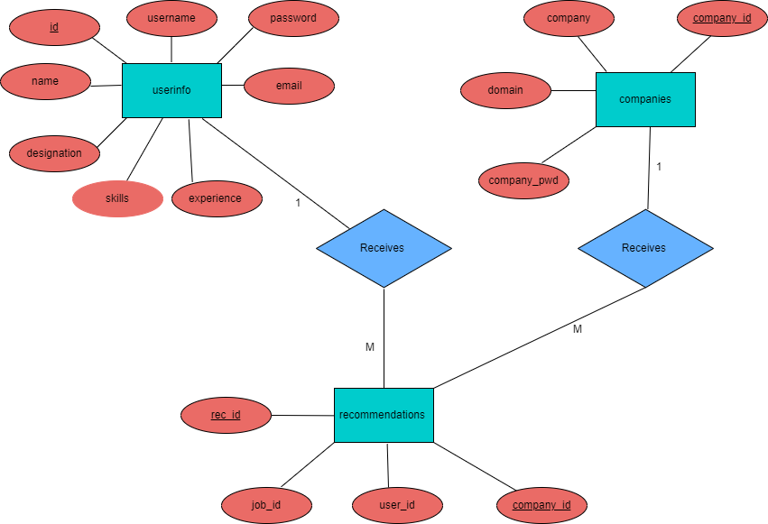

**DATA DICTIONARY:**

**1) userinfo table:**

|  |  |
| --- | --- |
| **Table Name** | userinfo |
| **Description** | Stores information about users who have signed up for the platform. |

|  |  |  |  |  |
| --- | --- | --- | --- | --- |
| **Sr. No** | **Field Name** | **Data Type** | **Constraints** | **Description** |
| 1 | id | INTEGER | PRIMARY KEY | Unique identifier for each user |
| 2 | username | VARCHAR | UNIQUE,NOT NULL | Username of the user |
| 3 | password | VARCHAR | NOT NULL | Hashed password of the user |
| 4 | name | VARCHAR | NOT NULL | Name of the user |
| 5 | email | VARCHAR | UNIQUE,NOT NULL | Email of the user |
| 6 | experience | INTEGER | NOT NULL | Experience of the user (in years) |
| 7 | designation | VARCHAR | NOT NULL | Designation of the user |
| 8 | skills | TEXT | NOT NULL | Skills possessed by the user |

**2) companies table:**

|  |  |
| --- | --- |
| **Table Name** | companies |
| **Description** | Contains details about registered companies on the platform. |

|  |  |  |  |  |
| --- | --- | --- | --- | --- |
| **Sr. No** | **Field Name** | **Data Type** | **Constraints** | **Description** |
| 1 | company_id | INTEGER | PRIMARY KEY | Unimeaningque identifier for each  company |
| 2 | company_pwd | VARCHAR |  | Password of the company for authentication |
| 3 | company | VARCHAR |  | Name of the company |
| 4 | domain | VARCHAR |  | The company’s official website |

**3) recommendations table:**

|  |  |
| --- | --- |
| **Table Name** | recommendations |
| **Description** | Maintains a record of job recommendations made to users. |

|  |  |  |  |  |
| --- | --- | --- | --- | --- |
| **Sr. No** | **Field Name** | **Data Type** | **Constraints** | **Description** |
| 1 | rec_id | INTEGER | PRIMARY KEY | Unique identifier for each  recommendation |
| 2 | user_id | INTEGER | NOT NULL | Foreign key referencing userinfo table |
| 3 | job_id | INTEGER | NOT NULL | Identifier of the recommended job |
| 4 | company_id | INTEGER | NOT NULL | Foreign key referencing companies  table |

* **Use Case Diagram:**

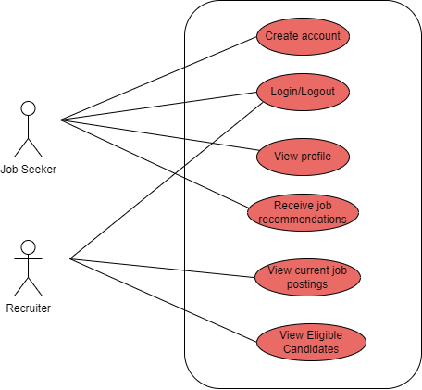

* **Class Diagram:**

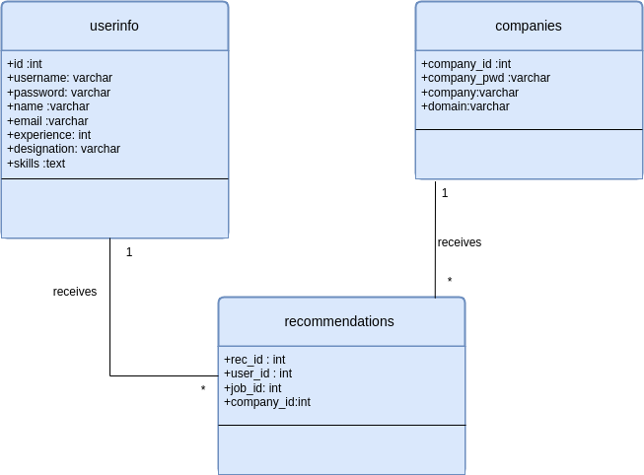

* **Activity Diagram (for Job Seeker):**

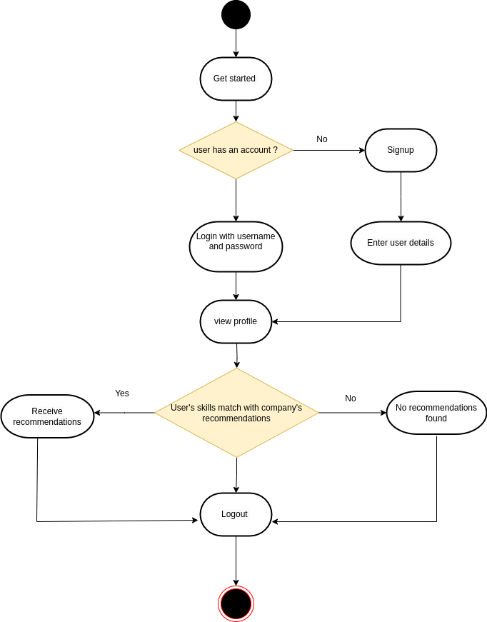

* **Activity Diagram (for Recruiter):**

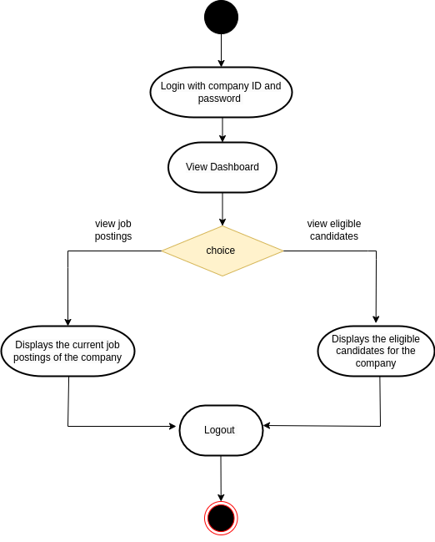

* **Sequence Diagram (for Job Seeker):**

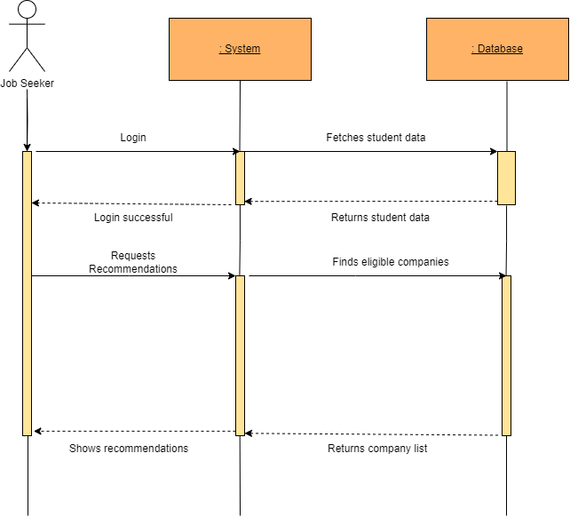

* **Sequence Diagram (for Recruiter):**

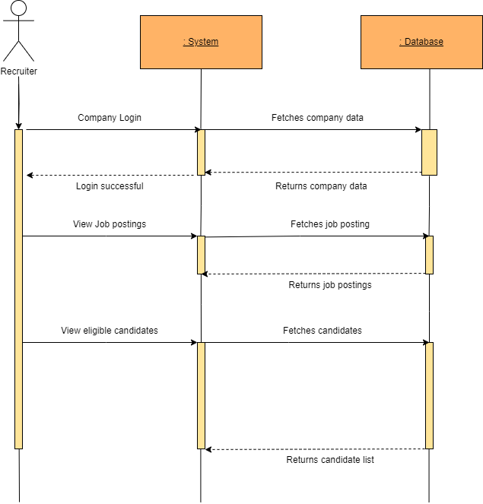

* **Collaboration Diagram (for Job Seeker):**

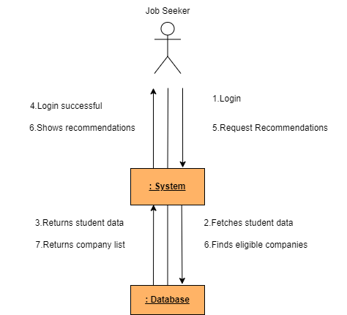

* **Collaboration Diagram (for Recruiter):**

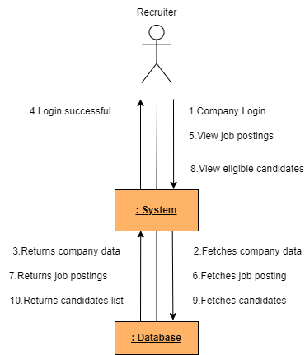

* **Deployment Diagram:**

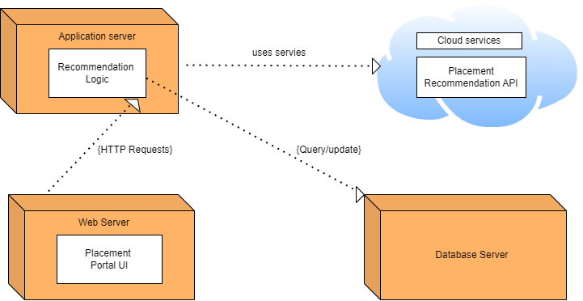

* **Component Diagram:**

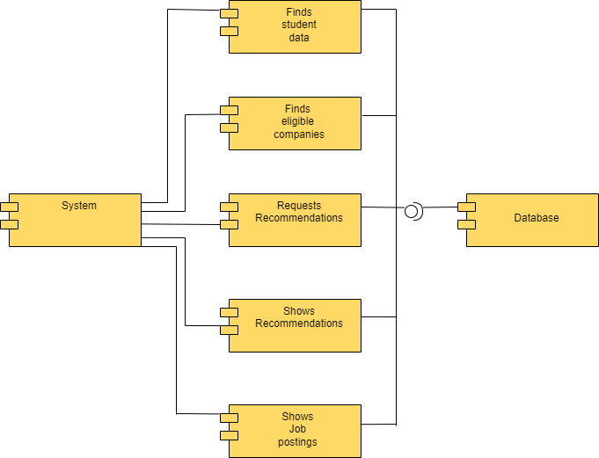

**TEST CASES:**

* Job Seeker:

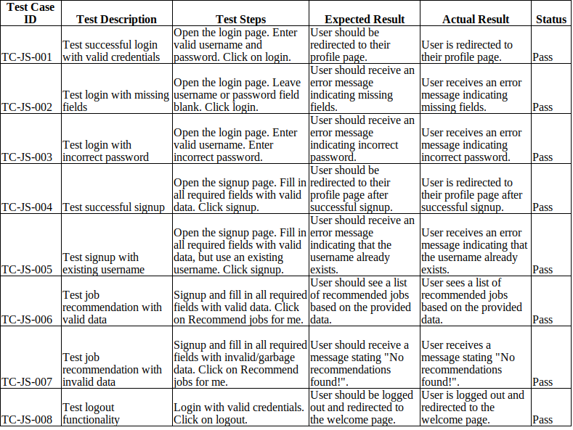

* Recruiter:

