Name | Sanjyot Satvi
Course Number | CPSC 449
Semester | Fall 2023
Exercise | 1
Section | 1

Setting Up the Environment :

1.Obtaining Chinook Db and extracting it

wget https://www.sqlitetutorial.net/wp-content/uploads/2018/03/chinook.zip
unzip chinook.zip
Output -
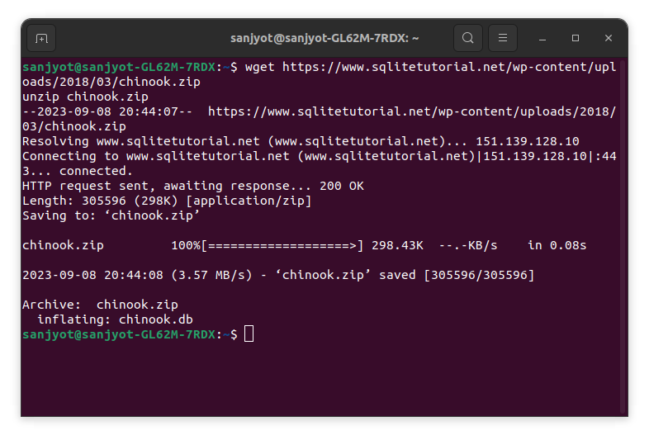
Fig 1.Output
2.Installing sqlite3 command line tool then dumping the database
sudo apt update
sudo apt install --yes sqlite3
sqlite3 chinook.db .dump

Output -
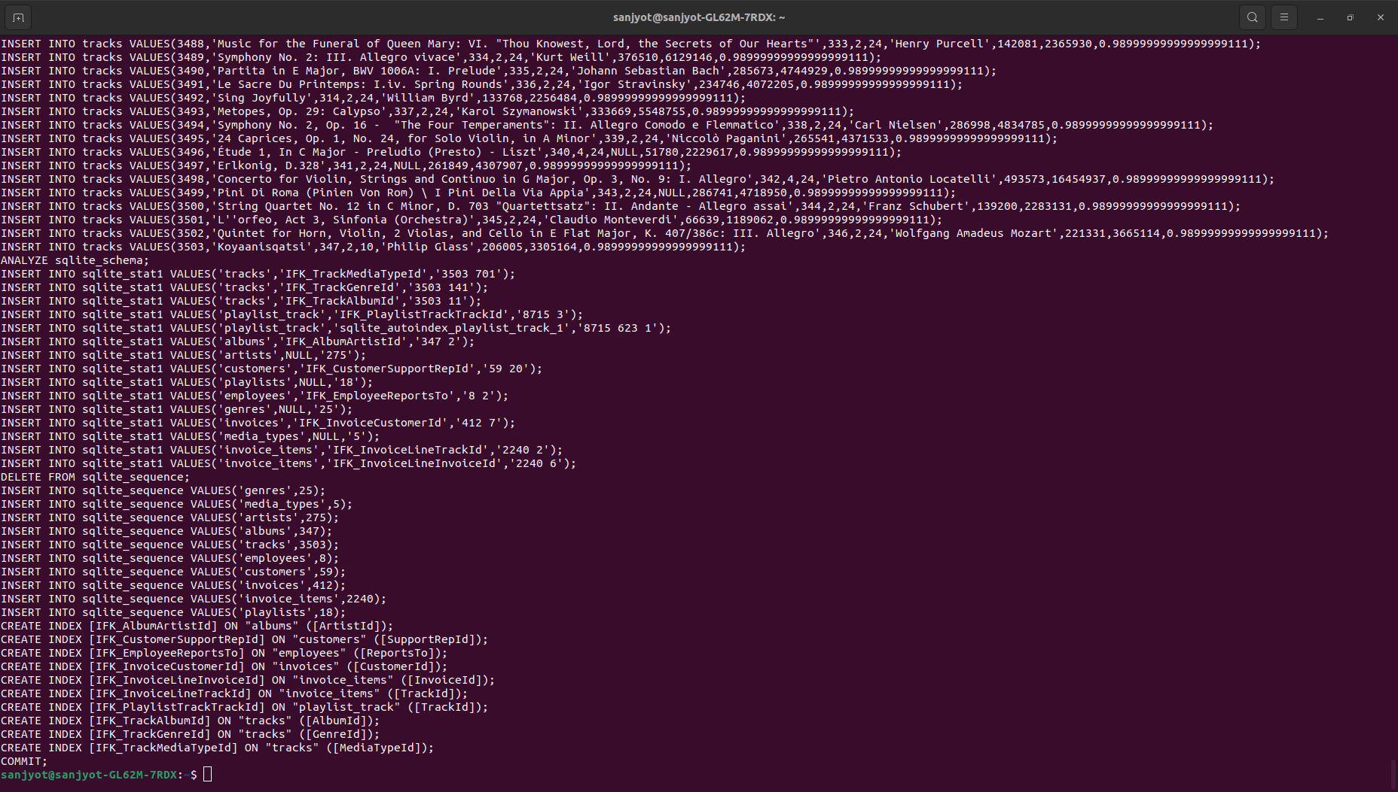
Fig.2 Output after dumping db
As per Fig.2 We successfully obtained the chinook.db and verified by dumping the database
3.Installing pip and venv packages
sudo apt install --yes python3-pip python3-venv
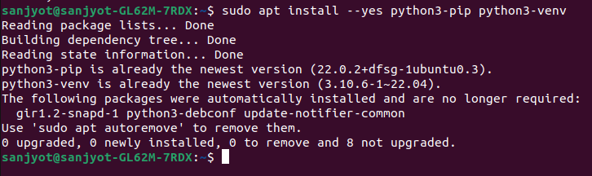
Fig 3.The packages were already installed successfully

4.Creating a Virtual Environment
We will create a virtual environment where all the packages required will be installed .
Commands to create virtual environment and activating the same
python3.10 -m venv $HOME/.venv
echo 'source $HOME/.venv/bin/activate' | tee -a $HOME/.bashrc
. $HOME/.venv/bin/activate

5. Installing n version manager for Node js

Use n-install to install the n version manager for Node.js , we reload the bash shell config and update the latest version of the Npm package manager

commands -
curl -s -L http://git.io/n-install | bash -s -- -y
. $HOME/.bashrc

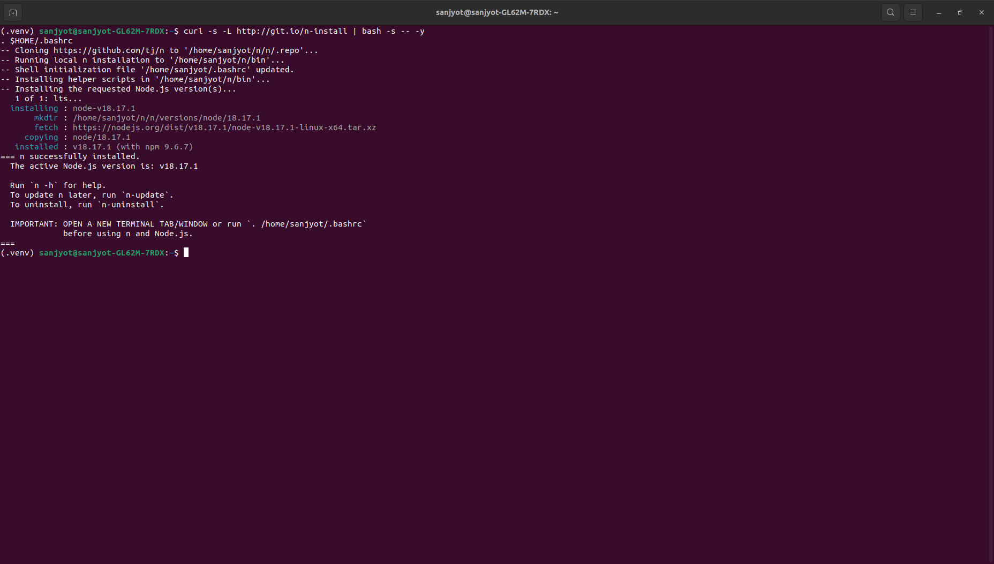
Fig 4.Output for Step 4

5.Installing Soul Server to expose REST API for our chinook Database
commands -
npm install --global soul-cli

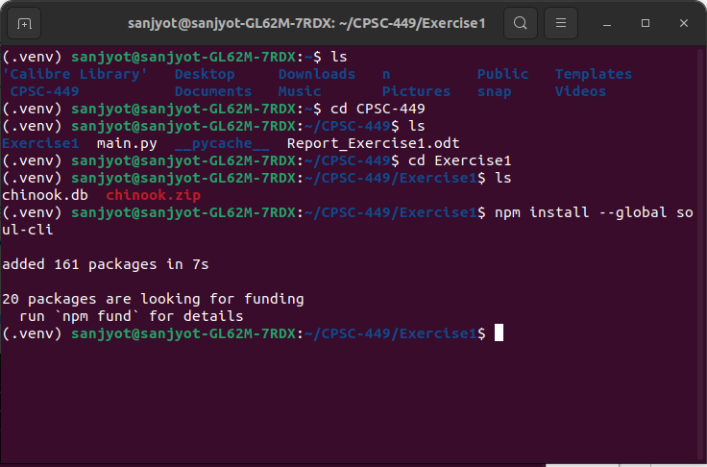
Fig 5. Installed Soul-cli globally

command -
npm update –global
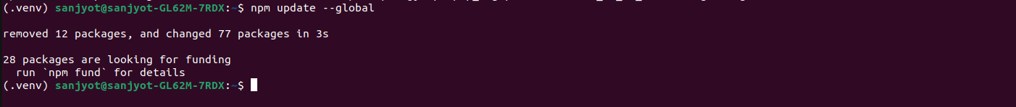
Fig 6. Output after updating packages

6.Install the tuql server to expose a GraphQL API for an existing database.
Commands -
npm install --global tuql
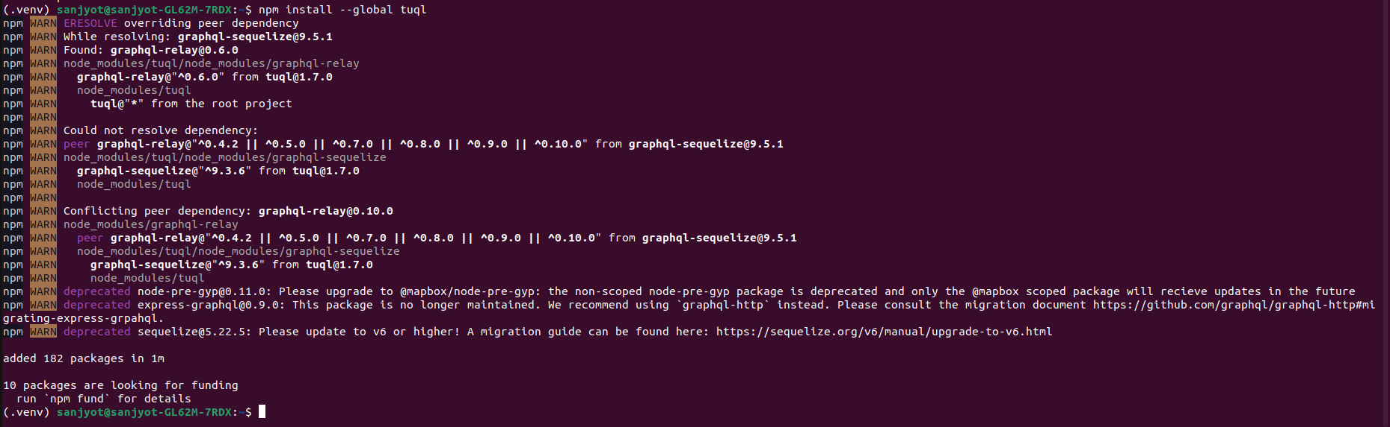
Fig 7. Installed tuql server to expose GraphQL API

7.Start the API servers
In separate terminal windows, start API servers for the chinook database
command -
soul --database chinook.db --studio
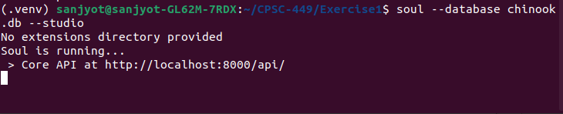
Fig 8. Soul Server is running Successfully at http://localhost:8000/api/
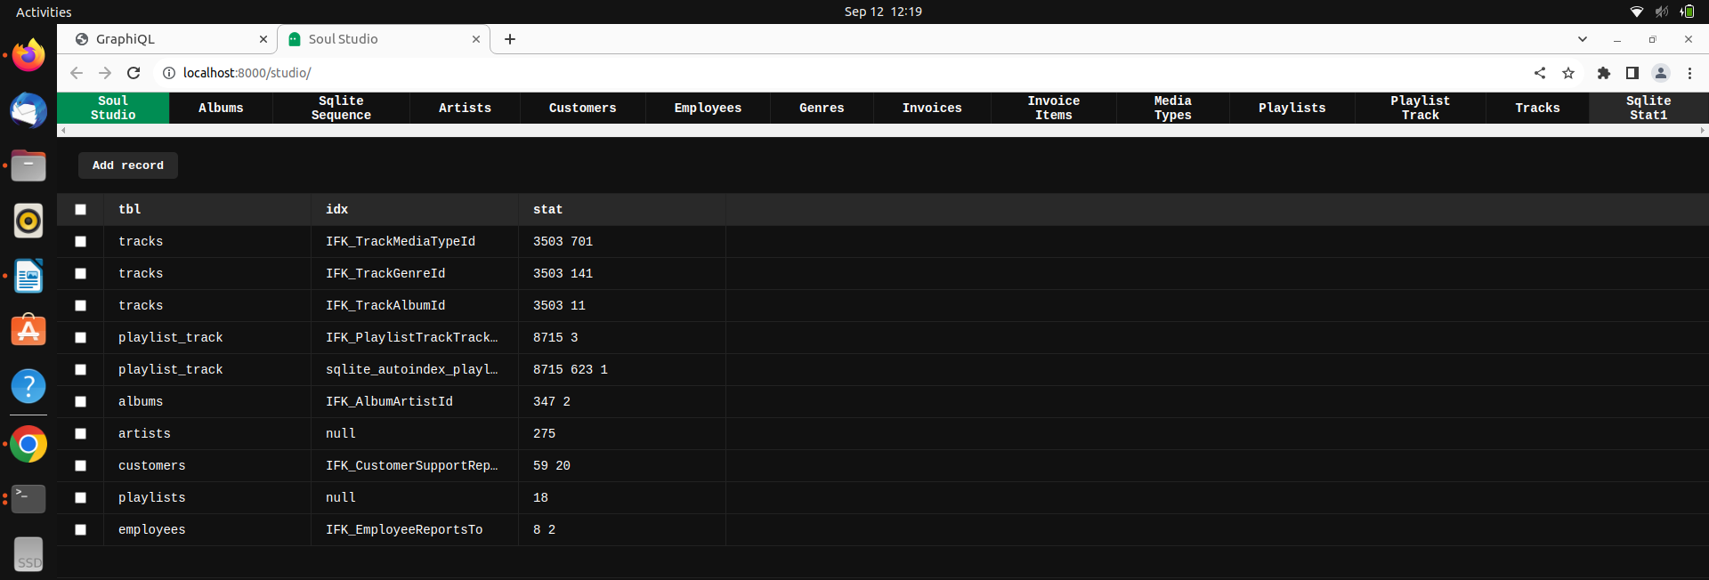
Fig 9. Soul Studio shows the database contents
command-
tuql --db chinook.db --graphiql
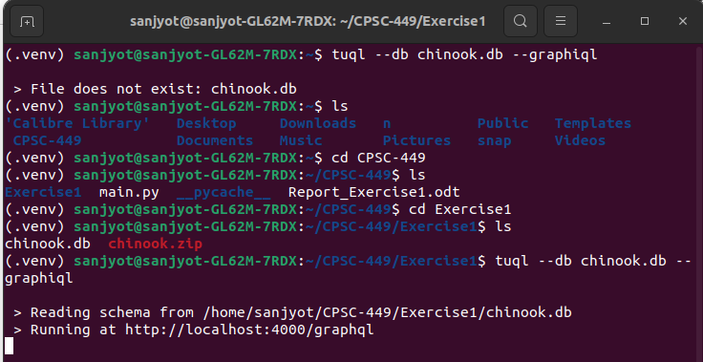
Fig 10. Tuql Server is running Successfully at http://localhost:4000/graphql/

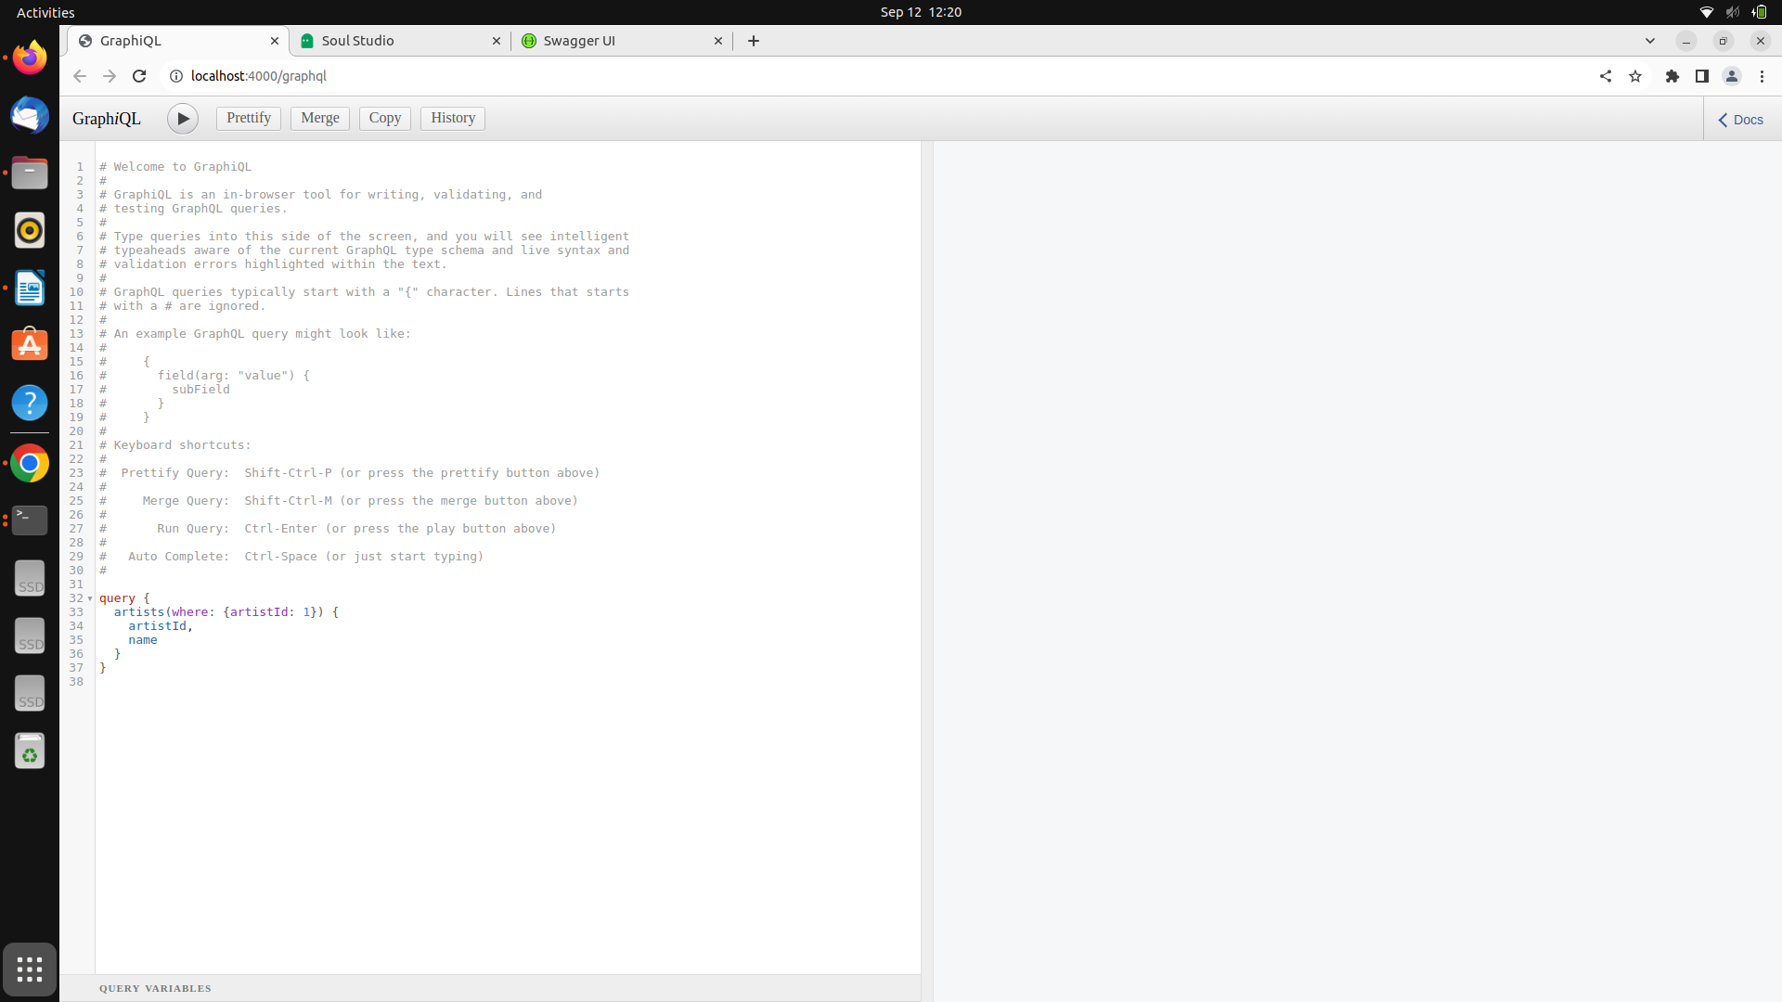
Fig 11. Output when accessing http://localhost:4000/graphql/

Querying data with REST and GraphQL
8.Retrieve a record
Visit the following URL to retrieve information about the first artist in the database using the REST API:
Endpoint
http://localhost:8000/api/tables/artists/rows/1
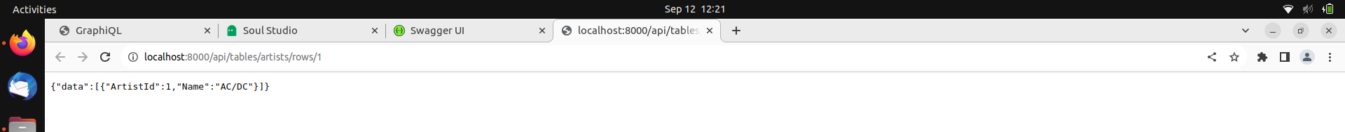
Fig 12. Output shows rows are retrieved through soul api

In GraphiQL, execute the following query to retrieve the same information from the GraphQL API:
query {
artists(where: {artistId: 1}) {
artistId,
name
}
}
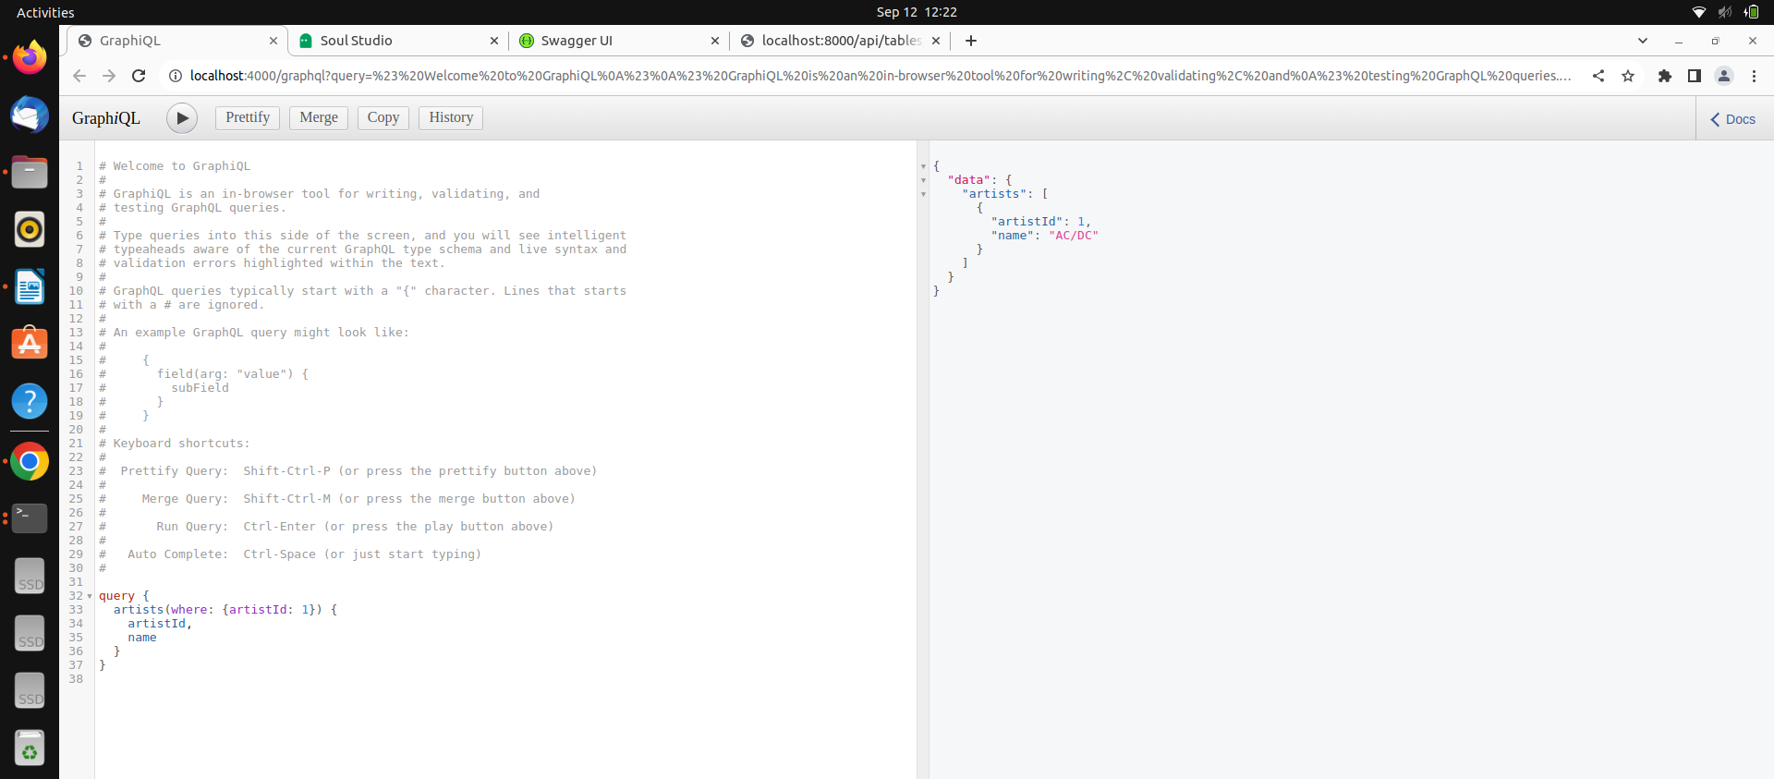
Fig 13. Successfully Ran Query in GraphiQL dashboard

9.Trying Complex Queries Using GraphQL

a.Albums by the artist “Red Hot Chili Peppers.”
query getAlbumsByName {
artists(where: {Name: "Red Hot Chili Peppers"}) {
artistId
name
albums {
albumId
title
}
}
}
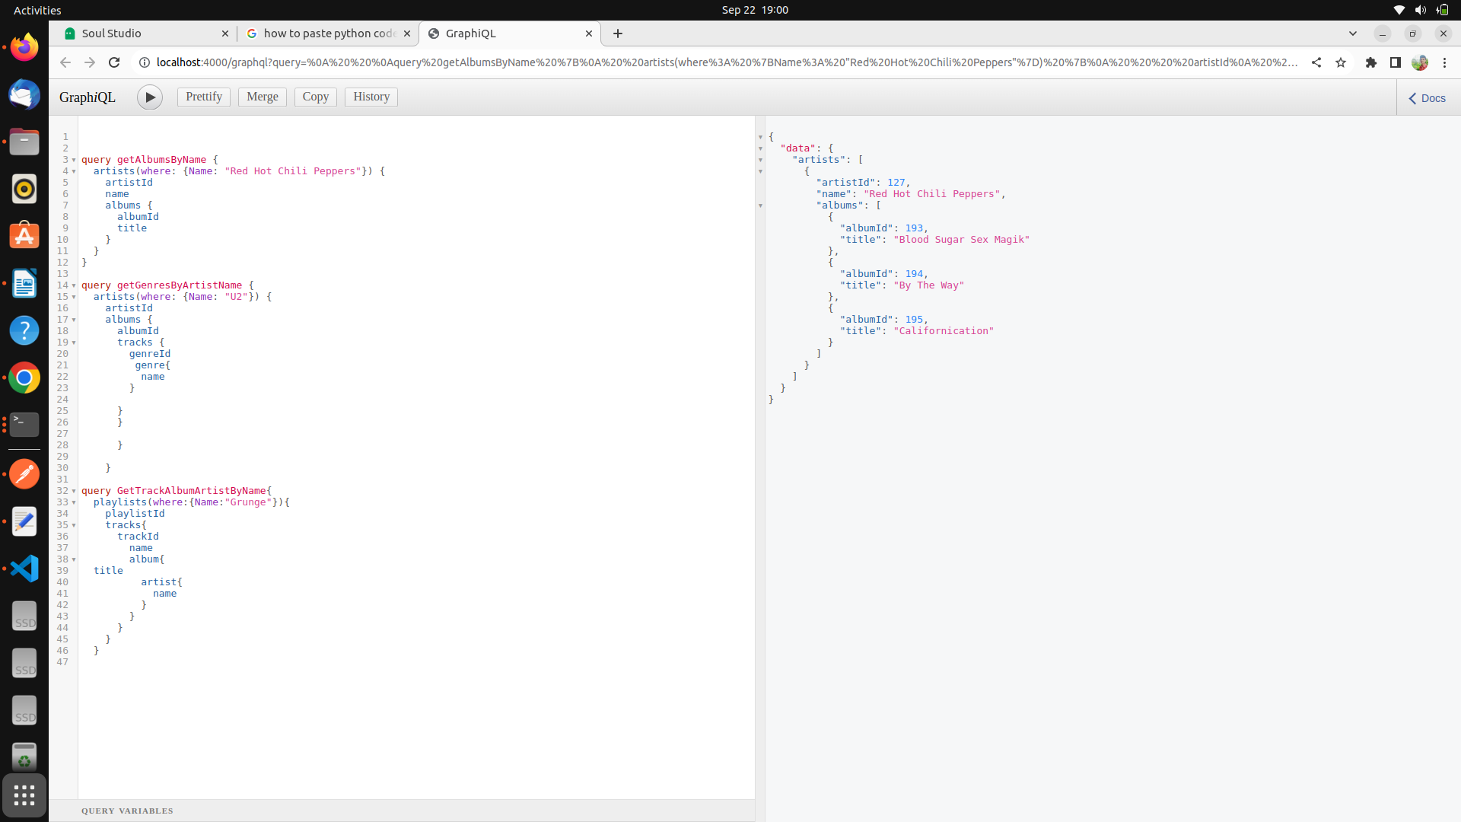
Fig 14.Output for Query to retrive Albums by artists “Red Hot Chilli Peppers”

2.Genres associated with the artist “U2.”

query getGenresByArtistName {
artists(where: {Name: "U2"}) {
artistId
albums {
albumId
tracks {
genreId
genre{
name
}
}
}
}
}
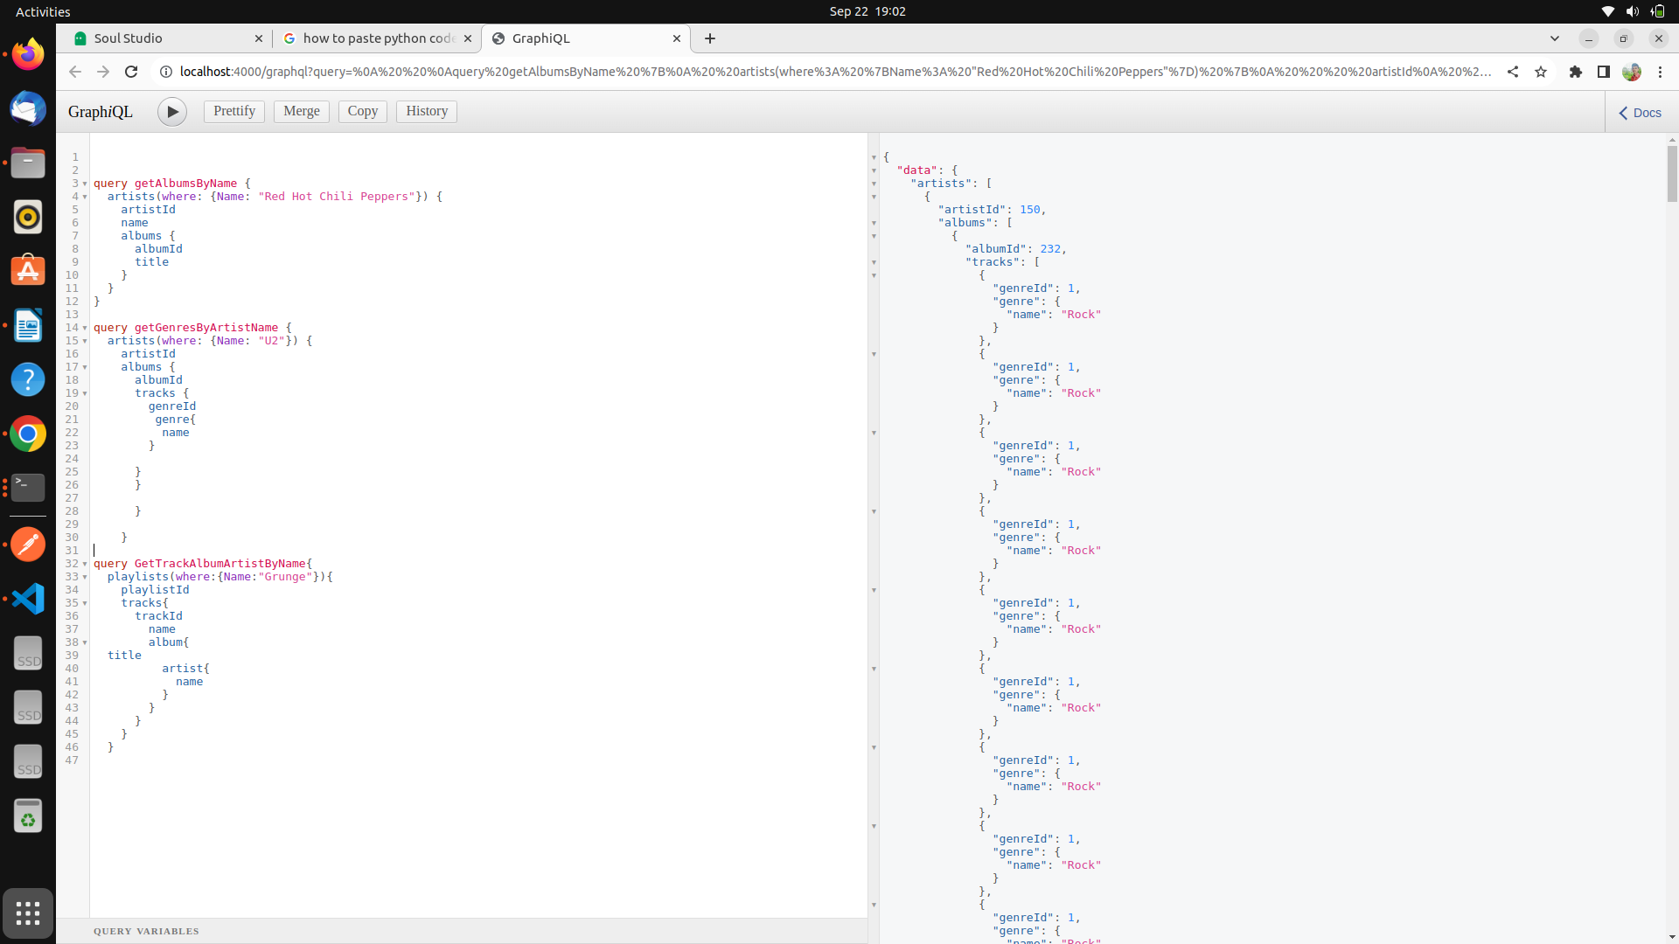
Fig 15. Output for Query to Retrive Genres associated with the artist U2.

3.Names of tracks on the playlist “Grunge” and their associated artists and albums.
query {
playlists(where:{Name:"Grunge"}){
playlistId
tracks{
trackId
name
album{
title
artist{
name
}
}
}
}
}
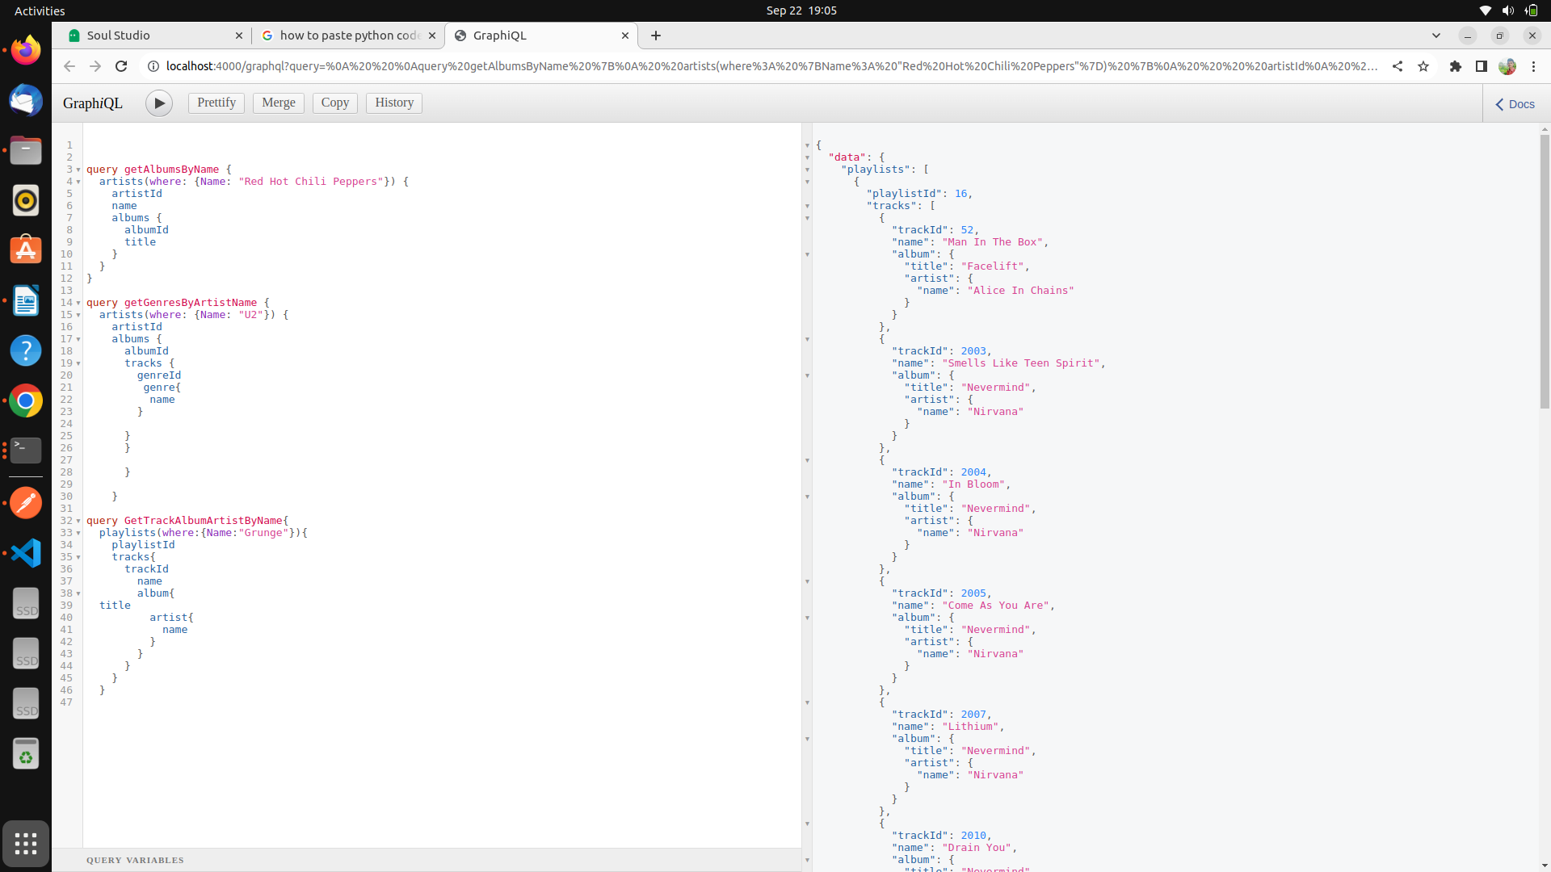

Fig 16. Retrieved tracks on the playlist “Grunge” and their associated artists and albums.

10. Installing Requests Package to Make API calls for REST in python
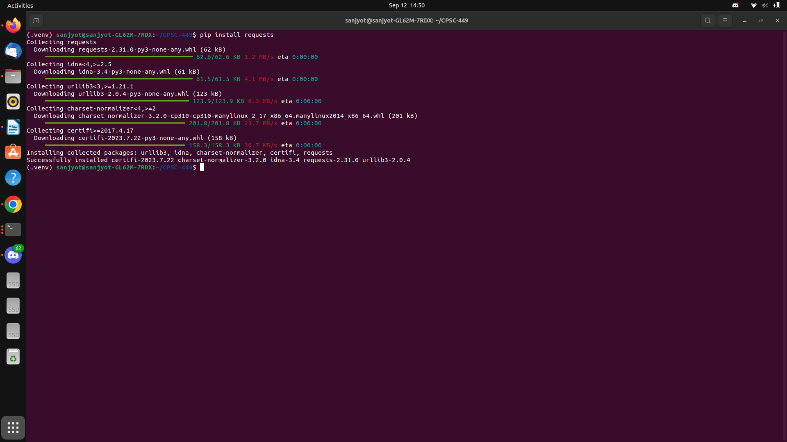
Fig 17. Successfully installed Requests Package

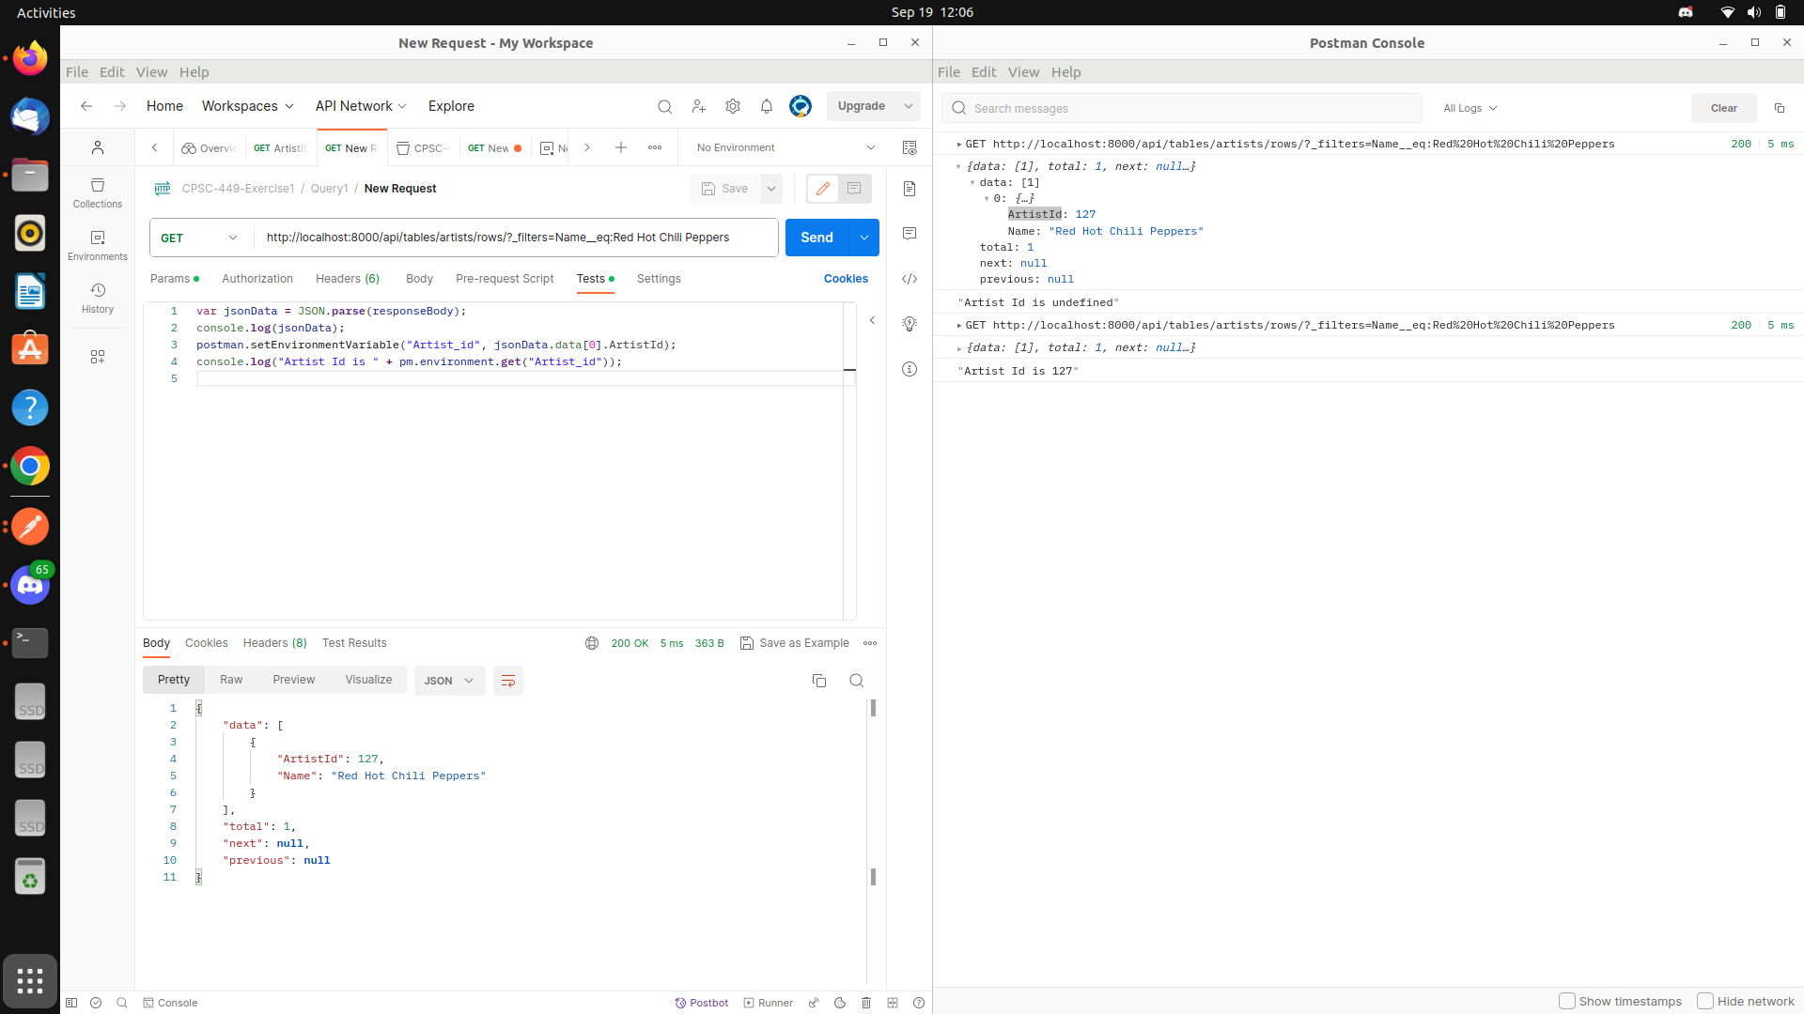
Query 1 Completed Postman
s

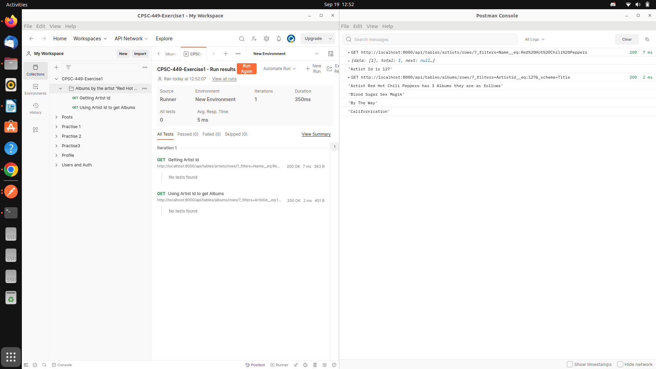

Query 2 postman – got bad request (need Pre -request script to pass single gener ID
s
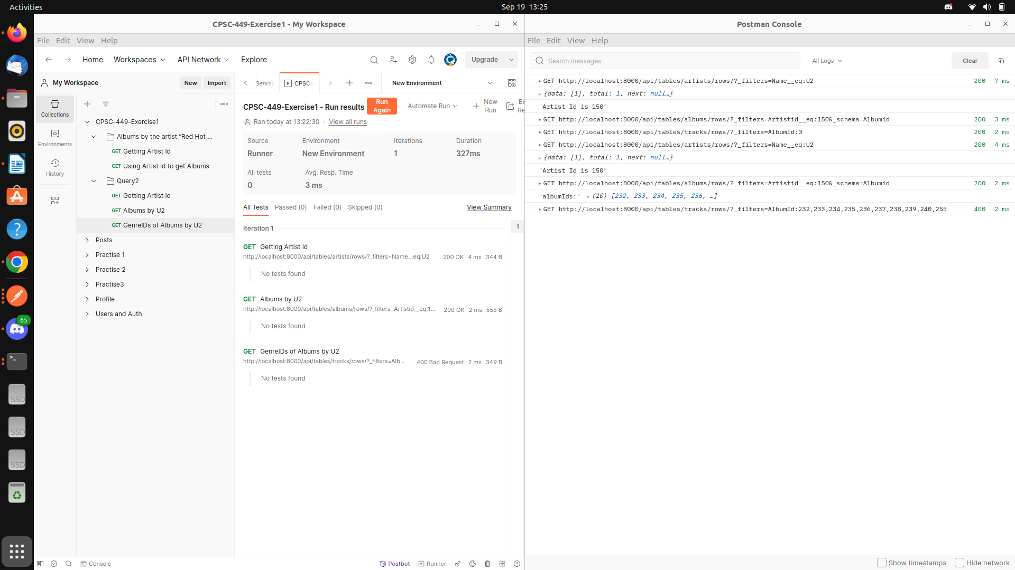
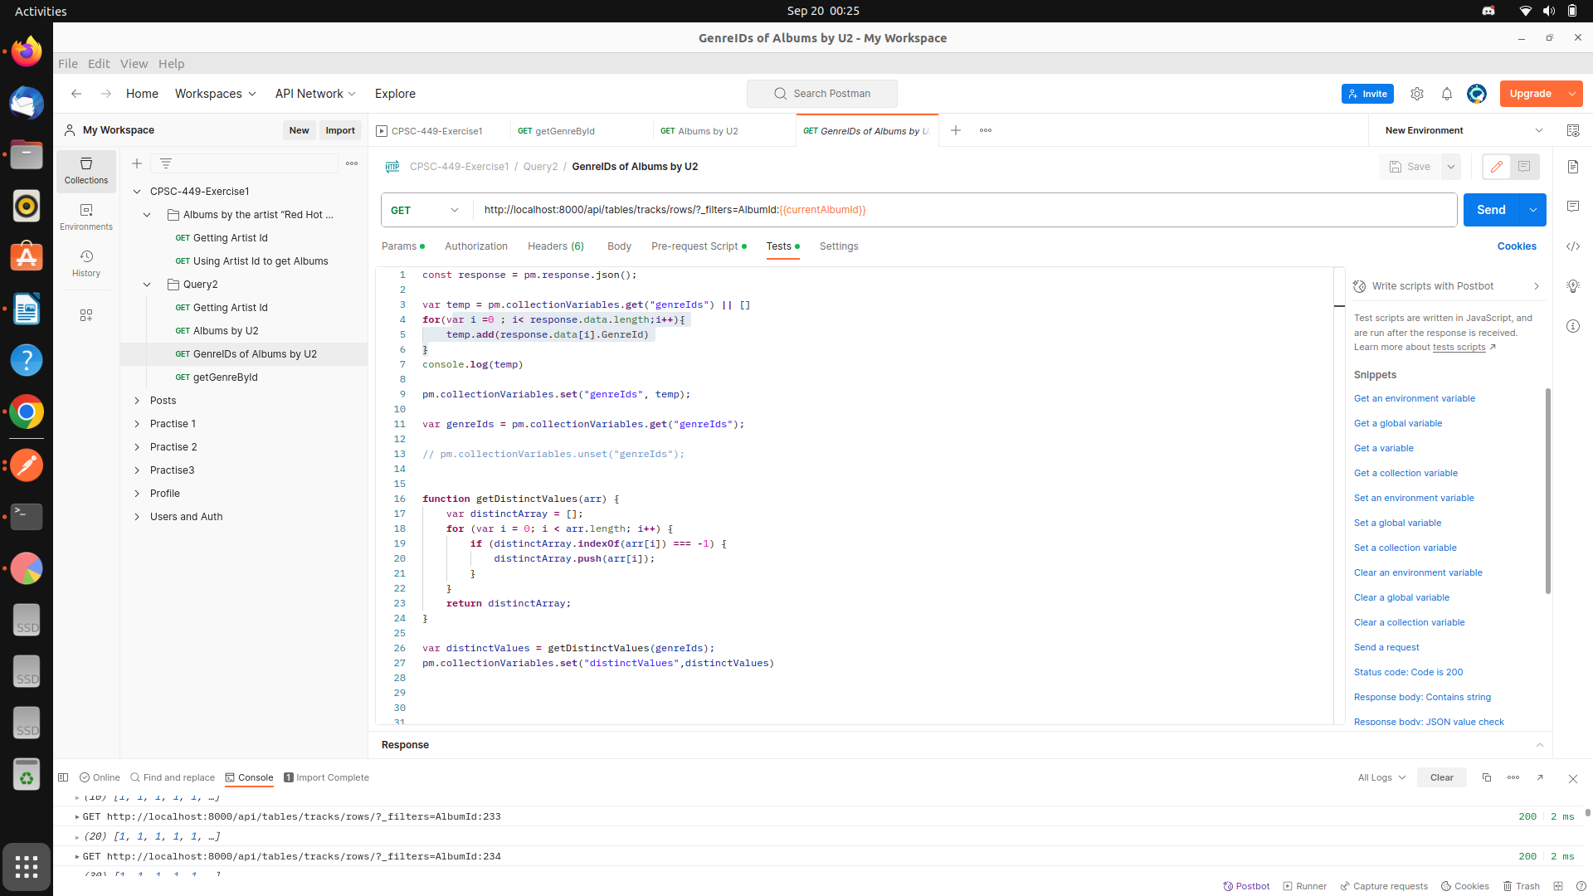
Reference --- https://www.postman.com/postman/workspace/postman-answers/request/9215231-3d9853fd-22d7-4f9e-8d4b-02cf8dc9c6e2
Added test script to get genre ids for all the albums and then wrote a function to get distinct genre Ids

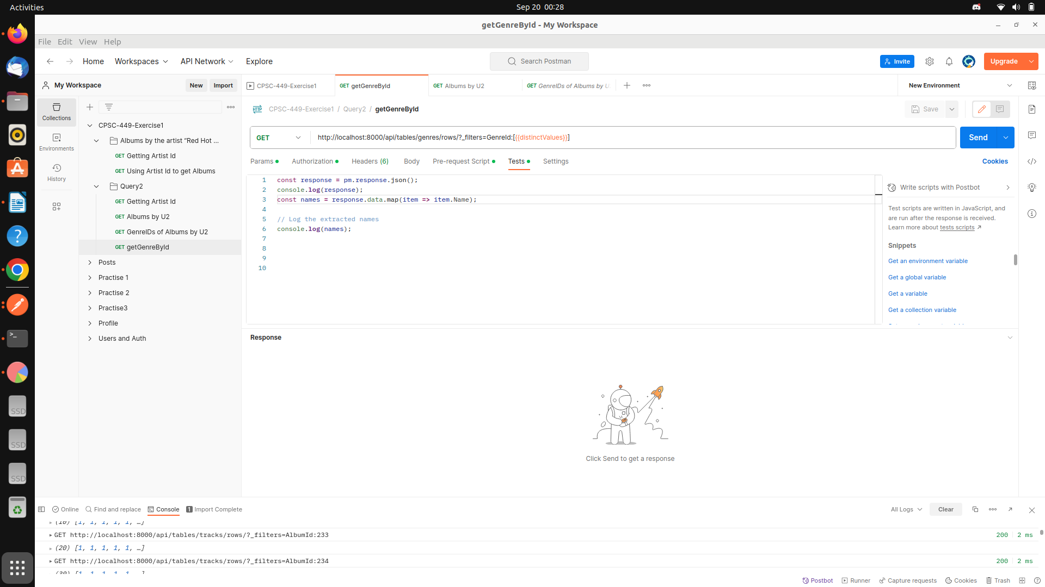
Added one more reest to get all the associated Genres based on the distinct genre ids

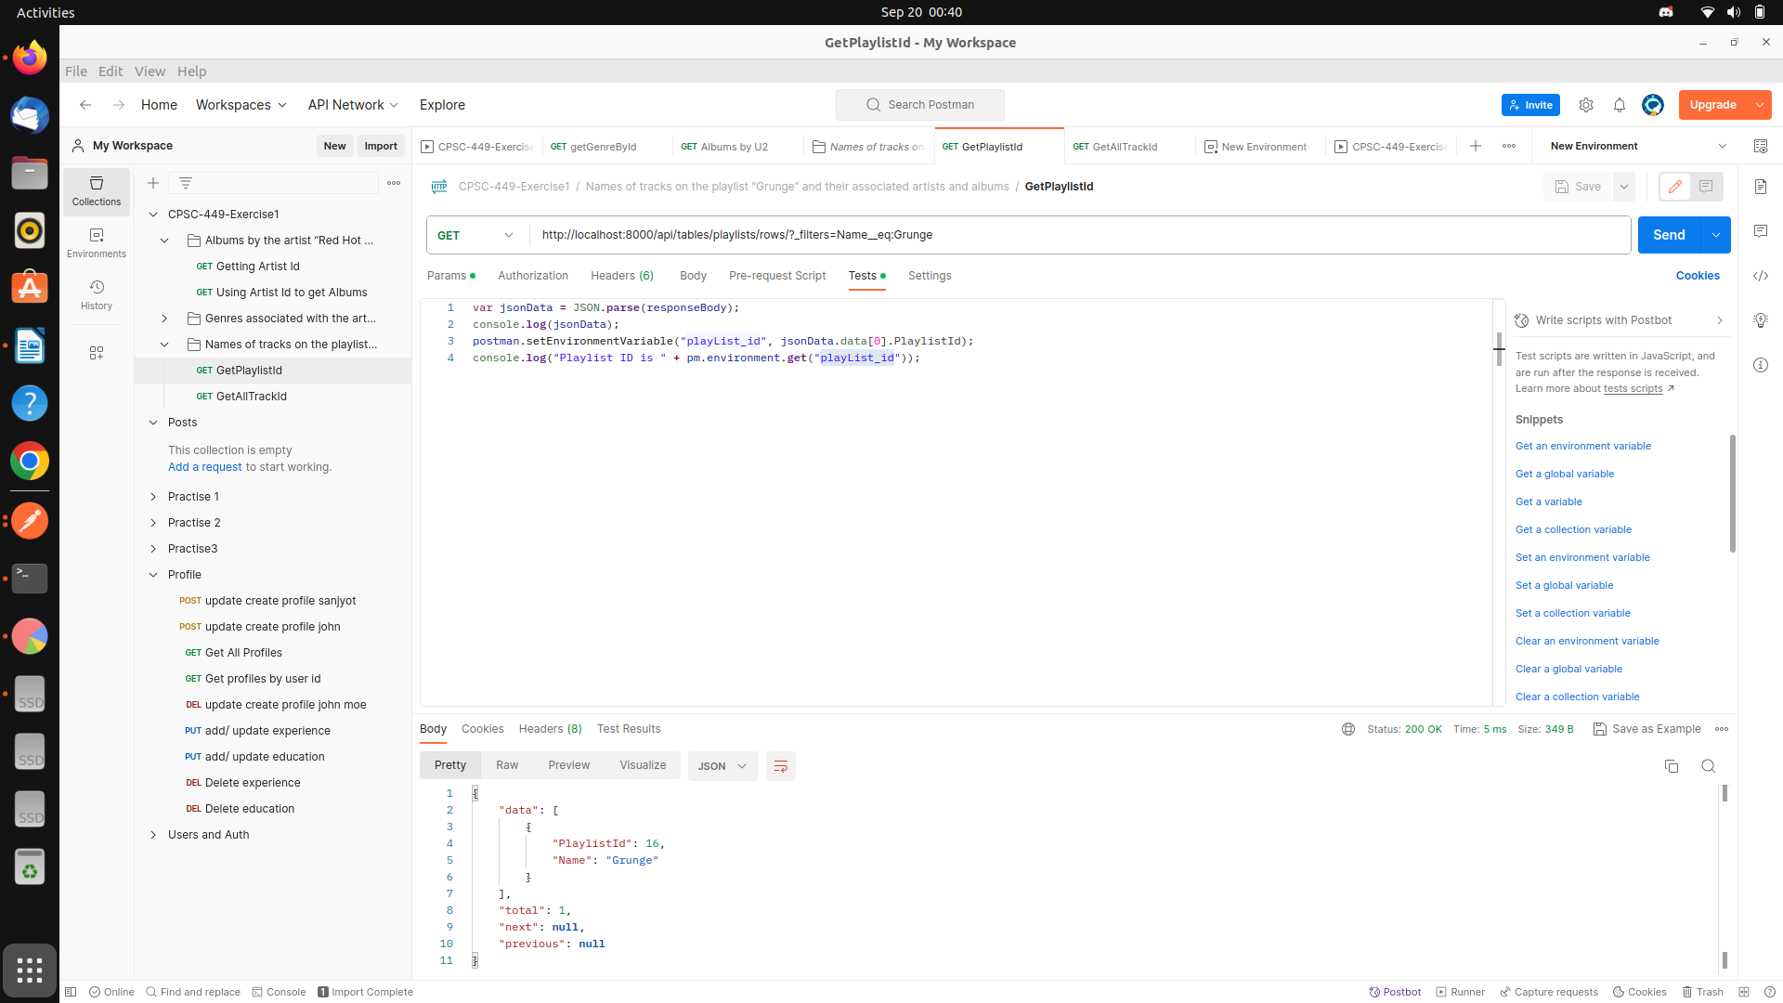
Query 3

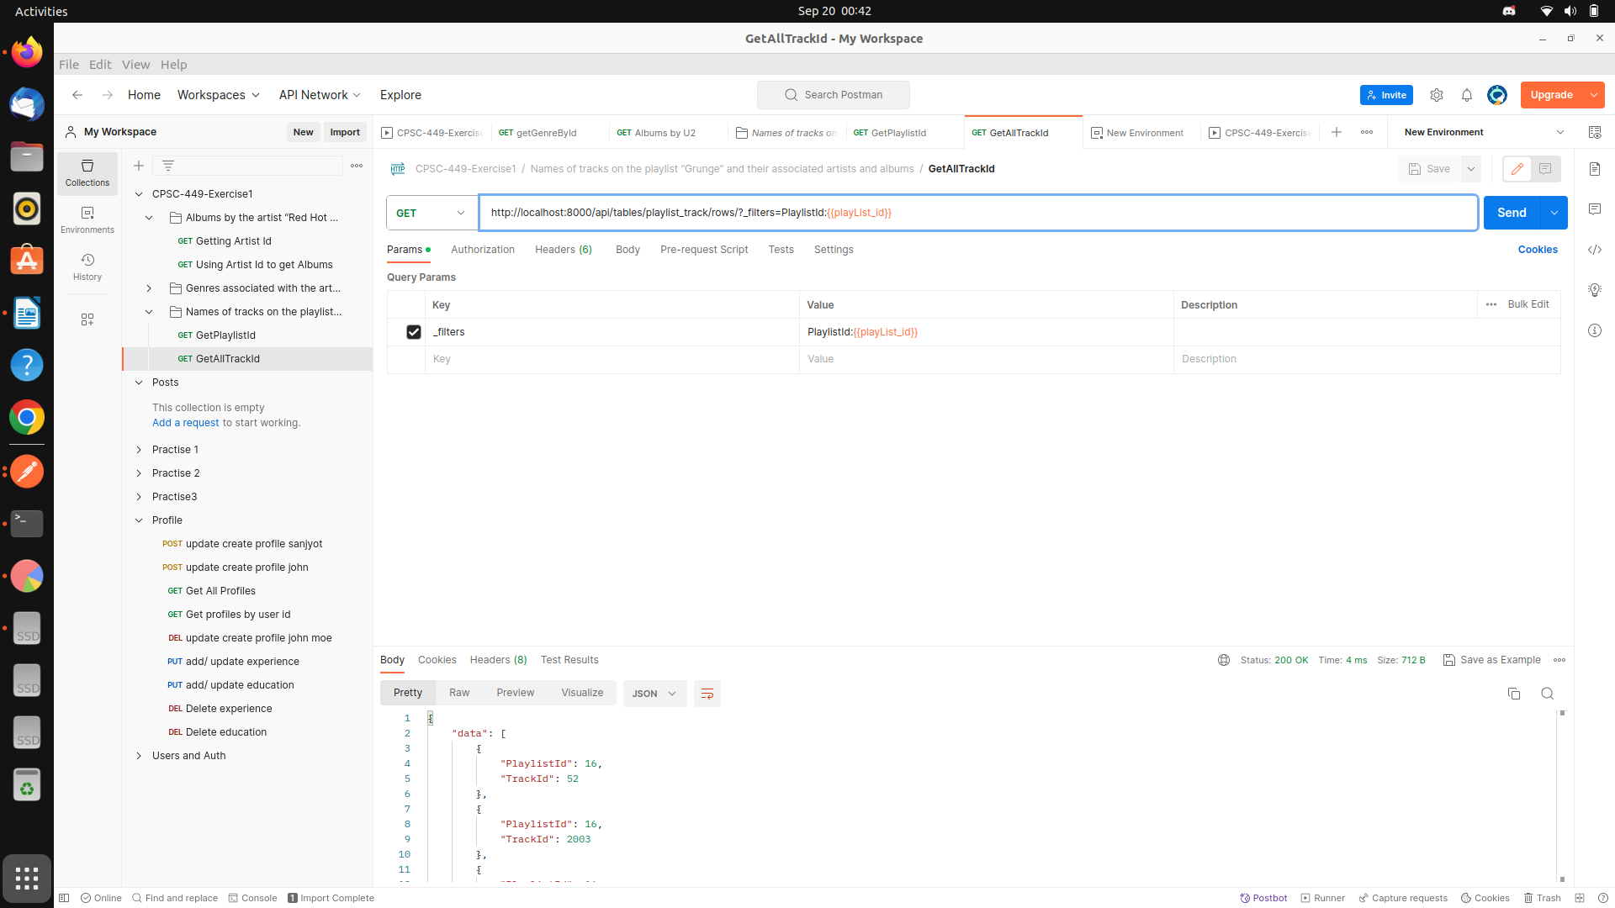
Getting playlists id of Grunge
Using playlist ID to get all Track ID associated with grunge
{"data":[{"PlaylistId":16,"TrackId":52},{"PlaylistId":16,"TrackId":2003},{"PlaylistId":16,"TrackId":2004},{"PlaylistId":16,"TrackId":2005},{"PlaylistId":16,"TrackId":2007},{"PlaylistId":16,"TrackId":2010},{"PlaylistId":16,"TrackId":2013},{"PlaylistId":16,"TrackId":2194},{"PlaylistId":16,"TrackId":2195},{"PlaylistId":16,"TrackId":2198},{"PlaylistId":16,"TrackId":2206},{"PlaylistId":16,"TrackId":2512},{"PlaylistId":16,"TrackId":2516},{"PlaylistId":16,"TrackId":2550},{"PlaylistId":16,"TrackId":3367}],"total":15,"next":null,"previous":null}

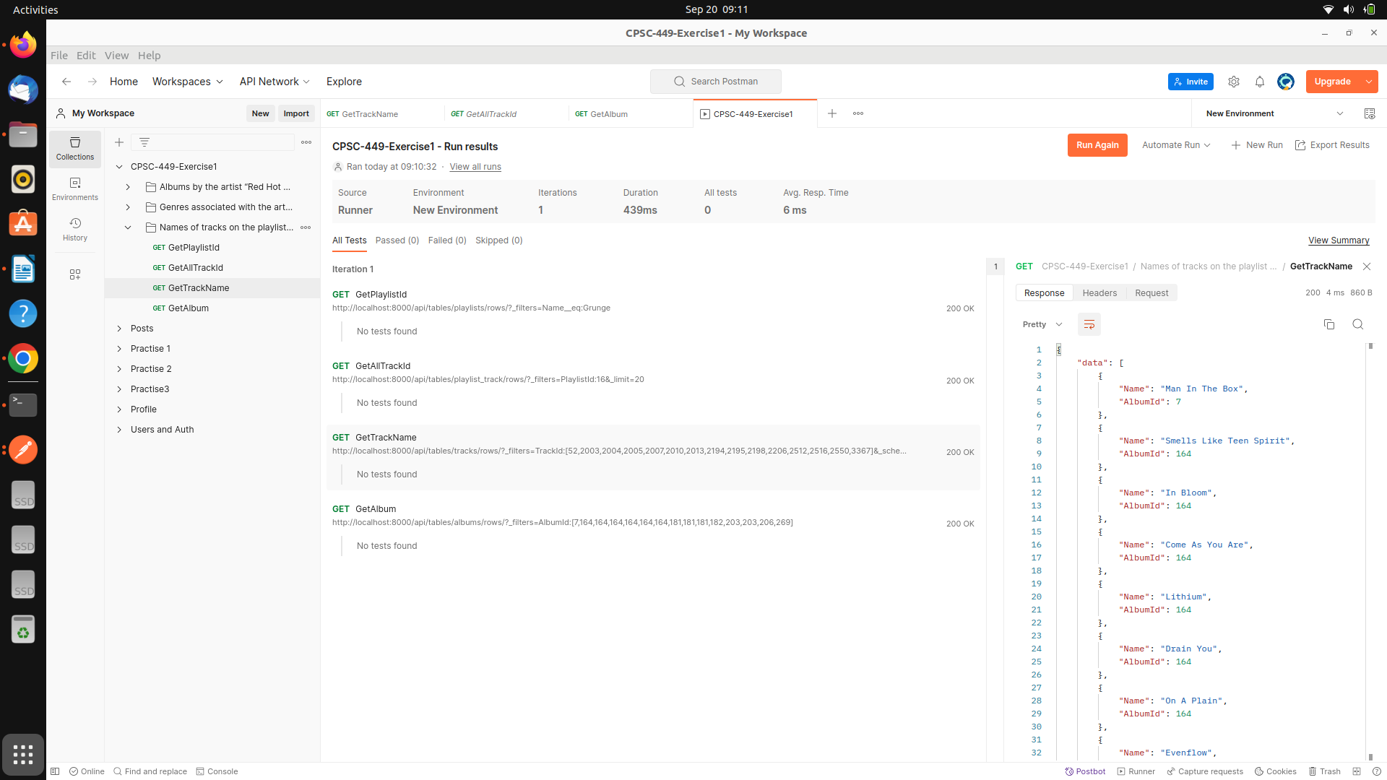
based on all the track ids I am querying to get all associated album ids for that particular track id .
http://localhost:8000/api/tables/tracks/rows/?_filters=TrackId:[52,2003,2004,2005,2007,2010,2013,2194,2195,2198,2206,2512,2516,2550,3367]&_schema=Name,AlbumId&_limit=25

Added schema to just get name and Album , limit search results to 25
next -----
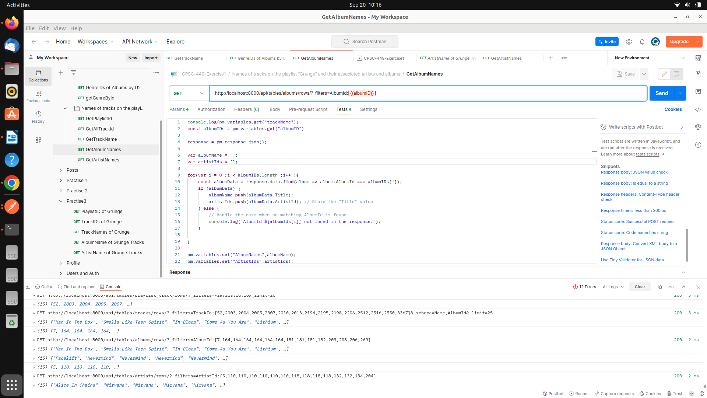
Request -
http://localhost:8000/api/tables/albums/rows/?_filters=AlbumId:[7,164,164,164,164,164,164,181,181,181,182,203,203,206,269]
response -
{"data":[{"AlbumId":7,"Title":"Facelift","ArtistId":5},{"AlbumId":164,"Title":"Nevermind","ArtistId":110},{"AlbumId":181,"Title":"Ten","ArtistId":118},{"AlbumId":182,"Title":"Vs.","ArtistId":118},{"AlbumId":203,"Title":"A-Sides","ArtistId":132},{"AlbumId":206,"Title":"Core","ArtistId":134},{"AlbumId":269,"Title":"Temple of the Dog","ArtistId":204}],"total":7,"next":null,"previous":null}
wrote test script to match Title for each of the Albums ( handling one to many relations )
ss

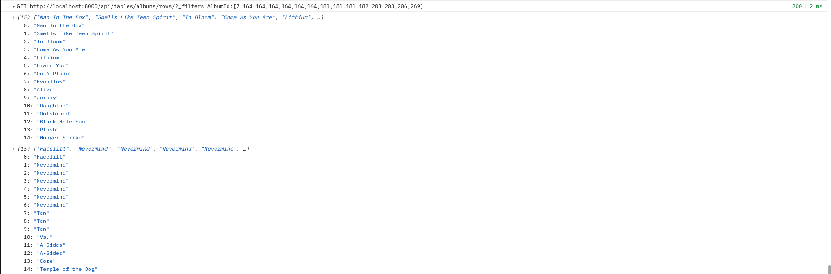
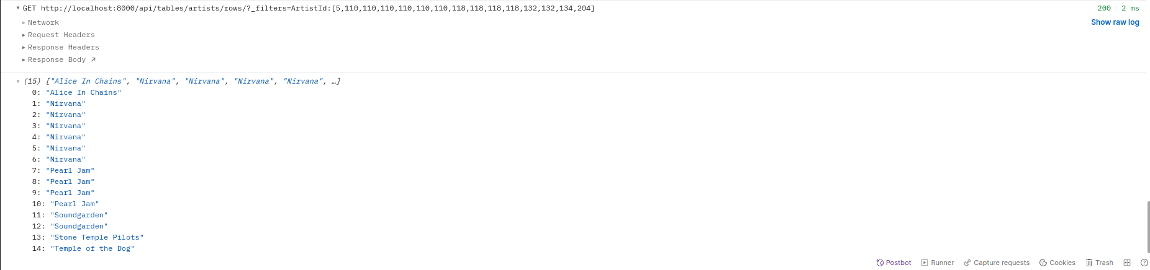
we also collected artistids to a variable
next --
we used artist ids collected in previous rtesponse to Call artists table and get artists names
URL: http://localhost:8000/api/tables/artists/rows/?_filters=ArtistId:[5,110,110,110,110,110,110,118,118,118,118,132,132,134,204]
{"data":[{"ArtistId":5,"Name":"Alice In Chains"},{"ArtistId":110,"Name":"Nirvana"},{"ArtistId":118,"Name":"Pearl Jam"},{"ArtistId":132,"Name":"Soundgarden"},{"ArtistId":134,"Name":"Stone Temple Pilots"},{"ArtistId":204,"Name":"Temple of the Dog"}],"total":6,"next":null,"previous":null}
s

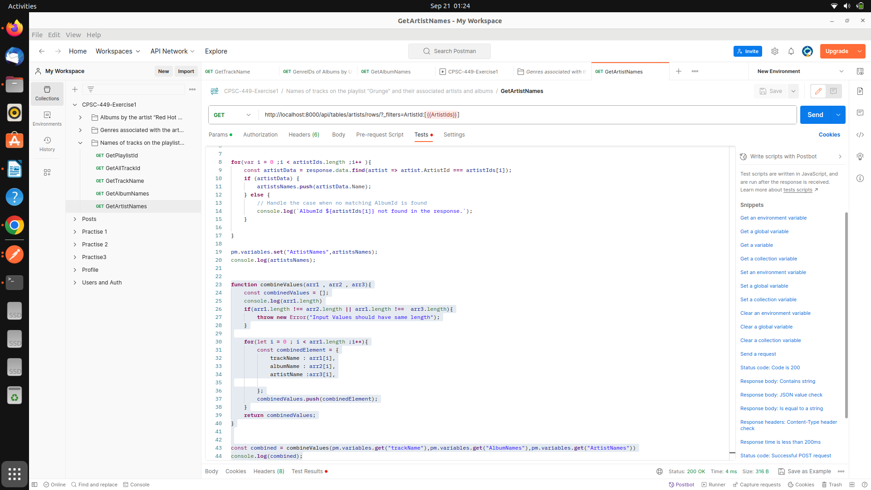
TO get the output in proper format wrote a fucntion to create and array of object with required data
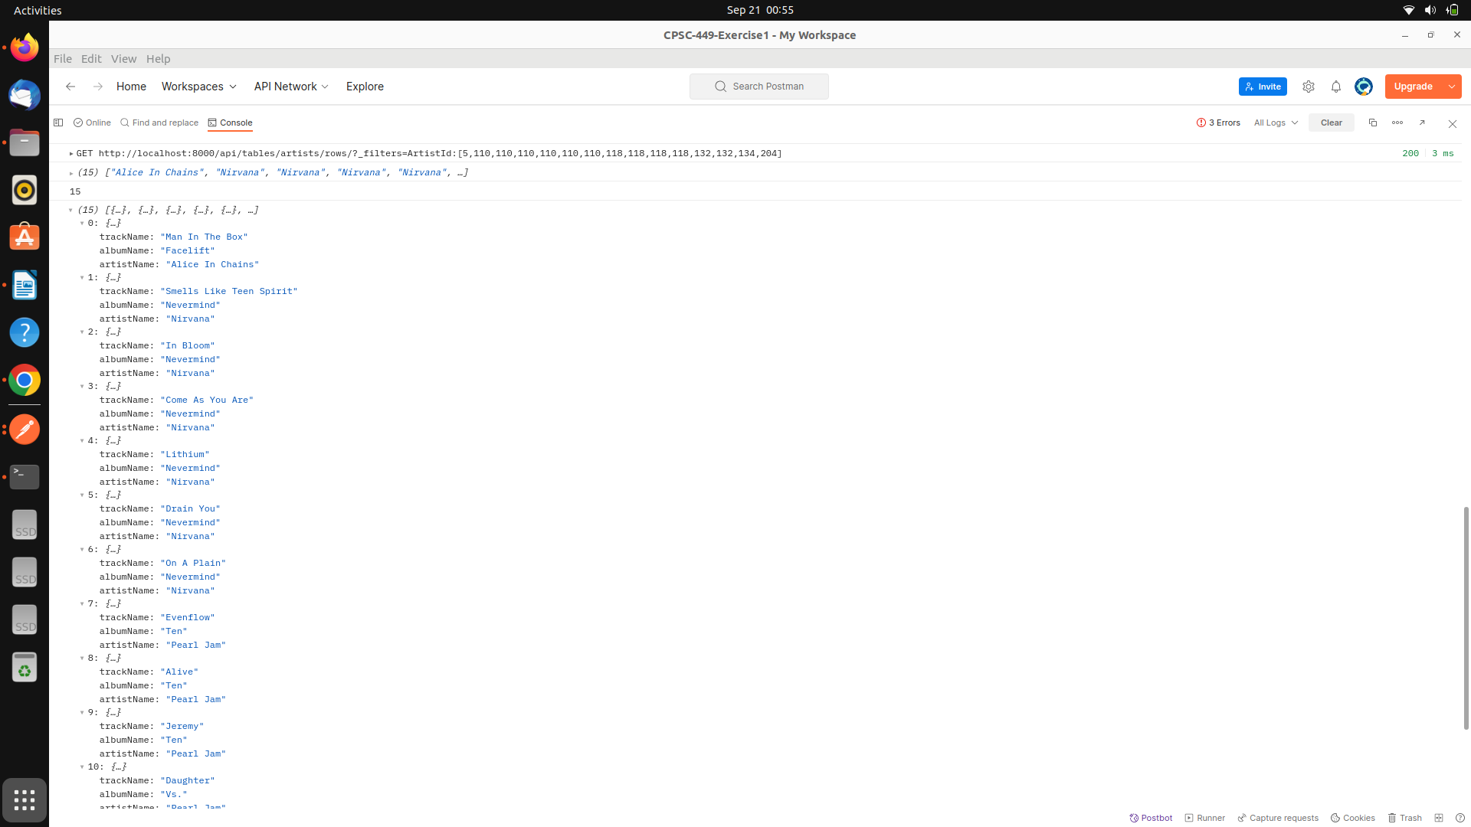
Output for query 3
Making Api Call through python Graph QL
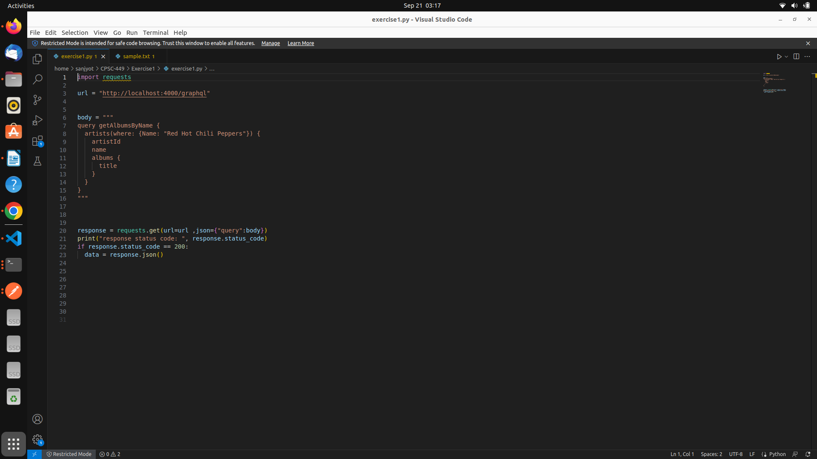
imported request library and refered https://requests.readthedocs.io/en/latest/ to send the request and run the query
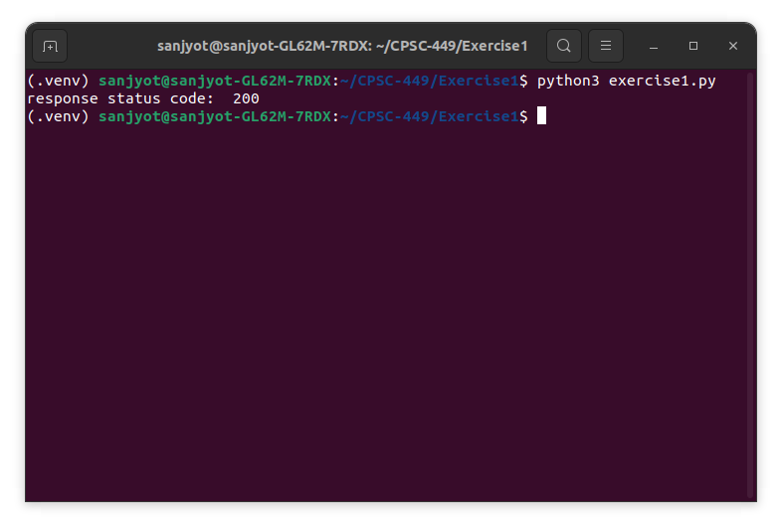
since response code is 200 I can verify that api is working correctly and giving me the response
---Next steps --
I will make and array of query and make get calls and pass the query as a parameter to graphql API , also using if elseif I will run data maipulation on the response to get response for each query in desired format
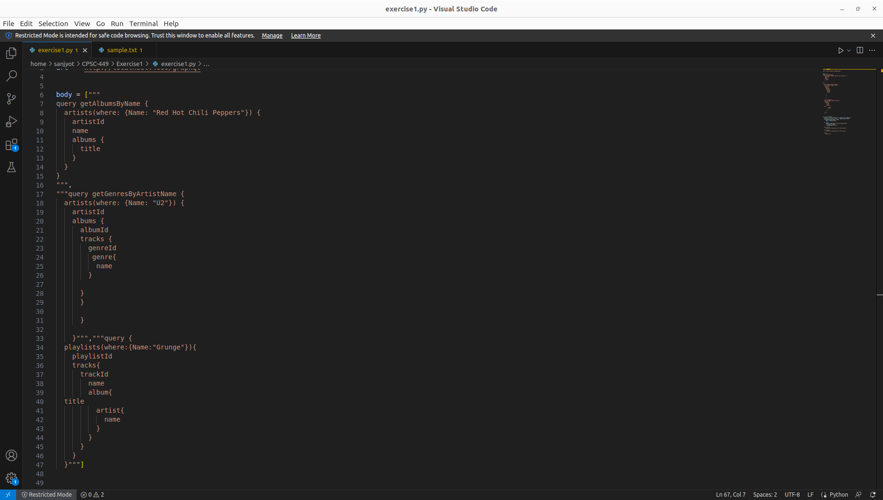
Added all the graphql queries wriiten earlier inside array , updated code using for loop
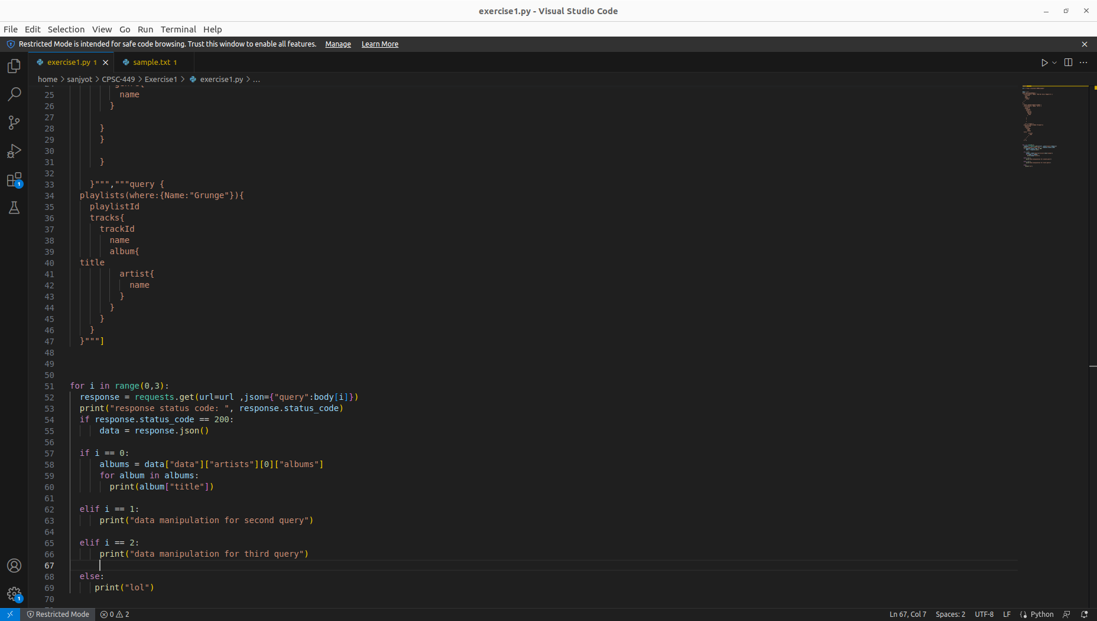

Running the Py file to get response for query 1
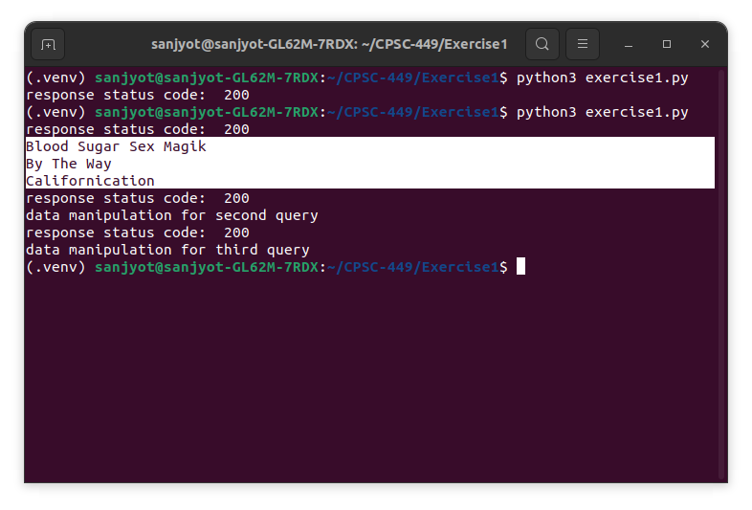

Updated the code to format the output in a neat way
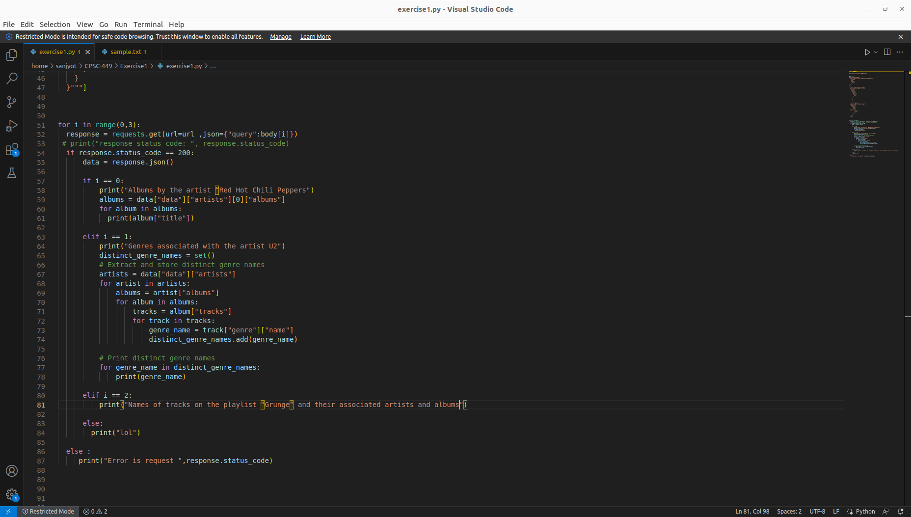

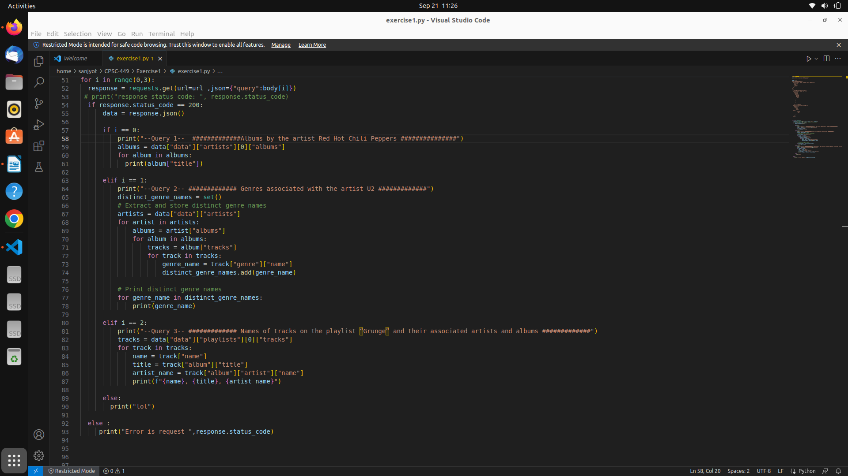

Output on running python file

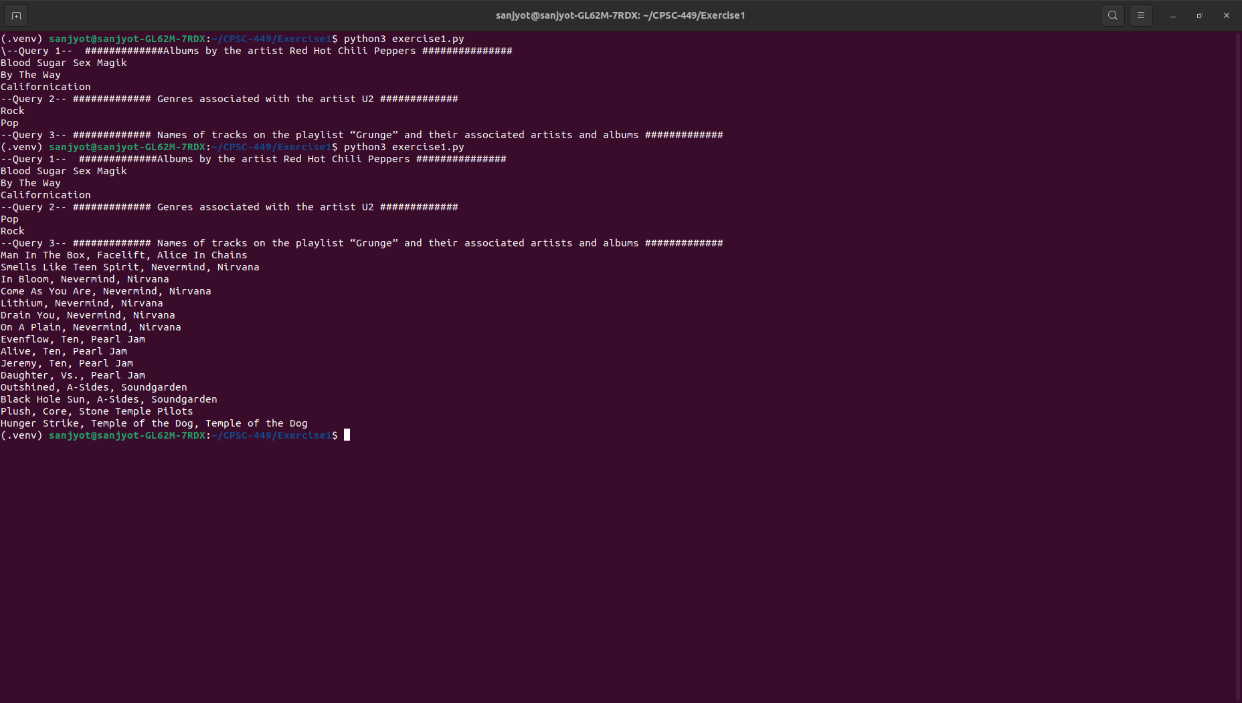
Making API calls python Rest API suing Soul
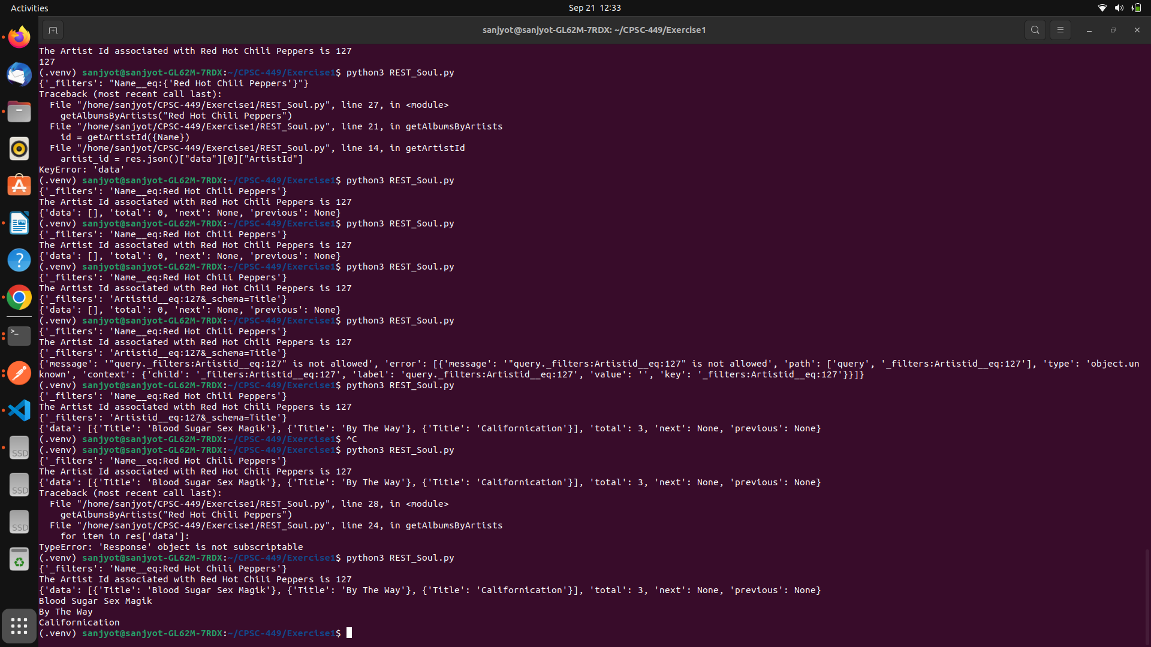s

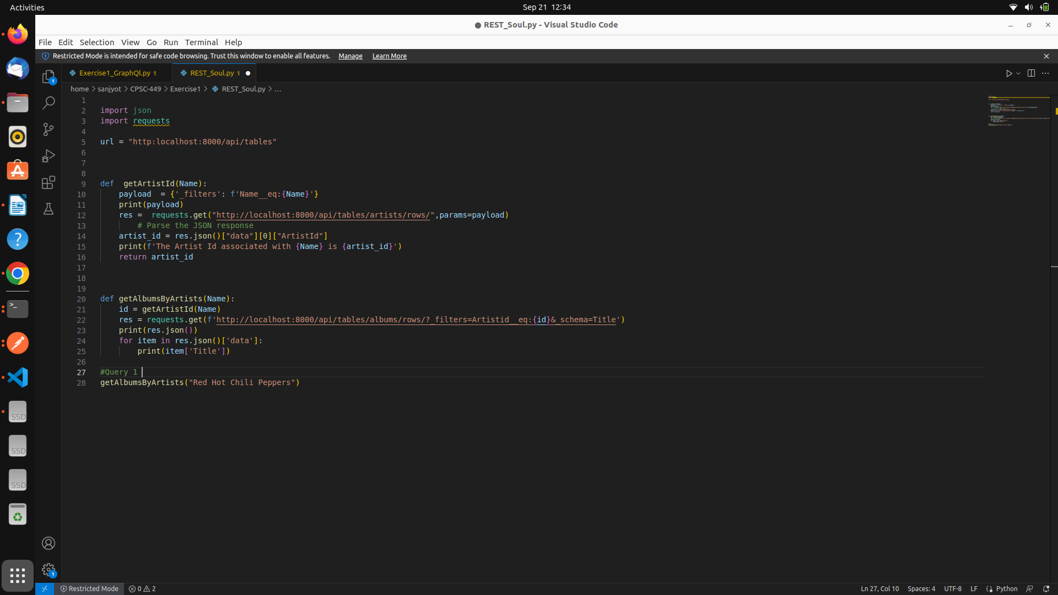s

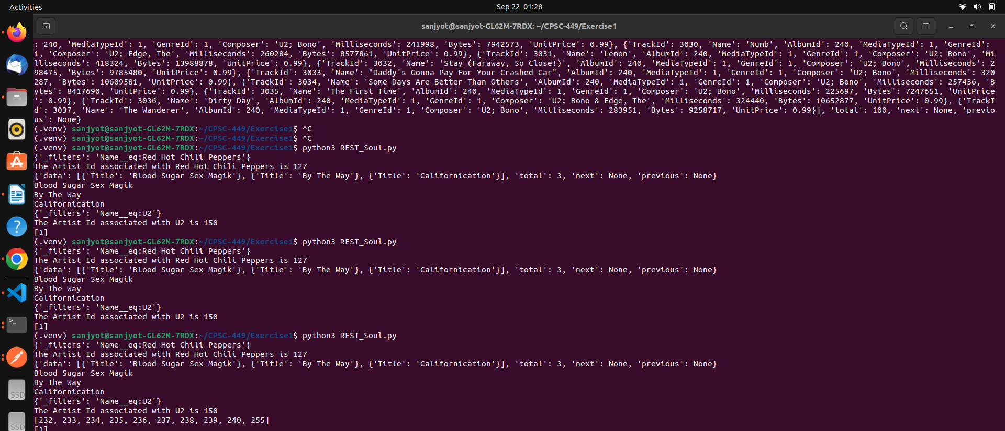
Geeting incomplete Json ID , because there is space in URL after Album number wrote logic to pass without sopace
s
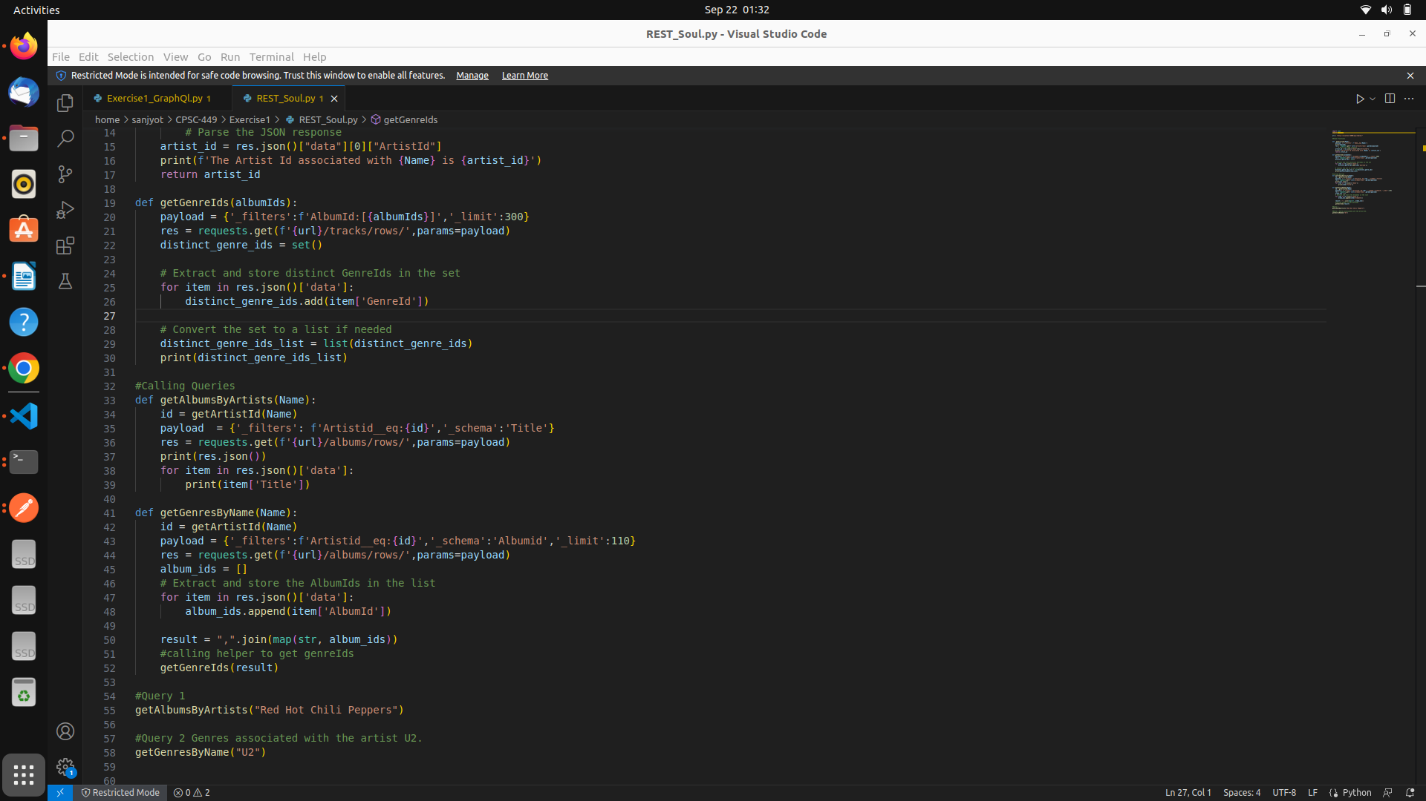
After updating the code I am getting distint genre ids for U2 I can use those to get Genere Names
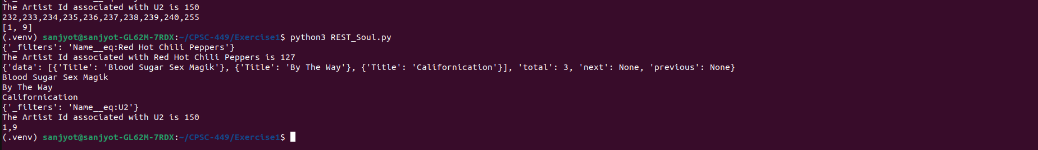
s

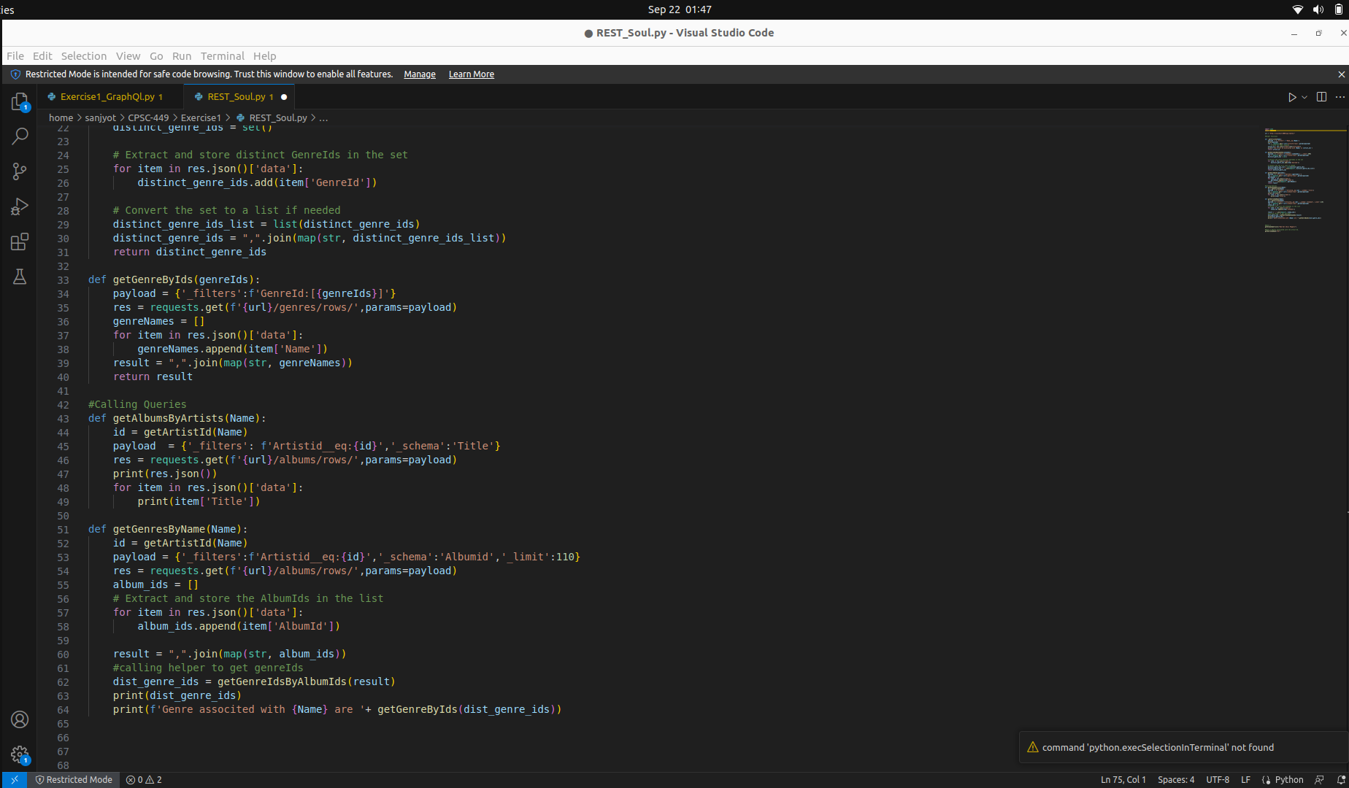
s

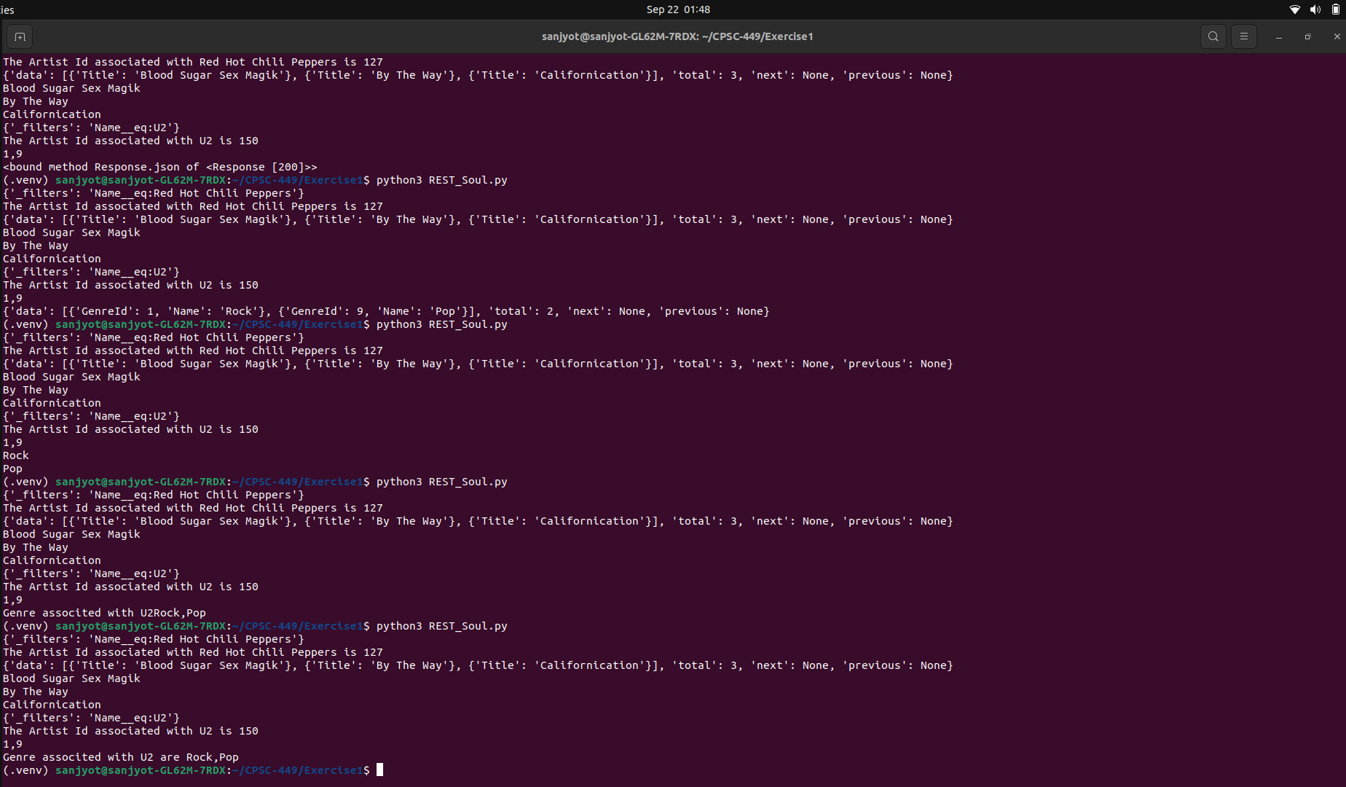
s

Updating Query 3
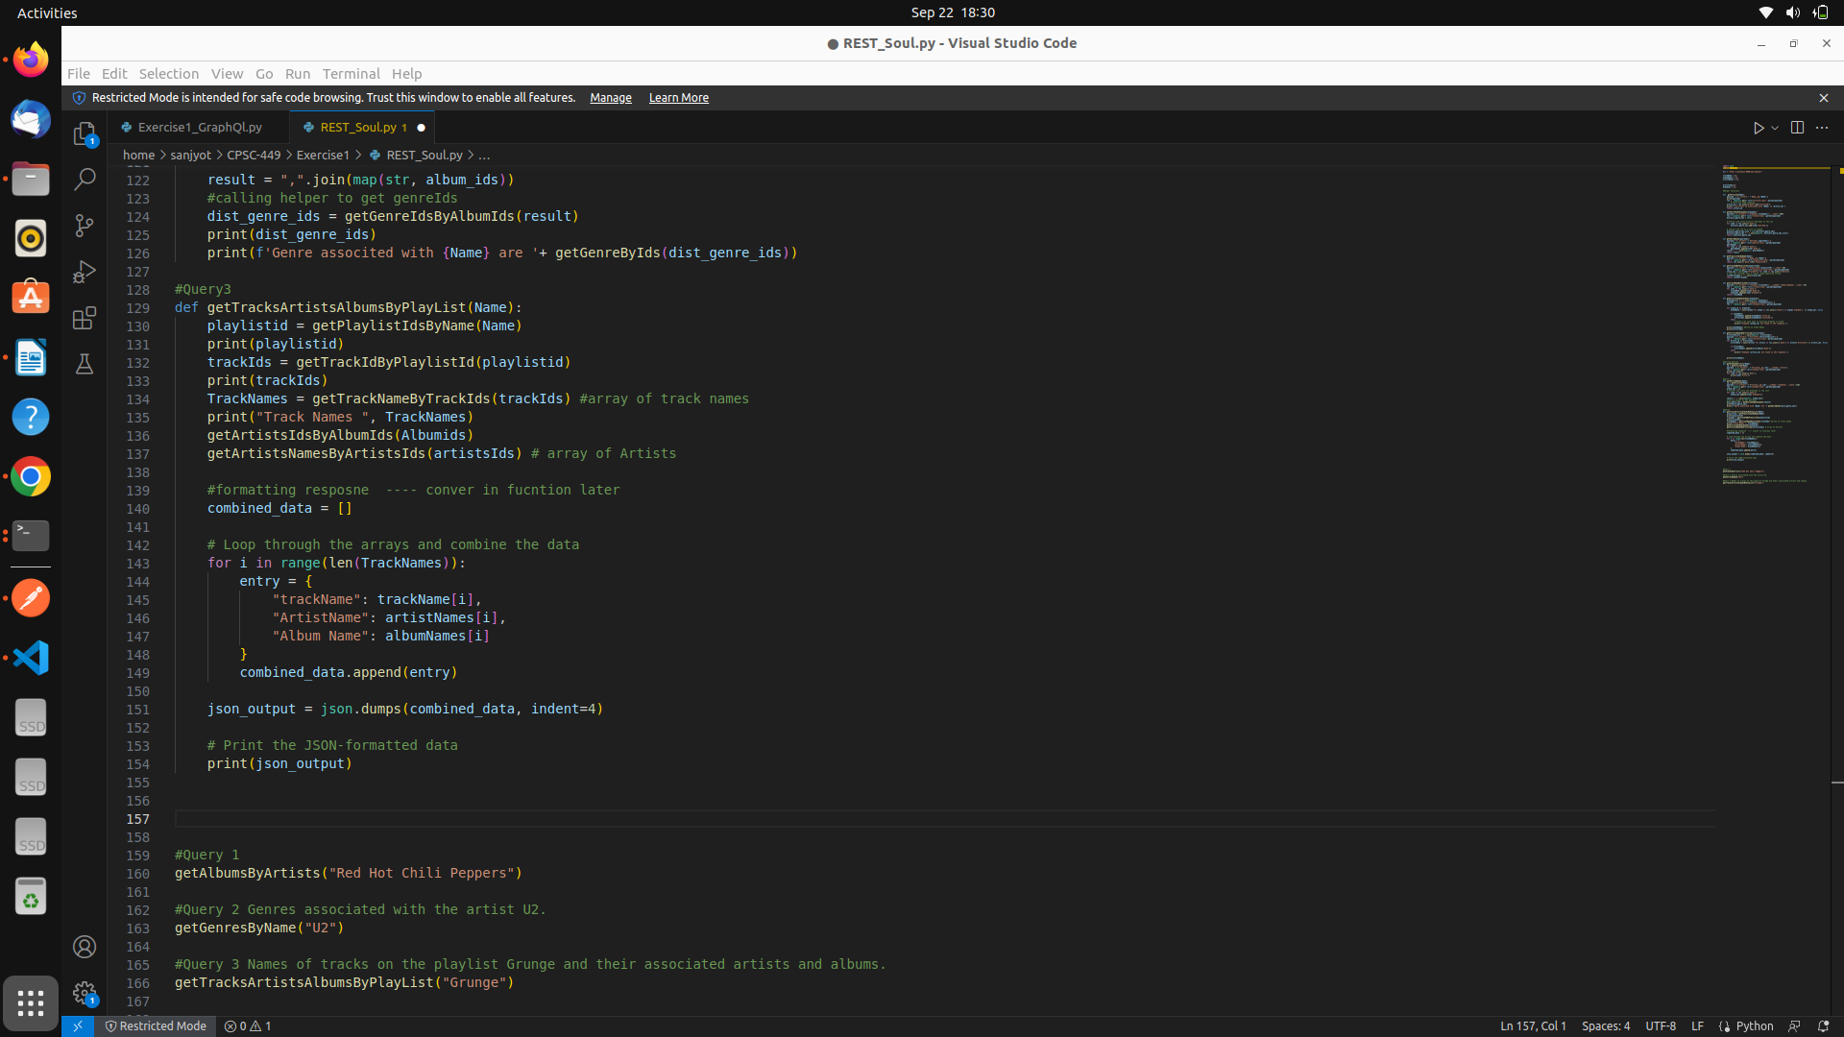
s

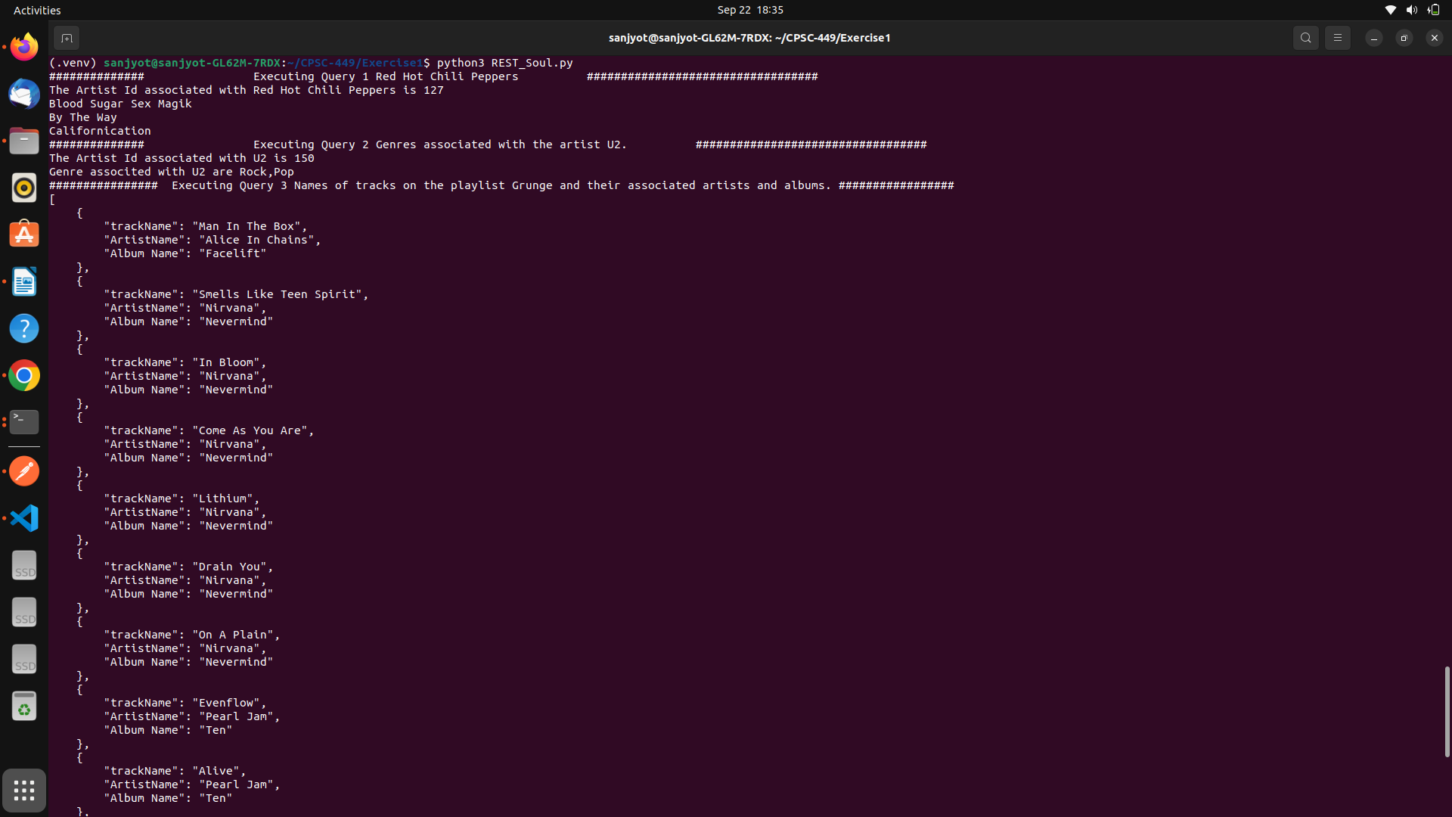
Output

Python Code for Soul
import json
import requests

url = "http://localhost:8000/api/tables/"

trackName = [];
albumNames = [];
artistNames = [];

artistsIds=[];
Albumids = [];

#Helper Functions

def getArtistId(Name):
payload = {'_filters': f'Name__eq:{Name}'}
res = requests.get(f'{url}/artists/rows/',params=payload)
artist_id = res.json()["data"][0]["ArtistId"]
print(f'The Artist Id associated with {Name} is {artist_id}')
return artist_id

def getGenreIdsByAlbumIds(albumIds):
payload = {'_filters':f'AlbumId:[{albumIds}]','_limit':300}
res = requests.get(f'{url}/tracks/rows/',params=payload)
distinct_genre_ids = set()

# Extract and store distinct GenreIds in the set
for item in res.json()['data']:
distinct_genre_ids.add(item['GenreId'])

# Convert the set to a list if needed
distinct_genre_ids_list = list(distinct_genre_ids)
distinct_genre_ids = ",".join(map(str, distinct_genre_ids_list))
return distinct_genre_ids

def getGenreByIds(genreIds):
payload = {'_filters':f'GenreId:[{genreIds}]'}
res = requests.get(f'{url}/genres/rows/',params=payload)
genreNames = []
for item in res.json()['data']:
genreNames.append(item['Name'])
result = ",".join(map(str, genreNames))
return result

def getPlaylistIdsByName(Name):
payload = {'_filters':f'Name__eq:{Name}'}
res = requests.get(f'{url}/playlists/rows/',params=payload)
return res.json()['data'][0]['PlaylistId']

def getTrackIdByPlaylistId(playlistId):
payload = {'_filters':f'PlaylistId:{playlistId}','_limit':20}
res = requests.get(f'{url}/playlist_track/rows/',params=payload)
track_ids = [str(item["TrackId"]) for item in res.json()["data"]]
# Join the TrackIds into a single comma-separated string
listOfTrackIds = ",".join(track_ids)
return listOfTrackIds

def getTrackNameByTrackIds(trackids):
payload = {'_filters':f'TrackId:[{trackids}]','_schema':'Name,AlbumId','_limit':25}
res = requests.get(f'{url}/tracks/rows/',params=payload)
for item in res.json()['data']:
trackName.append(item['Name'])
Albumids.append(item['AlbumId'])
return trackName

def getArtistsIdsByAlbumIds(Albumids):
AlbumIdslist = ",".join(map(str, Albumids))
payload = {'_filters':f'AlbumId:[{AlbumIdslist}]'}
res = requests.get(f'{url}/albums/rows/',params=payload)

for album_id in Albumids:
albumData = next((album for album in res.json()['data'] if album['AlbumId'] == album_id), None)

if albumData:
albumNames.append(albumData['Title'])
artistsIds.append(albumData['ArtistId'])
else:
# Handle the case when no matching AlbumId is found
print(f"AlbumId {album_id} not found in the response.")

#print(albumNames) #Array of Album Names
#print(artistsIds)

def getArtistsNamesByArtistsIds(artistsIds):
ArtistsIdsList = ",".join(map(str, artistsIds))
payload = {'_filters':f'ArtistId:[{ArtistsIdsList}]'}
res = requests.get(f'{url}/artists/rows/',params=payload)
for artist_id in artistsIds:
artistData = next((artist for artist in res.json()['data'] if artist['ArtistId'] == artist_id), None)

if artistData:
artistNames.append(artistData['Name'])
else:
print(f"AlbumId {artist_id} not found in the response.")

#print(artistNames)

#Calling Queries
def getAlbumsByArtists(Name):
print("############## Executing Query 1 Red Hot Chili Peppers ##################################")
id = getArtistId(Name)
payload = {'_filters': f'Artistid__eq:{id}','_schema':'Title'}
res = requests.get(f'{url}/albums/rows/',params=payload)
for item in res.json()['data']:
print(item['Title'])

#Query 2
def getGenresByName(Name):
print("############## Executing Query 2 Genres associated with the artist U2. ##################################")
id = getArtistId(Name)
payload = {'_filters':f'Artistid__eq:{id}','_schema':'Albumid','_limit':110}
res = requests.get(f'{url}/albums/rows/',params=payload)
album_ids = []
# Extract and store the AlbumIds in the list
for item in res.json()['data']:
album_ids.append(item['AlbumId'])

result = ",".join(map(str, album_ids))
#calling helper to get genreIds
dist_genre_ids = getGenreIdsByAlbumIds(result)
#print(dist_genre_ids)
print(f'Genre associted with {Name} are '+ getGenreByIds(dist_genre_ids))

#Query3
def getTracksArtistsAlbumsByPlayList(Name):
print("################ Executing Query 3 Names of tracks on the playlist Grunge and their associated artists and albums. #################")
playlistid = getPlaylistIdsByName(Name)
trackIds = getTrackIdByPlaylistId(playlistid)

TrackNames = getTrackNameByTrackIds(trackIds) #array of track names

getArtistsIdsByAlbumIds(Albumids)
getArtistsNamesByArtistsIds(artistsIds) # array of Artists

#formatting resposne ---- conver in fucntion later
combined_data = []

# Loop through the arrays and combine the data
for i in range(len(TrackNames)):
entry = {
"trackName": trackName[i],
"ArtistName": artistNames[i],
"Album Name": albumNames[i]
}
combined_data.append(entry)

json_output = json.dumps(combined_data, indent=4)

# Print the JSON-formatted data
print(json_output)

#Query 1
getAlbumsByArtists("Red Hot Chili Peppers")

#Query 2 Genres associated with the artist U2.
getGenresByName("U2")

#Query 3 Names of tracks on the playlist Grunge and their associated artists and albums.
getTracksArtistsAlbumsByPlayList("Grunge")

Response
.venv) sanjyot@sanjyot-GL62M-7RDX:~/CPSC-449/Exercise1$ python3 REST_Soul.py
############## Executing Query 1 Red Hot Chili Peppers ##################################
The Artist Id associated with Red Hot Chili Peppers is 127
Blood Sugar Sex Magik
By The Way
Californication
############## Executing Query 2 Genres associated with the artist U2. ##################################
The Artist Id associated with U2 is 150
Genre associted with U2 are Rock,Pop
################ Executing Query 3 Names of tracks on the playlist Grunge and their associated artists and albums. #################
[
{
"trackName": "Man In The Box",
"ArtistName": "Alice In Chains",
"Album Name": "Facelift"
},
{
"trackName": "Smells Like Teen Spirit",
"ArtistName": "Nirvana",
"Album Name": "Nevermind"
},
{
"trackName": "In Bloom",
"ArtistName": "Nirvana",
"Album Name": "Nevermind"
},
{
"trackName": "Come As You Are",
"ArtistName": "Nirvana",
"Album Name": "Nevermind"
},
{
"trackName": "Lithium",
"ArtistName": "Nirvana",
"Album Name": "Nevermind"
},
{
"trackName": "Drain You",
"ArtistName": "Nirvana",
"Album Name": "Nevermind"
},
{
"trackName": "On A Plain",
"ArtistName": "Nirvana",
"Album Name": "Nevermind"
},
{
"trackName": "Evenflow",
"ArtistName": "Pearl Jam",
"Album Name": "Ten"
},
{
"trackName": "Alive",
"ArtistName": "Pearl Jam",
"Album Name": "Ten"
},
{
"trackName": "Jeremy",
"ArtistName": "Pearl Jam",
"Album Name": "Ten"
},
{
"trackName": "Daughter",
"ArtistName": "Pearl Jam",
"Album Name": "Vs."
},
{
"trackName": "Outshined",
"ArtistName": "Soundgarden",
"Album Name": "A-Sides"
},
{
"trackName": "Black Hole Sun",
"ArtistName": "Soundgarden",
"Album Name": "A-Sides"
},
{
"trackName": "Plush",
"ArtistName": "Stone Temple Pilots",
"Album Name": "Core"
},
{
"trackName": "Hunger Strike",
"ArtistName": "Temple of the Dog",
"Album Name": "Temple of the Dog"
}
]

