Review comments: 15-05-2026

- Prepare a folder names as “Utilities” and add below given file here :
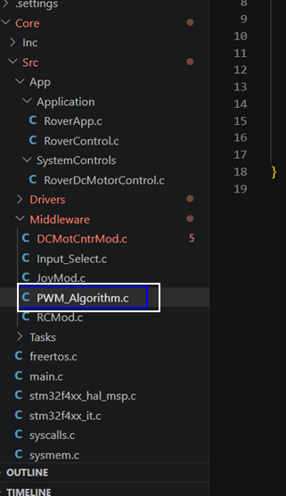

Change name of the file from “PWM_Algorithm” to “RampAlgorithm”

- I see the inputs are selected by this function

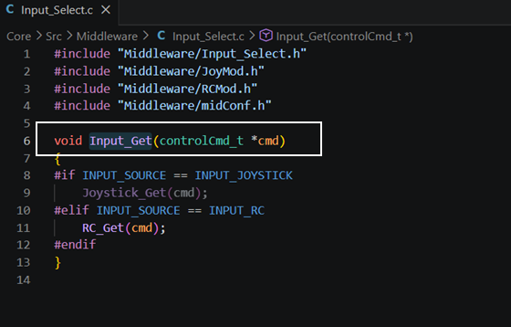

So, this should not be , decided by code but with requirements , so you can move this function in ,Roverapp.c file

- All functions shall start with its module name , so change below given function :
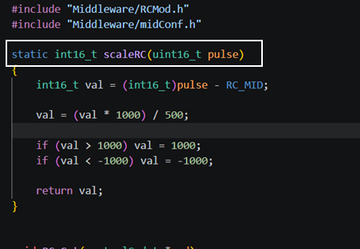

To
RC_ScaleInput()
And in other functions also this is the case you can change it.

- The main application shall always have 3 functions :

InputStruct_t input;
outputStruct_t OutPut;

App_getInput(&Inputs)
App_Run(Inputs,&outputs)
App_SetOutputs(output)

So ,
Can you modify the below given function like this

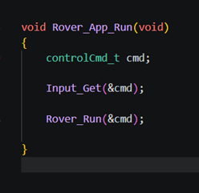

Also , please append the filename in front of the function like ,
RovApp_getInput();

Main idea is ,
- functions which collect “Input data”
- functions which processes “Input data” and generates “output data”
- functions which will send “output data”
shall be separated for better , modularity

