Review comments by sanjyot on 22-02-2026

- Tasks files shall be in “Task” folder and in App you can prepare 2 sub folders
SystemControls:
Rover_DC_Motor_control.c
Rover_Servo_motor_contro.c
Application :
Rover_Control.c

Like this, main applications will be in application folder

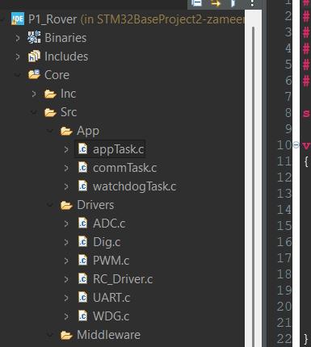

- ADC.c file

I see the function is : uint16_t ADC_GetValue(uint32_t channel)

So we may have more than one joystick ,which will be connected to different , pin inputs , like joystick will be connected to pin 1 and another joystick will be connected to pin 2.
Can this function accmodate multiple inputs , if yes how?

- Same comment for PWM also , we may have more than one PWM out Pins so, how to provide this to the Below given API :
void PWM_SetDuty(uint16_t duty)

- In dig.c file ,write definition is good
- void Dig_Write(GPIO_TypeDef *port, uint16_t pin, DigState_t state)

you can also add definition for digitalRead().

5. What is RC_Driver.c file?
6. as described in architecture document,
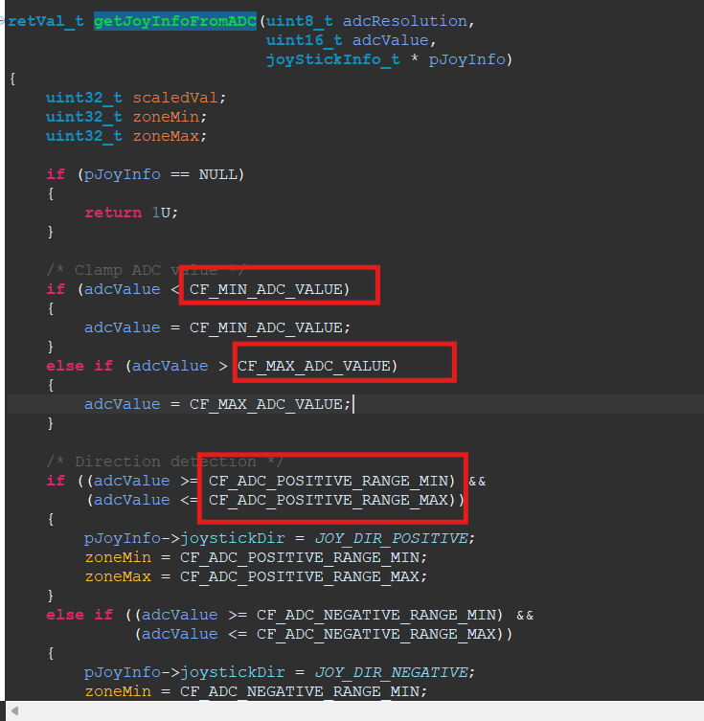

The value of these constants shall come from driverConfiguration.c file.
So that in case we want to change the resolation it shall be possible to change it from configuration file

- For neutral condition also we have minimum and maximum zone , which shall be added,

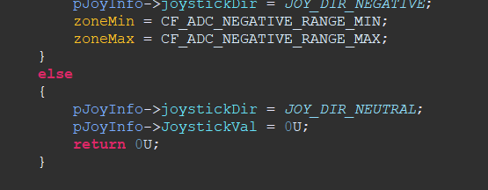

- Also if we are in zone then we shall return 0 or we shall return 1
- In app Task you can all the function,
void roverControlRun(void)

“roverControlRun()” definition shall be present in file roverControl.c file which should be present in “application” folder.
- I have not written this module till now , but
void DCMotor_Run(int16_t speed). Will have 2 inputs , direction and speed.
Also for joystick we will have , time vs speed curve which I will define .

