MIC Broth Microdilution Protocol
CLSI 100 + 100 µL format. One antibiotic × one bacterial strain × one plate (P1), 200 µL per well. Opentrons OT-2.
Script: MIC_2Fold_Dilution_1Antibiotic_1Strain_200uL.py

1. Overview
The robot builds a 2-fold antibiotic dilution series in 100 µL of broth across columns 1–10 of plate P1, then adds 100 µL of bacterial inoculum to columns 1–11. Mixing equal volumes halves both the antibiotic and the bacteria, so each liquid is prepared at twice its final concentration. With the antibiotic working solution at 200 µg/mL, column 1 ends at 100 µg/mL and column 10 at about 0.2 µg/mL.
Column 11 is the growth control (broth and bacteria, no antibiotic) and column 12 is the sterility control (broth only). The P300 is 8-channel, so every transfer fills a whole column and the eight rows (A–H) are eight replicates. No well holds more than 200 µL at any point.
The run has five pipetting steps and one pause before the bacteria are added, so the inoculum can be loaded fresh. Only the P300 multi (left mount) is used.

2. Deck Layout
The sketch shows the OT-2 deck from the front of the robot. Coloured channels show what goes into the reservoir, and yellow tips are the ones the protocol will use.
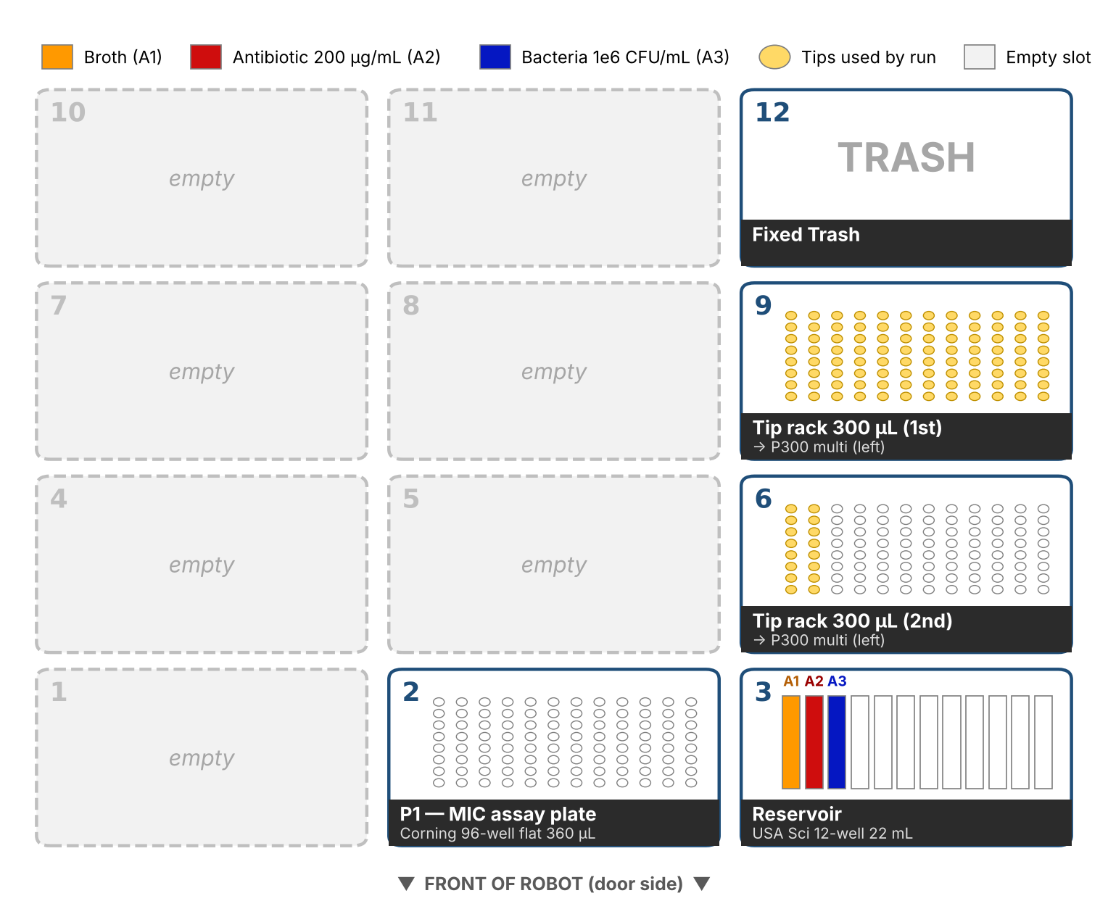
Slot | Labware | Contents / purpose
2 | Corning 96-well flat, 360 µL (P1) | MIC assay plate, starts empty
3 | USA Scientific 12-well reservoir, 22 mL | A1: broth; A2: antibiotic 200 µg/mL; A3: bacteria ≈1 × 10⁶ CFU/mL
6 | Opentrons 96 tip rack, 300 µL (2nd) | Used after slot 9 runs out (2 columns)
9 | Opentrons 96 tip rack, 300 µL (1st) | Used first (all 12 columns)
12 | Fixed trash | Used tips and the 100 µL discard from column 10

Slots 1, 4, 5, 7, 8, 10 and 11 stay empty. The run needs 14 columns of 300 µL tips, more than one rack holds, so a second full rack goes in slot 6. The P20 is not used and can stay mounted on the right.

3. Preparing the Reagents
Prepare the broth first, because it is also the diluent for the antibiotic and the bacteria. Make the antibiotic working solution before the run, and prepare the inoculum during the pause so it is used within 15 minutes, as CLSI recommends.

3.1 Broth (use regular M9 broth)

3.2 Antibiotic (highest final concentration 100 µg/mL)
Column 1 receives 200 µL of antibiotic. After 100 µL moves on in the dilution and 100 µL of bacteria is added, the antibiotic in column 1 is diluted 2-fold. To reach 100 µg/mL in column 1, the working solution in reservoir A2 must therefore be 200 µg/mL (2× the highest concentration).
- Make a concentrated stock from powder, correcting for potency: weight (mg) = volume (mL) × concentration (µg/mL) ÷ potency (µg/mg). Example: 10 mL of a 10,000 µg/mL (10 mg/mL) stock from powder with 950 µg/mg potency needs 10 × 10,000 ÷ 950 = 105.3 mg. Dissolve it in the solvent CLSI M100 lists for that drug.
- Dilute the stock to 200 µg/mL in CAMHB using C₁V₁ = C₂V₂. Make 4 mL; the robot uses 1.6 mL (8 channels × 200 µL) and the rest keeps the tips submerged.

Stock concentration | Stock volume | CAMHB volume (4 mL total)
10,000 µg/mL (10 mg/mL) | 80 µL | 3,920 µL
5,120 µg/mL | 156 µL | 3,844 µL
1,280 µg/mL | 625 µL | 3,375 µL

- Mix well and load the 4 mL into reservoir A2. Store or discard the stock according to the drug’s stability.
Solvent check: if the stock is in DMSO, 80 µL in 4 mL gives 2% DMSO in the working solution and 1% in column 1 after the bacteria are added, halving in each column after that. If your strain is sensitive to the solvent, use a more concentrated stock or run a solvent-only control.

3.3 Bacterial inoculum (≈1 × 10⁶ CFU/mL) (can swap this with food coloring)
CLSI targets 5 × 10⁵ CFU/mL in each well (acceptable range 2–8 × 10⁵). Because 100 µL of inoculum is mixed with 100 µL of antibiotic, the inoculum in reservoir A3 must be twice that, ≈1 × 10⁶ CFU/mL.
- Streak the strain on non-selective agar and incubate for 18–24 hours.
- Pick 3–5 well-isolated colonies of the same morphology and suspend them in sterile saline (0.85%) or broth. Vortex thoroughly; encapsulated or mucoid strains can clump.
- Adjust the suspension to a 0.5 McFarland standard, which is about 1–2 × 10⁸ CFU/mL for most Gram-negative rods (OD₆₂₅ of 0.08–0.13 in a 1 cm cuvette).
- Dilute it 1:150 in CAMHB: 80 µL of the 0.5 McFarland suspension into 12 mL of CAMHB. This gives about 12 mL at ≈1 × 10⁶ CFU/mL. The robot uses 8.8 mL (8 channels × 11 columns × 100 µL).
- When the robot pauses before Step 5, mix the inoculum and pour all of it into reservoir A3, then click Resume. Use it within 15 minutes of making the 0.5 McFarland suspension.
- Check the count: dilute 10 µL of the A3 inoculum into 10 mL of saline (1:1,000) and spread 100 µL on agar. About 100 colonies corresponds to 1 × 10⁶ CFU/mL; 40–160 colonies keeps the wells within the CLSI range.
The McFarland-to-CFU relationship varies between species. If your strain is not a typical Gram-negative rod, confirm the 1:150 dilution with plate counts the first time and adjust the dilution if needed.

3.4 What goes into the reservoir
Channel | Liquid | Load | Used by robot
A1 | Broth | 12 mL | 9.6 mL
A2 | Antibiotic, 200 µg/mL | 4 mL | 1.6 mL
A3 | Bacteria, ≈1 × 10⁶ CFU/mL in CAMHB | 12 mL (load at the pause) | 8.8 mL

The extra volume in each channel keeps all 8 tips of the multichannel submerged, because the tips aspirate 1 mm above the bottom and cannot reach the last part of each channel.

4. Pipette Settings
Pipette | Aspirate rate | Dispense rate | Tip height
P300 multi (left) | 150 µL/s | 300 µL/s | 1 mm above bottom

“Pre-wet” means the tip aspirates and dispenses once in the source before the real aspiration, which improves accuracy. All mixing uses 3 cycles of 150 µL in wells holding 200 µL.

5. Step-by-Step
Step 1 — Broth into columns 2–11 (one tip)
The P300 picks up the first column of tips from slot 9. It aspirates 100 µL of broth from reservoir A1 and dispenses it into P1 column 2, then repeats for columns 3 to 11, using the same tip throughout. Column 1 stays empty for the antibiotic.
Step 2 — Broth into column 12 (same tip)
With the same tip, the P300 transfers 200 µL of broth into column 12 (the sterility control, which receives nothing else), then drops the tip.
Column | Volume after Step 2 | Contents
1 | 0 µL | Empty
2–11 | 100 µL | Broth
12 | 200 µL | Broth
Step 3 — Antibiotic into column 1 (new tip)
The P300 picks up a fresh tip, pre-wets it in reservoir A2, and transfers 200 µL of the 200 µg/mL antibiotic into column 1. The tip is dropped.
Step 4 — 2-fold serial dilution, columns 1→10 (new tip)
The P300 picks up a fresh tip and pre-wets it in column 1. Using this one tip, it:
- Aspirates 100 µL from column 1, dispenses it into column 2 (now 200 µL), and mixes 3 times at 150 µL.
- Aspirates 100 µL from column 2, dispenses into column 3, and mixes.
- Repeats the pattern up to column 9 → column 10.
- Aspirates 100 µL from column 10 and dispenses it into the trash, then drops the tip.
Every column now holds 100 µL, and each has half the antibiotic of the column before it. The highest volume any well reaches is 200 µL, about 55% of the plate’s 360 µL capacity.
Column | Volume after Step 4 | Antibiotic (before bacteria)
1 | 100 µL | 200 µg/mL
2 | 100 µL | 100 µg/mL
3 | 100 µL | 50 µg/mL
4–9 | 100 µL | 25, 12.5, 6.25, 3.13, 1.56, 0.78 µg/mL
10 | 100 µL | 0.39 µg/mL
11 | 100 µL | 0 (broth only)
12 | 200 µL | 0 (broth only)
Pause — Load the inoculum
The robot pauses and shows a message in the Opentrons App. Prepare the inoculum as in section 3.3, mix it, pour it into reservoir A3, and click Resume. To run without stopping, set PAUSE_BEFORE_BACTERIA = False at the top of the script and load A3 before starting; the bacteria will then sit in the trough during Steps 1–4, so mix the channel before you start.
Step 5 — Bacteria into columns 1–11 (new tip per column)
For each of columns 1 to 11, the P300 picks up a fresh tip, pre-wets it in reservoir A3 (which also resuspends settled cells), aspirates 100 µL of inoculum, dispenses it into the column, mixes 3 times at 150 µL, and drops the tip. A fresh tip per column keeps antibiotic out of the inoculum trough.
This step uses 11 tip columns. After the first rack (slot 9) is used up, the robot continues automatically with the rack in slot 6. Column 12 receives no bacteria. Every well now holds 200 µL.

6. Final Plate Map
All wells hold 200 µL. Wells in columns 1–11 contain ≈5 × 10⁵ CFU/mL.
Column | Contents | Volume | Antibiotic
1 | Antibiotic + bacteria | 200 µL | 100 µg/mL
2 | Antibiotic + bacteria | 200 µL | 50 µg/mL
3 | Antibiotic + bacteria | 200 µL | 25 µg/mL
4 | Antibiotic + bacteria | 200 µL | 12.5 µg/mL
5 | Antibiotic + bacteria | 200 µL | 6.25 µg/mL
6 | Antibiotic + bacteria | 200 µL | 3.13 µg/mL
7 | Antibiotic + bacteria | 200 µL | 1.56 µg/mL
8 | Antibiotic + bacteria | 200 µL | 0.78 µg/mL
9 | Antibiotic + bacteria | 200 µL | 0.39 µg/mL
10 | Antibiotic + bacteria | 200 µL | 0.20 µg/mL
11 | Broth + bacteria (growth control) | 200 µL | 0
12 | Broth only (sterility control) | 200 µL | 0

To test a different range, change only the working solution in A2: it is always 2× the highest concentration you want in column 1. For example, 128 µg/mL in A2 gives 64 µg/mL down to 0.125 µg/mL.

7. After the Run
- Cover the plate with its lid or a breathable seal to limit evaporation.
- Incubate at 35 ± 2 °C in ambient air for 16–20 hours (non-fastidious organisms; check CLSI M07 for yours).
- Check the controls first: column 11 should be turbid and column 12 clear. If either fails, the plate is not valid.
- Read the MIC in each row as the lowest antibiotic concentration with no visible growth. With eight replicate rows, report the modal value and note any row that differs by more than one dilution.
- For routine work, run a CLSI quality-control strain (for example E. coli ATCC 25922 or S. aureus ATCC 29213) and confirm its MIC falls in the M100 QC range for your antibiotic.

8. Consumables
Item | Quantity
300 µL tips | 14 columns (112 tips): all of slot 9, 2 columns of slot 6
96-well plate | 1 (P1)
12-well reservoir | 1 (3 channels used)
CAMHB | ≥50 mL prepared (≈28 mL used)

9. Notes and Checks
- Well volumes. Wells never hold more than 200 µL, which removes the overflow risk of the previous 360 µL design.
- Rows are replicates. All eight rows receive the same antibiotic and strain, giving eight replicate dilution series.
- Second tip rack. Make sure both 300 µL racks are full at the start. The script always starts at A1 of the slot 9 rack.
- API level. The script uses API level 2.28, like your original file, so it needs an equally recent OT-2 app and robot software. It was checked in the Opentrons simulator: 14 tip-column pickups, the pause, and every transfer described here.
- Editing volumes. All volumes and the pause are named settings at the top of the script (BROTH_VOL, ANTIBIOTIC_VOL, BACTERIA_VOL, MIX_VOL, PAUSE_BEFORE_BACTERIA).

10. What Changed from the Original
- Four plates reduced to one plate (P1), in slot 2.
- Four antibiotics reduced to one, in reservoir A2. The bacterial stock plate is removed; one strain is loaded into reservoir A3.
- Volumes changed to the CLSI 100 + 100 µL format: 100 µL broth, 200 µL antibiotic in column 1, 100 µL transfers, 100 µL inoculum. Wells peak at 200 µL instead of 360 µL.
- Bacteria are added with the P300 instead of the P20, using two 300 µL tip racks (slots 9 and 6). The four 20 µL racks are no longer needed.
- A pause was added before the bacteria step so the inoculum is used fresh.
- 100 protocol steps reduced to 5, written as short loops with plain pipetting commands.

