Q_01:

package Q_01;

import javax.swing.JFrame;

public class Q_01 {

public static void main(String[] args) {

JFrame frame = new JFrame("Welcome to Java");

frame.setSize(800, 600);

frame.setDefaultCloseOperation(JFrame.EXIT_ON_CLOSE);

frame.setVisible(true);

}

}

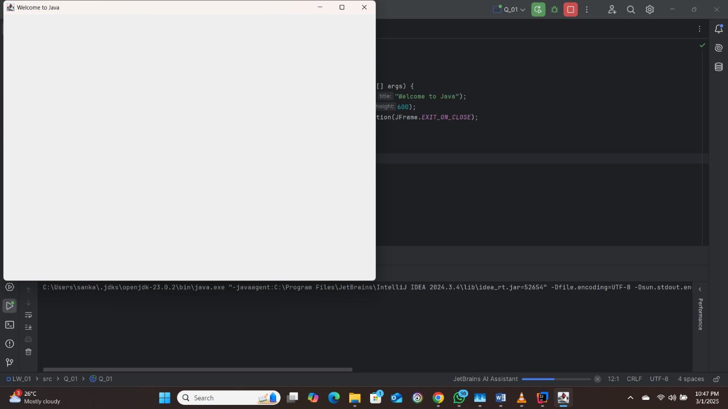

Q_02:

package Q_02;

import javax.swing.JFrame;

import java.util.Scanner;

public class Q_02 {

public static void main(String[] args) {

Scanner scanner = new Scanner(System.in);

System.out.print("Enter your first name: ");

String firstName = scanner.nextLine();

System.out.print("Enter your last name: ");

String lastName = scanner.nextLine();

JFrame frame = new JFrame(firstName + " " + lastName);

frame.setSize(800, 600);

frame.setDefaultCloseOperation(JFrame.EXIT_ON_CLOSE);

frame.setVisible(true);

}

}

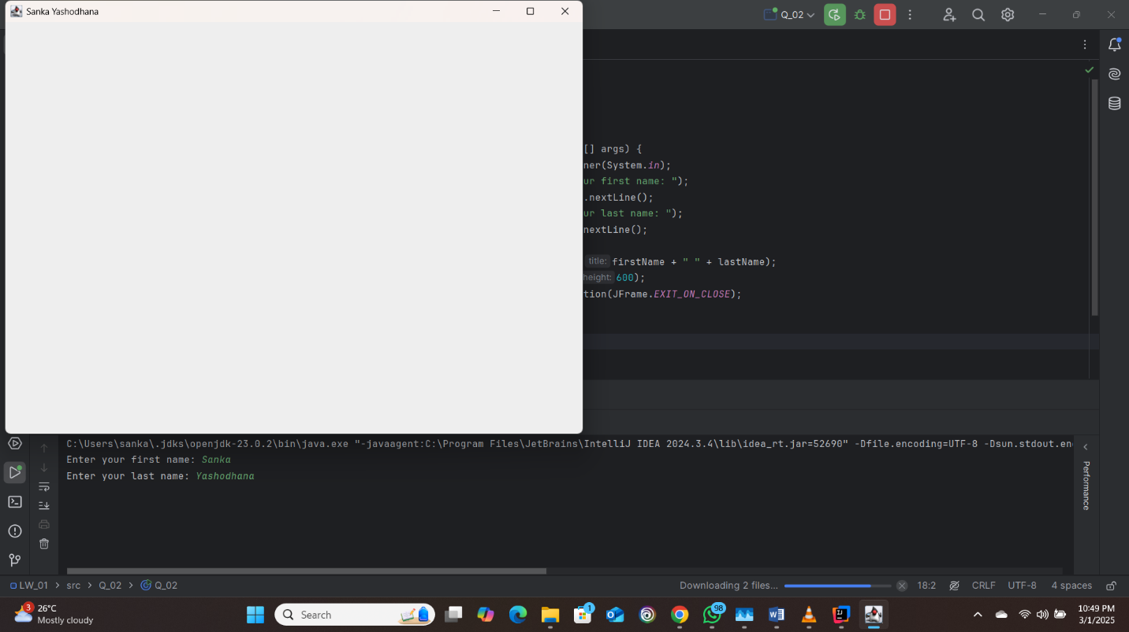

Q_03:

package Q_03;

import java.util.Scanner;

public class Q_03 {

public static void main(String[] args) {

Scanner scanner = new Scanner(System.in);

System.out.print("Enter your first name: ");

String firstName = scanner.nextLine();

System.out.print("Enter your middle name: ");

String middleName = scanner.nextLine();

System.out.print("Enter your last name: ");

String lastName = scanner.nextLine();

System.out.println(firstName + " " + middleName.charAt(0) + ". " + lastName);

}

}

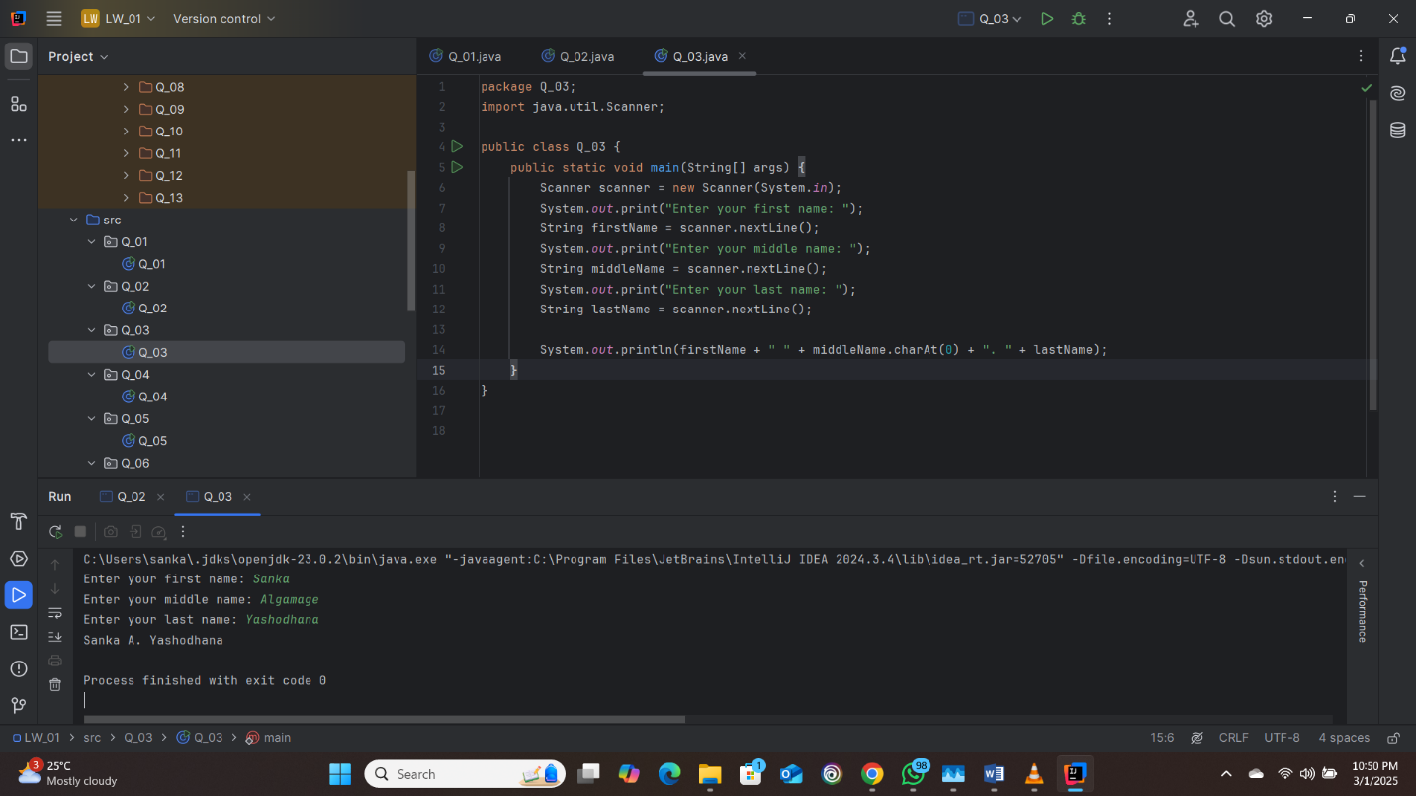

Q_04:

package Q_04;

import java.text.SimpleDateFormat;

import java.util.Date;

public class Q_04 {

public static void main(String[] args) {

SimpleDateFormat dateFormat = new SimpleDateFormat("dd MMM yyyy");

System.out.println(dateFormat.format(new Date()));

}

}

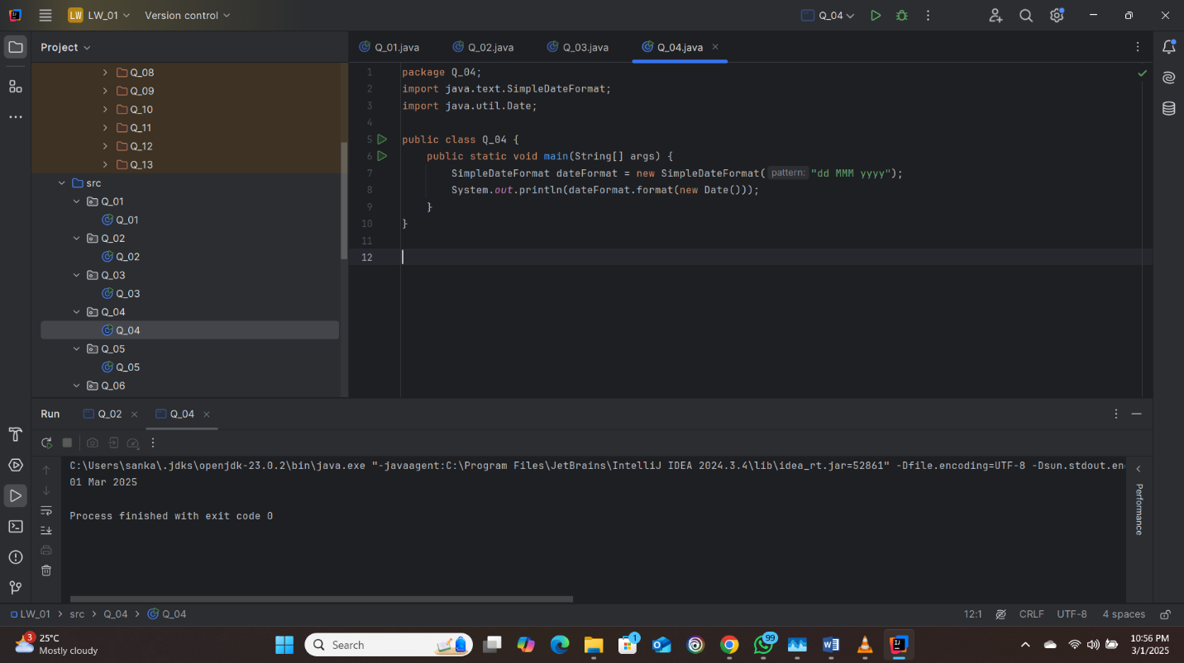

Q_05:

package Q_05;

import java.text.SimpleDateFormat;

import java.util.Date;

public class Q_05 {

public static void main(String[] args) {

SimpleDateFormat dateFormat = new SimpleDateFormat("EEEE, MMM dd, yyyy");

System.out.println(dateFormat.format(new Date()));

}

}

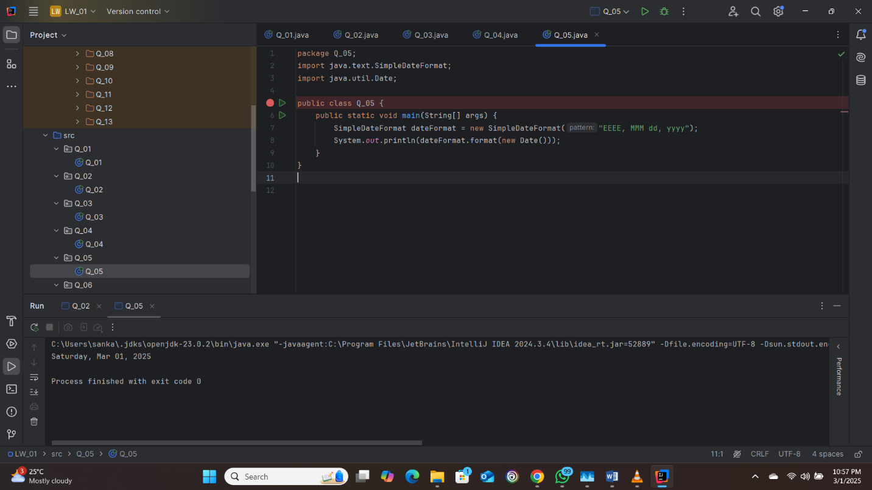

Q_06:

package Q_06;

import javax.swing.JFrame;

import java.util.Scanner;

public class Q_06 {

public static void main(String[] args) {

Scanner scanner = new Scanner(System.in);

System.out.print("Enter the width of the frame: ");

int width = scanner.nextInt();

System.out.print("Enter the height of the frame: ");

int height = scanner.nextInt();

scanner.nextLine(); // Consume the newline character

System.out.print("Enter the title of the frame: ");

String title = scanner.nextLine();

JFrame frame = new JFrame(title);

frame.setSize(width, height);

frame.setDefaultCloseOperation(JFrame.EXIT_ON_CLOSE);

frame.setVisible(true);

}

}

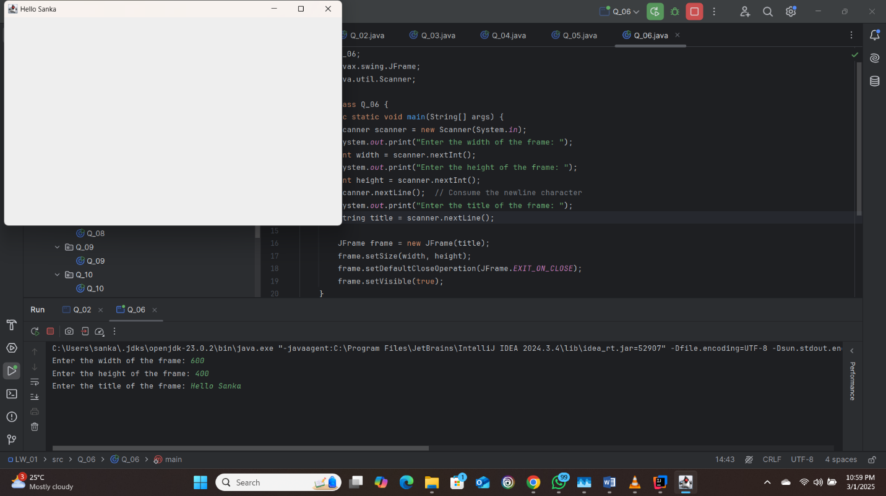

Q_07:

package Q_07;

import javax.swing.JFrame;

import java.text.SimpleDateFormat;

import java.util.Date;

public class Q_07 {

public static void main(String[] args) {

SimpleDateFormat timeFormat = new SimpleDateFormat("hh:mm:ss a");

String time = timeFormat.format(new Date());

JFrame frame = new JFrame(time);

frame.setSize(800, 600);

frame.setDefaultCloseOperation(JFrame.EXIT_ON_CLOSE);

frame.setVisible(true);

}

}

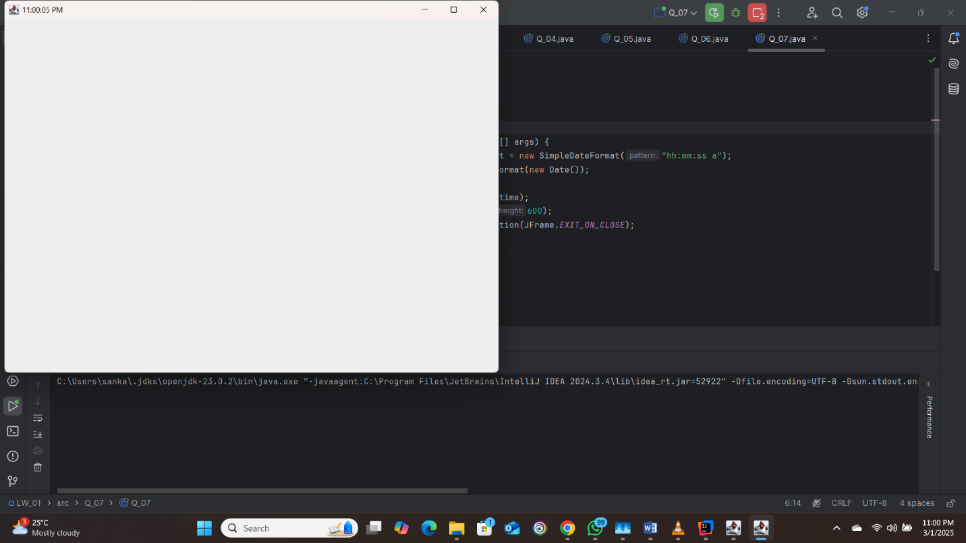

Q_08:

package Q_08;

import java.util.Scanner;

public class Q_08 {

public static void main(String[] args) {

Scanner scanner = new Scanner(System.in);

System.out.print("Enter a string with an exclamation mark: ");

String input = scanner.nextLine();

String[] parts = input.split("!");

System.out.println(parts[0].trim());

System.out.println(parts[1].trim());

}

}

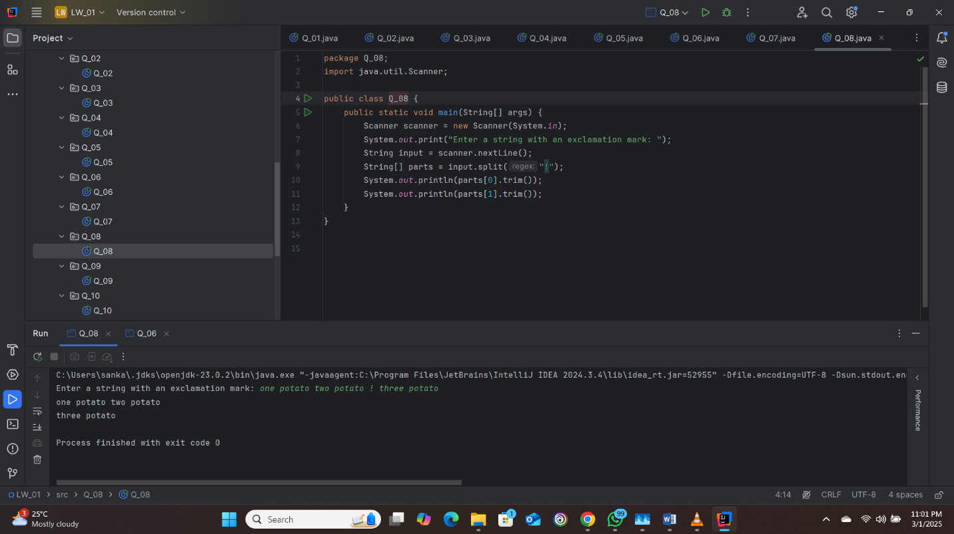

Q_09:

package Q_09;

import java.util.Scanner;

public class Q_09 {

public static void main(String[] args) {

Scanner scanner = new Scanner(System.in);

System.out.print("Enter a string: ");

String input = scanner.nextLine();

System.out.println(input.length());

System.out.println(input.charAt(0));

System.out.println(input.charAt(input.length() - 1));

}

}

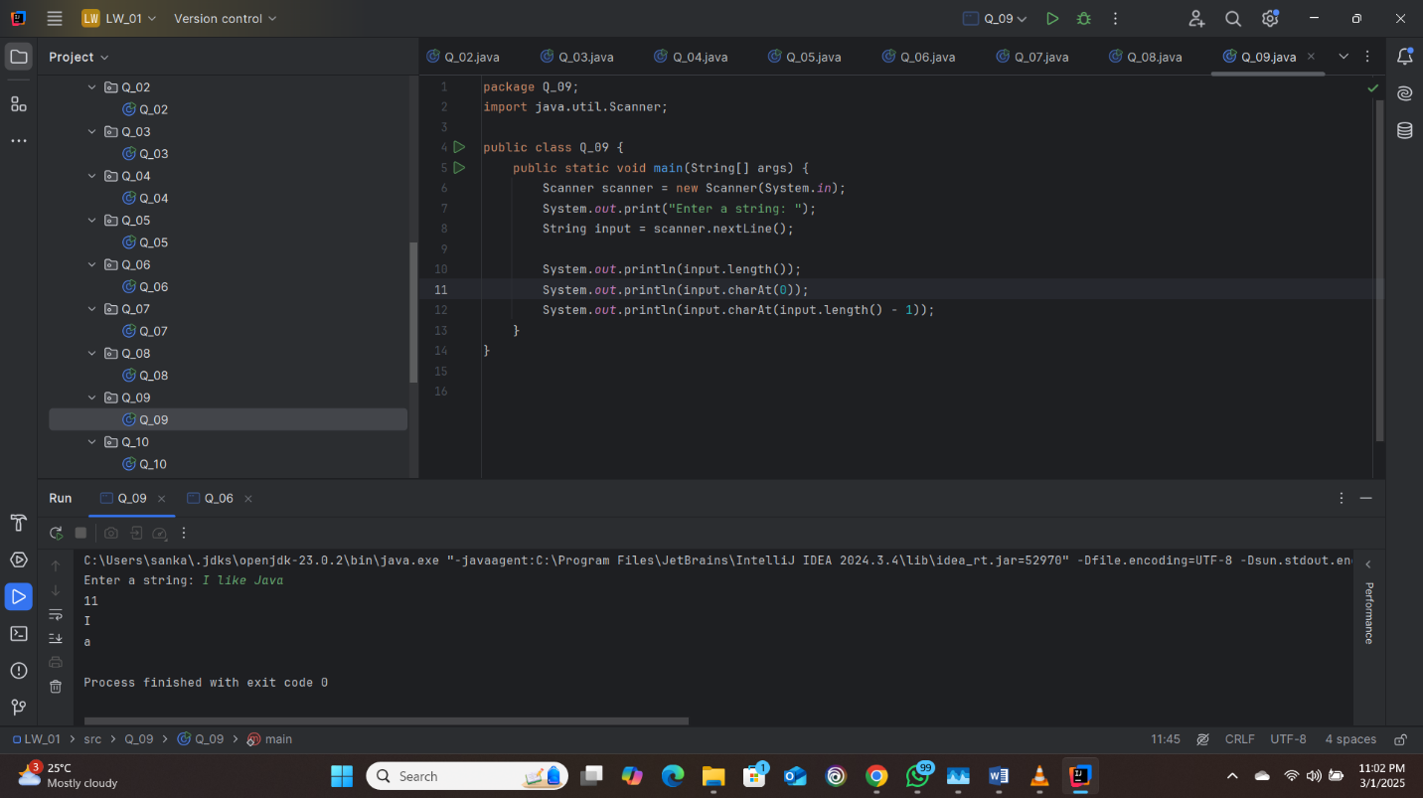

Q_10:

package Q_10;

import java.util.Scanner;

public class Q_10 {

public static void main(String[] args) {

Scanner scanner = new Scanner(System.in);

System.out.print("Enter an odd-length word: ");

String word = scanner.nextLine();

int middleIndex = word.length() / 2;

System.out.println(word.charAt(middleIndex));

}

}

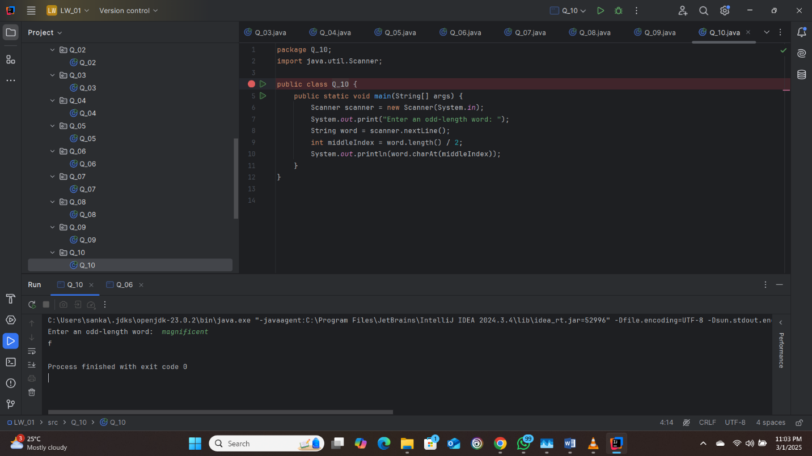

Q_11

package Q_11;

import java.util.Scanner;

public class Q_11 {

public static void main(String[] args) {

Scanner scanner = new Scanner(System.in);

System.out.print("Enter your full name (first middle last): ");

String firstName = scanner.next();

String middleName = scanner.next();

String lastName = scanner.next();

System.out.println(lastName + ", " + firstName + " " + middleName.charAt(0) + ".");

}

}

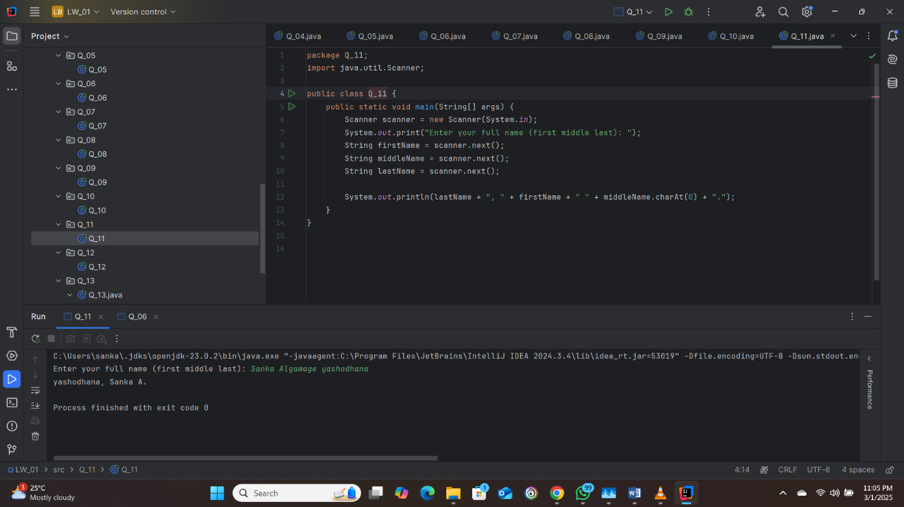

Q_12:

package Q_12;

import javax.swing.JFrame;

public class Q_12 {

public static void main(String[] args) {

JFrame frame = new JFrame("My First Frame");

frame.setSize(300, 200);

frame.setLocation(100, 50); // Position it 100px from the left and 50px from the top

frame.setDefaultCloseOperation(JFrame.EXIT_ON_CLOSE);

frame.setVisible(true);

}

}

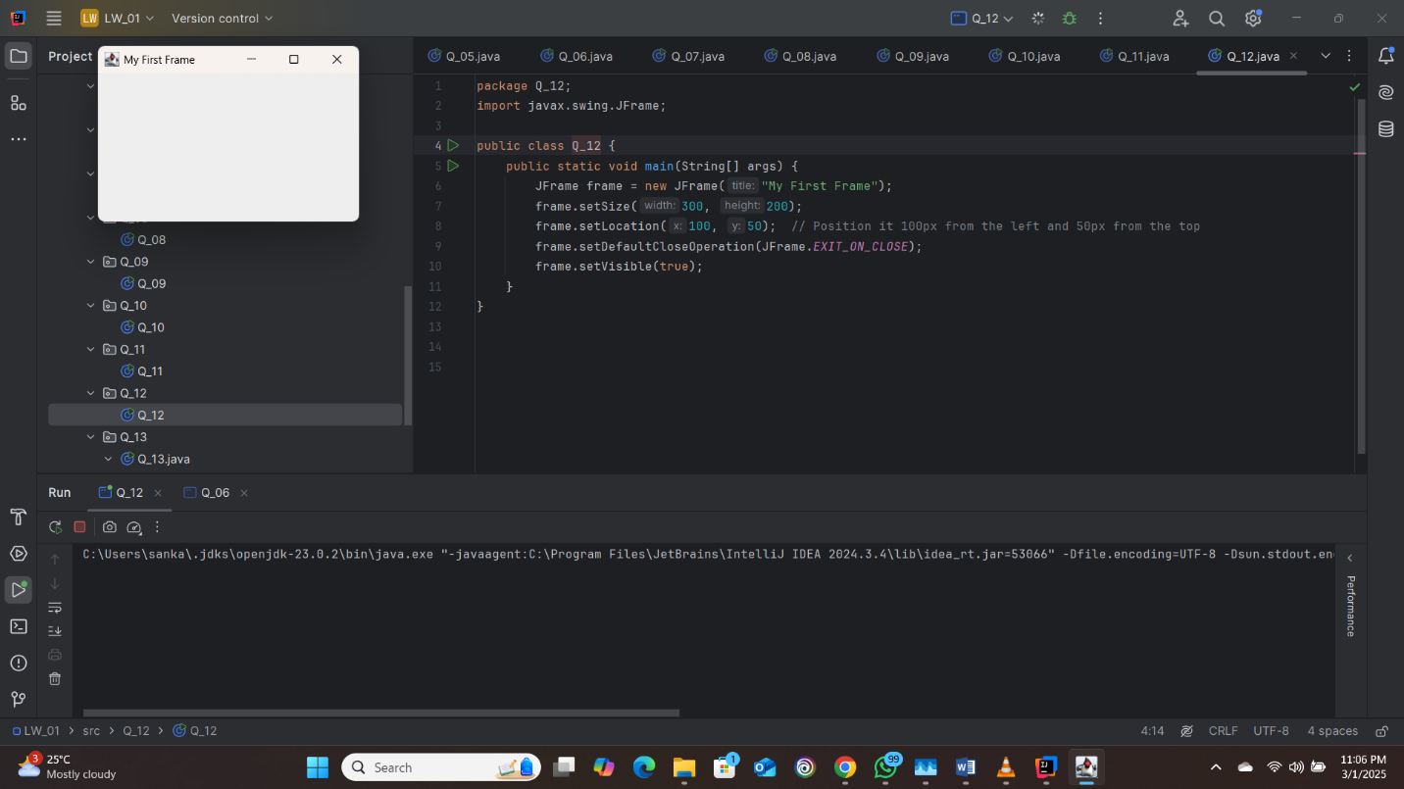

Q_13:

**What happens when this code is run:**

1. **Window Creation**: A window of size 500x250 pixels with the title "UOK" appears on the screen.
2. **Pause for 0.5 seconds**: The program pauses for half a second while the window is visible.
3. **Window Hides**: After the pause, the window disappears.
4. **Pause for 0.5 seconds**: The program pauses for another 0.5 seconds while the window is hidden.
5. **Window Reappears**: The window becomes visible again.

