A.D.S.Yashodhana

CT/2021/069

LW_02

1. package Q_01;  
  
public class one {public static void main(String[] args) {  
  
 double A = 5, B = 3, C = 2;  
 double X = 4, Y = 2;  
 double radius = 5;  
  
  
 double expressionA = Math.*sqrt*(Math.*pow*(B, 2) + 4 * A * C);  
 System.*out*.println("a. Square root of B² + 4AC: " + expressionA);  
  
  
 double expressionB = Math.*sqrt*(X + 4 * Math.*pow*(Y, 3));  
 System.*out*.println("b. Square root of X + 4Y³: " + expressionB);  
  
  
 double expressionC = Math.*cbrt*(X * Y);  
 System.*out*.println("c. Cube root of XY: " + expressionC);  
  
  
 double area = Math.*PI* * Math.*pow*(radius, 2);  
 System.*out*.println("d. Area of circle with radius " + radius + ": " + area);  
}  
}

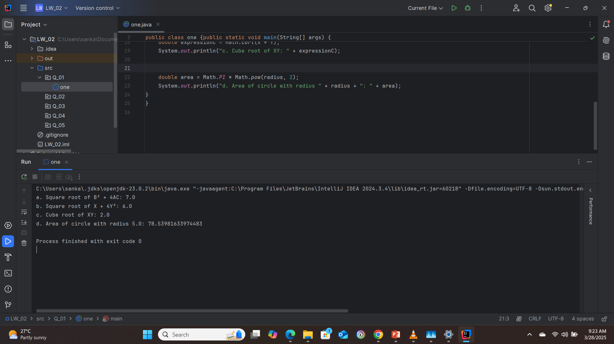

2. package Q_02;  
import java.util.Scanner;  
  
public class two {public static void main(String[] args) {  
 Scanner scanner = new Scanner(System.*in*);  
  
 System.*out*.print("Enter length in centimeters: ");  
 double centimeters = scanner.nextDouble();  
  
  
 double inches = centimeters / 2.54;  
  
  
 int feet = (int) (inches / 12);  
 double remainingInches = inches % 12;  
  
 System.*out*.printf("%.2f cm = %d feet %.2f inches%n", centimeters, feet, remainingInches);  
}  
}

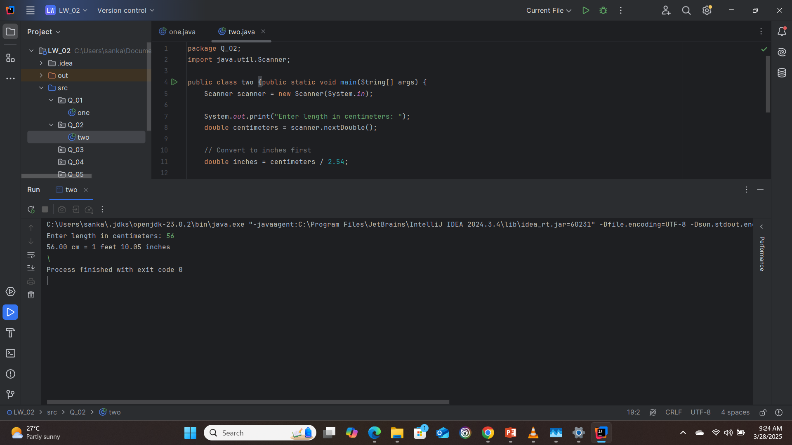

3. package Q_03;  
  
import java.util.Scanner;  
  
public class three {public static void main(String[] args) {  
 Scanner scanner = new Scanner(System.*in*);  
  
 System.*out*.print("Enter temperature in Celsius: ");  
 double celsius = scanner.nextDouble();  
  
 double fahrenheit = (1.8 * celsius) + 32;  
  
 System.*out*.printf("%.2f°C = %.2f°F%n", celsius, fahrenheit);  
}  
}

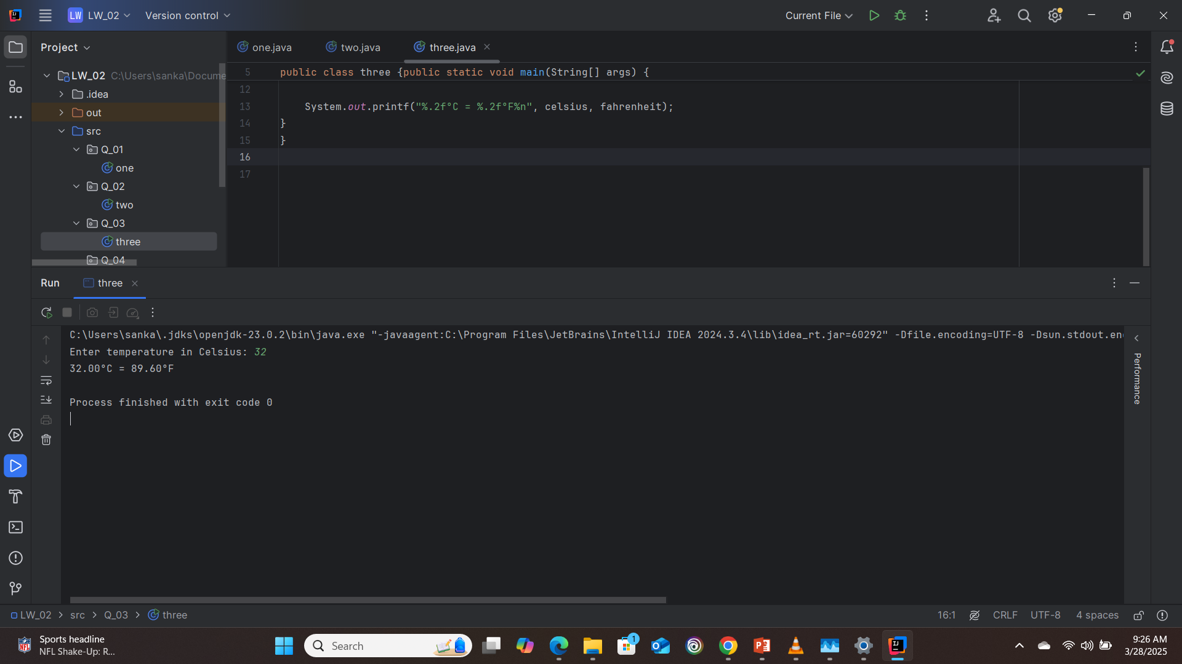

4. package Q_04;  
import java.util.Scanner;  
public class four {public static void main(String[] args) {  
 Scanner scanner = new Scanner(System.*in*);  
  
 System.*out*.print("Enter your weight in pounds: ");  
 double weight = scanner.nextDouble();  
  
 double calories = weight * 19;  
  
 System.*out*.printf("You need %.2f calories per day.%n", calories);  
}  
}

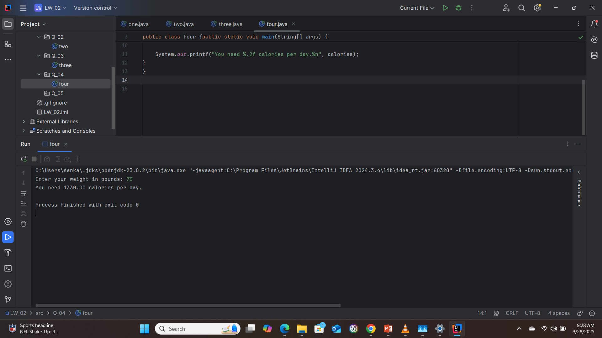

5. package Q_05;  
import java.util.Scanner;  
public class five {public static void main(String[] args) {  
 Scanner scanner = new Scanner(System.*in*);  
  
 System.*out*.print("Enter temperature in Fahrenheit: ");  
 double fahrenheit = scanner.nextDouble();  
  
 double celsius = (5.0 / 9.0) * (fahrenheit - 32);  
  
 System.*out*.printf("%.2f°F = %.2f°C%n", fahrenheit, celsius);  
}  
}

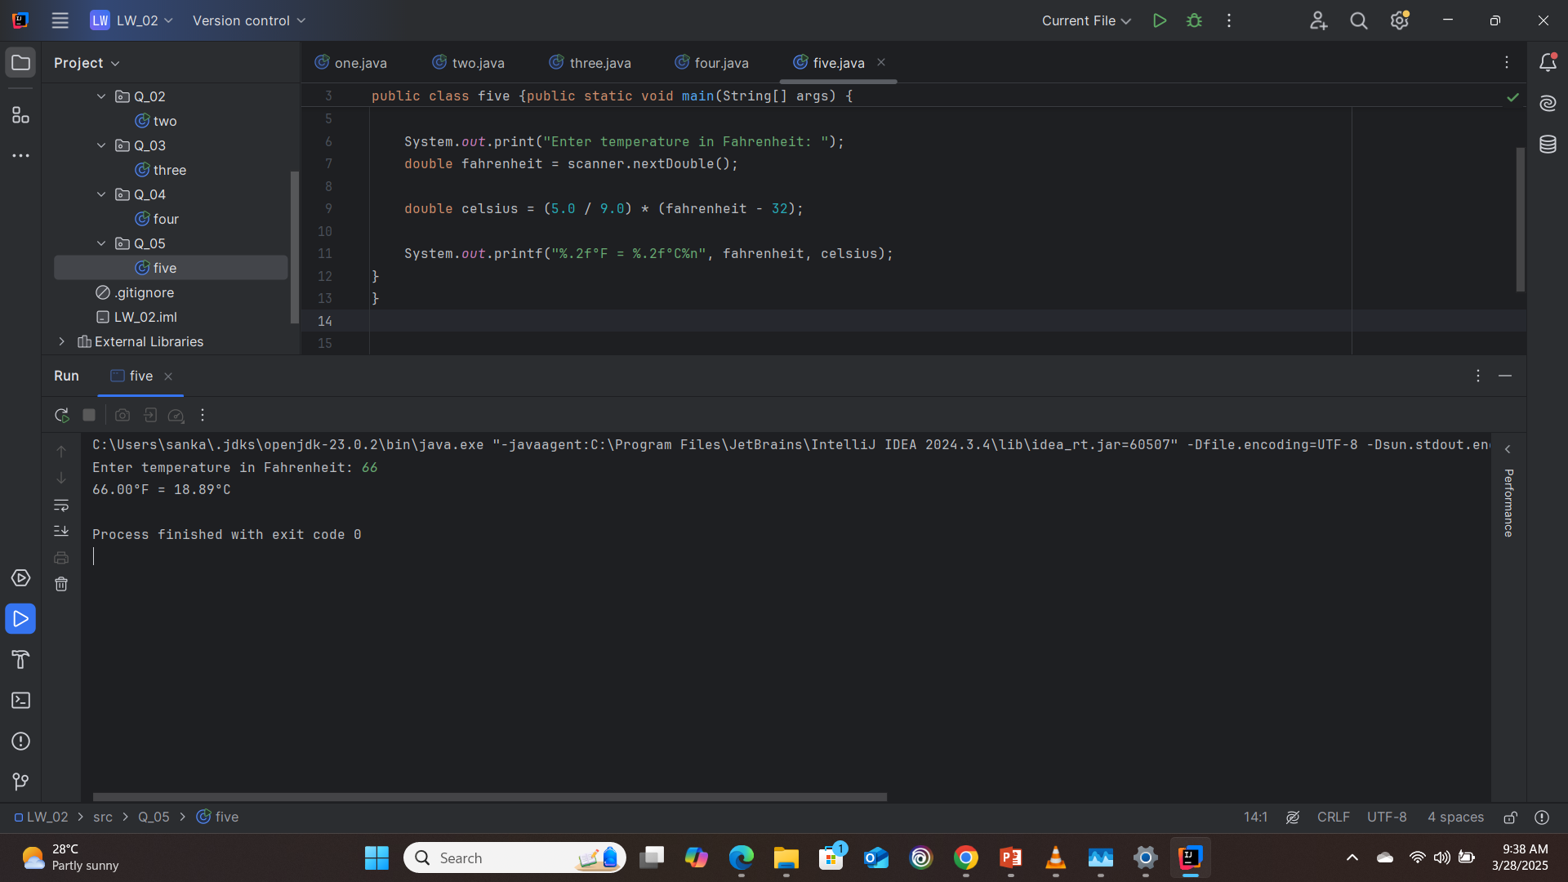

6. package Q_06;  
import java.util.Scanner;  
public class six {public static void main(String[] args) {  
 Scanner scanner = new Scanner(System.*in*);  
 int currentYear = java.time.Year.*now*().getValue();  
  
 System.*out*.print("Enter your birth year: ");  
 int birthYear = scanner.nextInt();  
  
 int age = currentYear - birthYear;  
  
 System.*out*.printf("You were born in %d and will be (are) %d this year.%n",  
 birthYear, age);  
}  
}

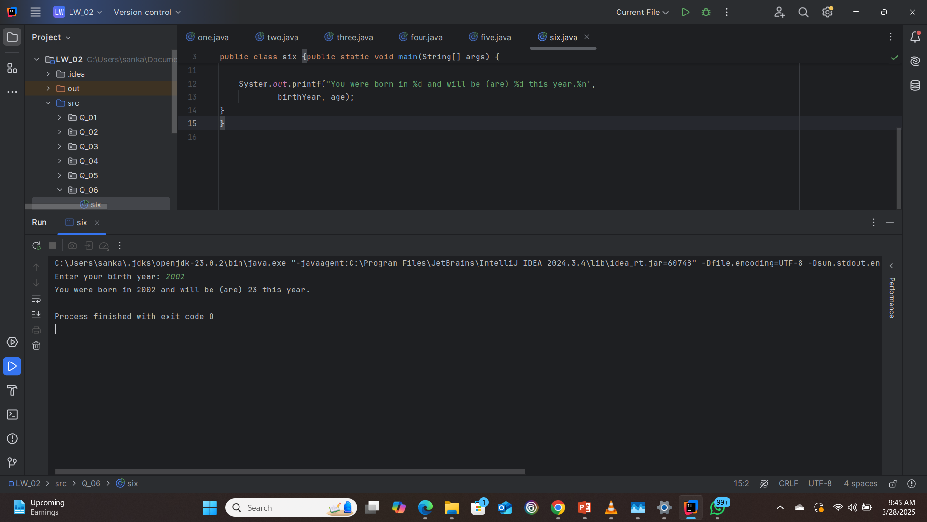

7. package Q_07;  
import java.util.Scanner;  
public class seven {public static void main(String[] args) {  
 Scanner scanner = new Scanner(System.*in*);  
  
 System.*out*.print("Enter your weight in kilograms: ");  
 int weight = scanner.nextInt();  
  
 System.*out*.print("Enter your height in centimeters: ");  
 int height = scanner.nextInt();  
  
 double bmi = weight / Math.*pow*(height / 100.0, 2);  
  
 System.*out*.printf("Your BMI is: %.2f%n", bmi);  
  
 if (bmi >= 20 && bmi <= 25) {  
 System.*out*.println("This is considered normal.");  
 } else if (bmi < 20) {  
 System.*out*.println("This is considered underweight.");  
 } else {  
 System.*out*.println("This is considered overweight.");  
 }  
}  
}

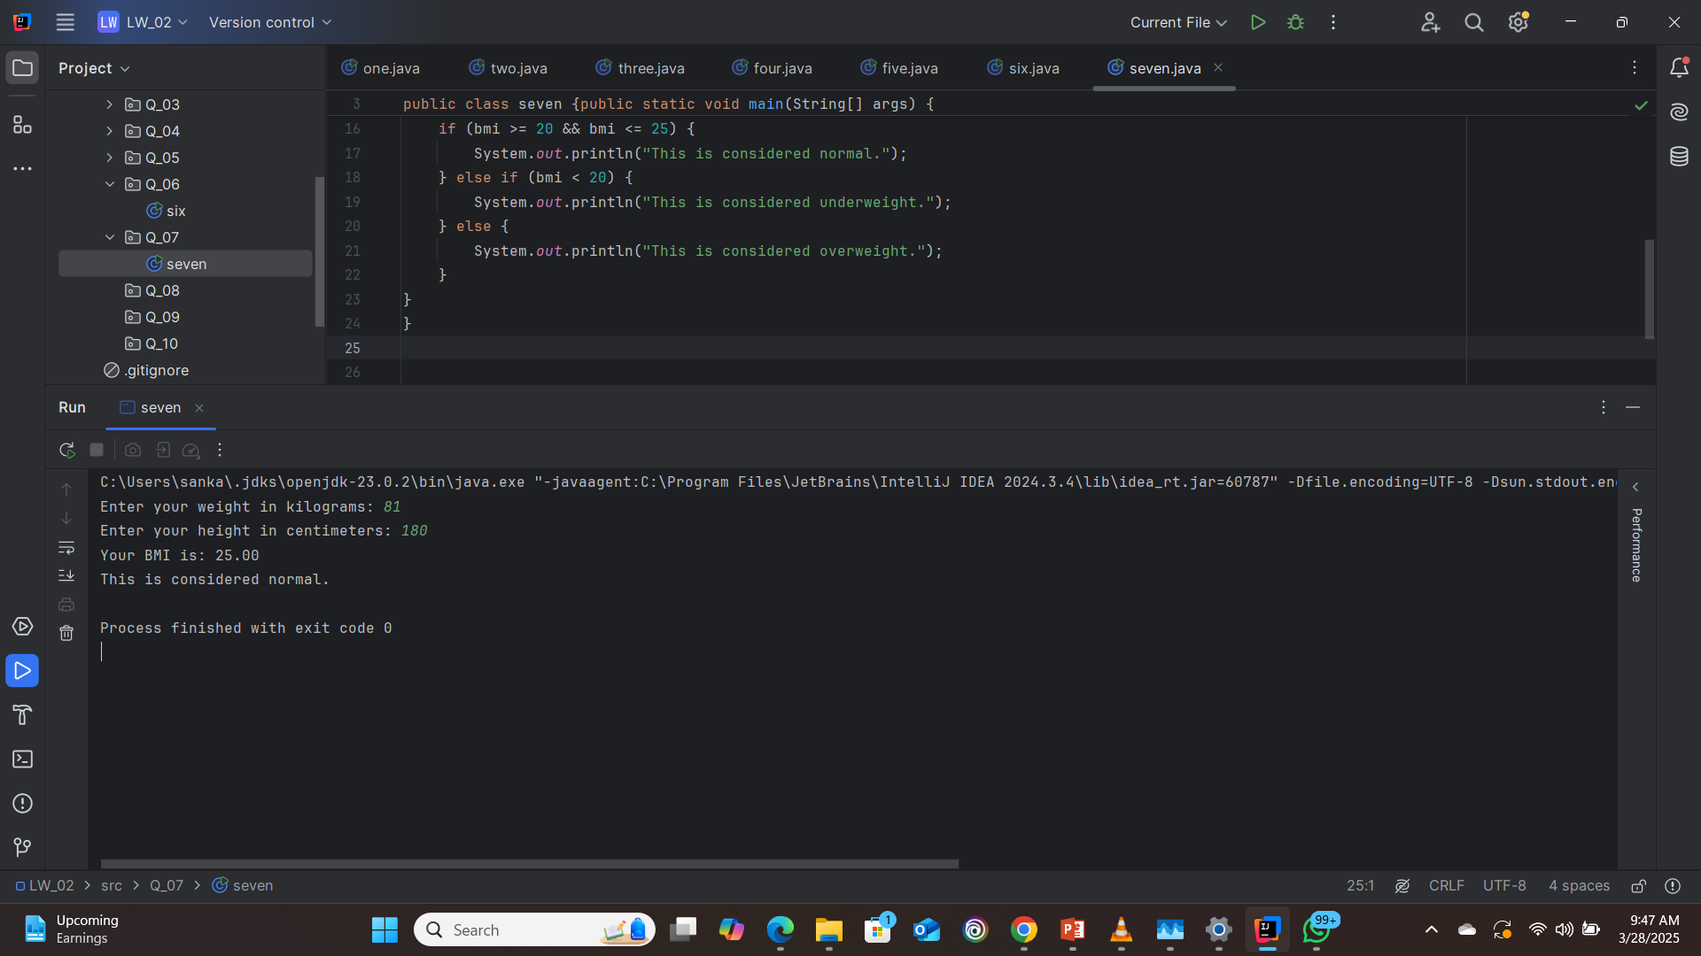

8. package Q_08;  
import java.util.Scanner;  
public class eight {public static void main(String[] args) {  
 Scanner scanner = new Scanner(System.*in*);  
 final double PI = 3.14;  
  
 System.*out*.print("Enter the radius of the sphere: ");  
 double radius = scanner.nextDouble();  
  
 double volume = (4.0 / 3.0) * PI * Math.*pow*(radius, 3);  
  
 System.*out*.printf("The volume of the sphere with radius %.2f is %.2f%n",  
 radius, volume);  
}  
}

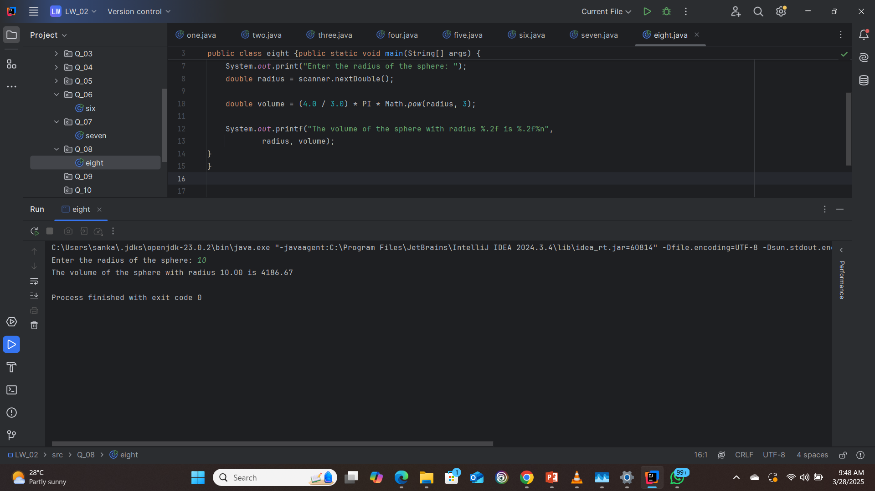

9. package Q_09;  
import java.util.Scanner;  
public class nine { public static void main(String[] args) {  
 Scanner scanner = new Scanner(System.*in*);  
  
 System.*out*.print("Enter principal amount (P): ");  
 double principal = scanner.nextDouble();  
  
 System.*out*.print("Enter annual interest rate (R): ");  
 double rate = scanner.nextDouble();  
  
 System.*out*.print("Enter number of years (N): ");  
 int years = scanner.nextInt();  
  
 double amount = principal * Math.*pow*(1 + (rate / 100), years);  
  
 System.*out*.printf("After %d years at %.2f%% interest, your investment will grow to $%.2f%n",  
 years, rate, amount);  
}  
}

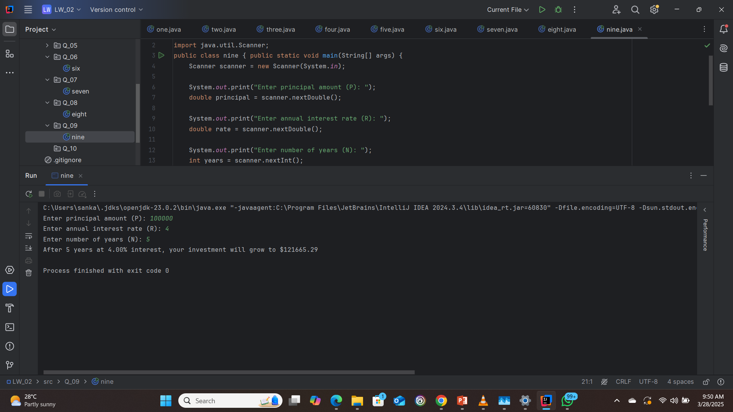

10. package Q_10;  
import java.util.Scanner;  
public class ten {public static void main(String[] args) {  
 final int MONTHS_IN_YEAR = 12;  
 Scanner scanner = new Scanner(System.*in*);  
  
 System.*out*.print("Enter loan amount: ");  
 double loanAmount = scanner.nextDouble();  
  
 System.*out*.print("Enter annual interest rate (%): ");  
 double annualInterestRate = scanner.nextDouble();  
  
 System.*out*.print("Enter loan period in years: ");  
 int loanPeriod = scanner.nextInt();  
  
 double monthlyInterestRate = annualInterestRate / 100.0 / MONTHS_IN_YEAR;  
 int numberOfPayments = loanPeriod * MONTHS_IN_YEAR;  
  
 double monthlyPayment = (loanAmount * monthlyInterestRate) /  
 (1 - Math.*pow*(1/(1 + monthlyInterestRate), numberOfPayments));  
 double totalPayment = monthlyPayment * numberOfPayments;  
  
 System.*out*.printf("Monthly payment: $%.2f%n", monthlyPayment);  
 System.*out*.printf("Total payment: $%.2f%n", totalPayment);  
}  
}

