1)

package Q_01;  
  
import java.util.Scanner;  
  
class Temperature {  
 private double celsius;  
  
  
 public Temperature() {  
 this.celsius = 0.0;  
 }  
  
  
 public Temperature(double celsius) {  
 this.celsius = celsius;  
 }  
  
  
 public double toCelsius() {  
 return celsius;  
 }  
  
  
 public double toFahrenheit() {  
 return celsius * 9 / 5 + 32;  
 }  
  
  
 public void setCelsius(double celsius) {  
 this.celsius = celsius;  
 }  
  
  
 public void setFahrenheit(double fahrenheit) {  
 this.celsius = (fahrenheit - 32) * 5 / 9;  
 }  
}  
public class one {  
 public static void main(String[] args) {  
 Scanner scanner = new Scanner(System.*in*);  
  
 System.*out*.print("Enter temperature in Celsius: ");  
 double celsiusInput = scanner.nextDouble();  
  
 Temperature temp = new Temperature(celsiusInput);  
 System.*out*.printf("%.2f°C is %.2f°F\n", temp.toCelsius(), temp.toFahrenheit());  
  
 scanner.close();  
 }  
}

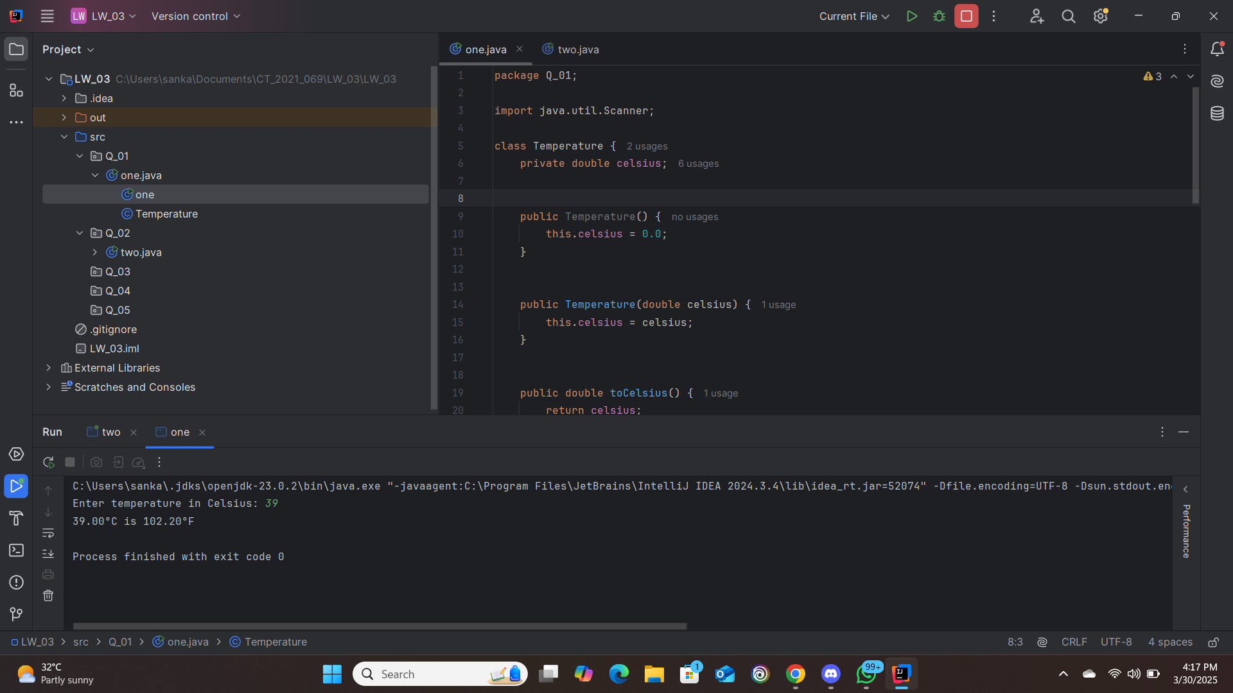

2)

package Q_02;  
import java.util.Scanner;  
class Temperature {  
 private double celsius;  
  
  
 public Temperature() {  
 this.celsius = 0.0;  
 }  
  
  
 public Temperature(double celsius) {  
 this.celsius = celsius;  
 }  
  
  
 public double toCelsius() {  
 return celsius;  
 }  
  
  
 public double toFahrenheit() {  
 return celsius * 9 / 5 + 32;  
 }  
  
  
 public void setCelsius(double celsius) {  
 this.celsius = celsius;  
 }  
  
  
 public void setFahrenheit(double fahrenheit) {  
 this.celsius = (fahrenheit - 32) * 5 / 9;  
 }  
}  
public class two {  
 public static void main(String[] args) {  
 Scanner scanner = new Scanner(System.*in*);  
  
 System.*out*.print("Enter temperature in Fahrenheit: ");  
 double fahrenheitInput = scanner.nextDouble();  
  
 Temperature temp = new Temperature();  
 temp.setFahrenheit(fahrenheitInput);  
 System.*out*.printf("%.2f°F is %.2f°C\n", fahrenheitInput, temp.toCelsius());  
  
 scanner.close();  
 }  
}

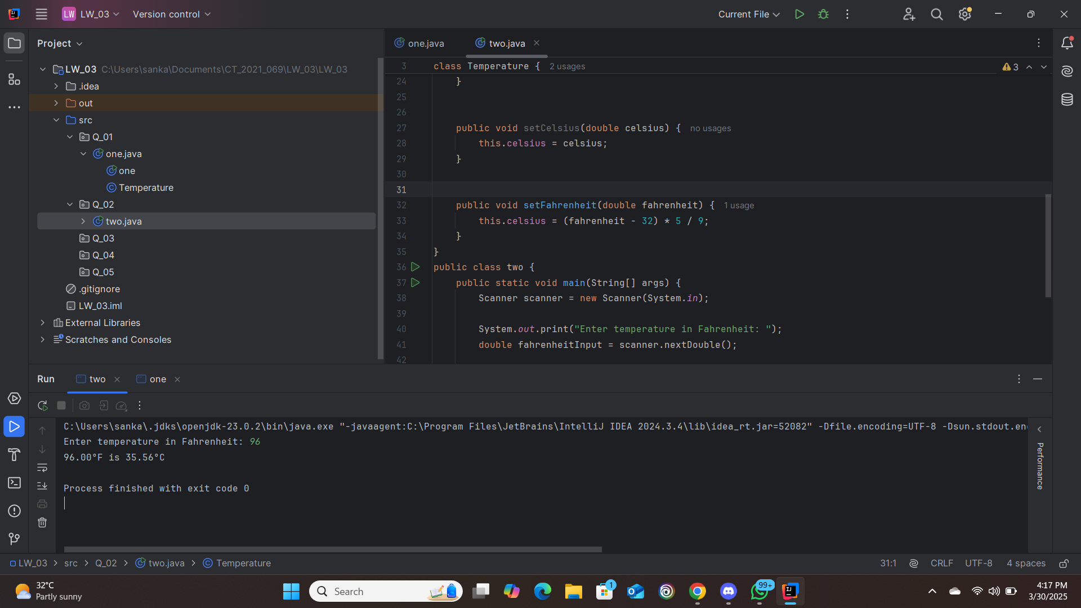

3)

package Q_03;  
import java.util.Scanner;  
class Circle {  
 private double radius;  
  
  
 public Circle() {  
 this.radius = 0.0;  
 }  
  
  
 public Circle(double radius) {  
 this.radius = radius;  
 }  
  
  
 public void setRadius(double radius) {  
 this.radius = radius;  
 }  
  
  
 public double computeArea() {  
 return Math.*PI* * radius * radius;  
 }  
  
  
 public double computeCircumference() {  
 return 2 * Math.*PI* * radius;  
 }  
}  
public class three {  
 public static void main(String[] args) {  
 Scanner scanner = new Scanner(System.*in*);  
  
 System.*out*.print("Enter inner radius (ri): ");  
 double ri = scanner.nextDouble();  
  
 System.*out*.print("Enter outer radius (ro): ");  
 double ro = scanner.nextDouble();  
  
 Circle innerCircle = new Circle(ri);  
 Circle outerCircle = new Circle(ro);  
  
 double shadedArea = outerCircle.computeArea() - innerCircle.computeArea();  
 System.*out*.printf("Area of the circular region: %.2f\n", shadedArea);  
  
 scanner.close();  
 }  
}

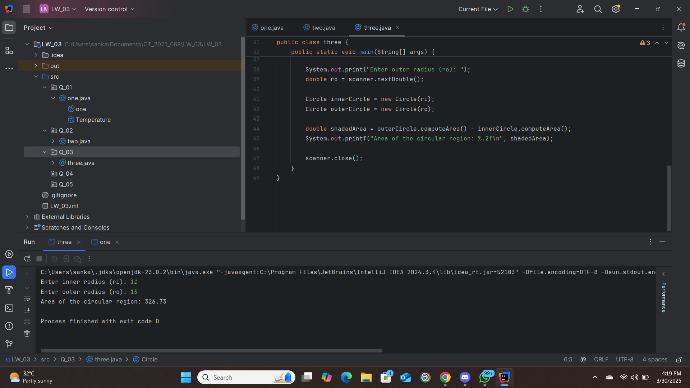

4)

package Q_04;  
class Owner {  
 private String ownerName;  
 private String phoneNo;  
  
 // Constructors  
 public Owner() {  
 this.ownerName = "Unknown";  
 this.phoneNo = "";  
 }  
  
 public Owner(String name, String num) {  
 this.ownerName = name;  
 this.phoneNo = num;  
 }  
  
 // Getters and Setters  
 public String getOwnerName() {  
 return ownerName;  
 }  
  
 public void setOwnerName(String name) {  
 this.ownerName = name;  
 }  
  
 public String getPhoneNo() {  
 return phoneNo;  
 }  
  
 public void setPhoneNo(String num) {  
 this.phoneNo = num;  
 }  
}  
class Bicycle {  
  
 private Owner owner;  
  
 // Constructors  
 public Bicycle() {  
 this.owner = new Owner();  
 }  
  
 public Bicycle(String name, String num) {  
 this.owner = new Owner(name, num);  
 }  
  
  
 public String getOwnerName() {  
 return owner.getOwnerName();  
 }  
  
  
 public void setOwnerName(String name) {  
 owner.setOwnerName(name);  
 }  
  
 public String getPhoneNo() {  
 return owner.getPhoneNo();  
 }  
  
  
 public void setPhoneNo(String num) {  
 owner.setPhoneNo(num);  
 }  
  
  
 public Owner getOwner() {  
 return owner;  
 }  
  
 public void setOwner(Owner owner) {  
 this.owner = owner;  
 }  
}  
public class four {  
 public static void main(String[] args) {  
  
 Bicycle bike1 = new Bicycle();  
 System.*out*.println("Bike1 Owner: " + bike1.getOwnerName());  
 System.*out*.println("Bike1 Phone: " + bike1.getPhoneNo());  
  
  
 Bicycle bike2 = new Bicycle("John Doe", "123-456-7890");  
 System.*out*.println("Bike2 Owner: " + bike2.getOwnerName());  
 System.*out*.println("Bike2 Phone: " + bike2.getPhoneNo());  
  
  
 Owner owner = new Owner("Jane Smith", "987-654-3210");  
 Bicycle bike3 = new Bicycle();  
 bike3.setOwner(owner);  
 System.*out*.println("Bike3 Owner: " + bike3.getOwnerName());  
 System.*out*.println("Bike3 Phone: " + bike3.getPhoneNo());  
 }  
}

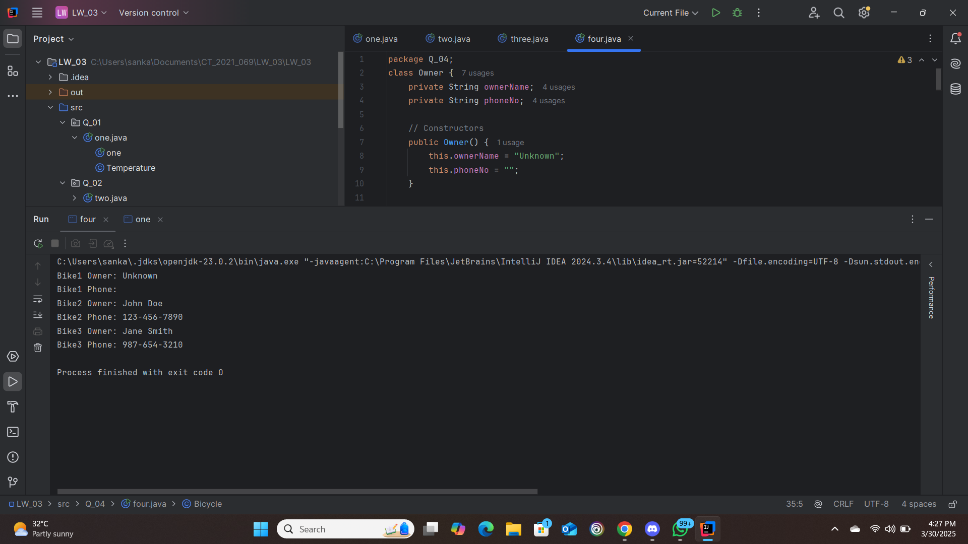

5)

package Q_05;  
  
  
class Course {  
 private String courseName;  
 private String courseCode;  
 private Lecturer lecturer;  
  
  
 public Course(String courseName, String courseCode) {  
 this.courseName = courseName;  
 this.courseCode = courseCode;  
 }  
  
  
 public String getCourseName() {  
 return courseName;  
 }  
  
 public void setCourseName(String courseName) {  
 this.courseName = courseName;  
 }  
  
 public String getCourseCode() {  
 return courseCode;  
 }  
  
 public void setCourseCode(String courseCode) {  
 this.courseCode = courseCode;  
 }  
  
 public Lecturer getLecturer() {  
 return lecturer;  
 }  
  
 public void setLecturer(Lecturer lecturer) {  
 this.lecturer = lecturer;  
 }  
}  
  
  
class Lecturer {  
 private String lecturerName;  
 private String courseTeaching;  
  
 // Constructor  
 public Lecturer(String lecturerName, String courseTeaching) {  
 this.lecturerName = lecturerName;  
 this.courseTeaching = courseTeaching;  
 }  
  
  
 public String getLecturerName() {  
 return lecturerName;  
 }  
  
 public void setLecturerName(String lecturerName) {  
 this.lecturerName = lecturerName;  
 }  
  
 public String getCourseTeaching() {  
 return courseTeaching;  
 }  
  
 public void setCourseTeaching(String courseTeaching) {  
 this.courseTeaching = courseTeaching;  
 }  
}  
  
  
class Student {  
 private String studentName;  
 private String degreeName;  
 private String courseFollowing;  
  
  
 public Student(String studentName, String degreeName) {  
 this.studentName = studentName;  
 this.degreeName = degreeName;  
 }  
  
  
 public String getStudentName() {  
 return studentName;  
 }  
  
 public void setStudentName(String studentName) {  
 this.studentName = studentName;  
 }  
  
 public String getDegreeName() {  
 return degreeName;  
 }  
  
 public void setDegreeName(String degreeName) {  
 this.degreeName = degreeName;  
 }  
  
 public String getCourseFollowing() {  
 return courseFollowing;  
 }  
  
 public void setCourseFollowing(String courseFollowing) {  
 this.courseFollowing = courseFollowing;  
 }  
}  
  
  
public class five {  
 public static void main(String[] args) {  
  
 Lecturer lecturer = new Lecturer("Dr. Smith", "Computer Science 101");  
  
  
 Course course = new Course("Computer Science 101", "CS101");  
 course.setLecturer(lecturer);  
  
  
 Student student1 = new Student("Alice Johnson", "Computer Science");  
 student1.setCourseFollowing(course.getCourseName());  
  
 Student student2 = new Student("Bob Williams", "Computer Science");  
 student2.setCourseFollowing(course.getCourseName());  
  
  
 System.*out*.println("=== Course Registration System ===");  
 System.*out*.println("\nCourse Information:");  
 System.*out*.println("Course Name: " + course.getCourseName());  
 System.*out*.println("Course Code: " + course.getCourseCode());  
 System.*out*.println("Lecturer: " + course.getLecturer().getLecturerName());  
  
 System.*out*.println("\nRegistered Students:");  
 System.*out*.println("1. " + student1.getStudentName() +  
 " (" + student1.getDegreeName() + ") - " +  
 student1.getCourseFollowing());  
 System.*out*.println("2. " + student2.getStudentName() +  
 " (" + student2.getDegreeName() + ") - " +  
 student2.getCourseFollowing());  
 }  
}

