**TITLE OF THE PROJECT**

CAR DEALERSHIP

MINI PROJECT REPORT

Submitted in partial fulfilment of the

requirements for the award of the degree of

**BACHELOR OF ENGINEERING**

IN

**INFORMATION TECHNOLOGY**

By

<D. Sankalp ><1602-19-737-038>

<P. Avanish Reddy >< 1602-19-737-006>



**Department of Information Technology**

**Vasavi College of Engineering (Autonomous)**

**(Affiliated to Osmania University)**

**Ibrahimbagh, Hyderabad - 31**

**VASAVI COLLEGE OF ENGINEERING(AUTONOMOUS)**

**(AFFILIATED TO OSMANIA UNIVERSITY)**

**HYDERABAD - 500 030**

**Department of Information Technology**



**DECLARATION BY CANDIDATE**

We, < D. Sankalp >, < P. Avanish Reddy >, bearing hall ticket number, **<**1602-19-737-038**>**, <1602-19-737-006> hereby declare that the project report entitled **<**” CAR DEALERSHIP”**>**

Department of Information Technology, Vasavi College of

Engineering, Hyderabad, is submitted in partial fulfillment of the

requirement for the award of the degree of **Bachelor of**

**Engineering** in **Information Technology**

This is a record of bonafide work carried out by me and the

results embodied in this project report has not been submitted to

any other university or institute for the award of any other degree

or diploma.

**< D. SANKALP >**

**<1602-19-737-038>**

**< P. AVANISH REDDY >**

**<1602-19-737-006>**

ACKNOWLEDGEMENT:

It gives us immense pleasure to thank the department of INFORMATION TECHNOLOGY, for introducing the subject “mini project” in BE third semester that let us learn and explore more features in “C programming language”.

I would also like to show my appreciation to our honourable principal, Dr S V RAMANA sir and HOD Dr Ram Mohan Rao sir, for supporting us and our beloved mini project lecturer, Mrs LEELAVATHI mam, for letting us properly understand the process of doing the mini project using c and for providing insight and expertise that greatly assisted the project.

My parents were my first teachers and they have provided me with such a great exposure that has helped me bloom. My family and friends will always be loved for sticking by me through thick and thin.

THANK YOU!

ABSTRACT:

The car dealership program helps the customer select which type of car he wants. This includes new cars and used cars. Customer can see the manufacturer, the model and specifications of the car. It will also sort the cars according to the customer’s interest. The customer can also lease cars and even sell his own car. The owner can change the prices of the cars, add new cars, remove old cars. There is also a feature of ordering cars which are not currently available. The customer can also check between various models and colors of a specific car. An option to take an insurance is also present when a car is bought. If a customer wants to buy or sell or order or lease a car his address proof and other personal information is collect.

INTRODUCTION:

This project deals with the following:

The car dealership program helps the customer select which type of car he wants. This includes new cars and used cars. Customer can see the manufacturer, the model and specifications of the car. It will also sort the cars according to the customer’s interest. The customer can also lease cars and even sell his own car. The owner can change the prices of the cars, add new cars, remove old cars. There is also a feature of ordering cars which are not currently available. The customer can also check between various models and colors of a specific car. An option to take an insurance is also present when a car is bought. If a customer wants to buy or sell or order or lease a car his address proof and other personal information is collected.

In real time it helps both manager and customer. For manager it helps him/her to keep a record of there selling the cars and many things, this helps them to keep them track of management quality by keeping a track of the ups and downs in sales in regular intervals

TECHNOLOGY

To implement any project successfully, there will be technological requirements which can either be software or hardware requirements.

1. Software requirements:

Since our project was supposed to be based on the C programming language, it is a bare necessity to have the knowledge and syntaxes of the language and a proper compiler and text editor to run and write the programs.

Compiler: Some of the many C compilers include:

1. Borland turbo C
2. Tiny C compiler
3. Portable C compiler
4. GCC compiler
5. Clang

Among the many available compilers, we have installed and used the GCC compiler to run/execute the code for “CAR DEALERSHIP” that we have written.

Text editor:

To actually write and complete a code in any language, a text editor is important. Some of the famous text editors are:

1. Vim editor
2. Notepad
3. Notepad++

Although these are some famous ones, we have installed ad made use of a text editor called Sublime Text. Around 500 lines of the source code for “CAR DEALERSHIP” implementation in C has been written there.

1. Hardware requirements:

Personal computer or a laptop (preferably windows version over Linux or mac).

DESIGN:

USE CASE DIAGRAM :

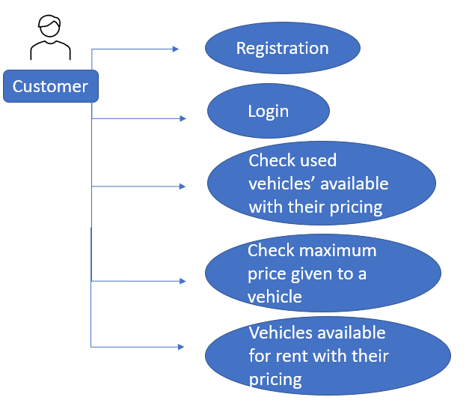

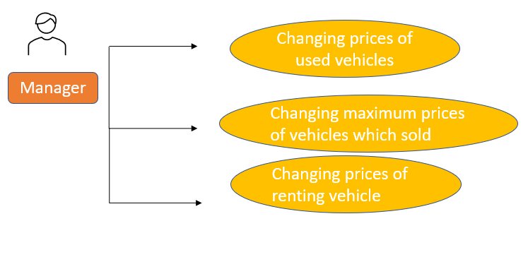

IMPLEMENTATION:

When a customer enters the application, he is presented with two options, namely login and register.

If the customer is a new customer who hasn’t been to the dealership before, he will have to register as a new user.

If the customer is familiar with the dealership, ze will be asked to login by entering the appropriate password.

Once the user logs in successfully, ze will be presented with the below mentioned options:

1. To see the list of used cars

2. To sell your car

3. Leasing cars details

4. If you want to return your car

5. Exit

Depending on the customer’s choice each module will run accordingly.

To implement the above-mentioned modules and menu, we have used the following techniques and approaches in C language:

1. File handling.
2. Deleting one line from a file.
3. Appending new line to that.
4. Used switch cases for edge-cases and menu.
5. Operations on arrays.

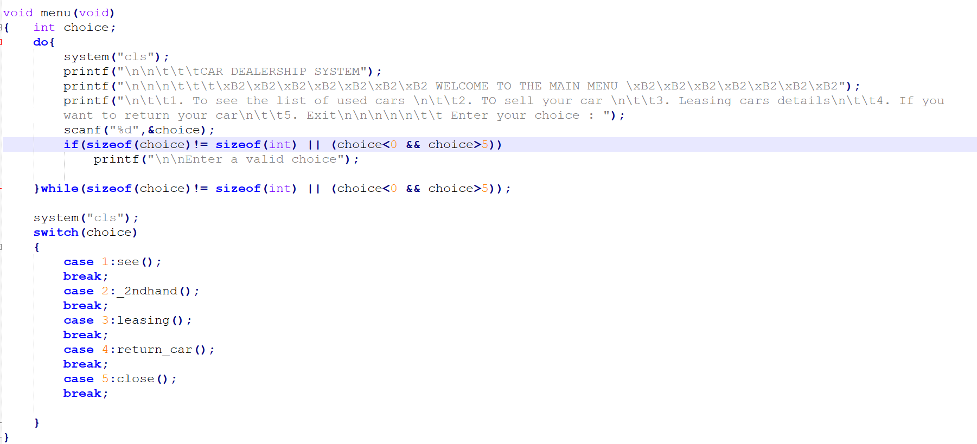

SOURCE CODE:

#include<stdio.h>

#include<stdlib.h>

#include<windows.h>

int i,j;

int main_exit;

void menu();

char kvp[40];

struct user

{

char name[30];

char password[30];

long int aadhar;

}t1;

void registration();

void login();

char fname[]={"mydatabase.txt"};

void registration()

{

FILE *fp;

struct user t1;

int g;

fp=fopen(fname,"a");

printf("\n\n\t\t\tPLEASE ENTER THE FOLLOWING DETAILS TO REGISTER !!");

printf("\n\nENTER USERNAME : ");

scanf("%s",t1.name);

printf("\n\nENTER PASSWORD : ");

scanf("%s",t1.password);

printf("\n\nENTER AADHAR NUMBER : ");

scanf("%ld", &t1.aadhar);

fwrite(&t1,sizeof(t1),1,fp);

fclose(fp);

printf("\n\n\t\t\tYou have successfully registered");

priyu:

printf("\n\t\t\tIf you want to login give 1\n\t\t\tIf you want to exit press 0\n\t\t\t: ");

scanf("%d",&g);

if(g==1)

{

login();

}

else if(g==0)

close();

else

{ printf("\n\t\t\tInvalid input please enter again : ");

goto priyu;

}

}

void login()

{

FILE *fp;

struct user t1;

char uname[20],pass[20];

int found=0,i;

sri:

printf("\n\n\t\t\tENTER YOUR LOGIN CREDENTIALS !!");

fp=fopen(fname,"rb");

printf("\n\n\n ENTER USERNAME: ");

scanf("%s",kvp);

printf("\nENTER PASSWORD :");

scanf("%s",pass);

while(1)

{

fread(&t1,sizeof(t1),1,fp);

if(feof(fp))

{

break;

}

if((strcmp(t1.name,kvp)==0) && (strcmp(t1.password,pass)==0))

{

found=1;

printf("\n\n\n========================================================\n\n");

printf("\n\n\t\t\tYou have logged in succesfully\n\n");

printf("\n\n\n");

menu();

}

}

if(found==0)

{

do{

printf("\n\n\t\t\tIncorrect login details\n\t\t\tIf you want to try again give 1\n\t\t\tIf you want to exit press 0");

scanf("%d",&i);

if(i==0)

close();

else if(i==1)

goto sri;

}while(!(i==1 || i==0));

}

fclose(fp);

exit(0);

}

void return_car()

{

FILE *ptr,*srh,*sri;

int t,rate,temp=1;

int choice;

float time;

float intrst;

FILE *tempFile;

char ch;

char abc[]="cars_lending1.txt";

char xyz[]="cars_lending.txt";

char pqr[]="cars_for_rent.txt";

sri=fopen(pqr,"a");

ptr=fopen(abc,"a+");

char s;

while(!feof(ptr))

{

s= fgetc(ptr);

printf("%c",s);

}

rewind(ptr);

printf("\n\n\t\t\tEnter the car number to return or 0 to go back to main menu : ");

scanf("%d",&t);

tempFile=fopen("cars_lending.txt","w");

if(t==0)

{

fclose(tempFile);

fclose(sri);

fclose(ptr);

menu();

}

else

{ char rented_car[50];

int i = 0;

while (ch != EOF)

{

ch = getc(ptr);

if (ch == '\n')

temp++;

if (temp != t)

{

putc(ch, tempFile);

}

else

{

putc(ch, sri);

}

if(temp == t)

{

rented_car[i] = ch;

i++;

}

}

rented_car[i] = '\0';

rewind(tempFile);

fseek(sri, 0, 2);

printf("\n\n\t\t\tThank you for lending our car, you will be charged accordingly\n\t\t\thave a nice day");

}

fclose(tempFile);

fclose(sri);

fclose(ptr);

remove(abc);

rename(xyz,abc);

if(t==0)

menu();

else

{

printf("\n\t\t\tEnter 1 to go to the main menu and 0 to exit:");

scanf("%d",&t);

if(t==1)

{

system("cls");

menu();

}

else

{

system("cls");

close();

}

}

}

void leasing()

{

FILE *ptr,*srh,*sri;

int t,rate,temp=1;

int choice;

float time;

float intrst;

FILE *tempFile;

char ch;

char abc[]="cars_for_rent.txt";

char xyz[]="cars_lending.txt";

char pqr[]="cars_lending1.txt";

sri=fopen(pqr,"a");

ptr=fopen(abc,"a+");

char s;

while(!feof(ptr))

{

s = fgetc(ptr);

printf("%c",s);

}

rewind(ptr);

printf("\n\nEnter the car number to lend or 0 to go back to main menu : ");

scanf("%d",&t);

system("cls");

tempFile=fopen("cars_lending.txt","w");

if(t==0)

{

fclose(tempFile);

fclose(sri);

fclose(ptr);

menu();

}

else

{

t+=3;

ch = getc(ptr);

while (ch != EOF)

{

ch = getc(ptr);

if (ch == '\n')

temp++;

if (temp != t)

{

putc(ch, tempFile);

}

else

{

putc(ch, sri);

}

}

fprintf(sri,"%s",t1.name);

rewind(tempFile);

printf("\n\n\t\t\tThank you for lending our car\n\t\t\thave a nice day");

}

fclose(tempFile);

fclose(sri);

fclose(ptr);

remove(abc);

rename(xyz,abc);

if(t==0)

menu();

else

{

printf("\n\n\t\t\tEnter 1 to go to the main menu and 0 to exit:");

scanf("%d",&main_exit);

if (main_exit==1)

{

system("cls");

menu();

}

else

{

system("cls");

close();

}

}

}

void _2ndhand()

{

FILE *sri,*our,*srh;

float k;

int i;

char h,s;

char xyz[]="damage.txt";

san:

printf("\n\nPlease tell us MRP of your car : ");

scanf("%f",&k);

k=k*(0.8);

our=fopen(xyz,"r");

printf("\n\n");

while((s=fgetc(our))!=EOF)

{

printf("%c",s);

}

printf("\n\n");

do{

printf("\nPlease select appropriate damage percentage\nIf you want give your MRP again, give 9\nIf you want to go to main menu, give 0\n\n");

scanf("%d",&i);

if(i==9 || i==0)

break;

else if(i<0 || i>5)

{

printf("\n\nPlease select valid input\1\n");

}

}while(i<0 || i>5);

if(i==9)

goto san;

else if(i==0)

{

menu();

}

switch(i)

{

case 1:

break;

case 2:k=k*(0.85);

break;

case 3:k=k*(0.75);

break;

case 4:k=k*(0.65);

break;

default:

printf("Sorry, you can't sell your car here!!");menu();break;

}

printf("We are offering %0.2f to your car\1\1",k);

printf("\n\nIf you want to sell your car give 1\nIf not press anyother key : ");

scanf(" %c",&h);

if(h=='1')

{

printf("\n\n\xB2\xB2\xB2\xB2\xB2\xB2\xB2Thank you for selling your car, have a nice day\xB2\xB2\xB2\xB2\xB2\xB2\xB2\n\n");

srh=fopen("sell_record.txt","a");

fprintf(srh," %s has sold car at %f \n",kvp,k);

fclose(srh);

}

else

{

menu();

}

}

void see(void)

{

FILE *ptr,*cs1,*sri;

int t,rate,temp=1;

int choice;

float time;

float intrst;

FILE *tempFile;

char ch;

char abc[]="cars.txt";

char xyz[]="cars_sold.txt";

char pqr[]="cars_sold1.txt";

sri=fopen(pqr,"a");

ptr=fopen(abc,"r");

char s;

while((s=fgetc(ptr))!=EOF)

{

printf("%c",s);

}

rewind(ptr);

printf("\n\nEnter the car number to buy or 0 to go back to main menu : ");

scanf("%d",&t);

system("cls");

tempFile=fopen("cars_sold.txt","w");

if(t==0)

{

system("cls");

close();

}

else

{

t+=3;

ch = getc(ptr);

while (ch != EOF)

{

ch = getc(ptr);

if (ch == '\n')

temp++;

if (temp != t)

{

putc(ch, tempFile);

}

else

{

putc(ch, sri);

}

}

rewind(tempFile);

printf("Thank you for buying car, have a nice day \1");

}

fclose(tempFile);

fclose(sri);

fclose(ptr);

remove(abc);

rename(xyz,abc);

if(t==0)

menu();

else

{

printf("\nEnter 1 to go to the main menu and 0 to exit:");

scanf("%d",&main_exit);

if (main_exit==1)

{

system("cls");

menu();

}

else

{

system("cls");

close();

}

}

}

void close(void)

{

printf("\n\n\n\n");

}

void menu(void)

{ int choice;

do{

system("cls");

printf("\n\n\t\t\tCAR DEALERSHIP SYSTEM");

printf("\n\n\n\t\t\t\xB2\xB2\xB2\xB2\xB2\xB2\xB2 WELCOME TO THE MAIN MENU \xB2\xB2\xB2\xB2\xB2\xB2\xB2");

printf("\n\t\t1. To see the list of used cars \n\t\t2. TO sell your car \n\t\t3. Leasing cars details\n\t\t4. If you want to return your car\n\t\t5. Exit\n\n\n\n\n\t\t Enter your choice : ");

scanf("%d",&choice);

if(sizeof(choice)!= sizeof(int) || (choice<0 && choice>5))

printf("\n\nEnter a valid choice");

}while(sizeof(choice)!= sizeof(int) || (choice<0 && choice>5));

system("cls");

switch(choice)

{

case 1:see();

break;

case 2:_2ndhand();

break;

case 3:leasing();

break;

case 4:return_car();

break;

case 5:close();

break;

}

}

int main()

{

//leasing();

printf("Give 1 for logging in\nGive 2 for register : ");//char pass[10],password[10]="ss";

int i;

do

{

scanf("%d",&i);

if(i==1)

{

login();

}

else if(i==2)

{

registration();

}

else

{

printf("\n\n\t\tPlease enter again\n\n");

}

}while(!(i==1 || i==2));

return 0;

}

TESTING & RESULTS:

Running and compiling:

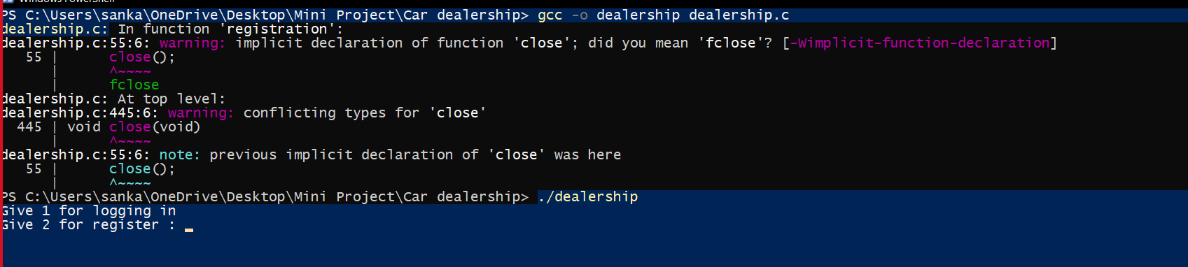

Login and register:

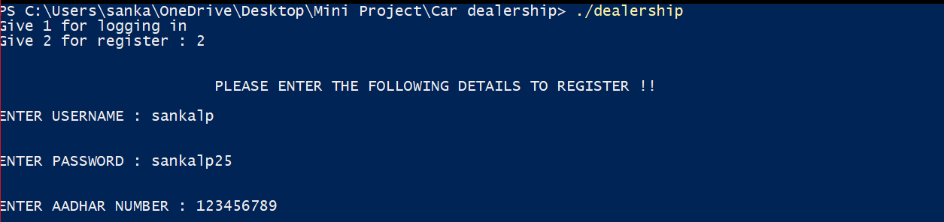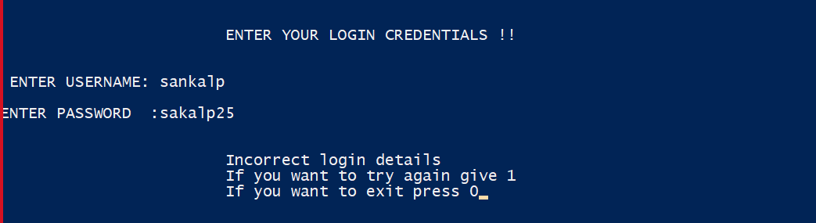

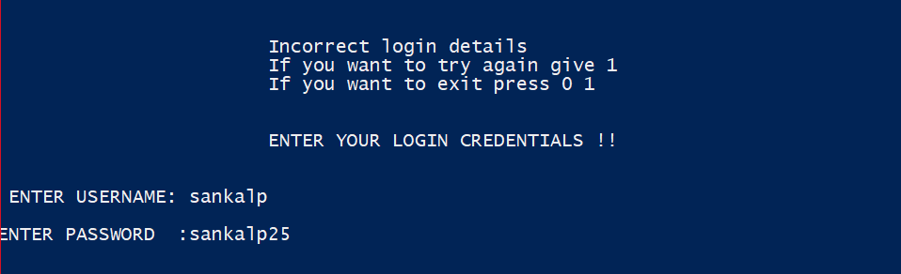

Menu:

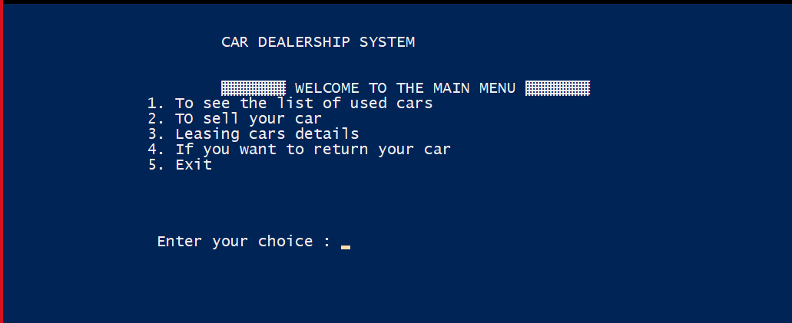

List of used cars:

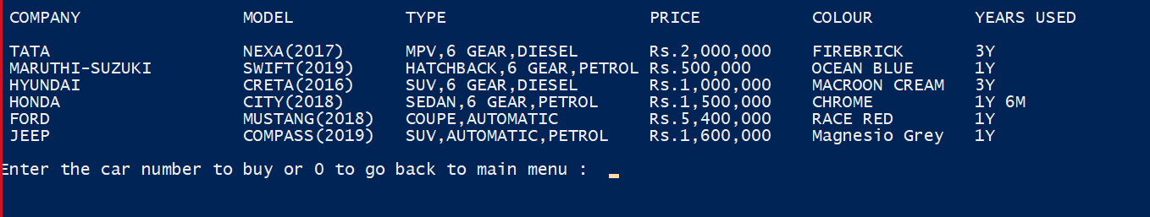

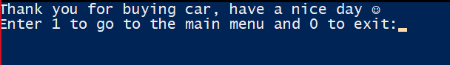

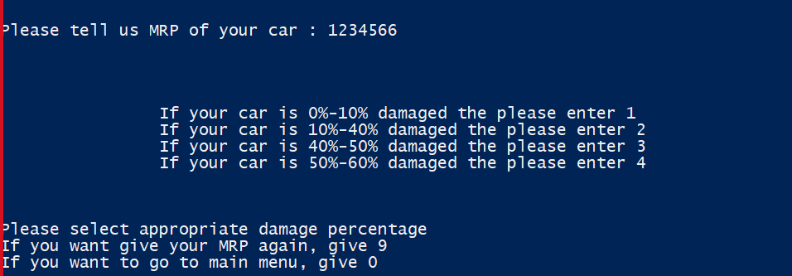

Selling car:

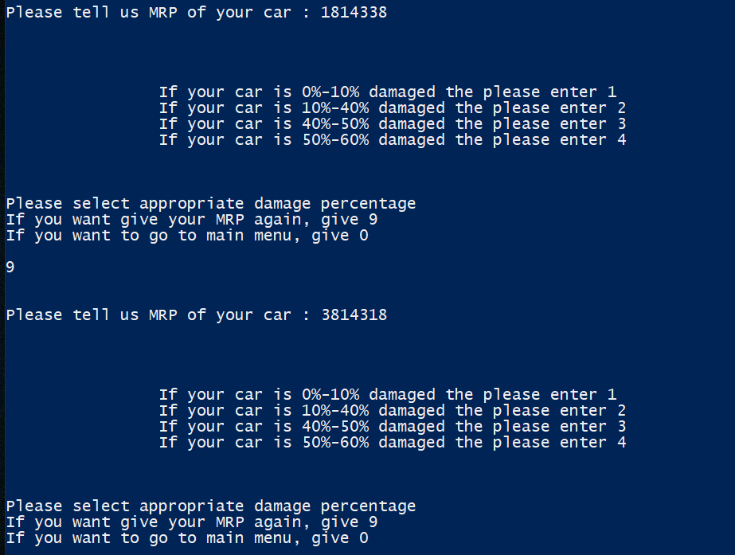

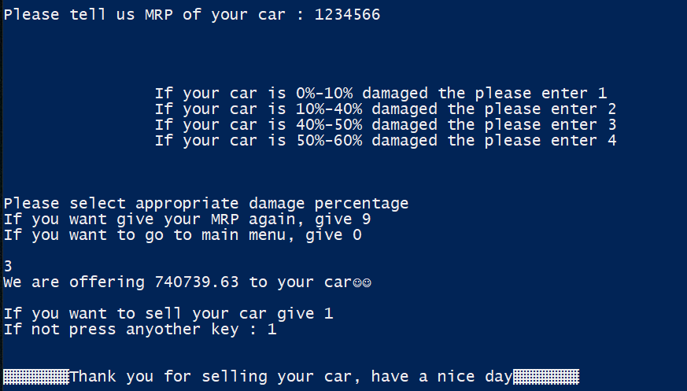

Lending cars :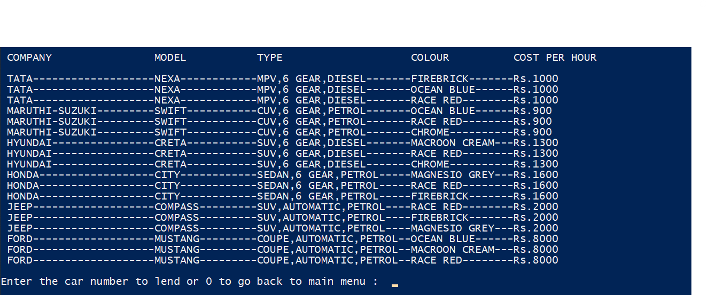

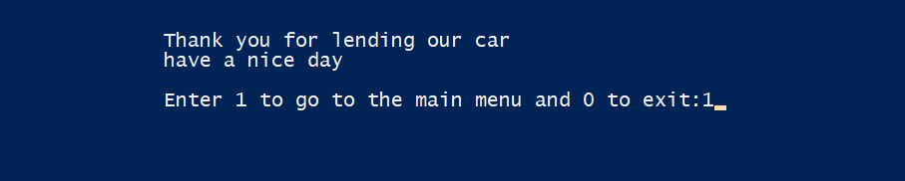

Exit

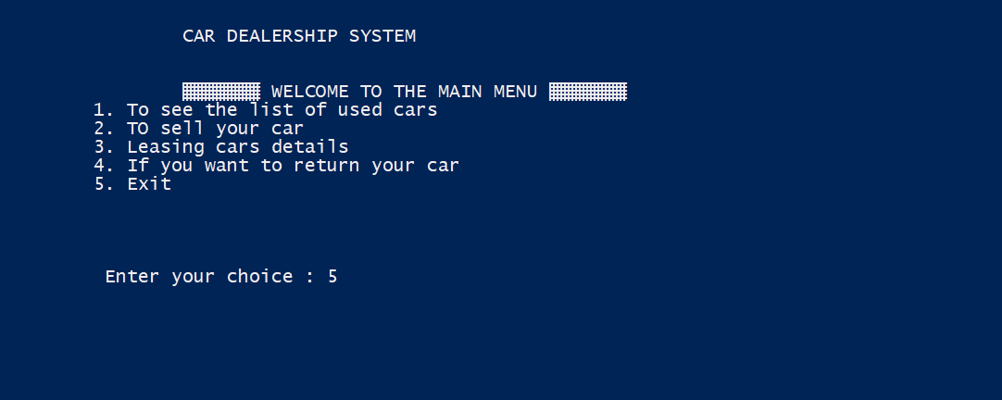

GITHUB REPOSITORY:

<https://github.com/sankalp-25/Cardealership-program>

The above mini project repository consists of the abstract, design document, source code and the report for " CAR DEALERSHIP "

ADDITIONAL LEARNINGS:

Apart from the immense understanding and practice of C language we obtained throughout the course of this project, there were many additional learnings too:

We have learned to work in a team. Each of us have different schedules but had the same goal which made us work towards it together and hence we completed it together. Doing the entire project during these uncertain times of COVID-19 was also a challenge. We spent time to coordinate through Microsoft teams and had our discussions.

We have learned to meet deadlines. Throughout these months, we successfully completed and submitted the mini project abstract, the design document, the different modules in the project and not the report too.

Thinking out of the box. We were constantly thinking about how to make this project better than the existing ones and user friendly.

DISCUSSION AND FUTURE WORK:

We plan on adding the following features in the near future.

1. Other vehicle like motorcycles trucks and other 2-wheelers, 3-wheelers and 4-weelers.
2. Insurance on vehicle that they buy from us and any other vehicle.
3. Adding all real-time cars to the data base.
4. Adding GUI to the application.
5. Proper-Safer-Billing experience.

REFERENCES:

1. https://www.w3resource.com/c-programming-exercises/file-handling/c-file-handling-exercise-8.php