Policy Portal — Homepage (Dashboard) & UI Revamp
PRD · v1 · for review
Proposed design (live prototype): https://policy-os-prototype.vercel.app/ — open this to see the target UI. This doc explains what changes, why, and what to build.
1. What this covers
A refresh of the Policy Portal UI and a rebuilt Home (dashboard) page. We do the global look-and-feel (sidebar, top bar, command palette), the Login page, and the Home page in detail. Every other page picks up the same styling — their own behaviour is written up separately. Build order: Login, then Home, then the rest. Connectors and any edition split are not part of this.
2. Why we're doing it
The home screen doesn't really work today. The Admin dashboard is a placeholder ("You will see all the major analytics here") and the numbers are dead — 0 active users, 0.00% passing. The Policy Manager dashboard has more on it (action cards, KPIs, attestations) but most of it shows zeros or empty panels. The overall look is dated and the numbers render badly, which is awkward because this is the first screen people see in a demo. On top of that, test/dummy entries ("wer", "demo", "Test Policy") show up in real lists, and the AI assistant is bolted on in a few different places instead of one.
3. Goals & how we'll know it worked
Goals: a Home that actually works and adapts to the user's role; one consistent look across the app; a single place to ask questions; and a clean login.
We don't have usage analytics yet, so part of this work is to start measuring. Once we do, these are the things to watch:
- Home shows real, role-scoped numbers instead of placeholder zeros (today the dashboard is effectively non-functional).
- Users do something from Home — ask a question or open a task — instead of landing on a dead screen.
- Fewer "where do I find X" questions from ABFL after rollout.
- Demos start on a screen we're happy to show.
4. Who uses it
Navigation and Home change based on the signed-in role — this already happens today (Admin sees Category and User Management; Policy Manager sees Assessments). Access is category-scoped, so a user only sees policies in the categories they're given.
Role | What they mostly do | Home variant
Admin | Manage users, categories, approvals | Manager view + Administration nav
Policy Manager | Upload/version policies, rules, raise changes | Manager view
Risk Approver | Review and approve changes | Manager view
End user (staff) | Read policies, ask questions, take assessments | Simplified view

5. Navigation & layout
A left sidebar (role-aware), a slim top bar with the page title, a search/command box (⌘K), notifications and the user menu. ⌘K lets you jump to any page or ask a question from anywhere. If an admin turns off a category, its policies disappear everywhere — sidebar, search and answers.
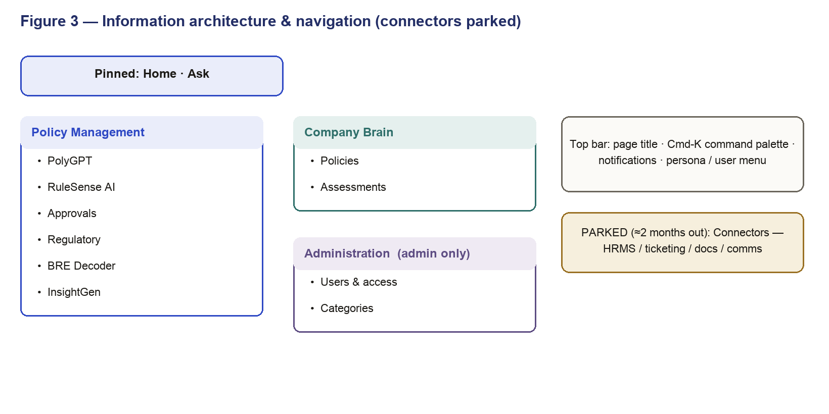
Figure 1 — Navigation & layout
6. Look & feel
One set of styles used everywhere. Light theme, a single accent colour, simple cards, lists and buttons. Numbers use a monospaced font so they line up and read cleanly (this fixes the current number styling). Keep it flat and uncluttered.
Every screen has to handle four states, not just the happy path:
- Loading — show skeletons, don't let the layout jump.
- Empty — a short, helpful message with a next step. Never show zeros as if they were real data.
- Error — a clear message and a retry.
- No access — hide or lock anything the role can't use.
It should work down to tablet width, be keyboard-accessible, and show money in ₹ with Indian number formatting.
7. Login
Keep the branded split-screen, restyled to the new look. Email and password now (SSO later). On a successful login we authenticate, work out the role and permissions, and drop the user on Home. The first few times someone logs in, we run a short product tour.
Flow
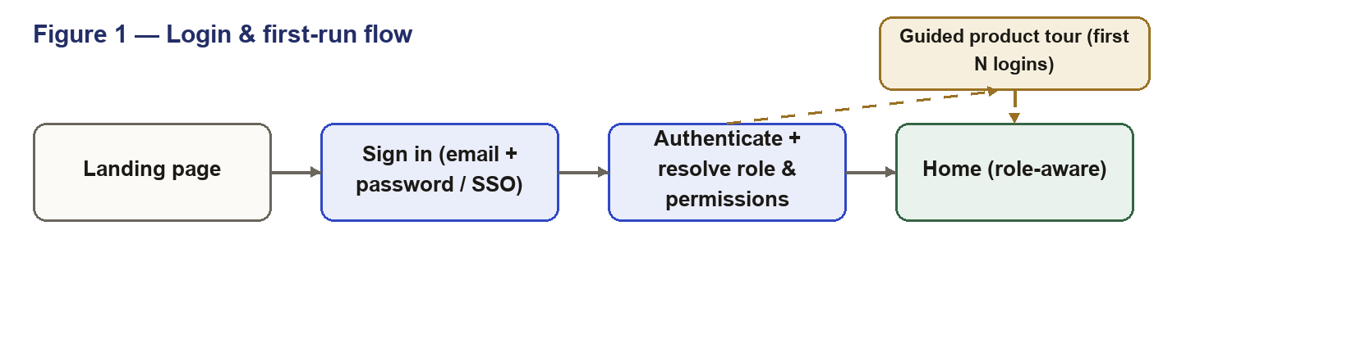
Figure 2 — Login & first-run flow
First few logins also kick off the guided tour (skippable).
8. Home (the main part)
Home is the front door: ask something, see the numbers that matter, jump to the main jobs, and see what needs attention — all scoped to the role. It replaces both of today's dashboards with one screen. See the prototype link at the top for the exact layout.
What's on it (Admin / Policy Manager / Risk)
- Ask bar (hero) — a plain-English question box with a few example prompts.
- Quick actions — Regulatory, PolyGPT, Approvals, InsightGen.
- KPIs — four headline numbers (below).
- Activity — pending approvals and recent attestations.
KPIs
KPI | What it shows | Opens
Active policies | Count the user can see | Policies
Pending approvals | Open requests (plus high-priority) | Approvals
Avg assessment score | Average, with trend | Assessments
Regulatory gaps | Circulars flagged, not yet actioned | Regulatory

Ask bar
A question in plain English. It answers only from policies the user is allowed to see and shows a citation to the page it used. It also handles "what if" questions (for example, "what if we raise the CIBIL cutoff to 720?").
End user (staff) version
Simpler: the Ask bar, three KPIs (policies you can access, assessments assigned, acknowledgements due), "My assessments" to take and submit, and a few quick-knowledge shortcuts.
Behaviour
Everything is scoped to the role. Use loading skeletons, real empty/error states, and never show placeholder zeros.
Flow
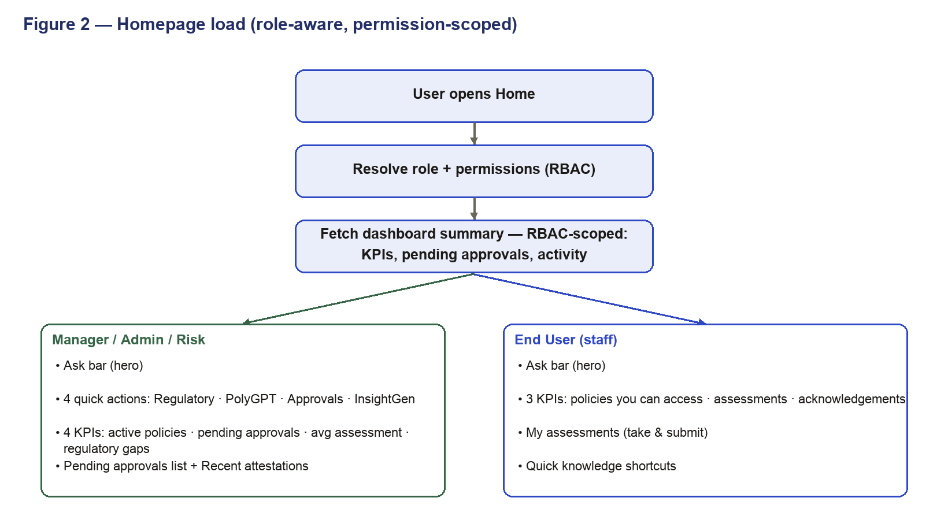
Figure 3 — Home load (role-aware)
9. How it talks to the backend
The UI is a single-page app sitting on top of the services we already have. Home reads one small, role-scoped summary call so it loads fast; the Ask bar calls the existing AI service, which only ever receives what the role is allowed to see. Model keys stay on the server, never in the browser.
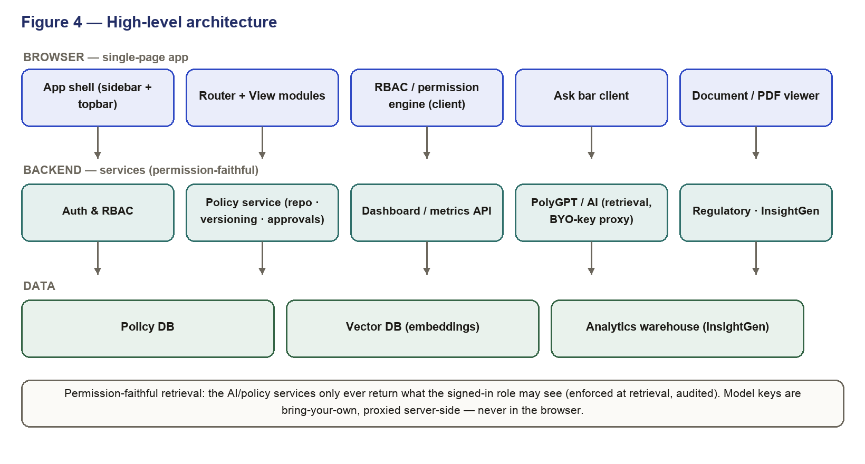
Figure 4 — High-level architecture
- GET /home/summary — role-scoped KPIs in one call.
- GET /approvals?status=pending — recent pending approvals for the user.
- GET /assessments/recent — recent attestation activity.
- POST /ask — a question, answered permission-faithfully with a citation.
10. Rollout
It's the same app with a new UI, shipped page by page (Login, then Home, then the rest). There's no data migration — Home reads existing services; we just add the summary endpoint. Ship to sandbox first, then to ABFL production behind a flag. Keep the old dashboard reachable until the new Home is verified, then switch the default route to it. The first-run tour helps existing users find their way around the new screen.
11. Not in this scope
- Connectors and the company-brain / agent work.
- Any edition split (one version only).
- The detailed behaviour of the other pages — they just adopt the new styling here and are specced on their own.
12. Open items
- Name of the in-product assistant (currently "AskDonna").
- Final colours and design assets from design.
- The /home/summary endpoint from backend.

