Policy Portal — Regulatory module
PRD · v1 · for review
Prototype reference (the upload → review → approve part): https://policy-os-prototype.vercel.app/ (Regulatory tab).
1. What this covers
A new Regulatory module, built from scratch. It watches what the regulators publish, brings new circulars in, checks whether each one actually applies to this lender, maps it to the policies it affects, and recommends the changes — then sends those changes through the approval workflow we already have. Uploading a circular by hand is supported too. This doc is just the Regulatory module; the rest of the app is covered elsewhere.
2. Why
NBFCs have to keep up with a lot of regulators, and today there's no system for it. When a new circular comes out, someone has to notice it, read it, figure out which of our policies it touches, and draft the change by hand. That's slow (it can take weeks to months), easy to miss, and hard to prove later. Compliance teams have been asking for exactly this, so it's one of the most sellable things we can build.
What good looks like: a new circular shows up on its own, the system correctly says whether it applies to us, points at the right policies, drafts sensible edits with a reason and a citation, and drops them into the approval queue — turning a weeks-long manual task into minutes. Nothing changes a live policy without a human approving it.
3. How it works
The whole thing is one pipeline. A circular comes in (watched page or manual upload), we store it, the AI checks if it's relevant to us, we map it to the affected policies, the AI drafts the changes, a person reviews them, and the accepted ones go to Approvals.
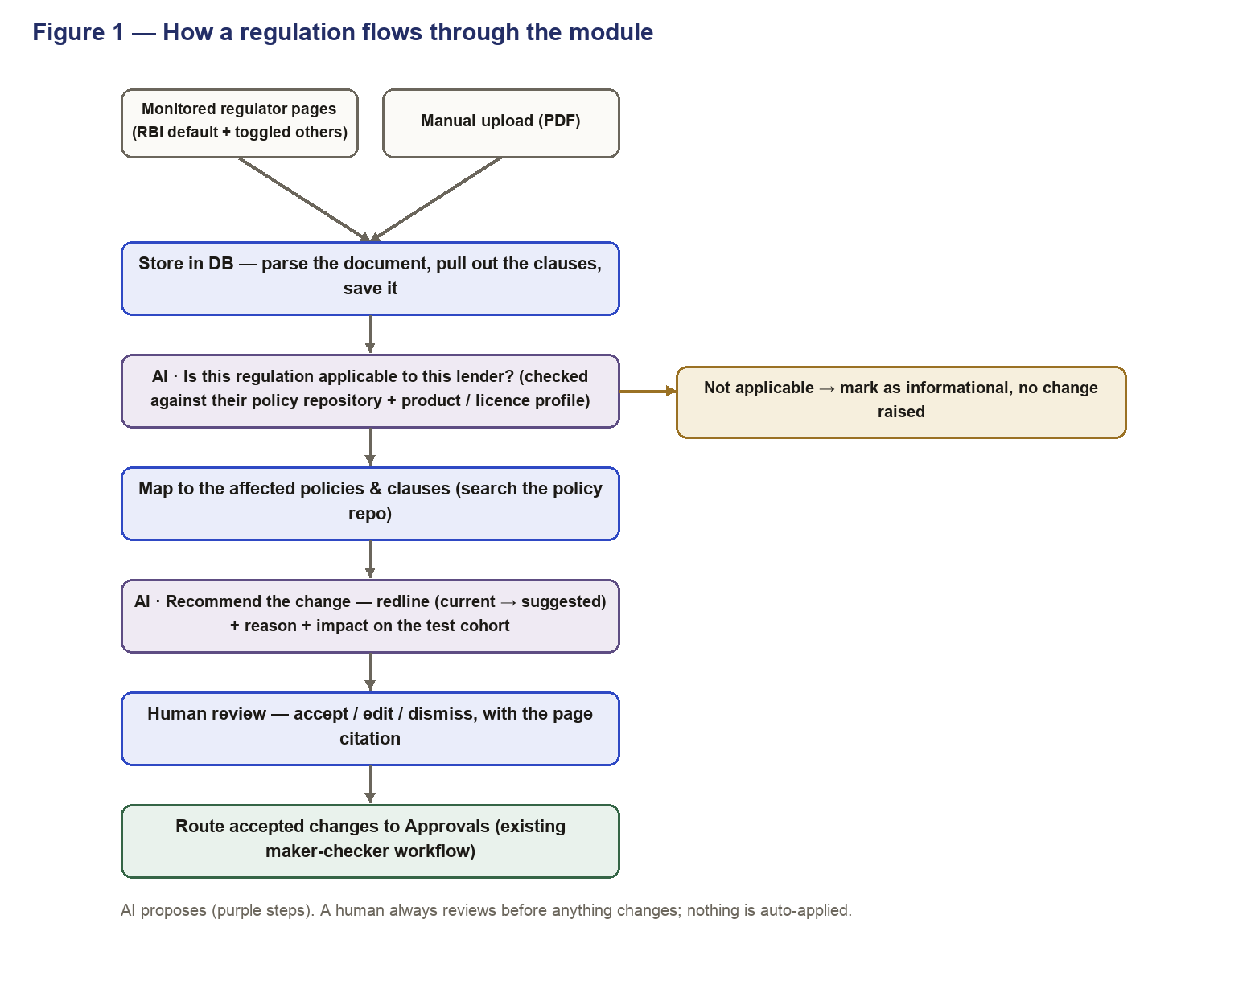
Figure 1 — How a regulation flows through the module
- Bring it in — either from a regulator page we monitor (new circular detected) or someone uploads the PDF.
- Store it — parse the document, pull out the individual clauses, and save the circular and clauses in the DB.
- Check relevance (AI) — does this apply to us? The AI compares the regulation against the lender's own policy repository and product/licence profile. If it doesn't apply, we mark it informational and stop there (no noise).
- Map it — for a relevant circular, find which policies and which clauses each provision touches, by searching the policy repo.
- Recommend changes (AI) — for each affected policy, draft a redline (current → suggested) with a short reason and a citation to the source page. Where the rule is numeric (a CIBIL cutoff, an LTV cap), show the impact on the test cohort.
- Review — compliance goes through each suggestion, with the cited page next to it, and accepts, edits or dismisses.
- Approve — accepted changes are raised into the existing maker-checker approval workflow. The live policy only changes once it's approved.
4. Pages to embed (coverage)
RBI is the bulk of what matters for an NBFC, so it's on by default. The rest are switched on per customer based on their licence and products. Where a regulator publishes a clean list we scrape it; where it doesn't, the customer uploads manually.
Authority | What it covers | Applies to | Monitored
RBI | Core NBFC rules — lending conduct, KYC/AML, asset classification, digital lending, microfinance | All NBFCs | Default (on)
FIU-IND | AML / PMLA reporting obligations | All NBFCs | On
MCA | Companies Act / filings / governance | All (as a company) | On
SEBI | Listed-entity and NCD / debt rules | If listed or issues NCDs | Toggle
NHB | Housing-finance rules | If a Housing Finance Co | Toggle
IRDAI | Insurance-distribution rules | If it distributes insurance | Toggle
DPDP / MeitY | Data privacy (borrower data) | All (rolling out) | Toggle
State / SROs | Money-lending acts; microfinance (MFIN); digital lending (FACE) | By state / product | Toggle (mostly manual)

Start with RBI, since it's ~80–90% of the relevant changes and has a structured notifications page that's the easiest to read. The others get added as customers need them.
5. The two AI steps
There are two places the AI does real work. Both are grounded in the customer's own data, and a human reviews the output — the AI never changes a policy by itself.
Relevance check
Input: the new regulation plus the lender's policy repository and product/licence profile. Output: does this apply, and roughly which areas. The point is to cut noise — a circular about something the lender doesn't do gets marked informational instead of generating busywork. If the AI isn't confident, flag it for a human to decide rather than dropping it.
Recommendation
Input: a relevant clause plus the policy it maps to. Output: a redline (what the policy says now vs what it should say), a short reason, a citation to the page, and — for numeric rules — the impact on the test cohort. Everything is a suggestion until a person accepts it.
6. Data model
Roughly what we store. A circular has many clauses; clauses map to policies; mappings produce suggestions; accepted suggestions link to an approval.
Entity | Key fields
Circular | id, regulator, ref, date, source (auto / manual), pages, status
Clause | id, circular_id, page, ref, text
Mapping | clause_id, policy_id, section, confidence
Suggestion | id, policy_id, current, suggested, rationale, impact, status, approval_id

7. Architecture
It's a new service that stores incoming circulars and then reuses what the product already has — the policy repository, the vector search over policies, the AI/LLM layer (bring-your-own key, permission-faithful), and the approval workflow. Every citation points back to the stored document.
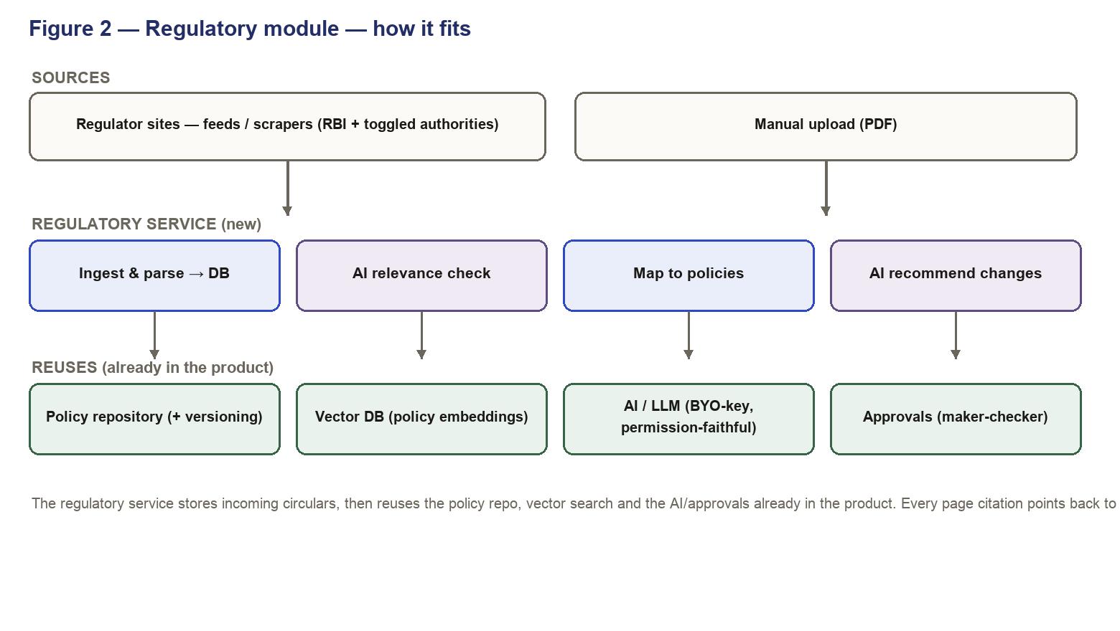
Figure 2 — Regulatory module — how it fits
8. Things to handle (edge cases)
- Duplicate circular — same ref uploaded or fetched twice → don't create it again.
- Not applicable — the relevance check says no → mark informational, keep it searchable, don't raise changes.
- Already compliant — the policy already meets the rule → show as 'no change needed', don't draft an edit.
- Low confidence — relevance or mapping is uncertain → flag for a human instead of guessing.
- No / partial mapping — a clause that doesn't clearly hit a policy → surface it for manual mapping.
- Re-run — re-opening or re-fetching a circular shouldn't lose review decisions or raise duplicate approvals.
9. Rollout
Manual upload works from day one. Turn on the RBI feed first (most value, cleanest source), in sandbox, then for ABFL. Add the other authorities by toggle as customers need them. Auto-scraping the messier sources can come as a fast follow. The AI steps always sit behind human review — we don't auto-apply anything to a live policy.
10. Not in this scope
- Connectors and the company-brain / agent work.
- Auto-deploying a policy change to a rule engine (that stays in RuleSense / BRE).
- Auto-applying changes without approval — every change goes through maker-checker.
11. Open items
- Which authorities to switch on for ABFL to start.
- How far we can auto-scrape each regulator vs. manual upload.
- The confidence threshold for the relevance check (when to auto-mark vs flag for a human).
- Naming of the assistant used in the recommendations.

