Policy Portal
Product Requirements Document — UI Revamp & Home (Dashboard)
Date | Author | Version | Status
23 Jun 2026 | Product | v1.0 | For review

1. Overview
This document covers a refresh of the Policy Portal interface and a redesigned Home (dashboard) page. The aim is a modern, consistent UI and a Home screen that genuinely orients the user and routes them to the work that matters. In scope: the global design system and app shell (sidebar, top bar, command palette), the Login page, and the Home page in detail. Every other page adopts the same design system; their page-level behaviour is specified in their own documents. The build order is Login → Home → Policy detail → the remaining pages.
2. Current state & problems
The interface works but is dated, and the dashboard does not function as a real landing screen.
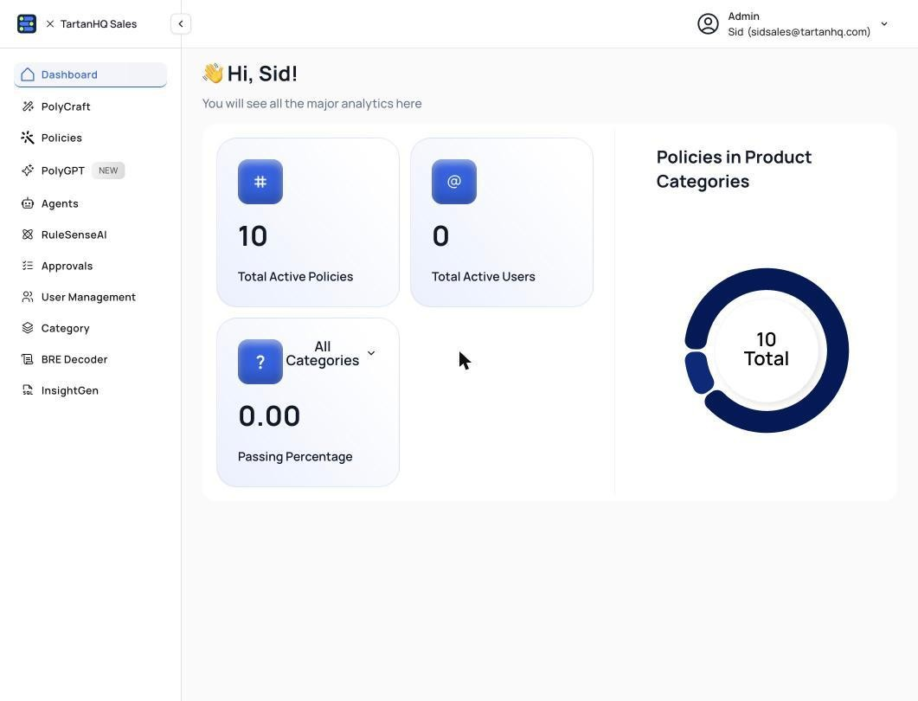
Figure A — Current Admin dashboard: a placeholder (“You will see all the major analytics here”) with non-working metrics (0 active users, 0.00% passing).
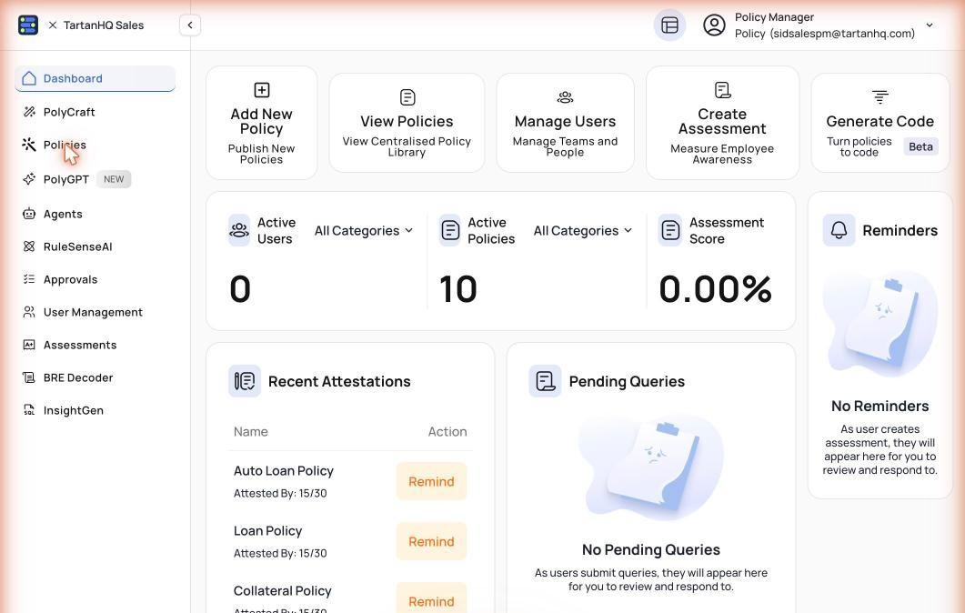
Figure B — Current Policy-Manager dashboard: a richer layout (action cards, KPIs, attestations) but with empty / zero states.
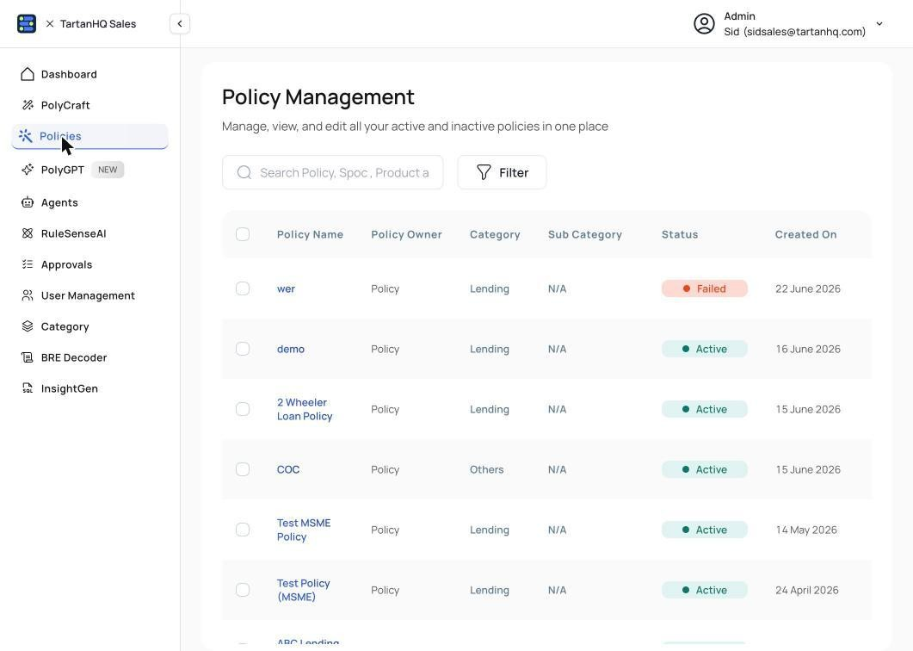
Figure C — Current Policy listing: useful, but cluttered with test/dummy entries (“wer”, “demo”, “Test Policy”).
- The Home page is inconsistent and largely non-functional — the Admin view is an empty placeholder; the Policy-Manager view is more complete but shows zeros and empty panels.
- The look is dated and numbers render poorly, which is noticeable in sales demos where this screen is seen first.
- Test / dummy data leaks into real views (policy list, metrics), which undermines trust.
- The AI assistant is surfaced in several places rather than one consistent entry point.
3. Goals & non-goals
Goals
- A consistent, modern design system applied across the product.
- A working, role-aware Home that shows the right numbers, routes to the key jobs, and surfaces what needs attention.
- One Ask command bar as the front door for natural-language questions — permission-faithful and citation-backed.
- A polished Login page as a strong first impression.
Non-goals
- No change to the underlying policy management, approval engine or AI retrieval — this is the presentation and Home layer over existing services.
- Connectors and the company-brain / agentic layer are out of scope; there are no separate product editions.
4. Personas & role-aware UI
Navigation and Home adapt to the signed-in role — each role sees only what it can use (today the Admin and Policy-Manager navigations already differ; e.g. the Policy Manager sees Assessments, the Admin sees Category & User Management). Access is category-scoped, so users only see their categories’ policies.
Role | Primarily does | Home variant
Admin | Manage users & access, categories, configure approvals. | Manager view + Administration
Policy Manager | Upload/version policies, RuleSense, raise & track changes, regulatory. | Manager view
Risk Approver | Review & approve changes (maker-checker). | Manager view (approvals-led)
End User (staff) | Read permitted policies, ask questions, take assessments. | Simplified view
5. Information architecture & navigation
A persistent, role-aware left sidebar; a slim top bar (page title, command palette, notifications, user menu); and a global ⌘K command palette to jump to any page or ask a question. Disabling a category removes its policies everywhere — sidebar, search and answers.
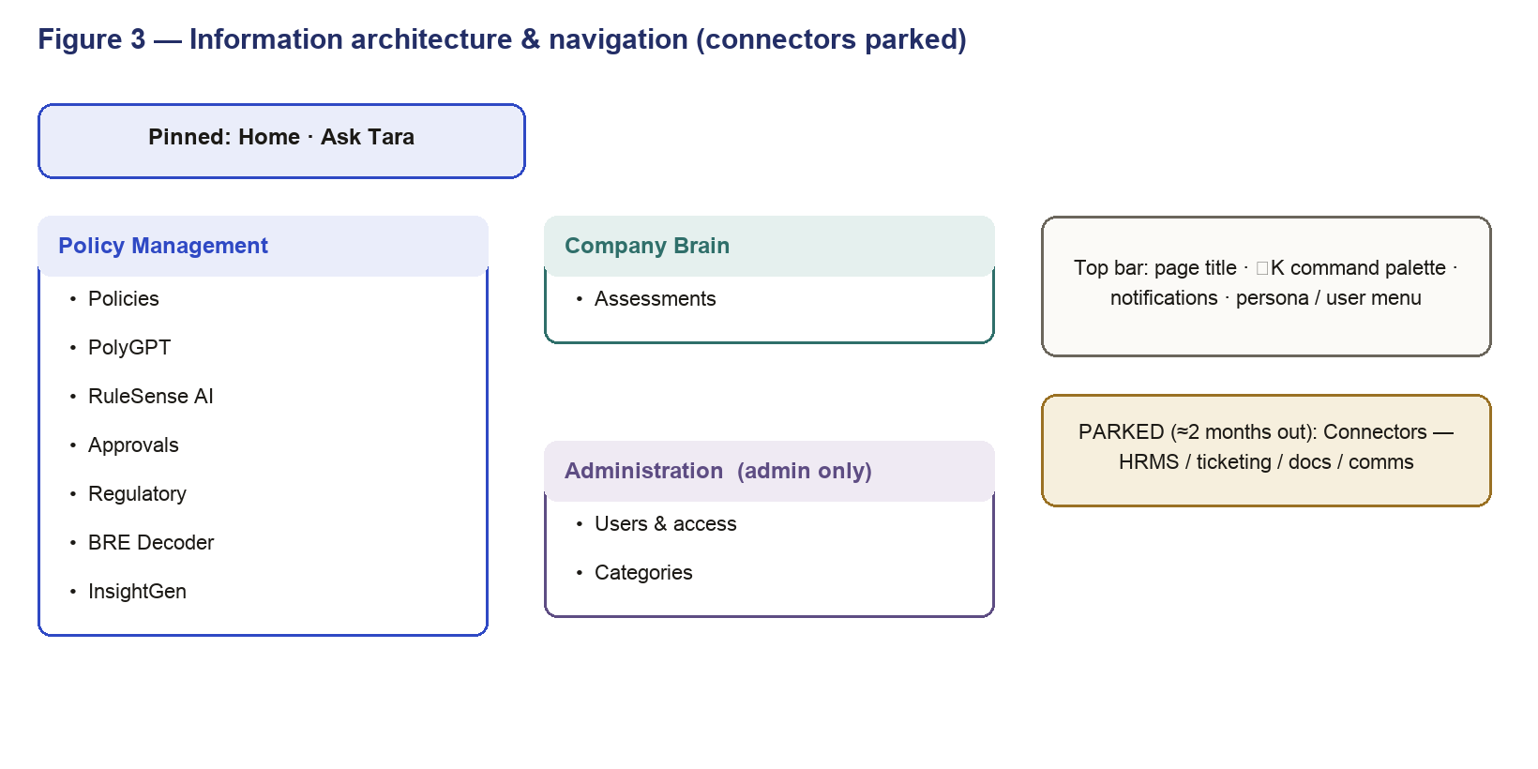
Figure 3 — Information architecture & navigation (Administration is admin-only)
6. Design system & UI standards
- Colour & style: a warm, light base with a single accent colour for primary actions and links; flat hairlines, no heavy gradients.
- Type: serif display headings, a clean sans body, and all numbers set in a monospaced font so figures align and read well (this fixes the current number-styling issue).
- Components: KPI card, action card, list row, pill/tag, buttons (primary / secondary / ghost / danger), modal, table, tabs, toast, side panel.
- Every screen handles four states: loading (skeletons, no layout jump), empty (a friendly state with a next action — never zeros-as-placeholder), error (clear message + retry), and permission (controls the role can’t use are hidden or locked).
- Responsive down to tablet; accessible (keyboard navigation, visible focus, AA contrast, alt text); money in ₹ with Indian number formatting, percentages to one decimal.
7. Login
Keep the branded split-screen feel, refreshed to the new design system: a clean value statement, email + password (SSO-ready), and a clear sign-in. On success the user is authenticated, their role and permissions are resolved, and they land on Home. First-time users see a short guided tour.
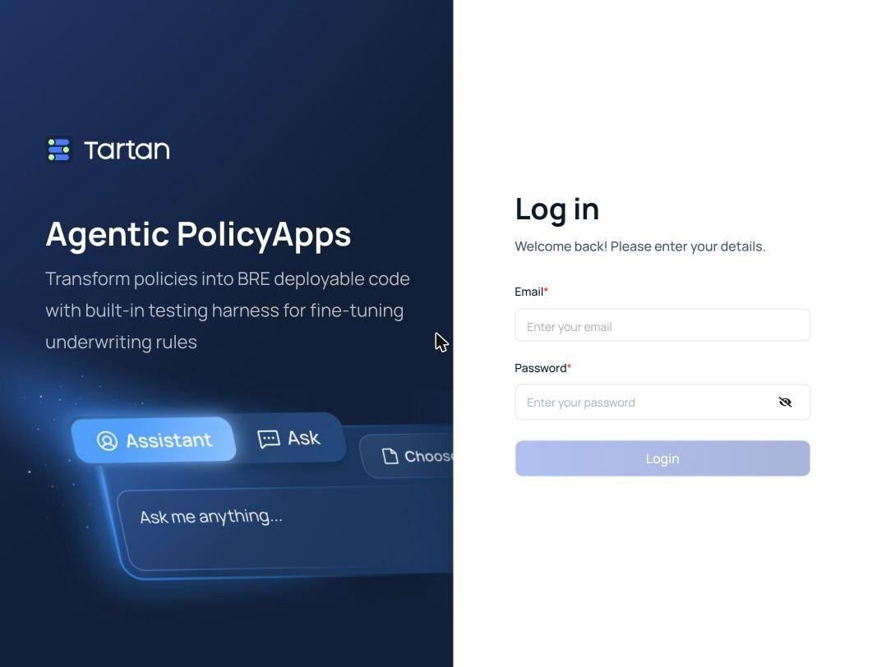
Figure D — Current login screen (to be refreshed to the new design system).
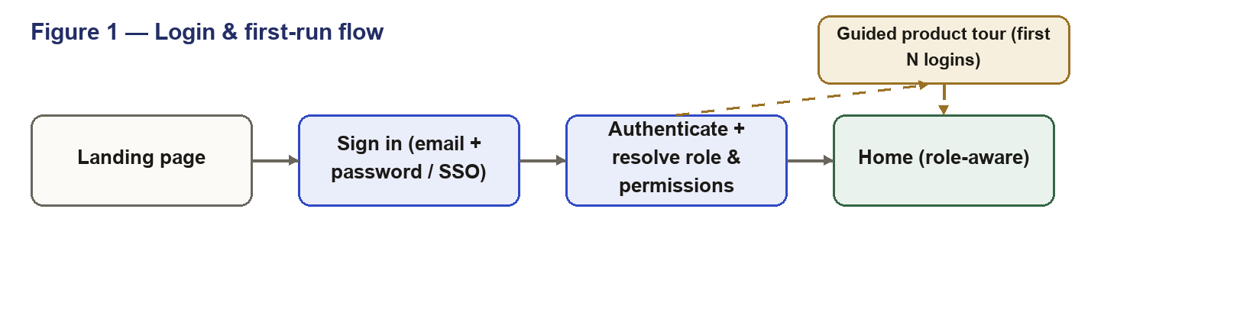
Figure 1 — Login & first-run flow
8. Home (Dashboard)
Home is the front door: ask anything, see the numbers that matter, jump to the key jobs, and see what needs attention — all scoped to the signed-in role. It replaces the inconsistent dashboards shown in Section 2 with one modern, working, role-aware screen.
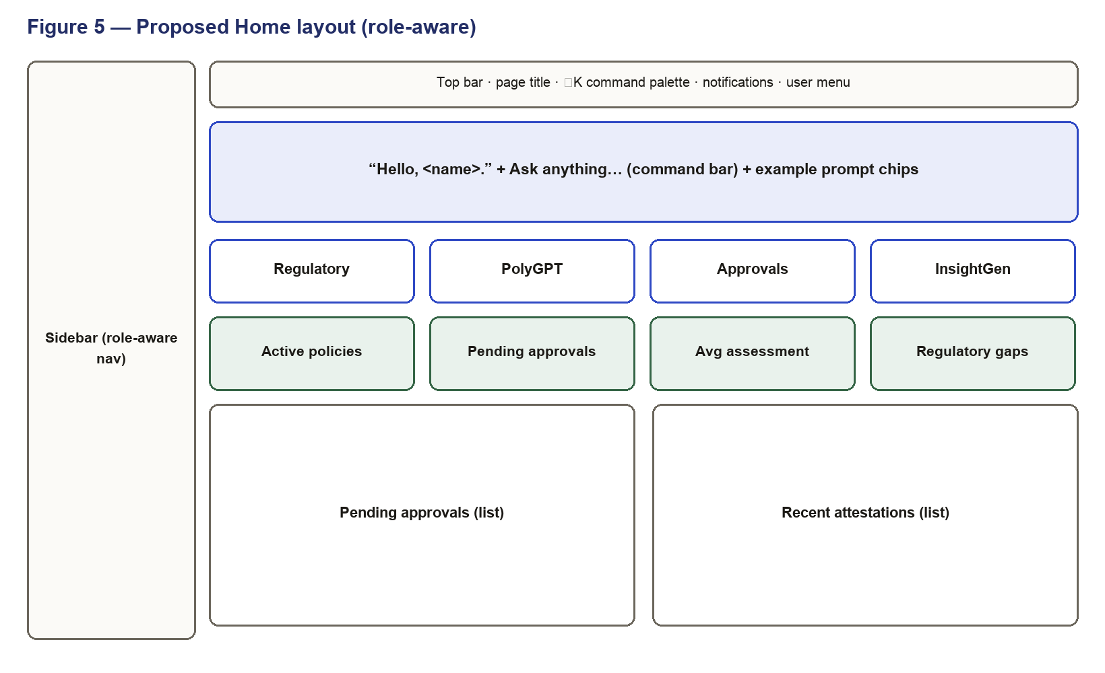
Figure 5 — Proposed Home layout (manager/admin). End users get a simplified version (8.4).
8.1 Sections
- Hero — Ask command bar: a single natural-language input (“Ask anything…”) with example prompt chips. It answers from the user’s permitted policies only, with a citation to the source page, and supports what-if questions (e.g. “What if we raise the CIBIL cutoff to 720?”).
- Quick actions: cards routing to Regulatory, PolyGPT, Approvals and InsightGen.
- KPIs: four headline numbers (below).
- Activity: Pending approvals and Recent attestations.
8.2 KPIs (manager / admin / risk)
KPI | Shows | Source / definition | On click
Active policies | Count visible to the user | Policy service, scoped to category access | → Policies
Pending approvals | Open requests (+ high-priority) | Approval engine, role-scoped | → Approvals
Avg assessment score | Average (+ trend) | Assessments module | → Assessments
Regulatory gaps | Circulars flagged, not yet actioned | Regulatory module | → Regulatory
8.3 Behaviour
- All Home data loads scoped to the user’s role and category access.
- Loading shows skeletons; empty shows a friendly state; errors show a clear message and retry — never zeros-as-placeholder.
- Quick actions and KPI cards navigate to the correct pages; activity rows link through.
8.4 End-User (staff) variant
- Hero Ask command bar (same).
- Three KPIs: policies you can access, assessments assigned, acknowledgements due.
- My assessments (take & submit) and Quick-knowledge shortcuts (leave / travel / KYC).
8.5 Load flow
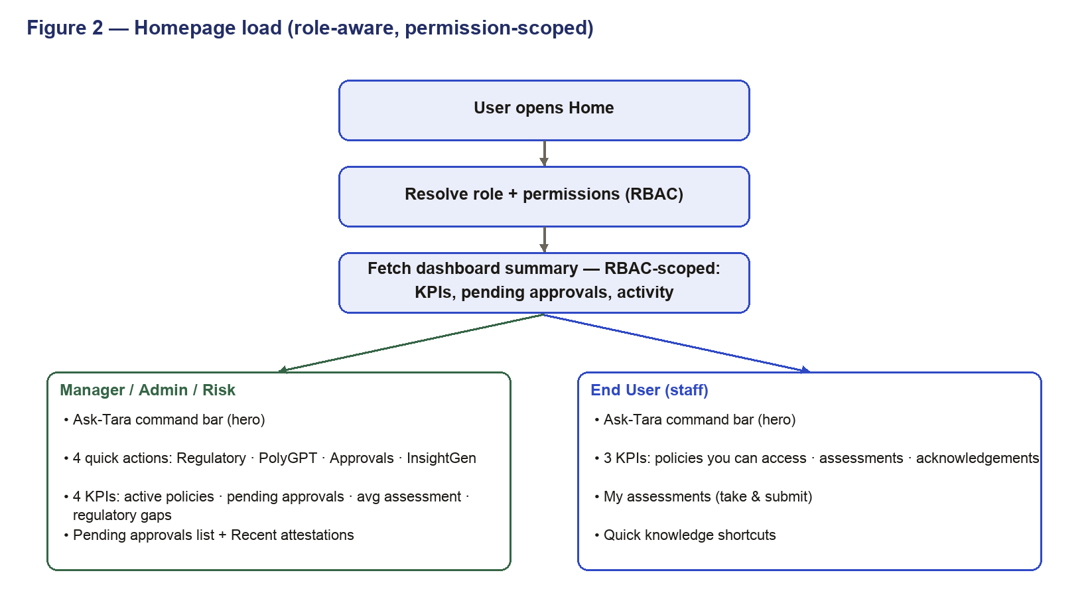
Figure 2 — Home load (role-aware, permission-scoped)
9. Architecture
The interface is a single-page app over existing services. Home reads a single, lightweight, role-scoped summary; the Ask bar calls the AI service, which only ever receives what the role may see. Model keys are bring-your-own and proxied server-side — never in the browser.
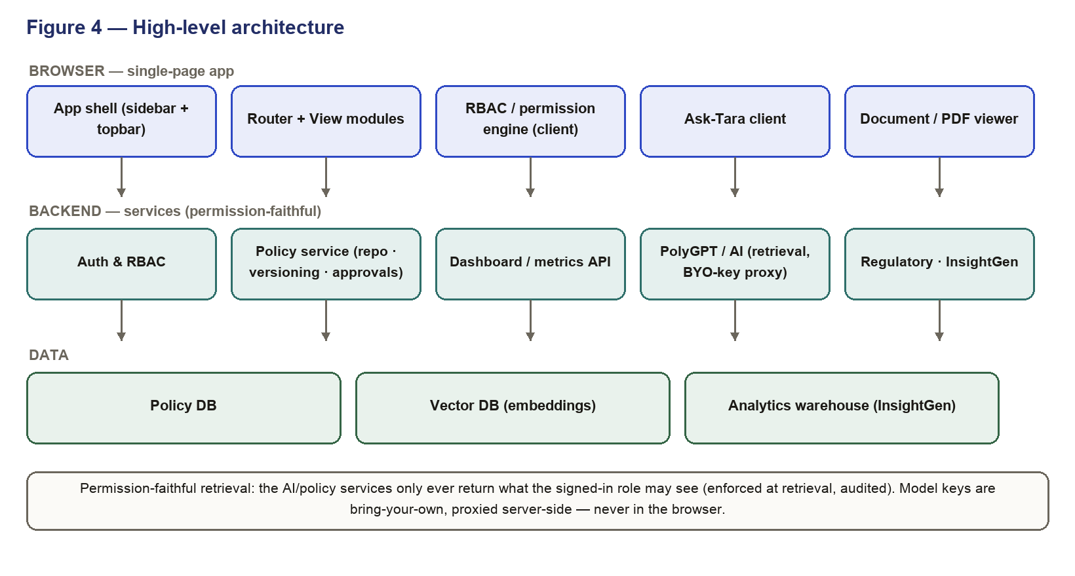
Figure 4 — High-level architecture
- GET /home/summary — role-scoped KPIs (active policies, pending approvals, avg assessment, regulatory gaps) in one call.
- GET /approvals?status=pending — recent pending approvals for the user.
- GET /assessments/recent — recent attestation activity.
- POST /ask — natural-language question → permission-faithful, citation-backed answer.
10. Cross-cutting requirements
- States: loading, empty and error states on every card and list.
- Analytics: instrument key events (page views, KPI and action-card clicks, Ask usage) — there is no usage analytics today.
- Accessibility & responsive: keyboard, focus, contrast, alt text; works down to tablet.
- Data hygiene: no test/dummy data or stale counts on Home; deleted policies must not appear in counts.
- Notifications: wire the top-bar notifications.
- Security: no keys or secrets in the browser; the Ask bar talks to the server, which proxies the model.
- Performance: Home should paint quickly — a single summary call, not many per-module calls.
11. Out of scope
- Connectors and the company-brain / agentic layer.
- Separate product editions.
- Page-level behaviour of Policies, PolyGPT, RuleSense, Approvals, Regulatory, InsightGen and Assessments (each adopts this design system; specified separately).
12. Open items
- Naming: the in-product assistant is currently referred to as “AskDonna”; the final name is to be confirmed.
- Final visual design: colour palette and component assets to be finalised with design.

