### ABSTRACT

The research work entitled “Assessment of an RC structure using fragility curve” deals with the tracing of a fragility curve for an existing as well for the structures which are proposed to be constructed. In the research work firstly the comparative analysis of a new and old structural models is carried out and the on the basis of the capacity curves the fragility curves are traced. A case of an old existing structure located in Pune is carried out and the comparative analysis is carried for the model with NDT and other model after retrofitting work is carried and fragility curves are traced for both the conditions. The methodology adopted for the research work is using the response spectrum approach of analysis, since lot of research work has carried out using the statistical approach and other meth- ods of tracing fragility curve. The research work is carried out on finite element analysis software SAP2000. The results obtained after analysis shows that the fragility curve (viz. probabilistic approach) is a useful tool for the assessment of an RC structure. It helps to determine various damage states in the structure, hence by using this method we can determine the damage levels in the structure and by using suitable methods of retrofiting we can minimize the damages in the structure. Thus by using this method we can determine the performance of the structure by using the fragility curve. Hence the method is useful for tracing of fragility curves of existing as well as proposed buildings.

***Keywords:*** Performance based analysis. Fragility curves. Seismic action. Non- linear analysis. Seismic behavior. Sap2000.

### ABBREVIATIONS

|  |  |
| --- | --- |
| PGA | Peak Ground Acceleration |
| HDMR | High Dimensional Model Representation |
| FEMA | Federal Emergency Management Agency |
| SPRA | Seismic Probability Risk Assessment |
| IM | Intensity Measurement |
| IDA | Incremental Dynamic Analysis |
| HAZUS | Hazards in US (United States) |
| NEHRP | National Earthquake Hazards Reduction Program |
| IO | Immediate Occupancy |
| LS | Life Safety |
| CP | Collapse Prevention |
| NDT | Non Destructive Test |
| UPV | Ultra-Sonic Pulse Velocity |

**Chapter 1**

**Introduction**

#### General

The earth is known as the mass on which the whole universe resides. Before sep- aration of this mass it was said to be a single mass. This mass was known as Gondwana land and it was having only single sea. Later on, this land mass was broken into pieces and those pieces started moving in different directions which formed continents. This continuous movement of land mass is known as continen- tal drift. These different pieces of land mass are known as tectonic plates, these plates are present in the semi-liquid form in the earth surface which is known as mantle. This plate generates pressure along the boundaries of the land mass over the years and this pressure is stored in the form of the strain energy. The point will reach when the built pressure cannot be sustained by the plate and small slip occurs which releases tremendous amount of energy which is known as ‘Earthquake’. It shakes the earth surface due to propagation of energy in all the possible directions. Plate movement is continued and they store energy inside it whose prediction and analysis is difficult .

Accidental and man-made events such as Impact, fire or explosion induces abnor- mal loads on the structures, which may lead to damage or even collapse of the structure. Number of earthquakes occur frequently all over the world. In these multiple earthquakes, it is reported that there are numerous structural damages. This earthquakes are observed in the countries like Tohoku (Japan), Christchurch (New Zealand), Chile, Nepal and in northern parts of India. Multiple earth- quakes occurs were complex fault system exists. The energy accumulated in the strains is not relieved in the single rupture, till the fault system is completely stabilized . If the structural system according to conventional approaches may not be sometimes able to withstand the loads.

These earthquakes in the past had created damages due to less structural resistance from the structure or due to the inadequate techniques in the work. Generally there was no any modern techniques evolved to make the structure seismic resis- tant, as a result of which there were incidence of the more damages in terms of economy and death [6]. There was no any proper kind of bands involved in the construction activities. They used the huge stone which was bonded by mud or either by the fly ash and the whole construction was continuous without any kind of bands, beams or columns. As a result if there was any occurrence of the seismic action, the structure would fail and create damage. There was no any use of the modern methods like bracing system, shear wall, damping system, isolation to the building, etc. as a result of which there was failure in the structure and there was more damage in terms of the deaths.

Since no structure can be made earthquake proof structure, it can be made earth- quake resistant. Now-a-days due to the advancement in technologies there has been evolution of new techniques. These techniques involve orientation of shear wall, providing bracing system, implementing damping systems at various loca- tions, introduction of different types of the concrete, etc.. Due to these, there has been innovation in the field of construction and has significant results. Due to the introduction of these techniques the direct action of seismic force has reduced and this helped to minimize the damages in the building .

One more technique involved in this, is assessment of the structure by using Fragility curves. Fragility curves are main components of probabilistic seismic risk assessment. This technique expresses the relationship between ground mo- tion intensity measure and predefined damage state. Structural fragility of the structure is as the as the conditional probability of the failure for the given inten- sity of ground motion where the failure occurs if the designed/assessed structure does not satisfy the requirements associated to a prescribed performance level (es- sentially serviceability or life safety). Fragility curve method helps us to determine the pre and post-earthquake damage of the structure. For analysis of the fragility is done by using push-over method, which is a non-linear analysis method .

With the help of fragility models it is helpful to derive the fragility curves, which helps to evaluate the damage state of structure for different ground motions in- tensity. Thus the fragility curves helps to measure the probability of exceeding damage state against the parameters that represent the severity of ground motion viz. PGA, PGV, arias intensity. For this reason, these curves can be regarded as a graphical representation of seismic vulnerability and constitute a very useful tool intended for studying the behavior of systems over a large range of earthquakes. Hence fragility curves are the key components of the probability of seismic risk assessment. Thus, the Figure1.1shows the typical fragility curve

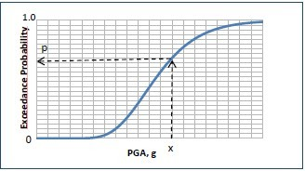

Figure 1.1: Fragility curve showing PGA vs. probability of exceedance

#### Methods of fragility curve assessment

Conventional methods for computing building fragilities are:

* + - Monte Carlo simulation (MCS)
    - Cornell et al. (2002)
    - HDMR method
    - Response Surface Method
    - ATC-63

##### HDMR (High Dimensional Model Representation) method

High Dimensional Model Representation is a tool that has been introduced re- cently for improving the efficiency of deducting high dimensional input-output system behavior. HDMR techniques are based on optimization and projection operator theory. Application of HDMR methodology to complex nonlinear model provides an efficient means to obtain an accurate reduced model of the original system. The uncertainty analysis of the outputs can be well approximated by MC simulation of the corresponding reduced model outputs. It is a general set of quantitative model assessment and analysis tool for capturing the high dimen- sional relationships between sets of input and output model variables.

##### Cornell method

Cornell et al. (2002) investigated a recognized probabilistic framework for seismic design and assessment of structures and its solicitation to steel moment-resisting frame buildings based on the Federal Emergency Management Agency (FEMA) steel moment frame guidelines. The framework was based on recognizing a per- formance objective expressed as the probability of exceedance for a specified per- formance level, that related to demand and capacity of which were described by the nonlinear dynamic displacements of the structure. To describe the random- ness and improbability in the structural demand given the ground motion level and the structural capacity probabilistic model distributions were used. A cus- tomary probabilistic tool, the total probability theorem was used to convolve the probability distributions for demand, capacity, and ground motion intensity haz- ard. An analytical expression was delivered for the probability of exceeding the performance level as the primary product of the development of framework.

#### Research gap

From the analytical study carried on the evaluation of the fragility curve it is found that the most of the study has carried out using HDMR (High Dimensional Model Representation) and by Cornell method. It is found that by using both the methods, fragility curves can be traced but these methods are more time consuming and requires number of statistical simulations carried before the tracing of the curves. Hence the same work can be carried out using the response spectrum methods which are less time consuming, efficient, economical and accurate. So during this research work the response spectrum method by push over analysis is being used.

#### Research objective

The following are the objectives of the project

1. To Study the effect of the age of structure on fragility curves.
2. To compute various parameters for multi-storey building like typical over strength and global ductility capacity (R), push over acceleration, spectral acceleration, spectral displacement, PGA and PGV.
3. To study the failure pattern of frame element.
4. To recommend guidelines and best method suitable for the analysis according to Indian standard.

#### Outline of report

The dissertation report is divided into following chapters. These chapter describes the different work conducted for study.

Chapter 1: This chapter is an introduction which consists on basic knowledge about the importance earthquake. This chapter also contains the basic ideal about the fragility curves.

Chapter 2: This chapter includes the review of all the previous literatures, the literature gap from each of the papers are also enlisted in the chapter. This chap- ter helps to know regarding the different methods used in the assessment of the structure, their advantages and disadvantages.

Chapter 3: This chapter gives the idea regarding the research work, includes the methodology adopted for modelling in the software, methods used for analysis, software validation including manual calculation and the varied results from soft- ware and procedure adopted for the tracing of the fragility curves.

Chapter 4: This chapter includes modeling and analysis part carried for the re- search work. Chapter includes the comparative analysis of two structural models, which includes the parameters used for modelling.

Chapter 5: In this chapter discussion of results is carried out. The results for different parameters are tabulated.

Chapter 6: In this chapter the discussion regarding the case study is carried out. This chapter includes the case study plane in Auto-CAD, its actual structure and modelling of the plan.

Chapter 7: This chapter includes the references used for the research work viz. literature papers, IS codes and books.

#### Closure

In this chapter some introduction and general information, methods and advan- tages is given along with the motivation and the outline of the project work. Chapter 2 discusses on the present theories regarding the fragility curves carried by different authors.

**Chapter 2**

**Literature Review**

#### General

In this chapter, the studies and practices adopted by many researchers are re- viewed. Also, research gaps in these studies are summarized, which are led to de- cide methodology of the dissertation work.There are various analytical researches made to study the effect of seismic action and the various damage states are stud- ied. Following are some of the literatures that are used as a reference to carry out the project work.

#### Review of previous studies:

##### Irmela Zentner, Max Gundel et.al (2017) “Fragility analysis method: Review of existing approaches and application”

This literature reviews regarding various methods for analysis of fragility curve. SPRA (Seismic Probability Risk Assessment) methodology has used in the re- search. The paper includes the researches made by different authors and consist of their individual reviews. They have considered a 3 Storey building for the pur- pose of the analysis, and used a finite element software Ansys. Analysis is carried using different methods and the details about individual method is also summa- rized in short. Accordingly, the safety factor method is economical and widely used for nuclear power plant, it helps to evaluate log normal curve. It does not contain any numerical simulation. Maximum livelihood method and linear regres- sion method does not require any spectral matching or scaling of accelogram till failure. Incremental dynamic analysis method is based on numerical simulation.

The method is used for analysis of multi-storey building or skyscrapers, and gives correct fragility curve. The advantage of linear regression method is that, it can be used when is observed and does not require any scaling of accelogram, but it requires the data before and after failure. The choice of Intensity Measurement (IM) has influence on fragility curve. The general performance of IM has influence on fragility curve, the general performance of IM depends on type of structure and failure mechanism. The fragility curve depends on correlation coefficient; higher is the correlation coefficient, better are the results. But from overall results in the review it is observed that, IDA is the best method for detection of fragility curves, it also gives probable damage but it is expensive .

##### F. Hosseinpour, A. E. Abdelnaby (2017) “Fragility curves for RC frames under multiple earthquake”

This literature focuses on the limitation observed during the work carried out in the past. The earlier work was carried by multiple authors, some of them consid- ered non-linear behavior for different models and showed that multiple earthquake at same time can cause uncontrollable damage and found that the cause of the failure is elastic perfect plastic system. Most of the study was carried out using non-linear behavior. For this research the authors have considered three models of different stories viz. 3, 7 and 12 stories, designed based on ASCE-05. The frames used are Intermediate moment resisting frames, the modelling was carried using a finite element method Zeus-NL. For behavior of steel reinforcement, modified Menegotto Pinto steel model is used to know the Bauschinger effect after crushing of concrete and buckling of reinforcement. The models are analysed for different cases of aftershock and main shock. The cases are curves derived on main shock, curves derived on main shock and aftershock to get maximum intensity, curves based on aftershock only without considering any damage, curves based on after- shock only by considering damage. After analysis they found that the last case gives better results. Effect of vertical acceleration causes increase in axial force vibration leading to reduction of shear capacity, drift ratio is also affected due to vertical component. It shows that aftershock fragility curve decreases with increase in number of stories, vertical component does not affect fragility curves.

##### Emanuele Brunesi, Fulvio Parisi (2017) “Progressive collapse fragility models of European reinforced concrete framed building based on push- down analysis”

The literature reviews regarding the pushdown analysis of the structure. The push- down analysis were compared with IDA (Incremental Dynamic Analysis) curves using non-linear regression method which are derived and implemented according to European standard code. The 4 storied, 4x4 bay RC framed structure which was composed and connected by one way RC joist slab and continuous cast in- situ continuous beam, the non-linear analysis was carried out. The fiber based modelling was used in analysis which helps explicitly for localization of plasticity throughout the members. The accuracy of the model was compared with numer- ical results from past test which were carried out on one-third scaled structure. The pushdown is relatively a simple approach and gives load displacement capacity curves, but the disadvantage of capacity curve is that the structure becomes dy- namically unsafe as overloads may produce progressive fracture of other members. The authors in the paper have considered a bilinear constructive model with small hardening ratio. Apart from loading scheme flextural-axial hinging mechanism was seen and secondary beam contribution for gravity load distribution. According to total probability theorem fragility model do not consider uncertainty and load intensity of abnormal loading on single column. Paper concludes that structural response is related to flextural axial hinging mechanism. The secondary beams provide additional stiffness and resistance to single column loss, secondary beams help to make median load capacity thrice and half the downward displacement. The seismic design according to EC8 gives increase in vertical load capacity by 50% to 80%.

##### Linda Astriana, Senot Sangadji et.al (2017) “Assessing seismic perfor- mance of moment resisting frame and frame-shear wall system using seismic fragility curve”

The literature reviews about the seismic performance of moment resisting frame and shear wall system. The model consist of a ten multi-storied office building located in Indonesia. The modelling is done on the HAZUS methodology, the re- sponses are derived analytically are used to generate more reliable and uniform set of fragility curve. The non-linear behavior pushover analysis, pushover analysis is a static equivalent analysis, involves applying lateral load incrementally. Higher mode effects are considered for more complex structure, capacity spectrum is also plotted which a plot of spectral acceleration and spectral displacement. The ca- pacity curve is derived from non-linear incremental static analysis for structure; the structural curves are generated from structural response data. From the re- sults after analysis it is found that the frame with shear wall gives fragility curves and performs better during earthquake. It has better lateral load resistance as compared to that of ordinary moment resisting frame.

##### Cong-Thuat, Thien-Phu Le et.al (2017) “A novel method based on maximum likelihood estimation for the construction of seismic fragility curves using numerical simulation”

This literature reviews regarding the different methods of numerical simulation used for the assessment of fragility curves. The methods used for the simulation are maximum livelihood estimation method, probabilistic seismic capacity model and numerical simulation. The aim of this literature is to propose a unique method improving the fragility assessment. This paper includes evaluation of the different parameters like peak ground acceleration (PGA), peak ground velocity (PGV), spectral acceleration a period of interest (PSa), etc. The methods are helpful for the seismic evaluation and also for seismic retrofitting of the structure. The accu- racy is checked by using Monte-Carlo simulation method. In order to compare the effectiveness of the proposed methods it is necessary to propose some comparison criteria; this comparison criteria is known as Mean square error. Higher the MSE value of fragility curve, farther it is from Monte-Carlo results. But Monte-Carlo method of simulation is used only for seek of reference, use of this method is less as it is more costly and also more time consuming.. From the overall analysis it is found that maximum livelihood method is efficient in fragility curve construction via numerical simulation. But after the validation and verification test performed shows that ERMLE methods shows improvement in MLE method.

##### Sashi Kanth Tadinada, Abhinav Gupta (2017) “Structural fragility of T-joint connection in large scale piping systems using equivalent elastic time-history simulation”

The literature reviews about the seismic analysis of a non-linear connection in piping system. There is a large damage as a result of the deformation at locations such as T-joints, elbows, valves, etc. and as a result of the ductility decreases and the failure occurs. Since during the primary analysis the structure remains elastic, the technique of linearization along with equivalent elastic properties helps for the further analysis. Large scale piping system have intrinsic geometry, and the method of Monte-Carlo have drawback in the analysis. Using the simplified linear approximation without any analysis may cause inaccurate fragility curve, the seismic fragility of non-linear system can be carried by using multiple time history analysis. For the purpose of accurate and precise analysis the Bayesian updating method can be used effectively for the prediction which will be effective even in limited quantity of non-linear data. The results shown that methodology based on elastic static analysis along with Bayesian updating helps in the seismic evaluation and computation of fragility curve with critical non-linear connection can give better results in large scale piping system.

##### Shinyoung Kwag, Abhinav Gupta (2018) “Computationally efficient fragility assessment using equivalent elastic limit state and Bayesian updating”

This literature reviews regarding the limitations that have been experienced dur- ing the equivalent limit state formulation and present valuable enhancement. The aim of the authors is to account for the effect of uncertainty in the nonlinear characteristics and effect of non-classical damping. During this study authors have listed many linearization methods viz. Equivalent viscous damping method, Elastic strain energy method, Empirical method, stochastic linearization method, Secant stiffness method and Equivalent elastic limit (ELS) concept. The study re- lates to the effect of uncertainty in non-linear model and the effect of non-classical damping. The equivalent limit state method, negative values of turning ratio is not same as that of positive values. ELS method helps to minimize the error between response quantities. In this paper analysis have carried out using hysteretic non- linear behavior along with ELS approach. The efficiency of the method is checked by using three systems viz. ELS method alone, ELS and Bayesian updating in conjunction and the curves by non-linear time history analysis. The Bayesians framework gives limited results for actual non-linear simulation or for real exper- imental fragilities. The equivalent elastic limit state is modified presentation of secondary system.

##### Tiziana Rossetto, Pierre Gehl et.al (2016) “FRACAS: A capacity spec- trum approach for seismic fragility assessment including record vari- ability”

This literature reviews regarding the new approach of assessment of fragility curves viz. Fragility through capacity spectrum assessment (FRACAS). In this authors have used capacity spectrum method and used inelastic spectra for deriving earth- quake ground motion, this is useful for the construction of fragility curves. In this paper the authors have made comparison of FRACAS with non-linear time history analysis (NLTHA). The structural response obtained is expressed as engineering demand parameter (EDP) and this approach involves carrying out incremental dynamic analysis (IDA). The advantage of using IDA is effect of record-to-record variability can be included in this assessment. The accuracy depends on the mod- elling of SDOF system. At each analysis point (AP) the response of SDOF under the ground motion is assessed through Newmark-beta time-Integration method. But the method is time consuming than commonly used approaches, but it is faster than time history analysis. In this research authors have considered two four storey RC MRF frame and comparative study is carried for FRACAS and NLTHA. The models are designed based on Italian codes; after analysis FRACAS adapts the capacity spectrum method for assessment derived from earthquake ac- celogram for construction of fragility curves. The FRACAS shows well response than NLTHA, the simplicity and rapidity over other methods that use the accel- ogram directly.

##### Tushar K. Mandal, Nikil N. Pujari et.al (2016) “Seismic fragility analy- sis of typical Indian PHWR containment: Comparison of fragility mod- els”

This literature reviews regarding the fragility analysis of Pressurized heavy water reactor (PHWR). The structure consist of 700 MWe, which is a typical Indian structure; the seismic analysis of which is carried out using a finite element soft- ware Abaqus. The analysis work is carried out with non-linear modelling along with time history analysis and displacement based failures are considered. The results of this is compared using 3 IDA based models; IDA method helps to give better and more accurate analysis. The work is carried out with reference to Indian standards like IS-456:2000 and IS: 10262. From analysis it is observed that beam column element with fiber section cannot account for effect of shear deformation. The damage evaluation is based on seismic design evaluation concept of ASCE43- Fragility analysis for the structure is carried out by using different methods viz. IDA, regression method, maximum livelihood method and proposed method. Amongst these the proposed method of regression and IDA gives best results. But following to this the livelihood method is to be more demanding. The regression method avoids the recalculation of parameters for every limit state. From the analysis we conclude that proposed method gives reasonable seismic intensity at low probability of failure. The method is also computation intensive for multiple limit state, conventional method fails to give realistic estimate for fragility curve. The livelihood method can give good estimate but it is computation intensive. The livelihood method estimate fragility curve well in low PGA range, but fails to give good estimate at higher range.

**Ioanna Ioannou, John Douglas et.al (2015) “Assessing the impact of ground-motion variability and uncertainty on empirical fragility curves”** The literature reviews regarding the database of damaged building which are stim- ulated using earthquake ground motion which considers the spatial variability and a known fragility curve. Hence this database are then inverted for deriving the empirical fragility curves. Generally these curves are measured by assuming the intensity measure levels. The intensities are generally predicted by using ground motion prediction equations (GMPE’s) or it is recently carried by using shake maps. In this paper, the impact of ground motion variability and uncertainty in empirical fragility curves is studied by using series of experiments. The IML’s are generated by assuming the absence or presence of ground motion. In the paper, the seismic analysis for each building is determined by Monte Carlo analysis. Gen- erally the IML for remaining building are determined by using a process known as kriging. From the results it is clear that ground motion variability leads to considerable uncertainty in empirical fragility curves. The two types of scenarios are used for construction of fragility curves .i.e. BASE and CHECK. According to these adjacent building is not same. From the analysis of scenario it is concluded that the impact of variability in ground motion is significant which leads to flat- ter and wider fragility curves. The network for ground motion recording station should be dense to reduce uncertainty in empirical equation.

##### Gautham. A, K. Gopi Krishna (2017) “Fragility Analysis – A Tool to Assess Seismic Performance of Structural Systems”

This paper reviews regarding the increasing trend for the usage of seismic eval- uation methods for the structures which are subjected to the ground motion; since the traditional method was found to be insufficient due to uncertainty and randomness occurring due to an earthquake. But it is observed that instead of seismic evaluation, the probabilistic approach has increased the accuracy of seis- mic analysis. Fragility curve is one of the probabilistic approach which determines and correlates demand and capacity to establish probabilistic characteristics up to certain limit. Hence the aim of this paper is to define the potential of fragility curve in performance of structural system. During the analysis various build- ing configuration and irregularities are also considered. During the overall study the method given by A. H. Barbat is adopted for the analysis. From the results obtained it is concluded that the fragility analysis is a beneficial tool for the per- formance of structure.

##### Siti Nur Aqilah Saruddin, Fadzli Mohamed Nazri (2015). “Fragility curves for low- and mid-rise buildings in Malaysia”

In this paper, study is carried out on development of fragility curve for Malaysian low and high rise building which consist of a reinforced concrete and steel mo- ment resisting frames. The research work contains the prototype models of three and six storey frames, which are designed using Euro code using Incremental dy- namic analysis for various sets of ground motion records and scaling periods. The structural performance is checked for various damage states which includes imme- diate occupancy, damage control, life safety and collapse prevention. The fragility curves were plotted for different materials and at different heights. Thus from the overall research work carried out the researchers concluded that the fragility curve is highly useful tool for predicting extent of probability damages.

##### H. Barbat, L. G. Pujades et.al (2009) “Seismic damage evalua- tion in urban areas using capacity spectrum method: Application to Barcelona”

The literature reviews regarding the risk assessments and the seismic vulnerabil- ity methods, the research is being carried out for the building located in Spain, Barcelona. During this research, different models comprising of different heights were compared and the curves were traced for different seismic conditions and also for different damage states. The analysis and results are interpreted with the HAZUS manual and the results are obtained. The different damage states viz. slight, moderate, complete and severe damage states have determined for different structures with different storey height and the structures constructed according to its period of construction.

#### Review of codes

**FEMA-273(1997)**

“NEHRP guidelines for the seismic rehabilitation of buildings”. It defined three structural performance levels and acceptance criteria that relates the earthquake- induced forces and deformations in the structure directly depend on these perfor- mance levels which are basically three types as,

* + 1. Immediate Occupancy (IO)
    2. Life Safety (LS)
    3. Collapse Prevention (CP)

**HAZUS manual**

HAZUS is a technical manual published by United States, which is known as hazards in United States. The manual contains different values according to the age of the structure classified according to the age of the construction. Using this manual various values required at the time of analysis are taken directly. This values are divided as post code (used for old building which are constructed about 40-50 years ago), pre code (used for the building which are constructed about 25-30 years ago) and high code (used for buildings which are constructed recently).

#### Closure

As per the previous literatures studied, most of the research work is carried by us- ing different methods of fragility assessments like Safety factor method, Regression analysis method, Maximum livelihood method, Monte Carlo method, Incremental dynamic analysis method,HDMR and Cornell method but very few researches have been carried out using response spectrum method. Hence by using this methods of analysis we can obtain accurate results by increasing the interval of ground mo- tion intensities. Chapter 3 includes methodology adopted for the research work, method of the analysis and the authentication of research work using software validation by solving the problem manually and on software, and carrying out percentage variation.

## Chapter 3

**Methodology Adopted**

#### Introduction

In this chapter, modelling of RC structure in SAP2000 software is explained. Important points are discussed and steps for modelling are illustrated in brief.

#### Modelling in SAP2000

SAP2000 is a software used for the design and analysis of different structural mem- bers. Following are some of the points considered in the design of RC structure. Figure3.1shows the procedure adopted in SAP2000

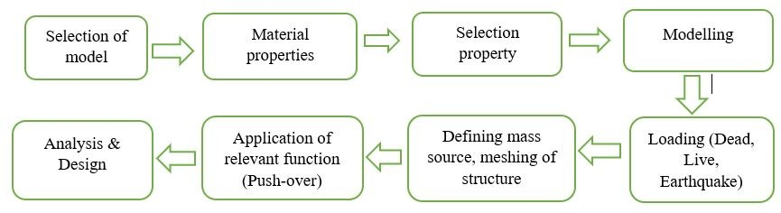

Figure 3.1: Flow chart for procedure in SAP2000

##### Type of part model

A square shaped grid model is prepared for the analysis purpose. The fixed type of restraints are taken during the modeling of structure.

##### Type of material

The structure is made up of a composite material consisting of a reinforcements (rebars) and concrete. The rebars are of the grade Fe500 MPa and the concrete is of grade M20, as per the guidelines specified by IS: 1893:2016 and IS: 13920:2016.

##### Section properties

Rectangular, square and circular sections can be assigned for beam and column members. The slab members are assigned as thin-membrane section in software. For the slabs, we may assign them according to aspect ratio .i.e. one-way and two-way slabs.

##### Modelling

By considering all the above parameters a model has been prepared in the rect- angular grid manner.

##### Loading

Loads coming over the structures are considered according IS standards as per the use of the structure i.e. Residential or Commercial and accordingly they are assigned. The Live loads are generally considered in range of 2.5 kN/m2 or 3 kN/m2. The Dead loads are considered as 3 kN/m2 or 3.5kN/m2. The Earthquake loadings are considered according to IS: 1893:2016. Zone factor considered is IV, response reduction factor is 5, Importance factor 1.5 and spectral acceleration is considered by using time f acceleration which depends on soil condition, which is considered as medium soil.

##### Defining mass source and meshing to a structure

Mass of the structure i.e. self-weight as well as additional mass due to surface loads line loads, usually DL +LL. SAP2000 has 3 options to define mass source

* + - 1. Element mass source: - Defines mass using mass per unit volume of material defined and it also considers additional load like live load and dead load.
      2. Additional mass source: - It includes additional loads like cladding etc.
      3. Specified mass source: - It is the best way to define loads, as per IS: 1893: 2016 consider dead load as 100% and live load as 25%.

Meshing helps us to make the structure to behave as a single structure throughout and this helps the structure to act like box type.

##### Assigning of function

Assigning of the function helps for further analysis of structure. This functions include Response spectrum, Time history function, Push-over function etc. As- signing of function varies according to the needs of user.

##### Analysis and Design

After performing all the above steps, model is run and analysis is carried out. The modelled is checked for the different parameters and all members are analysed. If any of the member is failed it can be replaced with another section and it can be made safe.

#### Method of analysis

The analysis for any structure can be carried out using following methods, 1.Linear static analysis

1. Linear dynamic analysis
2. Nonlinear static analysis 4.Nonlinear dynamic analysis
3. **Linear static method**

This method is used for estimation of demands of structure whose response is dominated by primary mode and is allowed to behave in elastic range. Lateral loads are based primarily on time period of structure. This method is also known as equivalent static method.

1. **Linear dynamic analysis**

This method of analysis is used for the estimation of demands of structure whose response is dominated by more than one node, this method is used to estimate the demand of any structure.

The linear dynamic analysis is further classified as response spectrum method of analysis. Using response spectrum method the big values of displacements and member forces in every mode can be identified by using smooth spectra which is common for numerous earthquakes.

1. **Nonlinear staticanalysis**

Analysis is carried under predominant vertical load and by increasing the load slightly which helps to determine the deformations in the buildings. The perfor- mance of the structure is checked by using capacity curves. The nonlinear static analysis is also called as push over analysis.

1. **Nonlinear dynamic analysis**

This method is a combination of ground motion with detailed structural model. In this model is subjected to ground motion record which produces checks of part distortions for each degree of freedom. This method is further classified as time history method, analysis is carried out by using the old earthquake records.

#### Software validation

The software validation is the process of checking whether the software works as per the specification given by the user and also helps to check that it gives us correct results. So for the software validation I have considered following problem.

**Problem statement**

4 storey square RC frames is to be constructed in Pune as shown in Figure3.2. Work out seismic forces on a structure by seismic coefficient method using IS 1893:2016. All beams and columns having size 300 x 400 mm. Thickness of roof and floor slab=120 mm. Thickness of wall=150 mm around it. Height of floor=3m. Density of concrete=25 kN/m3. Live load=4 kN/m2.



Figure 3.2: Grid plan

**Calculations of base shear for software validation:**

**1.) Calculation of seismic weight of roof level:**

W4 = Column + Beam + Slab + Wall + Live load

= (1.5x0.3x0.4x25x25) + (40x8x0.3x0.4x25) + (32x32x0.12x25) + [320x9]+0

= 7024.5 kN

Seismic weight of other floors,

W3=W2=W1= Column + Beam + Slab + Wall + Live load

= (25x3x0.3x0.4x25) + (40x8x0.3x0.4x25) + (32x32x0.12x25) + [320x9] + (32x32x2)

W3=W2=W1= 9185 kN

1. **Calculation of total seismic weight:**

W=W1 + W2 + W3 + W4

= (3x9185) + 7024.5

= 34579.5 kN

1. **Calculation of horizontal seismic:**

*Ah* = *Z X I X Sa*

2 *R g*

Z= Zone factor = Zone III = 0.16 ———- For Pune

I= Importance factor = 1 ———- For residential buildings

R= Response reduction factor =5 ——- For RC special moment resisting frame Sa/g=2.5 ———- soil type (medium type)

Ta = 0.09h/*d*0*.*5

=0.09 x 12 / 320*.*5

= 0.1909188 sec.

Sa/g= 2.5 (medium soil type) Ah = 0.16/2 x 1/5 x 2.5

= 0.04

1. **Calculation of base shear:**

Vb= Ah.W

= 0.04 x 34579.5

= 1383.18 kN

1. **Calculation of lateral forces at each floor:**

*Qi* = *Vb.Wi.h*2*/* Σ *Wi.h*2

*i*

*i*

Σ *Wi.h*2= 9185 x 32 + 9185 x 62 + 9185 x 92 + 7024.5 x 122

*i*

= 2168838 kN

Q1= 1383.18 x 9185 x 32 / 2168838

= 52.71 kN

Q2 = 1383.18 x 9185 x 62 / 2168838

= 210.87 kN

Q3 = 1383.18 x 9185 x 92 / 2168838

= 474.47 kN

Q4 = 1383.18 x 7024.5 x 122 / 2168838

= 645.10 kN

Software base shear = 1458 kN as shown in Figure3.3

##### % Variation = 5.13 %

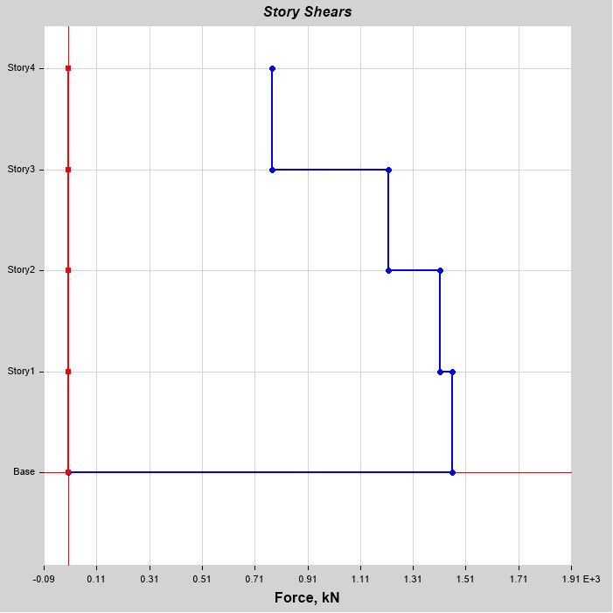

Figure 3.3: Base shear by software

#### Fragility Curve

The fragility curves are traced by using the Non-linear static analysis, in which the results are interpreted based on the capacity curves obtained after analysis. Based on results of capacity curves we can trace the fragility curves. The research work is carried out using the work done by A. H. Barbat, Pugade et.al.For the tracing of the fragility curve the guidelines given by HAZUS technical manual are used]. The procedure carried to trace the fragility curve is as follows,

1. The equation for the fragility curve is given by,

1

*P* (*d /s* ) = *φ*[

*log*( *sd* )]

*s d βd*

*s*

*sd, ds*

Where,

sd,ds = Threshold spectral displacement for a given damage state. *β*ds= Standard deviation of natural logarithm of the damage state. *φ* = Standard normal cumulative distribution function.

sd = Spectral displacement of the structure.

1. The value of beta ( *β*) is found by using the HAZUS technical manual, by referring the article 5. The value of beta depends on the type of the con- struction viz. timber, steel, composite, reinforced concrete etc. . . the age of the structure, and accordingly the values from different codes are used. The codes include high-code, moderate code, low code and pre-code.

The high code includes the structures which are constructed recently, the moderate code includes the structure which are constructed about 20-25 years ago, the low code includes the structure which are old and constructed about 50 years ago and the pre-code includes the structures which are constructed earlier during pre-independence period.

1. Determine the values of “Du and Dy” based on the capacity curves.
2. Determine the damage states in the structure by using the values tabulated in table 4.1.

|  |  |
| --- | --- |
| **Damage states** | **Spectral displacements** |
| Slight damage (sd1) | 0.7 Dy |
| Moderate damage (sd2) | Dy |
| Severe damage (sd3) | Dy + 0.25 (Du-Dy) |
| Complete damage (sd4) | Du |

Table 3.1: Spectral displacement for different damage states

1. The suitable spectral acceleration values are selected and the fragility curves are traced for different damage states and for different spectral acceleration values. The procedural steps for tracing of the fragility curve is shown by using a tree diagram, which is as shown,

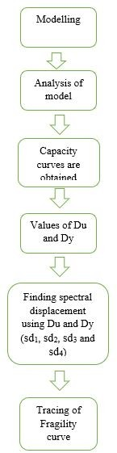

#### Closure

In the current chapter we have studied methodology for tracing of the fragility curve after capacity curve have traced, now in the chapter 4 discussion regard- ing modelling and analysis of the structure by using a comparative study of two building structures using grid plane is being carried out. The parameters that are considered during the analysis are tabulated separately.

## Chapter 4

**Modelling And Analysis**

#### Problem statement

This chapter includes the procedure adopted for the modelling and analysis of the grid plan. The overall modelling is carried using SAP2000 by using Response spectrum analysis of Non-linear dynamic analysis.

#### Problem statement

Analysis of regular building with G+11 stories have been carried out. The building is assumed to be located in zone IV. The analysis is carried by Seismic approach coefficient method by using SAP2000 software as shown in Figure4.2and4.3.

The seismic response of the building in terms of the Storey displacement, spectral acceleration have been evaluated. The size of the building in plane is 25 m x 25 m. All supports are considered to be fixed. Other specification considered for the plan are considered as below in Table4.1.

Table 4.1: Parameters for modelling

|  |  |  |
| --- | --- | --- |
| **Description** | **Sizes (mm)** | |
| **New building** | **Old building** |
| Beam size | 230 x 450 | 230 x 450 |
| Column size | 450 x 600 | 450 x 600 |
| Slab thickness | 150 | 150 |
| External wall | 230 | 230 |
| Internal walls | 150 | 150 |
| Height of floor | 3000 | 3000 |
| Grade of concrete | Fe500 MPa | Fe400 MPa |
| Grade of concrete | M25 MPa | M20 |
| Size of rebars used | 20 and 16 | 20 and 16 |
| Size of rebars for stirrups | 8 | 8 |
| Number of bays in X and Y direction | 5 NOS | 5 NOS |
| Spacing between bays | 5000 | 5000 |

Spacing between bays 5000mm X 5000mm The size of beam and column are se- lected after analyzing and designing of the sections. The columns which are unsafe at initial analysis are revised by using the given sections and are made safe.

The parameters taken for the old building model are taken as per IS 15988 code of retrofiting. The modification factor (Knowledge factor) considered as a multi- plying factor is 0.8, which is given in Table4.1of IS 15988 [].](#_bookmark119)

The storey data for the modeling is as tabulated in Table4.2,

Table 4.2: Storey data

|  |  |  |  |  |
| --- | --- | --- | --- | --- |
| **Name** | **Height (m)** | **Elevation (m)** | **Similar To** | **Splice Story** |
| Story12 | 3 | 34 | None | No |
| Story11 | 3 | 31 | Story12 | No |
| Story10 | 3 | 28 | Story12 | No |
| Story9 | 3 | 25 | Story12 | No |
| Story8 | 3 | 22 | Story12 | No |
| Story7 | 3 | 19 | Story12 | No |
| Story6 | 3 | 16 | Story12 | No |
| Story5 | 3 | 13 | Story12 | No |
| Story4 | 3 | 10 | Story12 | No |
| Story3 | 3 | 7 | Story12 | No |
| Story2 | 3 | 4 | Story12 | No |
| Story1 | 3 | 1 | Story12 | No |
| Base | 0 | 0 | None | No |

Loads considered during the analysis are as follows:

1. **Gravity loads**

The intensity of dead load and live load at various floor levels considered in the study are listed below.

1. **Dead load –**

Weight of Slab = 3.75 kN/*m*2 Weight of Floor Finish = 1.5 kN/*m*2

1. **Live Load**

Live Load at all floor levels has been taken as 2 kN/*m*2.

1. **Seismic Load**

IS 1893(part I) is used for seismic load calculations. The mass of the building is supposed to be lumped at the floor levels. The weight of columns, beams and walls have been equally distributed to the floors above and below. The floor load includes the self-weight of the floor load as per the codal provisions. For the purpose of analysis, the following seismic factors were considered.

* 1. Response Reduction factor = 5 (SMRF)
  2. Importance factor = 1.2
  3. Zone factor = 0.24 (Zone IV)
  4. Damping ratio = 5%
  5. Soil type = Type II
  6. Imposed load = 2 kN/*m*2

1. **Load Patterns**

The load patterns cosidered during the analysis are tabulated in Table4.3.

Table 4.3: Load pattern

|  |  |  |  |
| --- | --- | --- | --- |
| **Name** | **Type** | **Self-Weight Multiplier** | **Auto Load** |
| Dead | Dead | 1 | IS 875 (Part 1) |
| Live | Live | 0 | IS 875 (Part 2) |
| Super Dead (F.F.) | Dead | 0 |  |
| EQ-x | Seismic | 0 | IS1893(Part1):2016 |
| EQ-y | Seismic | 0 | IS1893(Part1):2016 |

1. **Function**

Response spectrum functions as shown in Table4.4.

Table 4.4: Response spectrum function

|  |  |  |  |  |  |
| --- | --- | --- | --- | --- | --- |
| **Name** | **Period Sec** | **Acceleration** | **Damping Ratio** | **Z** | **Soil Type** |
| IS RS | 0 | 0.336 | 0.05 | 0.24 | II |
| IS RS | 0.1 | 0.84 |  |  |  |
| IS RS | 0.55 | 0.84 |  |  |  |
| IS RS | 0.8 | 0.5712 |  |  |  |
| IS RS | 1 | 0.457 |  |  |  |
| IS RS | 1.2 | 0.3808 |  |  |  |
| IS RS | 1.4 | 0.3264 |  |  |  |
| IS RS | 1.6 | 0.2856 |  |  |  |
| IS RS | 1.8 | 0.2539 |  |  |  |
| IS RS | 2 | 0.2285 |  |  |  |
| IS RS | 2.5 | 0.1828 |  |  |  |
| IS RS | 3 | 0.1523 |  |  |  |
| IS RS | 3.5 | 0.1306 |  |  |  |
| IS RS | 4 | 0.1142 |  |  |  |
| IS RS | 4.5 | 0.1142 |  |  |  |
| IS RS | 5 | 0.1142 |  |  |  |
| IS RS | 5.5 | 0.1142 |  |  |  |
| IS RS | 6 | 0.1142 |  |  |  |
| IS RS | 6.5 | 0.1142 |  |  |  |
| IS RS | 7 | 0.1142 |  |  |  |
| IS RS | 7.5 | 0.1142 |  |  |  |
| IS RS | 8 | 0.1142 |  |  |  |
| IS RS | 8.5 | 0.1142 |  |  |  |
| IS RS | 9 | 0.1142 |  |  |  |
| IS RS | 9.5 | 0.1142 |  |  |  |
| IS RS | 10 | 0.1142 |  |  |  |

After assigning all the seismic parameters, the modelling for push-over analysis is carried out. The performance and the damage state of the structure is determined by using push-over analysis.

The performance of any building frame is a combination of the performance of all its structural and non-structural components. The performance levels are discrete

damage states identified from a continuous spectrum of possible damage states. The structural performance levels based on the roof drifts are as follows (FEMA 356, 2000).

1.Immediate occupancy (IO) 2.Life safety (LS)

3.Collapse prevention (CP)

The nonlinear procedures of FEMA require definition of the nonlinear load- deformation relation. Such a curve showing a typical load deformation relation and target performance levels curve is shown in Figure4.1.

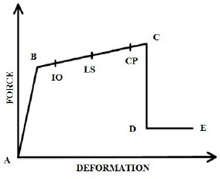

Figure 4.1: Typical force-deformation curve showing performance levels

It is a piece-wise linear curve defined by five points as explained above.

1.Point A. corresponds to no load condition.

2.Point B. corresponds to the start of yielding

3.Point C. corresponds to the ultimate strength.

4.Point D. corresponds to the residual strength.

For computational stability, it is recommended to specify non-zero residual

strength beyond C. In absence of the modelling of the descending branch of a load versus deformation curve, the residual strength can be assumed to be 20% of the yield strength.

5.Point E.

Corresponds to the maximum deformation capacity with the residual strength. To maintain computational stability, a high value of deformation capacity is assumed.

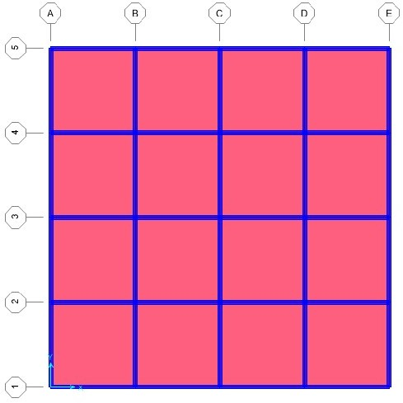

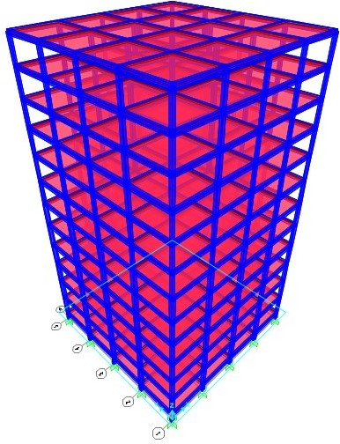Figure 4.2: Plan model in SAP2000

Figure 4.3: Plan model in SAP2000

#### Closure

In the current chapter, discussion regarding the modelling of the structure is car- ried out. In chapter 5 discussion regarding the results obtained after analysis is tabulated by considering the different parameters.

## Chapter 5

**Results And Discussion**

#### Parameters

##### Max. storey drift for new building model and old building model:

Maximum storey drift for new building model and old building model are tabulated in Table5.1and shown in Figure5.1.

Table 5.1: Maximum storey drift

|  |  |  |  |  |
| --- | --- | --- | --- | --- |
| **Story** | **Elevation (m)** | **Location** | **New building model** | **Old building model** |
| Base | 0 | Top | 0 | 0 |
| Plinth | 1 | Top | 0.0155 | 0.0524 |
| Story1 | 4 | Top | 0.0232 | 0.10369 |
| Story2 | 7 | Top | 0.0277 | 0.1169 |
| Story3 | 10 | Top | 0.0285 | 0.1153 |
| Story4 | 13 | Top | 0.0275 | 0.1093 |
| Story5 | 16 | Top | 0.0257 | 0.10047 |
| Story6 | 19 | Top | 0.0235 | 0.09101 |
| Story7 | 22 | Top | 0.0211 | 0.08125 |
| Story8 | 25 | Top | 0.0186 | 0.07136 |
| Story9 | 28 | Top | 0.0016 | 0.06142 |
| Story10 | 31 | Top | 0.0135 | 0.05148 |
| Story11 | 34 | Top | 0.011 | 0.0416 |

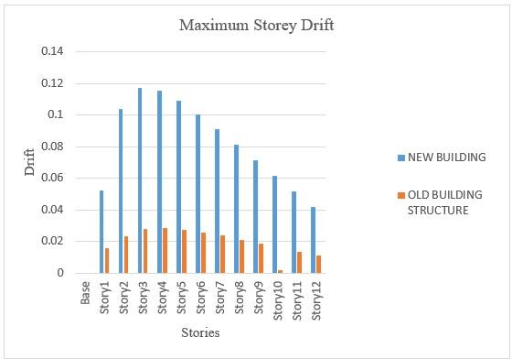

Figure 5.1: Maximum storey drift

##### Moment for new building model and old building model

Moment for new building model and old building model are tabulated in Table 5.2and shown in Figure5.2.

Table 5.2: Maximum moment (kN.m)

|  |  |  |  |  |
| --- | --- | --- | --- | --- |
| **Story** | **Elevation** | **Location** | **New building model** | **Old building model** |
|  | m |  | kN-m | kN-m |
| Base | 0 | Top | 2300 | 2132 |
| Plinth | 1 | Top | 2241 | 1998 |
| Story1 | 4 | Top | 1978 | 1902 |
| Story2 | 7 | Top | 1896 | 1896 |
| Story3 | 10 | Top | 1782 | 1603 |
| Story4 | 13 | Top | 1569 | 1415 |
| Story5 | 16 | Top | 1349 | 1215 |
| Story6 | 19 | Top | 1245 | 1045 |
| Story7 | 22 | Top | 1011 | 997 |
| Story8 | 25 | Top | 916 | 869 |
| Story9 | 28 | Top | 840 | 789 |
| Story10 | 31 | Top | 770 | 695 |
| Storey 11 | 34 | Top | 0 | 0 |

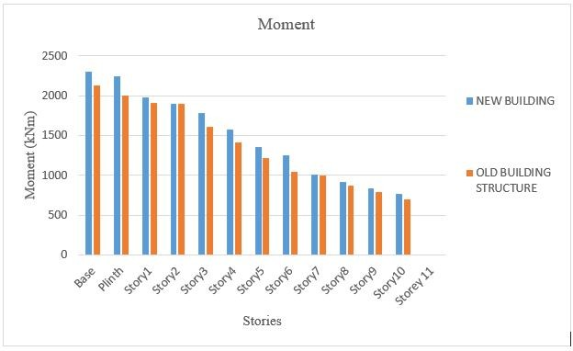

Figure 5.2: Maximum moment (kN.m)

##### Spectral displacement for new building model and old building

**model:**

Spectral displacement for new building model and old building model are tabulated in Table5.3and shown in Figure5.3.

Table 5.3: Spectral displacement (mm)

|  |  |  |  |
| --- | --- | --- | --- |
| **Story** | **Elevation** | **New building** | **Old building** |
|  | m | mm | mm |
| Base | 0 | 0 | 0 |
| Plinth | 1 | 3.257 | 5.44 |
| Story1 | 4 | 10.221 | 10.52 |
| Story2 | 7 | 18.537 | 19.15 |
| Story3 | 10 | 27.089 | 29.01 |
| Story4 | 13 | 35.347 | 37.69 |
| Story5 | 16 | 43.059 | 49.55 |
| Story6 | 19 | 50.103 | 55.64 |
| Story7 | 22 | 56.422 | 61.356 |
| Story8 | 25 | 61.99 | 69.706 |
| Story9 | 28 | 66.796 | 77.89 |
| Story10 | 31 | 70.839 | 82.35 |
| Story11 | 34 | 74.13 | 89.56 |

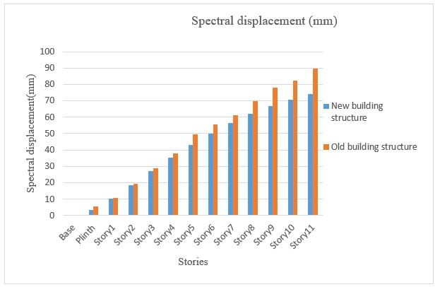

Figure 5.3: Spectral displacement (mm)

##### Ductility ratio for new building model and old building model:

Ductility ratio for new building model and old building model are tabulated in Table5.4and shown in Figure5.4.

Table 5.4: Ductility ratio

|  |  |  |  |
| --- | --- | --- | --- |
| **Story** | **Elevation (m)** | **New building** | **Old building** |
| Base | 0 | 0 | 0 |
| Plinth | 1 | 2.89 | 3.69 |
| Story1 | 4 | 4.69 | 5.98 |
| Story2 | 7 | 7.69 | 8 |
| Story3 | 10 | 8.96 | 9.86 |
| Story4 | 13 | 9.95 | 11.89 |
| Story5 | 16 | 11.87 | 13.25 |
| Story6 | 19 | 13.96 | 15.68 |
| Story7 | 22 | 15.49 | 17.96 |
| Story8 | 25 | 17.89 | 19.98 |
| Story9 | 28 | 19.12 | 21.36 |
| Story10 | 31 | 21.25 | 23.69 |
| Story11 | 34 | 23.35 | 25.69 |

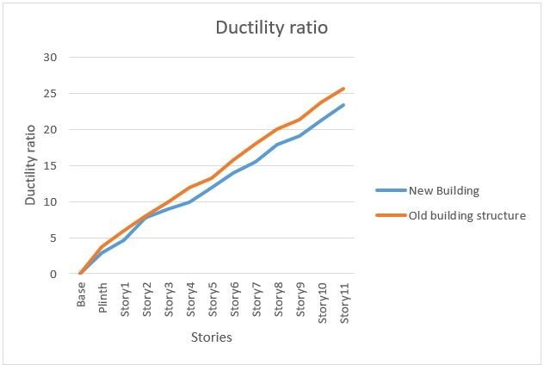

Figure 5.4: Ductility ratio

#### Failure patterns

The Failure patterns for different modes of failure occuring at hinges are shown as below.

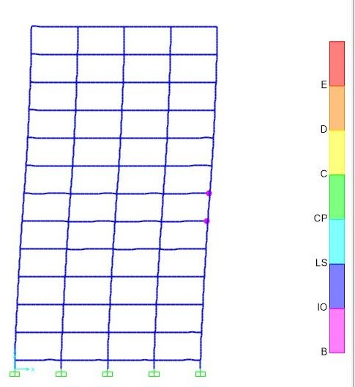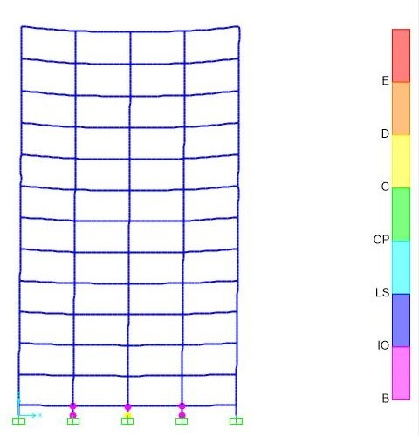(a) Step 1 for new building model (b) Step 1 for old building model

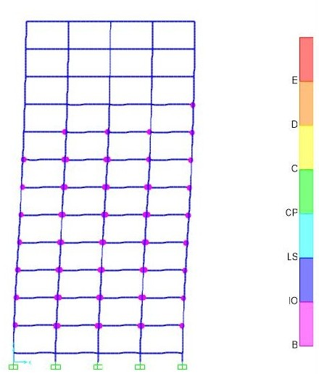 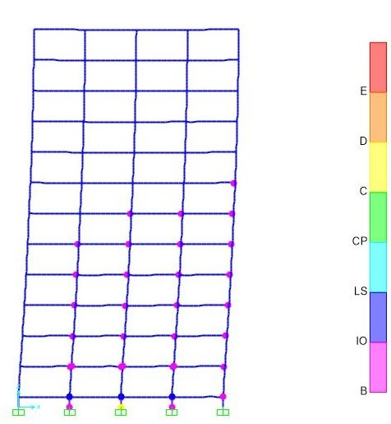

(a) Step 2 for new building model (b) Step 2 for old building model

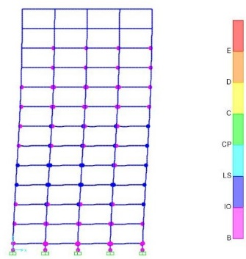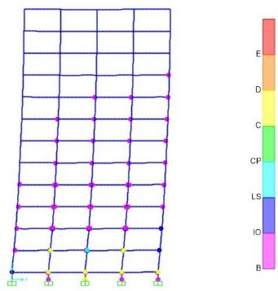

(a) Step 3 for new building model (b) Step 3 for old building model

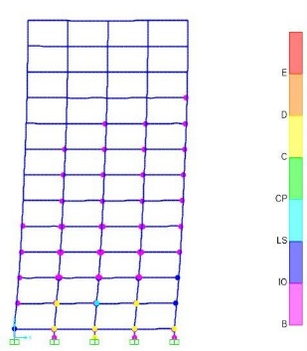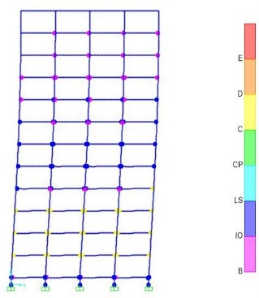

(a) Step 4 for new building model (b) Step 4 for old building model

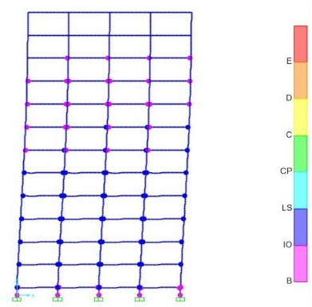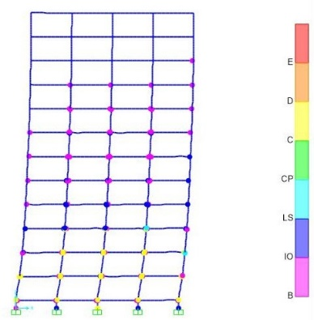

(a) Step 5 for new building model (b) Step 5 for old building model

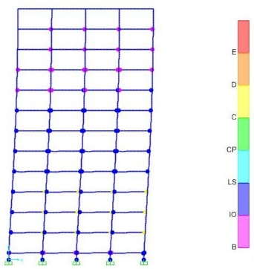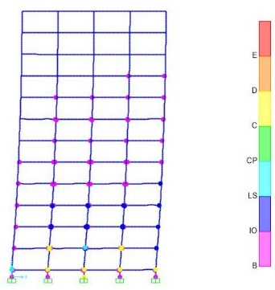

(a) Step 6 for new building model (b) Step 6 for old building model

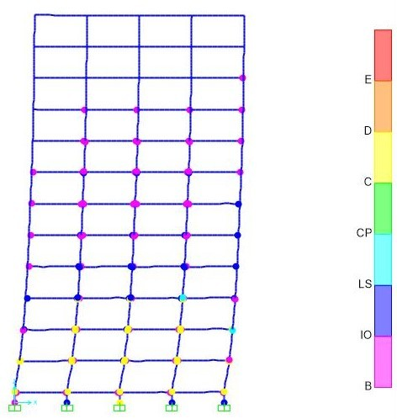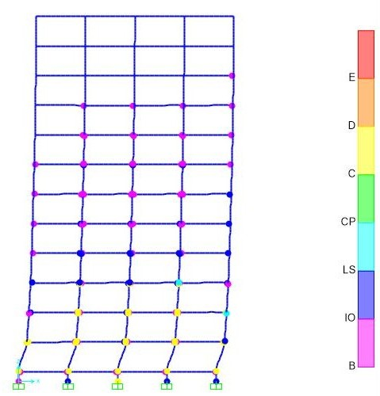

(a) Step 7 for new building model (b) Step 7 for old building model

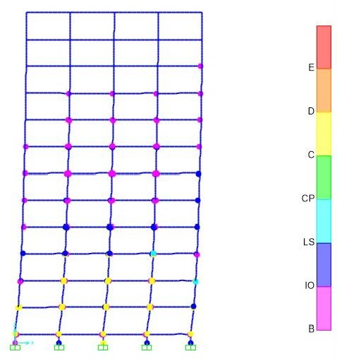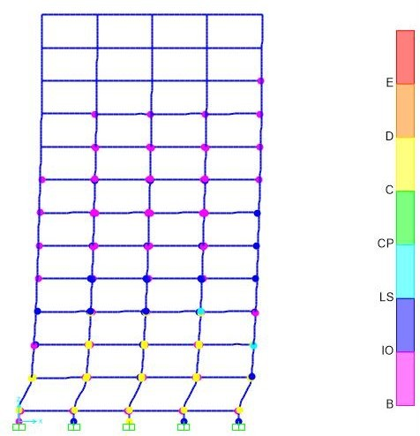

(a) Step 8 for new building model (b) Step 8 for old building model

The failure pattern obtained after the analysis helps to the determine the damage levels in a particular structure. From the analysis carried out, the damage level in old building structure is observed to be more as compared to that of new building model. From the figures we can observe the hinge formations at the joints and accordingly this helps to determine the damage levels in the structure.

The damage levels are observed for different steps. In the current study analysis is carried out for the 8 steps of damage levels. From the damage step level observed, the damage state in new building structural model is less and hence in general the damage level is considered as the moderate level of damage.

The damage level observed for different steps in old building structure is more as compared to that of new building structural model. It is observed that at step 8 the damage level is observed to be severe and it requires some techniques to prevent the damages.

#### Capacity curve for new building and old building model

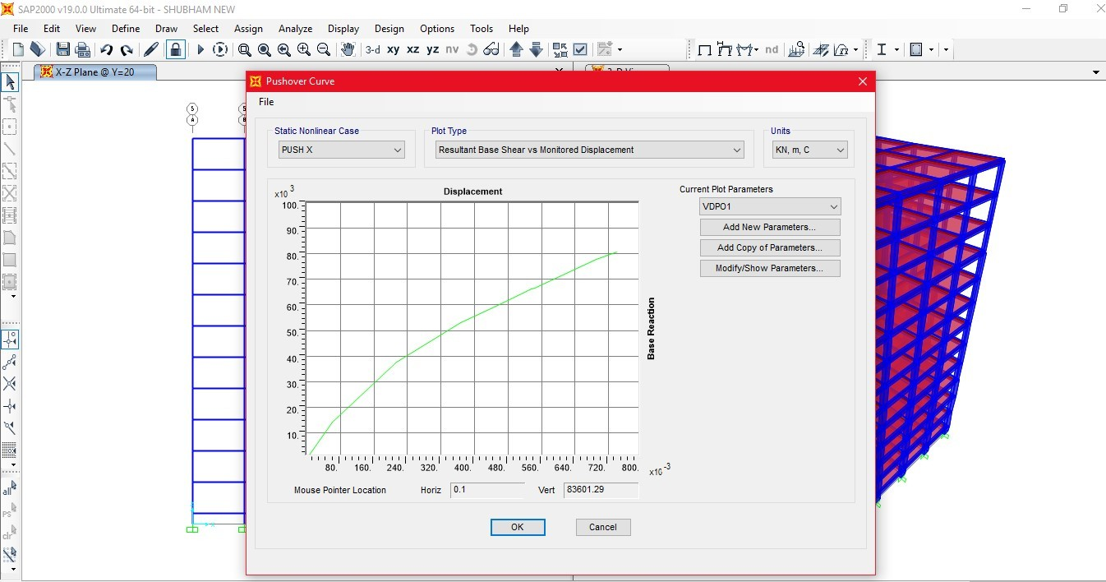The capacity curve for new building and old building model are shown in Figure 5.13and5.14.

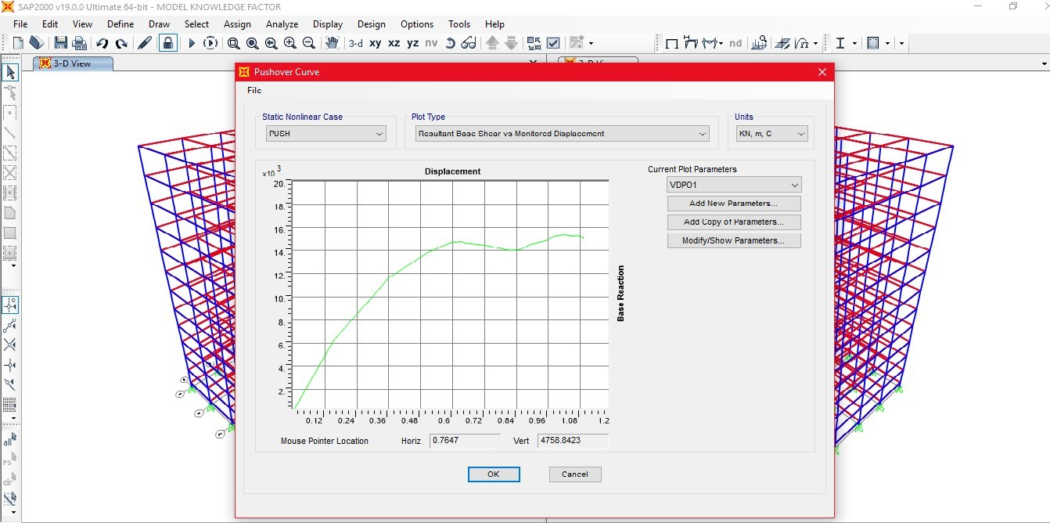Figure 5.13: Capacity curve for new building structure

Figure 5.14: Capacity curve for old building structure

#### Fragility curve for new building and old building model

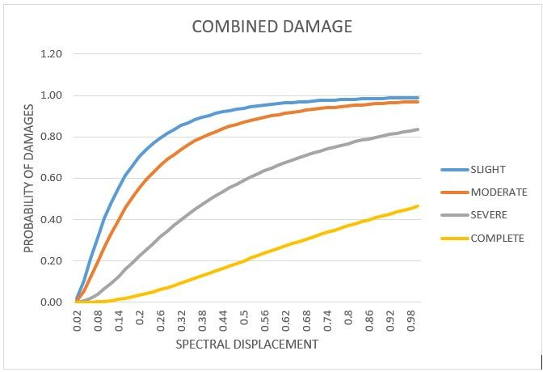The fragility curve for new building and old building model are shown in Figure 5.15and5.16.

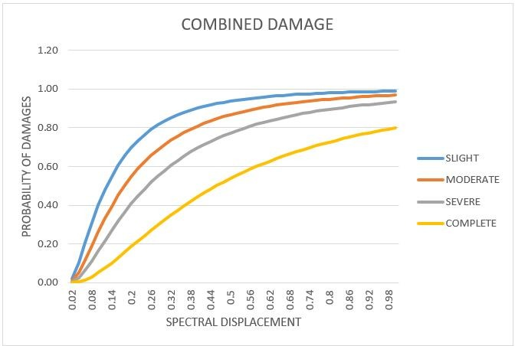Figure 5.15: Push over curve for new building structure

Figure 5.16: Push over curve for old building structure

## Chapter 6

**Case Study of an existing building in the Pune**

#### General

For seek of the case study the building situated in Pune is being selected which is shown in Figure6.1and6.2. The building is a G+3 storied reinforced structureconstructed about 27 years ago. Since it is an old structure it is considered for the case study. The parameters which are present in the structure are tabulated Table6.1. The moedlling of the case study plan is carried out using SAP2000 as shown in Figure6.3and6.4.

Table 6.1: Parameters present in structure

|  |  |
| --- | --- |
| **Parameters** | **Description** |
| No. of stories | G+3 |
| Grade of concrete | M20 |
| Grade of steel | Fe415 |
| Year of construction | 1989 |
| Proximity to sea | Nearly 8 km |
| Size of beam | 230 x 380 |
| Size of column | 230 x 450 |
| Exterior walls | 230mm |
| Shape of structure | Rectangular building |

During the study, firstly, the structural auditing is carried out and the strength of every components are determined by using NDT. The NDT includes reboundhammer test, ultra sonic pulse velocity test (UPV), potentiometer test and core testing. After the NDT the results are analysed and accordingly the retrofitting work is carried out. The retrofitting work includes filling of minor cracks, wa- terproofing operations and column jacketing for weak columns. The comparative analysis of the structure is carried out by comparing the results obtained after NDT and then after the retrofitting work. The comparison is carried out for the different damage states and its percentage change is measured.

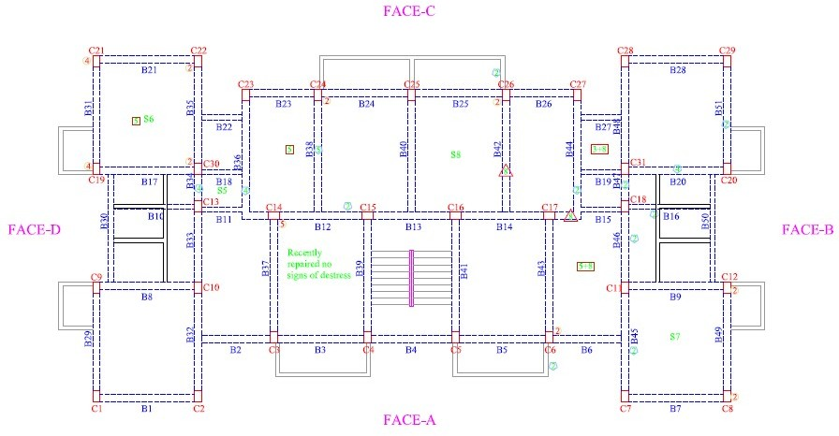

Figure 6.1: Case study plan drawn using Auto-CAD of existing building located at Pune

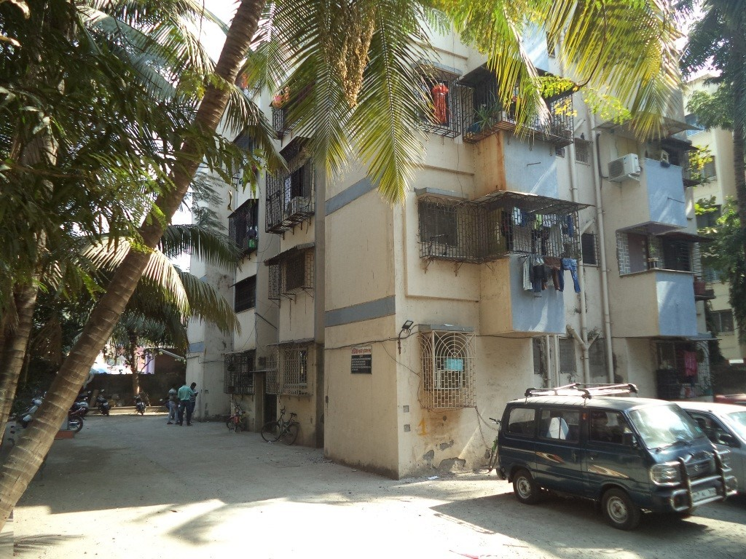Figure 6.2: Existing structure plan for building located at Pune

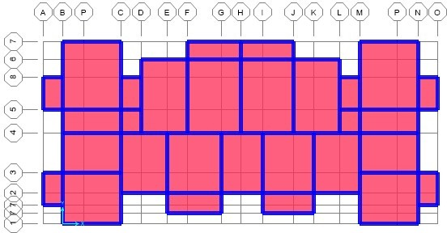

Figure 6.3: Case study plan modelled using SAP200 (Plan view)

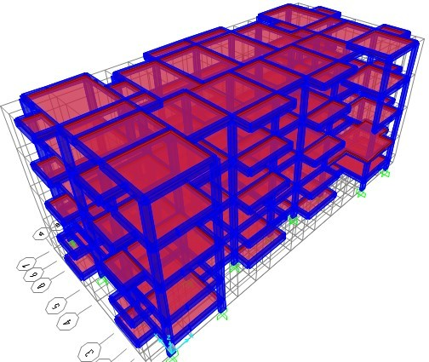

Figure 6.4: Case study plan modelled using SAP200 (Elevation view)

#### Tests conducted:

**Rebound hammer test**

It is a non-destructive test carried on the concrete which helps to determine com- pressive strength of concrete conveniently and rapidly.It consists of a device which consists of spring controlled mass that slides on plunger within the tubular instru- ment. As per IS: 13311(2)-1992 22], the main objective of this test is,

* + 1. To determine compressive strength by relating rebound index and compres- sive strength.
    2. To determine quality of concrete based on strength. The quality of concrete is determined by using the standard values which are tabulated in Table6.2.
    3. The sample reading taken for the rebound hammer test is shown in Figure 6.5.

Table 6.2: Standard values for rebound hammer test

|  |  |
| --- | --- |
| **Rebound value** | **Quality of concrete** |
| Greater than 40 | Very good hard layer |
| 30 to 40 | Good layer |
| 20 to 30 | Fair layer |
| Less than 20 | Poor concrete |
| 0 | Delaminated |

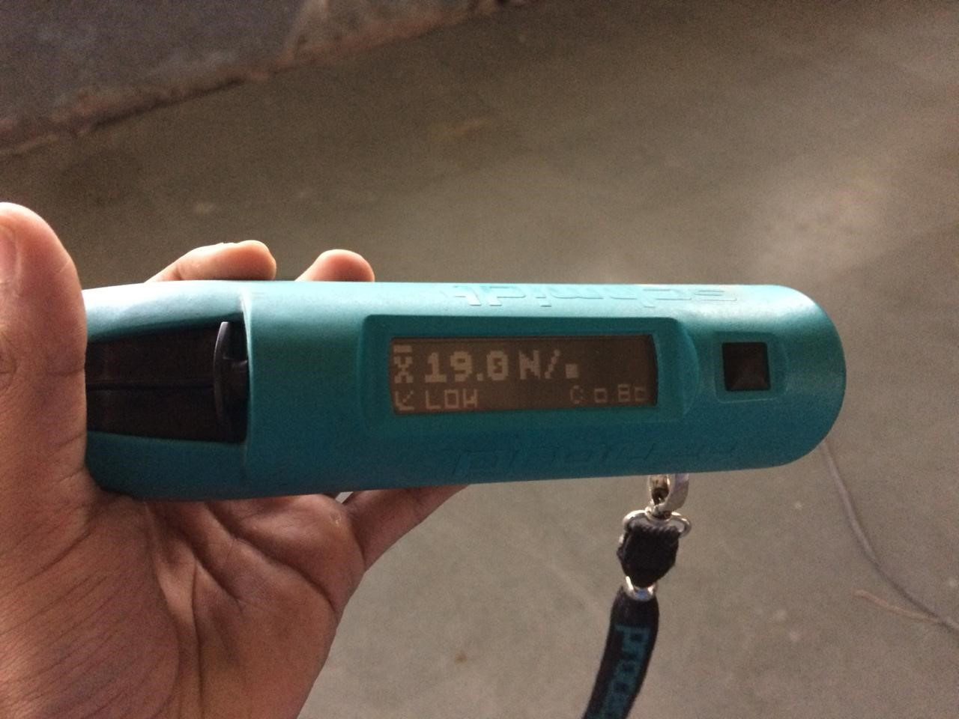Figure 6.5: Rebound hammer readings

Results tabulated in the Table6.3indicates the minimum and maximum values taken for structural components of the structure. The values shown in the table shows that the structure requires immediate retrofitting work to avoid further deterioration of the structure.

Table 6.3: Minimum and maximum Rebound hammer values for structural components

|  |  |  |
| --- | --- | --- |
| **Member** | **Rebound Hammer Test Values (in MPa)** | |
| **Maxi.** | **Mini.** |
| Column | 22.2 | 14.2 |
| Beam | 21.8 | 12.8 |
| Slab | 19.8 | 15.2 |

**Ultra sonic pulse velocity test**

It is another nondestructive test to check the quality of concrete as well as natural rocks. In this test the strength is measured by calculating the time required by the ultra-sonic pulse to pass through the particular structural component. If the time required by the pulse is more it is considered as the concrete is in the good condition and if the pulse travels immediately the concrete is considered to be the worst concrete. The test is conducted by using the specifications given by IS 13311-1992.

The quality of concrete can be determined by considering the pulse velocity values tabulated in Table6.4.

Table 6.4: Standard values for ultrasonic pulse velocity test

|  |  |
| --- | --- |
| **Pulse velocity (km/sec)** | **Concrete quality** |
| Above 4.5 | Excellent |
| 3.5 to 4.5 | Good |
| 3.0 to 3.5 | Medium |
| Below 3.0 | Doubtful |

**Half-cell potentiometer test**

This test is used to measure the corrosion in reinforcement by means of an elec- trical resistance between and the reinforced bar and the surface. In this process the reinforced steel act as an electrode and the surface acts an electrolyte. The corrosion activity can be evaluated by means of the potential gradient; higher is the potential gradient, higher the risk of corrosion and vice versa. The limitation

of this test is that it does not tell us the actual corrosion rate, but it tells us the probability of the corrosion activity depending on the surrounding condition of the surface. The corrosion rate can be evaluated by using following values which are tabulated in table6.5.

Table 6.5: Standard half-cell potentiometer values

|  |  |
| --- | --- |
| **Half-cell potential (mV)** | **% chances of corrosion activity** |
| Less than -200 | 10% |
| -200 to -350 | 50 % (uncertain) |
| Above -350 | 90% |

**Core sampling**

Core sampling is the process in which the samples are extracted from the sections by using the drillers. The drilling machine consist of different sizes of bites and by using this bites the samples are extracted as shown in Figure6.6. The extracted sample are than taken for testing, thePhenolphthale inindicators are spread over the samples and if the colour turns to pink the samples are said to be affected and has less strength.

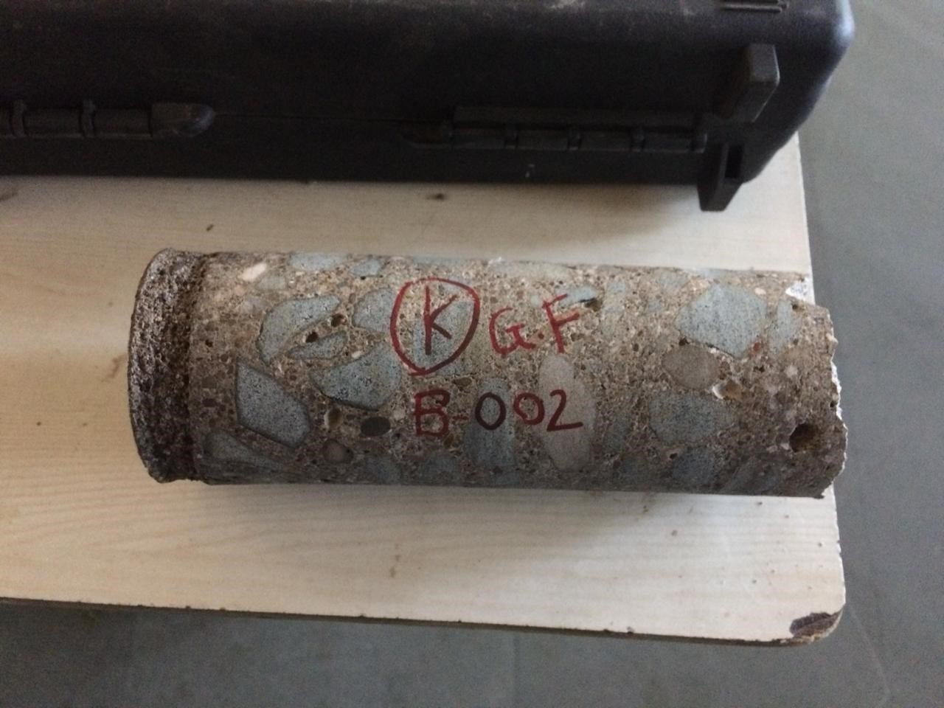

Figure 6.6: Core samples extracted from column section

#### Results and discussion

The results obtained after NDT and retrofitting work are tabulated in Table6.6. which shows the different damage states in the structure.

Table 6.6: Spectral displacement for different damage states

|  |  |  |  |  |  |
| --- | --- | --- | --- | --- | --- |
| **Damage**  **states (Sd)** | | **Slight**  **damage** | **Moderate**  **damage** | **Severe**  **damage** | **Complete**  **damage** |
| **Threshold displacement** | **Structure without**  **retrofiting** | Sd1=  0.026754 | Sd2= 0.038221 | Sd3= 0.149319 | Sd4= 0.482613 |
| **Structure**  **with retrofiting** | Sd1= 0.030254 | Sd2= 0.043220 | Sd3= 0.165637 | Sd4= 0.53289 |
| *β* | 0.92 | 0.91 | 0.85 | 0.97 |

The percentage change for each damage states are tabulated in Figure6.7.

Table 6.7: Percentage variation in spectral displacement

|  |  |  |  |  |
| --- | --- | --- | --- | --- |
| **Damage**  **States** | **Slight**  **damage** | **Moderate**  **damage** | **Severe**  **damage** | **Complete**  **damage** |
| **Percentage variation** | 13.08% | 13.08% | 10.92% | 10.41% |

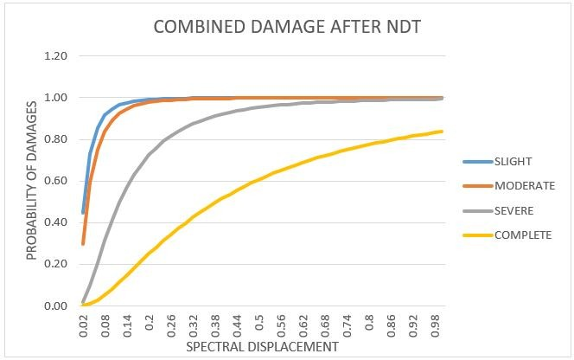The fragility curve traced for both the conditions are as shown in Figure6.7and Figure6.8.

Figure 6.7: Fragility curve for structure after NDT

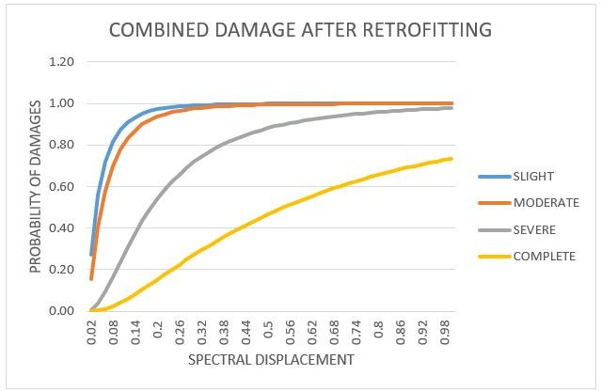Figure 6.8: Fragility curve for structure after retrofitting

#### Conclusion

After the analysis carried out for the case study plan, following results have been concluded;

* + 1. After the analysis is carried out for the case study plan following conclusions can be made, As the retrofitting work is carried out the % variation for different damage states are obtained and observed that there is a % variation of about 13.08% for slight damage, 13.08% for moderate damage, 10.92% for severe damage and 10.41% for complete damage.
    2. After retrofitting the spectral displacement have increased and since the prob- ability function is inversely proportional to spectral displacement, curve is found to be less stiffer as compared to that of the non-retrofitted model.
    3. Thus the fragility curve method helps to determine the probable damages in the structure.

#### Closure

In this chapter, the study and behavior of an old existing structure is carried out and the comparative results are discussed by tracing the fragility curves for both the structure. In chapter 8 the references used for the research work are enlisted.

## Chapter 7

**Conclusion**

#### Introduction

The chapter comprises of the conclusions which are obtained after the comparative analysis of the structural models and the discussion of the results are carried according to those results.

#### Conclusion

* + 1. The analysis carried out for new building structure and old building struc- ture shows that the fragility curves depends on the age of the structure .i.e. the fragility curve for old building structure is more stiffer than new building structure which shows that curve deflection depends on deviation parame- ters which is inversely proportional to probability function and shows that behavior depends on age of structure.
    2. From the analysis carried out it is found that the max. storey drift for new building varies by 39% as compared to that of new building model; moment for new building varies by 43% as compared to that of old building structure; spectral displacement for new building varies by 40% as compared to that with old building and the ductility ratio for the new building varies by 22% when compared with that of old building structure.
    3. The general failure pattern of the structure can be analyzed using this method and the failure patterns for different modes are shown in section 5.2. which shows that the modes of hinge failure are critical for old building structure as compared to that of new building structure. The hinge formation for old building structure is more critical compared to that of new building structure which shows that damages are more in old building structure.
    4. The overall analysis carried shows that response spectrum by Non-linear pushover analysis is more useful as compared to that of time history method of analysis for tracing of the fragility curves. Thus non-linear static pushover analysis method is more useful and less time consuming.

*Assessment of Multi-Storey RC Structure by Using Fragility Curve Method*

#### Future scope

* + 1. The fragility curve method can be used to calculate the damage levels in the infrastructural projects like evaluation of damage states for different types of bridges and its components, retaining structures, culvers, retaining walls etc.
    2. The method can also use for the evaluation of damages in the steel structures, like industrial sheds, storage sheds, silos etc.

### REFERENCES

[1]L. Astriana, S. Sangadji, E. Purwanto, and S. Kristiawan, “Assessing seismic performance of moment resisting frame and frame-shear wall system using seismic fragility curve,” *Procedia engineering*, vol. 171, pp. 1069–1076, 2017.

[2]D. D. o. H. S. F. E. M. A. F. . Washington, “Improvement of nonlinear static seismic analysis procedures,” 2015.

[3]P. Agarwal and M. Shrikhande, *Earthquake resistant design of structures*. PHI learning private limited, 2006.

[4]F. Hosseinpour and A. Abdelnaby, “Fragility curves for rc frames under multiple earthquakes,” *Soil Dynamics and Earthquake Engineering*, vol. 98, pp. 222–234, 2017.

[5]E. Brunesi and F. Parisi, “Progressive collapse fragility models of european re- inforced concrete framed buildings based on pushdown analysis,” *Engineering Structures*, vol. 152, pp. 579–596, 2017.

[6]K. G. Krishna *et al.*, “Fragility analysis–a tool to assess seismic performance of structural systems,” *Materials Today: Proceedings*, vol. 4, no. 9, pp. 10565– 10569, 2017.

[7]A. H. Barbat, L. G. Pujades, and N. Lantada, “Seismic damage evaluation in urban areas using the capacity spectrum method: application to barcelona,” *Soil Dynamics and Earthquake Engineering*, vol. 28, no. 10-11, pp. 851–865, 2008.

[8]I. Zentner, M. Gu¨ndel, and N. Bonfils, “Fragility analysis methods: Review of existing approaches and application,” *Nuclear Engineering and Design*, vol. 323, pp. 245–258, 2017.

[9]I. Ioannou, J. Douglas, and T. Rossetto, “Assessing the impact of ground- motion variability and uncertainty on empirical fragility curves,” *Soil Dy- namics and Earthquake Engineering*, vol. 69, pp. 83–92, 2015.

[10]C.-T. Dang, T.-P. Le, and P. Ray, “A novel method based on maximum likelihood estimation for the construction of seismic fragility curves using

numerical simulations,” *Comptes Rendus M´ecanique*, vol. 345, no. 10, pp. 678– 689, 2017.

[11]S. K. Tadinada and A. Gupta, “Structural fragility of t-joint connections in large-scale piping systems using equivalent elastic time-history simulations,” *Structural Safety*, vol. 65, pp. 49–59, 2017.

[12]S. Kwag and A. Gupta, “Computationally efficient fragility assessment using equivalent elastic limit state and bayesian updating,” *Computers & Struc- tures*, vol. 197, pp. 1–11, 2018.

[13]T. Rossetto, P. Gehl, S. Minas, C. Galasso, P. Duffour, J. Douglas, and

O. Cook, “Fracas: A capacity spectrum approach for seismic fragility assess- ment including record-to-record variability,” *Engineering Structures*, vol. 125, pp. 337–348, 2016.

[14]T. K. Mandal, S. Ghosh, and N. N. Pujari, “Seismic fragility analysis of a typical indian phwr containment: comparison of fragility models,” *Structural Safety*, vol. 58, pp. 11–19, 2016.

[15]S. N. A. Saruddin and F. M. Nazri, “Fragility curves for low-and mid-rise buildings in malaysia,” *Procedia Engineering*, vol. 125, pp. 873–878, 2015.

[16]V. Hosur, *Earthquake- Resistant Design of Building Structures*. WILEY Pre- cise Textbook, 2013.

[17]H. M. 4, “Technical manual for seismic resistant parameters,” 2015.

[18]B. of Indian Standards (IS456), “Plain and reinforced concrete- code of prac- tice(fourth revision),” 2007.

[19]B. of Indian Standards (IS 15988), “Indian standard for seismic evaluation and strengthening of existing reinforced concrete buildings - guidelines,” 2013.

[20]B. of Indian Standards (IS 1893), “Indian standard criteria for earthquake resistant design of structures, part 1: general provisions and building (sixth revision),” 2016.

[21]B. of Indian Standards (IS 13920), “Ductile design and detailing of reinforced concrete structures subjected to seismic forces—code,” 2016.

[22]B. of Indian Standards (IS 13311), “Indian standard code for non-destructive testing of concrete-methods of tests,” 1992.