MANIPAL INSTITUTE OF TECHNOLOGY
(A constituent Institute of Manipal University)
MANIPAL - 576 104, KARNATAKA, INDIA
MARCH 2017

Road safety Analysis using data mining approach

By

- Lakshita Garg
(140911222)
IT-B
Roll no. 28
Batch B1

- Sankalp kumar
(140911116)
IT-B
Roll no. 19
Batch B1

Under the Guidance of

Ms.Anju R

Mr.Nirmal Kumar Nigam

Mrs.Girija

INTRODUCTION:
India is one of the countries with highest accident rate. There is one death every four minutes due to road accidents in India. Even after multiple attempts by the Government and increased traffic security, no noticeable change has been observed in this figure. We have used the Data mining approach to arrive at a solution for this problem. Our project would aim at dividing the different states and union territories in the country into various zones based on their vulnerability and then use classification measures to determine major contributing factors for accidents in that given zone. This is done keeping in mind that results obtained are based on datasets of previous years and are subjected to change. These results will help us understand the causes for increased accident rate better and come up with solutions that are more specific.

- PROBLEM DEFINITION:
To improvise Road safety system of India and figure out exact causes for increased number of accidents. Also, ensure the causes are more area-specific making it easier for the government to implement rules or work further on them.

- OBJECTIVE:
Our objective is to analyze the data of road accidents available for various states and union territories of India to arrive at the primary causes that lead to accidents in a given area. Also, we study the states and the union territories of India against the contributing causes and the educational background of the driver to draw efficient conclusions in order to facilitate road safety in the country.

- SCOPE/IMPORTANCE OF PROJECT
The project can not only implement better road safety measures , but also help us understand what measures should be given more importance according to different zones of the country. This might lead to reduced number of accidents, saving numerous lives and avoiding damage to property. As the analysis is based on Indian states and union territories, the evaluated pattern and conclusions can be used for a more efficient and uniform Road system for the entire nation.

- METHODOLOGY
For the analysis, we will be first fetching all the data required using datasets available on dataset.gov.in. Then missing values will be taken care of and data will be normalized using data preprocessing techniques. We will work further by dividing various states and union territories into clusters using K-Means algorithm. The basis for this division will be the vulnerability of a given zone towards accidents according to the dataset available. The clusters formed will have labels (Very high, high, Medium and Low); based on the vulnerability analysis. Once clusters have been formed quality of clusters is then evaluated using “Within Cluster sum of squares” Method. And finally, Decision tree will be made use of to determine primary causes for a particular cluster using J-48 for implementation. We also tried implementing RANDOM FOREST method for classification but that gave us only an accuracy of 86% which was lower than accuracy we achieved using Decision Tree.

DATA PREPROCESSING 1.2012 Road Traffic Accident dataset
2. Treatment of missing values 3.Min-Max Normalization

CLUSTERING (K-MEANS)
1. Use WSS Method to arrive at the best K.
2. Determines the accident prone states and union territories of India

CLASSIFICATION
1. Use Decision Tree to discover the dominant cause for accidents
2. Use Cross Validation to check error rate

- RESULTS
Shown below are the outputs we got by following the methodology above.

WSS Plot :

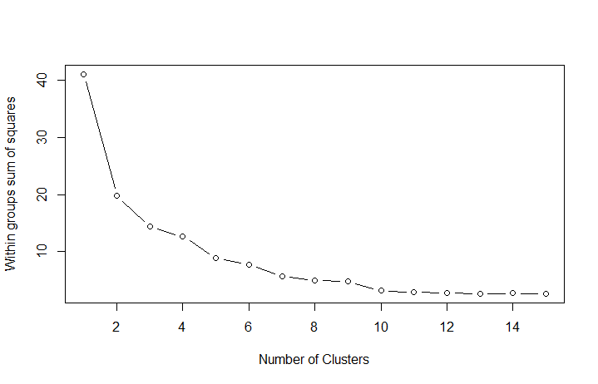
The point at which the curve bends (elbow) indicates the value of K.
We first took the value of K as 3 to get an accuracy of 66%.
Then we used the took the value of K as 4 to get an accuracy of 74%.
Therefore we chose the value of K as 4.

Scatter Plot.

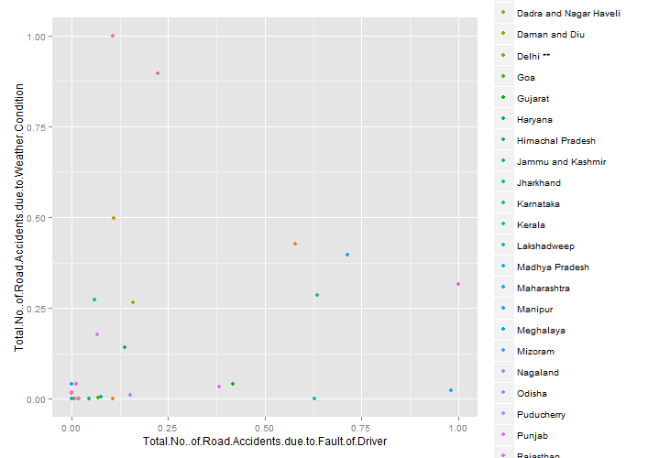
The first scatter plot is state-wise plot including all the states and Union territories.

Bar Plots:

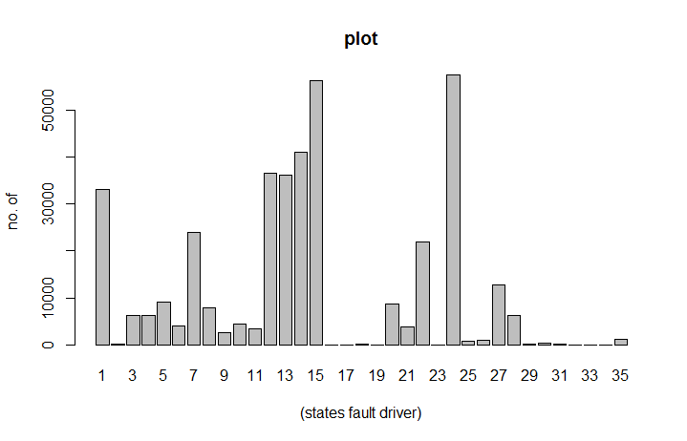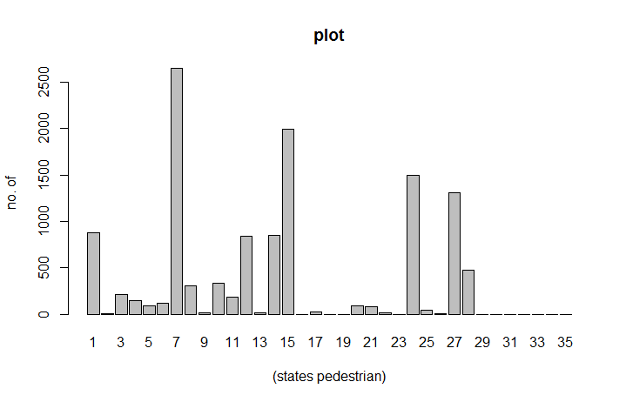
Due to driver’s fault Due to Pedestrian’s fault
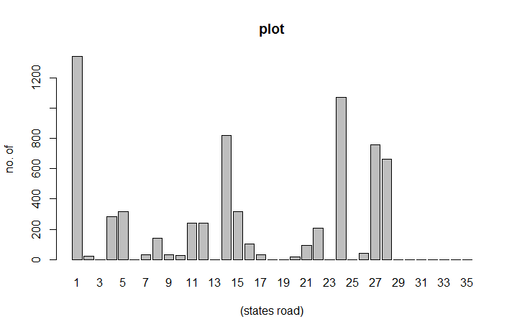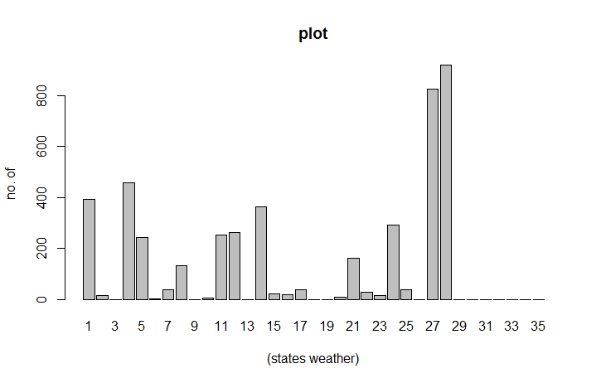
Due to Bad roads Due to bad weather conditions

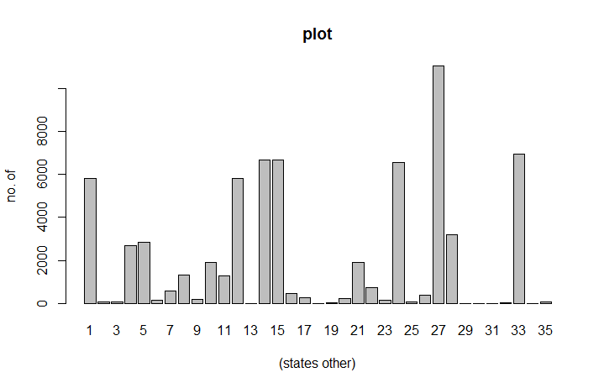
Using these bar plots, we labeled the states and union territories in the data sets as Very High, High, Medium and Low based on their vulnerability towards various factors.

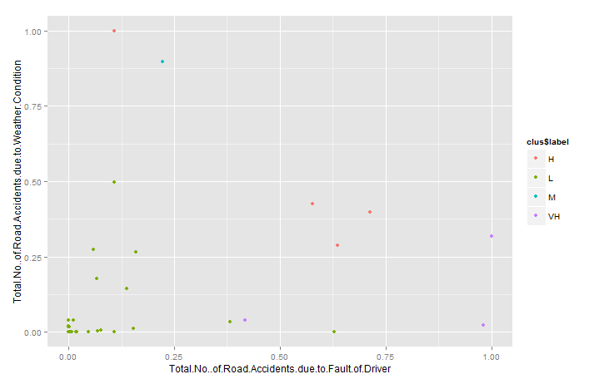
Then we plotted the scatter plot with respect to labels.

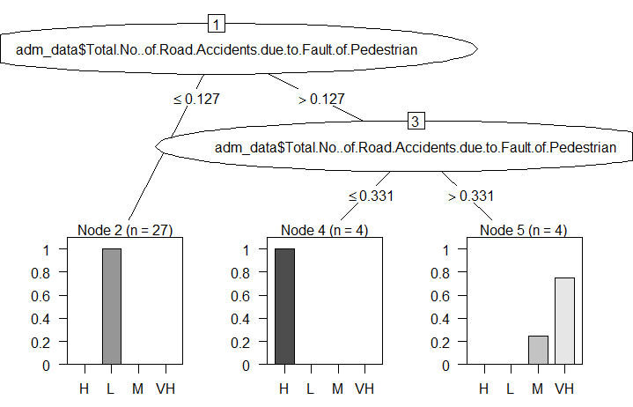

- CONCLUSION

So basically , we saw how cluster analysis helps us to determine the accident prone states and territories of India. These clusters are labeled to be classified with the help of decision tree to conclude the dominant factor, backing the accidents.

The Decision tree we plotted helped us conclude that two major causes are Fault_of_Cyclist and Fault_of_Pedestarian , which are way more dominant and relevant for the clusters we have formed.At first, we used the decision tree algorithm to find out that Fault_of_Cyclist was the deciding factor and it had the information gain ratio same as Fault_of_Pedestarian. The decision tree with Fault_of_cyclist on cross-validation gave us an error rate of 18%. Then, we used Fault_of_Pedestrain which after cross validation gave us an error rate of 9% . So if the value of this attribute is less than 0.127 then it is a part of low region ,otherwise its between [0.127-0.331] then it’s a part of high cluster and for greater than 0.331 it’s a part of both medium and very high.

VII. REFERENCES

-Data Mining Approach to Analyze the Road Accidents in India(A research paper by: Ayushi Jain, Garima Ahuja, Anuranjana, Deepti Mehrotra)

-Open Government Data (OGD) Platform India [Online] Available 2016: https://data.gov.in/catalogs/sector/Transport-
9383

-Han and Kamber (second edition)[ For reference to algorithms and concepts]

