A

Data Science & Big data analytics Mini Project Report submitted to Savitribai Phule Pune University, Pune

‘Attendence System‘

A

In partial Fulfillment for the awards of Degree of Engineering in Computer Engineering

**Submitted by**

## Mr.Sankalp Mali (T400240854)

## Mr.Aniket Jaitkar (T400240812)

## Mr.Akalank Jawale (T400240814)

**Under the Guidance of**

# Mrs.Prof.

# Rubi Mandal

**Department of Computer Engineering**





**2024-25**

**Certificate**

This is to certify that,

Sankalp Mali, (T400240854)

Aniket Jaitkar, (T400240812)

Akalank Jawale, (T400240814)

have successfully completed the Mini project entitled “ **Attendence System** ”under my guidance in partial fulfillment of the requirements for the Third Year of Engineering in Computer Engineering under the Savitribai Phule Pune University during the academic year 2024-2025

**Date:25/04/2025**

**Place:Pune**

**Dr. Vinod Kimbahune**

**Project Guide**

**Prof.Rubi Mandal**

**HOD**

**Dr. Nitin Sherje**

**Pincipal**

## Acknowledgements

With deep sense of gratitude we would like to thank all the people who have lit our path with their kind guidance. We are very grateful to these intellectuals who did their best to help during our project work.

It is our proud privilege to express a deep sense of gratitude to **Pro,Dr. Nitin Sherje** Principal of for his comments and kind permission to complete this project. We remain indebted to **Dr. Vinod Kimbahune,** H.O.D.Computer Engineering Department for his timely suggestion and valuable guidance.

The special gratitude goes to **Prof. Rubi Mandal** excellent and precious guidance in completion of this work .We thanks to all the colleagues for their appreciable help for our working project. With various industry owners or lab technicians to help, it has been our endeavor throughout our work to cover the entire project work.

We are also thankful to our parents who provided their wishful support for our project completion successfully .And lastly we thank our all friends and the people who are directly or indirectly related to our project work.

Mr .Sankalp Mali

Mr.Aniket Jaitkar

Mr.Akalank Jawale

***Abstract***

*In modern educational and organizational settings, accurate attendance tracking is essential for performance monitoring, resource planning, and security. Traditional methods such as manual roll calls or biometric systems are time-consuming, prone to error, and often susceptible to manipulation. This project presents an intelligent* ***AI and Machine Learning-based Attendance System*** *that leverages computer vision techniques to automate headcount and attendance management efficiently.*

*Using real-time video feeds, the system employs* ***face detection and recognition algorithms*** *to identify and verify individuals present in a given space. Deep learning models such as CNNs (Convolutional Neural Networks) are trained on facial datasets to ensure high accuracy in various lighting conditions and angles. The system is designed to handle large crowds, detect multiple faces simultaneously, and automatically log attendance data with timestamps.*

*This approach significantly reduces administrative overhead, enhances reliability, and ensures non-intrusive monitoring. Additionally, the system incorporates* ***privacy and security measures*** *to safeguard personal data. The project demonstrates the potential of AI-powered solutions in transforming traditional administrative processes into smart, automated systems.*

# Table of Contents

|  |  |  |
| --- | --- | --- |
| ***Abstract*** |  | |
| ***Table of Contents*** |  |  |
| ***List of Abbreviations*** |  |  |
| ***List of Figures*** |  |  |
| ***Introduction*** |  |  |
| *1.1 Overview* |  |  |

* 1. *Aim/Motivation*
  2. *Objective*
  3. *Organization of Report*

***2Literature Survey***

***3 Problem Statement***

1. ***Software Requirements Specification***
   1. *Hardware Requirements*
   2. *Software Requirements*
2. ***System Design***
   1. *Project Block Diagram*
   2. *GUI of Working System*
3. ***Conclusion and Future Scope References***

## List of Abbreviations

|  |  |
| --- | --- |
| *AI -* | *Artificial Intelligence* |

|  |  |
| --- | --- |
| *ML -* | *Machine Learning* |

|  |  |
| --- | --- |
| *CNN -* | *Convolutional Neural Network* |

|  |  |
| --- | --- |
| *YOLO -* | *You Only Look Once (Real-time Object Detection)* |

|  |  |
| --- | --- |
| *Open-CV -* | *Open Source Computer Vision Library* |

|  |  |
| --- | --- |
| *ROI* | *-Region of Interest* |

|  |  |
| --- | --- |
| *API -* | *Application Programming Interface* |

|  |  |
| --- | --- |
| *DB -* | *Database* |

|  |  |
| --- | --- |
| *GUI -* | *Graphical User Interface* |

|  |  |
| --- | --- |
| *IoT -* | *Internet of Things* |

|  |  |
| --- | --- |
| *FPS -* | *Frames Per Second* |

|  |  |
| --- | --- |
| *HOG -* | *Histogram of Oriented Gradients* |

|  |  |
| --- | --- |
| *DNN -* | *Deep Neural Network* |

|  |  |
| --- | --- |
| *ID -* | *Identification* |

|  |  |
| --- | --- |
| *OCR -* | *Optical Character Recognition (if used for ID cards)* |

|  |  |
| --- | --- |
| *GPU -* | *Graphics Processing Unit* |

|  |  |
| --- | --- |
| *LAN -* | *Local Area Network (if applicable)* |

## List of Figures

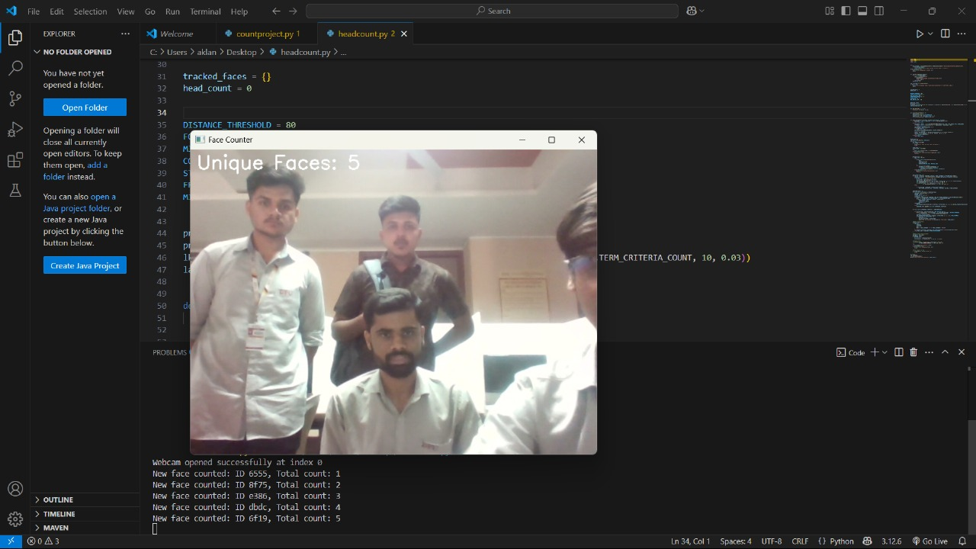

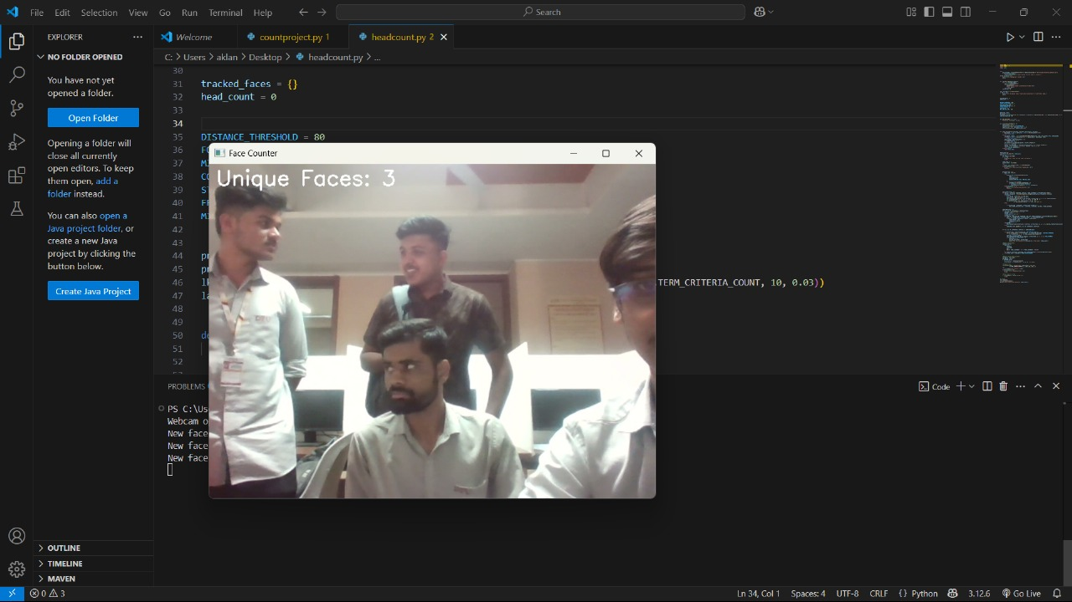

## Chapter 1 Introduction

*Attendance management is a critical aspect in educational institutions, workplaces, and public gatherings, where tracking the presence of individuals ensures productivity, safety, and accountability. Conventional attendance systems, such as manual entry, ID cards, or biometric scanners, are often time-consuming, inefficient, and susceptible to human error or misuse.*

*With rapid advancements in* ***Artificial Intelligence (AI)*** *and* ***Machine Learning (ML)****, particularly in the fields of* ***Computer Vision*** *and* ***Deep Learning****, it has become possible to develop smart systems that automate and enhance traditional administrative tasks. This project proposes an intelligent* ***Attendance System using AI and ML****, capable of performing real-time* ***head counting and face recognition*** *through video streams.*

*The system utilizes powerful tools such as* ***OpenCV*** *for image processing and* ***YOLO (You Only Look Once)*** *for fast and accurate object detection, enabling it to detect and count individuals in a given frame. Further,* ***Convolutional Neural Networks (CNNs)*** *are employed for recognizing and verifying faces to mark attendance reliably. This non-intrusive and automated approach reduces the need for manual intervention, increases accuracy, and ensures efficient record-keeping.*

*Designed for scalability and adaptability, the system can be deployed in classrooms, offices, events, or any environment where monitoring attendance is essential. Additionally, the implementation includes a secure database for storing attendance logs and a user-friendly interface for administrators to manage and review reports.*

## Chapter 2 Literature Survey

*In recent years, several approaches have been explored to automate attendance systems, shifting from traditional manual processes to advanced AI-powered solutions. The integration of* ***computer vision****,* ***machine learning****, and* ***deep learning*** *has enabled researchers and developers to create systems that are not only faster and more accurate but also scalable and non-intrusive.*

***1. Traditional Methods:*** *Initial attendance systems relied heavily on manual sign-ins or biometric methods such as fingerprint scanners and RFID cards. While these systems offered a level of automation, they were limited by physical contact, susceptibility to spoofing, and time consumption, especially in large groups. Moreover, they often required specialized hardware and were prone to hygiene concerns, particularly post-pandemic.*

***2. Face Recognition-Based Systems:*** *Face recognition has emerged as a prominent solution for non-contact attendance systems. Systems using* ***Haar Cascade classifiers*** *and* ***LBPH (Local Binary Pattern Histograms)*** *showed promising results for static image-based recognition. However, their performance declined under varying lighting conditions, occlusions, or angles.*

***3. Deep Learning and CNNs:*** *Recent research emphasizes the use of* ***Convolutional Neural Networks (CNNs)****, which significantly improve accuracy in face detection and recognition tasks. Architectures like* ***VGG-Face****,* ***FaceNet****, and* ***DeepFace*** *are widely used for training facial embeddings that enhance recognition even in complex environments.*

***4. Real-Time Detection with YOLO:*** *The YOLO (You Only Look Once) object detection algorithm, particularly in its newer versions (YOLOv4, YOLOv5), offers fast and accurate real-time detection of faces and objects. This capability has led to its adoption in headcount-based attendance systems, where multiple individuals can be detected in a single frame with minimal latency.*

***5. OpenCV and Real-World Integration:*** *OpenCV remains one of the most widely used libraries for image processing in real-world applications. Studies have demonstrated successful integration of OpenCV with camera systems to process video streams, detect faces in real-time, and interface with databases for logging attendance.*

***6. Challenges and Improvements:*** *While AI-based attendance systems offer several advantages, studies highlight challenges such as handling spoof attacks (e.g., photos or videos), ensuring data privacy, and improving recognition accuracy in crowded or low-light conditions. Research is ongoing to enhance robustness through techniques like* ***multi-modal authentication*** *and* ***privacy-preserving AI models****.*

## Chapter 3 Problem Statement

*Traditional attendance methods such as manual roll calls, RFID cards, and biometric systems are often inefficient, time-consuming, and prone to errors or manipulation. These methods may also raise hygiene concerns due to physical contact and are not scalable for large groups or dynamic environments. Additionally, they lack real-time monitoring capabilities and require user interaction, which can disrupt workflows or classroom sessions. To overcome these limitations, there is a need for an intelligent, contactless attendance system that can accurately detect and count individuals using video feeds. This project proposes an AI and Machine Learning-based solution that leverages computer vision technologies, including YOLO for real-time object detection and CNNs for face recognition, to automate attendance tracking efficiently and reliably in diverse settings.*

## Chapter 4

**Software Requirements Specification**

| ***Component*** | ***Tool / Technology*** | ***Purpose*** |
| --- | --- | --- |
| ***Programming Language*** | ***Python*** | *Primary language for building the system due to its strong AI/ML ecosystem.* |
| ***Image Processing*** | ***OpenCV (Open Source Computer Vision Library)*** | *Used for handling real-time image and video capture, face detection, and preprocessing tasks.* |
| ***Object Detection*** | ***YOLOv5 (You Only Look Once)*** | *Real-time object detection model to detect multiple faces in a single video frame.* |
| ***Deep Learning Framework*** | ***TensorFlow*** *or* ***PyTorch*** | *To build, train, or use pre-trained CNN models for face recognition.* |
| ***Face Recognition Model*** | ***FaceNet*** */* ***Dlib*** */* ***OpenFace*** | *Models used to extract facial embeddings and match individuals.* |
| ***GUI Framework*** | ***Tkinter*** */* ***PyQt5*** */* ***Flask (for web-based UI)*** | *For building a user-friendly graphical or web interface to manage the system.* |
| ***Database*** | ***MySQL*** *or* ***SQLite*** | *To store user data, attendance records, and system logs securely.* |
| ***IDE (Development Environment)*** | ***Visual Studio Code (VS Code)*** */* ***PyCharm*** | *Used for writing and managing code efficiently.* |
| ***Operating System*** | ***Windows*** */* ***Linux*** | *The system should be compatible with commonly used operating systems.* |

## Chapter 5

**System Design and Result**

* 1. **Project Block Diagram**

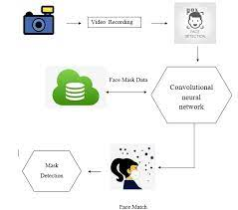

* 1. **GUI of Working System**

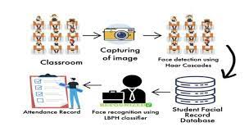

## Chapter 6 Conclusion and Future Scope

*The AI and Machine Learning-based Attendance System provides an efficient, scalable, and contactless solution to attendance tracking, addressing the limitations of traditional methods such as manual roll calls and biometric systems. By leveraging* ***YOLO*** *for real-time object detection and* ***Convolutional Neural Networks (CNNs)*** *for face recognition, the system is able to accurately detect and identify individuals, making the attendance process seamless and automated. The system's integration with a user-friendly GUI and secure database ensures ease of use and data integrity. This solution has the potential to significantly enhance administrative efficiency, reduce human error, and provide a more reliable, scalable alternative for environments such as classrooms, offices, and public events.*

*While the current system provides a robust solution for automated attendance, there are several areas for improvement and expansion:*

1. ***Enhanced Accuracy:*** *The face recognition accuracy could be further improved by training with a larger and more diverse dataset to handle variations in lighting, angles, and occlusions more effectively.*
2. ***Multi-modal Authentication:*** *To increase security and robustness, the system could incorporate additional methods such as* ***fingerprint scanning*** *or* ***voice recognition****, offering* ***multi-modal authentication*** *for a more comprehensive identification process.*
3. ***Scalability and Deployment:*** *The system could be optimized for large-scale environments, such as auditoriums or stadiums, with the ability to handle multiple cameras and real-time video streams for larger crowds.*
4. ***Cloud Integration:*** *Integrating the system with cloud-based platforms for data storage and processing could improve accessibility, facilitate remote monitoring, and allow for better scalability.*
5. ***Facial Recognition with Mask Detection:*** *In light of global health concerns, future versions of the system could be enhanced to recognize individuals wearing masks, using techniques that distinguish between face coverings and exposed facial features.*
6. ***Integration with Other Systems:*** *The system can be integrated with* ***Learning Management Systems (LMS)*** *or* ***HR software*** *to provide automatic attendance tracking for academic or corporate environments, ensuring real-time updates and reports.*

## References

*•* ***Haar, P.*** *(2001). "Rapid Object Detection using a Boosted Cascade of Simple Features." Proceedings of the IEEE Computer Society Conference on Computer Vision and Pattern Recognition (CVPR), 1, 511-518.*

* *This paper introduces the* ***Haar Cascade classifier****, which has been a foundational technique in face detection, influencing many later developments in computer vision.*

*•* ***Redmon, J., Divvala, S., Girshick, R., & Farhadi, A.*** *(2016). "You Only Look Once: Unified, Real-Time Object Detection." Proceedings of the IEEE Conference on Computer Vision and Pattern Recognition (CVPR).*

* *This paper presents* ***YOLO (You Only Look Once)****, a real-time object detection system that is particularly useful for applications such as face detection in your attendance system.*

*•* ***Schroff, F., Kalenichenko, D., & Philbin, J.*** *(2015). "FaceNet: A Unified Embedding for Face Recognition and Clustering." Proceedings of the IEEE Conference on Computer Vision and Pattern Recognition (CVPR).*

* *This paper discusses the* ***FaceNet*** *system, which provides high-accuracy facial recognition by learning embeddings of faces for various recognition tasks.*

*•* ***Zhang, K., Zhang, Z., & Li, Z.*** *(2016). "Joint Face Detection and Alignment Using Multitask Cascaded Convolutional Networks." IEEE Signal Processing Letters, 23(10), 1499-1503.*

* *Introduces a multitask CNN for face detection and alignment, which can be crucial for improving the accuracy and robustness of face recognition in dynamic environments.*

*•* ***Bradski, G.*** *(2000). "The OpenCV Library." Dr. Dobb’s Journal of Software Tools.*

* *This article introduces* ***OpenCV****, the widely used library in computer vision for real-time image processing, which plays a central role in your attendance system for handling video inputs and face detection.*

*•* ***Goodfellow, I., Bengio, Y., & Courville, A.*** *(2016). "Deep Learning." MIT Press.*

* *A foundational book on deep learning, covering CNNs and their application in various computer vision tasks, including facial recognition.*

*•* ***Liu, W., Anguelov, D., Erhan, D., Szegedy, C., & Reed, S.*** *(2016). "Ssd: Single Shot MultiBox Detector." European Conference on Computer Vision (ECCV).*

* *This paper discusses another object detection framework (****SSD****), which offers real-time performance similar to YOLO, useful for detecting multiple objects in video feeds.*

*•* ***Kale, S., & Jawarkar, A.*** *(2019). "Face Recognition-Based Attendance System Using OpenCV and Python." International Journal of Engineering and Advanced Technology (IJEAT), 8(6S), 34-39.*

* *Discusses the implementation of face recognition for attendance systems using* ***OpenCV*** *and* ***Python****, similar to the approach used in your project.*

*.*