GAN-Enhanced Paddy Leaf Disease Detection Through Dual-View Imaging

Introduction:
🌾 Paddy Leaf Disease Classification using Dual-View EfficientNet-B0 (4 Classes)
Classes: Brown Spot, Healthy Paddy, Hispa, Leaf Blast
Pair-Aware Stratified Splitting (T1 / B1 Leak-Free) & PyTorch Transfer Learning
🔬 Core Architecture: Simultaneous Dual-View Feature Fusion
Paddy leaves exhibit distinct visual pathology across both surface planes:
- T1: Adaxial / Front / Top view of the leaf
- B1: Abaxial / Back / Bottom view of the leaf
Unlike conventional single-image models, this model is trained on both sides simultaneously. For every specimen, the Top (T1) and Bottom (B1) views are fed as a paired input through a shared Siamese EfficientNet-B0 feature extractor. Visual representations from both surfaces are concatenated and fused before the classification head predicts the disease category.

📋 Complete End-to-End Pipeline:
- GPU & Environment Verification: Ensure CUDA availability and deterministic reproducibility.
- Dataset Setup & Extraction: Mount Google Drive or upload dataset ZIP (Segregation final.zip).
- Class & Integrity Check: Auto-detect directory, count images, and verify zero corrupted files.
- Leaf-Pair Aware Splitting (80% Train / 20% Val): Groups T1 and B1 by physical leaf ID to guarantee zero data leakage.
- Data Augmentation & Paired PyTorch DataLoader: Realistic transforms applied to leaf pairs.
- Dual-View Siamese EfficientNet-B0: Pretrained ImageNet backbone with feature fusion.
- 50-Epoch Training Loop: AdamW optimizer, ReduceLROnPlateau scheduler, and best checkpoint saving.
- Evaluation Curves: Plot Training vs. Validation Loss and Accuracy curves.
- Interactive Testing Suite ("Upload Testing Folder"): Manual test dataset upload, automated T1/B1 pair detection, full classification report, confusion matrix, and CSV prediction export.
- Single-Leaf Pair Diagnosis Demo: Upload T1 and B1 images of any leaf for instant diagnosis.
- Artifact Export & Download: Save model weights (.pth), class_to_idx.json, and figures.
Activation function:
EfficientNet-B0 → Feature Fusion → Linear → BatchNorm → SiLU → Dropout → Linear → 4 classes
SiLU — Sigmoid Linear Unit, also known as Swish.
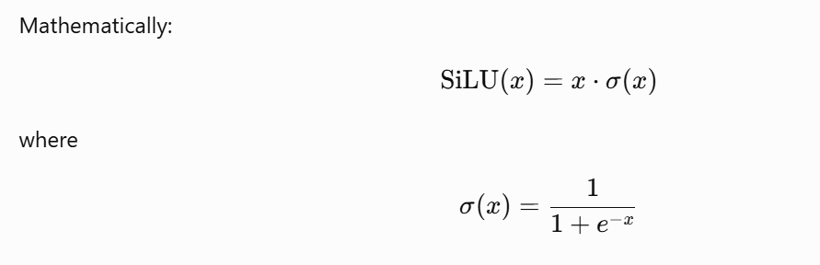 classifier uses:
Linear → Batch Normalization → SiLU → Dropout → Linear

Count Images per Class & Verify File Integrity:
=======================================================
CLASS NAME | IMAGE COUNT
=======================================================
Brown spot | 230
Healthy Paddy | 406
Hispa | 172
Leaf Blast | 204
-------------------------------------------------------
TOTAL IMAGES | 1012
=======================================================
Audit Split & Verify Zero Data Leakage:
=================================================================
CLASS | LEAVES | TRAIN IMGS | VAL IMGS | TOTAL
=================================================================
Brown spot | 230 | 184 | 46 | 230
Healthy Paddy | 406 | 325 | 81 | 406
Hispa | 172 | 138 | 34 | 172
Leaf Blast | 204 | 163 | 41 | 204
-----------------------------------------------------------------
TOTAL | 1012 | 810 | 202 | 1012
=================================================================
Specimen Overlap (Train ∩ Val): 0 (Expected: 0)

Train Dual-View Model for 50 Epochs:
=================================================================
DUAL-VIEW TRAINING
=================================================================
Device : cuda
GPU : NVIDIA GeForce RTX 2050
GPU Memory : 4.00 GB
Epochs : 50
Checkpoint : D:\Segregation\best_dual_efficientnet_b0.pth
=================================================================
AMP : ENABLED
=================================================================
Epoch | Train Loss | Train Acc (%) | Val Loss | Val Acc (%) | Learning Rate | GPU (GB)
1 | 1.1679 | 49.26 | 0.8175 | 69.80 | 0.0001000 | 1.56
2 | 0.7905 | 69.14 | 0.6933 | 76.73 | 0.0001000 | 1.56
3 | 0.6390 | 76.67 | 0.6486 | 75.25 | 0.0001000 | 1.56
4 | 0.5365 | 79.14 | 0.7498 | 74.26 | 0.0001000 | 1.56
5 | 0.4785 | 81.98 | 0.7036 | 77.72 | 0.0001000 | 1.56
6 | 0.3975 | 85.93 | 0.7004 | 77.23 | 0.0001000 | 1.56
7 | 0.3878 | 87.16 | 0.6382 | 79.21 | 0.0001000 | 1.56
8 | 0.3416 | 87.90 | 0.6077 | 80.20 | 0.0001000 | 1.56
9 | 0.3275 | 88.27 | 0.6426 | 81.19 | 0.0001000 | 1.56
10 | 0.2967 | 88.52 | 0.7118 | 80.69 | 0.0001000 | 1.56
11 | 0.3260 | 88.40 | 0.6726 | 79.21 | 0.0001000 | 1.56
12 | 0.2871 | 89.63 | 0.6775 | 79.21 | 0.0000500 | 1.56
13 | 0.2555 | 90.25 | 0.6095 | 80.20 | 0.0000500 | 1.56
14 | 0.2528 | 89.63 | 0.6184 | 80.20 | 0.0000500 | 1.56
15 | 0.2394 | 91.23 | 0.6324 | 80.20 | 0.0000250 | 1.56
16 | 0.2438 | 91.98 | 0.7381 | 79.70 | 0.0000250 | 1.56
17 | 0.2317 | 90.74 | 0.6371 | 79.70 | 0.0000250 | 1.56
18 | 0.2235 | 90.12 | 0.6287 | 78.71 | 0.0000125 | 1.56
19 | 0.2358 | 90.00 | 0.6011 | 80.69 | 0.0000125 | 1.56
20 | 0.2083 | 91.73 | 0.6331 | 80.20 | 0.0000125 | 1.56
21 | 0.1940 | 91.73 | 0.6661 | 80.20 | 0.0000063 | 1.56
22 | 0.2200 | 90.86 | 0.6419 | 80.20 | 0.0000063 | 1.56
23 | 0.2139 | 92.47 | 0.6167 | 80.69 | 0.0000063 | 1.56
24 | 0.1932 | 92.10 | 0.7096 | 80.20 | 0.0000031 | 1.56
25 | 0.2044 | 93.21 | 0.6565 | 80.20 | 0.0000031 | 1.56
26 | 0.1940 | 92.22 | 0.6607 | 79.70 | 0.0000031 | 1.56
27 | 0.1880 | 91.73 | 0.7234 | 80.20 | 0.0000016 | 1.56
28 | 0.2232 | 90.74 | 0.6659 | 80.69 | 0.0000016 | 1.56
29 | 0.1961 | 92.84 | 0.6396 | 79.70 | 0.0000016 | 1.56
30 | 0.1975 | 92.10 | 0.6762 | 79.21 | 0.0000008 | 1.56
31 | 0.2078 | 91.48 | 0.6895 | 80.20 | 0.0000008 | 1.56
32 | 0.1953 | 92.22 | 0.6484 | 80.20 | 0.0000008 | 1.56
33 | 0.2024 | 91.36 | 0.6129 | 80.69 | 0.0000004 | 1.56
34 | 0.2049 | 92.22 | 0.6648 | 79.70 | 0.0000004 | 1.56
35 | 0.1826 | 92.35 | 0.6601 | 79.70 | 0.0000004 | 1.56
36 | 0.2040 | 91.98 | 0.6403 | 80.20 | 0.0000002 | 1.56
37 | 0.2064 | 91.23 | 0.6468 | 80.69 | 0.0000002 | 1.56
38 | 0.2259 | 91.60 | 0.6946 | 79.21 | 0.0000002 | 1.56
39 | 0.1868 | 91.48 | 0.6762 | 79.21 | 0.0000001 | 1.56
40 | 0.1965 | 91.60 | 0.7054 | 79.21 | 0.0000001 | 1.56
41 | 0.2101 | 91.11 | 0.6611 | 79.70 | 0.0000001 | 1.56
42 | 0.2021 | 90.99 | 0.6991 | 79.21 | 0.0000000 | 1.56
43 | 0.2247 | 90.86 | 0.6652 | 79.70 | 0.0000000 | 1.56
44 | 0.1877 | 93.09 | 0.6649 | 80.20 | 0.0000000 | 1.56
45 | 0.1997 | 91.73 | 0.6946 | 79.70 | 0.0000000 | 1.56
46 | 0.1967 | 92.35 | 0.6930 | 80.20 | 0.0000000 | 1.56
47 | 0.1899 | 92.35 | 0.6502 | 80.20 | 0.0000000 | 1.56
48 | 0.2076 | 90.86 | 0.6726 | 80.69 | 0.0000000 | 1.56
49 | 0.2097 | 91.73 | 0.6337 | 80.69 | 0.0000000 | 1.56
50 | 0.1782 | 92.96 | 0.6470 | 80.20 | 0.0000000 | 1.56
=================================================================
TRAINING COMPLETE
=================================================================
Training Time : 595.41 minutes
Best Validation Acc : 81.19%
Best Model : D:\Segregation\best_dual_efficientnet_b0.pth
====================================================
Plot Accuracy & Loss Curves:
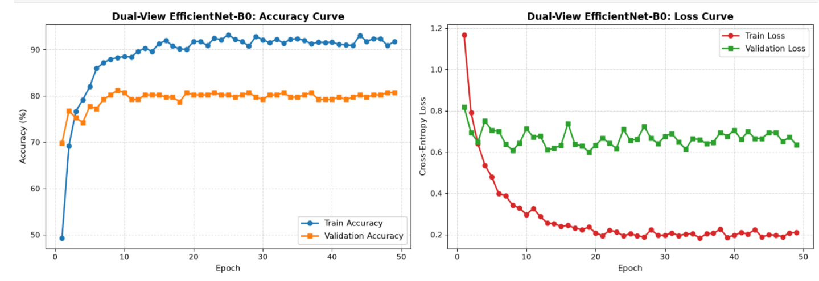

Upload Testing Folder & Evaluate on Unseen Test Dataset:
Brown spot:
No. | T1 Image | B1 Image | Prediction | Confidence
1 | 000234_t458.JPG | 000233_b458.JPG | Brown spot | 83.38%
2 | 000236_t460.JPG | 000235_b460.JPG | Brown spot | 69.35%
3 | 000238_t462.JPG | 000237_b462.JPG | Brown spot | 94.57%
4 | 000240_t464.JPG | 000239_b464.JPG | Brown spot | 98.30%
5 | 000244_t468.JPG | 000243_b468.JPG | Brown spot | 99.90%
6 | 000246_t470.JPG | 000245_b470.JPG | Brown spot | 95.67%
7 | 000248_t472.JPG | 000247_b472.JPG | Brown spot | 81.81%
8 | 000250_t474.JPG | 000249_b474.JPG | Brown spot | 92.79%
9 | 000252_t476.JPG | 000251_b476.JPG | Brown spot | 88.74%
10 | 000254_t478.JPG | 000253_b478.JPG | Brown spot | 87.78%
11 | 000256_t480.JPG | 000255_b480.JPG | Brown spot | 98.30%
12 | 000258_t482.JPG | 000257_b482.JPG | Brown spot | 89.75%
13 | 000260_t484.JPG | 000259_b484.JPG | Brown spot | 79.99%
14 | 000262_t486.JPG | 000261_b486.JPG | Brown spot | 99.22%
15 | 000266_t490.JPG | 000265_b490.JPG | Brown spot | 99.48%
16 | 000268_t492.JPG | 000267_b492.JPG | Brown spot | 99.35%
17 | 000270_t494.JPG | 000269_b494.JPG | Brown spot | 89.99%
18 | 000272_t496.JPG | 000271_b496.JPG | Brown spot | 53.73%
19 | 000274_t498.JPG | 000273_b498.JPG | Brown spot | 98.80%
20 | 000276_t500.JPG | 000275_b500.JPG | Brown spot | 99.75%
21 | 000278_t502.JPG | 000277_b502.JPG | Brown spot | 91.40%
22 | 000280_t504.JPG | 000279_b504.JPG | Brown spot | 64.55%
23 | 000282_t506.JPG | 000281_b506.JPG | Brown spot | 72.36%
24 | 000284_t508.JPG | 000283_b508.JPG | Brown spot | 48.08%
25 | 000286_t510.JPG | 000285_b510.JPG | Brown spot | 85.83%
26 | 000244_t736.JPG | 000243_b736.JPG | Brown spot | 72.36%

Metric | Result
Total Test Leaf Pairs | 26
Overall Accuracy | 100.00%
Macro Precision | 25.00%
Macro Recall | 25.00%
Macro F1-Score | 25.00%
Weighted F1-Score | 100.00%

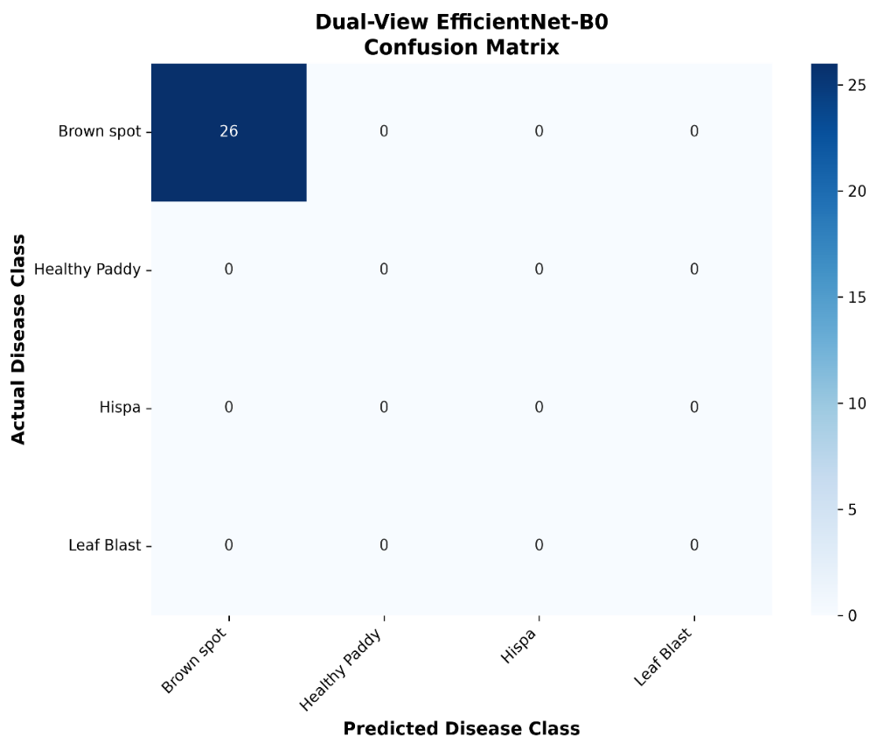
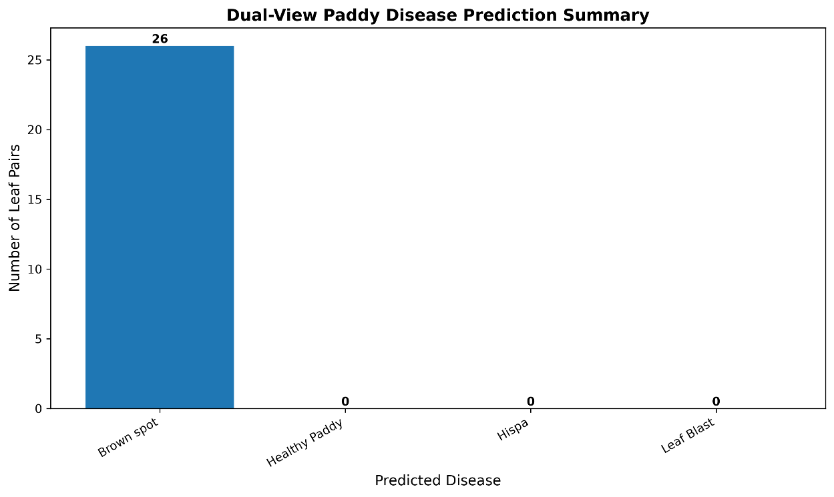

Healthy Paddy:
No. | T1 Image | B1 Image | Prediction | Confidence
1 | 000408_t521.JPG | 000407_b521.JPG | Healthy Paddy | 99.95%
2 | 000410_t523.JPG | 000409_b523.JPG | Healthy Paddy | 97.96%
3 | 000412_t525.JPG | 000411_b525.JPG | Healthy Paddy | 99.70%
4 | 000414_t527.JPG | 000413_b527.JPG | Healthy Paddy | 99.66%
5 | 000416_t529.JPG | 000415_b529.JPG | Healthy Paddy | 99.53%
6 | 000418_t531.JPG | 000417_b531.JPG | Healthy Paddy | 99.08%
7 | 000420_t533.JPG | 000419_b533.JPG | Healthy Paddy | 99.64%
8 | 000422_t535.JPG | 000421_b535.JPG | Healthy Paddy | 99.59%
9 | 000424_t537.JPG | 000423_b537.JPG | Healthy Paddy | 99.71%
10 | 000426_t539.JPG | 000425_b539.JPG | Healthy Paddy | 99.63%
11 | 000428_t541.JPG | 000427_b541.JPG | Healthy Paddy | 84.05%
12 | 000430_t543.JPG | 000429_b543.JPG | Healthy Paddy | 88.97%
13 | 000432_t545.JPG | 000431_b545.JPG | Healthy Paddy | 99.10%
14 | 000434_t547.JPG | 000433_b547.JPG | Healthy Paddy | 94.69%
15 | 000436_t549.JPG | 000435_b549.JPG | Healthy Paddy | 88.39%
16 | 000438_t551.JPG | 000437_b551.JPG | Healthy Paddy | 95.42%
17 | 000440_t553.JPG | 000439_b553.JPG | Healthy Paddy | 97.81%
18 | 000442_t555.JPG | 000441_b555.JPG | Healthy Paddy | 96.64%
19 | 000444_t557.JPG | 000443_b557.JPG | Healthy Paddy | 98.87%
20 | 000446_t559.JPG | 000445_b559.JPG | Healthy Paddy | 94.84%
21 | 000448_t561.JPG | 000447_b561.JPG | Healthy Paddy | 99.89%
22 | 000450_t563.JPG | 000449_b563.JPG | Healthy Paddy | 62.71%
23 | 000452_t565.JPG | 000451_b565.JPG | Healthy Paddy | 99.55%
24 | 000454_t567.JPG | 000453_b567.JPG | Healthy Paddy | 95.93%
25 | 000456_t569.JPG | 000455_b569.JPG | Healthy Paddy | 97.23%
26 | 000458_t571.JPG | 000457_b571.JPG | Healthy Paddy | 97.06%
27 | 000460_t573.JPG | 000459_b573.JPG | Healthy Paddy | 99.43%
28 | 000462_t575.JPG | 000461_b575.JPG | Healthy Paddy | 97.82%
29 | 000464_t577.JPG | 000463_b577.JPG | Healthy Paddy | 65.34%
30 | 000466_t579.JPG | 000465_b579.JPG | Healthy Paddy | 99.41%
31 | 000468_t581.JPG | 000467_b581.JPG | Healthy Paddy | 99.93%
32 | 000470_t583.JPG | 000469_b583.JPG | Healthy Paddy | 94.37%
33 | 000472_t585.JPG | 000471_b585.JPG | Healthy Paddy | 95.85%
34 | 000474_t587.JPG | 000473_b587.JPG | Healthy Paddy | 99.90%
35 | 000476_t589.JPG | 000475_b589.JPG | Healthy Paddy | 99.73%
36 | 000478_t591.JPG | 000477_b591.JPG | Healthy Paddy | 97.01%
37 | 000480_t593.JPG | 000479_b593.JPG | Healthy Paddy | 97.86%
38 | 000482_t595.JPG | 000481_b595.JPG | Healthy Paddy | 98.26%
39 | 000484_t597.JPG | 000483_b597.JPG | Healthy Paddy | 87.59%
40 | 000486_t599.JPG | 000485_b599.JPG | Healthy Paddy | 98.74%
41 | 000488_t601.JPG | 000487_b601.JPG | Healthy Paddy | 98.77%
42 | 000490_t603.JPG | 000489_b603.JPG | Healthy Paddy | 99.38%
43 | 000492_t605.JPG | 000491_b605.JPG | Healthy Paddy | 99.12%
44 | 000494_t607.JPG | 000493_b607.JPG | Healthy Paddy | 99.62%
45 | 000496_t609.JPG | 000495_b609.JPG | Healthy Paddy | 97.95%
46 | 000498_t611.JPG | 000497_b611.JPG | Healthy Paddy | 99.77%
47 | 000500_t613.JPG | 000499_b613.JPG | Healthy Paddy | 98.41%
48 | 000212_t615.JPG | 000211_b615.JPG | Healthy Paddy | 98.26%
49 | 000214_t617.JPG | 000213_b617.JPG | Healthy Paddy | 87.59%
50 | 000506_t619.JPG | 000505_b619.JPG | Healthy Paddy | 98.08%
51 | 000508_t621.JPG | 000507_b621.JPG | Healthy Paddy | 99.67%

Metric | Result
Total Test Leaf Pairs | 51
Overall Accuracy | 100.00%
Macro Precision | 25.00%
Macro Recall | 25.00%
Macro F1-Score | 25.00%
Weighted F1-Score | 100.00%

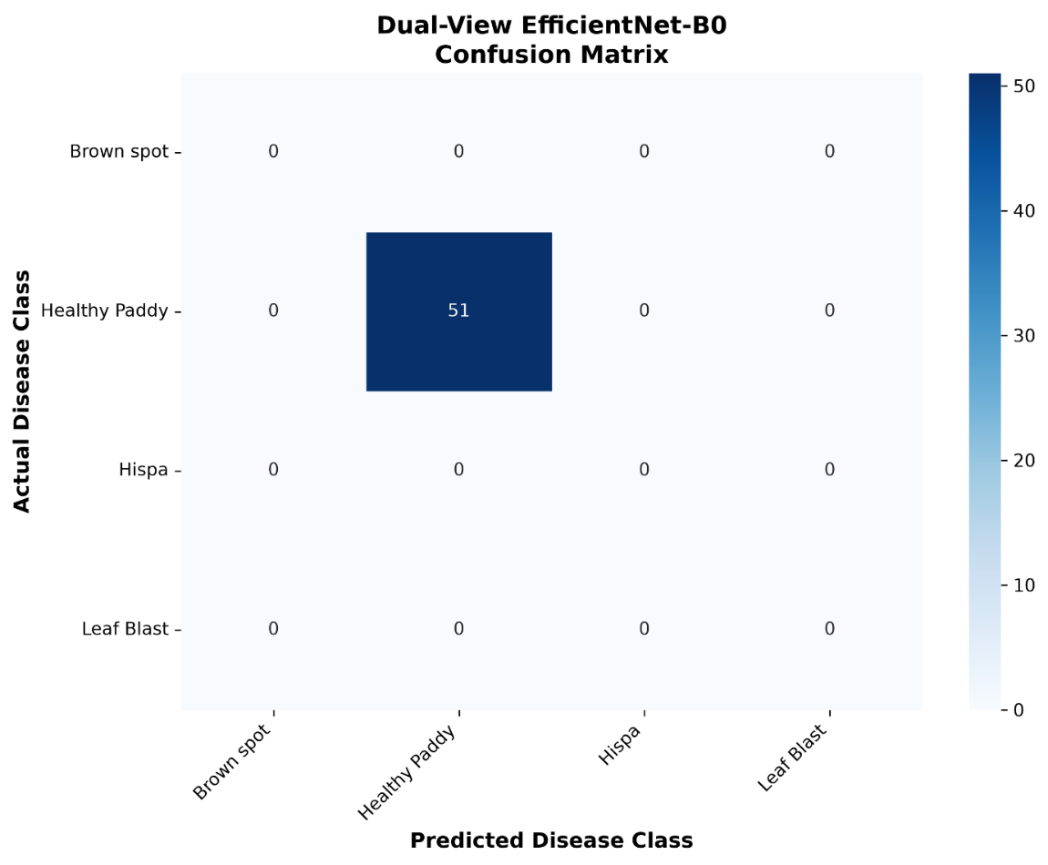
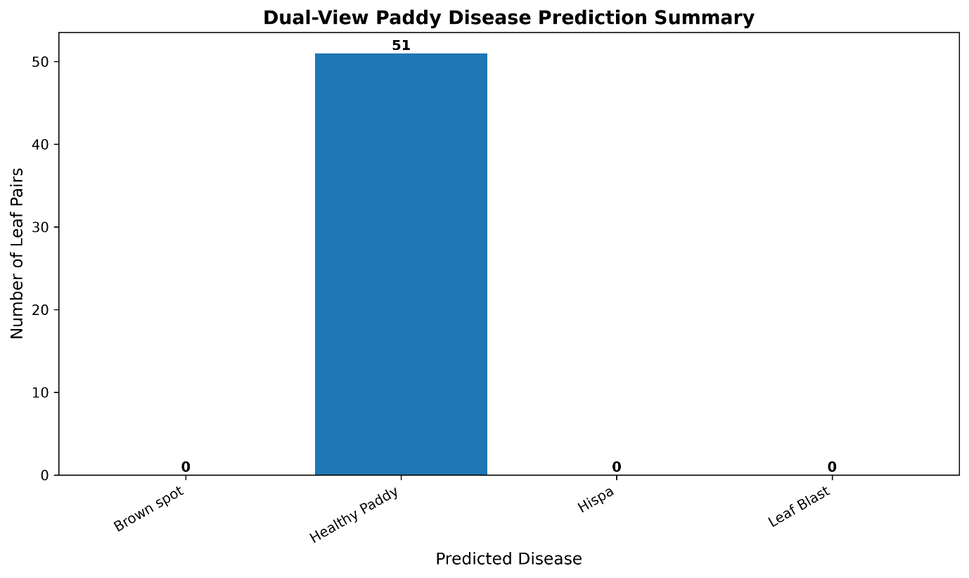
Hispa:
No. | T1 Image | B1 Image | Prediction | Confidence
1 | 000174_t577.JPG | 000173_b577.JPG | Hispa | 99.04%
2 | 000176_t579.JPG | 000175_b579.JPG | Hispa | 94.50%
3 | 000180_t583.JPG | 000179_b583.JPG | Hispa | 97.39%
4 | 000182_t585.JPG | 000181_b585.JPG | Hispa | 92.63%
5 | 000184_t587.JPG | 000183_b587.JPG | Hispa | 97.36%
6 | 000186_t589.JPG | 000185_b589.JPG | Hispa | 60.37%
7 | 000188_t591.JPG | 000187_b591.JPG | Hispa | 97.19%
8 | 000190_t593.JPG | 000189_b593.JPG | Hispa | 93.25%
9 | 000192_t595.JPG | 000191_b595.JPG | Hispa | 93.25%
10 | 000194_t597.JPG | 000193_b597.JPG | Hispa | 95.54%
11 | 000196_t599.JPG | 000195_b599.JPG | Hispa | 51.57%
12 | 000198_t601.JPG | 000197_b601.JPG | Hispa | 97.99%
13 | 000202_t605.JPG | 000201_b605.JPG | Hispa | 50.00%
14 | 000204_t607.JPG | 000203_b607.JPG | Hispa | 99.31%
15 | 000206_t609.JPG | 000205_b609.JPG | Hispa | 97.56%
16 | 000210_t613.JPG | 000209_b613.JPG | Hispa | 96.85%

Metric | Result
Total Test Leaf Pairs | 16
Overall Accuracy | 100.00%
Macro Precision | 25.00%
Macro Recall | 25.00%
Macro F1-Score | 25.00%
Weighted F1-Score | 100.00%

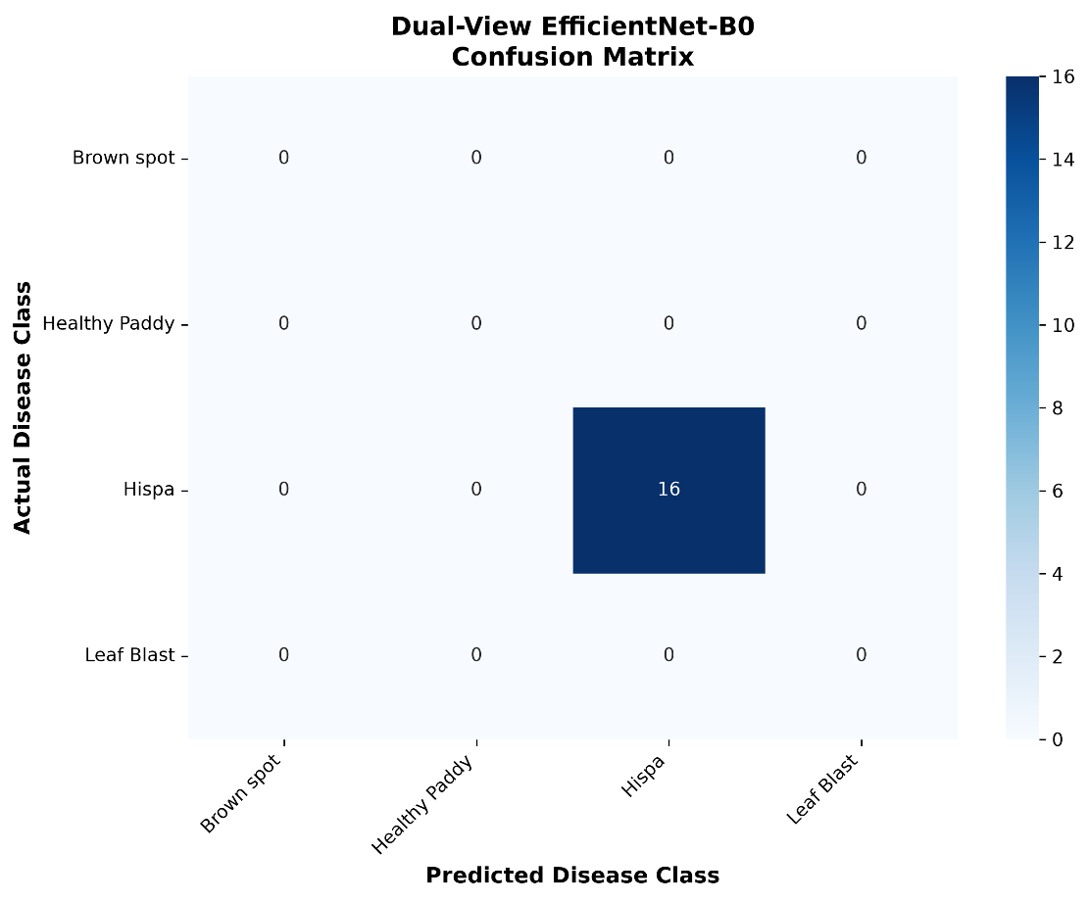
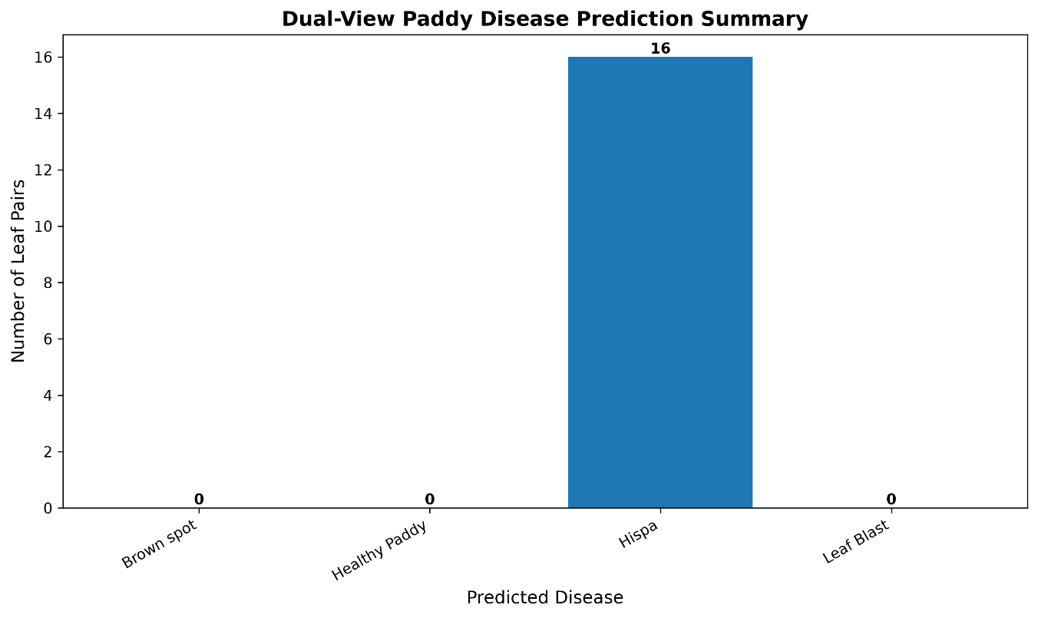

Leaf Blast:
No. | T1 Image | B1 Image | Prediction | Confidence
1 | 000242_t466.JPG | 000241_b466.JPG | Leaf Blast | 87.45%
2 | 000264_t488.JPG | 000263_b488.JPG | Leaf Blast | 52.76%
3 | 000206_t698.JPG | 000205_b698.JPG | Leaf Blast | 97.91%
4 | 000208_t700.JPG | 000207_b700.JPG | Leaf Blast | 98.00%
5 | 000210_t702.JPG | 000209_b702.JPG | Leaf Blast | 99.16%
6 | 000212_t704.JPG | 000211_b704.JPG | Leaf Blast | 87.01%
7 | 000214_t706.JPG | 000213_b706.JPG | Leaf Blast | 97.48%
8 | 000216_t708.JPG | 000215_b708.JPG | Leaf Blast | 99.42%
9 | 000218_t710.JPG | 000217_b710.JPG | Leaf Blast | 97.95%
10 | 000220_t712.JPG | 000219_b712.JPG | Leaf Blast | 97.37%
11 | 000222_t714.JPG | 000221_b714.JPG | Leaf Blast | 98.12%
12 | 000224_t716.JPG | 000223_b716.JPG | Leaf Blast | 97.21%
13 | 000226_t718.JPG | 000225_b718.JPG | Leaf Blast | 98.64%
14 | 000228_t720.JPG | 000227_b720.JPG | Leaf Blast | 92.43%
15 | 000230_t722.JPG | 000229_b722.JPG | Leaf Blast | 52.76%
16 | 000234_t726.JPG | 000233_b726.JPG | Leaf Blast | 99.68%
17 | 000236_t728.JPG | 000235_b728.JPG | Leaf Blast | 97.55%
18 | 000238_t730.JPG | 000237_b730.JPG | Leaf Blast | 94.57%
19 | 000240_t732.JPG | 000239_b732.JPG | Leaf Blast | 99.20%
20 | 000242_t734.JPG | 000241_b734.JPG | Leaf Blast | 99.32%
21 | 000246_t738.JPG | 000245_b738.JPG | Leaf Blast | 88.94%
22 | 000248_t740.JPG | 000247_b740.JPG | Leaf Blast | 92.68%
23 | 000250_t742.JPG | 000249_b742.JPG | Leaf Blast | 93.15%
24 | 000252_t744.JPG | 000251_b744.JPG | Leaf Blast | 90.12%
25 | 000254_t746.JPG | 000253_b746.JPG | Leaf Blast | 89.56%
26 | 000256_t748.JPG | 000255_b748.JPG | Leaf Blast | 97.99%

Metric | Result
Total Test Leaf Pairs | 26
Overall Accuracy | 100.00%
Macro Precision | 25.00%
Macro Recall | 25.00%
Macro F1-Score | 25.00%
Weighted F1-Score | 100.00%

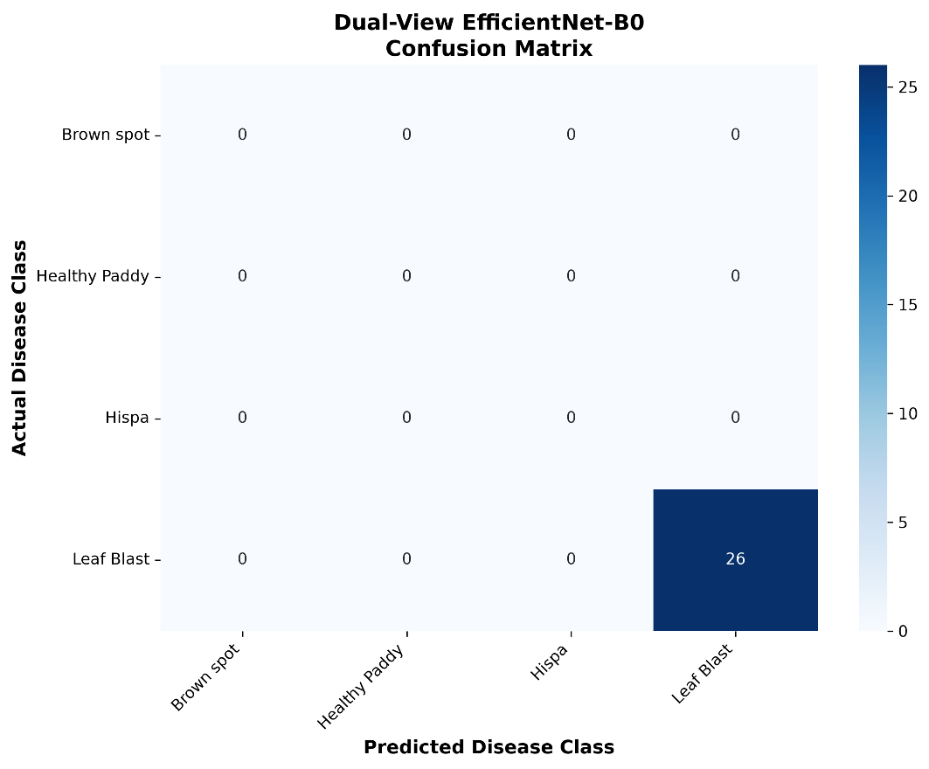
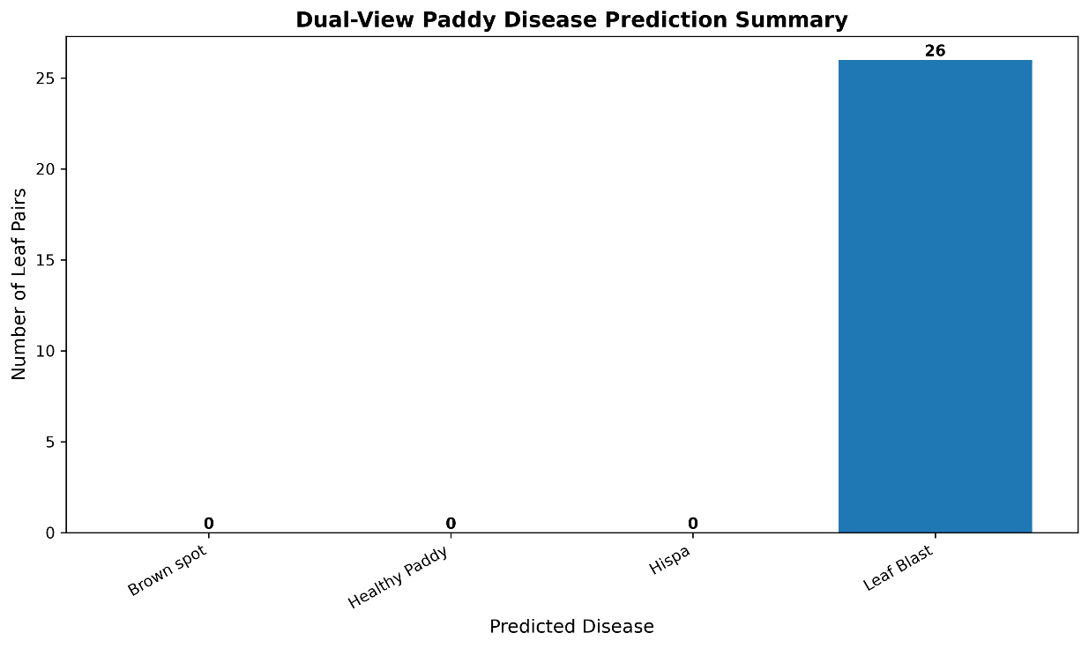

Comparative Performance Analysis of Top + Bottom and Top-Only Inputs:
Brown spot:
No. | Image | Predicted Class | Confidence
1 | 000234_t458.JPG | Brown spot | 78.95%
2 | 000236_t460.JPG | Brown spot | 54.52%
3 | 000238_t462.JPG | Hispa | 40.56%
4 | 000240_t464.JPG | Brown spot | 97.75%
5 | 000244_t468.JPG | Brown spot | 99.96%
6 | 000244_t736.JPG | Leaf Blast | 81.71%
7 | 000246_t470.JPG | Brown spot | 94.15%
8 | 000248_t472.JPG | Brown spot | 57.98%
9 | 000250_t474.JPG | Brown spot | 96.90%
10 | 000252_t476.JPG | Hispa | 94.40%
11 | 000254_t478.JPG | Brown spot | 88.58%
12 | 000256_t480.JPG | Brown spot | 99.17%
13 | 000258_t482.JPG | Brown spot | 99.20%
14 | 000260_t484.JPG | Brown spot | 80.05%
15 | 000262_t486.JPG | Brown spot | 98.69%
16 | 000266_t490.JPG | Brown spot | 99.72%
17 | 000268_t492.JPG | Brown spot | 96.21%
18 | 000270_t494.JPG | Brown spot | 75.14%
19 | 000272_t496.JPG | Brown spot | 85.91%
20 | 000274_t498.JPG | Brown spot | 61.06%
21 | 000276_t500.JPG | Brown spot | 99.71%
22 | 000278_t502.JPG | Brown spot | 94.43%
23 | 000280_t504.JPG | Brown spot | 67.11%
24 | 000282_t506.JPG | Leaf Blast | 81.71%
25 | 000284_t508.JPG | Healthy Paddy | 72.00%
26 | 000286_t510.JPG | Brown spot | 85.25%

Metric | Result
Total Test TOP Images | 26
Overall Accuracy | 80.77%
Macro Precision | 25.00%
Macro Recall | 20.19%
Macro F1-Score | 22.34%
Weighted F1-Score | 89.36%

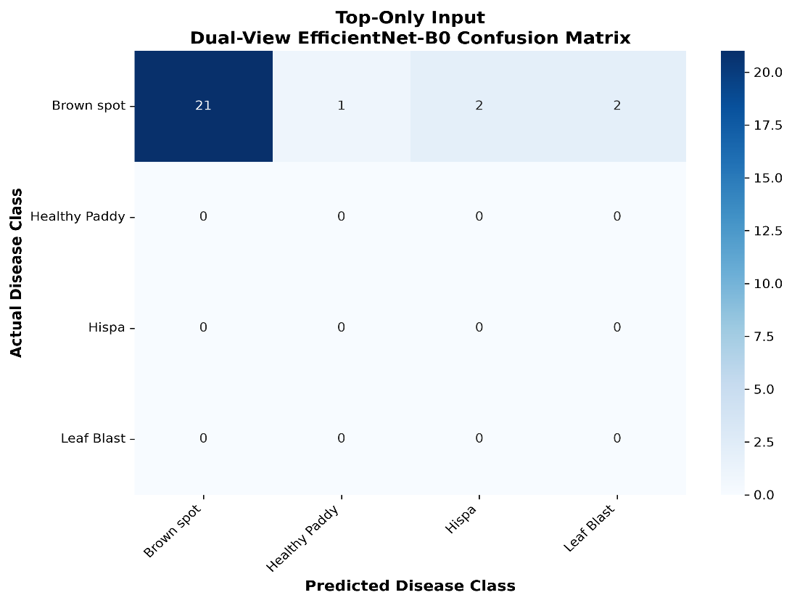

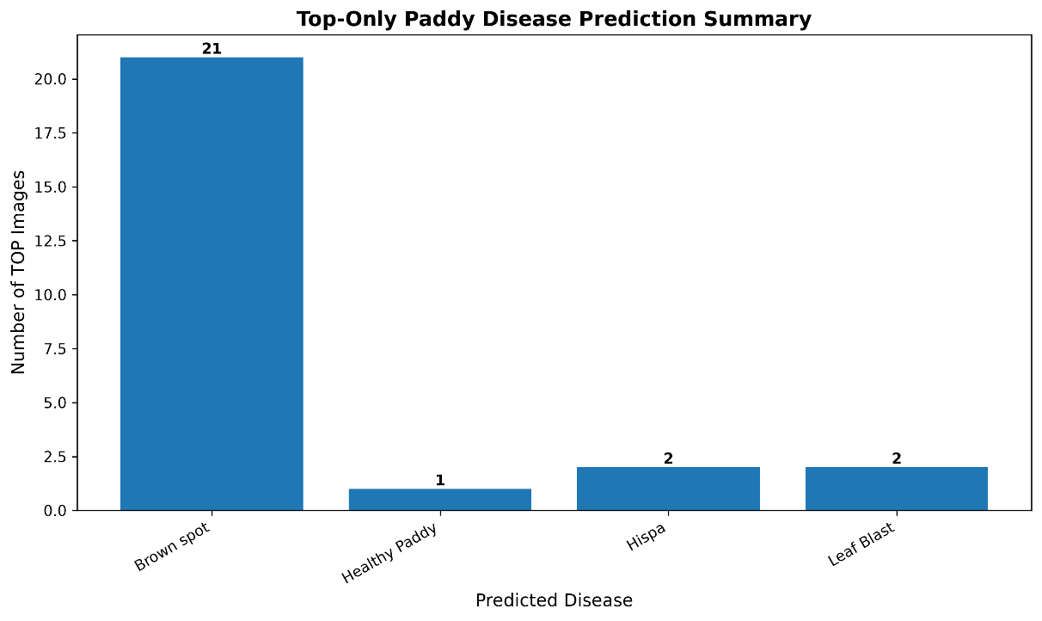
Healthy Paddy:
No. | Image | Prediction | Confidence
1 | 000212_t615.JPG | Healthy Paddy | 99.80%
2 | 000214_t617.JPG | Healthy Paddy | 85.20%
3 | 000408_t521.JPG | Healthy Paddy | 99.87%
4 | 000410_t523.JPG | Healthy Paddy | 94.62%
5 | 000412_t525.JPG | Healthy Paddy | 99.89%
6 | 000414_t527.JPG | Healthy Paddy | 99.94%
7 | 000416_t529.JPG | Healthy Paddy | 99.69%
8 | 000418_t531.JPG | Healthy Paddy | 99.91%
9 | 000420_t533.JPG | Healthy Paddy | 99.74%
10 | 000422_t535.JPG | Healthy Paddy | 98.50%
11 | 000424_t537.JPG | Healthy Paddy | 99.58%
12 | 000426_t539.JPG | Healthy Paddy | 99.76%
13 | 000428_t541.JPG | Healthy Paddy | 99.36%
14 | 000430_t543.JPG | Healthy Paddy | 84.23%
15 | 000432_t545.JPG | Healthy Paddy | 99.19%
16 | 000434_t547.JPG | Healthy Paddy | 95.28%
17 | 000436_t549.JPG | Healthy Paddy | 90.96%
18 | 000438_t551.JPG | Healthy Paddy | 96.28%
19 | 000440_t553.JPG | Healthy Paddy | 95.98%
20 | 000442_t555.JPG | Healthy Paddy | 86.51%
21 | 000444_t557.JPG | Healthy Paddy | 98.41%
22 | 000446_t559.JPG | Healthy Paddy | 91.83%
23 | 000448_t561.JPG | Healthy Paddy | 99.95%
24 | 000450_t563.JPG | Healthy Paddy | 82.68%
25 | 000452_t565.JPG | Healthy Paddy | 99.94%
26 | 000454_t567.JPG | Healthy Paddy | 92.59%
27 | 000456_t569.JPG | Healthy Paddy | 98.35%
28 | 000458_t571.JPG | Healthy Paddy | 94.76%
29 | 000460_t573.JPG | Healthy Paddy | 99.52%
30 | 000462_t575.JPG | Healthy Paddy | 96.96%
31 | 000464_t577.JPG | Healthy Paddy | 72.72%
32 | 000466_t579.JPG | Healthy Paddy | 97.31%
33 | 000468_t581.JPG | Healthy Paddy | 99.86%
34 | 000470_t583.JPG | Healthy Paddy | 96.82%
35 | 000472_t585.JPG | Healthy Paddy | 96.73%
36 | 000474_t587.JPG | Healthy Paddy | 99.94%
37 | 000476_t589.JPG | Healthy Paddy | 99.84%
38 | 000478_t591.JPG | Healthy Paddy | 98.08%
39 | 000480_t593.JPG | Healthy Paddy | 96.25%
40 | 000482_t595.JPG | Healthy Paddy | 99.80%
41 | 000484_t597.JPG | Healthy Paddy | 85.20%
42 | 000486_t599.JPG | Healthy Paddy | 97.70%
43 | 000488_t601.JPG | Healthy Paddy | 98.53%
44 | 000490_t603.JPG | Healthy Paddy | 99.66%
45 | 000492_t605.JPG | Healthy Paddy | 98.02%
46 | 000494_t607.JPG | Healthy Paddy | 99.69%
47 | 000496_t609.JPG | Healthy Paddy | 95.13%
48 | 000498_t611.JPG | Healthy Paddy | 99.81%
49 | 000500_t613.JPG | Healthy Paddy | 92.06%
50 | 000502_t615.JPG | Healthy Paddy | 97.39%
51 | 000504_t617.JPG | Healthy Paddy | 99.92%
52 | 000506_t619.JPG | Healthy Paddy | 98.74%
53 | 000508_t621.JPG | Healthy Paddy | 99.32%

Metric | Result
Total Test TOP Images | 53
Overall Accuracy | 100.00%
Macro Precision | 25.00%
Macro Recall | 25.00%
Macro F1-Score | 25.00%
Weighted F1-Score | 100.00%

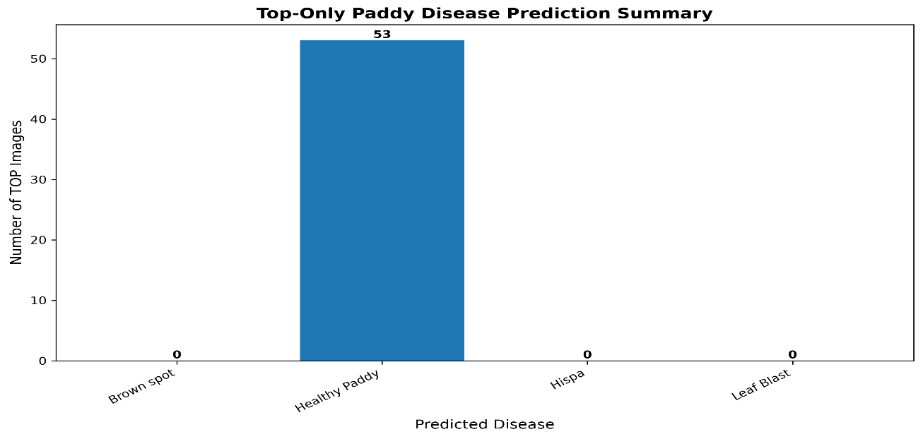
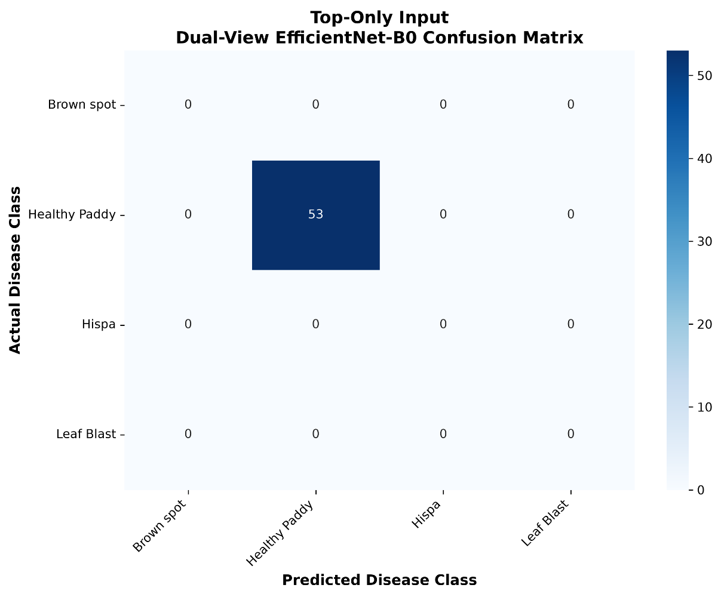
Hispa:
No. | Image | Prediction | Confidence
1 | 000174_t577.JPG | Hispa | 99.09%
2 | 000176_t579.JPG | Hispa | 93.37%
3 | 000180_t583.JPG | Hispa | 93.66%
4 | 000182_t585.JPG | Hispa | 96.44%
5 | 000184_t587.JPG | Hispa | 97.95%
6 | 000186_t589.JPG | Hispa | 57.61%
7 | 000188_t591.JPG | Hispa | 94.34%
8 | 000190_t593.JPG | Hispa | 98.25%
9 | 000192_t595.JPG | Hispa | 89.91%
10 | 000194_t597.JPG | Hispa | 96.76%
11 | 000196_t599.JPG | Hispa | 78.21%
12 | 000198_t601.JPG | Hispa | 90.13%
13 | 000202_t605.JPG | Healthy Paddy | 59.66%
14 | 000204_t607.JPG | Hispa | 99.65%
15 | 000206_t609.JPG | Hispa | 95.74%
16 | 000210_t613.JPG | Hispa | 68.69%

Metric | Result
Total Test TOP Images | 16
Overall Accuracy | 93.75%
Macro Precision | 25.00%
Macro Recall | 23.44%
Macro F1-Score | 24.19%
Weighted F1-Score | 96.77%

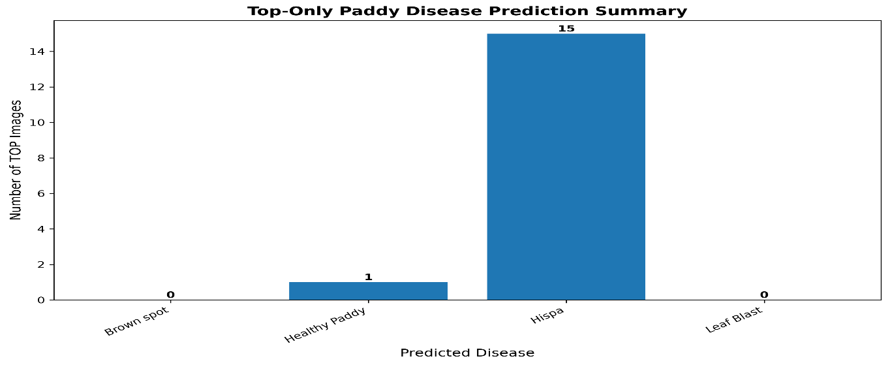
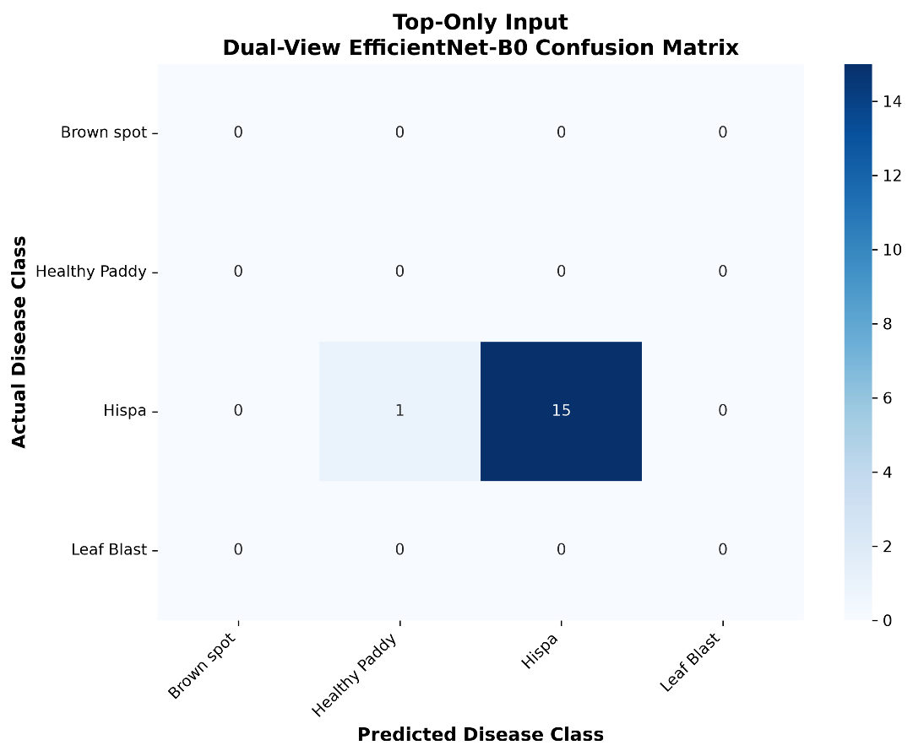

Leaf Blast:
No. | Image | Prediction | Confidence
1 | 000206_t698.JPG | Leaf Blast | 98.03%
2 | 000208_t700.JPG | Leaf Blast | 97.27%
3 | 000210_t702.JPG | Leaf Blast | 99.02%
4 | 000212_t704.JPG | Leaf Blast | 97.48%
5 | 000214_t706.JPG | Leaf Blast | 97.04%
6 | 000216_t708.JPG | Leaf Blast | 96.24%
7 | 000218_t710.JPG | Leaf Blast | 98.28%
8 | 000220_t712.JPG | Leaf Blast | 97.59%
9 | 000222_t714.JPG | Leaf Blast | 96.54%
10 | 000224_t716.JPG | Leaf Blast | 97.38%
11 | 000226_t718.JPG | Leaf Blast | 99.03%
12 | 000228_t720.JPG | Leaf Blast | 93.84%
13 | 000230_t722.JPG | Leaf Blast | 60.63%
14 | 000234_t726.JPG | Leaf Blast | 98.48%
15 | 000236_t728.JPG | Leaf Blast | 93.96%
16 | 000238_t730.JPG | Leaf Blast | 98.15%
17 | 000240_t732.JPG | Leaf Blast | 99.14%
18 | 000242_t466.JPG | Leaf Blast | 80.57%
19 | 000242_t734.JPG | Leaf Blast | 98.57%
20 | 000246_t738.JPG | Leaf Blast | 94.88%
21 | 000248_t740.JPG | Leaf Blast | 95.03%
22 | 000250_t742.JPG | Leaf Blast | 88.73%
23 | 000252_t744.JPG | Leaf Blast | 80.07%
24 | 000254_t746.JPG | Leaf Blast | 83.00%
25 | 000256_t748.JPG | Leaf Blast | 98.07%
26 | 000264_t488.JPG | Leaf Blast | 60.63%

Metric | Result
Total Test TOP Images | 26
Overall Accuracy | 100.00%
Macro Precision | 25.00%
Macro Recall | 25.00%
Macro F1-Score | 25.00%
Weighted F1-Score | 100.00%

