## Sankalp Chapalgaokar Jitendra Kumar EE15B018 EE15B030

## Q1

### A)

The given passband is plotted as shown below. It is passband version of sinc(t).

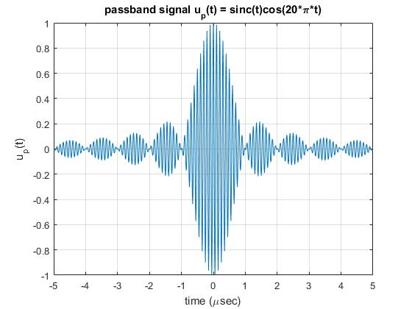

### B)

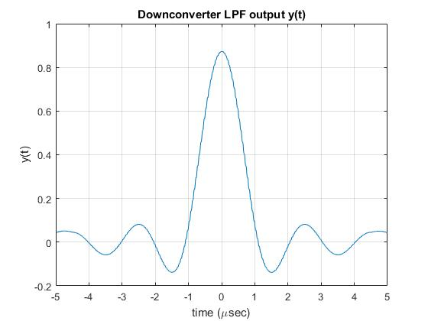

#### Observation

The expected output of the LPF is the exact sinc function but as seen from the diagram, it is kind of distorted sinc. For eliminating the higher frequencies, we should implement the LPF in frequency domain with amplitude of 1, but here we are multiplying LPF in time domain which means it will be sinc in the frequency domain. But here using sinc is not making much difference because sinc has high gain at lower frequencies and low gain at higher frequencies.

## Q2)

The Square Root Raised Cosine (SRRC) pulse is converted to normalized frequency response with roll-off factor of 0.35, 0.7 and 1. We are using 8X oversampling factor and the truncation length of 10 symbols in the representation of the SRRC pulse. Symbol rate is taken as 25 K symbols/sec. Following plots show the normalized frequencies for different roll-off factor.

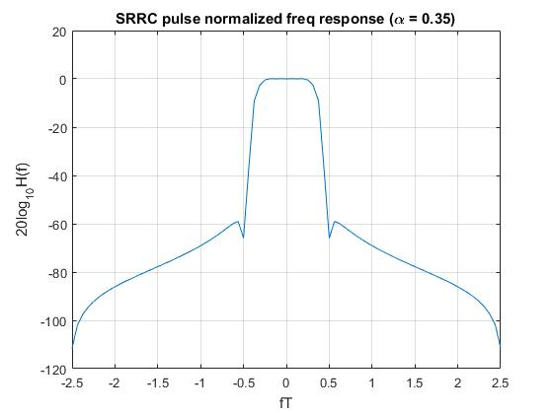

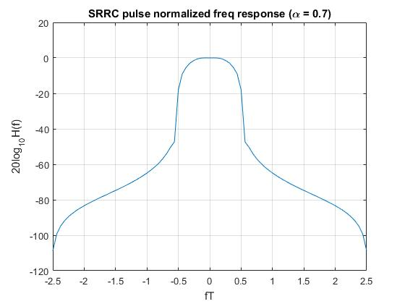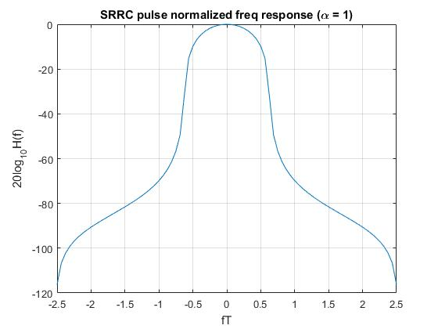

## Q3)

Taking the SRRC pulse from Q2 considering α = 0.35 and convolving it with itself results into RC pulse. The RC pulse is as shown as follows.

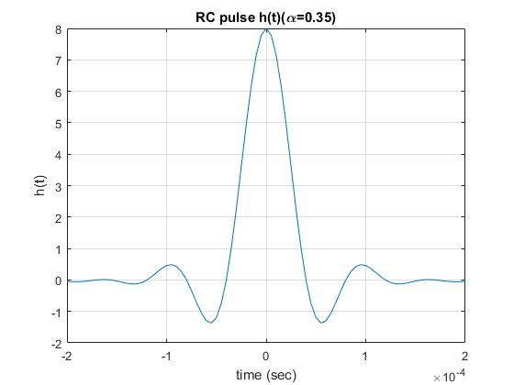

Random sequence of bits $±1$ is shown in following figure.

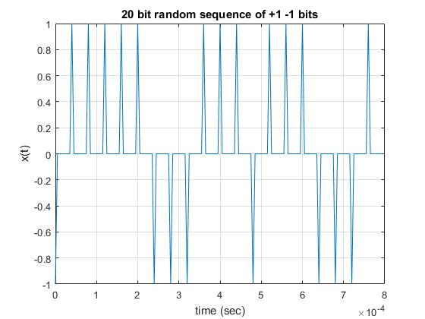

Applying RC pulse sequence for the above random sequence of bits we get the pulse shaped sequence as shown in following figure.

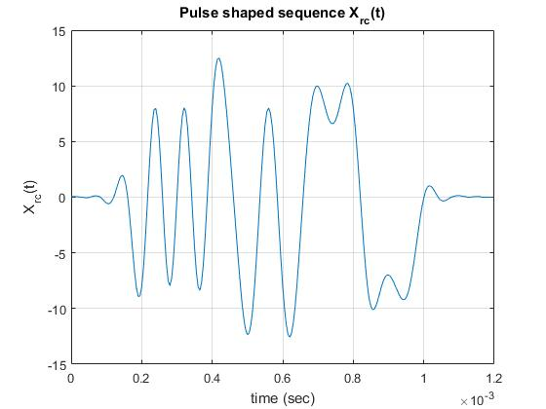

Sampling values at samples the resultant waveform at symbol-spaced sampling points

which correspond to the peak of the RC pulse are:

-8.0282, -8.0411, 7.9559, -8.0323, 7.9550, 7.9896, 8.0256, 7.9923, 8.0854, 7.9104, 7.9298, 7.9168, -7.9849, -8.1002, 7.9279, 7.9736, 7.9439, -7.9643, 8.0522, 7.9574

The eye diagram is as follows.

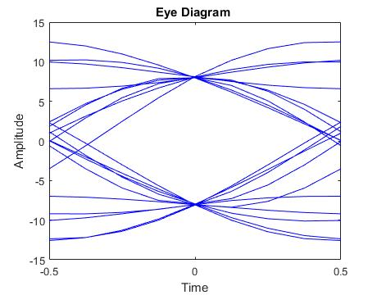

### Honour code

I certify that this assignment submission is my own work and not from obtained from any other source.

