Practical Examination
Roll No.: EN23107064
Name : Sankalp Laxman Khatake
Problem Statement: To assess the candidate’s ability to collaborate using GitHub, implement changes in a feature branch, and create a proper Pull Request (PR) for code review.

Git Hub
- Login in github
- Create a new repository
- Install git.
- Clone git repository through terminal.
- Push the file on github repository from local host folder.


1)Login in Github

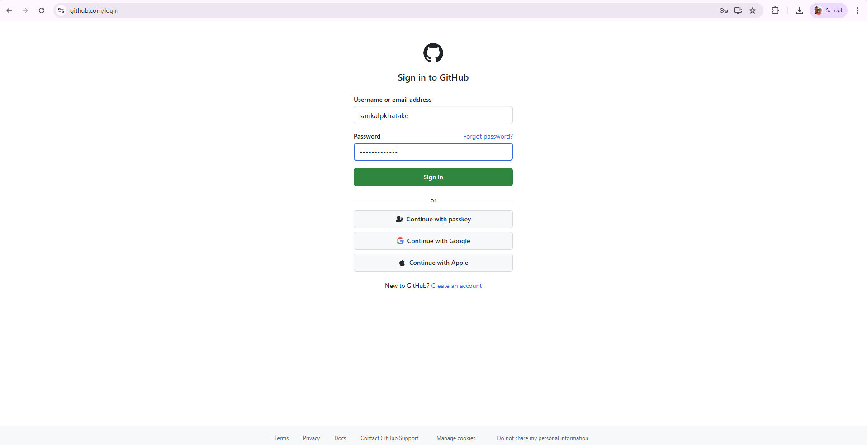

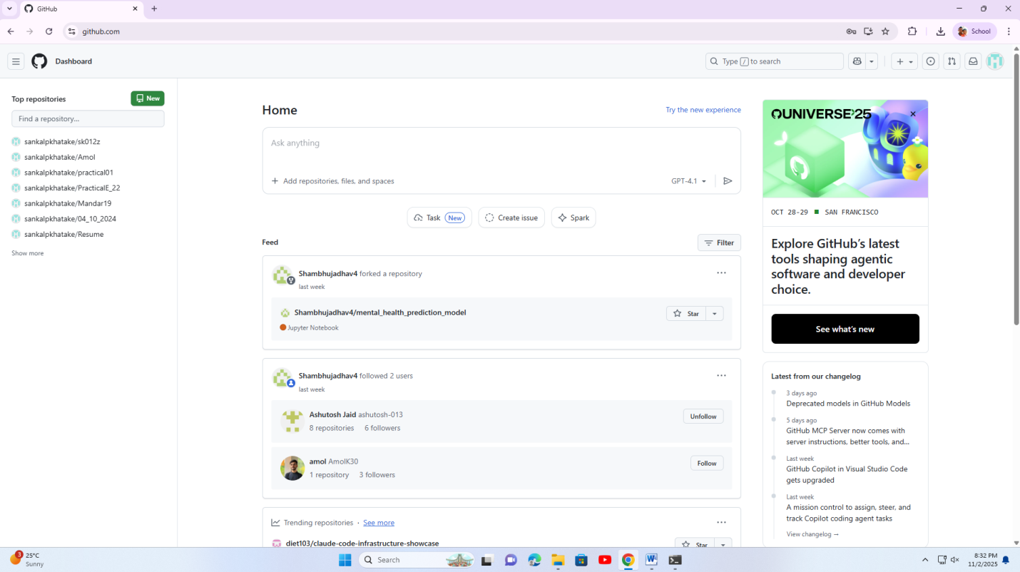

2) Create a new repository.
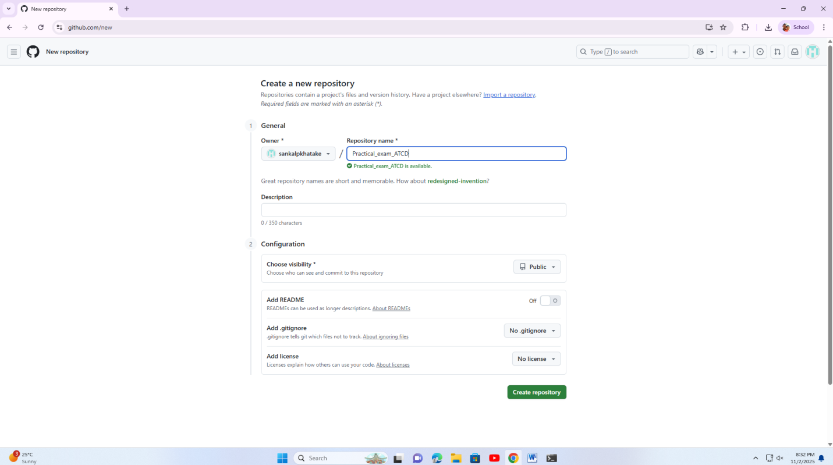

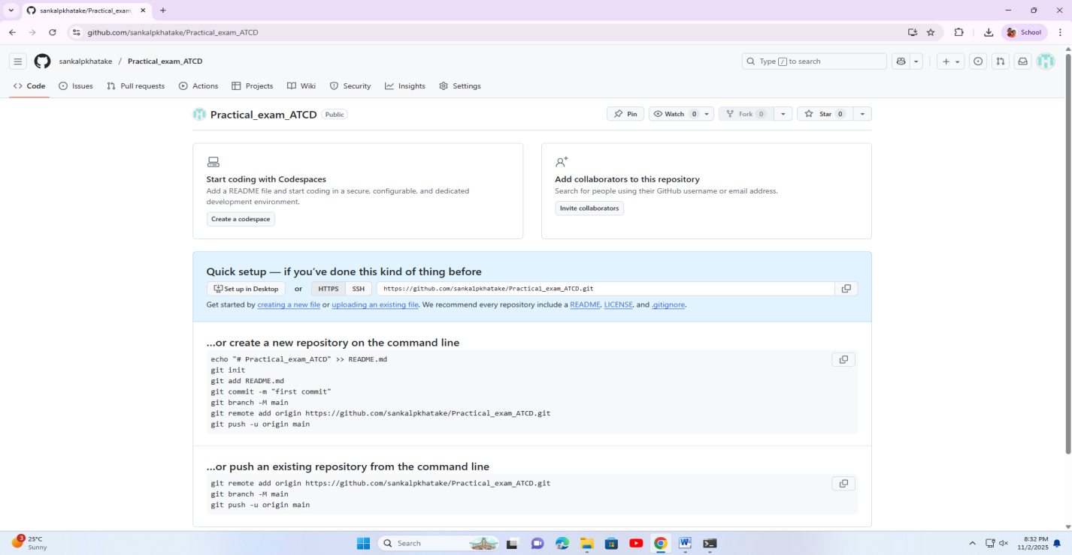

3) Install git on Windows
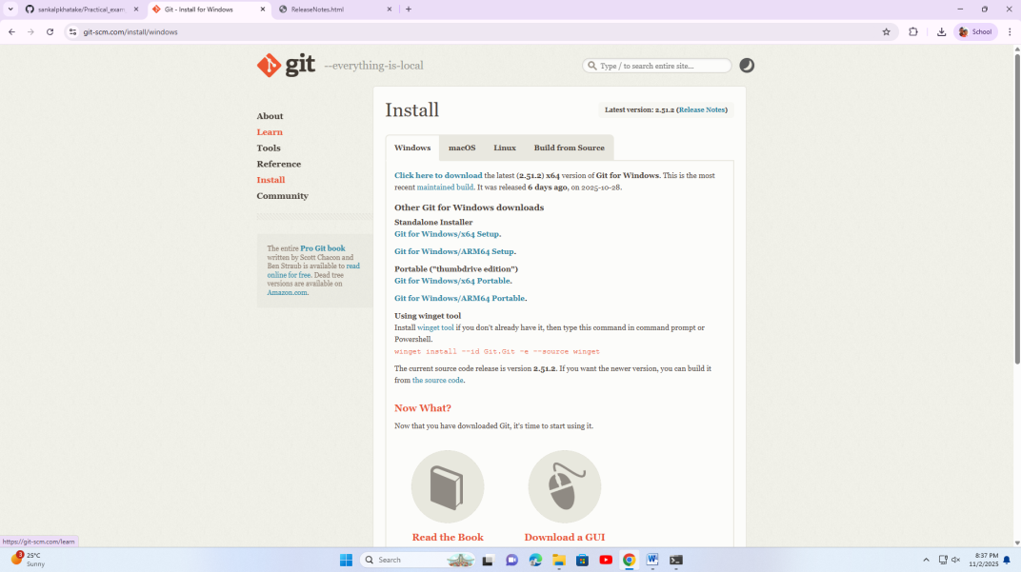

4) Clone git repository and Push the file on github repository from local host folder through terminal

Windows PowerShell
Copyright (C) Microsoft Corporation. All rights reserved.

Install the latest PowerShell for new features and improvements! https://aka.ms/PSWindows

PS C:\Users\admin> git --version
git version 2.51.2.windows.1
PS C:\Users\admin> git clone https://github.com/sankalpkhatake/practical_exam_ATCD.git
Cloning into 'practical_exam_ATCD'...
warning: You appear to have cloned an empty repository.
PS C:\Users\admin> cd "C:\Users\admin\Desktop\EN23107064"
PS C:\Users\admin\Desktop\EN23107064> git init
Initialized empty Git repository in C:/Users/admin/Desktop/EN23107064/.git/
PS C:\Users\admin\Desktop\EN23107064> git add EN23107064.txt
fatal: pathspec 'EN23107064.txt' did not match any files
PS C:\Users\admin\Desktop\EN23107064> dir

Directory: C:\Users\admin\Desktop\EN23107064

Mode LastWriteTime Length Name
---- ------------- ------ ----
-a---- 11/2/2025 8:42 PM 0 EN23107064.docx

PS C:\Users\admin\Desktop\EN23107064> git add EN23107064.docx
PS C:\Users\admin\Desktop\EN23107064> git add .
PS C:\Users\admin\Desktop\EN23107064> git commit -m "Add Exam excute file"
Author identity unknown

*** Please tell me who you are.

Run

git config --global user.email "you@example.com"
git config --global user.name "Your Name"

to set your account's default identity.
Omit --global to set the identity only in this repository.

fatal: unable to auto-detect email address (got 'admin@pcl17.(none)')
PS C:\Users\admin\Desktop\EN23107064> git config --global user.name "sankalpkhatake"
PS C:\Users\admin\Desktop\EN23107064> git config --global user.email "sankalp.khatake.aids.2023@vpkbiet.org"
PS C:\Users\admin\Desktop\EN23107064> git config --list
diff.astextplain.textconv=astextplain
filter.lfs.clean=git-lfs clean -- %f
filter.lfs.smudge=git-lfs smudge -- %f
filter.lfs.process=git-lfs filter-process
filter.lfs.required=true
http.sslbackend=schannel
core.autocrlf=true
core.fscache=true
core.symlinks=false
pull.rebase=false
credential.helper=manager
credential.https://dev.azure.com.usehttppath=true
init.defaultbranch=master
user.name=sankalpkhatake
user.email=sankalp.khatake.aids.2023@vpkbiet.org
core.repositoryformatversion=0
core.filemode=false
core.bare=false
core.logallrefupdates=true
core.symlinks=false
core.ignorecase=true
PS C:\Users\admin\Desktop\EN23107064> git commit -m "Add Exam excute file"
[master (root-commit) 945eec1] Add Exam excute file
1 file changed, 0 insertions(+), 0 deletions(-)
create mode 100644 EN23107064.docx
PS C:\Users\admin\Desktop\EN23107064> git push -u origin main
error: src refspec main does not match any
error: failed to push some refs to 'origin'
PS C:\Users\admin\Desktop\EN23107064> git push -u origin master
fatal: 'origin' does not appear to be a git repository
fatal: Could not read from remote repository.

Please make sure you have the correct access rights
and the repository exists.
PS C:\Users\admin\Desktop\EN23107064> git branch -M main
PS C:\Users\admin\Desktop\EN23107064> git push -u origin main
fatal: 'origin' does not appear to be a git repository
fatal: Could not read from remote repository.

Please make sure you have the correct access rights
and the repository exists.
PS C:\Users\admin\Desktop\EN23107064> git branch
* main
PS C:\Users\admin\Desktop\EN23107064> git remote add origin https://github.com/yourusername/EN23107064.git
PS C:\Users\admin\Desktop\EN23107064> git push -u origin main
info: please complete authentication in your browser...
remote: Repository not found.
fatal: repository 'https://github.com/yourusername/EN23107064.git/' not found
PS C:\Users\admin\Desktop\EN23107064> git push -u origin main
info: please complete authentication in your browser...
remote: Repository not found.
fatal: repository 'https://github.com/yourusername/EN23107064.git/' not found
PS C:\Users\admin\Desktop\EN23107064> git push -u origin main
info: please complete authentication in your browser...
remote: Repository not found.
fatal: repository 'https://github.com/yourusername/EN23107064.git/' not found
PS C:\Users\admin\Desktop\EN23107064> git remote add origin https://github.com/sankalpkhatake/Practical_exam_ATCD.git
error: remote origin already exists.
PS C:\Users\admin\Desktop\EN23107064> git remote set-url origin https://github.com/sankalpkhatake/Practical_exam_ATCD.git
PS C:\Users\admin\Desktop\EN23107064> git remote -v
origin https://github.com/sankalpkhatake/Practical_exam_ATCD.git (fetch)
origin https://github.com/sankalpkhatake/Practical_exam_ATCD.git (push)
PS C:\Users\admin\Desktop\EN23107064> git push -u origin main
info: please complete authentication in your browser...
Enumerating objects: 3, done.
Counting objects: 100% (3/3), done.
Writing objects: 100% (3/3), 235 bytes | 235.00 KiB/s, done.
Total 3 (delta 0), reused 0 (delta 0), pack-reused 0 (from 0)
To https://github.com/sankalpkhatake/Practical_exam_ATCD.git
* [new branch] main -> main
branch 'main' set up to track 'origin/main'.
PS C:\Users\admin\Desktop\EN23107064> git add .
PS C:\Users\admin\Desktop\EN23107064> git commit -m "Add Exam excute file01"
On branch main
Your branch is up to date with 'origin/main'.

nothing to commit, working tree clean
PS C:\Users\admin\Desktop\EN23107064> git push
Everything up-to-date
PS C:\Users\admin\Desktop\EN23107064> git status
On branch main
Your branch is up to date with 'origin/main'.

nothing to commit, working tree clean
PS C:\Users\admin\Desktop\EN23107064> git add EN23107064.docx
PS C:\Users\admin\Desktop\EN23107064> git commit -m "Updated."
On branch main
Your branch is up to date with 'origin/main'.

Changes not staged for commit:
(use "git add <file>..." to update what will be committed)
(use "git restore <file>..." to discard changes in working directory)
modified: EN23107064.docx

Untracked files:
(use "git add <file>..." to include in what will be committed)
~$23107064.docx
~WRL0003.tmp

no changes added to commit (use "git add" and/or "git commit -a")
PS C:\Users\admin\Desktop\EN23107064> git add EN23107064.docx
PS C:\Users\admin\Desktop\EN23107064> git commit -m "Updated02"
[main 0881e77] Updated02
1 file changed, 0 insertions(+), 0 deletions(-)
PS C:\Users\admin\Desktop\EN23107064> git push
Enumerating objects: 5, done.
Counting objects: 100% (5/5), done.
Delta compression using up to 12 threads
Compressing objects: 100% (2/2), done.
Writing objects: 100% (3/3), 1.16 MiB | 1.89 MiB/s, done.
Total 3 (delta 0), reused 0 (delta 0), pack-reused 0 (from 0)
To https://github.com/sankalpkhatake/Practical_exam_ATCD.git
945eec1..0881e77 main -> main
PS C:\Users\admin\Desktop\EN23107064> git status
On branch main
Your branch is up to date with 'origin/main'.

Untracked files:
(use "git add <file>..." to include in what will be committed)
~$23107064.docx
~WRL0003.tmp

nothing added to commit but untracked files present (use "git add" to track)
PS C:\Users\admin\Desktop\EN23107064>

