|  |  |
| --- | --- |
|  | **Cognizant Academy**  **truYum**  **FSE Web UI Specification Document**  **Version 1.0** |
| |  |  |  |  | | --- | --- | --- | --- | |  | **Prepared By / Last Updated By** | **Reviewed By** | **Approved By** | | **Name** | Chandrasekaran Janardhanan | Vimalathithan Krishnan | Ramadevanahalli Lingachar, Shashidhara Murthy | | **Role** | Learning Solution Designer | Learning Solution Architect | Learning Solution Lead | | **Signature** |  |  |  | | **Date** |  |  |  | |
|  |

Table of Contents

1.0 Introduction 4

1.1 Purpose of this document 4

1.2 Definitions & Acronyms 4

1.3 Project Overview 4

1.4 Scope 4

1.5 Intended Audience 4

1.6 Hardware and Software Requirement 4

2.0 Forking and Cloning 5

3.0 Images 5

4.0 Fonts 5

5.0 Icons 5

6.0 Responsive Web Design (RWD) and User Experience Design 5

7.0 Header and Footer 6

7.1 Header for Anonymous User 6

7.1.1 Desktop 6

7.1.1 Mobile (Collapsed Menu) 6

7.1.1 Mobile (Expanded Menu) 6

7.2 Header After Login 6

7.2.1 Desktop 6

7.2.2 Mobile (Collapsed Menu) 7

7.2.3 Mobile (Expanded Menu) 7

7.1 Footer 7

7.1.1 Desktop 7

7.1.2 Mobile (Collapsed Menu) 7

8.0 View Menu Item List 7

8.1 Menu Item List Anonymous & Customer (TYUS003 & TYUC002) 7

8.1.1 Desktop 8

8.1.1 Tablet 9

8.1.2 Mobile 10

8.2 Menu Item List Admin (TYUC001) 11

8.2.1 Desktop 11

8.2.1 Tablet 12

8.2.1 Mobile 13

9.0 Search Menu Item (TYUS004) 14

9.1.1 Desktop 14

9.1.2 Tablet 15

9.1.3 Mobile 15

10.0 Edit Menu Item (TYUC003) 15

10.1 Edit Menu Item 15

10.1.1 Desktop 16

10.1.2 Tablet 17

10.1.3 Mobile 18

10.2 Edit Menu Item Status 19

11.0 Add to Cart (TYUC004) 19

11.1 Menu Item List Customer (Add to Cart success) 19

12.0 View Cart (TYUC005) 21

12.1 Cart 21

12.1.1 Desktop 21

12.1.2 Tablet 21

12.1.1 Mobile 22

12.1 Cart Empty 22

13.0 Remove item from Cart (TYUC006) 24

13.1 Remove Cart 24

14.0 Signup (TYUS006) 24

14.1 Signup 24

14.1.1 Desktop 24

14.1.1 Tablet 25

14.1.1 Mobile 26

15.0 Login (TYUS007) 26

15.1 Login 26

15.1.1 Desktop 27

15.1.2 Tablet 27

15.1.3 Mobile 28

15.1.1 Validations 29

16.0 Logout (TYUS008) 29

17.0 Standards and Guidelines 29

17.1 HTML 29

17.2 CSS 30

18.0 Submission 31

18.1 Code submission instructions 31

19.0 Change Log 31

# Introduction

## Purpose of this document

The purpose of this document is to define the user interface specification for truYum project.

## Definitions & Acronyms

|  |  |
| --- | --- |
| Definition / Acronym | Description |
| HTML | Hyper Text Markup Language |
| CSS | Cascading Style Sheet |
| RWD | Responsive Web Design |
| UX Design | User Experience Design |

## Project Overview

Refer truyum-user-stores.xlsx for understanding the functionality and features.

## Scope

Develop static HTML web pages for truYum application.

## Intended Audience

* Product Owner
* Scrum Master
* Application Architect
* Project Manager
* Test Manager
* Development Team
* Testing Team

## Hardware and Software Requirement

1. Hardware Requirement:
   1. Developer Desktop PC with 8GB RAM
2. Software Requirement
   1. Notepad ++ for editing HTML and CSS
   2. Chrome Browser

# Forking and Cloning

**Project to fork:**

<https://code.cognizant.com/genc-java/truyum-ui-template>

# Images

Use free stock images from the following website:

<https://unsplash.com/>

**NOTE:** Do not download images and place them in the project folder as this in will unnecessary increase the project size. Refer the direct internet URL of the image in the ‘src’ attribute of image.

# Fonts

Use google fonts for the web page.

https://fonts.google.com/

**NOTE:** Do not download fonts and place them in the project folder as this in will unnecessary increase the project size. Refer the direct internet URL of the the font.

# Icons

Use google material icons.

# RWD and UX Design (TYUS001 and TYUS002)

Bootstrap 4 has to be used for responsive web design. For good user experience refer the layouts specified in this document.

# Header and Footer

Header and Footer should be uniformly applied across all screens as specified below.

## Header for Anonymous User

### Desktop



### Mobile (Collapsed Menu)



### Mobile (Expanded Menu)

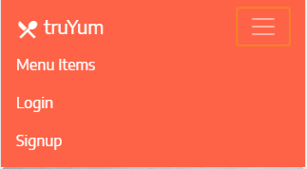

|  |  |
| --- | --- |
| **Navbar Item** | **Links to** |
| Menu Items | menu-item-list.html |
| Login | login.html |
| Signup | signup.html |

## Header After Login

### Desktop



The name John should dynamically based on the logged in user.

### Mobile (Collapsed Menu)



### Mobile (Expanded Menu)

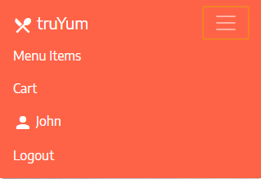

|  |  |
| --- | --- |
| **Navbar Item** | **Links to** |
| Menu Items | menu-item-list-admin.html |
| Cart | cart.html |
| Logout | menu-item-list.html |

## Footer

### Desktop



### Mobile (Collapsed Menu)



# View Menu Item List

## Menu Item List Anonymous & Customer (TYUS003 & TYUC002)

Displays the list of menu items for Anonymous user and Customer.

File (Anonymous User): truyum-ui-template/menu-item-list.html

File (Customer): truyum-ui-template/menu-item-list-customer.html

### Desktop

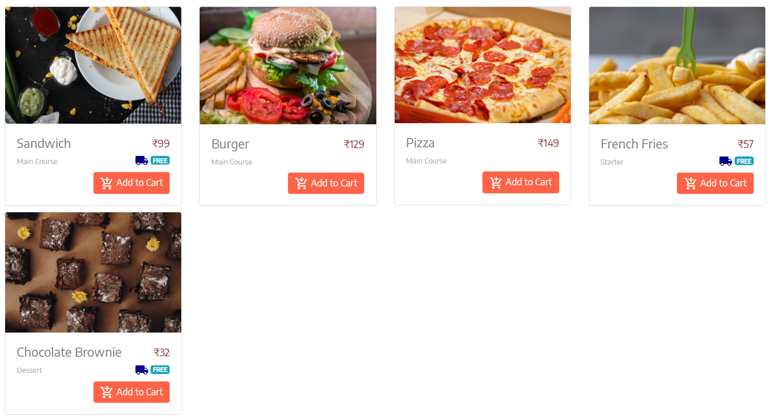

### Tablet

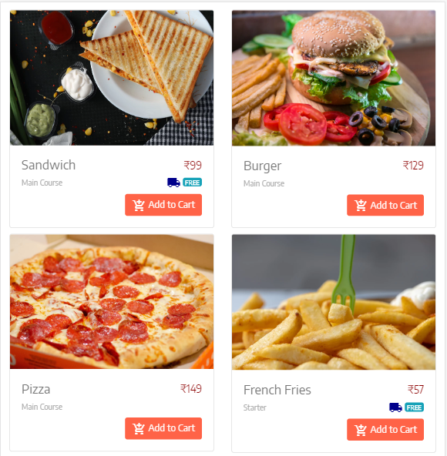

### Mobile

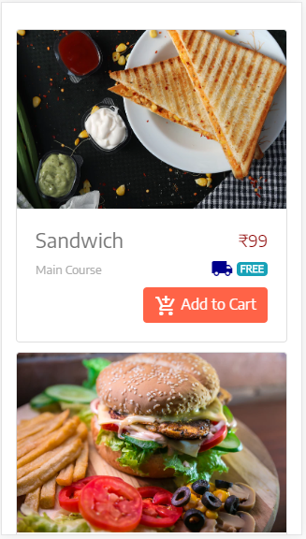

**Field Specification**

The menu items are listed in table kind of structure. Find below the specification for each column in the Menu Item List table.

|  |  |  |
| --- | --- | --- |
| **Field Name** | **Field Type** | **Description** |
| Name | Label | Displays the title of the menu item |
| Price | Label | Display the price of the menu item in currency format with two decimal places. Should include the currency symbol as well. |
| Active | Label | Display ‘Yes’ or ‘No’ based on whether the item is in stock or not |
| Date of Launch | Label | Display date of expiry in DD/MM/YYYY format |
| Category | Label | Displays the category of the menu item |
| Free Delivery | Label | Display ‘Yes’ or ‘No’ based the respective menu item delivery status |
| Add to Cart | Link | If user is logged in display login.html, else display success message (refer TYUC004) |

## Menu Item List Admin (TYUC001)

Displays the list of menu items for admin with edit option.

File: truyum-ui-template/menu-item-list-admin.html

### Desktop

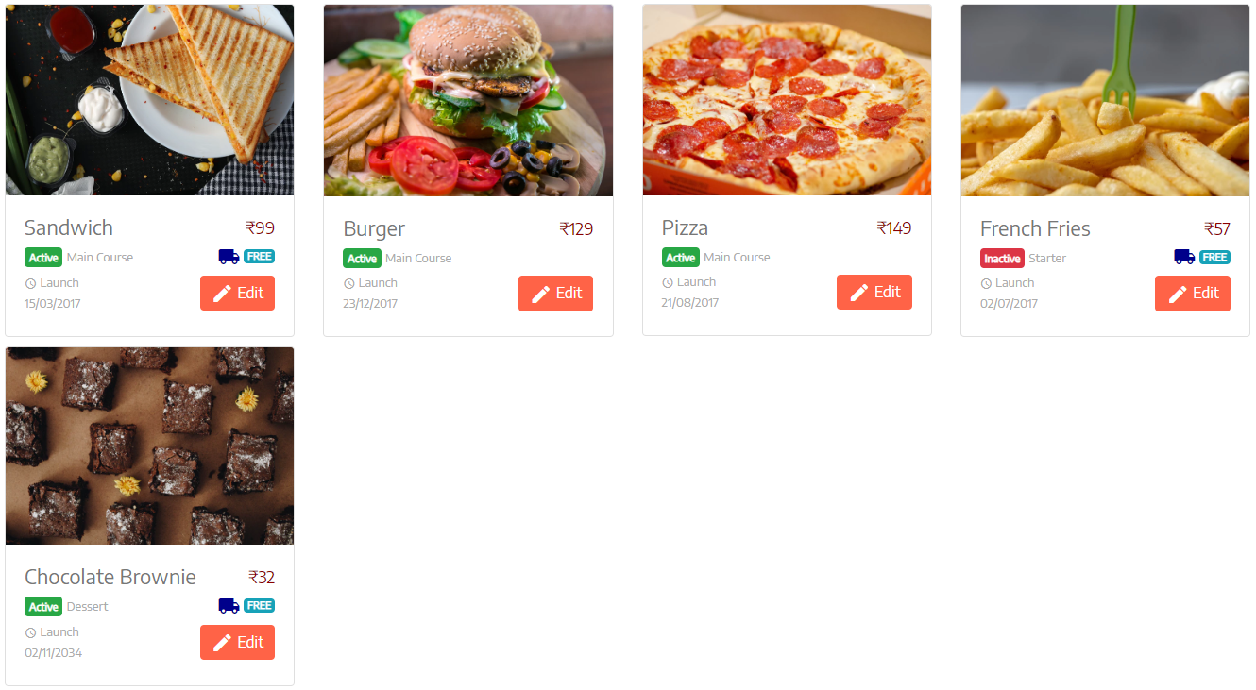

### Tablet

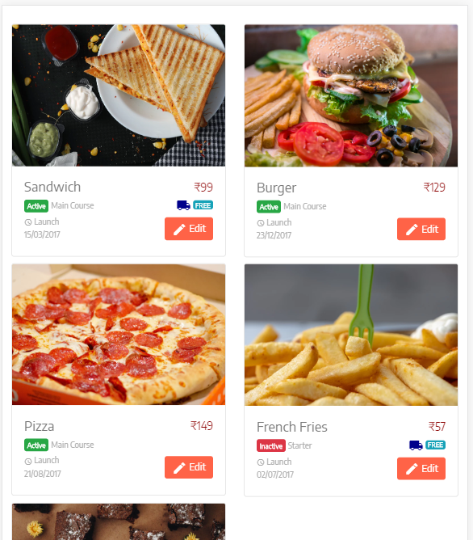

### Mobile

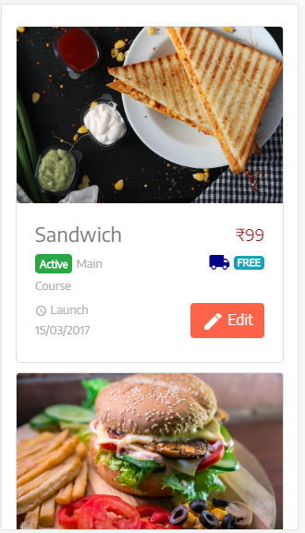

**Field Specification**

|  |  |  |
| --- | --- | --- |
| **Field Name** | **Field Type** | **Description** |
| Name | Label | Displays the title of the menu item |
| Price | Label | Display the price of the menu item in currency format with two decimal places. Should include the currency symbol as well. |
| Category | Label | Displays the category of the menu item |
| Free Delivery | Label | Display ‘Yes’ or ‘No’ based the respective menu item delivery status |
| Action | Link | Display ‘Add to Cart’ link, it displays the same page with notification message that the Menu Item is added into the cart or not |

# Search Menu Item (TYUS004)

This search bar needs to be included in all the screens where menu items are listed.

File: truyum-ui-template/menu-item-list.html

File: truyum-ui-template/menu-item-list-customer.html

File: truyum-ui-template/menu-item-list-admin.html

### Desktop

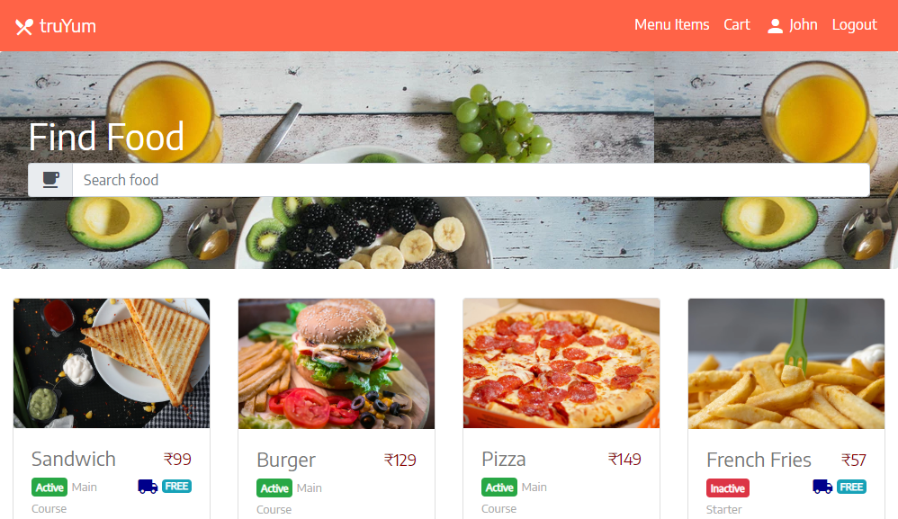

### Tablet

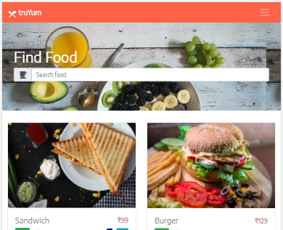

### Mobile

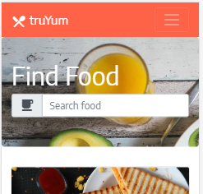

# Edit Menu Item (TYUC003)

## Edit Menu Item

Screen with form fields to edit the menu item details. This page is arrived by clicking the Edit link in menu-item-list-admin.html.

File: truyum-ui-template/edit-menu-item.html

### Desktop

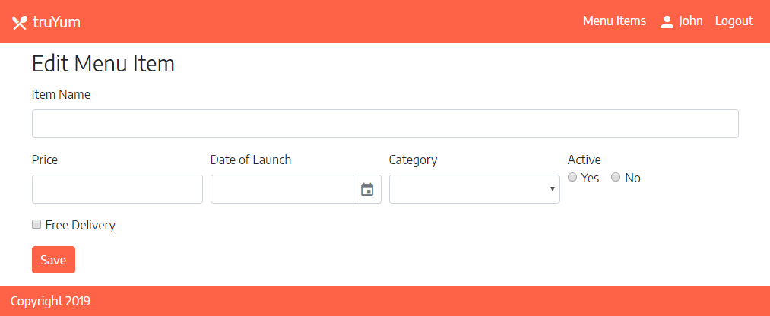

File: truyum-ui-template/edit-menu-item-validation.html

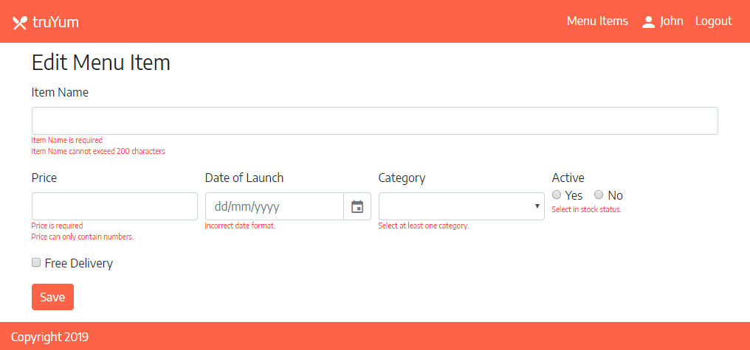

### Tablet

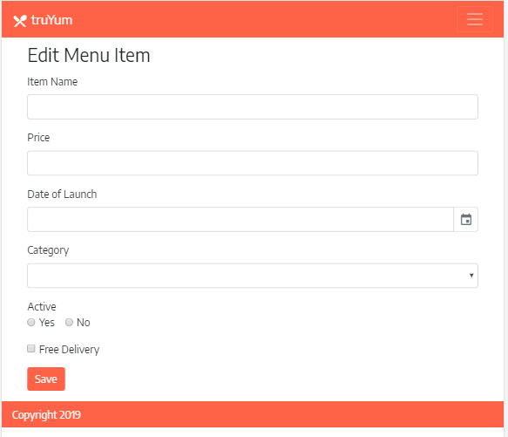

### Mobile

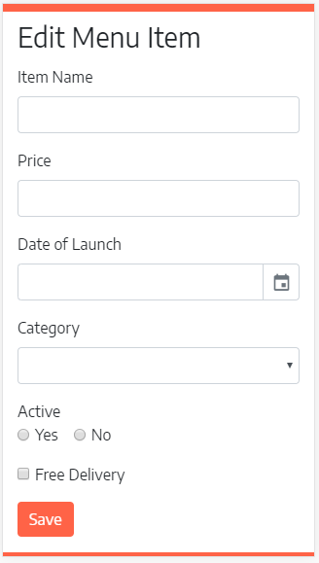

**Field Specification**

|  |  |  |  |
| --- | --- | --- | --- |
| **Field Name** | **Field Type** | **Name in HTML** | **Validation Message** |
| Item Name | Text Box | title | * Item Name is required. * Item Name cannot exceed 200 characters. |
| Price | Text Box | price | * Price is required. * Price has to be a number. |
| Date of Launch | Text Box | dateOfLaunch | * Date of Launch is required |
| Active | Radio Buttons | active |  |
| Category | Drop Down List | category | * Select one category |
| Free Delivery | Checkbox | freeDelivery |  |
| Save | Submit | submit | Button used by user to submit the form for saving a Menu Item. Above mentioned validations needs to be done on click of this button. The message needs to be displayed using JavaScript alert. |

## Edit Menu Item Status

Display the status of submission of edit menu item form. This page is arrived after clicking save in edit-menu-item.html.

File: truyum-ui-template/edit-menu-item-success.html

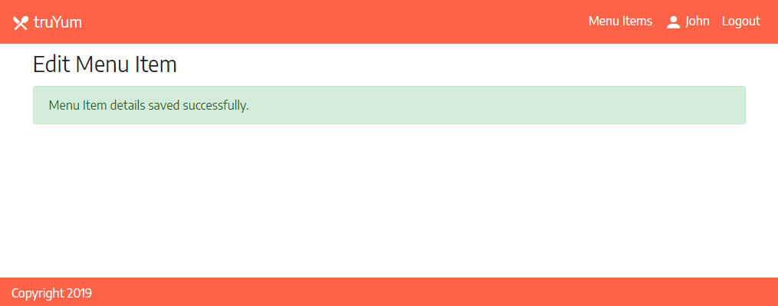

# Add to Cart (TYUC004)

## Menu Item List Customer (Add to Cart success)

Customer can add a menu item to Cart by clicking “Add to Cart” link in menu-item-list-customer.html. On clicking this link a page similar to Menu Item List page is displayed with the message that the Menu Item has been added to the cart successfully. The below layout specifies the layout for the specific menu item that has been added by the user to the cart. Similar layout needs to be provided on each respective menu item click. Include respective message in one menu item as part of completion of this web page.

File: truyum-ui-template/menu-item-list-customer-add-to-cart.html

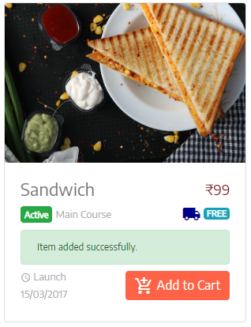

# View Cart (TYUC005)

## Cart

Displays the list of items added to the cart. This screen is arrived based on the navigation link in the top of the screen from menu-item-list-customer.html.

File: truyum-ui-template/cart.html

### Desktop

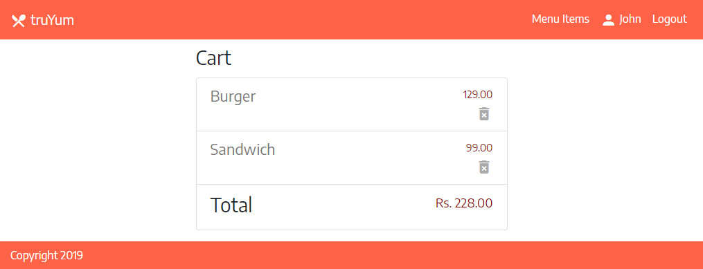

### Tablet

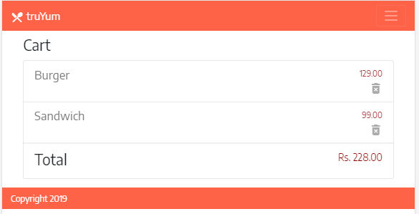

### Mobile

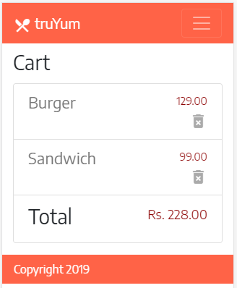

**Field Specification**

|  |  |  |
| --- | --- | --- |
| **Field Name** | **Field Type** | **Description** |
| Name | Label | Displays the title of the menu item |
| Free Delivery | Label | Display ‘Yes’ or ‘No’ based the respective menu item delivery status |
| Price | Label | Display the price of the menu item in currency format with two decimal places. Should include the currency symbol as well. |
| Delete | Link | Display ‘Delete’ link, which displays the same page with notification message that the item is deleted from the Cart successfully. |

## Cart Empty

Displays the view when there are no items in the cart. The Menu Item List link in the message should point to menu-item-list-customer.html.

File: truyum-ui-template/cart-empty.html

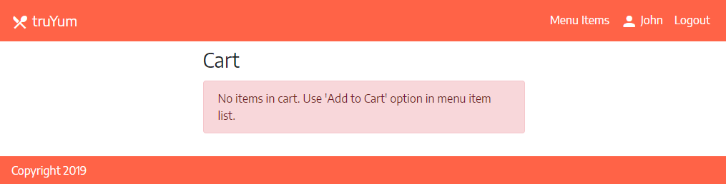

# Remove item from Cart (TYUC006)

## Remove Cart

When Customer click ‘Delete’ link in cart.html, this page is displayed with the message that the item had been removed from the Cart successfully.

File: truyum-ui-template/cart-notification.html

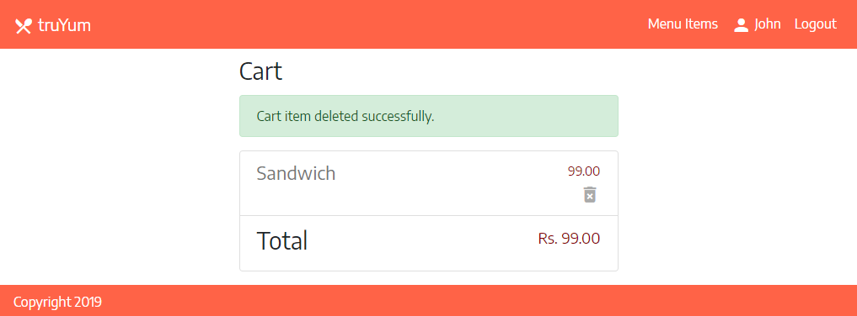

# Signup (TYUS006)

## Signup

Customer signup into truYum application using this option.

### Desktop

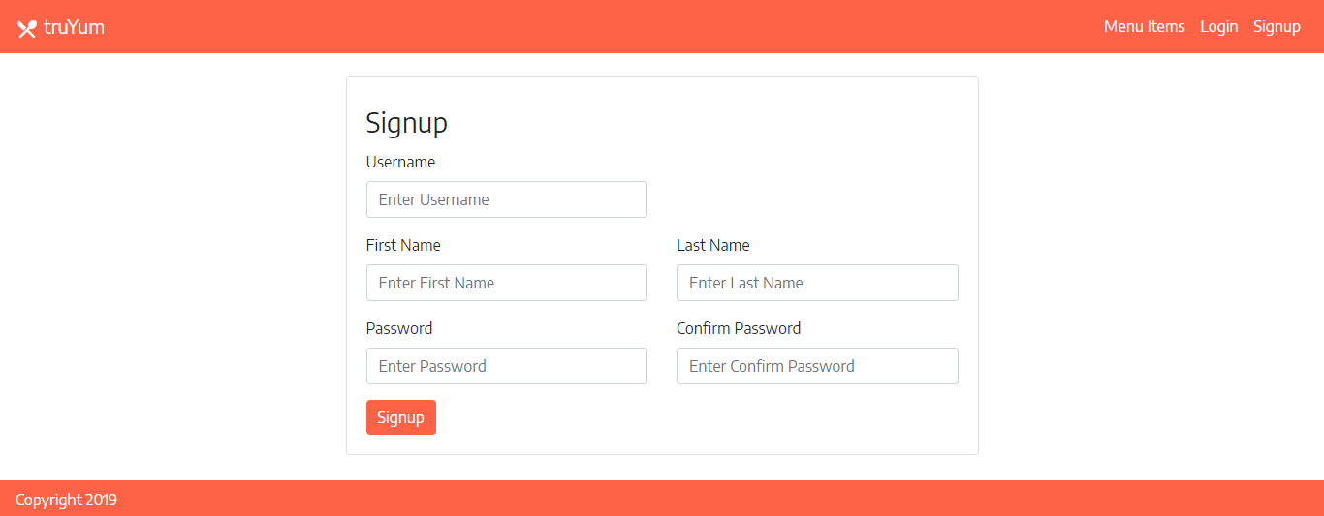

### Tablet

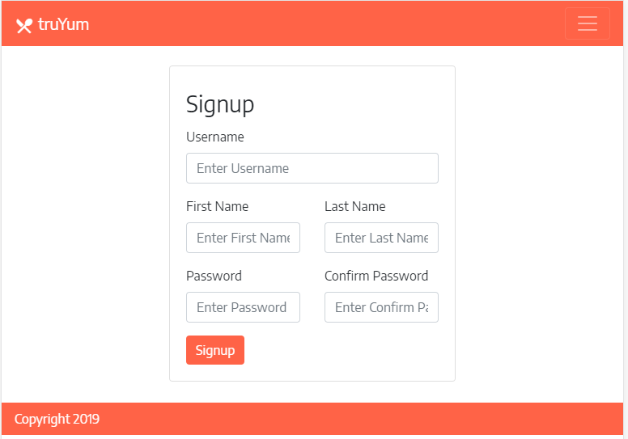

### Mobile

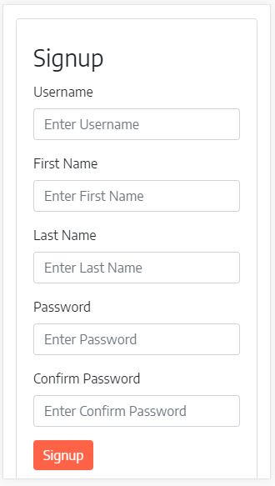

# Login (TYUS007)

## Login

This screen will be used by admin and customer to login.

### Desktop

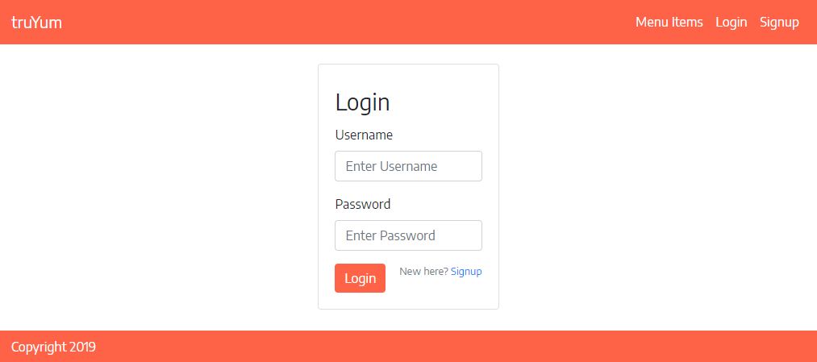

### Tablet

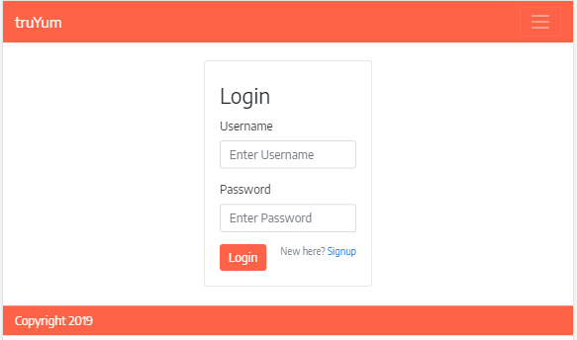

### Mobile

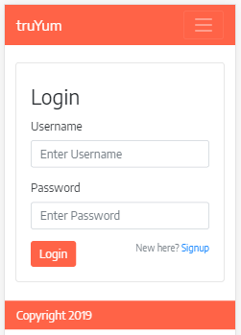

### Validations (TYUS005)

The message “Please login before adding an item to Cart” should be displayed when “Add to Cart” button is clicked without login.

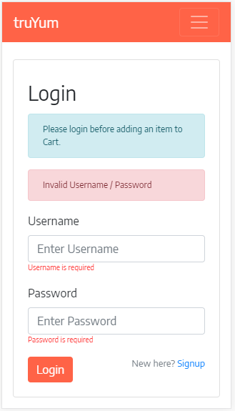

# Logout (TYUS008)

Clicking on the logout link should display menu-item-list.html.

# Standards and Guidelines

## HTML

1. Place all HTML files under WebContent folder.
2. HTML5 semantic tags has to be used wherever applicable. Avoid using div tags for header, footer, article and navigation bar.
3. Document Type should be defined as

<!DOCTYPE html>

1. Form fields must always include a <label> element with a "for" attribute matching the "id".

<label for="field-email">email</label>

<input type="email" id="field-email" name="email" value="" />

1. Each form field should have "name" attribute.
2. All tag names and attributes must be written in lowercase.
3. Inline style should be never used. Style should be in an external CSS and should be linked to the document.
4. Add one more tab on the next line after opening a tag
5. Reduce one tab on line when tag is closed

## CSS

1. CSS files names should be style.css
2. CSS files should be placed in style folder.
3. Feel free to change the Background Color, Font, Font Size and Font Color of the screen. But it should be applied consistently across screens using CSS. Following are the element in the screen that can be targeted for style change:
   1. Navigation Bar
   2. Page Heading
   3. Form Elements
   4. Messages
4. Reuse styles wherever applicable. Potential areas are Application Name, Page Title, Form Fields and Buttons
5. Selector names should be in lower case with words separated by hyphen.

.page-title {

margin: 20px;

}

1. Selector class names should be relevant to the purpose of the element where the style is applied. For example if common style needs to be applied for all text boxes in an application.
2. Properties should be followed by a colon and a space
3. Properties and values should be in lower case
4. Use hexadecimal code for color definition

Example:

.login-form {

background: #fdfdfd;

display: block;

margin: 0;

margin-left: 20px;

}

## Bootstrap (RWD and UX)

1. Do not use <p> or <br> for spacing between elements. Use mb-0, mb-1, mb-2, etc. for bottom margin and mt-0, mt-1, mt-2, etc. for top margin.
2. Avoid using bootstrap tables, as table data will not be responsive in mobile devices.
3. When designing screens ensure that equal spacing is provided between elements vertically. Refer example below, spacing between elements, the padding applied around are uniform:



1. When designing user interface for viewing data, do not use labels and values, convey the visual details and actions using icons, font size, font color, badge and other components available in bootstrap.

Examples:

* 1. For displaying Date of Birth, we can display a birthday icon adjacent to the date instead of having the label “Date of Birth”
  2. Instead of having a button with label delete, there can be an trash icon.

1. Design should concentrate on user experience
2. Make the design clear and simple

# Submission

## Code submission instructions

Use git add, commit and push commands to upload your code into remote GltLab repository.

During commit, give the commit message as “bootstrap”.

# Change Log

|  |  |  |  |  |
| --- | --- | --- | --- | --- |
|  | Changes Made | | | |
| V1.0.0 | Initial baseline created on <dd-Mon-yy> by <Name of Author> | | | |
| Vx.y.z | <Please refer the configuration control tool / change item status form if the details of changes are maintained separately. If not, the template given below needs to be followed> | | | |
| **Section No.** | **Changed By** | **Effective Date** | **Changes Effected** |
|  |  |  |  |