**Name: Sankalp Redgaonkar  
Final Project Part III**

1) Color Coded Map Demographic Attribute

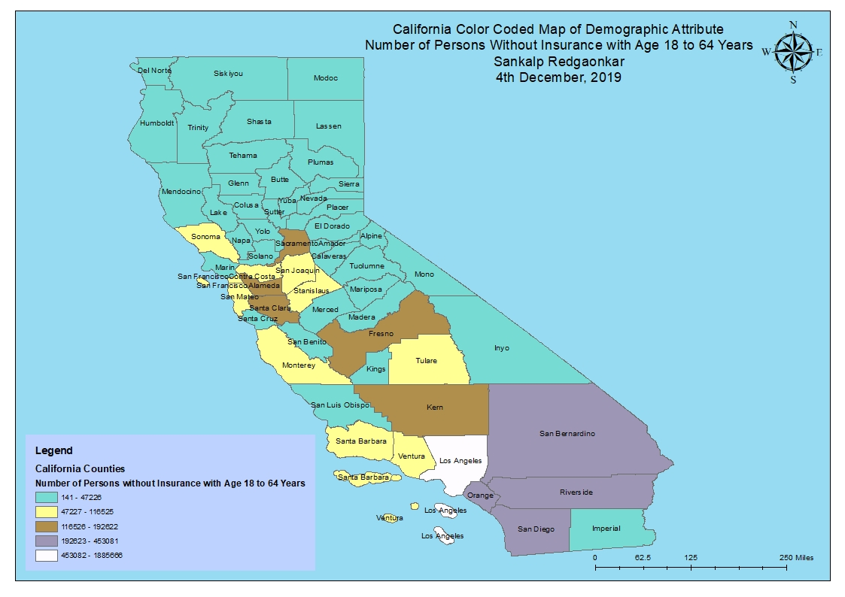

2) Color Coded Map Count

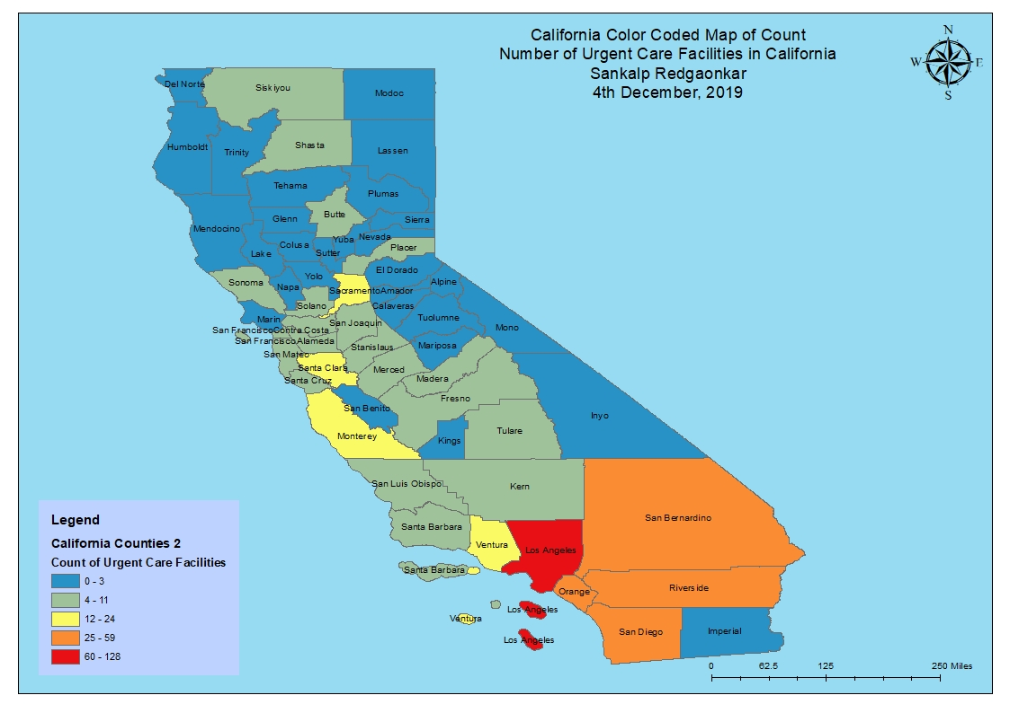

3) RQ1 Zoomed Out Map

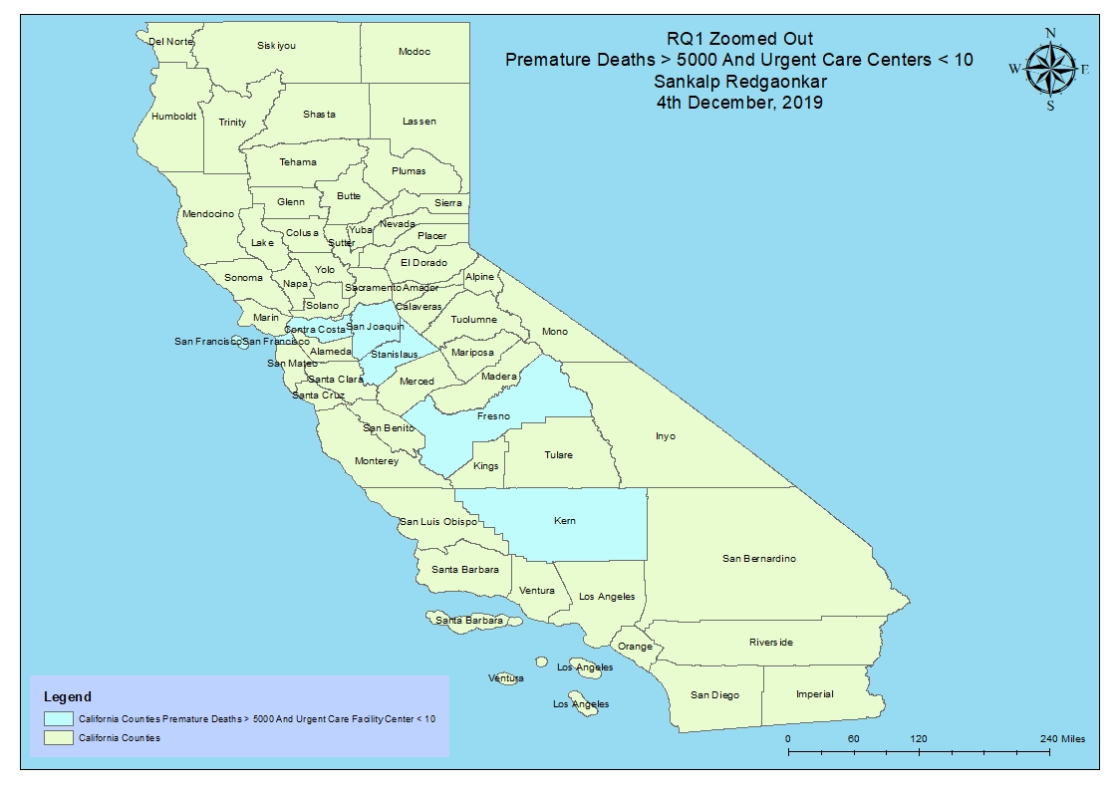

4) RQ1 Zoomed In Map

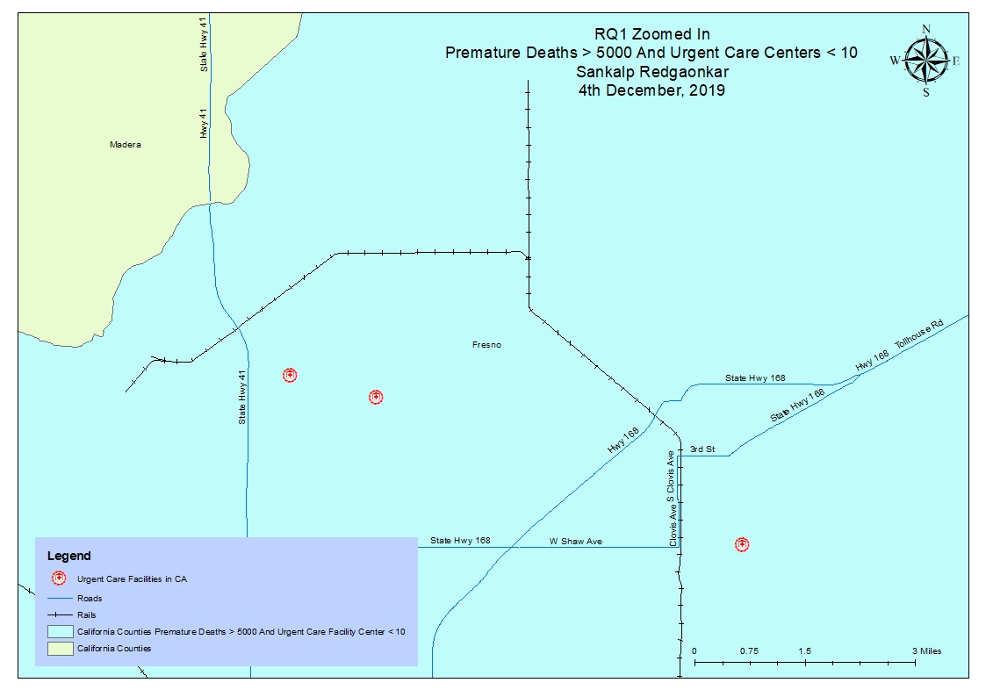

5) RQ2 Zoomed Out Map

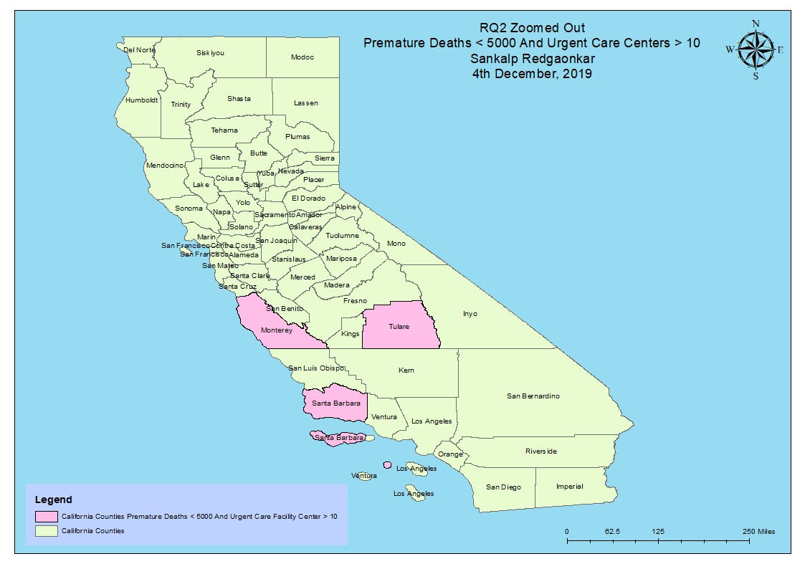

6) RQ2 Zoomed In Map

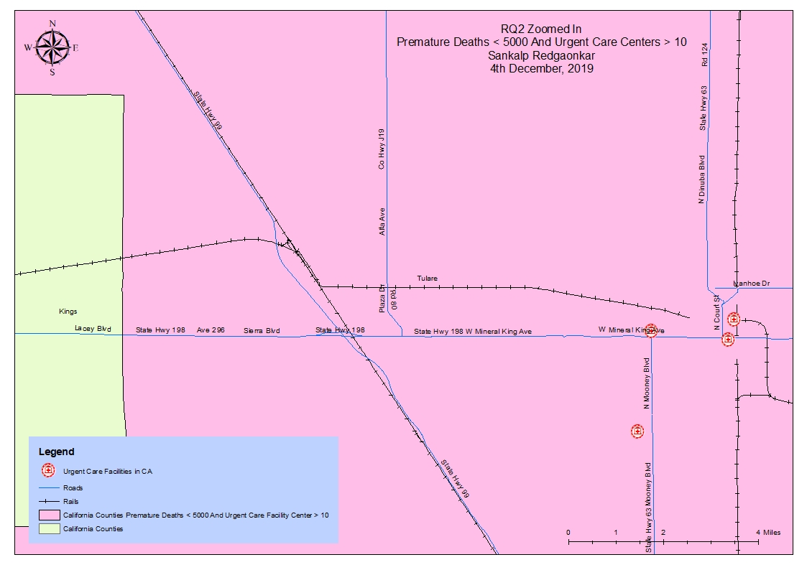

7) RQ1 and RQ2 Data Frame

