**CS 551 Advanced Software Engineering**

**First Increment Report**

R3

REDUCE RECYCLE REUSE

**Project Team: PG8**

**Team Members:** Sarika Bommavaram (08)

Gouri Priya Vangavargu (50)

Sankalp Racharla (43)

Sasidhar Malladi (32)

**Import Existing Services/API:**

In this phase we are currently using services such as Maps, Providing locations address based on zip code, city of end user.

We are using several API's in our application. They are listed below

→ **White pages API**:

This API is used locate the various recycling centers depending on users choice of location and also depends on type of recycling waste.

→ **Google Maps API:**

This API is used to get the map to the user to his destination. It provides guidance to the user by providing the directions to the destination depending upon his choice of selected recycling center.

**Detail Design of Services:**

**Service Description:**

In this phase our application is implementing both location and map service for end user. Here end user will provide his choice of location, application will provide list of nearest recycling centers to his given location and if user clicks on the locations provided he will get a map from his place to the selected recycling center.

**Implementation of REST Services:**

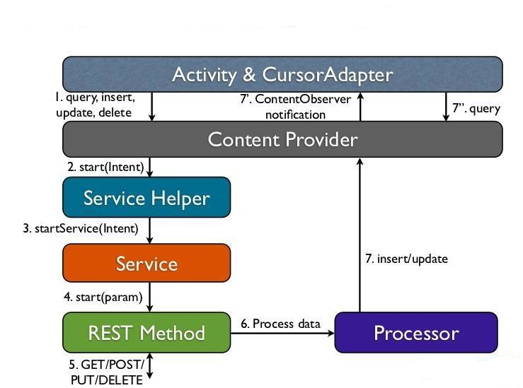

**ScrumDo Stories:**

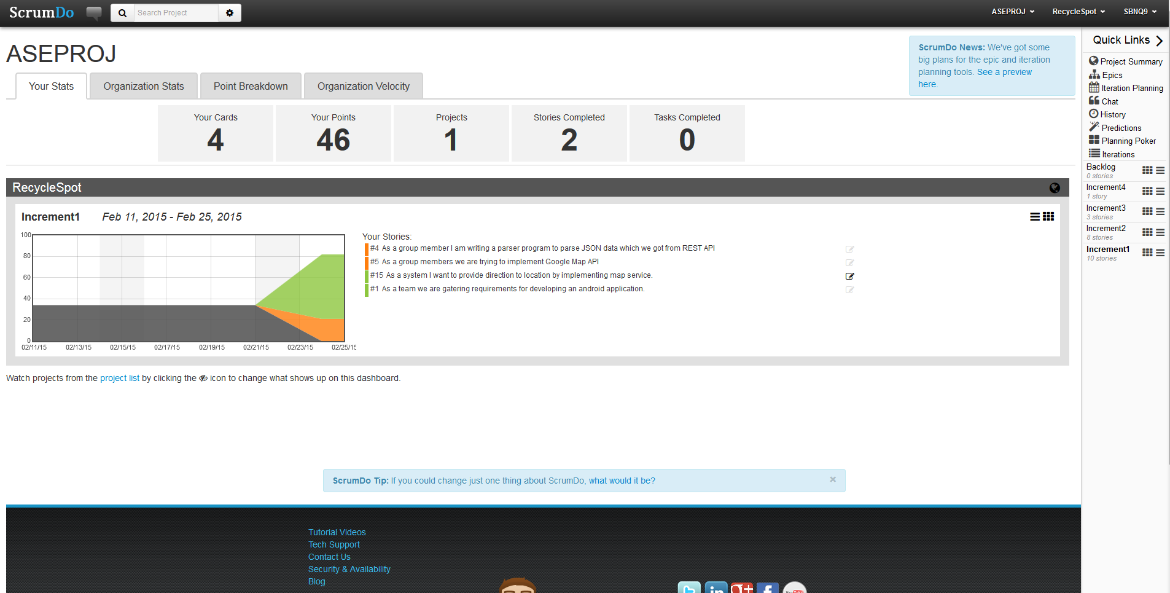

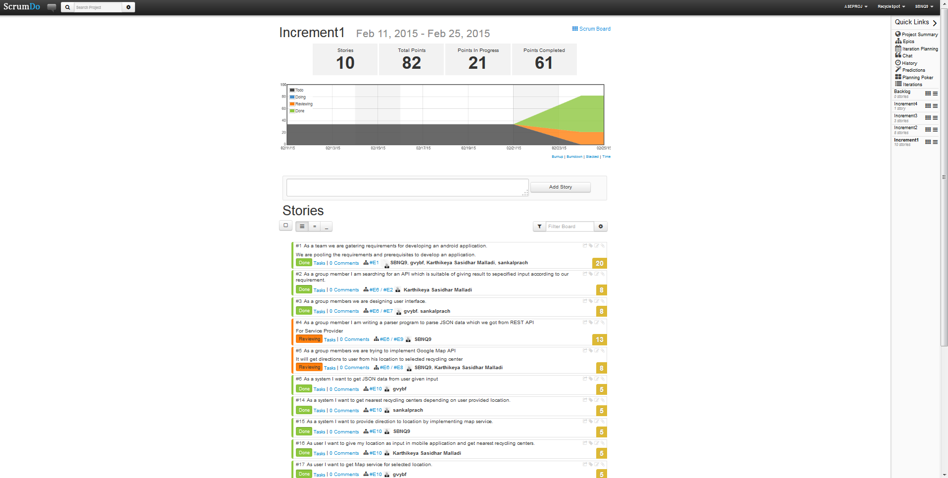

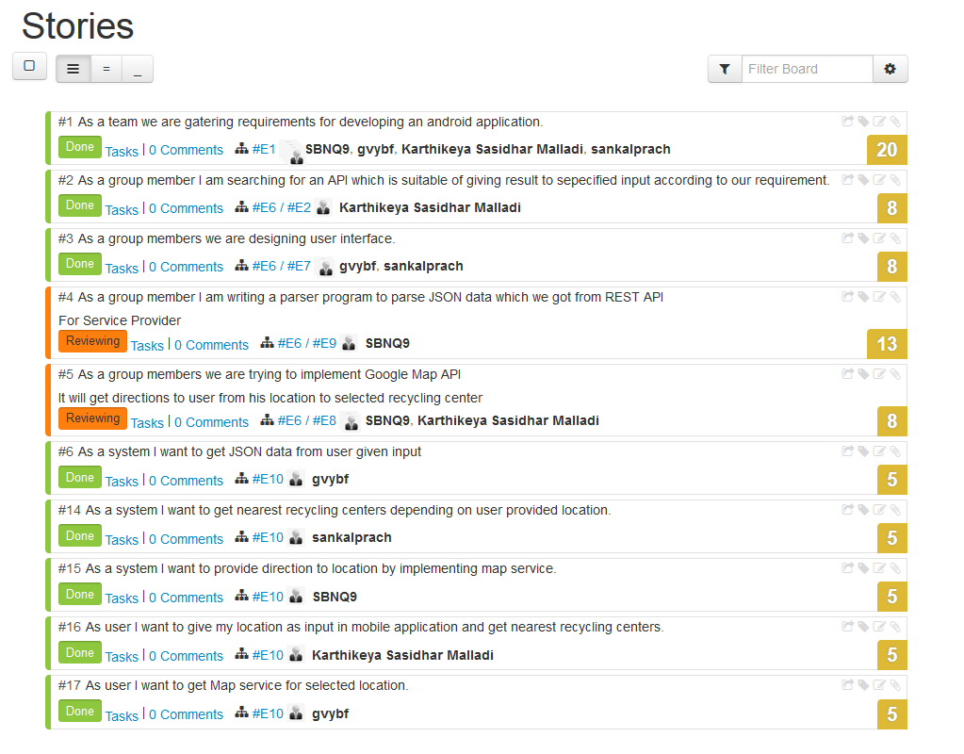

**Sequence Diagram:**



**Class Diagram:**

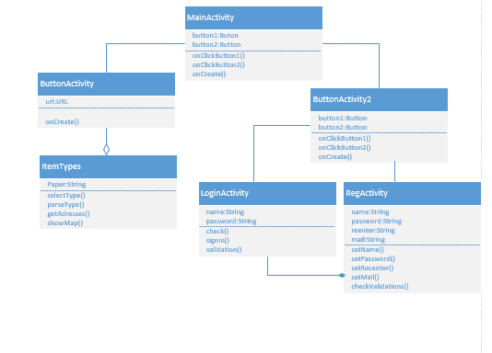

**Design of Mobile Client Interface**:

PAGE FOR Service Provider

SQL DB

SIGN UP

SIGN IN

REGISTRATION PAGE

USER

SERVICE PROVIDER

COMMUNITY PEOPLE

Maps

Notify

Near addresses

Types of Recycling Materials

Enter Zip Code

**Design of Unit Test Cases:**

**Button Click Options:**

There are cases to select options through buttons and the functions need to be tested whether they are working properly. We are using these buttons to call other activity from existing.

**IMPLEMENTATION:**

**Implementation of user Interface:**

We implemented basic user Interface, when app started user will see two options like service provider and community people as these are basically two types of people who can use this app.

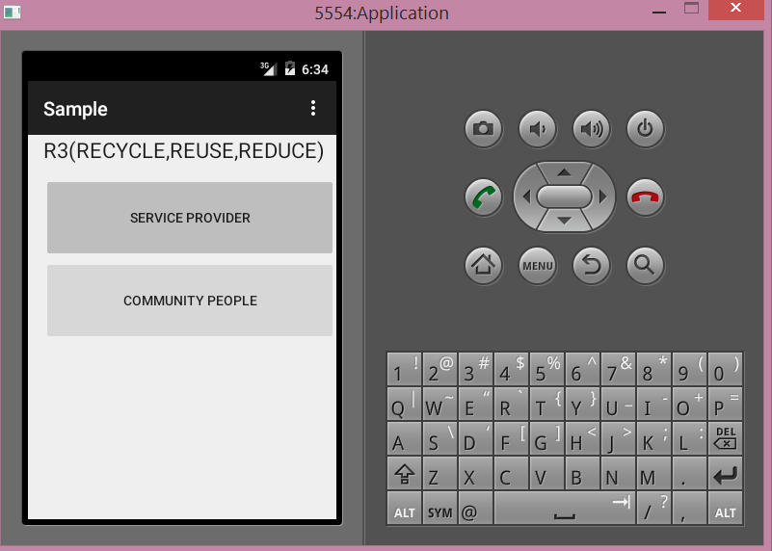

When Community people selects their button the will be converted to the following page

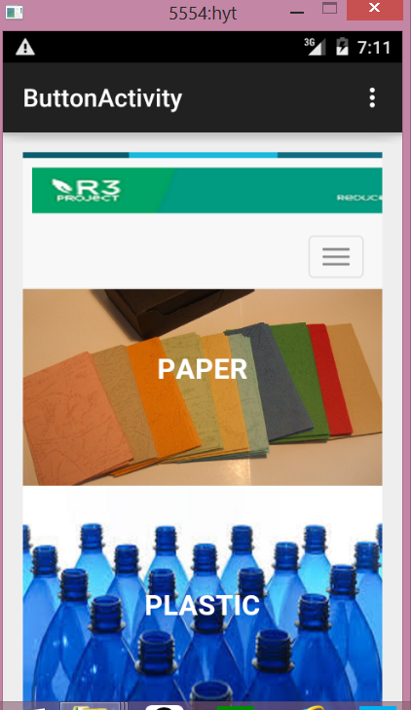

We used Twitter bootstrap in developing the UI page as it is more Userfriendly.And In this page one can find different types of Recycle waste and one can select according to their requirement. And we used more UI, like when user clicks the option he will find out the description and proceed(“Ready to Recycle”) so that he can proceed to further to enter the Zip code. In next page he will find the list of address.

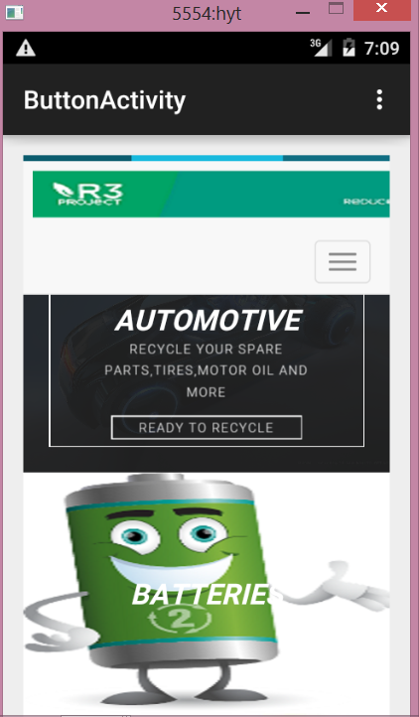

When Service Provider option clicked he will see the following options

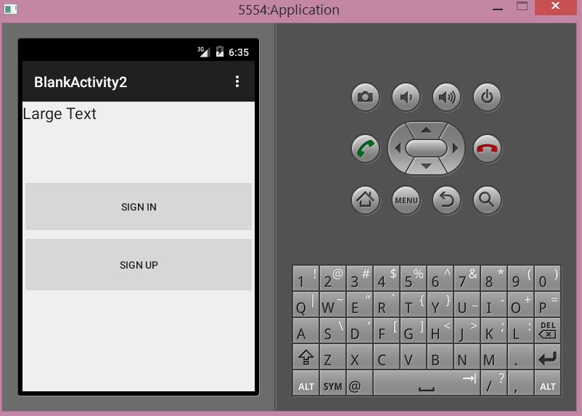

**TESTING:**

**Test Case 1**

**Object:** Verifying and Validating R3

**Test Case Id:** TC R3– 01

**Test Case Name:** To check the working of Button(Service Provider,Communty People).

**Test Procedure:** Look and feel of R3 is tested with positive behavior of application.

**Data Matrix:**

|  |  |  |  |  |  |
| --- | --- | --- | --- | --- | --- |
| **S.no.** | **Description** | **Input Required** | **Expected Value** | **Actual Value** | **Comparison of Results** |
| **1** | Working of Button(Service Provider) | Left Mouse click on Service Provider button | Should navigate to Screen having SignIn and SignUp | Displaying the next page with SignIn and SignUp options | Success |
| **2** | Working of Button(Community People) | Left Mouse click on Community People button | Should navigate to Screen having all the various recycle items to recycle | Displaying Screen having all the various recycle items to recycle | Success |

Scrum Do Link:

<https://www.scrumdo.com/organization/aseproj/dashboard>