Created VPC, subnet, route table and IGW.

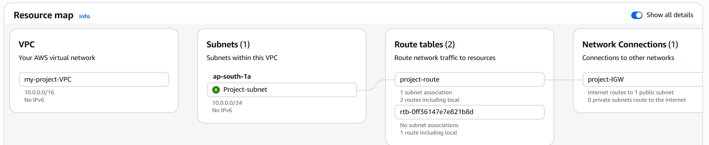

Created EC2 instance for backend server in the created VPC:
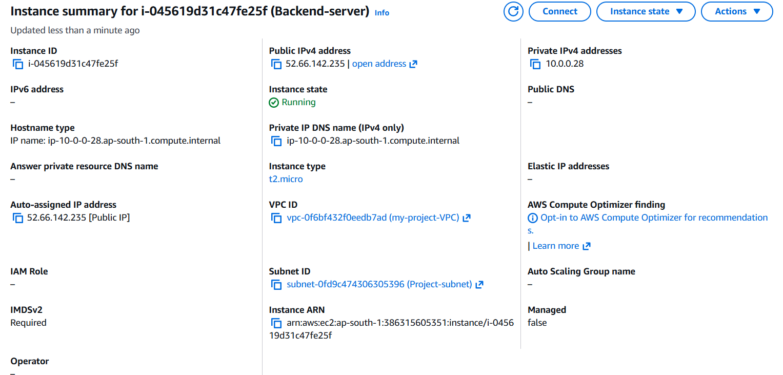

Logged in server and performed repository update:

Installed packages nodejs, npm, nginx and git

Cloned the repo
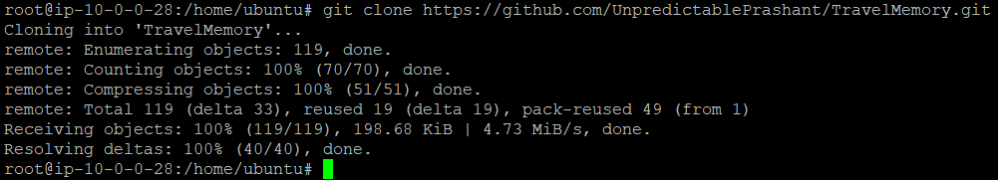

Switched the directory:

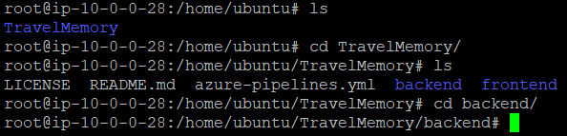

Creating Database in mongo DB atlas:

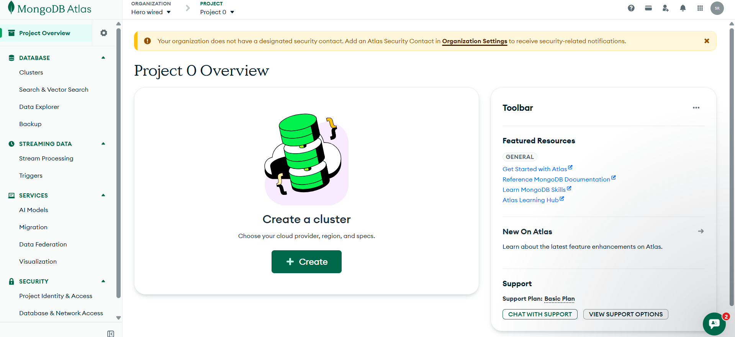

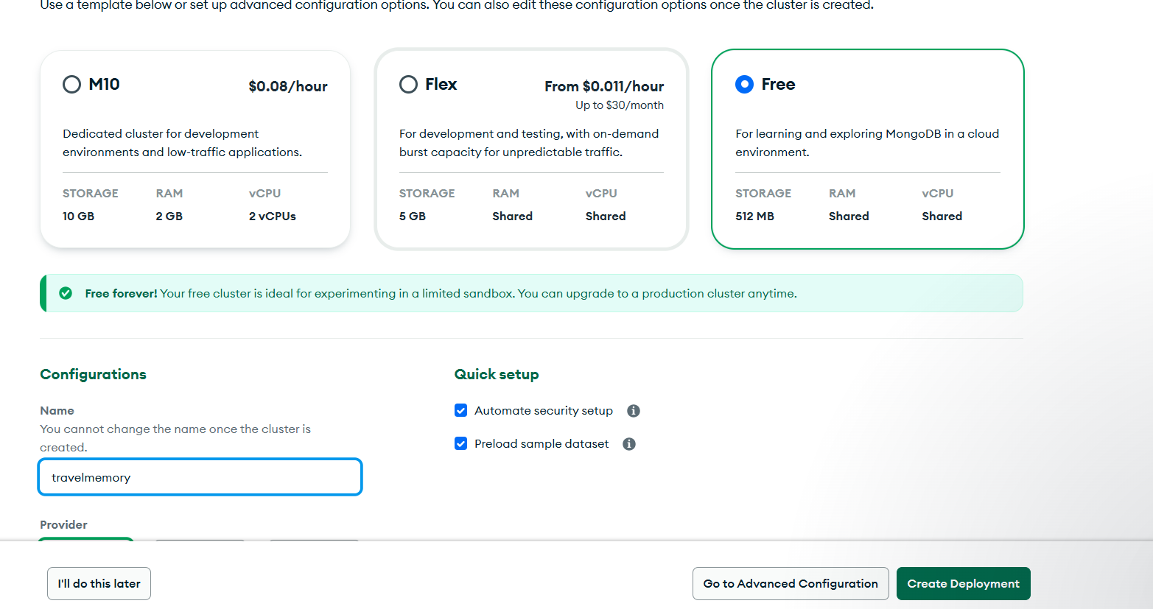

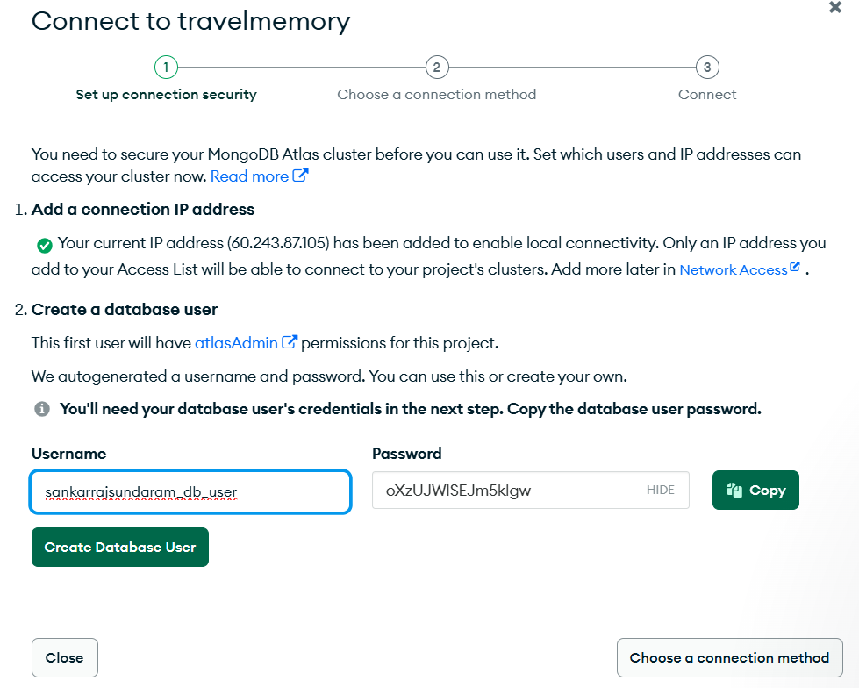

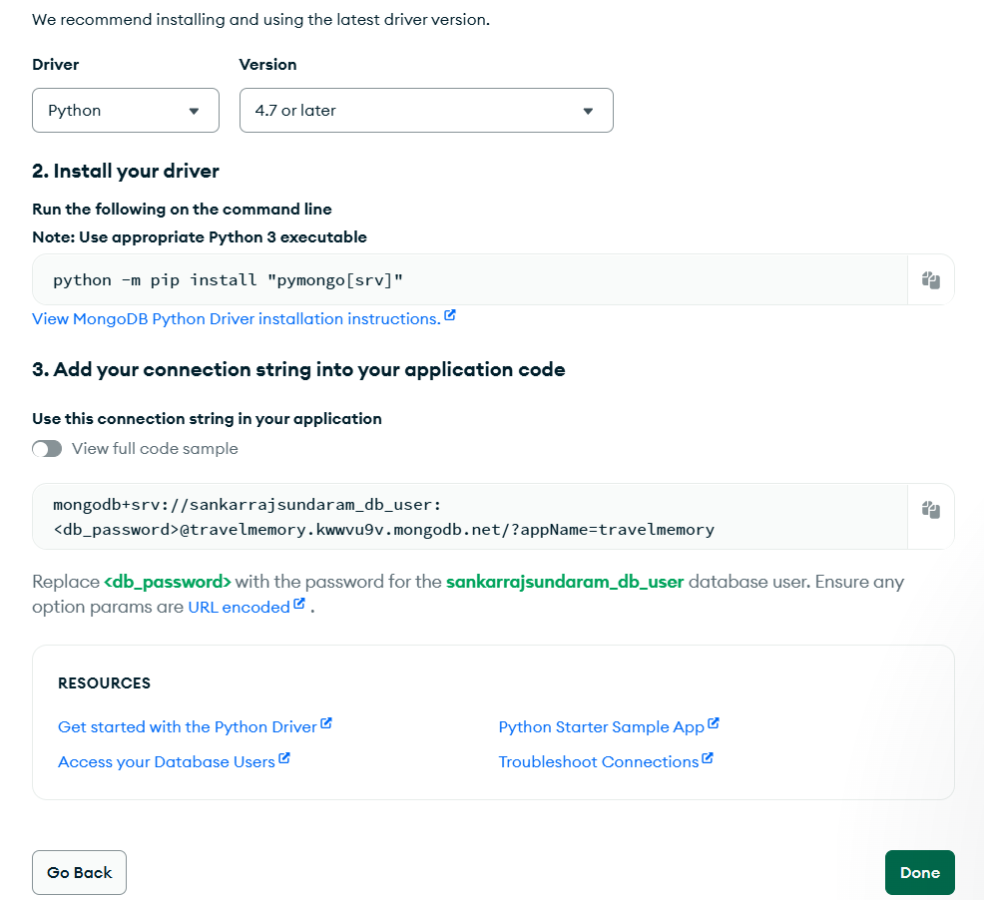

Created .env file and passed the parameters:

Installed the node dependencies:
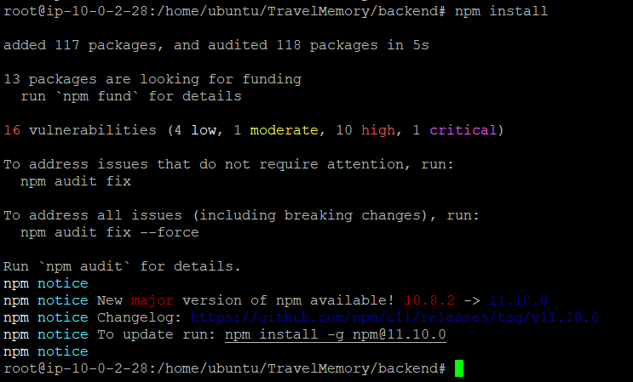

Started the web application:

Installed PM2 to make the application always running:

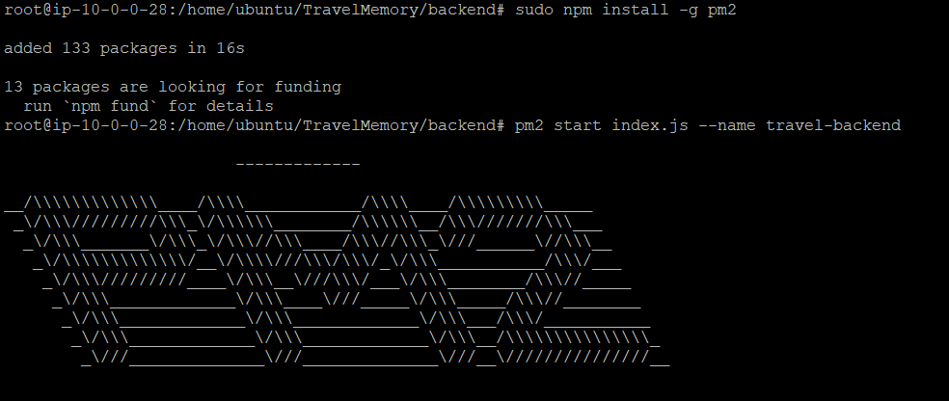

Configuring reverse proxy:
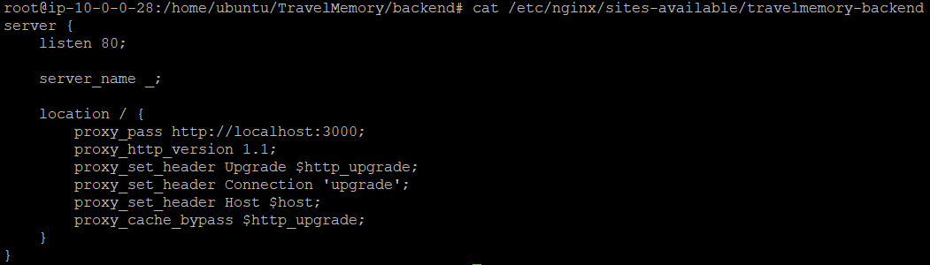
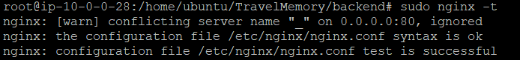

Checked the reverse proxy:
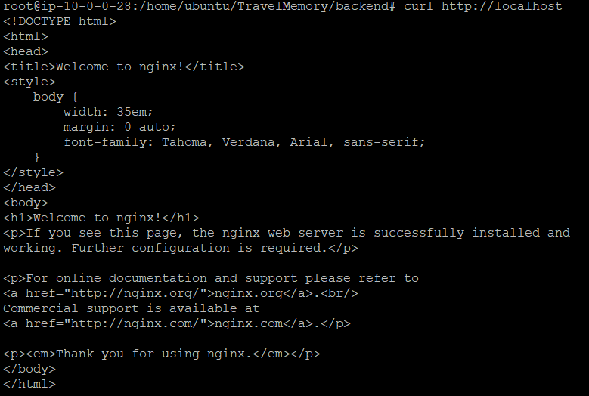

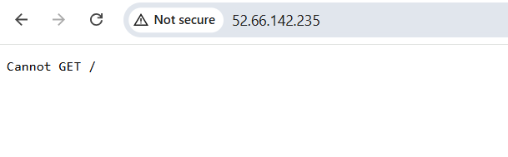

List of ports opened for the backend server:

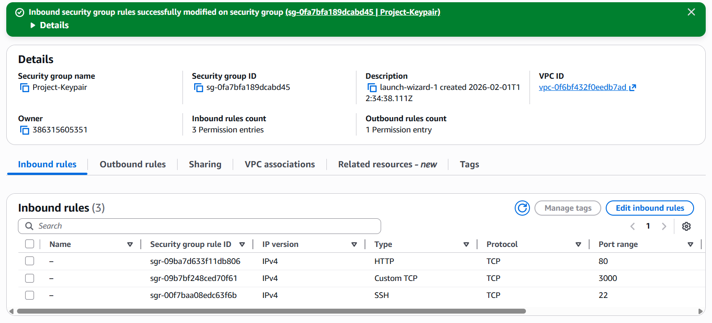

Task 2:

Created front end server:

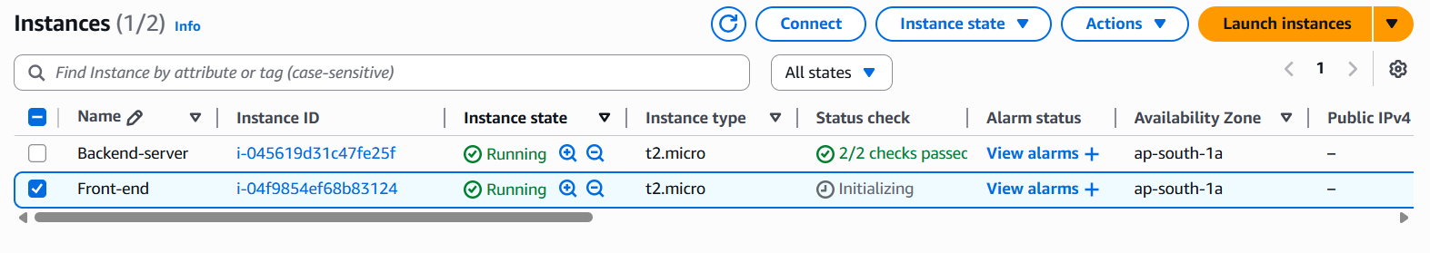

Clone the url:

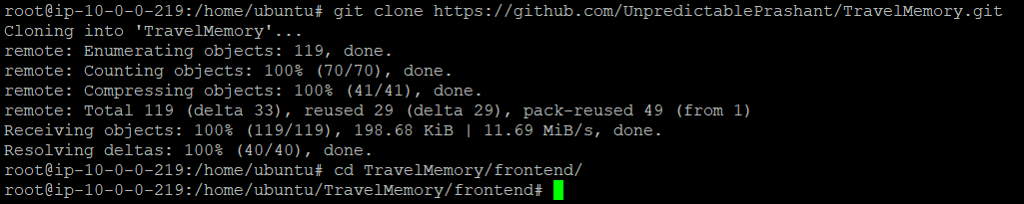

Updated the url.js file with the public ip of backend server as per below screen shot:
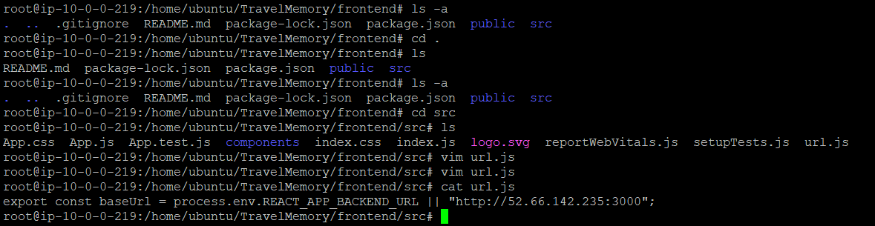

Installed the NPM package:
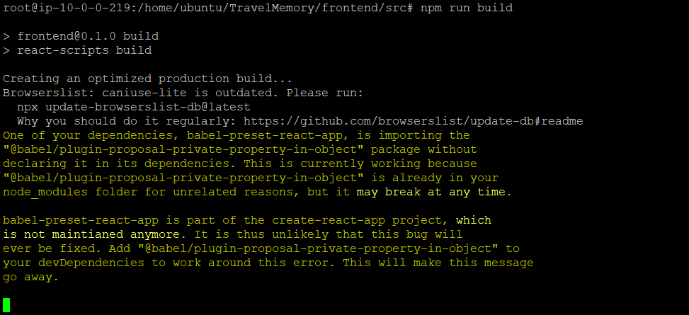
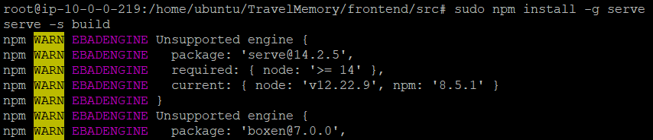

Started the frontend application:

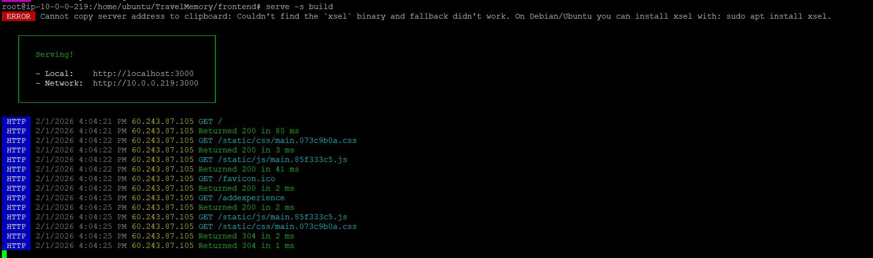

Updated the data from the git hub repo:

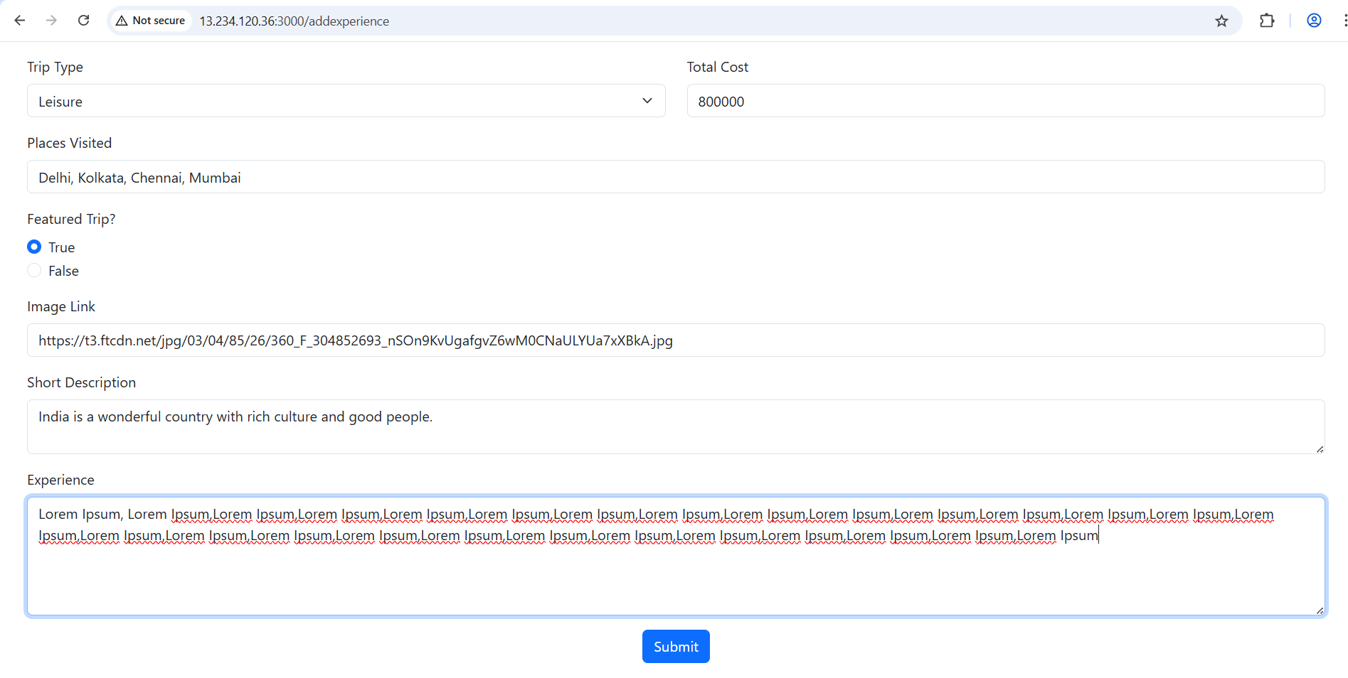

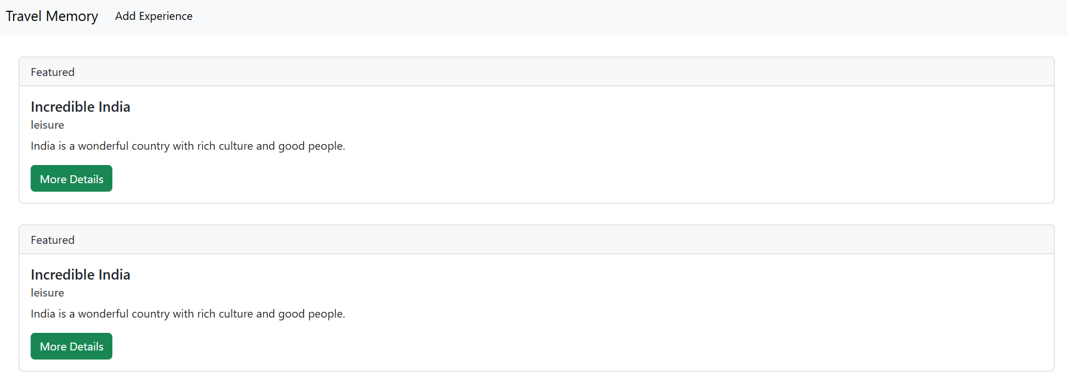

Task 3:

Created AMI, and used the image in Autoscaling Group:

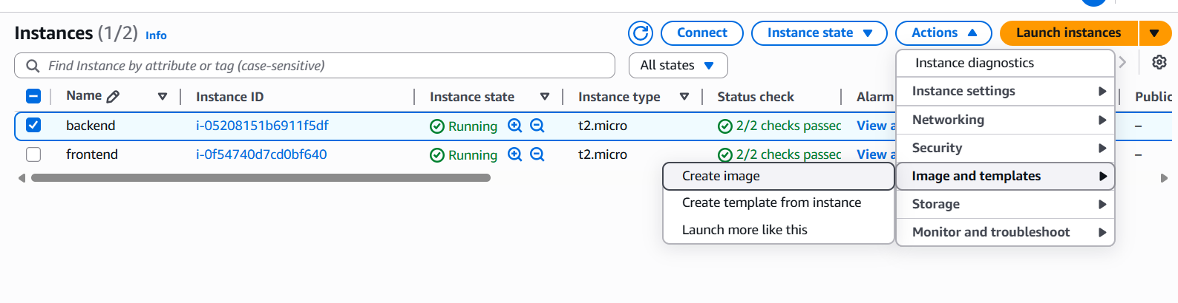

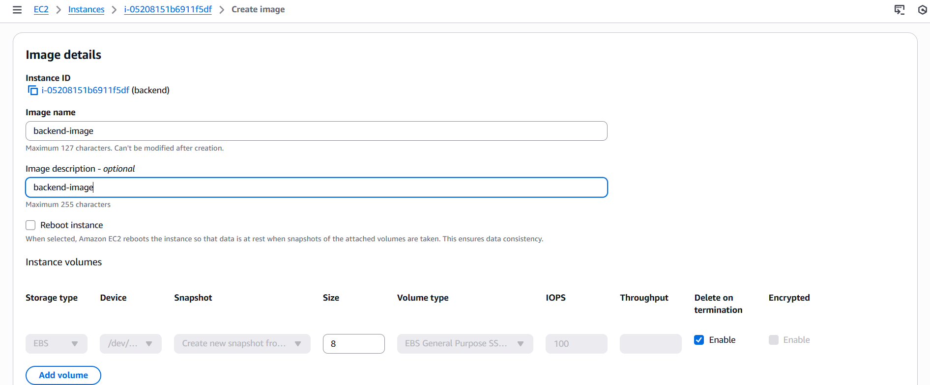

Create a template which would be used in the ASG:

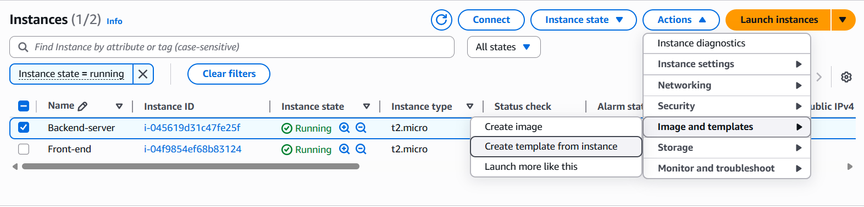

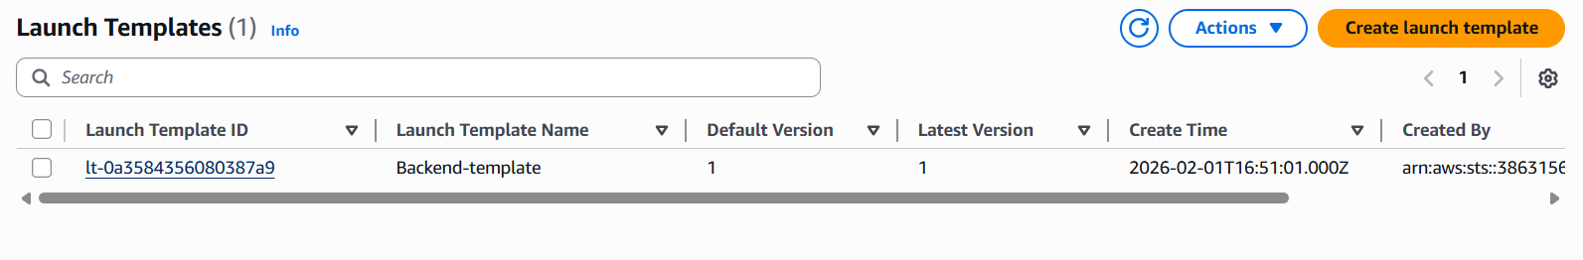

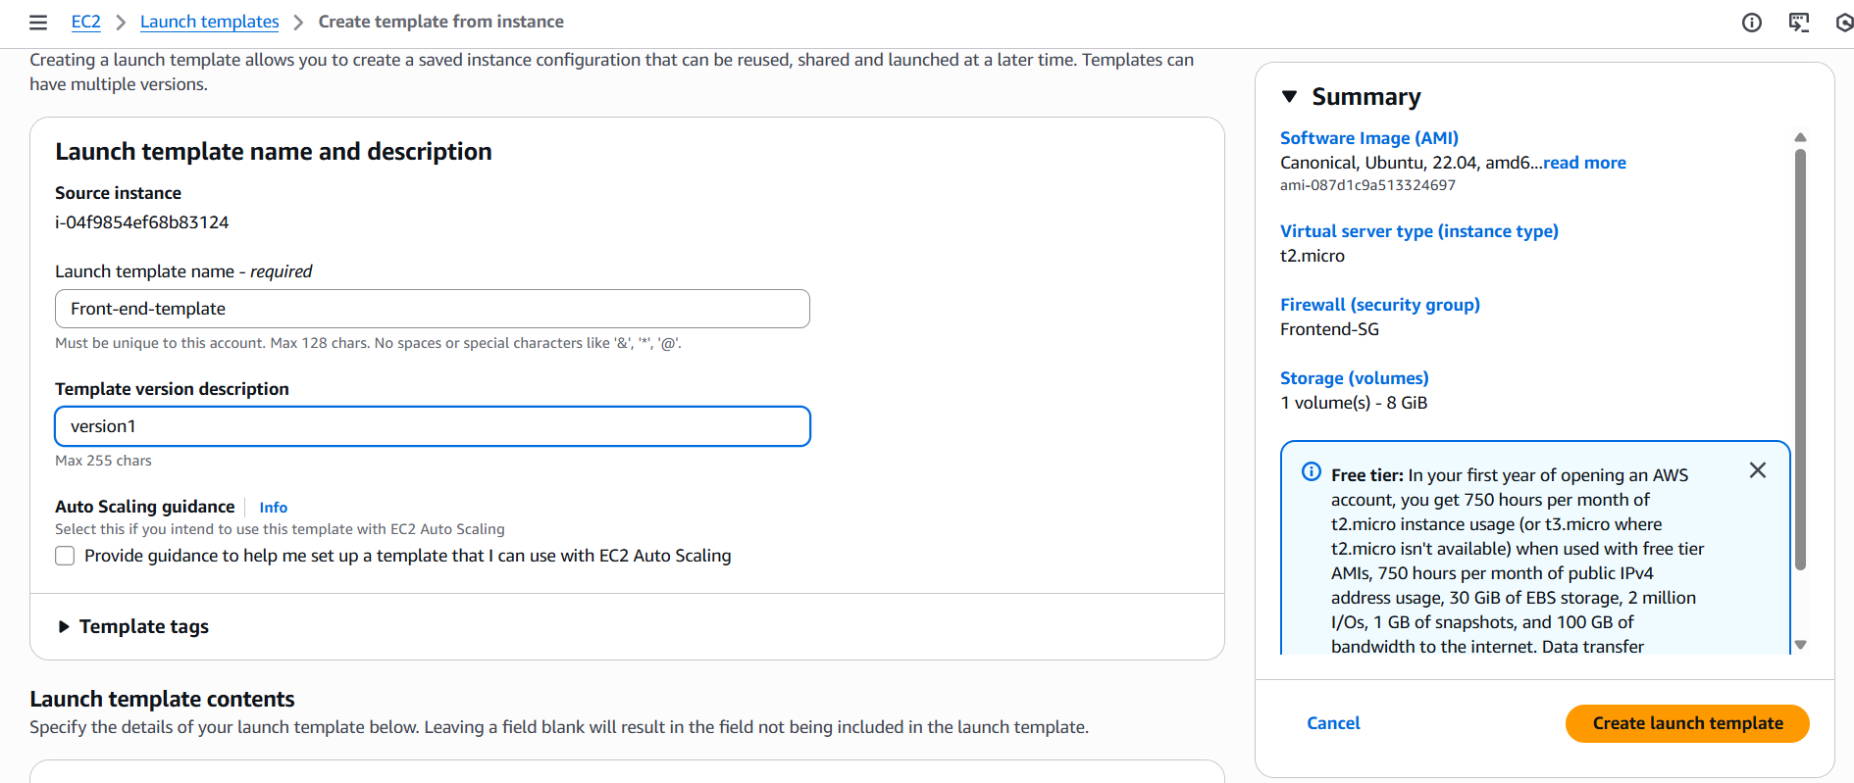

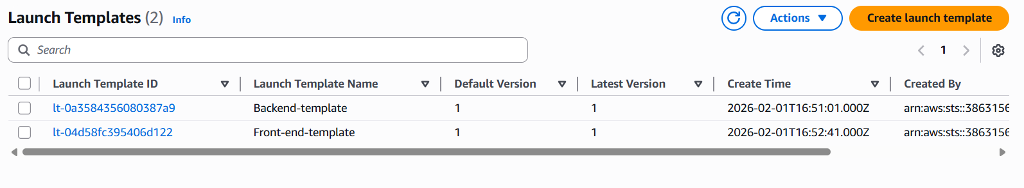

Created Auto Scaling group and chose the already created template and AMI image:

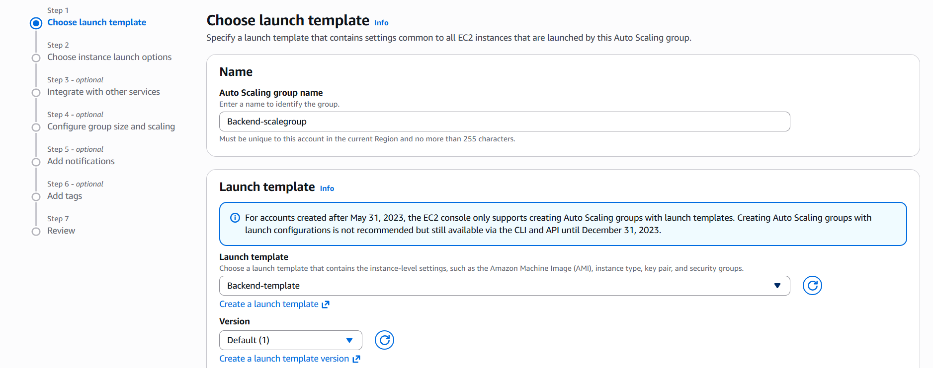

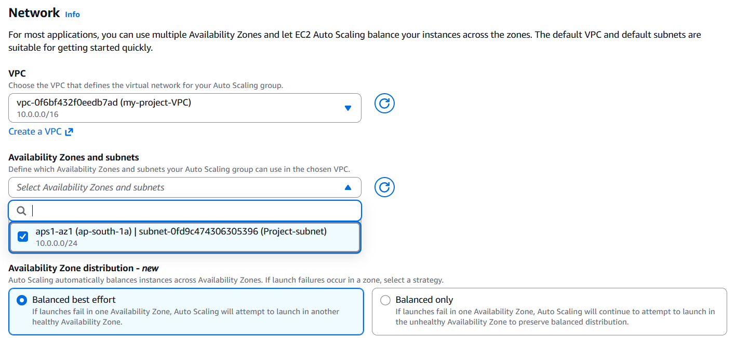

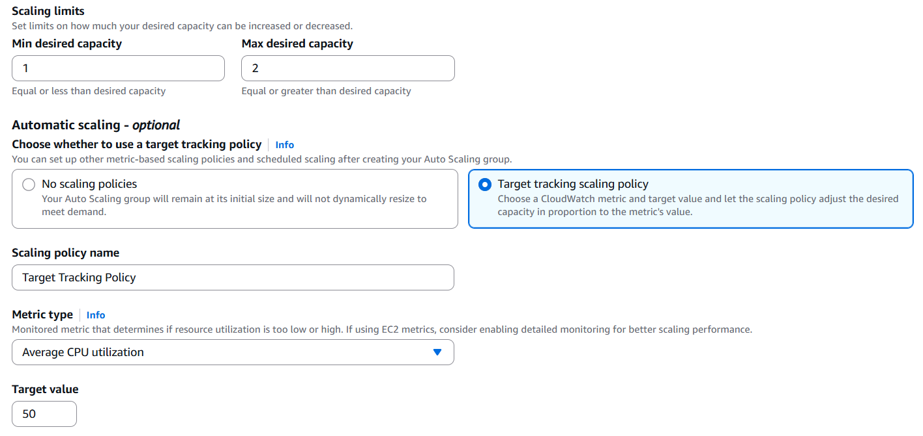

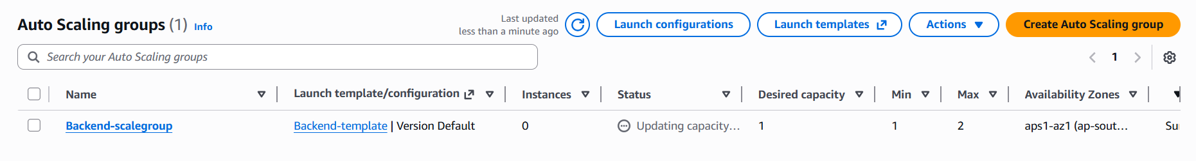

Created target group:

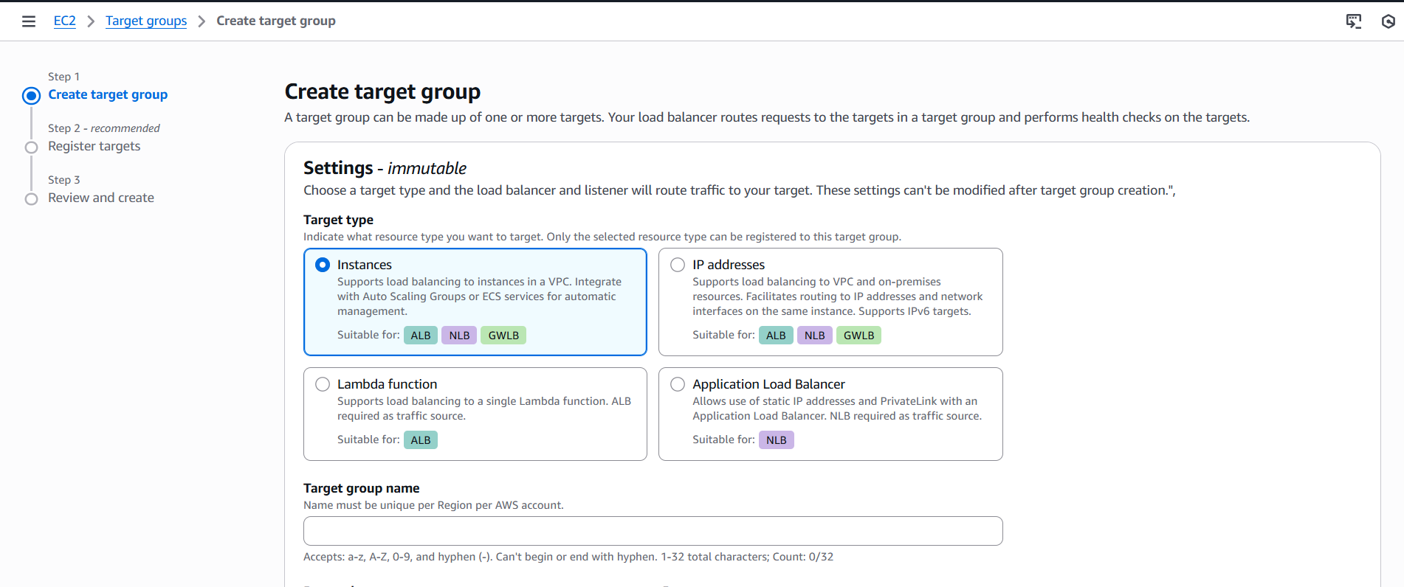

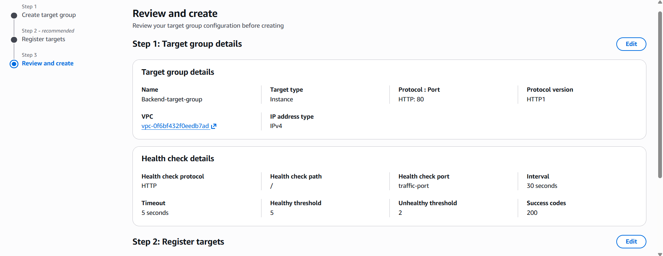

Created LB:

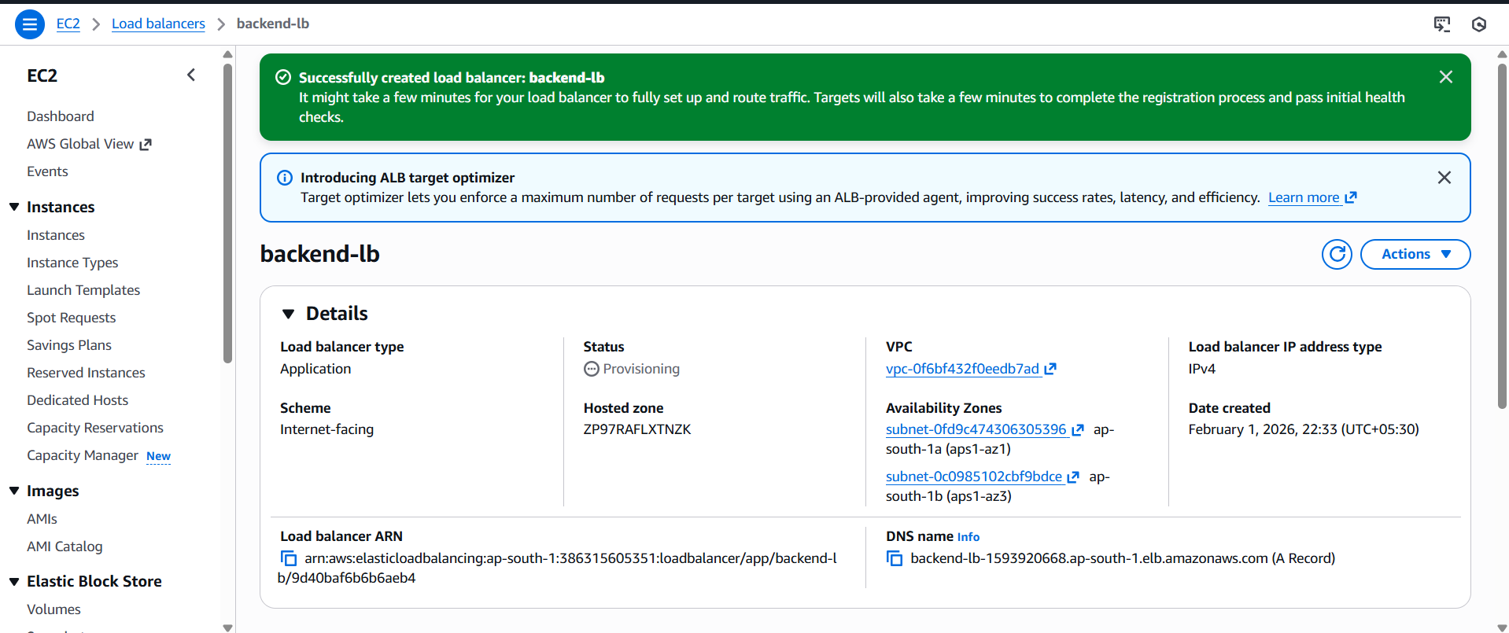

Checked with DNS name of LB:

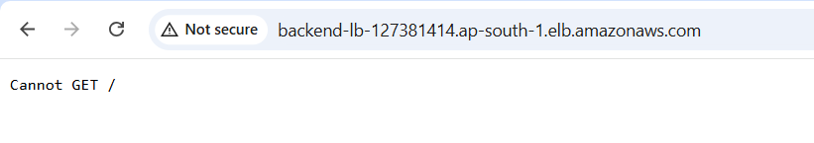

Repeated the autoscaling and lb creation for frontend instance as well and check it.

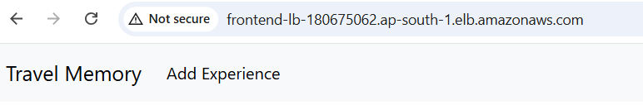

Task-4:

Purchased a domain:

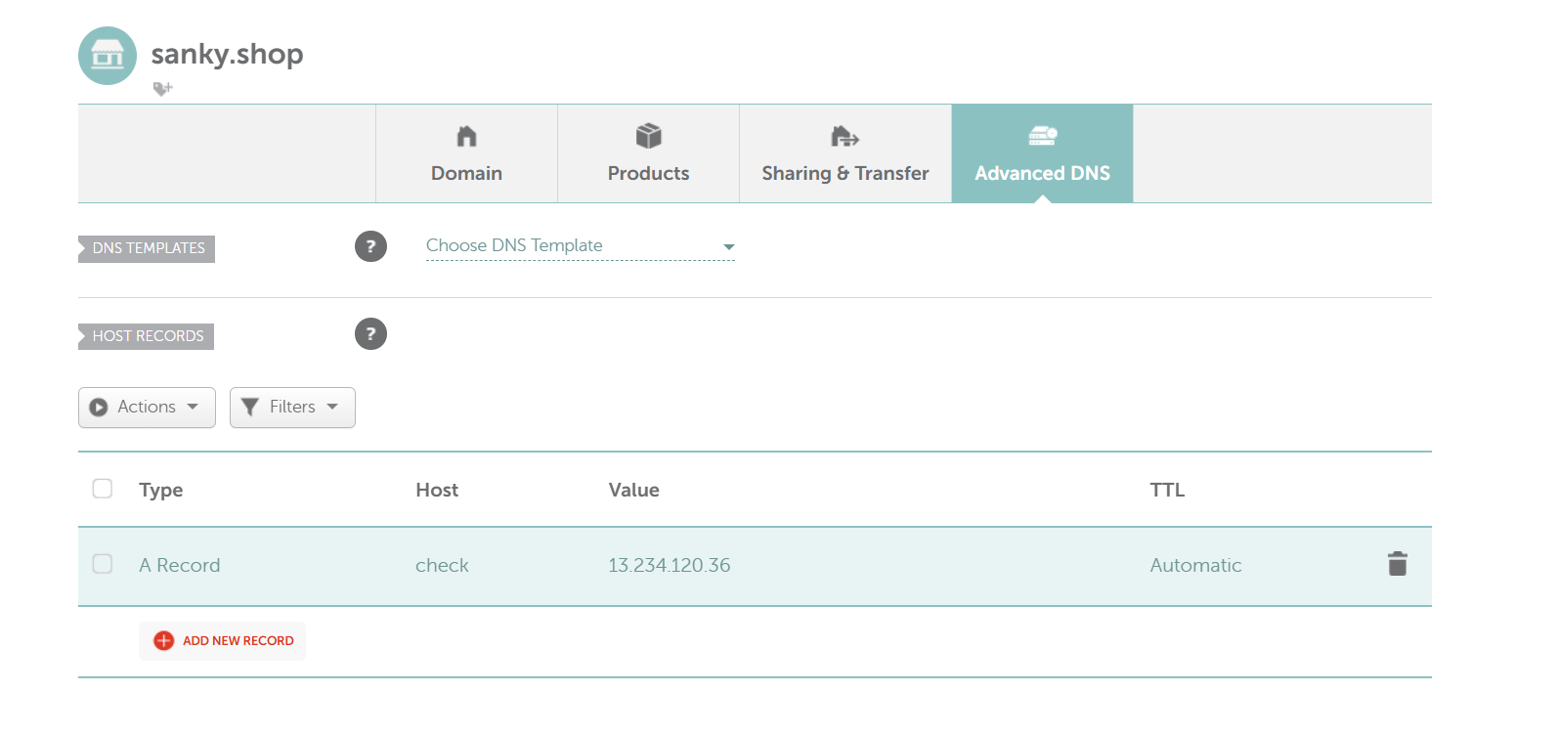
Created CNAME in the DNS record:

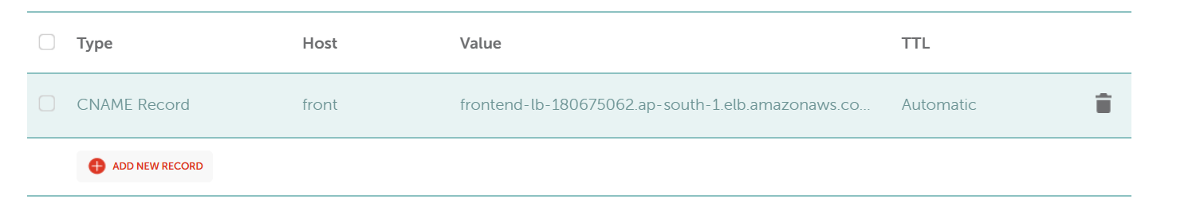

Checked the CNAME in browser: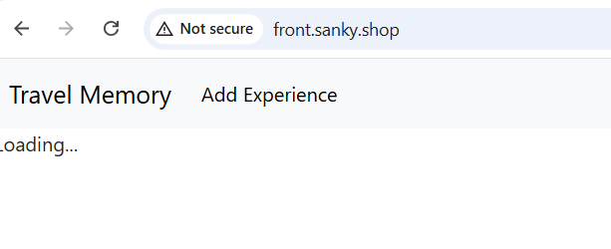
Copied the public ip of frontend server:

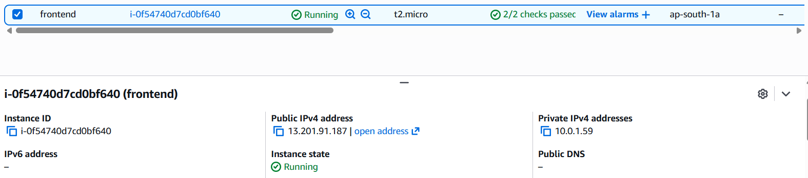

Created the A record:

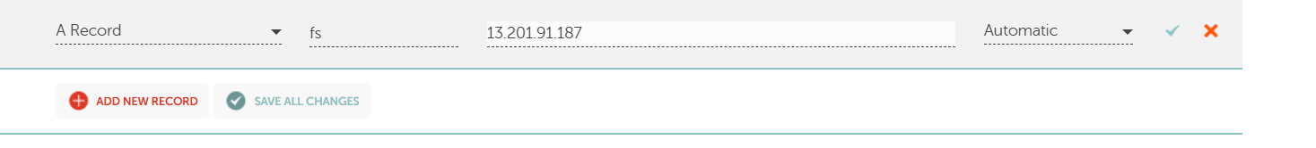

Verified the same:

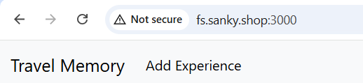

Architecture diagram:

