Assignment 1: Automated Instance Management Using AWS Lambda and Boto3

- Setup:

Two ec2 instance created.

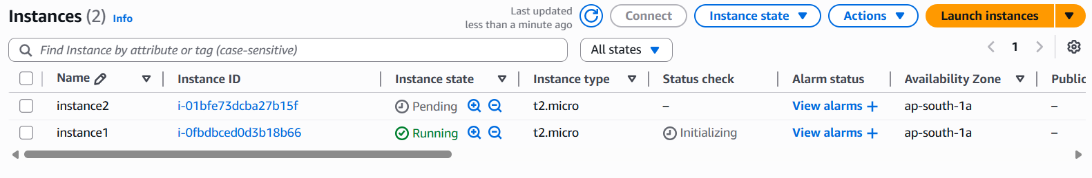
Tag Auto-Start and Auto-Stop added.

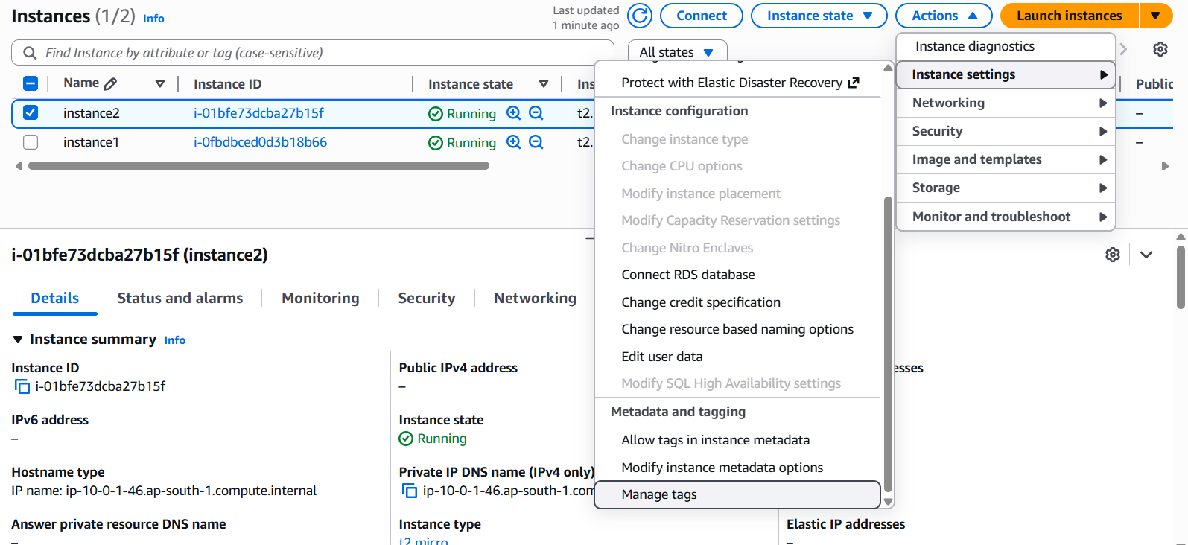

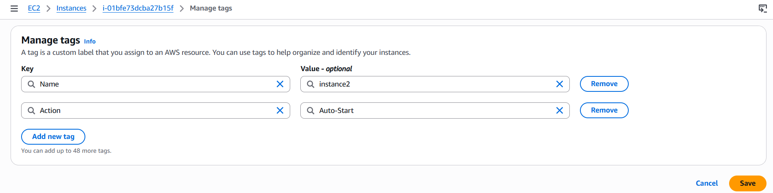

- Lambda function Creation:

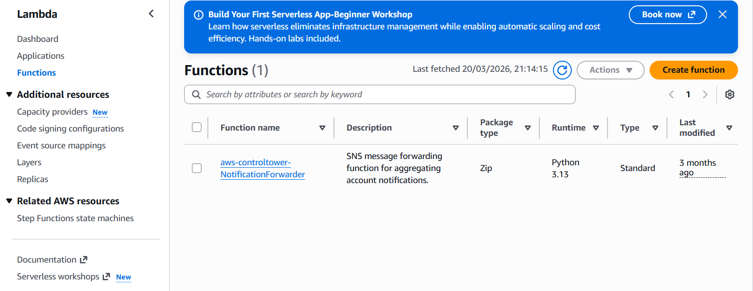

Created lambda function as per below screen shot

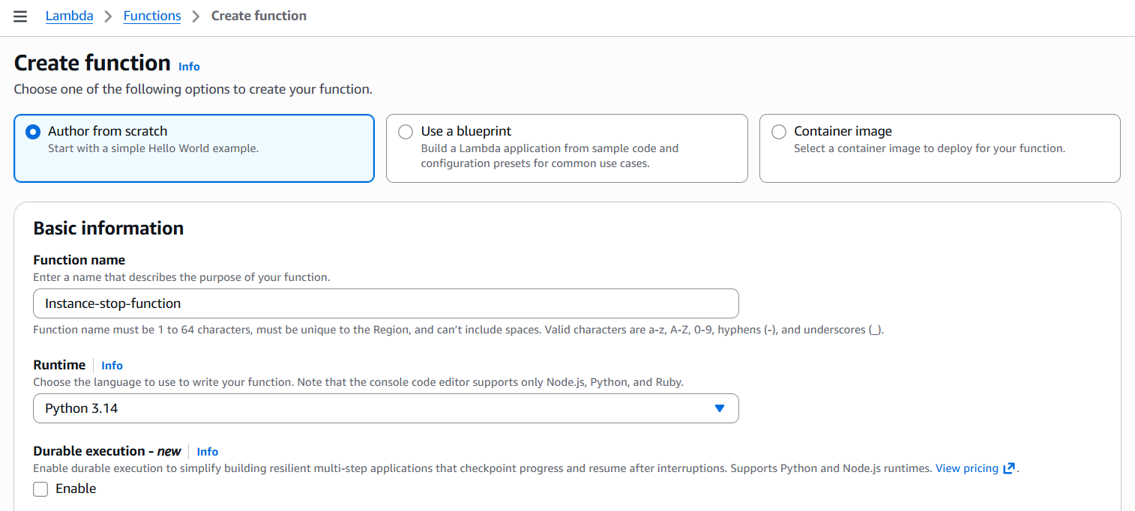

Created a role with ec2 full access policy.

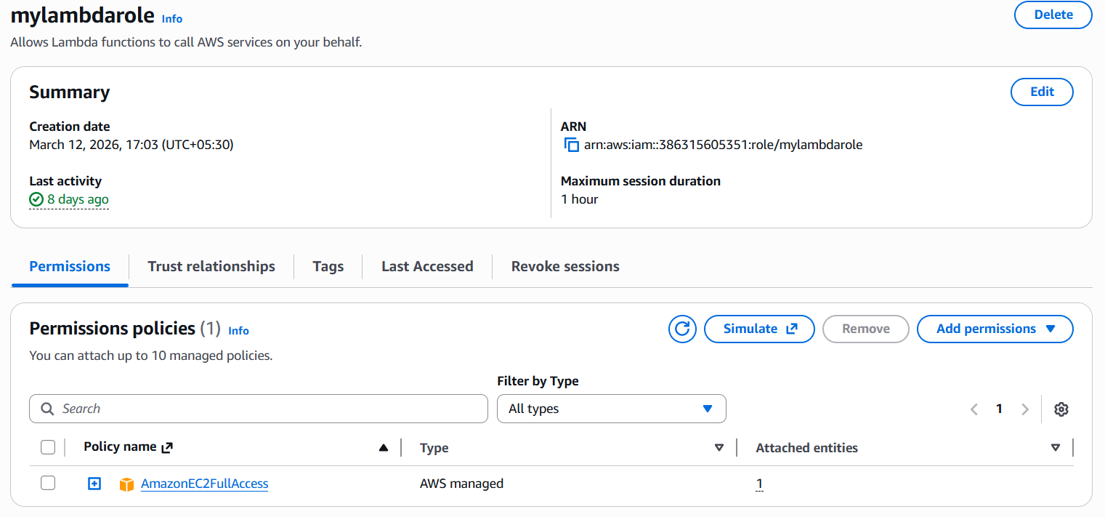

Attached this role to the lambda function:
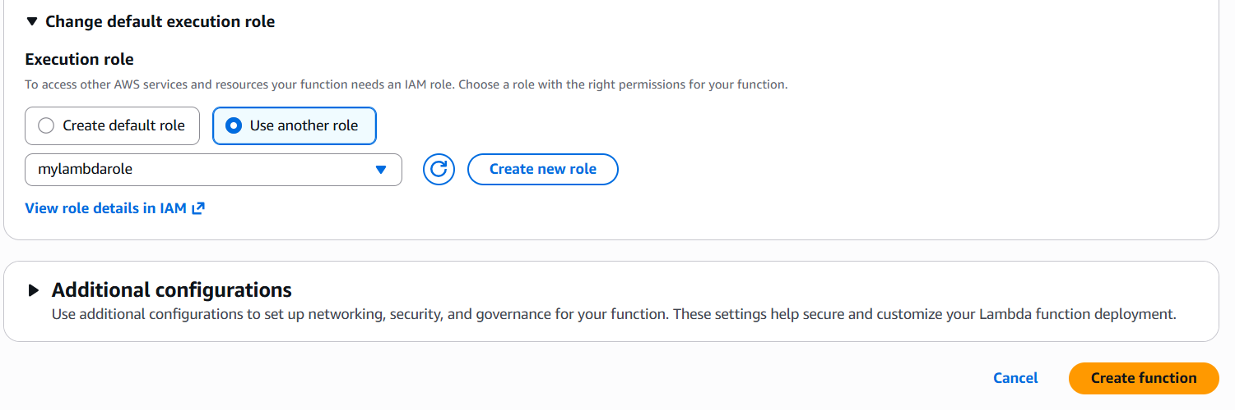

In the coding space, entered my python code to stop and start the instances as per the tag value:

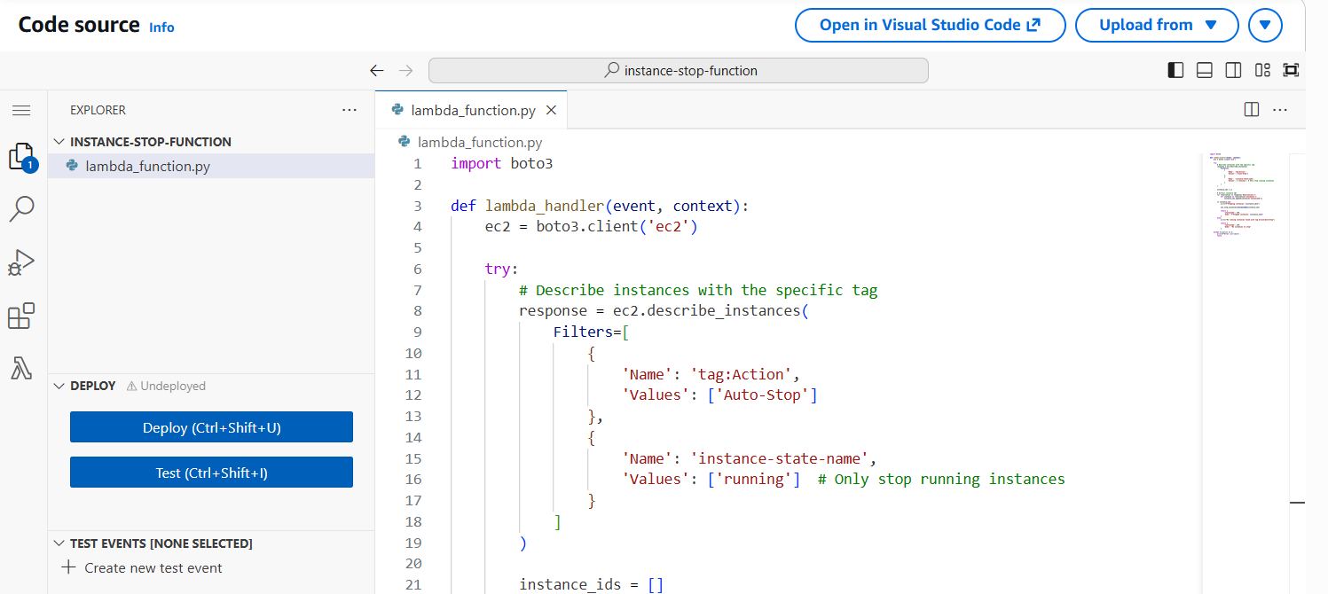

Followed by deployed it and tested:

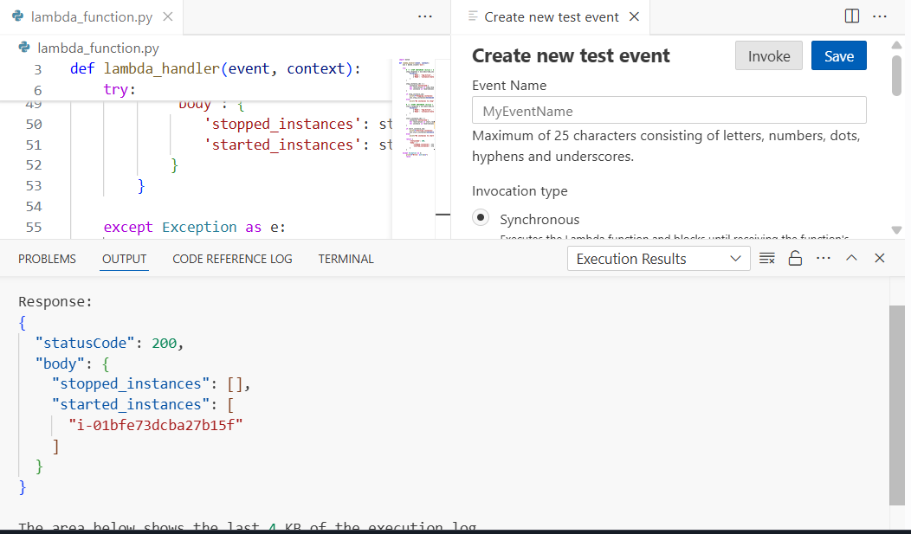

The same has been verified from the EC2 console:

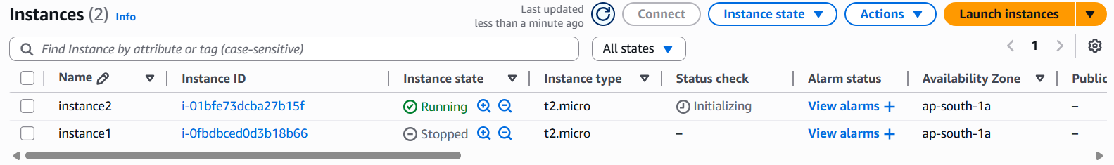

Assignment 2: Audit S3 Bucket Permissions and Notify for Public Buckets

- SNS set-up:

Created a topic.
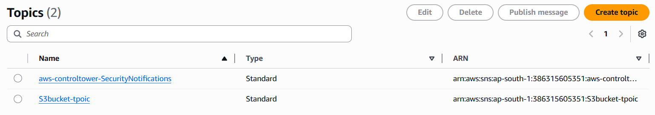

Created subscription.
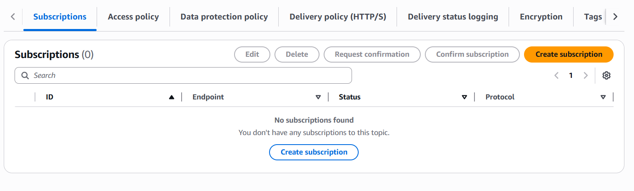

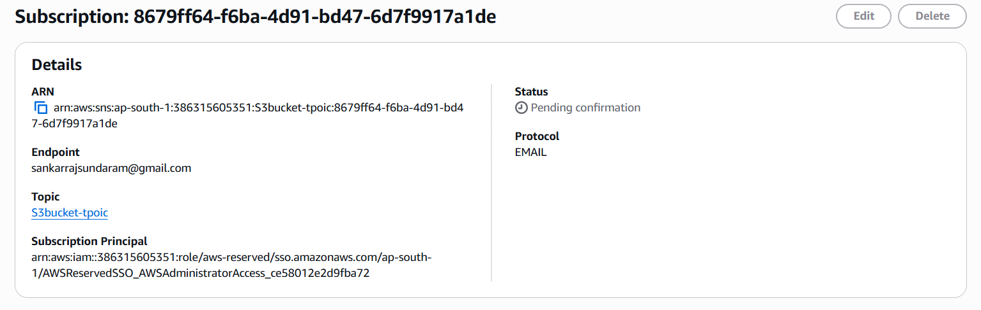

Created a role with S3 access and SNS access for lambda service

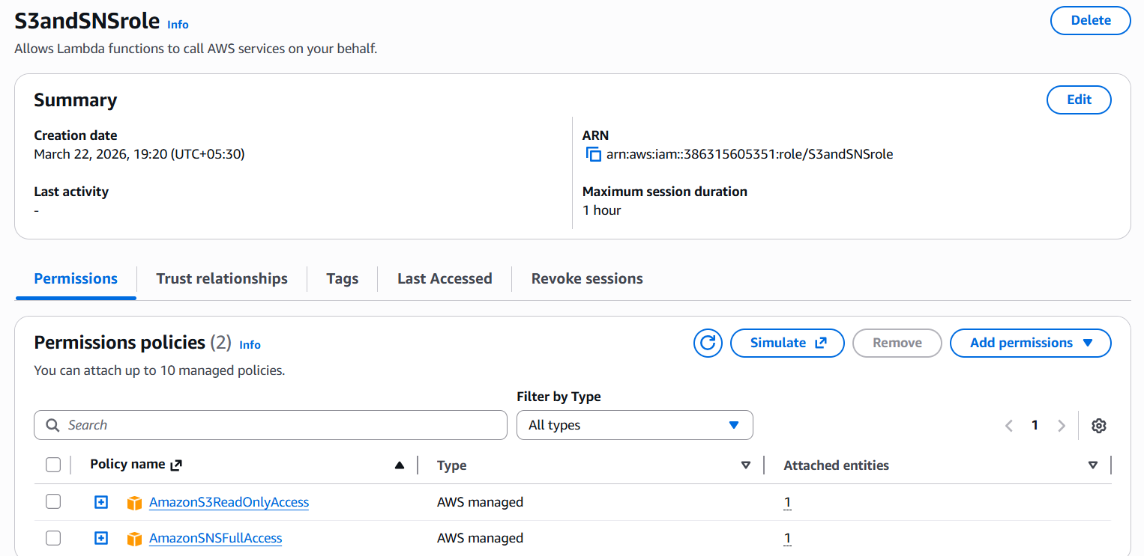

Confirmed the subscription status by accepting it from mail.
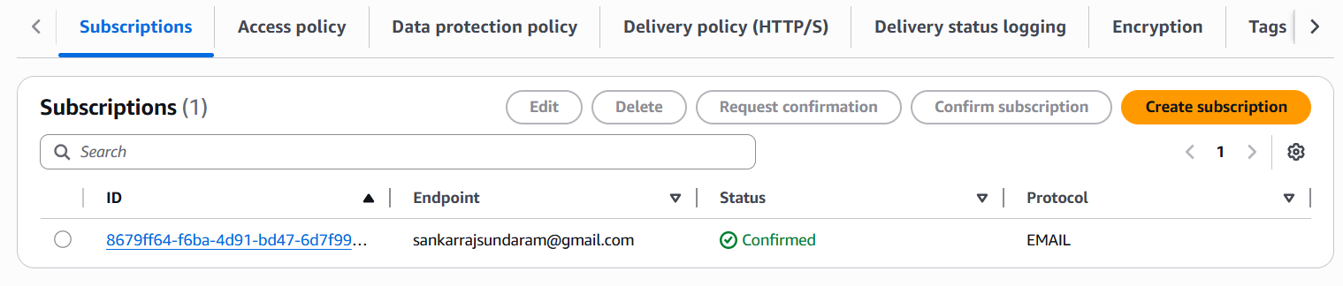

Created a bucket in public:

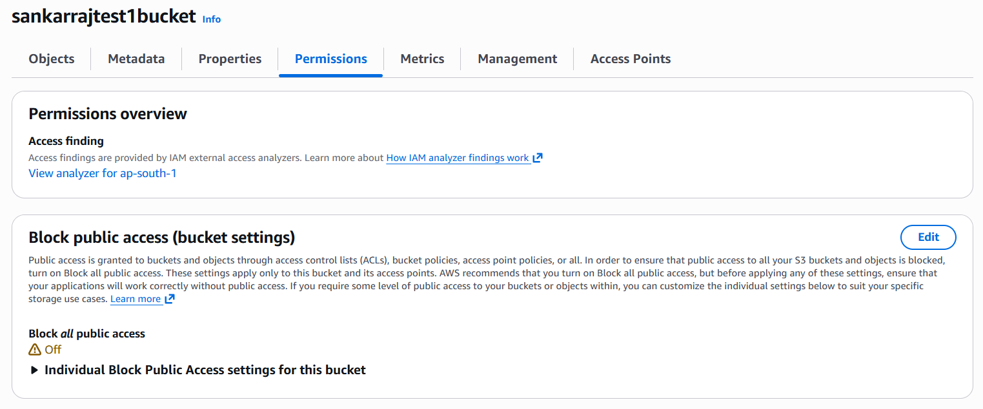

Created the Lambda and executed the python code.

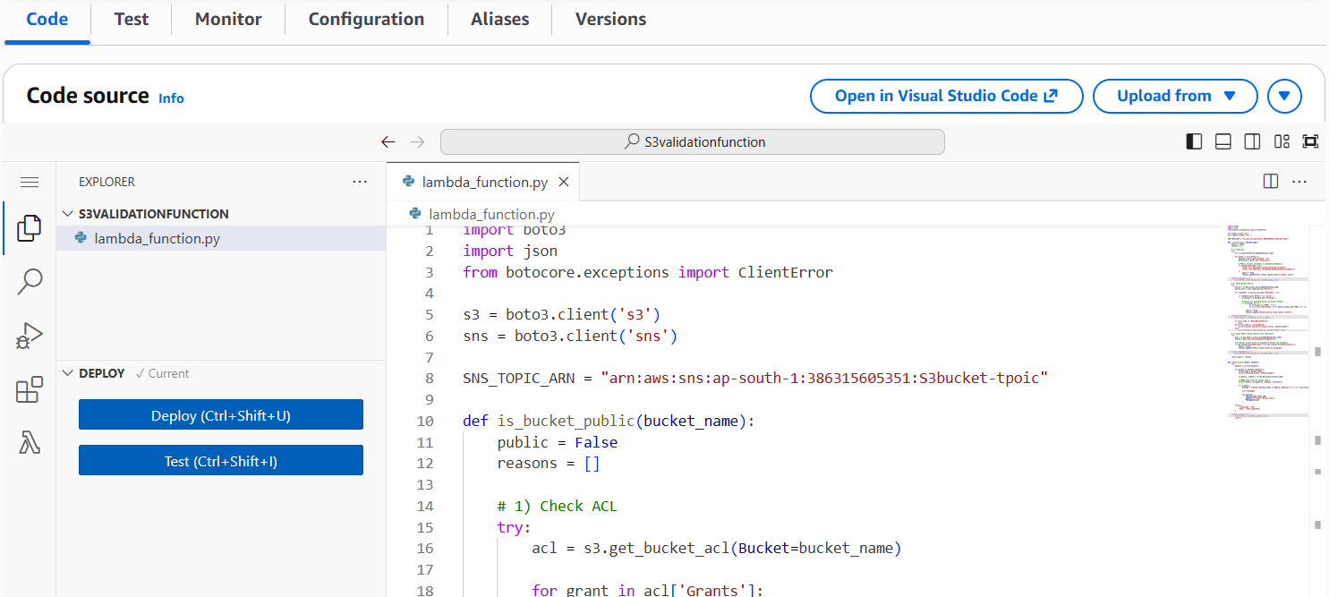

Tested the function.

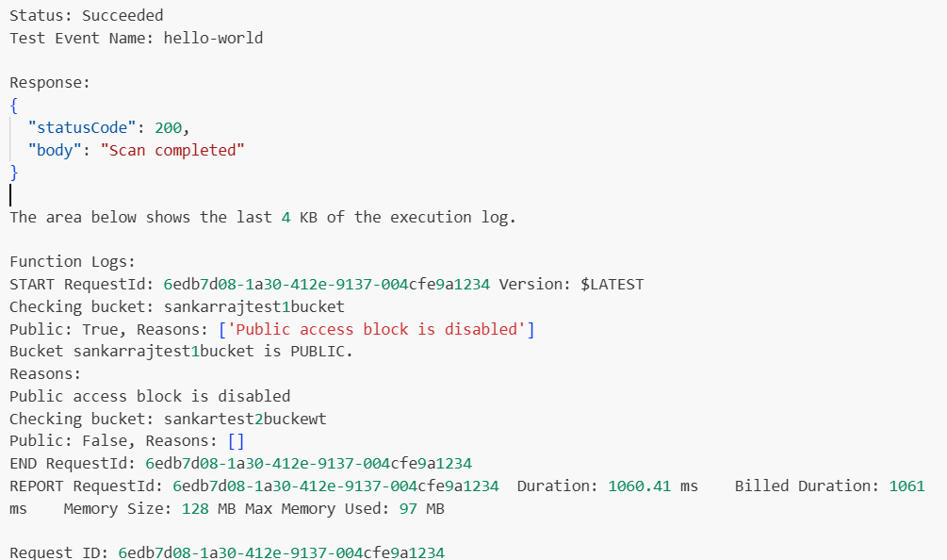

Mail notification also received.

Created event bridge to run the lambda function daily.
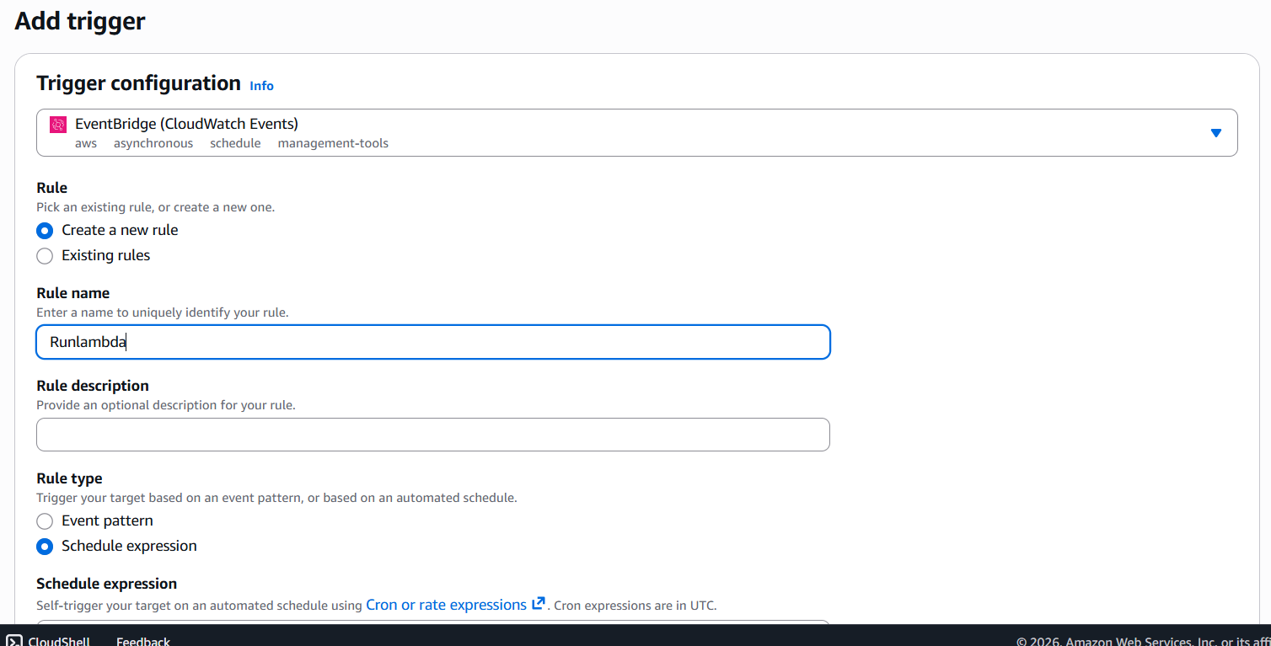

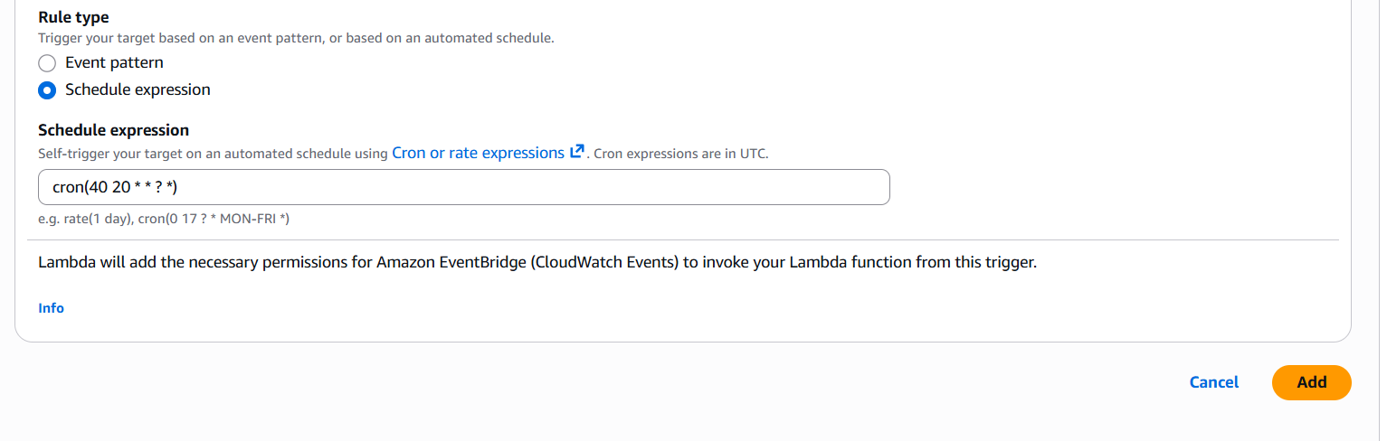

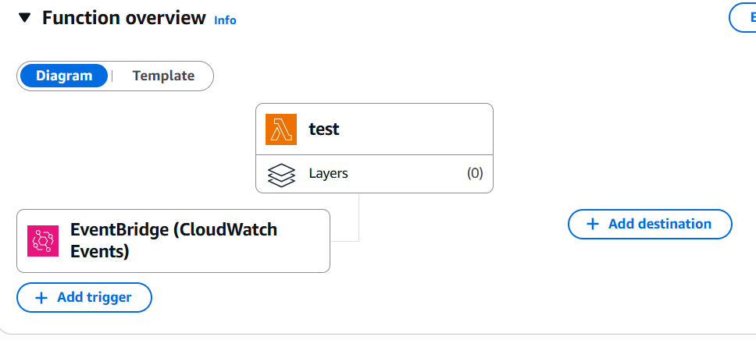
==================================================================================
Assignment 3: Monitor EC2 Instance State Changes Using AWS Lambda, Boto3, and SNS

SNS Setup:
Created subscription and topic.
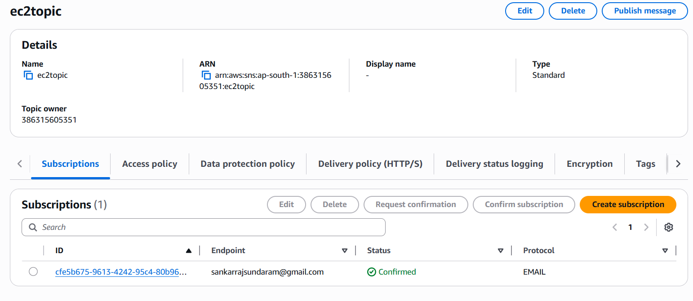

Lambda IAM Role:

Created lambda role for accessing EC2 and SNS.

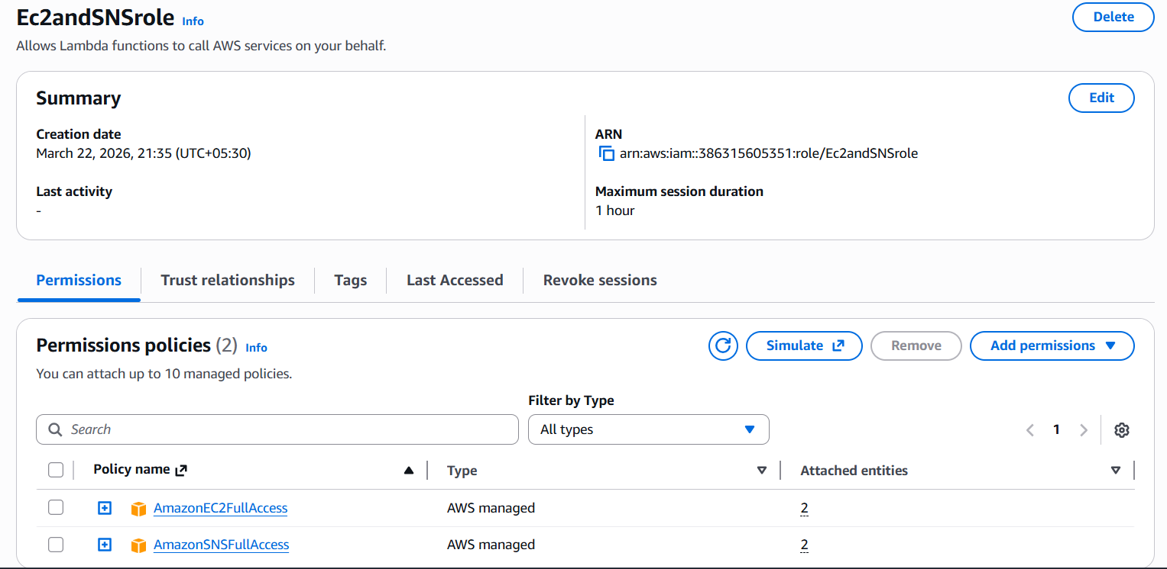

Lambda Function:

Created Lambda function.
ter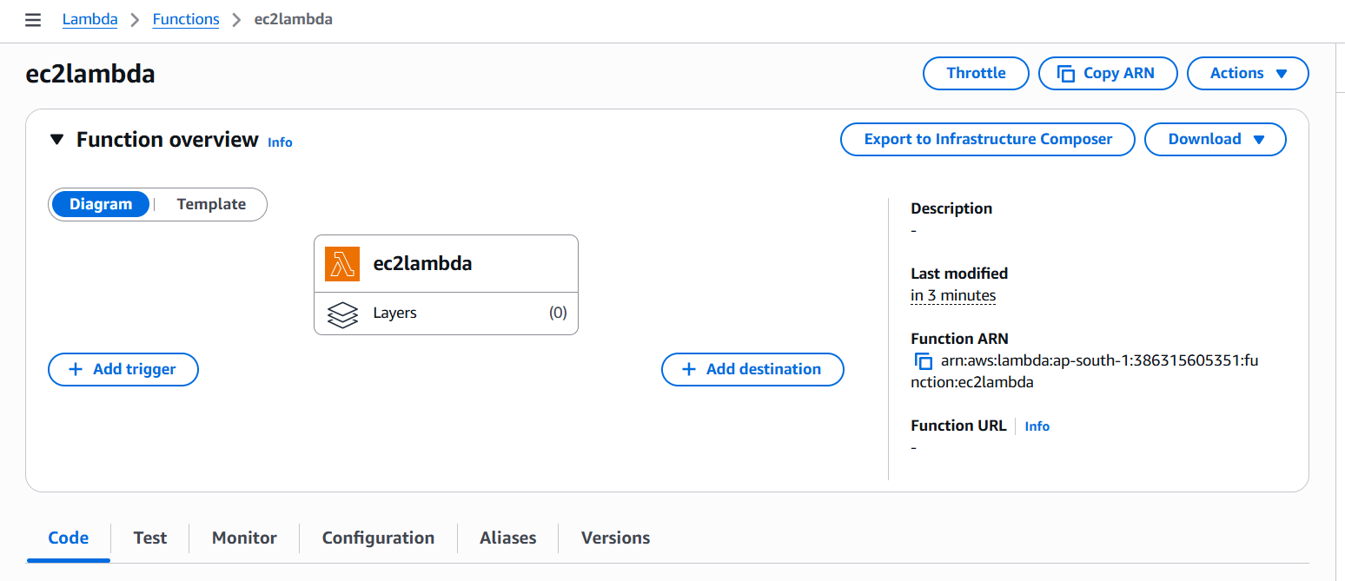

Created event bridge with below configurations.

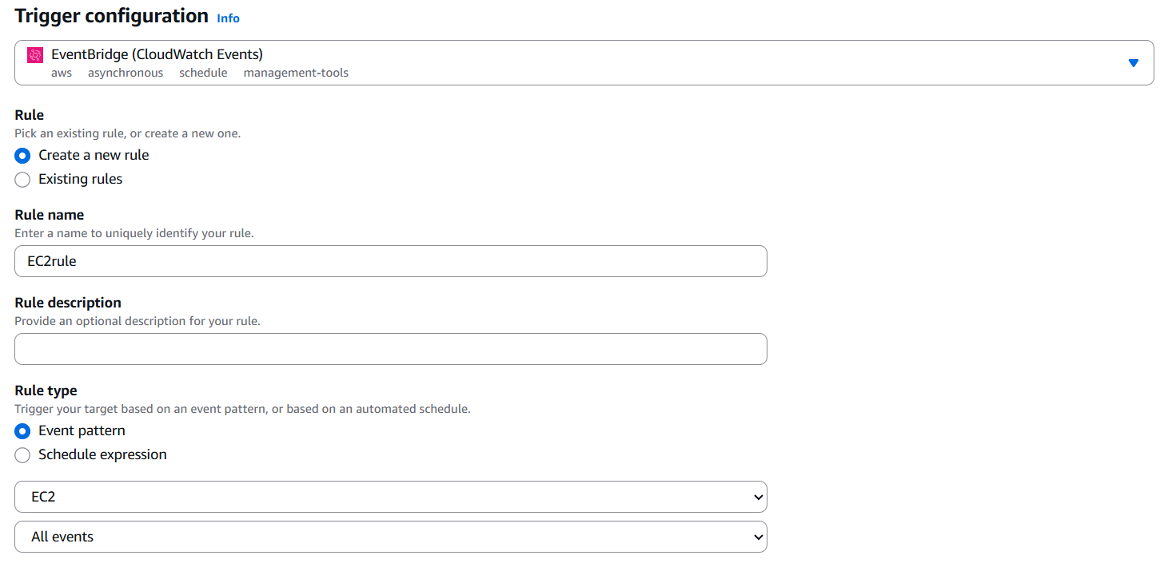

When instance was turned off, received the mail trigger.
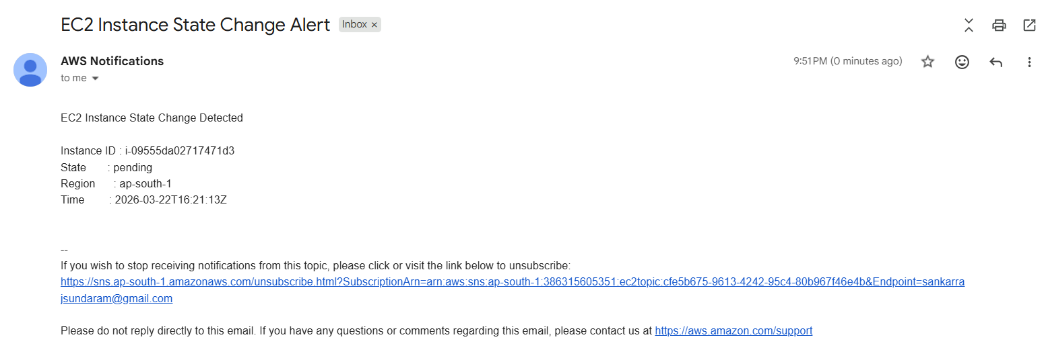
Assignment 4: Restore EC2 Instance from Snapshot

Created Snapshot.
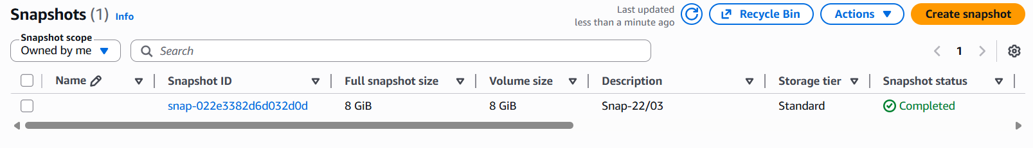

Created Lambda function.

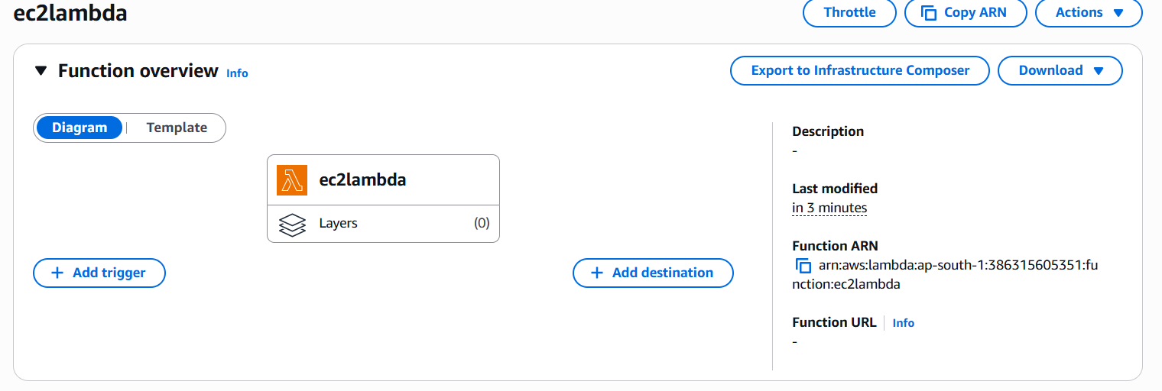

Executed the code to deploy an Ec2 instance from snapshot using lambda.

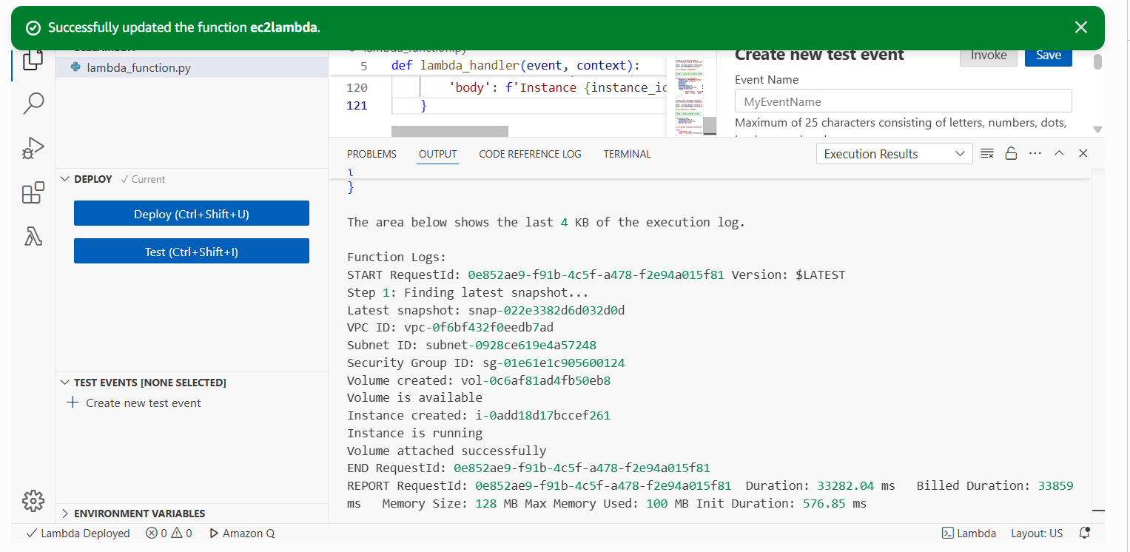

This instance was created by executing the code.

