How to use the SPIC Web Tool

*Necessary software*

Apache tomcat 6, Java, Chrome browser

*File Structure*

Source Code

JavaApplication1 => Source code of the server

sp => Source code of the web tool

Necessary Files => Files necessary for the web tool to run

*Prepare Environment*

1. Use **sp.war** in ur tomcat
2. Replace **server.xml** and **keystore** in ur tomcats conf folder. Change the path in **keystoreFile** in **server.xml** (this is because of https access for microphone).
3. Copy **SPIC** folder in **C** dir
4. Copy ur word chains into **SPIC/data** folder and name the chains (1.txt 2.txt 3.txt) as per experiment sequence.
5. For self test copy word chains into **SPIC/data2** folder
6. **log.log** is where u get info about the time stamps

2015-05-18 10:23:18.735

trial,computer,startTime,stoptime,target,distract

C:\SPIC\data\2syll.txt,0:0:0:0:0:0:0:1,0.59,8.2838,X

*startTime = when the word is presented*

*Stoptime = when the user respond*

*Computer = computer ip*

*How to start*

1. Open cmd
2. Run –jar “C://SPIC//server2.jar”
3. Open chrome and type
   1. localhost/sp/ (if it’s the same machine as server)
   2. server ip say 192.48.75.11/sp
4. ur browser will look like this  
    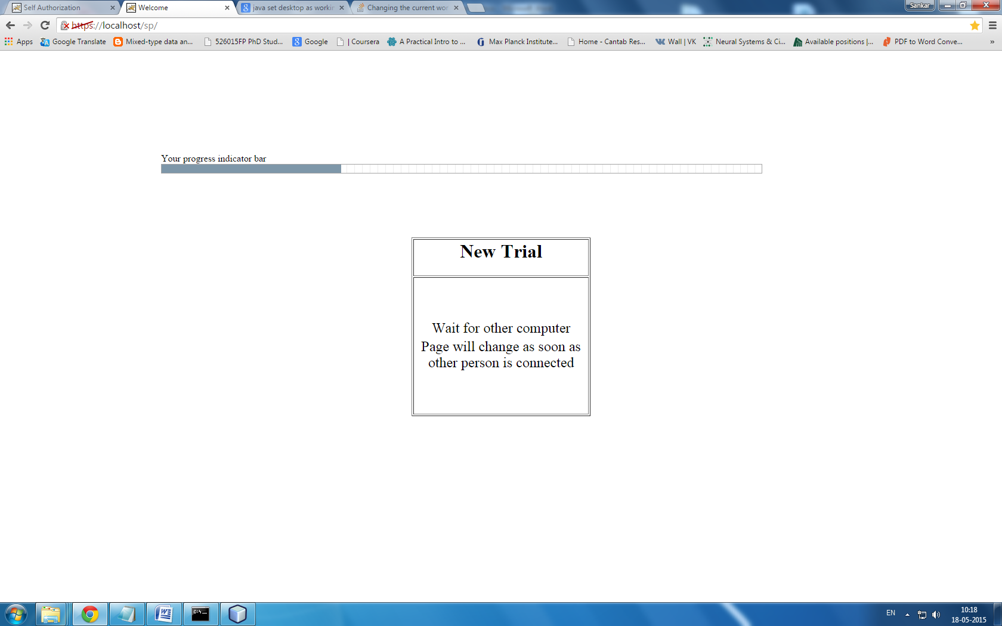
5. Wait for other computer to connect. when it does the screen will look like this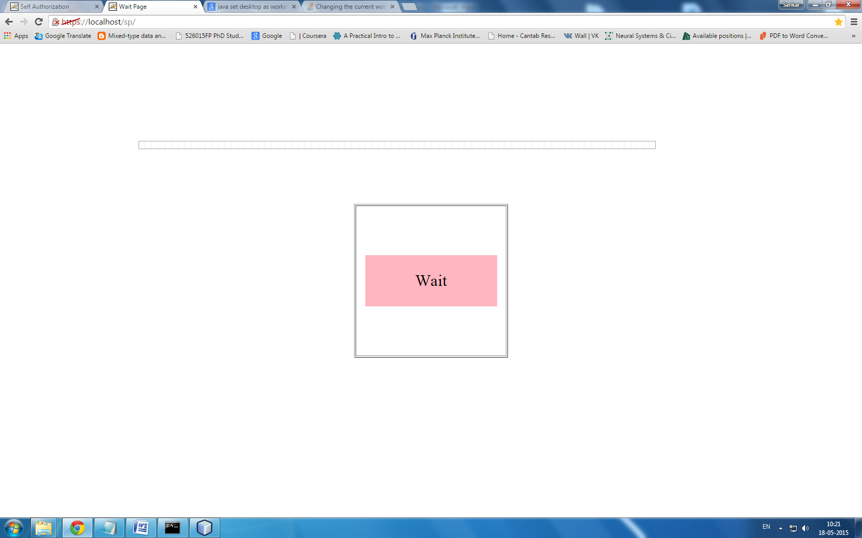  
   And the other computer screen will look 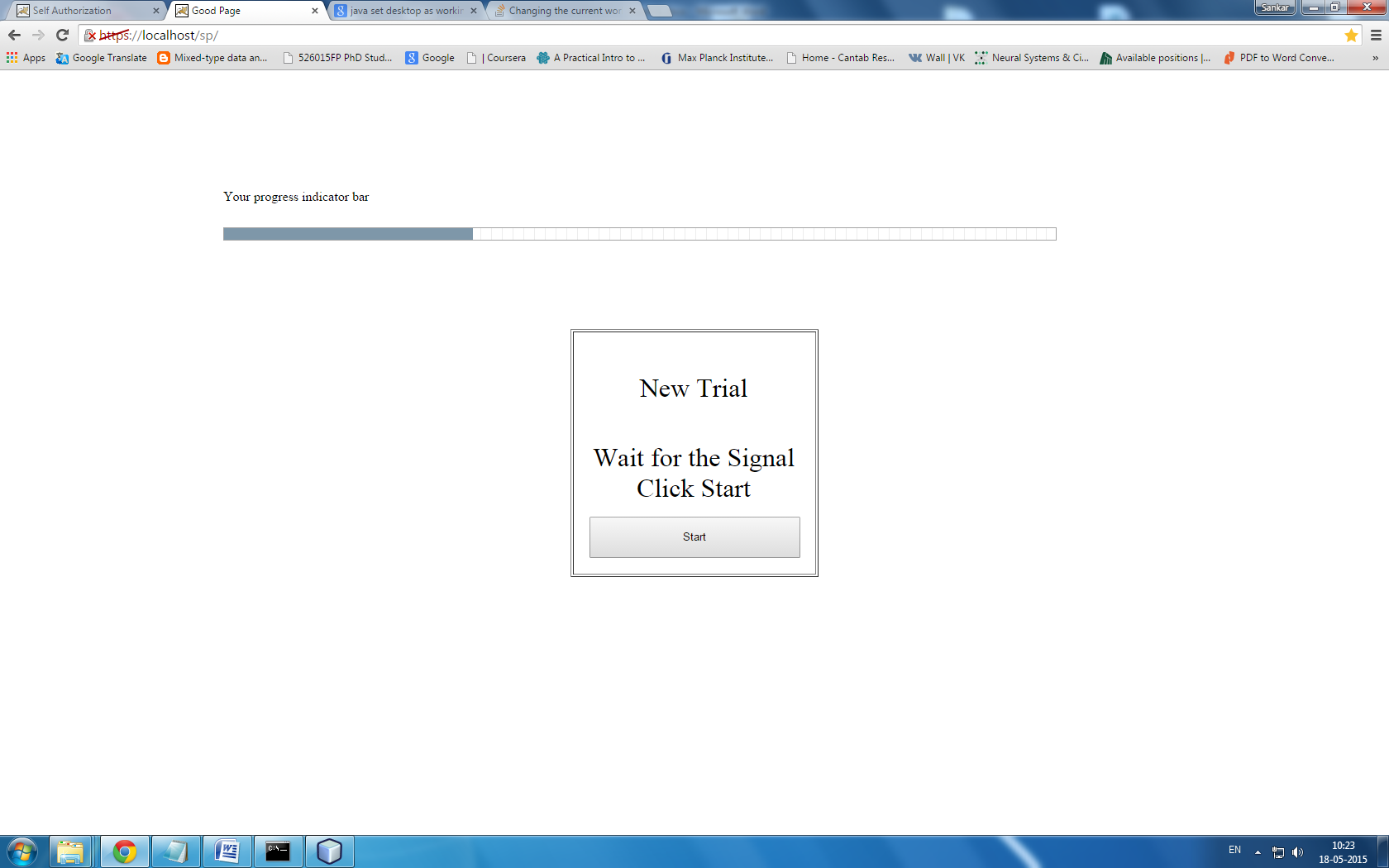
6. Now click start and the words will appear in the first computer.

Now if the voice key doesn’t work type

* 1. 192.48.75.11/sp/index2.jsp

Its manual button click procedure.

For self test type

1. 192.48.75.11/sp/selfauth.jsp

*Administer the Experiment*

In order to control the experiment type in browser

localhost/sp/admin.jsp

Here u can

1. upload/delete words chains,
2. see the current expeiment logs,
3. get log back up in to **SPIC/stat** folder
4. Restart the whole experiment