**Module1 Critical Thinking Git Repo**

|  |
| --- |
| <https://github.com/sankar228/csu-ms-aiml/tree/3b8cf02b7b0cc0392403b300dbf35ff1179f19b9/CSC500/module1> |

**Part1 source code**

|  |
| --- |
| def main():      num1 = int(input("Enter the first number: "))      num2 = int(input("Enter the second number: "))        sum = add(num1, num2)      print(f"{num1} + {num2} = {sum}")        sub = subtract(num1, num2)      print(f"{num1} - {num2} = {sub}")      def add(num1, num2):      return num1 + num2  def subtract(num1, num2):      return num1 - num2  if __name__ == '__main__':      main() |

**Part1 Code execution:**

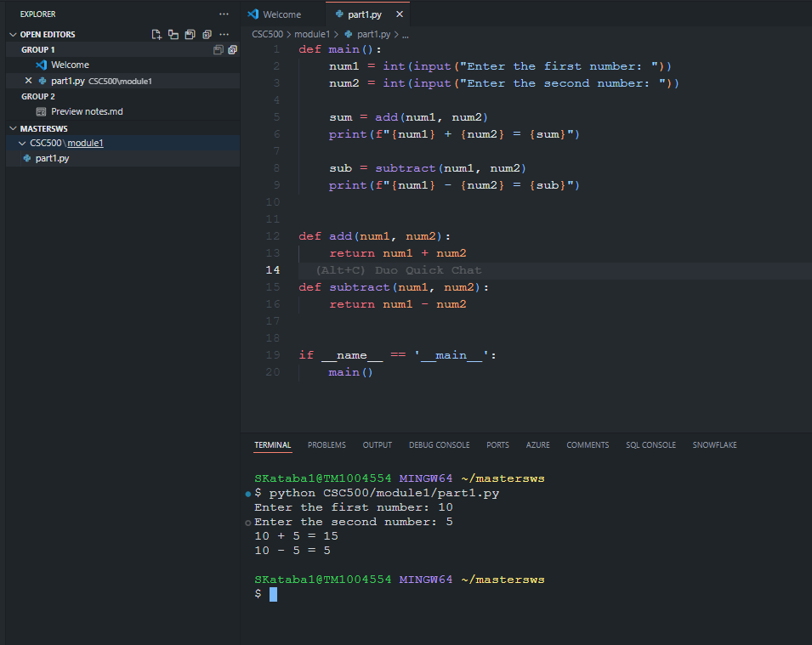

**Part2 Source code:**

|  |
| --- |
| def main():      num1 = int(input("Enter the first number: "))      num2 = int(input("Enter the second number: "))        mul = multiply(num1, num2)      print(f"{num1} * {num2} = {mul}")        div = divistion(num1, num2)      print(f"{num1} / {num2} = {div}")      def multiply(num1, num2):      return num1 * num2  def divistion(num1, num2):      return num1 / num2  if __name__ == '__main__':      main() |

**Part2 Code execution:**

