# Module 1

I am selecting ‘**Multi AI Agent framework for Monitoring and Alerting system** for ABC System”. I would like name this framework “**HiveMon**”.

The **ABC** system is a middleware application designed to handle large volumes of data collected from diverse sources, including RESTful APIs, file-based systems, streaming events and relational databases. It is crucial to monitor and report any failures during data collection or processing, and to enhance automation for taking timely corrective actions.

We are developing **HiveMon**, a multi-agent AI framework that proactively monitors, alerts, and responds to potential issues. By leveraging Generative AI models, HiveMon intelligently oversees system operations and delivers timely notifications to relevant teams, ensuring smoother and more reliable data processing.

# Module 2

**Stakeholder Engagement Assessment Matrix** for **ABC Systems** company for executing **HiveMon** Multi AI Agent

[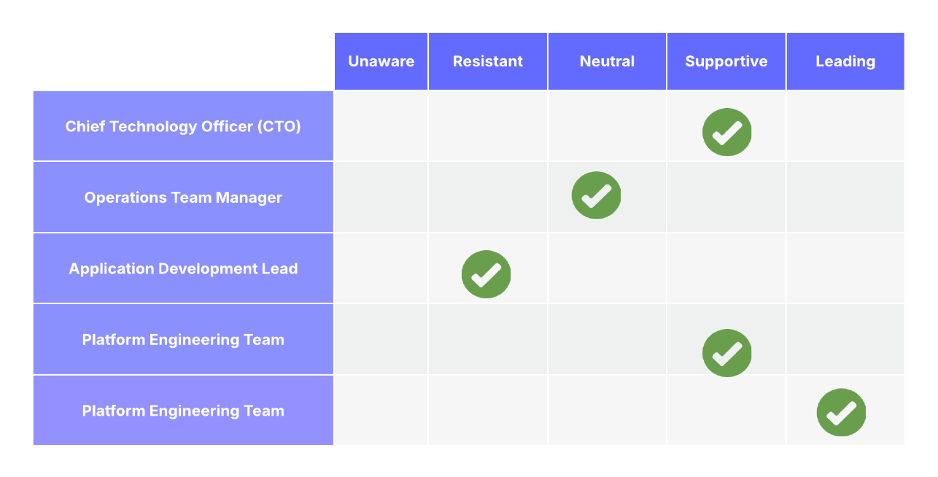](https://lucid.app/lucidchart/f15cb19e-0c30-4acd-9125-1d88bda754c0/edit?crop=content&page=0&signature=be34ce46f47da9a2ab083caf19d2609fb569725c56bff9337ed06de3fc0c7279)

**Use case Study on the engagement levels**

1. **Unaware**

There are no critical stakeholders unaware inside ABC company.

Everyone critical has at least some awareness of **HiveMon** project.

1. **Resistant**

'Application Development Lead' may fear that AI-based automation will replace traditional monitoring practices or introduce complexity they aren't familiar with. so we need organize focused workshops with them to demonstrate how HiveMon assists rather than replaces manual monitoring, and co-develop integration strategies with their applications.

1. **Neutral**

Initially, operations managers might stay neutral, wanting to see concrete proof of reliability and how HiveMon would fit into their existing workflows. Pilot the solution with smaller datasets, demonstrate clear benefits like early alerts and reduced downtime, and gradually move them to supportive.

1. **Supportive**

The CIO supports innovation and understands the need for advanced monitoring for scalability.

The Platform Team sees HiveMon as a tool to improve system resilience. Keep these groups informed with monthly updates and let them advocate for the project to wider internal audiences.

1. **Leading**

as a project manager we are actively steering the project: gathering requirements, managing AI model integration, overseeing testing, and ensuring stakeholder alignment. Conduct regular steering committee meetings, manage risks, and celebrate quick wins to maintain momentum.

# Module 3

To Bild **HiveMon** multi AI agent system, we are going make use of the systems and processes. This allows us to manage the project requirements, develop and manage sprints.

**Project environment Variables:** Below are the System environment variables used for the project context

|  |  |  |  |
| --- | --- | --- | --- |
| **Variable Type** | **Variable Name** | **Purpose** | **Developer/Owner** |
| Cloud Infrastructure | Azure / AWS | Host model and agents | DevOps |
| AI Libraries | OpenAI API, PyTorch, LangChain | Core for generative AI and decision logic | AI Engineer |
| Data Sources | Spark Logs, Airflow Logs | Event streams for monitoring agents | Data Engineer |
| Messaging | Slack API, Kafka, Email Gateway | Alert delivery mechanism | Integration Team |
| Compliance | GDPR, SOC2 | Ensure safe handling of logs/data | Security Officer |

**Project Scope:** Below are the tools and elements used for defining the project scope. This would ensure the quality of the project documentation and collaboration between the teams.

|  |  |  |  |
| --- | --- | --- | --- |
| **Scope Element** | **Description** | **Artifact** | **Tool Used** |
| Requirements Gathering | Identify alert criteria, AI logic, and stakeholder needs | Product backlog, user stories | Jira, Confluence |
| Scope Definition | Document functional and non-functional boundaries | Scope Statement | Word / Confluence |
| WBS Creation | Decompose into modules: AI agent, Alerting, UI, API | Work Breakdown Structure | Excel, Lucidchart |
| Scope Control | Manage backlog updates and change control | Sprint backlog, Change Log | Jira, Git |

**Organization systems:** We have few tool and processes options from organization to use for executing this project. We are documenting all the usable tools and processes.

|  |  |  |  |
| --- | --- | --- | --- |
| **System Type** | **Name** | **Role in Project** | **Frequency** |
| Code Repository | GitHub | Codebase version control | Daily |
| CI/CD Pipeline | GitLab CICD/ Azure DevOps / Jenkins | Deployment and testing automation | Per commit/sprint |
| Task Management | Jira | Sprint planning, Epics, task tracking | Daily/Weekly |
| Knowledge Mgmt | Confluence / Google Docs | Requirements, documentation, meeting notes | Weekly |