# Module 1

I am selecting ‘**Multi AI Agent framework for Monitoring and Alerting system** for ABC System”. I would like name this framework “**HiveMon**”.

The **ABC** system is a middleware application designed to handle large volumes of data collected from diverse sources, including RESTful APIs, file-based systems, streaming events and relational databases. It is crucial to monitor and report any failures during data collection or processing, and to enhance automation for taking timely corrective actions.

We are developing **HiveMon**, a multi-agent AI framework that proactively monitors, alerts, and responds to potential issues. By leveraging Generative AI models, HiveMon intelligently oversees system operations and delivers timely notifications to relevant teams, ensuring smoother and more reliable data processing.

# Module 2

## Stakeholder Engagement Assessment Matrix

for **ABC Systems** company for executing **HiveMon** Multi AI Agent.

This Assessment Matrix primary use is to provide a clear, visual representation of the current and desired levels of stakeholder engagement in a project or initiative. By doing so, it helps in several key ways, like Understanding current engagement levels, define desired engagement levels, identify engagement gaps.

[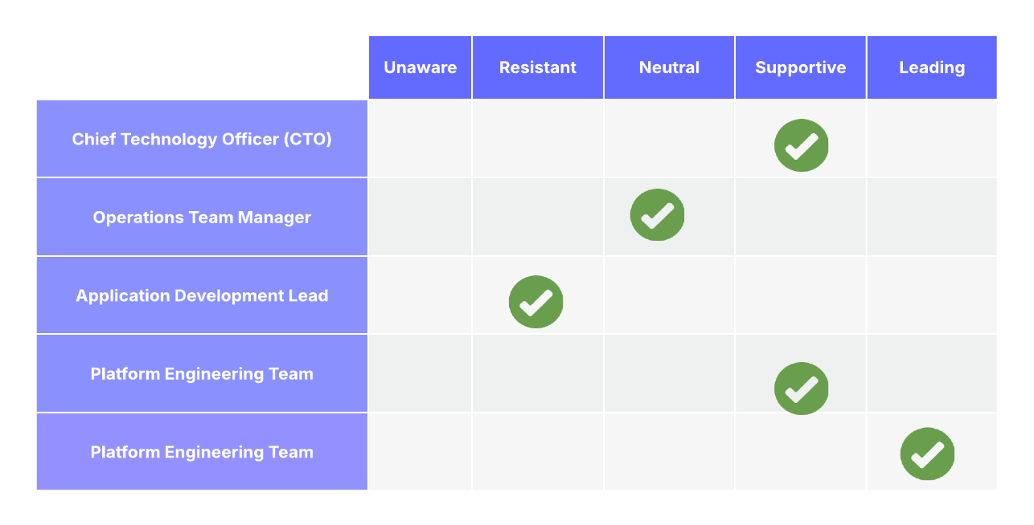](https://lucid.app/lucidchart/f15cb19e-0c30-4acd-9125-1d88bda754c0/edit?crop=content&page=0&signature=be34ce46f47da9a2ab083caf19d2609fb569725c56bff9337ed06de3fc0c7279)

**Use case Study on the engagement levels**

1. **Unaware**

There are no critical stakeholders unaware inside ABC company.

Everyone critical has at least some awareness of **HiveMon** project.

1. **Resistant**

'Application Development Lead' may fear that AI-based automation will replace traditional monitoring practices or introduce complexity they aren't familiar with. so we need organize focused workshops with them to demonstrate how HiveMon assists rather than replaces manual monitoring, and co-develop integration strategies with their applications.

1. **Neutral**

Initially, operations managers might stay neutral, wanting to see concrete proof of reliability and how HiveMon would fit into their existing workflows. Pilot the solution with smaller datasets, demonstrate clear benefits like early alerts and reduced downtime, and gradually move them to supportive.

1. **Supportive**

The CIO supports innovation and understands the need for advanced monitoring for scalability.

The Platform Team sees HiveMon as a tool to improve system resilience. Keep these groups informed with monthly updates and let them advocate for the project to wider internal audiences.

1. **Leading**

as a project manager we are actively steering the project: gathering requirements, managing AI model integration, overseeing testing, and ensuring stakeholder alignment. Conduct regular steering committee meetings, manage risks, and celebrate quick wins to maintain momentum.

# Module 3

## Systems and Processes

To Build **HiveMon** multi AI agent system, we are going to make use of the below systems and processes. This allows us to manage the project requirements, develop and manage sprints.

**Project environment Variables:** Below are the System environment variables used for the project context

|  |  |  |  |
| --- | --- | --- | --- |
| **Variable Type** | **Variable Name** | **Purpose** | **Developer/Owner** |
| Cloud Infrastructure | Azure / AWS | Host model and agents | DevOps |
| AI Libraries | OpenAI API, PyTorch, LangChain | Core for generative AI and decision logic | AI Engineer |
| Data Sources | Spark Logs, Airflow Logs | Event streams for monitoring agents | Data Engineer |
| Messaging | Slack API, Kafka, Email Gateway | Alert delivery mechanism | Integration Team |
| Compliance | GDPR, SOC2 | Ensure safe handling of logs/data | Security Officer |

**Project Scope:** Below are the tools and elements used for defining the project scope. This would ensure the quality of the project documentation and collaboration between the teams.

|  |  |  |  |
| --- | --- | --- | --- |
| **Scope Element** | **Description** | **Artifact** | **Tool Used** |
| Requirements Gathering | Identify alert criteria, AI logic, and stakeholder needs | Product backlog, user stories | Jira, Confluence |
| Scope Definition | Document functional and non-functional boundaries | Scope Statement | Word / Confluence |
| WBS Creation | Decompose into modules: AI agent, Alerting, UI, API | Work Breakdown Structure | Excel, Lucidchart |
| Scope Control | Manage backlog updates and change control | Sprint backlog, Change Log | Jira, Git |

**Organization systems:** We have few tool and processes options from organization to use for executing this project. We are documenting all the usable tools and processes.

|  |  |  |  |
| --- | --- | --- | --- |
| **System Type** | **Name** | **Role in Project** | **Frequency** |
| Code Repository | GitHub | Codebase version control | Daily |
| CI/CD Pipeline | GitLab CICD/ Azure DevOps / Jenkins | Deployment and testing automation | Per commit/sprint |
| Task Management | Jira | Sprint planning, Epics, task tracking | Daily/Weekly |
| Knowledge Mgmt | Confluence / Google Docs | Requirements, documentation, meeting notes | Weekly |

# Module 4

## project scope

The first phase of the project deals with the critical functionality of using agile methodology by splitting them into sprints.

In Scope:

* Design and development of multi-agent architecture
* Data modelling to host the data availability events
* Real time alert generation and escalation workflow
* Generative AI based anomaly detection
* Dashboard and reporting for stakeholders

**Milestones & Timelines**

Project plan for Sprint 1 to cover the critical requirements. This template of project phases will be used for the subsequent Sprint’s

**[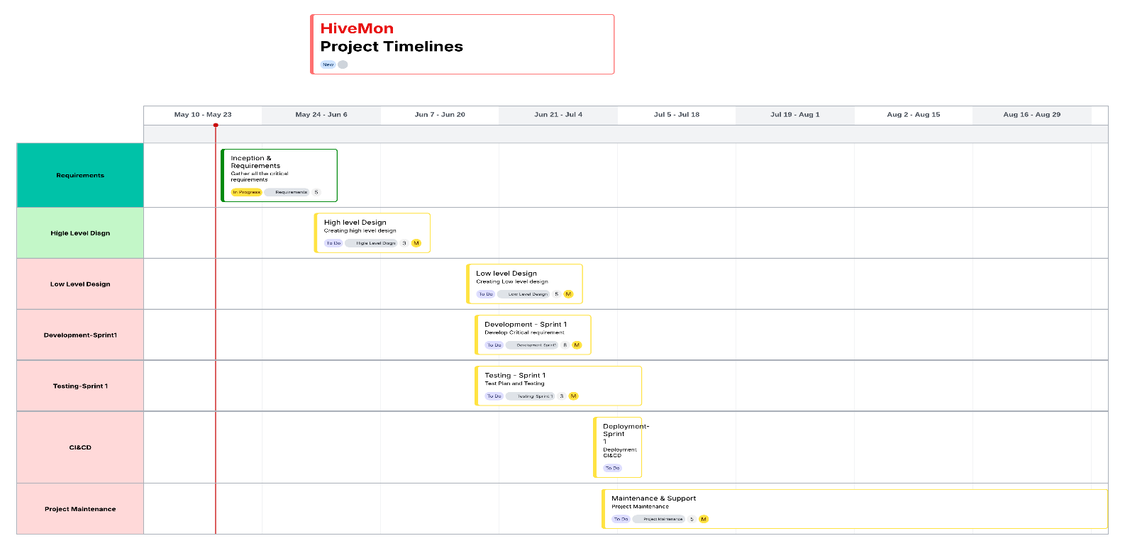](https://lucid.app/lucidchart/fb2dee8f-f807-4a75-9d8c-4d18dc9a52a4/edit?crop=content&page=0&signature=978c8aee83fb96e1cec76a0210bd2cba1b8de7e671de2c157e1fc9fe73701b5e)**

**Budget estimates**

Budget plan including the resource cost, tools and maintenance. Keeping 20% extra for as emergency fund for covering the overlays

|  |  |
| --- | --- |
| **Category** | **Estimate Cost (USD)** |
| Development Resource | $500,000 |
| AI/ML Consultant Services | $250,000 |
| Tools & Subscriptions | $50,000 |
| Cloud Infrastructure | $25,000 |
| Training & Documentation | $15,000 |
| Contingency (20%) | $150,000 |
| **Total Estimated Budget** | **$990,000** |

**Resource Planning**

This project demands specialized AI expertise, which often comes at a premium when sourcing from the current market. Given the importance of security, we plan to engage a temporary consultant with the necessary expertise to support the application's security requirements.

|  |  |  |
| --- | --- | --- |
| **Resource Role** | **Number Of Resources** | **EmploymentType** |
| Project Manager | 1 | FTE |
| AI Engineers | 2 | FTE |
| Backend Developers | 3 | FTE |
| DevOps Engineer | 1 | FTE |
| QA/Test Engineers | 1 | FTE |
| Business Analyst | 1 | FTE |
| Security Expert (Consultant) – Part-time | 2 | PT |

**Goal Alignment**

It is important to align Business and Technical to drive the project in the right direction

**Business Goals:**

Minimize system downtime

Improve data pipeline reliability

Reduce MTTR (Mean Time to Resolution)

**Technical Goals:**

Use AI to proactively detect issues

Enable flexible alerting and notification workflows

Maintain secure and compliant data monitoring

# Module 5

## Design Methodology and Development Roadmap for HiveMon

HiveMon will adopt an Agile-DevOps hybrid design methodology. This approach combines the iterative nature of Agile development with the automation and continuous integration principles of DevOps. It enables close collaboration with stakeholders, adaptive planning, early delivery, and continuous improvement.

### Core Design Phases and Activities:

Below are the different development phases involved in the project execution. Please refer to the Gantt chart for sprint planning.

* Requirement Analysis and Feasibility
* Architecture and System Design
* UI and Visualization Layer Design
* Development & Integration Planning
* Security and Compliance
* QA Testing and Feedback Loops

### Tools and Techniques

Below tools for Design and Development plan, in addition to development tools and softwares.

**Jira**: creating intakes and Sprint/Epic/Task creations for collaboration

**GitHub**: code repository, CI&CD

**Lucidchart**: architecture and process flow

### Project Design and Development Roadmap chart

The Gantt chart below outlines the project execution plan, breaking the work into multiple sprints along with their respective durations. It provides a clear overview of the resource requirements and the level of effort needed for each task

Requirements gathering is distributed across multiple sprints to break down high-level requirements into smaller, manageable components, allowing for parallel development and execution.

[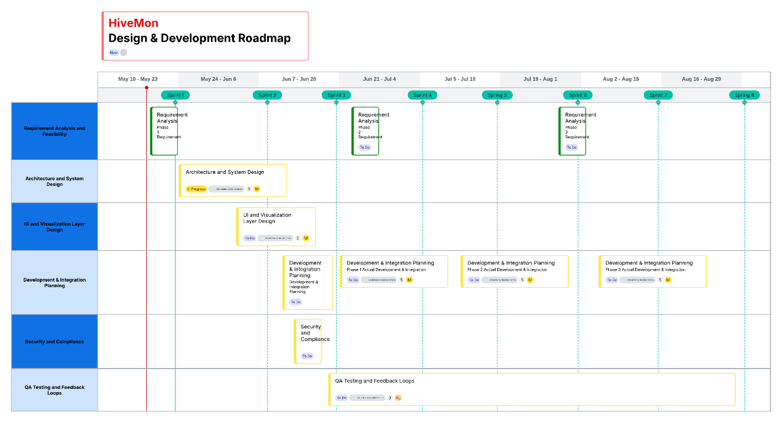](https://lucid.app/lucidchart/58e6f133-4771-4372-a71c-23e4911094c5/edit?crop=content&page=0&signature=f1fbf49d472114a889296437e6b073df1c76c635418b99f6ecfff4f2e5835ea0)

# Module 6

### Risk Considerations

The following key risks have been identified in the execution of the HiveMon AI Agent framework

**Evolving Data Sources**: Data sources may lack sufficient detail or standardization, making it difficult for AI models to interpret field-level context accurately. This could impact the precision of agent responses.

**AI Model Drift**: As project requirements evolve, the initial choice of AI models may become less effective, necessitating re-evaluation and potential model replacement.

**Integration Delays**: External (northbound) systems may not align with the project timeline, potentially delaying end-to-end integration and testing phases.

**Security Vulnerabilities:** Given the use of live logs, alerts, and AI, security is paramount. Vulnerabilities in data handling or alert channels (like Slack, Kafka, Email) could expose sensitive information. To tackle this, security experts will participate in design reviews and recommend best practices for secure data flow and access control.

**Resource Constraints:** AI engineers and security consultants are high-demand roles. Availability issues can delay sprints, especially those needing domain expertise. The mitigation plan includes a balanced resourcing structure: full time internal staff and flexible consultant involvement to ensure continuity.

**Budget Overruns:** Though rare, unforeseen tool costs or hiring needs could inflate costs. To address this, a 20% contingency reserve is part of the original budget, and milestone-based budget reviews will flag concerns early.

### Rix matrix

The HiveMon risk matrix identifies key technical, operational, and organizational risks that could impact project success. Each risk is evaluated by likelihood and impact, with targeted mitigation strategies to ensure project continuity and resilience.

|  |  |  |  |  |
| --- | --- | --- | --- | --- |
| **Risk** | **Likelihood** | **Impact** | **Severity** | **Mitigation strategy** |
| Evolving Data Sources | High | High | Critical | Collaborate with source teams to standardize data dictionaries |
| AI Model Drift | Medium | High | High | Design flexible architecture supporting pluggable models |
| Integration Delays | Medium | Medium | Moderate | Build buffer time into schedule, engage external teams early |
| Security Vulnerabilities | Medium | High | High | Include part-time security experts for audits and secure design |
| Team Resource Constraints | High | Medium | High | Use clear role definitions and leverage consultants as needed |
| Budget Overruns | Low | High | Moderate | Allocate 20% contingency and monitor expenses sprint-wise |