**HiveMon**, is a multi-agent AI framework that proactively monitors, alerts, and responds to potential issues. By leveraging Generative AI models, HiveMon intelligently oversees system operations and delivers timely notifications to relevant teams, ensuring smoother and more reliable data processing.

**Stakeholder Engagement Assessment Matrix** for **ABC Systems** company for executing **HiveMon** Multi AI Agent

[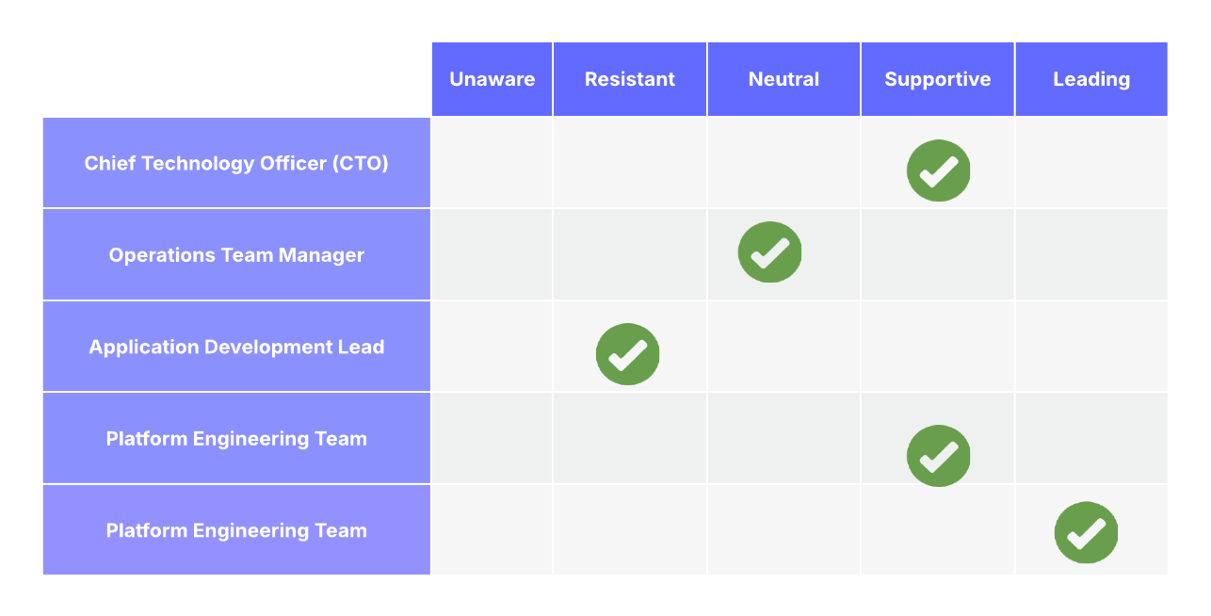](https://lucid.app/lucidchart/f15cb19e-0c30-4acd-9125-1d88bda754c0/edit?crop=content&page=0&signature=be34ce46f47da9a2ab083caf19d2609fb569725c56bff9337ed06de3fc0c7279)

**Use case Study on the engagement levels**

1. **Unaware**

There are no critical stakeholders unaware inside ABC company.

Everyone critical has at least some awareness of **HiveMon** project.

1. **Resistant**

'Application Development Lead' may fear that AI-based automation will replace traditional monitoring practices or introduce complexity they aren't familiar with. so we need organize focused workshops with them to demonstrate how HiveMon assists rather than replaces manual monitoring, and co-develop integration strategies with their applications.

1. **Neutral**

Initially, operations managers might stay neutral, wanting to see concrete proof of reliability and how HiveMon would fit into their existing workflows. Pilot the solution with smaller datasets, demonstrate clear benefits like early alerts and reduced downtime, and gradually move them to supportive.

1. **Supportive**

The CIO supports innovation and understands the need for advanced monitoring for scalability.

The Platform Team sees HiveMon as a tool to improve system resilience. Keep these groups informed with monthly updates and let them advocate for the project to wider internal audiences.

1. **Leading**

as a project manager we are actively steering the project: gathering requirements, managing AI model integration, overseeing testing, and ensuring stakeholder alignment. Conduct regular steering committee meetings, manage risks, and celebrate quick wins to maintain momentum.