STRATEGIC PLANNING REPORT
Project-Title: Data-Driven Inventory Management and Delivery Optimization for an E-Commerce Logistics Company
Project Area: Logistics Data Analysis
Internship/Program: YuvaIntern
Submitted by: Sankari D
Date: 15th – 21st October, 2026.
Github_Project_Link: https://github.com/sankari-d27/Week_3_ECommerce_Logistics_Data_Analysis_Visualization.git

Summary: Exploratory Data Analysis (EDA) using Jupyter Notebook for Python code, Pandas, NumPy, Matplotlib, and Seaborn to examine product demand, order values, inventory levels, delivery performance, shipping costs, and customer ratings.
Table of Content:
3. Week 3 – Advanced Data Analysis and Visualization
3.1 Introduction
3.2 Exploratory Data Analysis
3.3 Product Demand Analysis
3.4 Inventory Analysis
3.5 Delivery Analysis
3.6 Shipping Cost Analysis
3.7 Business Insights
3.8 Conclusion

3. WEEK 3 - Advanced Data Analysis and Visualization in E-Commerce Logistics
3.1. Introduction
Week 3 focuses on advanced data analysis and visualization of the cleaned e-commerce logistics dataset. The primary objective is to identify meaningful patterns in product demand, sales performance, inventory availability, warehouse operations, delivery efficiency, and shipping costs.
Python libraries, including Pandas, NumPy, Matplotlib, and Seaborn, were used to perform statistical analysis, calculate key performance indicators (KPIs), identify potential data anomalies, and create visualizations.
The dataset initially contained 71 records and 15 columns. After identifying and removing one duplicate order ID, the analysis dataset contained 70 unique orders. The analysis provides a foundation for developing data-driven strategies to improve inventory management, reduce logistics costs, and enhance customer satisfaction.

3.2. Exploratory Data Analysis
Exploratory Data Analysis (EDA) was conducted to understand the structure, quality, and characteristics of the dataset before interpreting business performance.
The analysis covered the following areas:
- Product demand and category-wise order distribution.
- Recorded order value and sales trends.
- Inventory levels and reorder requirements.
- Stockout indicators and warehouse-level inventory risks.
- Delivery times and late-delivery performance.
- Shipping costs and potential cost anomalies.
- Customer ratings and relationships among logistics KPIs.
Data Quality and Validation
The initial data validation identified the following issues:
- Duplicate records: One exact duplicate record was identified, resulting in 70 unique orders after deduplication.
- Missing values: One missing shipping cost and one missing inventory level were found.
- Invalid order value: One order contained a negative order value of ₹500, requiring verification.
- Invalid delivery durations: Two records contained zero or negative delivery durations and were excluded from valid delivery-time calculations.
- Potential shipping-cost outlier: One shipment recorded a shipping cost of ₹25,000, substantially higher than the other recorded costs.
The dataset was prepared for analysis by removing the duplicate order ID and excluding invalid delivery durations from delivery performance calculations. Missing values were not automatically replaced, and the unusual shipping cost and negative order value were retained for investigation.
These validation steps help improve the reliability of the analysis and prevent data-quality issues from being mistaken for genuine business trends.
Descriptive Statistics
The descriptive analysis produced the following key results:
Metric | Result
Unique orders | 70
Total recorded order value | ₹8,78,300
Average order value | ₹12,547.14
Median order value | ₹5,600
Average valid delivery time | 3.35 days
Median valid delivery time | 3 days
Average customer rating | 4.04 out of 5
Average recorded shipping cost | ₹666.81

The average order value is substantially higher than the median, indicating that some high-value orders influence the overall average. The unusually high shipping-cost observation also affects the average shipping cost, making the median a useful complementary measure.
#Import libraries and load CSV
import pandas as pd
import numpy as np
import matplotlib.pyplot as plt
import seaborn as sns
from pathlib import Path
sns.set_theme(style="whitegrid")
plt.rcParams["figure.figsize"] = (9, 5)

Output:
Dataset loaded successfully
Rows: 71
Columns: 15
Unique order IDs: 70
# Load dataset
df = pd.read_csv("ecommerce_logistics_week2.csv")

# Convert order date to datetime
df["Order_Date"] = pd.to_datetime(
df["Order_Date"], errors="coerce"
)

# Create folder for visualizations
output_dir = Path("Images")
output_dir.mkdir(exist_ok=True)

print("Dataset loaded successfully")
print("Rows:", len(df))
print("Columns:", len(df.columns))
print("Unique order IDs:", df["Order_ID"].nunique())

display(df.head())
#Data quality and validation
# Missing values
missing_report = pd.DataFrame({
"Missing_Count": df.isnull().sum(),
"Missing_Percentage": (
df.isnull().sum() / len(df) * 100
).round(2)
})

print("MISSING VALUE REPORT")
display(missing_report[missing_report["Missing_Count"] > 0])

# Duplicate records
print("Exact duplicate rows:", df.duplicated().sum())
print("Duplicate order IDs:", df["Order_ID"].duplicated().sum())

display(
df[df["Order_ID"].duplicated(keep=False)]
.sort_values("Order_ID")
)

# Invalid or unusual records
print("Negative order values:")
display(df[df["Order_Value"] < 0])

print("Zero or negative delivery days:")
display(df[df["Delivery_Days"] <= 0])

print("Shipping costs above 5,000:")
display(df[df["Shipping_Cost"] > 5000])

print("Late deliveries:")
display(
df[df["Delivery_Days"] > df["Expected_Days"]][
["Order_ID", "Delivery_Partner",
"Delivery_Days", "Expected_Days"]
])
Output:
MISSING VALUE REPORT
 | Missing_Count | Missing_Percentage
Shipping_Cost | 1 | 1.41
Inventory_Level | 1 | 1.41
Exact duplicate rows: 1
Duplicate order IDs: 1

 | Order_ID | Order_Date | Customer_ID | Product_Category | Order_Value | Shipping_Cost | Warehouse | Delivery_Partner | Delivery_Days | Expected_Days | Order_Status | Customer_Rating | Return_Flag | Inventory_Level | Reorder_Level
1 | ORD1002 | 2026-01-03 | CUST002 | Fashion | 2500 | 180.0 | Mumbai | BlueDart | 2 | 3 | Delivered | 4 | No | 10.0 | 15
30 | ORD1002 | 2026-01-03 | CUST002 | Fashion | 2500 | 180.0 | Mumbai | BlueDart | 2 | 3 | Delivered | 4 | No | 10.0 | 15
Negative order values:
 | Order_ID | Order_Date | Customer_ID | Product_Category | Order_Value | Shipping_Cost | Warehouse | Delivery_Partner | Delivery_Days | Expected_Days | Order_Status | Customer_Rating | Return_Flag | Inventory_Level | Reorder_Level
61 | ORD1061 | 2026-03-03 | CUST061 | Fashion | -500 | 190.0 | Mumbai | Ecom Express | 3 | 4 | Delivered | 4 | No | 14.0 | 19
Zero or negative delivery days:
 | Order_ID | Order_Date | Customer_ID | Product_Category | Order_Value | Shipping_Cost | Warehouse | Delivery_Partner | Delivery_Days | Expected_Days | Order_Status | Customer_Rating | Return_Flag | Inventory_Level | Reorder_Level
32 | ORD1032 | 2026-02-02 | CUST032 | Fashion | 3600 | 190.0 | Chennai | Ecom Express | 0 | 3 | Delivered | 4 | No | 14.0 | 19
41 | ORD1041 | 2026-02-11 | CUST041 | Electronics | 27500 | 500.0 | Hyderabad | Delivery | -2 | 4 | Delivered | 3 | No | 18.0 | 12
Shipping costs above 5,000:
Order_ID | Order_Date | Customer_ID | Product_Category | Order_Value | Shipping_Cost | Warehouse | Delivery_Partner | Delivery_Days | Expected_Days | Order_Status | Customer_Rating | Return_Flag | Inventory_Level | Reorder_Level
ORD1031 | 2026-02-01 | CUST031 | Electronics | 18500 | 25000.0 | Bangalore | Delivery | 3 | 4 | Delivered | 5 | No | 22.0 | 20

Late deliveries:
 | Order_ID | Delivery_Parner | Delivery_Days | Expected_Days
2 | ORD1003 | Ecom Express | 5 | 4
5 | ORD1006 | Ecom Express | 6 | 5
8 | ORD1009 | Ecom Express | 7 | 5
11 | ORD1012 | Ecom Express | 5 | 4
12 | ORD1013 | Delivery | 4 | 3
16 | ORD1017 | Delivery | 4 | 3
20 | ORD1021 | Ecom Express | 6 | 5
23 | ORD1024 | Ecom Express | 5 | 4
28 | ORD1029 | BlueDart | 5 | 4
43 | ORD1043 | Ecom Express | 4 | 3
48 | ORD1048 | BlueDart | 4 | 3
52 | ORD1052 | Ecom Express | 5 | 4
53 | ORD1053 | BlueDart | 6 | 5
55 | ORD1055 | Ecom Express | 5 | 4
60 | ORD1060 | Delivery | 5 | 4

# Prepare the analysis dataset
# Preserve df unchanged for data-quality reporting.
analysis = df.drop_duplicates(
subset="Order_ID", keep="first"
).copy()

# Do not treat invalid delivery durations as valid measurements.
analysis["Delivery_Days_Valid"] = (
analysis["Delivery_Days"].where(
analysis["Delivery_Days"] > 0))

# Mark late deliveries using positive delivery durations.
analysis["Late"] = (
analysis["Delivery_Days_Valid"]
> analysis["Expected_Days"])

# Flag records at or below the reorder threshold.
analysis["Reorder_Alert"] = (
analysis["Inventory_Level"]
<= analysis["Reorder_Level"])

# Actual recorded stockout indicator.
analysis["Stockout"] = (
analysis["Inventory_Level"] <= 0)
print("Original records:", len(df))
print("Records after duplicate-ID removal:", len(analysis))
print("Unique orders:", analysis["Order_ID"].nunique())

Output:
Original records: 71
Records after duplicate-ID removal: 70
Unique orders: 70

#3.2. Exploratory data analysis and descriptive statistics
numeric_columns = [
"Order_Value",
"Shipping_Cost",
"Delivery_Days_Valid",
"Expected_Days",
"Customer_Rating",
"Inventory_Level",
"Reorder_Level"]
print("DESCRIPTIVE STATISTICS")
display(analysis[numeric_columns].describe().round(2))
print("Median values")
display(analysis[numeric_columns].median().round(2))
print("Missing values in analysis dataset")
display(
analysis.isnull().sum()
.to_frame("Missing_Count")
.query("Missing_Count > 0"))

Output:
DESCRIPTIVE STATISTICS
 | Order_Value | Shipping_Cost | Delivery_Days_Valid | Expected_Days | Customer_Rating | Inventory_Level | Reorder_Level
count | 70.00 | 69.00 | 68.00 | 70.00 | 70.00 | 69.00 | 70.00
mean | 12547.14 | 666.81 | 3.35 | 3.54 | 4.04 | 29.87 | 31.56
Std | 14483.83 | 2977.92 | 1.32 | 0.93 | 0.97 | 17.29 | 17.41
Min | -500.00 | 110.00 | 1.00 | 2.00 | 2.00 | 8.00 | 6.00
25% | 2725.00 | 150.00 | 2.00 | 3.00 | 4.00 | 17.00 | 19.00
50% | 5600.00 | 220.00 | 3.00 | 4.00 | 4.00 | 27.00 | 25.50
75% | 18500.00 | 480.00 | 4.00 | 4.00 | 5.00 | 45.00 | 43.00
Max | 52000.00 | 25000.00 | 7.00 | 5.00 | 5.00 | 80.00 | 80.00

Median values
Order_Value 5600.0
Shipping_Cost 220.0
Delivery_Days_Valid 3.0
Expected_Days 4.0
Customer_Rating 4.0
Inventory_Level 27.0
Reorder_Level 25.5
dtype: float64
Missing values in analysis dataset
 | Missing_Count
Shipping_Cost | 1
Inventory_Level | 1
Delivery_Days_Valid | 2

#3.3 Product demand analysis
Product demand was evaluated by grouping orders according to product category and calculating the number of unique orders, total recorded order value, and average order value.
Electronics and Fashion recorded the highest order counts, with 19 orders each. However, Electronics generated the highest recorded order value, accounting for approximately 73.3% of the total recorded value.
Home & Kitchen ranked second in total recorded order value, despite having only 11 orders. This indicates a relatively high average order value for this category.
Beauty recorded the lowest order count and total recorded order value among the five categories.
Business Implications
- Electronics should receive close attention in inventory planning because of its high recorded order value.
- Fashion requires adequate stock availability because it has a high order count.
- Home & Kitchen inventory planning should consider the comparatively high value per order.
- Grocery and Beauty stock policies should be aligned with their demand patterns to avoid unnecessary inventory accumulation.
Order count represents observed demand in this dataset, not necessarily total market demand. A longer observation period and product-level sales history would improve demand forecasting.

category_demand = analysis.groupby(
"Product_Category").agg(Order_Count=("Order_ID", "nunique"),
Total_Order_Value=("Order_Value", "sum"),
Average_Order_Value=("Order_Value", "mean")).sort_values("Order_Count", ascending=False)
print("PRODUCT CATEGORY ANALYSIS")
display(category_demand.round(2))
category_demand["Order_Count"].plot( kind="bar", color="steelblue")
plt.title("Number of Orders by Product Category") plt.xlabel("Product Category")
plt.ylabel("Unique Orders")
plt.xticks(rotation=30, ha="right")
plt.tight_layout()
plt.savefig(output_dir / "01_product_demand.png", dpi=300)
plt.show()
Output:
PRODUCT CATEGORY ANALYSIS
Product_Category | Order_Count | Total_Order_Value | Average_Order_Value | 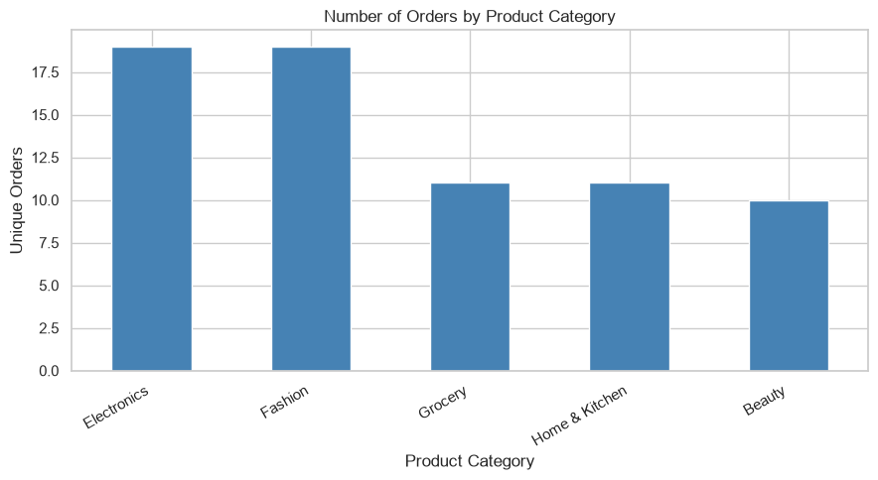
Electronics | 19 | 643500 | 33868.42
Fashion | 19 | 83400 | 4389.47
Grocery | 11 | 27900 | 2536.36
Home & Kitchen | 11 | 104400 | 9490.91
Beauty | 10 | 19100 | 1910.00

#Sales and order value analysis
category_sales = (
analysis.groupby("Product_Category")["Order_Value"]
.sum()
.sort_values(ascending=False))
print("TOTAL RECORDED ORDER VALUE BY CATEGORY")
display(category_sales.to_frame("Total_Order_Value").round(2))
category_sales.plot(kind="bar", color="seagreen")
plt.title("Total Recorded Order Value by Category")
plt.xlabel("Product Category")
plt.ylabel("Order Value")
plt.xticks(rotation=30, ha="right")
plt.tight_layout()
plt.savefig(output_dir / "02_sales_by_category.png", dpi=300)
plt.show()
print(
"Total recorded order value:",
round(analysis["Order_Value"].sum(), 2))

OutPut:
TOTAL RECORDED ORDER VALUE BY CATEGORY
Product_Category | Total_Order_Value | 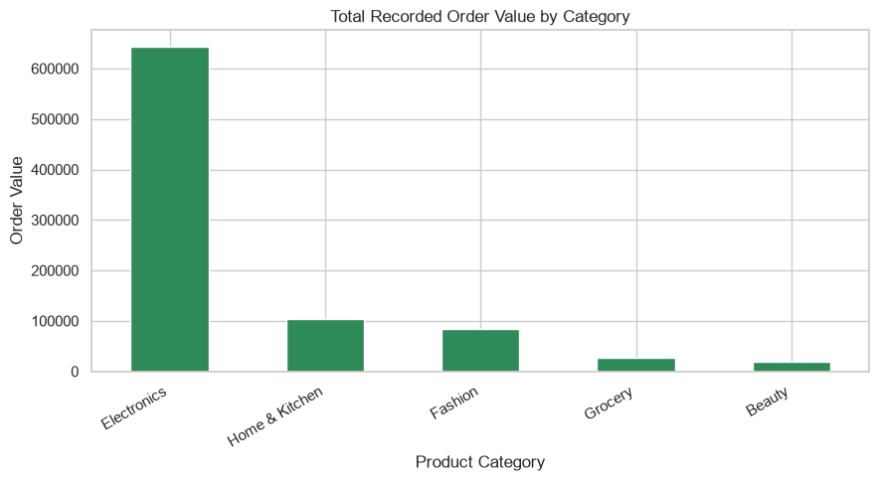
Electronics | 643500
Home & Kitchen | 104400
Fashion | 83400
Grocery | 27900
Beauty | 19100

3.4. Inventory and warehouse analysis
Inventory performance was assessed by comparing recorded inventory levels with reorder thresholds across five warehouses: Bangalore, Chennai, Delhi, Hyderabad, and Mumbai.
inventory = analysis.dropna(
subset=["Inventory_Level", "Reorder_Level"]
).copy()
warehouse_summary = inventory.groupby("Warehouse").agg(
Average_Inventory=("Inventory_Level", "mean"),
Average_Reorder_Level=("Reorder_Level", "mean"),
Number_of_Records=("Order_ID", "nunique"),
Reorder_Alerts=("Reorder_Alert", "sum"),
Stockout_Records=("Stockout", "sum"))
warehouse_summary["Reorder_Alert_Rate_Pct"] = (
inventory.groupby("Warehouse")["Reorder_Alert"].mean() * 100)
print("WAREHOUSE INVENTORY ANALYSIS")
display(warehouse_summary.round(2))
warehouse_summary["Average_Inventory"].plot(
kind="bar", color="darkorange")
plt.title("Average Recorded Inventory by Warehouse")
plt.xlabel("Warehouse")
plt.ylabel("Average Inventory Units")
plt.xticks(rotation=30, ha="right")
plt.tight_layout()
plt.savefig(output_dir / "03_warehouse_inventory.png", dpi=300)
plt.show()
Warehouse Inventory Findings
Warehouse | Average Inventory | Reorder Alert Rate
Bangalore | 28.76 units | 52.94%
Chennai | 27.67 units | 58.33%
Delhi | 37.93 units | 73.33%
Hyderabad | 28.58 units | 66.67%
Mumbai | 25.23 units | 92.31%

Mumbai recorded the highest reorder alert rate at 92.31%, indicating that most observed records for this warehouse had inventory at or below the corresponding reorder threshold. Delhi also showed a high alert rate of 73.33%.
Bangalore recorded the lowest reorder alert rate at 52.94%. Delhi had the highest average recorded inventory level, while Mumbai had the lowest.
Across the 69 records with available inventory information, 47 records were at or below their reorder levels, representing approximately 68.12% of the records assessed.
No recorded stockout was identified because none of the available inventory levels was zero or negative.
Business Implications
- Mumbai should be prioritized for inventory replenishment review.
- Delhi requires a detailed assessment of product-level stock distribution because a relatively high average inventory coexists with a high reorder alert rate.
- Reorder policies should be reviewed against actual product demand, supplier lead times, and safety stock requirements.
- Inventory should be analysed at the product and warehouse level before transferring stock or increasing purchase quantities.
The absence of recorded stockouts does not necessarily mean that stockouts never occur. The dataset only provides inventory snapshots associated with order records and may not capture stockouts between observations.

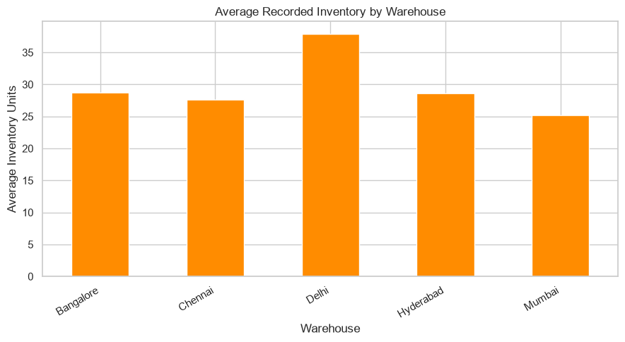

#Stockout and replenishment analysis
print(
"Records at or below reorder level:",
int(inventory["Reorder_Alert"].sum()))
print(
"Reorder alert rate (%):",
round(inventory["Reorder_Alert"].mean() * 100, 2))
print(
"Records with zero or negative inventory:",
int(inventory["Stockout"].sum()))
print(
"Recorded stockout rate (%):",
round(inventory["Stockout"].mean() * 100, 2))
alert_by_warehouse = (
inventory.groupby("Warehouse")["Reorder_Alert"]
.mean()
.mul(100)
.sort_values(ascending=False))
print("REORDER ALERT RATE BY WAREHOUSE (%)")
display(alert_by_warehouse.round(2))
alert_by_warehouse.plot(
kind="bar", color="tomato")

plt.title("Reorder Alert Rate by Warehouse")
plt.xlabel("Warehouse")
plt.ylabel("Records at or Below Reorder Level (%)")
plt.xticks(rotation=30, ha="right")
plt.tight_layout()
plt.savefig(output_dir / "04_reorder_alerts.png", dpi=300)
plt.show()
Output:
Records at or below reorder level: 47
Reorder alert rate (%): 68.12
Records with zero or negative inventory: 0
Recorded stockout rate (%): 0.0
REORDER ALERT RATE BY WAREHOUSE (%)
Warehouse  Mumbai 92.31  Delhi 73.33  Hyderabad 66.67  Chennai 58.33  Bangalore 52.94  Name: Reorder_Alert, dtype: float64 | 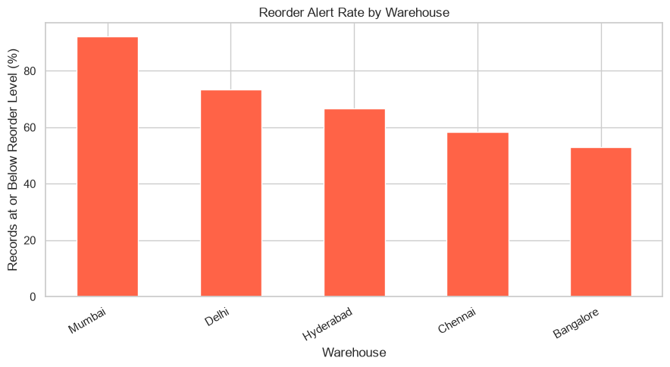

#3.5. Delivery performance by delivery partner
Delivery performance was evaluated by comparing actual delivery durations with expected delivery durations for each shipment. Records with invalid delivery durations were excluded.
Delivery Partner Performance
Delivery Partner | Shipments Analysed | Average Delivery Time | Late Shipments | Late Rate
BlueDart | 23 | 3.04 days | 3 | 13.04%
Delivery | 22 | 2.73 days | 3 | 13.64%
Ecom Express | 23 | 4.26 days | 9 | 39.13%

The delivery analysis shows differences in delivery speed and punctuality among the three partners.
Delivery recorded the shortest average delivery time at 2.73 days, while BlueDart recorded a slightly higher average of 3.04 days. Ecom Express had the longest average delivery time at 4.26 days and the highest late-delivery rate at 39.13%.
Across the 68 valid delivery observations, 15 shipments were late, producing an overall late-delivery rate of approximately 22.06%.
Business Implications
- Ecom Express should be reviewed to identify the causes of longer delivery times and late shipments.
- BlueDart and Delivery provide useful benchmarks for comparing delivery performance.
- Delivery partner selection should consider reliability, cost, service coverage, and shipment characteristics rather than speed alone.
- Regular monitoring of on-time delivery rates can help identify recurring delays and improve customer satisfaction.
The findings indicate an association between delivery partner and observed performance. They do not establish that the delivery partner alone caused the delays, because shipment distances, destinations, product types, and other operational factors were not controlled for.
delivery = analysis.dropna(
subset=["Delivery_Days_Valid", "Expected_Days", "Delivery_Partner"]).copy()
delivery["Late"] = (
delivery["Delivery_Days_Valid"] > delivery["Expected_Days"])
delivery_summary = delivery.groupby(
"Delivery_Partner"
).agg(
Shipment_Count=("Order_ID", "nunique"),
Average_Delivery_Days=("Delivery_Days_Valid", "mean"),
Median_Delivery_Days=("Delivery_Days_Valid", "median"),
Late_Shipments=("Late", "sum"),
Late_Rate=("Late", "mean"))
delivery_summary["Late_Rate_Pct"] = (
delivery_summary["Late_Rate"] * 100)
print("DELIVERY PARTNER PERFORMANCE")
display(delivery_summary.round(2))
delivery_summary["Average_Delivery_Days"].plot(
kind="bar", color="cornflowerblue")
plt.title("Average Delivery Time by Delivery Partner")
plt.xlabel("Delivery Partner")
plt.ylabel("Average Delivery Days")
plt.xticks(rotation=30, ha="right")
plt.tight_layout()
plt.savefig(output_dir / "05_delivery_performance.png", dpi=300)
plt.show()
delivery_summary["Late_Rate_Pct"].plot(
kind="bar", color="indianred")
plt.title("Late Delivery Rate by Delivery Partner")
plt.xlabel("Delivery Partner")
plt.ylabel("Late Delivery Rate (%)")
plt.xticks(rotation=30, ha="right")
plt.tight_layout()
plt.savefig(output_dir / "06_late_delivery_rate.png", dpi=300)
plt.show()

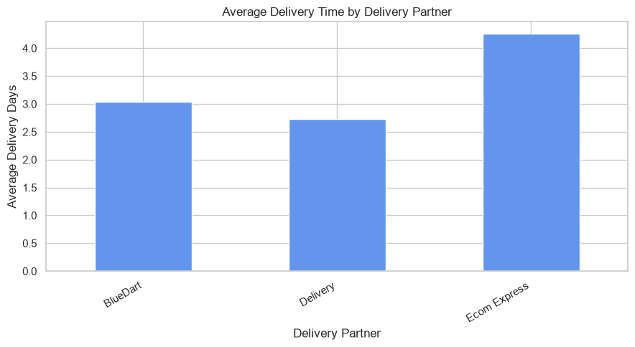 | 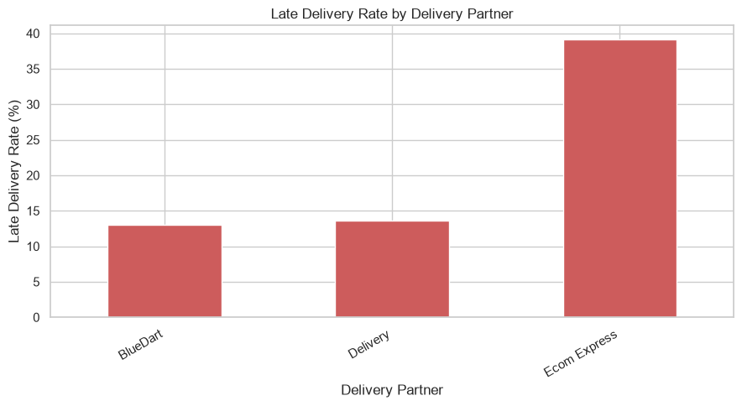

#3.6. Shipping cost analysis
Shipping cost analysis was conducted to compare average costs, median costs, total recorded costs, and the distribution of shipping expenses across delivery partners.
Shipping Cost Findings
Delivery Partner | Shipments with Cost Data | Average Shipping Cost | Median Shipping Cost | Total Recorded Shipping Cost
BlueDart | 23 | ₹331.09 | ₹210 | ₹7,615
Delivery | 23 | ₹1,330.00 | ₹190 | ₹30,590
Ecom Express | 23 | ₹339.35 | ₹350 | ₹7,805

The recorded shipping costs show that Delivery has a much higher average cost than the other partners. However, its median cost is only ₹190, suggesting that the average is strongly affected by an unusually expensive shipment.
Order ORD1031 recorded a shipping cost of ₹25,000, making it a significant potential outlier. This value should be verified against the original shipment invoice or logistics records before any correction is made.
When this observation is excluded, the average shipping cost for Delivery across its remaining 22 cost records would be approximately ₹254.09. This illustrates how a single extreme value can distort the overall average.
Business Implications
- The ₹25,000 shipping charge should be investigated before drawing conclusions about the normal cost of the Delivery partner.
- Median shipping costs should be considered alongside averages when comparing logistics providers.
- Shipping costs should be evaluated against shipment weight, package dimensions, distance, service type, and delivery time.
- Cost-control decisions should be based on validated charges and comparable shipment characteristics.
The current dataset does not establish that faster shipping necessarily costs more. A broader dataset containing service levels and shipment characteristics would be required to assess that relationship reliably.
cost_data = analysis.dropna(
subset=["Shipping_Cost", "Delivery_Partner"]).copy()
cost_summary = cost_data.groupby("Delivery_Partner").agg(
Shipment_Count=("Order_ID", "count"),
Average_Shipping_Cost=("Shipping_Cost", "mean"),
Median_Shipping_Cost=("Shipping_Cost", "median"),
Total_Shipping_Cost=("Shipping_Cost", "sum"))
print("SHIPPING COST SUMMARY")
display(cost_summary.round(2))
sns.boxplot(data=cost_data, x="Delivery_Partner",y="Shipping_Cost")
plt.title("Shipping Cost Distribution by Delivery Partner")
plt.xlabel("Delivery Partner")
plt.ylabel("Shipping Cost")
plt.xticks(rotation=30, ha="right")
plt.tight_layout()
plt.savefig(output_dir / "07_shipping_cost_distribution.png", dpi=300)
plt.show()
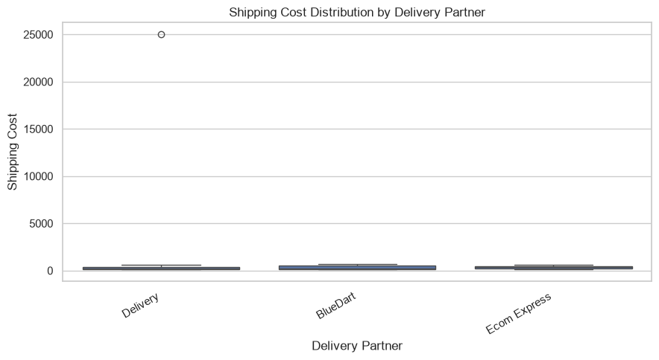
# IQR-based outlier investigation
cost = cost_data["Shipping_Cost"]
q1 = cost.quantile(0.25)
q3 = cost.quantile(0.75)
iqr = q3 - q1
outliers = cost_data[
(cost_data["Shipping_Cost"] < q1 - 1.5 * iqr)
| (cost_data["Shipping_Cost"] > q3 + 1.5 * iqr)]
print("POTENTIAL SHIPPING COST OUTLIERS")
display(
outliers[["Order_ID", "Shipping_Cost", "Delivery_Partner"]])

Output:
POTENTIAL SHIPPING COST OUTLIERS
 | Order_ID | Shipping_Cost | Delivery_Partner
31 | ORD1031 | 25000.0 | Delivery

#Delivery time versus shipping cost | 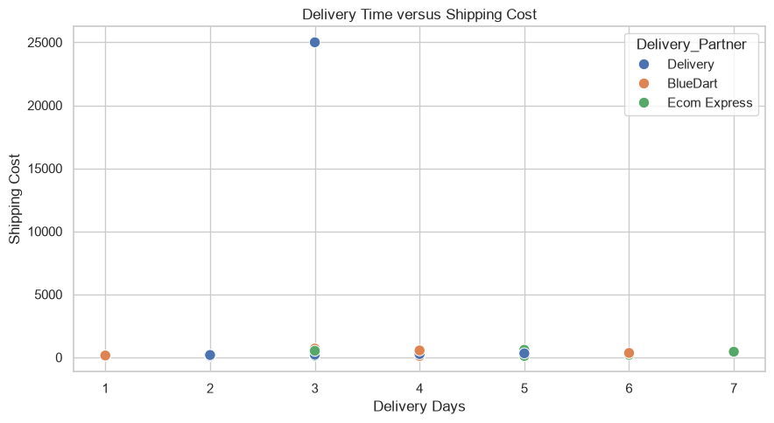
relationship_data = analysis.dropna(
subset=["Delivery_Days_Valid", "Shipping_Cost",
"Delivery_Partner"])
sns.scatterplot(
data=relationship_data,
x="Delivery_Days_Valid",
y="Shipping_Cost",
hue="Delivery_Partner",
s=80)
plt.title("Delivery Time versus Shipping Cost")
plt.xlabel("Delivery Days")
plt.ylabel("Shipping Cost")
plt.tight_layout()
plt.savefig(output_dir / "08_delivery_vs_shipping_cost.png", dpi=300)
plt.show()
correlation = relationship_data[
["Delivery_Days_Valid", "Shipping_Cost"]
].corr().iloc[0, 1]
print("Delivery time and shipping cost correlation:",
round(correlation, 3))

#Monthly order value trend
monthly_order_value = (
analysis.dropna(subset=["Order_Date"])
.groupby(analysis["Order_Date"].dt.to_period("M"))["Order_Value"].sum())
print("MONTHLY RECORDED ORDER VALUE")
display(monthly_order_value.to_frame("Order_Value"))
monthly_order_value.index = monthly_order_value.index.astype(str)
monthly_order_value.plot(
marker="o", linewidth=2, color="purple")
plt.title("Monthly Recorded Order Value")
plt.xlabel("Month")
plt.ylabel("Total Order Value")
plt.tight_layout()
plt.savefig(output_dir / "09_monthly_order_value.png", dpi=300)
plt.show()
Output:
MONTHLY RECORDED ORDER VALUE | 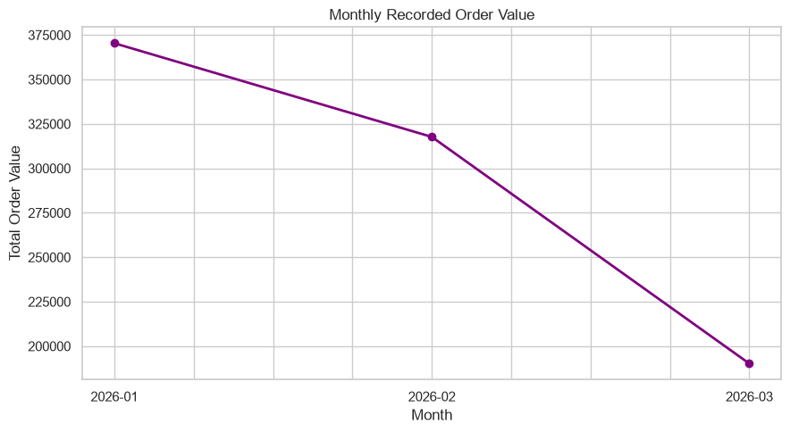

Order_Date  2026-01 | Order_Value  370400
2026-02 | 317700
2026-03 | 190200

#Correlation heatmap
correlation_columns = [
"Order_Value",
"Shipping_Cost",
"Delivery_Days_Valid",
"Expected_Days",
"Customer_Rating",
"Inventory_Level",
"Reorder_Level"
]

correlation_matrix = analysis[
correlation_columns
].corr()
print("CORRELATION MATRIX")
display(correlation_matrix.round(2))

plt.figure(figsize=(10, 7))

sns.heatmap(
correlation_matrix,
annot=True,
cmap="coolwarm",
vmin=-1,
vmax=1,
fmt=".2f",
linewidths=0.5)
plt.title("Correlation Matrix of Logistics KPIs")
plt.tight_layout()
plt.savefig(output_dir / "10_correlation_heatmap.png", dpi=300)
plt.show()
Output:
CORRELATION MATRIX
 | Order_Value | Shipping_Cost | Delivery_Days_Valid | Expected_Days | Customer_Rating | Inventory_Level | Reorder_Level
Order_Value | 1.00 | 0.11 | 0.21 | 0.32 | 0.15 | -0.04 | -0.03
Shipping_Cost | 0.11 | 1.00 | -0.01 | 0.09 | 0.13 | -0.05 | -0.07
Delivery_Days_Valid | 0.21 | -0.01 | 1.00 | 0.79 | -0.74 | 0.16 | 0.14
Expected_Days | 0.32 | 0.09 | 0.79 | 1.00 | -0.43 | 0.13 | 0.12
Customer_Rating | 0.15 | 0.13 | -0.74 | -0.43 | 1.00 | -0.03 | 0.00
Inventory_Level | -0.04 | -0.05 | 0.16 | 0.13 | -0.03 | 1.00 | 0.75
Reorder_Level | -0.03 | -0.07 | 0.14 | 0.12 | 0.00 | 0.75 | 1.00

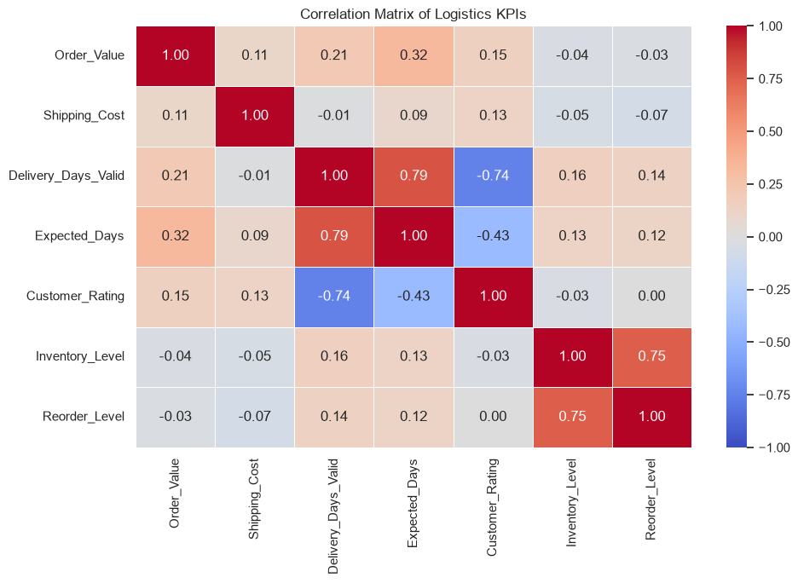
#Final KPI summary
late_rate = delivery["Late"].mean() * 100

kpis = pd.DataFrame({
"Metric": [
"Unique Orders",
"Total Recorded Order Value",
"Average Shipping Cost",
"Average Positive Delivery Days",
"Late Delivery Rate (%)",
"Average Customer Rating",

"Reorder Alert Rate (%)",  "Recorded Stockout Rate (%)"],  "Value": [  analysis["Order_ID"].nunique(),  analysis["Order_Value"].sum(),  analysis["Shipping_Cost"].mean(),  analysis["Delivery_Days_Valid"].mean(),  late_rate,  analysis["Customer_Rating"].mean(),  inventory["Reorder_Alert"].mean() * 100,  inventory["Stockout"].mean() * 100]})  print("WEEK 3 LOGISTICS KPI SUMMARY")  display(kpis.round(2))  kpis.to_csv(output_dir / "week3_kpi_summary.csv", index=False)  print("Charts and KPI summary saved in:", output_dir.resolve()) | 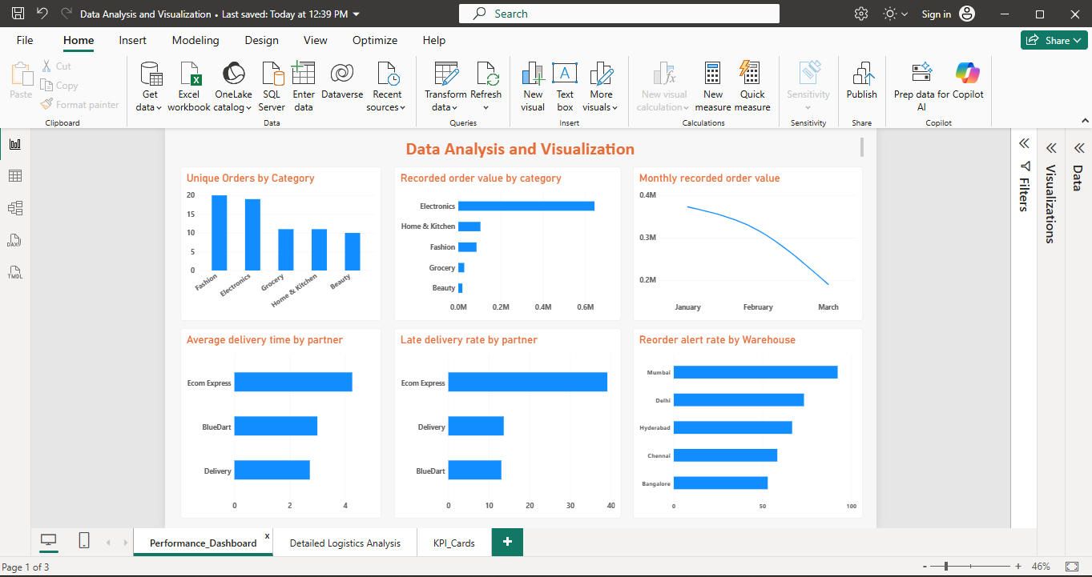

WEEK 3 LOGISTICS KPI SUMMARY
 | Metric | Value |  | Metric | Value
0 | Unique Orders | 70.00 | 4 | Late Delivery Rate (%) | 22.06
1 | Total Recorded Order Value | 878300.00 | 5 | Average Customer Rating | 4.04
2 | Average Shipping Cost | 666.81 | 6 | Reorder Alert Rate (%) | 68.12
3 | Average Positive Delivery Days | 3.35 | 7 | Recorded Stockout Rate (%) | 0.00

3.7. Expected Insights
Power BI Visualization and Business Decision-Making
Power BI can transform the Week 3 logistics dataset into an interactive dashboard for monitoring order value, product demand, inventory replenishment, delivery performance, and transportation costs.
The category analysis shows that Electronics recorded ₹6,43,500 in order value, representing approximately 73.3% of the total recorded order value. This highlights the financial importance of Electronics inventory planning.
Delivery performance analysis identifies Ecom Express as an area requiring investigation, with an average delivery time of 4.26 days and a late-delivery rate of 39.13%. The warehouse analysis also identifies Mumbai as a priority for replenishment review because 92.31% of assessed inventory records were at or below their reorder thresholds.
The shipping-cost analysis requires special attention because order ORD1031 contains a recorded shipping charge of ₹25,000. This observation substantially increases the average shipping cost and should be verified against the original invoice.
The monthly trend shows that recorded order value decreased from ₹3,70,400 in January to ₹1,90,200 in March 2026. Further analysis is required to determine whether this reflects a genuine reduction in demand or incomplete observation periods.
Overall, the Power BI dashboard supports data-driven decisions by highlighting operational risks, identifying areas for further investigation, and making performance indicators easier to compare. The results should be interpreted alongside the dataset's limitations, including its small sample size, missing values, and anomalous records.
The analysis may reveal:
- High-demand products require greater inventory availability.
- Some products may remain in warehouses for long periods.
- Certain warehouses may have excess inventory.
- Express shipping may provide faster delivery but at a higher cost.
- Certain locations may experience longer delivery times.
- Demand may increase during particular months or seasons.
These findings should be confirmed using the actual dataset.
3.8. Conclusion
Week 3 converts the cleaned e-commerce dataset into meaningful business insights using statistical analysis and visualization.
