HW-2

Team Member:

Lakshmi Sankari Vissapragada(G01481312) - lvissapr@gmu.edu

Building Docker image

  - Create Dockerfile in HW1 folder

FROM nginx:alpine
COPY . /usr/share/nginx/html

EXPOSE 80
Open terminal and perform the below operations:

  - Check Docker running status using below commands
docker --version
docker ps

  - Now login to docker hub from terminal using below command
docker login

  - Build the Docker image using below command
docker build -t sankari1205/swe645-hw2:latest .

  - Now push the above built docker image to Docker Hub using below command
docker push sankari1205/swe645-hw2:latest
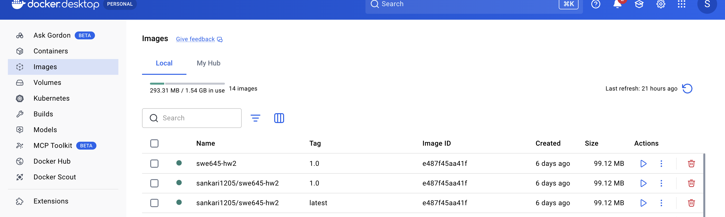

Rancher setup

Install Docker on Rancher instance in ec2

Launch EC2 instance
  - AMI: Ubuntu Server 20.04 LTS (or newer)
  - Type: t2.large (or better)
  - Storage: ≥30 GB

Security Group inbound rules:
- 22 (SSH)
- 80 (HTTP)
- 443 (HTTPS)
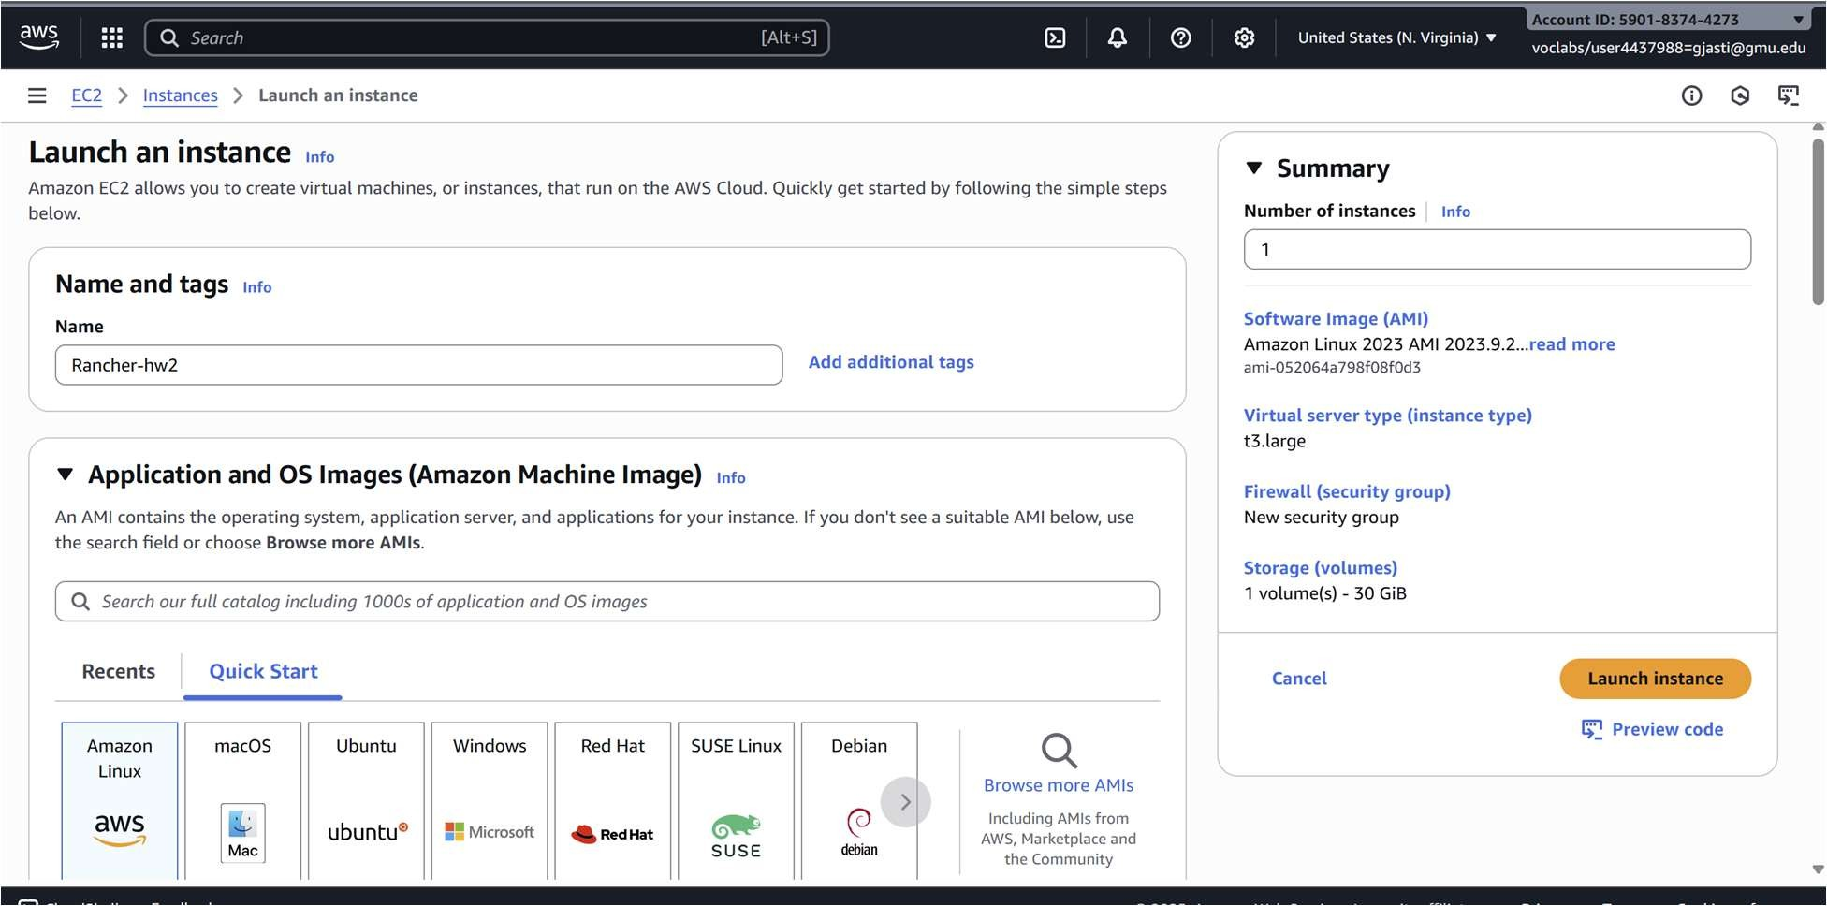

Now, Install Docker on Rancher instance in ec2 sudo apt-get update
sudo apt-get upgrade -y

sudo apt-get install docker.io -y sudo systemctl enable docker sudo systemctl start docker

Run Rancher in Docker

sudo docker run -d --restart=unless-stopped \
-p 80:80 -p 443:443 \
--privileged rancher/rancher:stable

Access Rancher UI

- Open browser → https:// 98.89.70.148
- Accept SSL warning → login page
- Run the password retrieval command shown in UI:
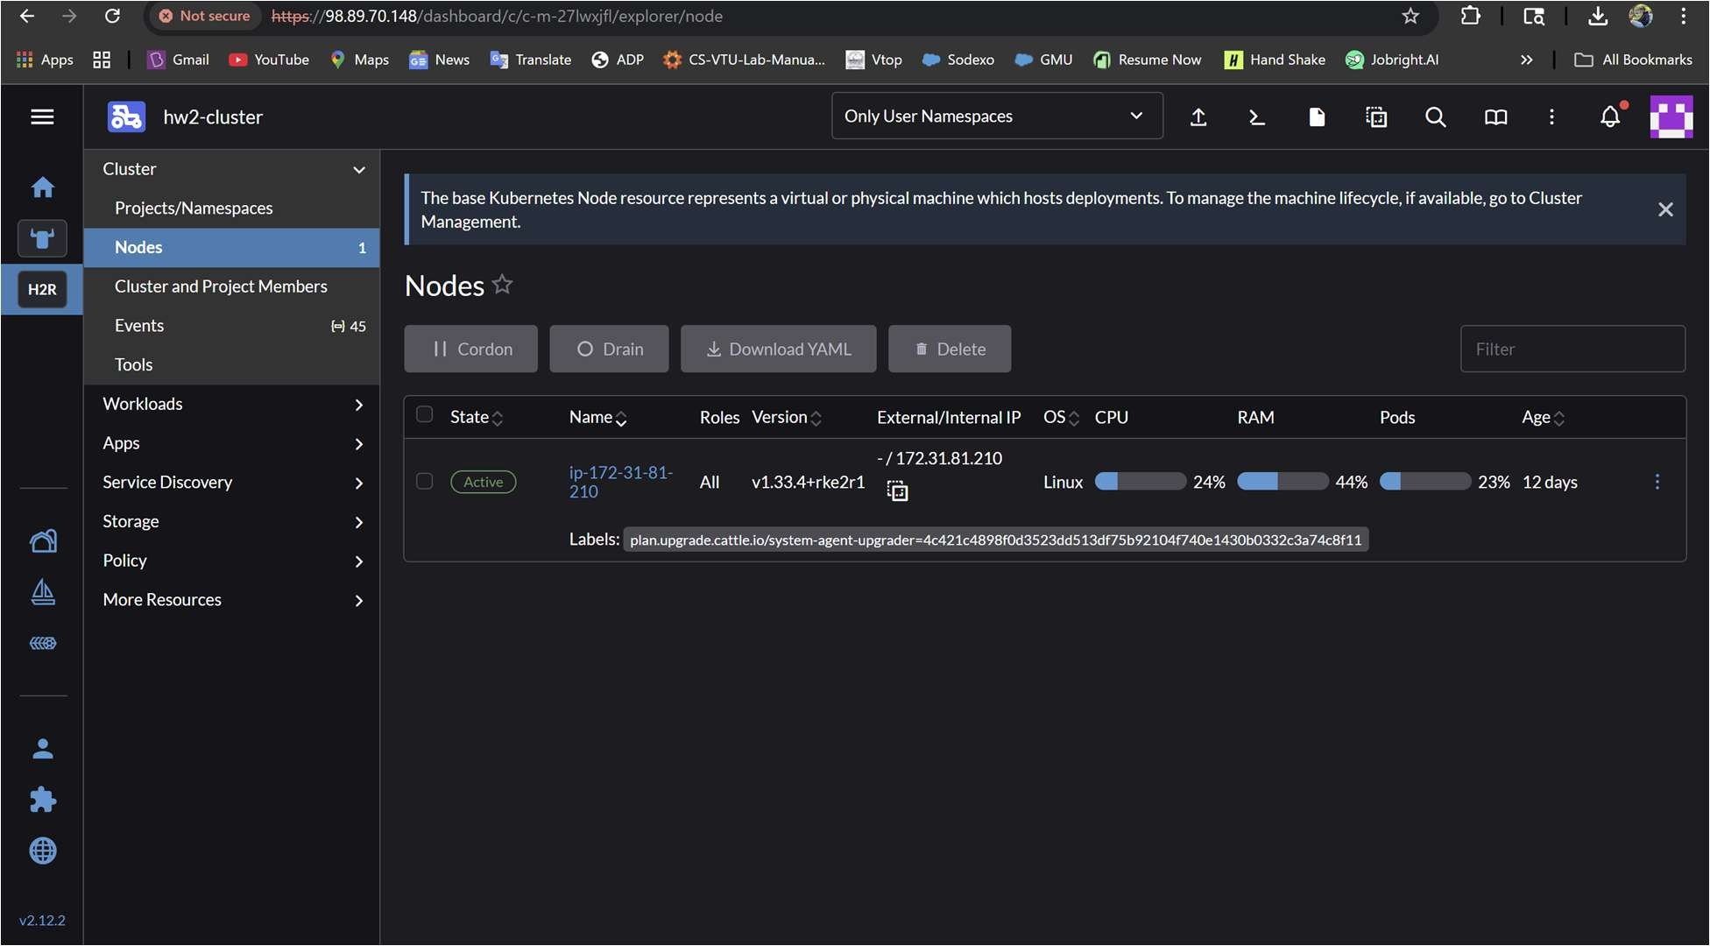
sudo docker logs <container_id> 2>C1 | grep "Bootstrap Password" Use password → set your own admin password.

Create Kubernetes Cluster in Rancher
  - In Rancher: menu → Cluster Management → Create.
  - Choose Custom (RKE2).
  - Enter cluster name (e.g., hw2-cluster).

Select All roles (etcd, Control Plane, Worker).
  - Copy the registration command shown by Rancher.
  - Run it on the Rancher EC2 VM:
curl --insecure -fL https://98.89.70.148/system-agent-install.sh | sudo sh -s - -- server https://98.89.70.148 --label 'cattle.io/os=linux' --token z2lbsktjbrsqggvdk4nl2h8stj85xfv5cvb775w6mrvth5pv6mtmxl --ca-checksum dcc0c9a7651c102f036acd0610c42f04c999ac03b4a1dca554771090f5cccc26 -- etcd --controlplane –worker
- Configure Deployment Files for Kubernetes kubectl apply -f hw1-deployment.yaml kubectl apply -f hw1-service.yaml

Sanity check for pods
kubectl get pods kubectl get deployments kubectl get svc

Access the App
http://98.89.70.148:30080/
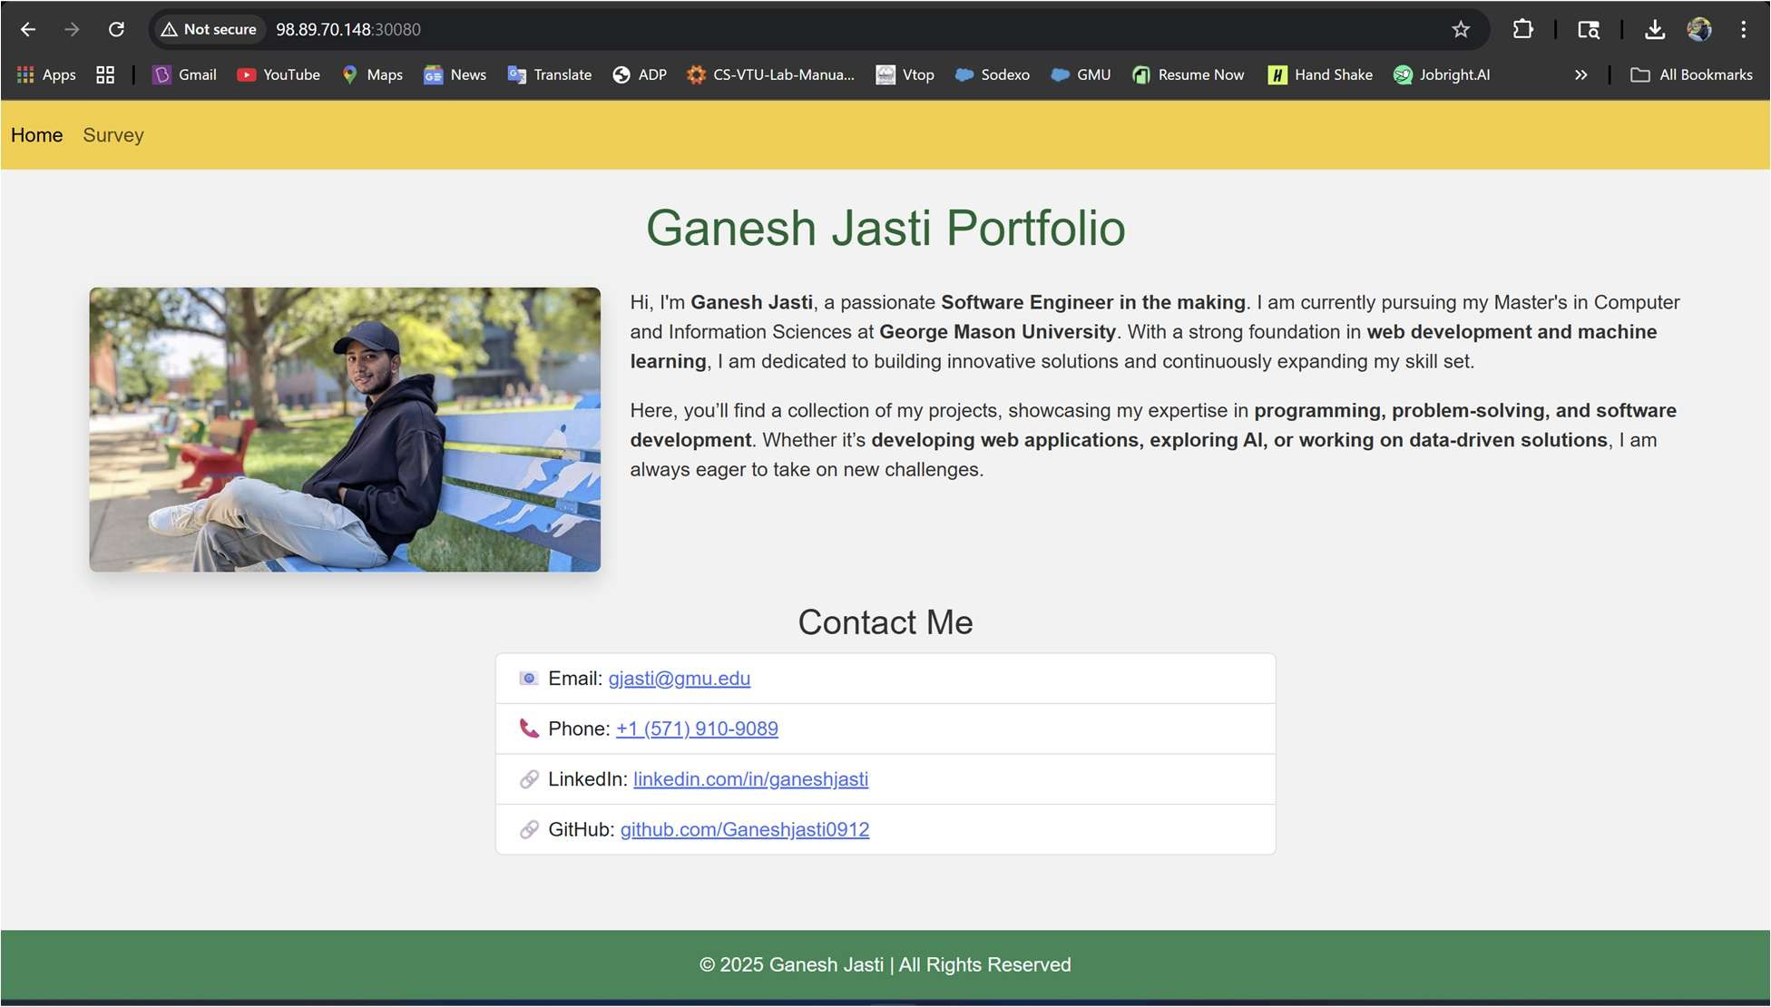

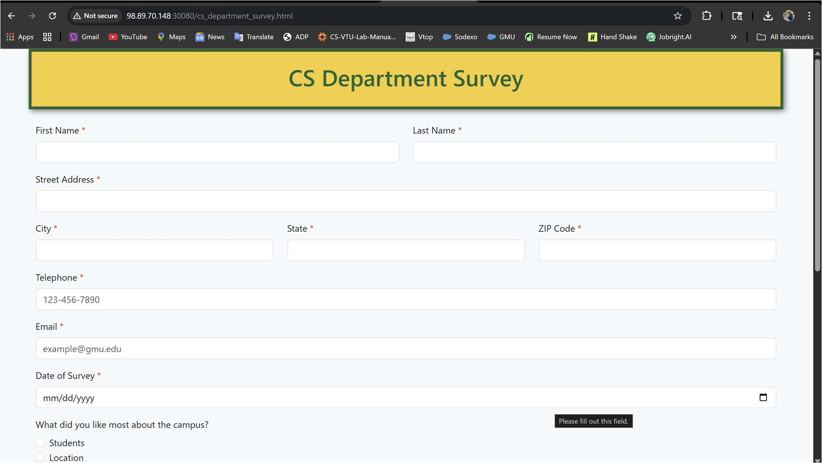

Connect Jenkins EC2 with Rancher Kubernetes Cluster
First setup Jenkins instance in ec2 and launch it,

Download KubeConfig from Rancher
  - Go to Rancher UI: https://98.89.70.148
  - Navigate to:

Cluster Management → Clusters
  - Click the three-dot menu next to your cluster → Download KubeConfig
  - Save the file as config

Copy KubeConfig to Jenkins Home
sudo su -
mkdir -p /var/lib/jenkins/.kube
cp /root/config /var/lib/jenkins/.kube/config chown -R jenkins:jenkins /var/lib/jenkins/.kube

Switch to Jenkins User G Verify Access

sudo su - jenkins
export KUBECONFIG=/var/lib/jenkins/.kube/config kubectl get nodes

Update Jenkins Pipeline to Use KubeConfig
environment {
IMAGE_NAME = "ganesh0912/student-survey" KUBECONFIG = "/var/lib/jenkins/.kube/config"
}

Setup Jenkins CI/CD Pipeline
We now set up a Jenkins pipeline that:
- Clones the GitHub repo
- Builds the Docker image
- Pushes to Docker Hub
- Deploys to Kubernetes using kubectl

- Add Docker Hub Credentials
  - Go to: Jenkins → Manage Jenkins → Credentials → (Global) → Add Credentials
  - Type: Username and Password
  - ID: docker-hub-creds
  - Username: ganeshjasti0912
  - Password: *****

Install Required Plugins
  - GitHub Integration
  - Docker Pipeline
  - Kubernetes CLI (kubectl) Plugin

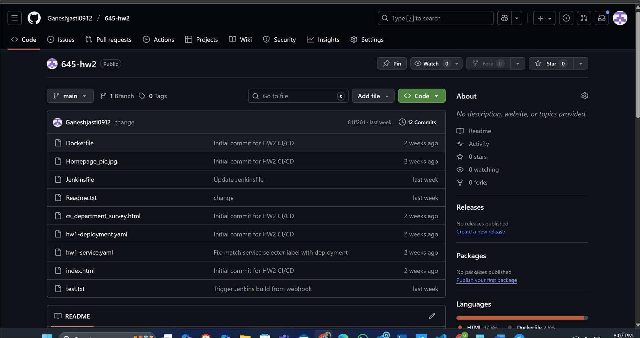
Configure GitHub Webhook
  - Go to your GitHub repo → Settings → Webhooks → Add webhook
  - Payload URL: http://52.6.142.204:8080
  - Content type: application/json
  - Event trigger: Just the push event
You must allow port 8080 in your EC2 Security Group.

G. Configure Jenkins Pipeline Job
- Go to Jenkins → New Item → Choose Pipeline
- Name: hw2-pipeline
- Select "Pipeline script from SCM"
- SCM: Git
- Repository URL:
https://github.com/Ganeshjasti0912/645-hw2.git
- Branch: main
- Script Path: Jenkinsfile

Test the Pipeline
Push a new change to your GitHub repo:
  - git add .
  - git commit -m "trigger build"
  - git push origin main
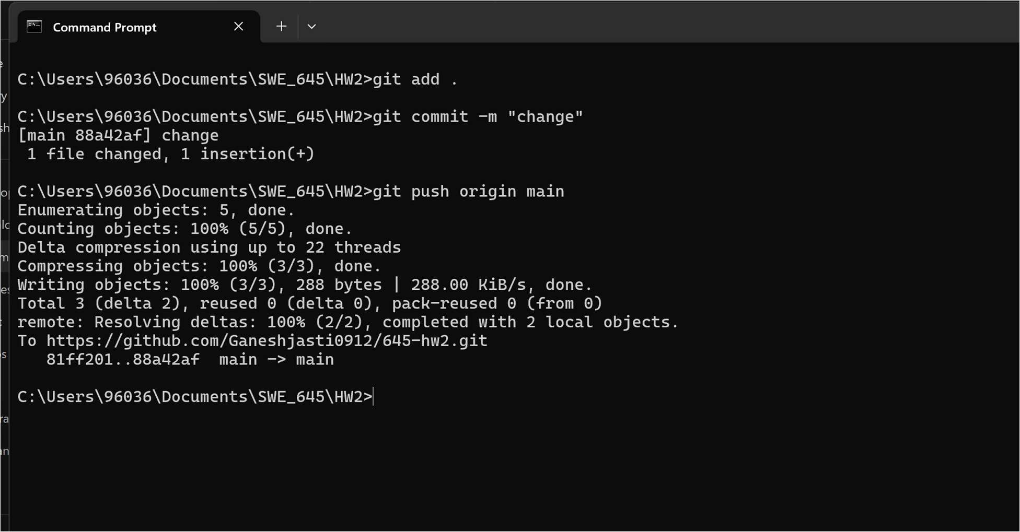

Jenkins will automatically trigger:
- Build Docker image
- Push to Docker Hub
- Deploy to Kubernetes via kubectl apply

