**SOFTWARE REQUIREMENT SPECIFICATION FOR**

**SPECIAL LAB PORTAL**

**STUDENT NAME :** Sivasankari S

**ROLL NO :** 7376221SE149

**SEAT NO :**  94

**PROJECT ID :** 14

**PROBLEM STATEMENT :** Special Lab Portal

1. **Introduction:**

**1.1. Purpose:**

The purpose of this document is to present a detailed description of the Special Lab Portal. It will explain the purpose and features of the system, the interfaces of the system, what the system will do, the constraints under which it must operate and how the system will react to external stimuli.

* 1. **Scope of Project:**
* This software system will serve as a portal for the Special Lab, enabling students to select their special lab and to track their achievement and targets. From an administrative perspective, this system will provide a **details of students from various special lab about their achievements, targets and their active participation**.

* Faculty have the ability to select or reject students for their special lab. Once the student is selected he/she will be the member of respective special lab, where faculty can track the achievements, targets of their special lab students.
* Management have the ability to approve or reject the inactive students list and they can also change a student from inactive to active. Management can also edit the options to the details shown for the registration of the student. They have the ability to change someone to participate in special case.

1. **System Overview:**

**2.1. Users:**

1. **Students:**

They have the ability to submit application for the Special lab

Selection process, upload the relevant details, Schedule slots(date and

time)for selection process, monitor the result of their selection, and view

their own special lab dashboard to track their achievements and targets.

1. **Faculty:**

Approve or reject students in an interview, manage students

active/inactive lists, view and access the analytical dashboard for target

and achievement tracking of students.

1. **Management:**

Review the inactive list, accept or reject the inactive list,

manage special cases, manage registration, manage students from

inactive to active, review documents submitted for special cases.

* 1. **Features:**

1. **Login:**

Students can register for an account or login with their existing account.

1. **Registration:**

Students can input relevant details for registration, can book their slots for selection process. Details of registration and students list will be shared to faculty via mail.

1. **Process Status:**

Result of the selection process will be shared to students via mail,

If they were selected then, both students and faculty can view their own special lab dashboard.

1. **Faculty Access:**

Faculty can view their special lab students dashboard, manage active

and inactive students lists, can raise one as inactive with suitable remarks.

1. **Admin Access:**

Admin can view all special lab details, students list in a category of

either active or inactive, approve or reject the inactive list, manage special

cases and black box students based on the valid reason and their performance.

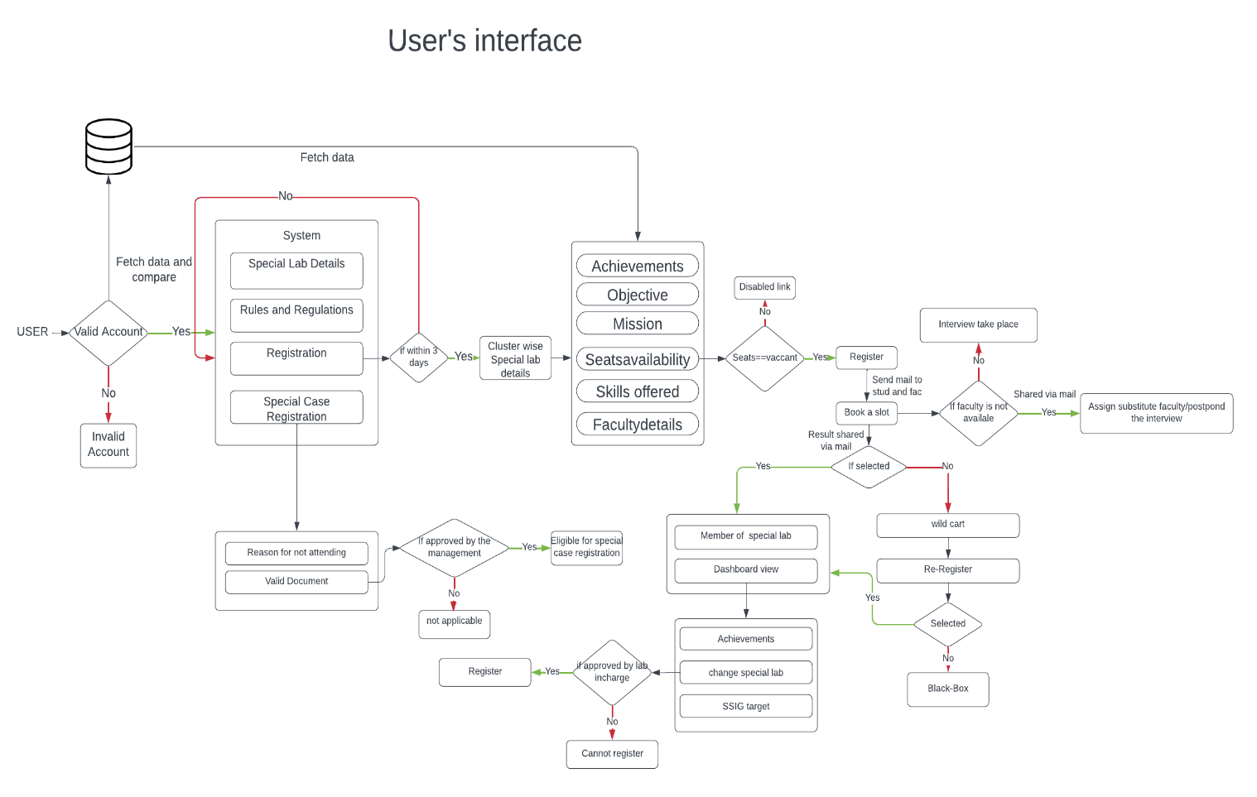

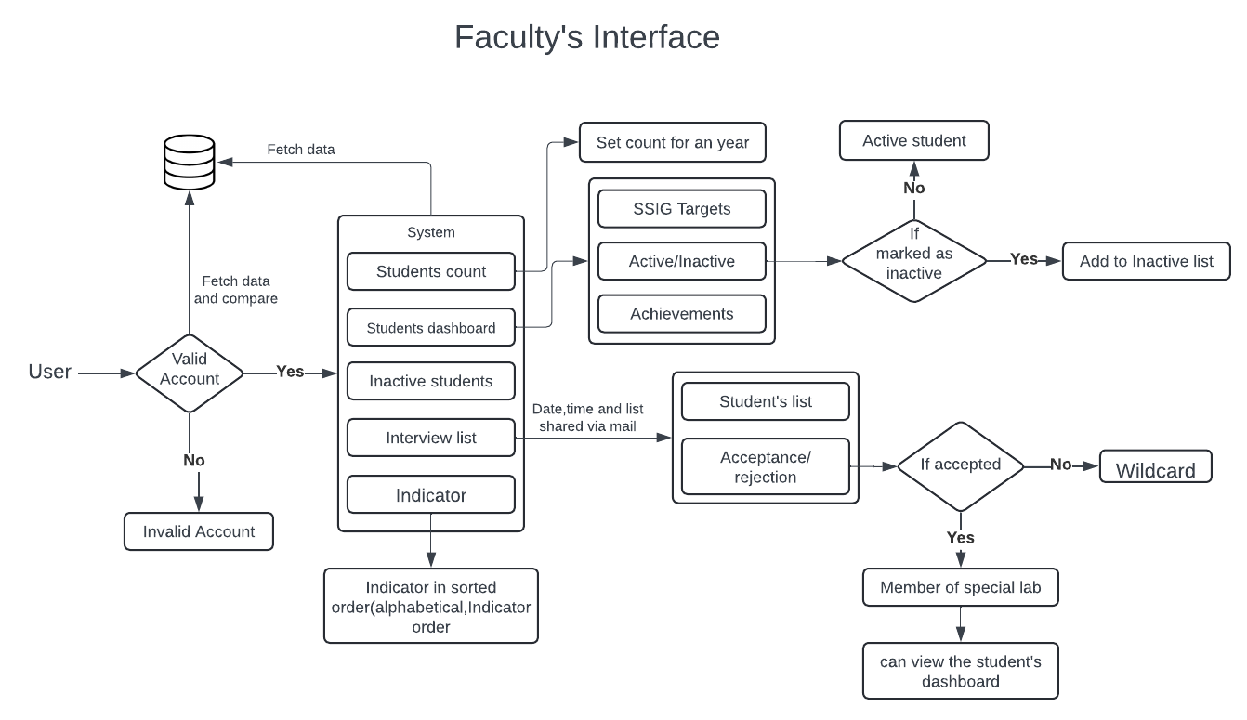

1. 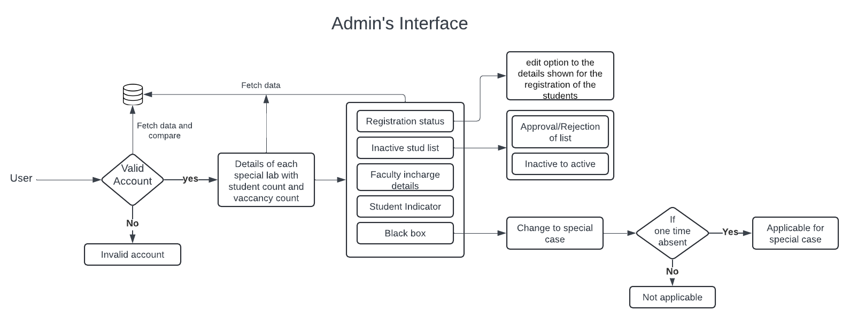**Requirements:**

**3.1. Functional Requiremnets:**

* **User Management:**
* Students can register and login.
* Faculty have access control with an analytical dashboard of students.
* Admins have access control with an analytical dashboard and

dedicated features.

* **Registration:**

* Students can submit their application for selection process with

appropriate details and can select their slots.

* Application form contains:
* Name of the student
* Roll number
* Email
* Year of study
* Reason for applying
* **Process Status:**
* Students selection result shared to individual students via mail.
* If the student is not selected then they can apply for wildcard (within

3days).

* If the student is absent for the interview they will be listed in a black

box and they can request to join twice per semester.

* If there is a valid reason for not attending then they can apply for

special case with management’s approval.

* **Faculty Dashboard:**
* Faculty can view a list of student applied for the selection process.
* Process details (date, time and Student list) is shared to faculty via

mail.

* Faculty can select or reject the students who are all attending the

interview.

* Faculty can raise students as inactive with suitable remarks.
* **Admin’s Dashboard:**

* Admin can review the Inactive list and approve or reject the inactive list.
* Admin can change someone from inactive to active based on their

performance.

* Admin can change someone to participate in special case by approving the valid document.
  1. **Non-Functional Requirements:**
* **Performance:**

The system must respond to user actions within 2 seconds to ensure

efficient usability and must handle a concurrent user load of at least 100 user

without significant performance degradation.

* **Usability:**

The User interface should be intuitive and user-friendly, with clear and

concise error message provided to guide user in case of input errors or system

failures.

* **Scalability:**

The system should be designed to accommodate an increasing number of users and data volume over time, and it should be scalable to support additional features and functionalities as per future requirements.

* **Reliability:**

The system should be available 24/7 with minimal downtime and should

have a backup and recovery mechanism in place to prevent data loss in case of

system failures or crashes.

* **Security:**

User data must be encrypted during transmission and storage, and access to sensitive functionalities should be restricted to authorized admin users through secure authentication mechanisms.

**Stack:**

|  |  |
| --- | --- |
| **COMPONENTS** | **TECH STACK** |
| Front End | * HTML * CSS * JS |
| Back end | * Python * Django(python web) |
| Database | * PostgreSQL * MySQL |
| API | * Open API * SOAP APIs * REST Ful API |

**Prototype of the Project:**

1. 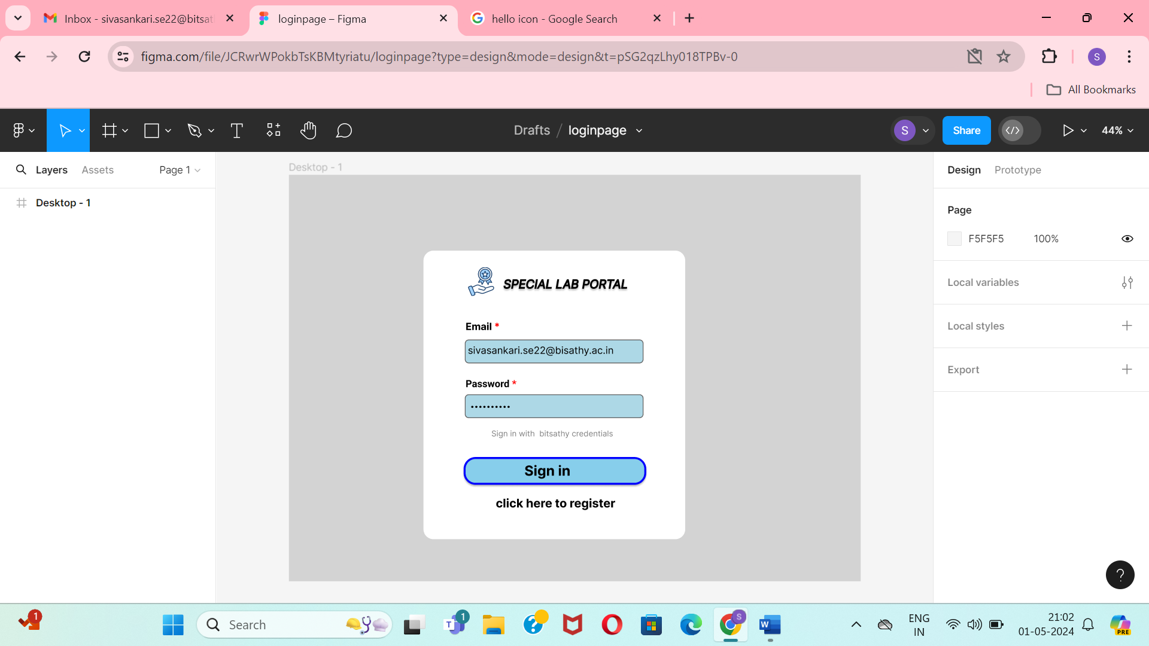Login page
2. Register Form

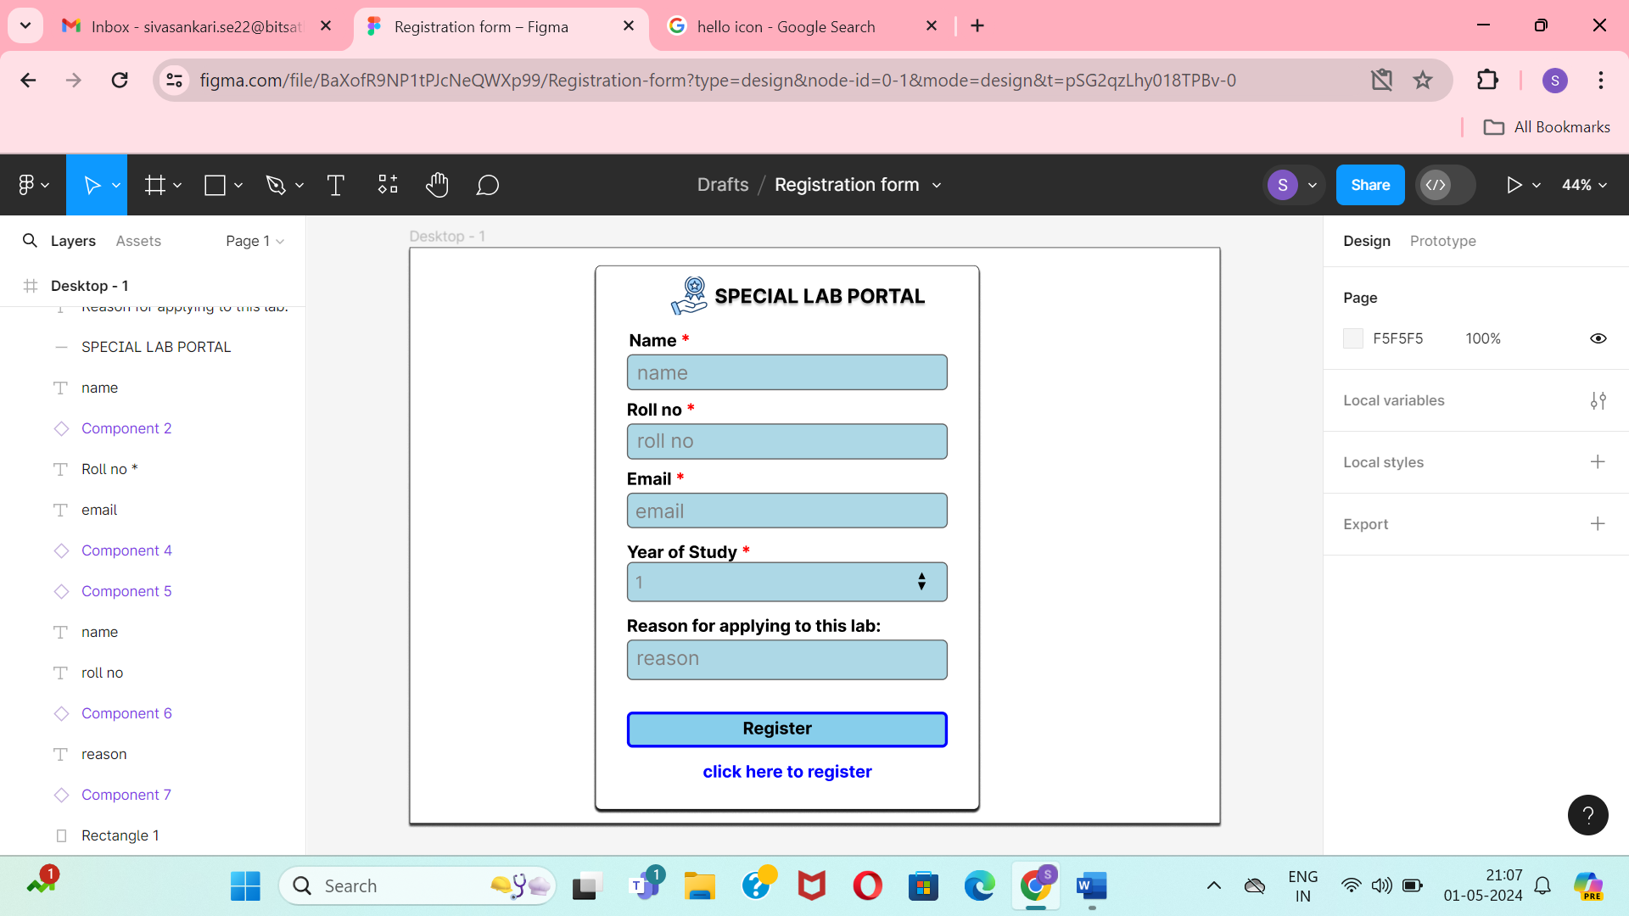

1. 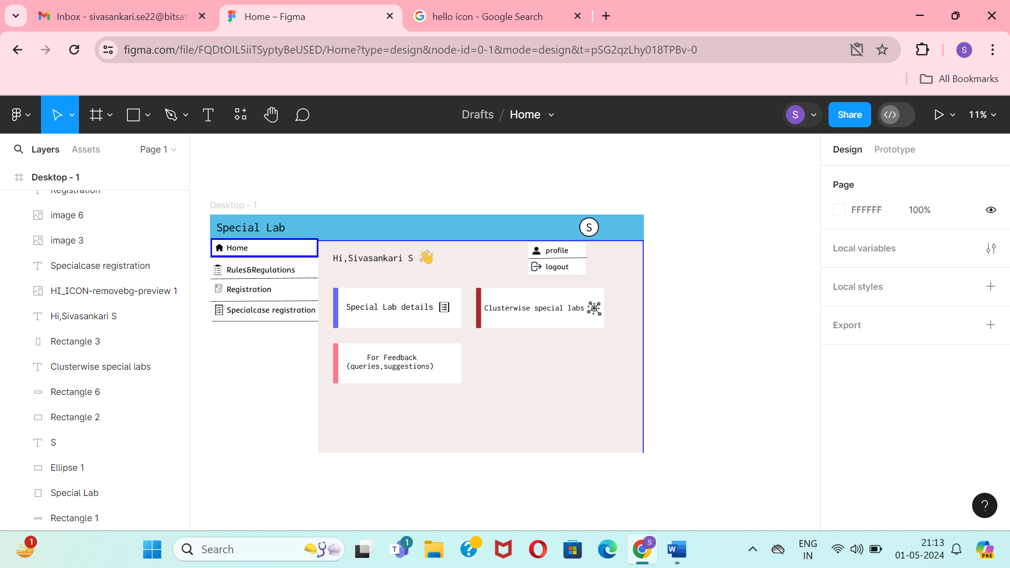Student’s view
2. Special case Registration form

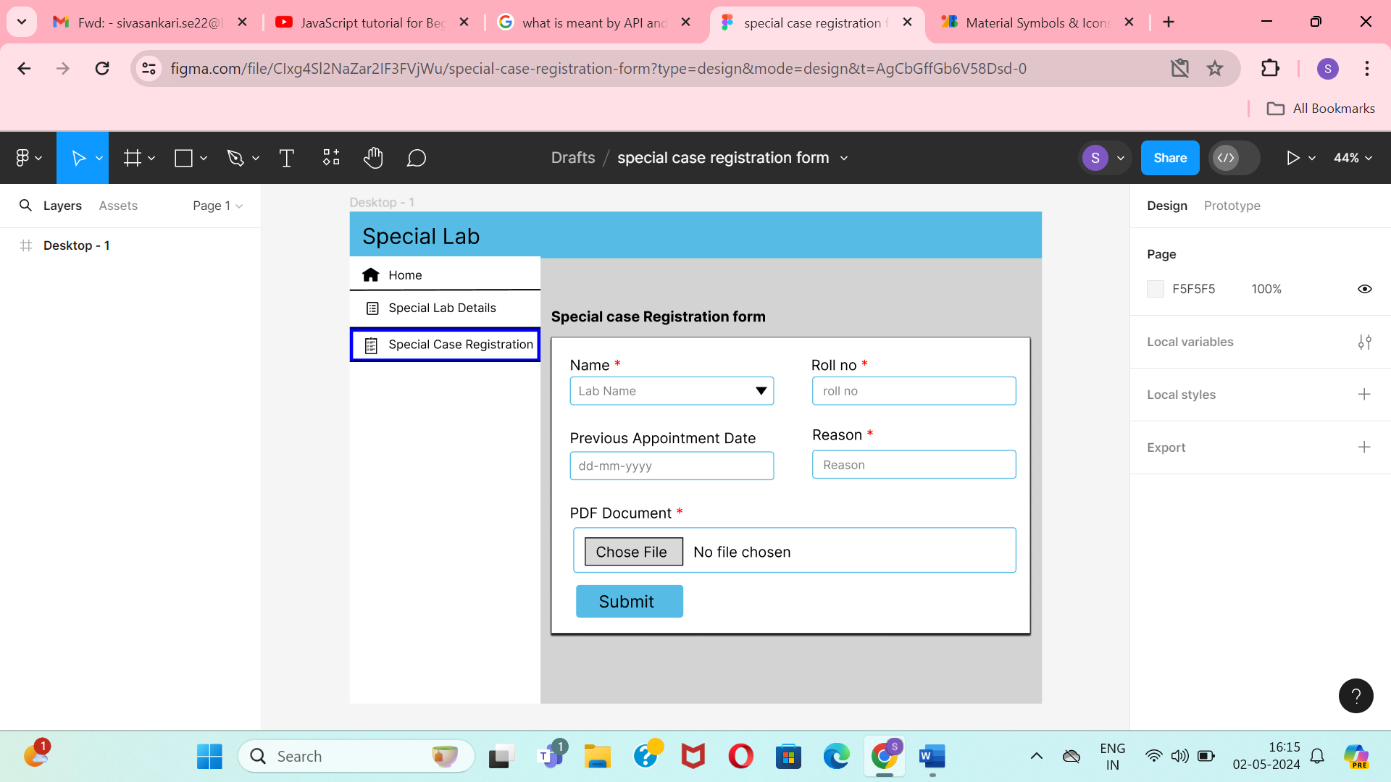

1. Faculty’s view

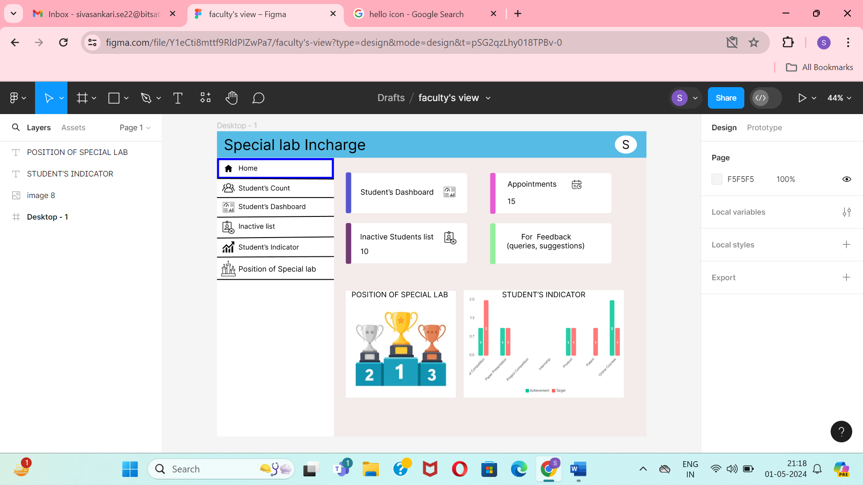

1. 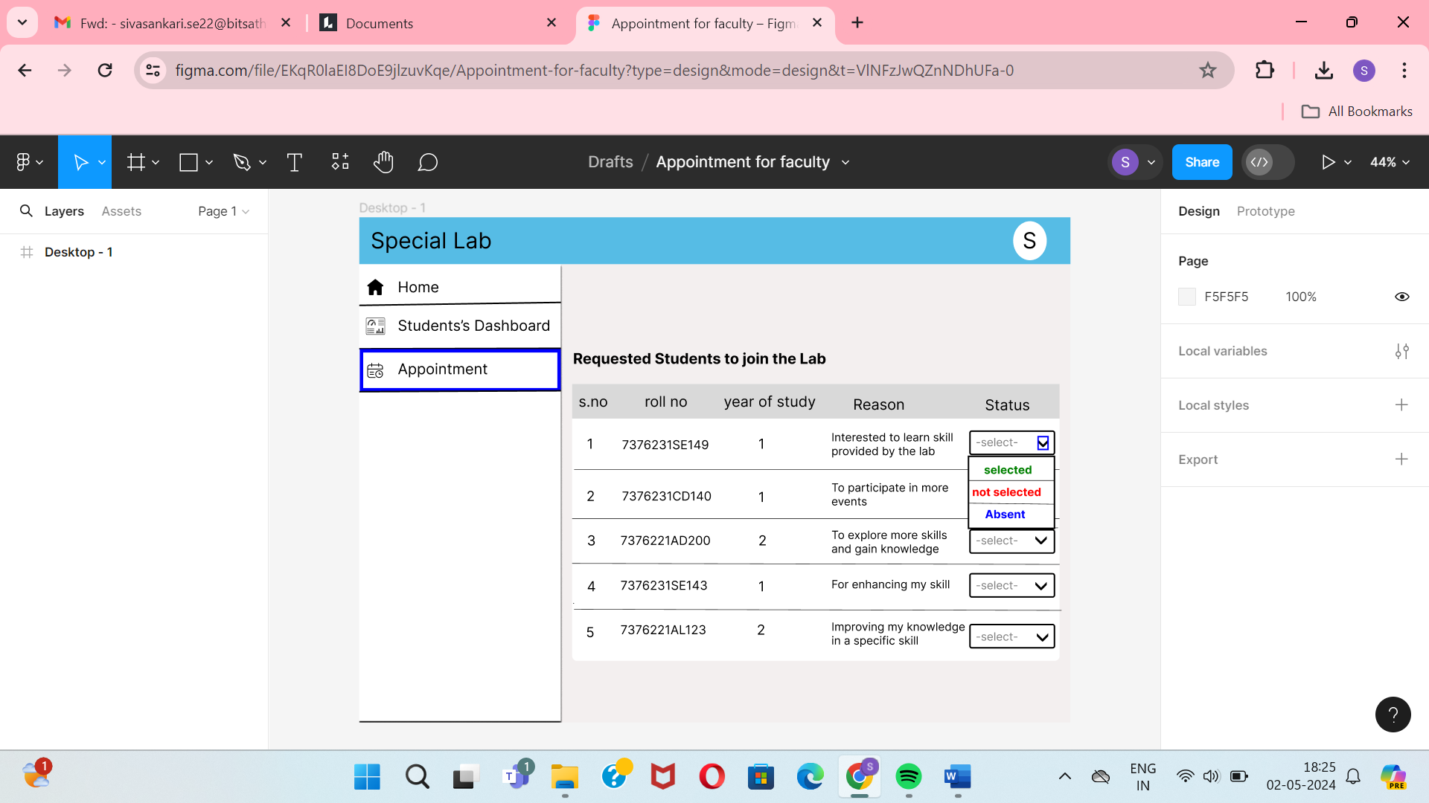Appointment page for Faculty
2. Schedule page for faculty

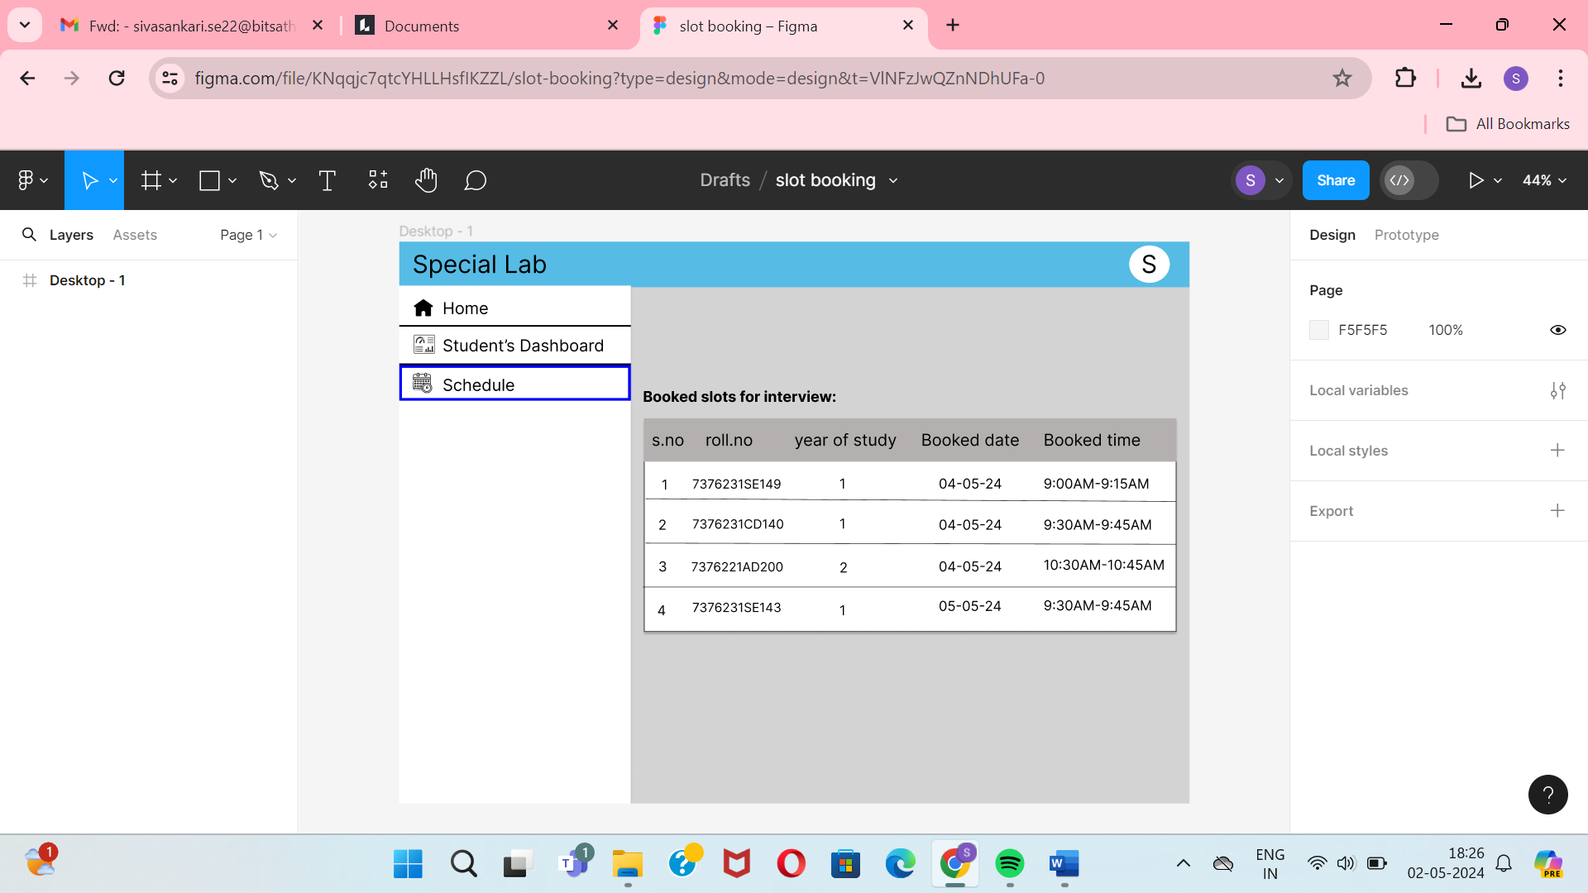

1. 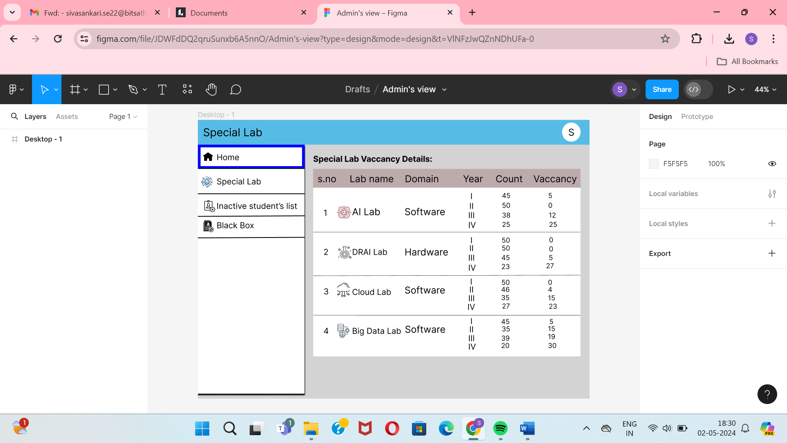Admin’s view
2. Inactive list for Admin

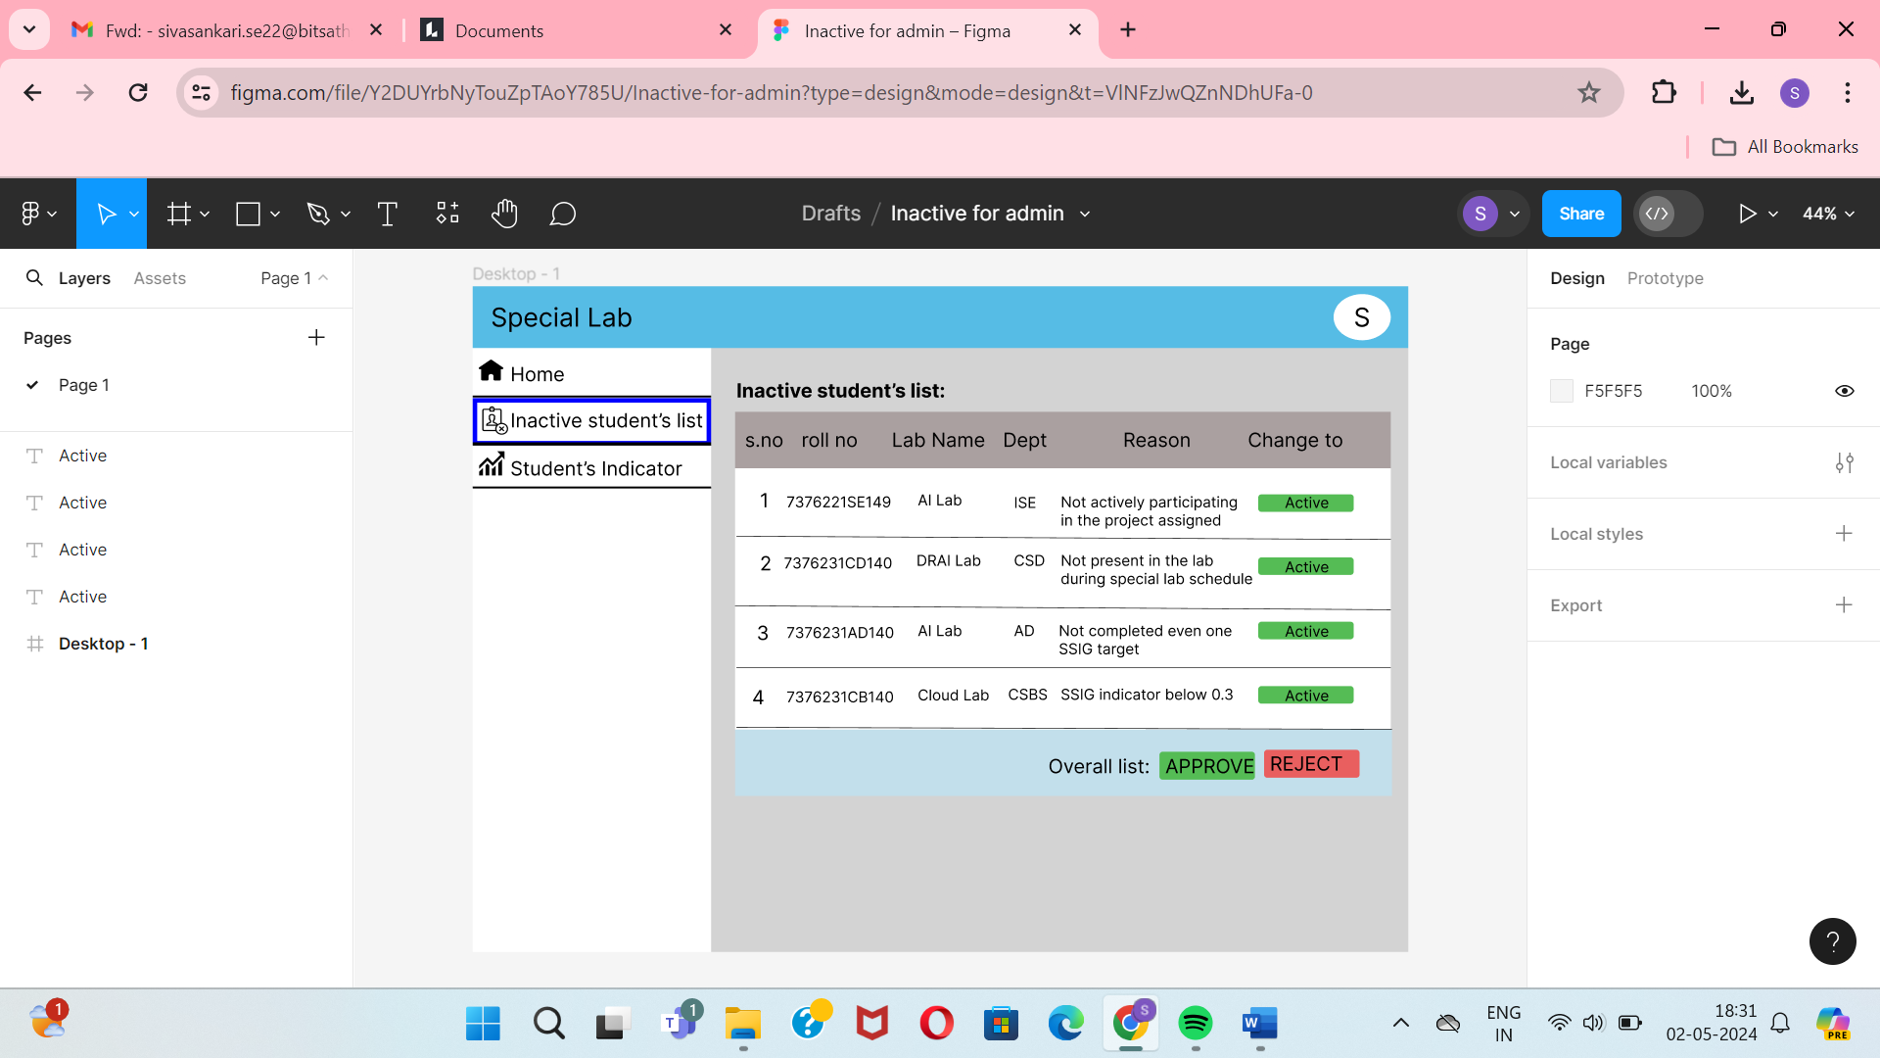

1. 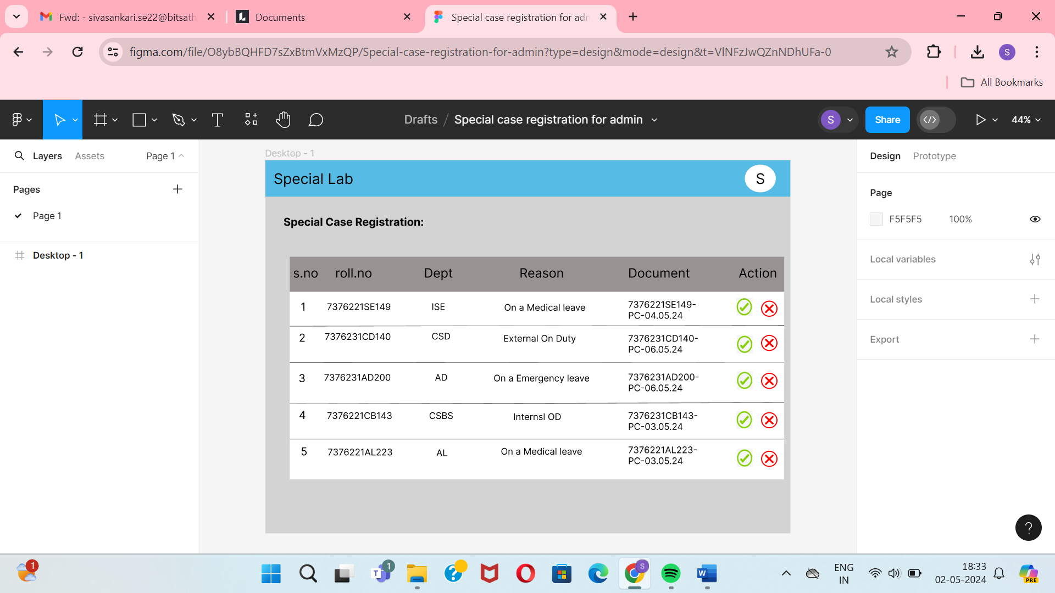Special Case Registration for Admin