Report: Illuminating Insights to Boost Sales Performance

Our analysis reveals key opportunities to increase sales by optimizing product offerings, targeting high-potential customer segments, and leveraging top-performing stores. By focusing on these areas, the company can expect significant growth in the upcoming quarters.

Key Insights from Customer Analysis

**Demographic Distribution**: Describe how understanding customer demographics (e.g., gender, age, location) can help the company tailor marketing campaigns to target specific segments more effectively.

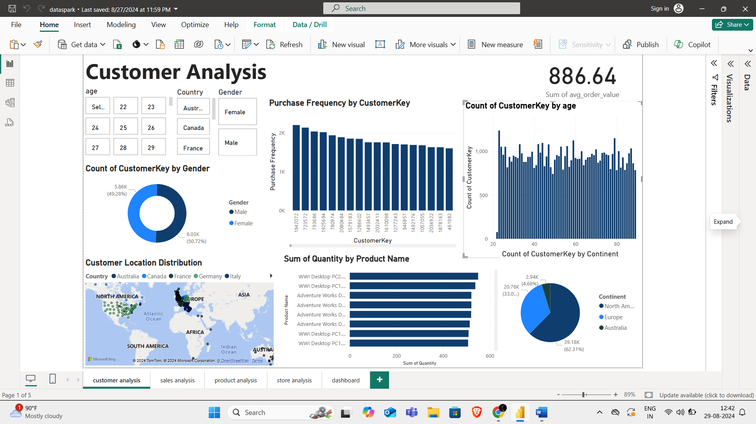 

Customers aged 23-34 in USA,UK are the most active buyers. Targeting this demographic with personalized promotions can drive higher engagement.

**Purchase Patterns**: Outline purchasing behaviors, such as average order value and frequency. Discuss how this information can inform marketing and product strategies.

 

Customers with higher purchase frequency tend to buy more premium products. Promoting upselling opportunities for these customers can increase the average order value

**Customer Segmentation**: segmenting customers based on behavior and demographics can guide personalized marketing efforts and improve customer retention.

Segmenting customers into loyalty tiers (e.g., frequent buyers vs. occasional buyers) allows for more targeted retention strategies, such as offering exclusive discounts to high-value customers.

Key Insights from Sales Analysis

**Overall Sales Performance**: Provide insights into sales trends over time. Highlight any seasonality or peak sales periods and how the company can capitalize on these trends.

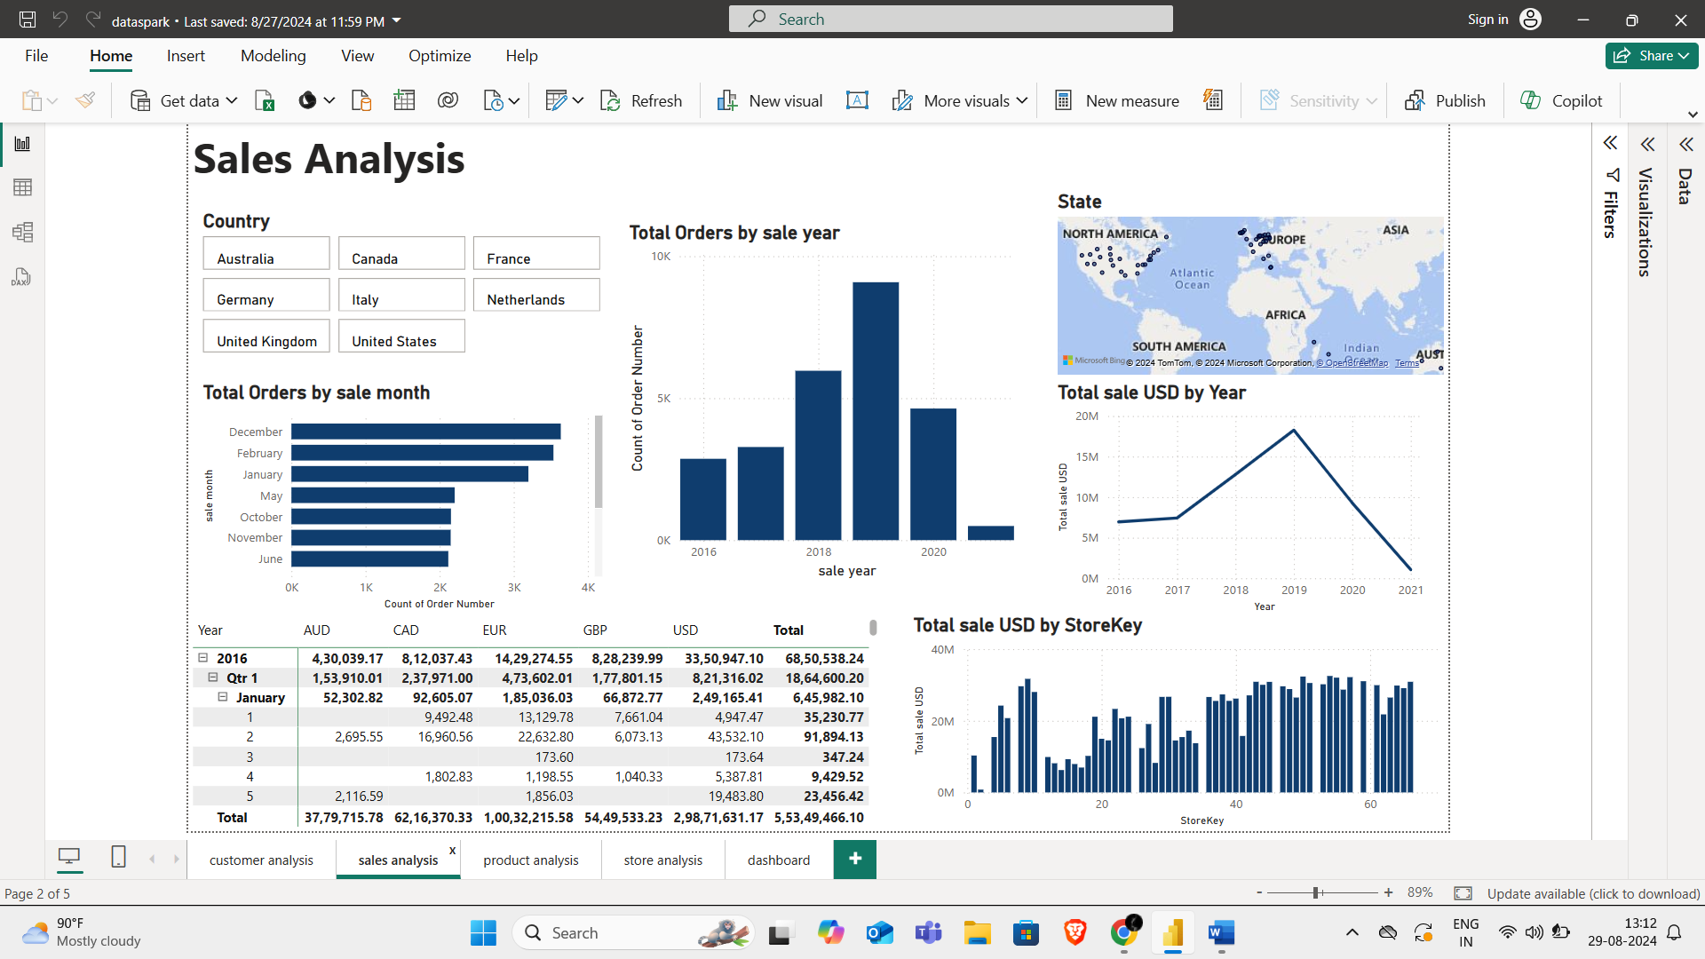

Sales peak during the holiday season, particularly in December. A focused marketing push and inventory optimization during this period can significantly boost revenue.

**Sales by Product**: Identify top-performing products. Recommend strategies for promoting these products further.

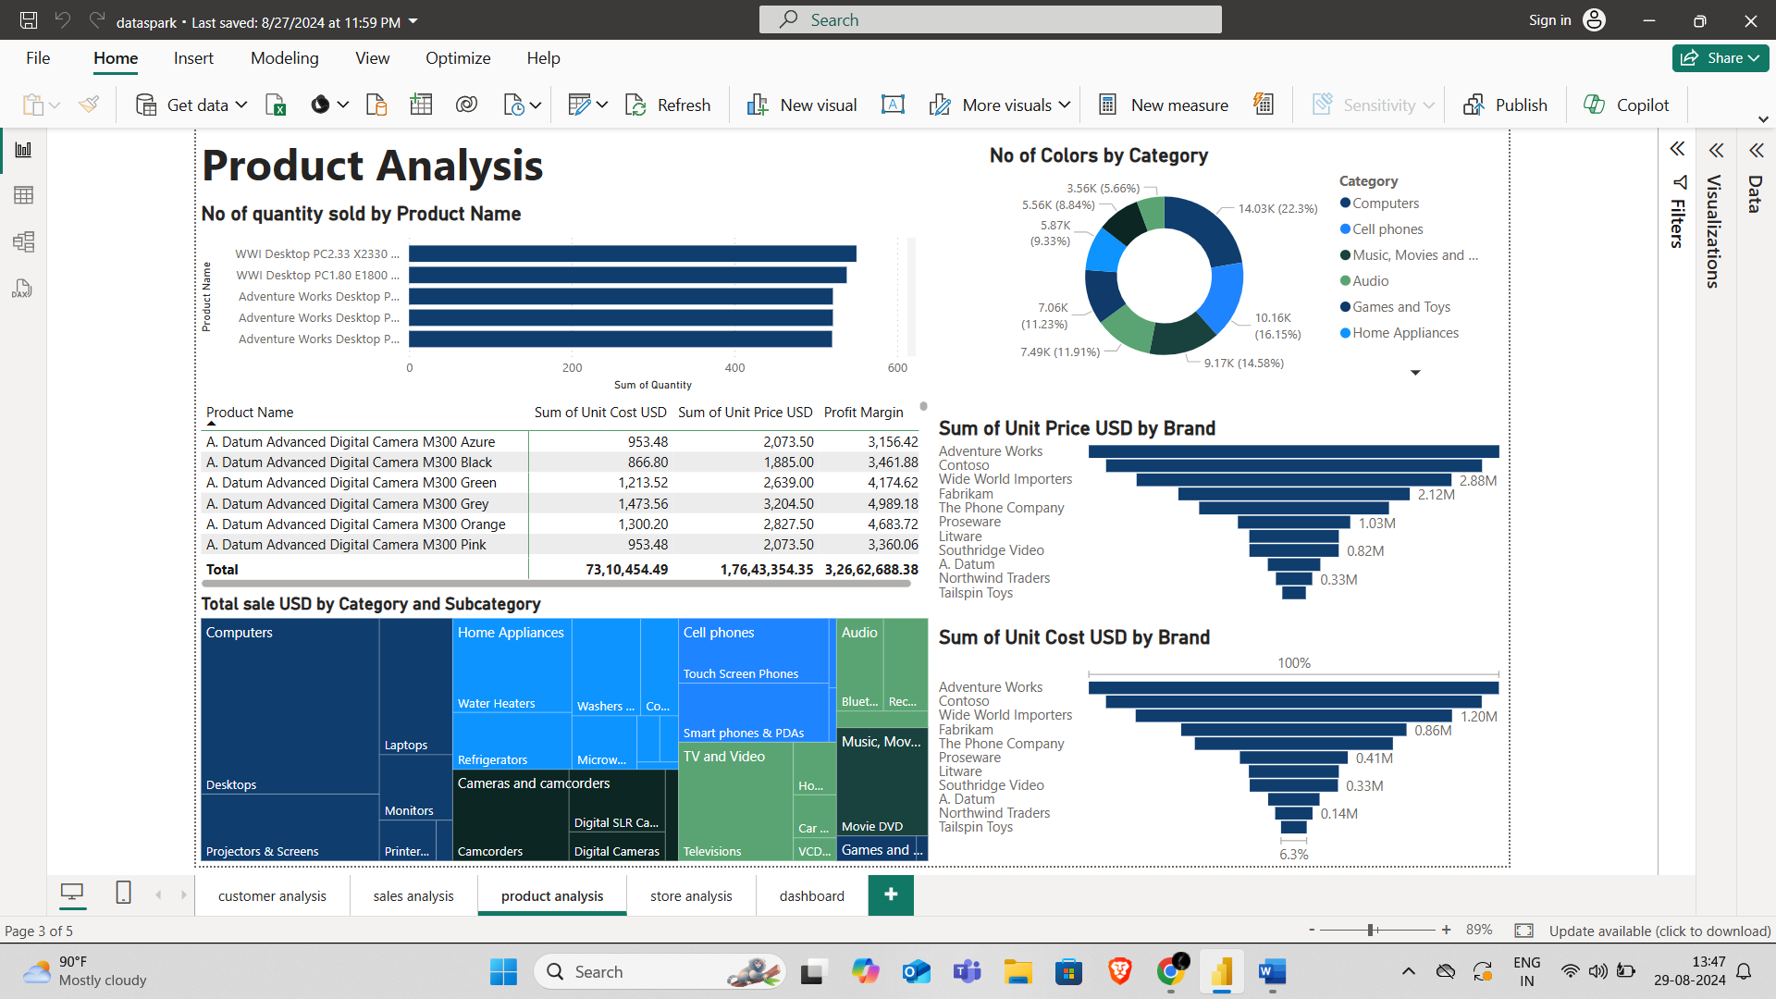

By this diagram, top seller product,which is contributing more percentage of total sales. Increasing visibility through featured listings and bundling with related products can drive even more sales.

**Sales by Store**: store performance and recommend optimizing underperforming stores or expanding successful ones.

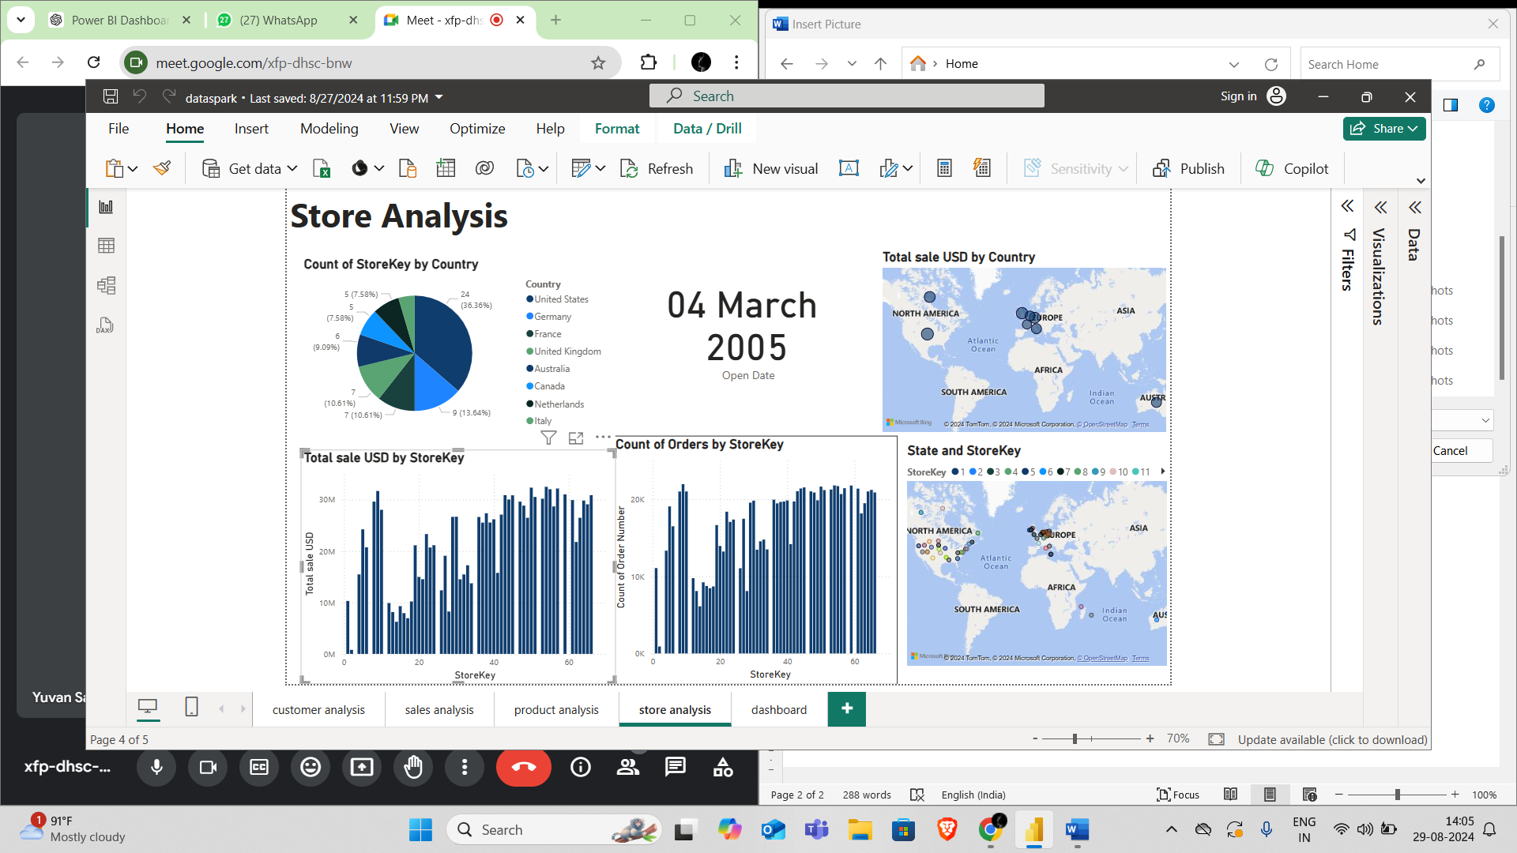

Store Y outperforms others with a 30% higher average sales per square meter. Expanding store Y's model to other locations could enhance overall profitability.