**Remote server to local**

Step1:

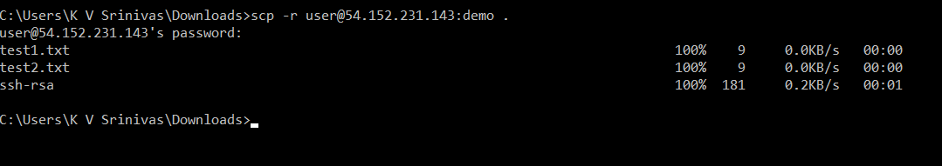

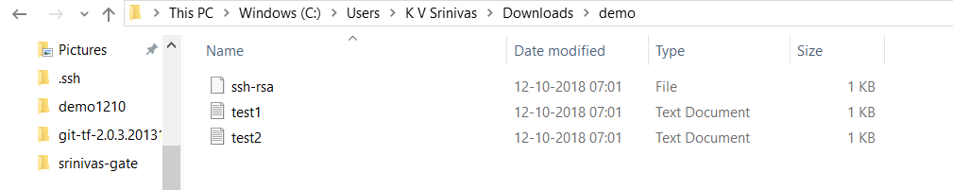

Cd C:\Users\K V Srinivas\Downloads\demo

ssh-keygen

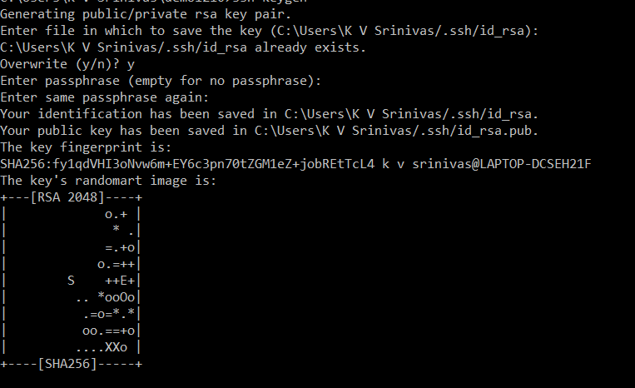

Open the file id_rsa.pub and copy into bitbucket ssh-key area

Step2:

In local shared path, we can find the files that imported using scp commands.

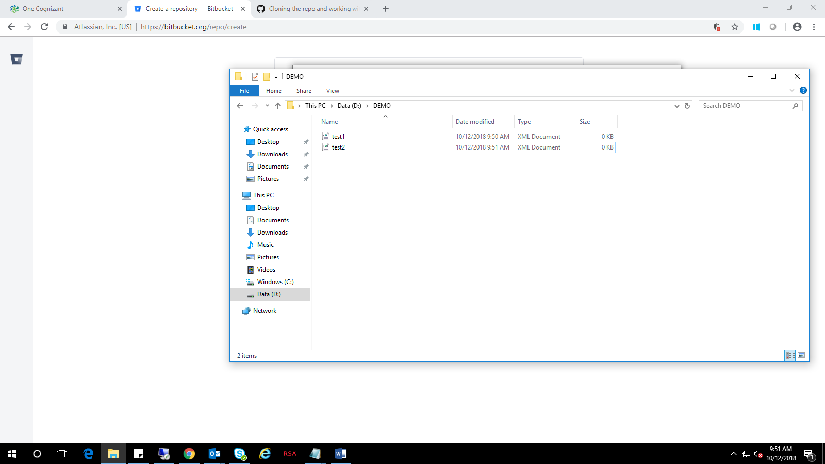

Step3:

Open Bitbucket , create a new repository.

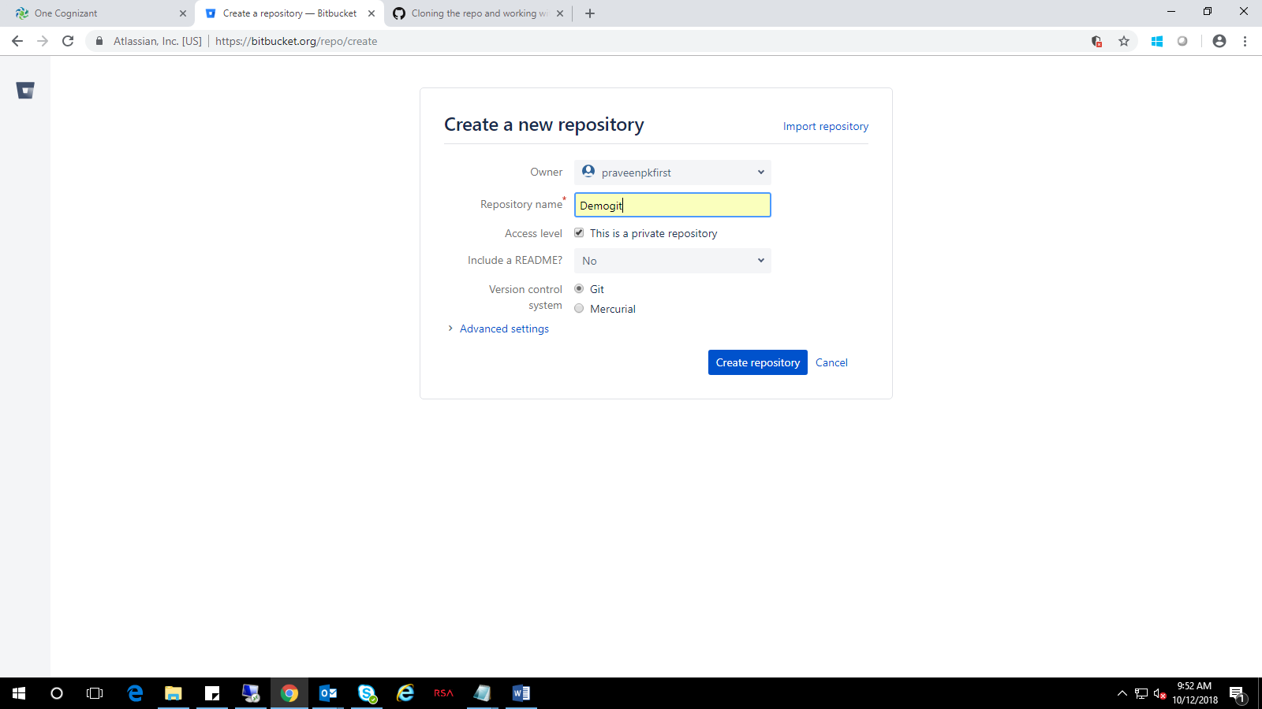

Step4:

From Local Sharedpath , open Git here

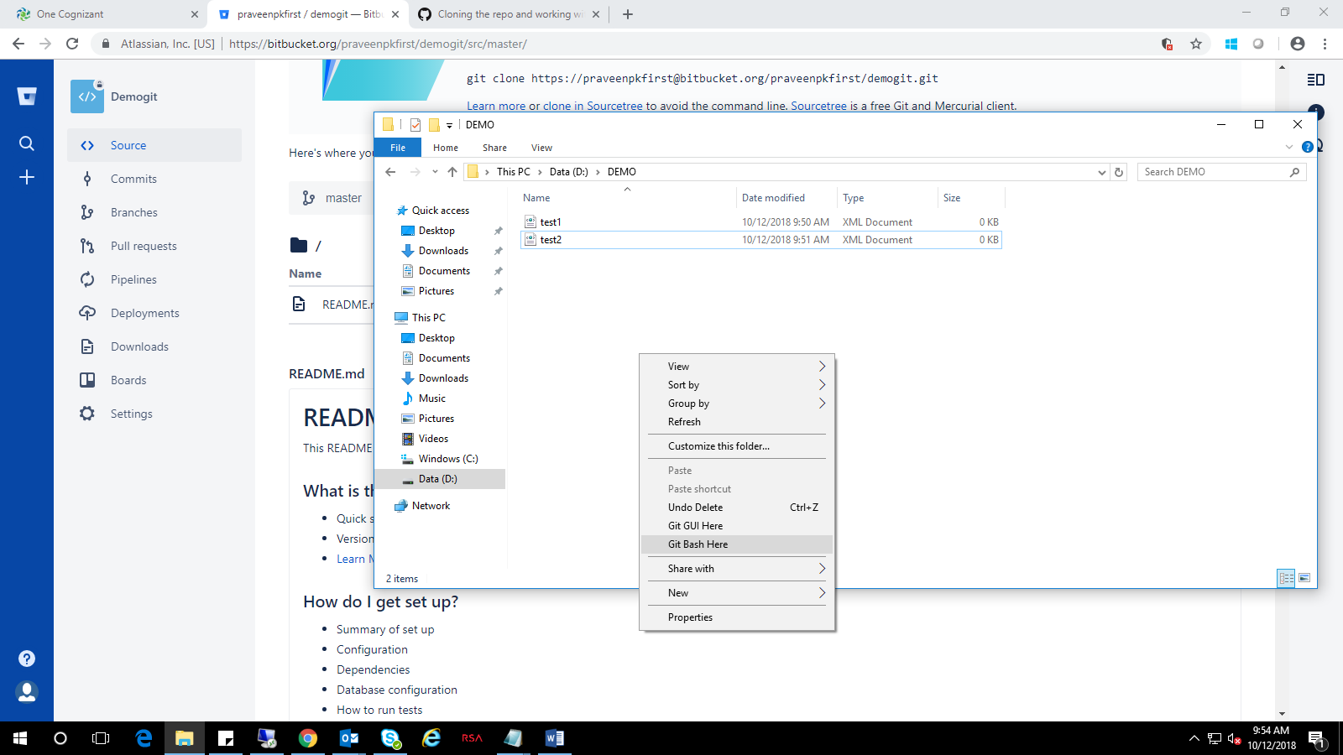

Step5:

Initialize the git repository here, by giving <git init> command.

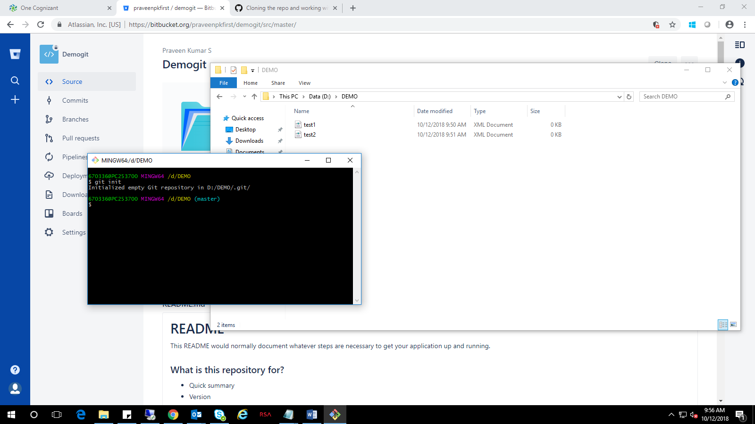

Step6:

To see the files in the folder which are not uploaded to git repository are shown here, by giving <git status> command. If it shows red colour, it means that are not get uploaded.

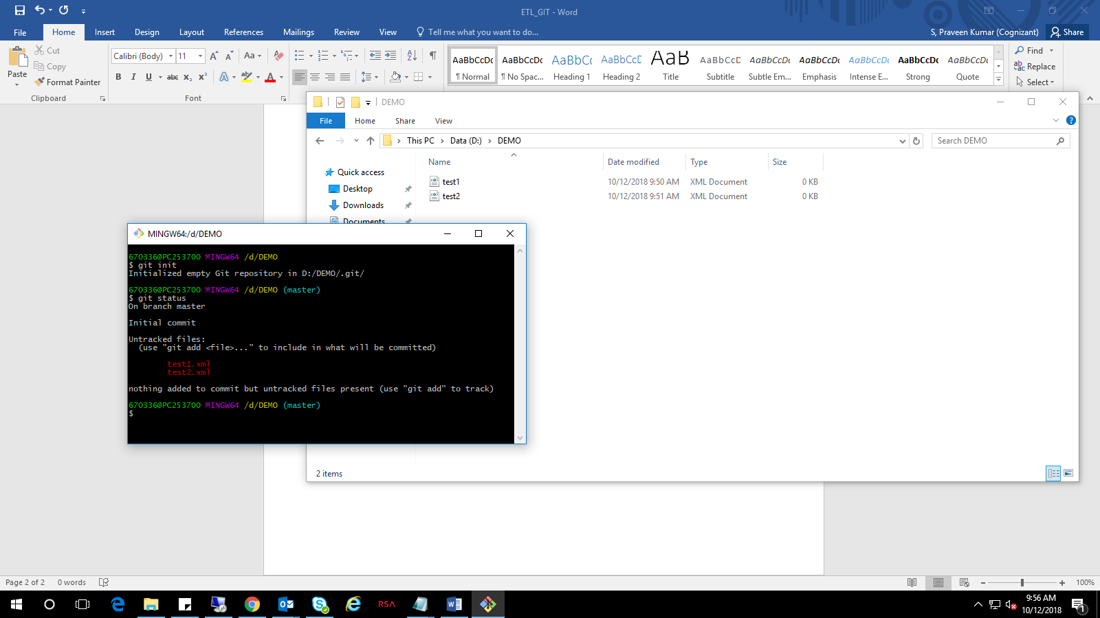

Step7:

To add the files to git repository by giving <git add .> command.After that we can check with < git status > command,it shows in green colour.

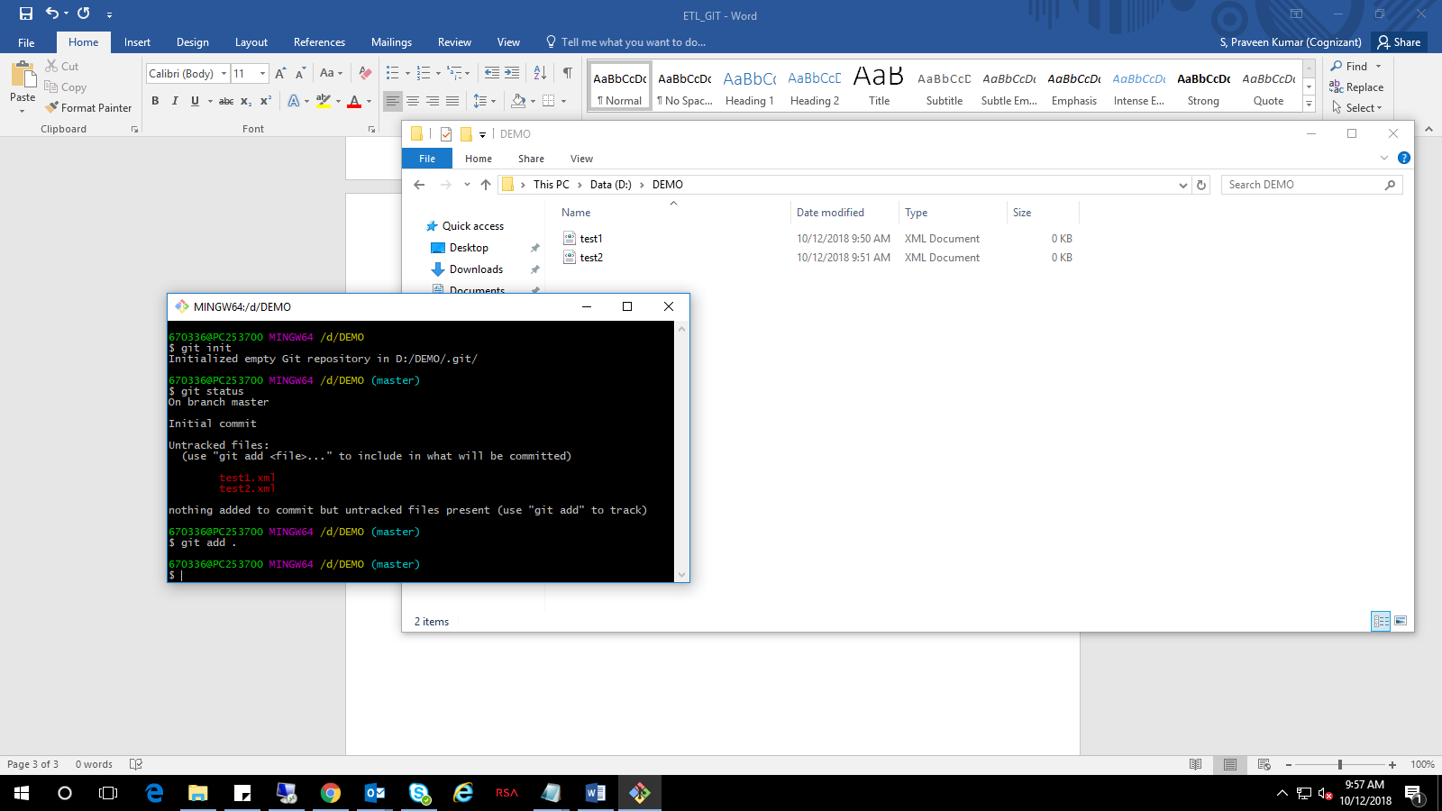

Step8:

Then we have to commit it for save the changes by < git commit –m “msg” > command.

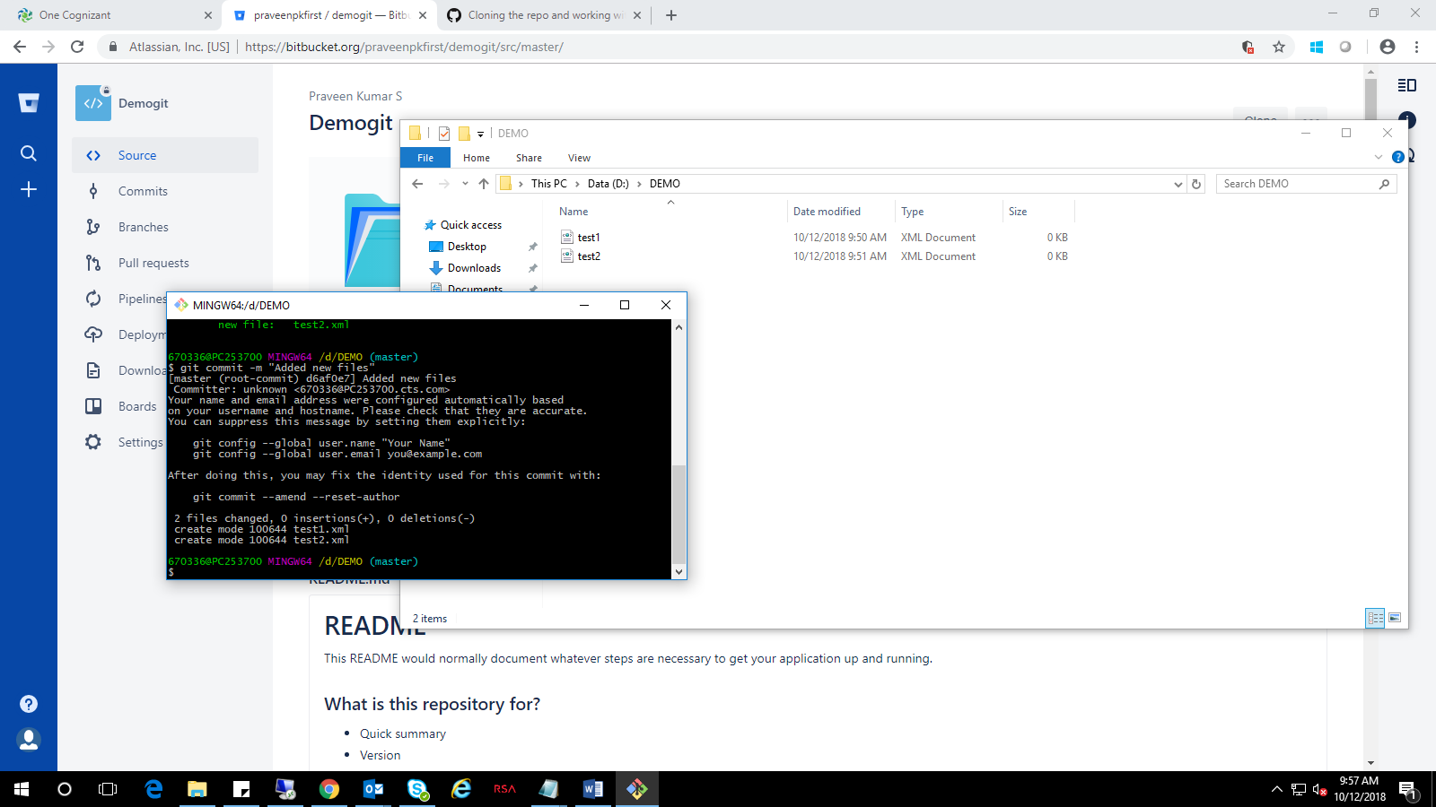

Step9:

Copy the bitbucket repository URL here.

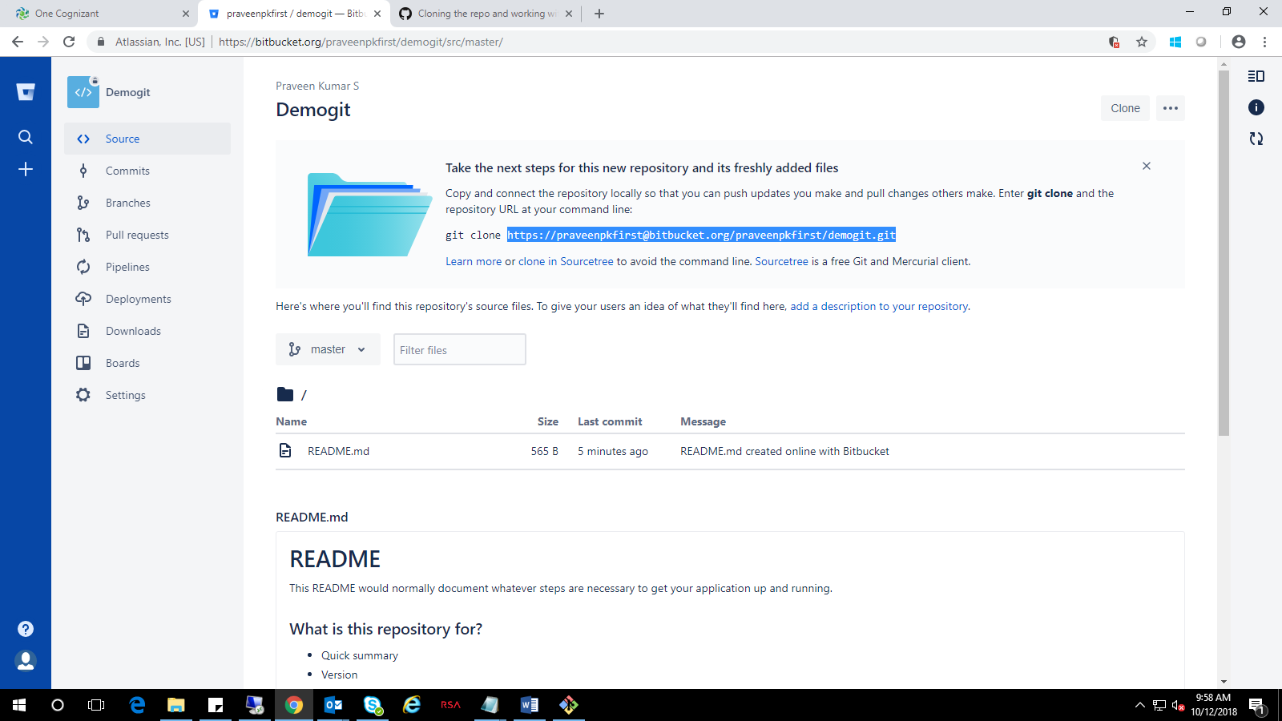

Step10:

Here we connect the git to bitbucket by giving < git remote add origin REPO_URL > command.

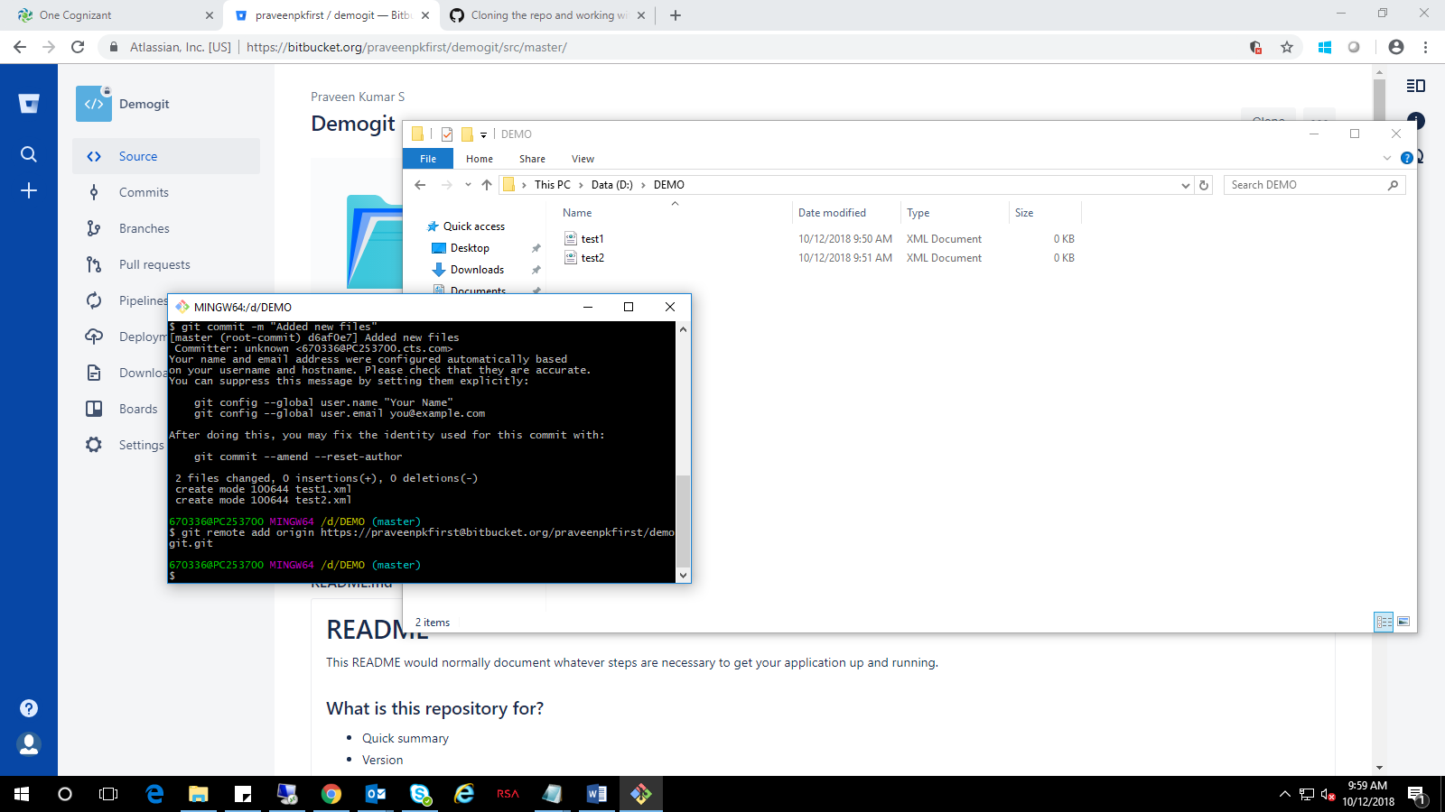

Step11:

Using < git pull origin master > command to get any changes in Bitbucket to git.

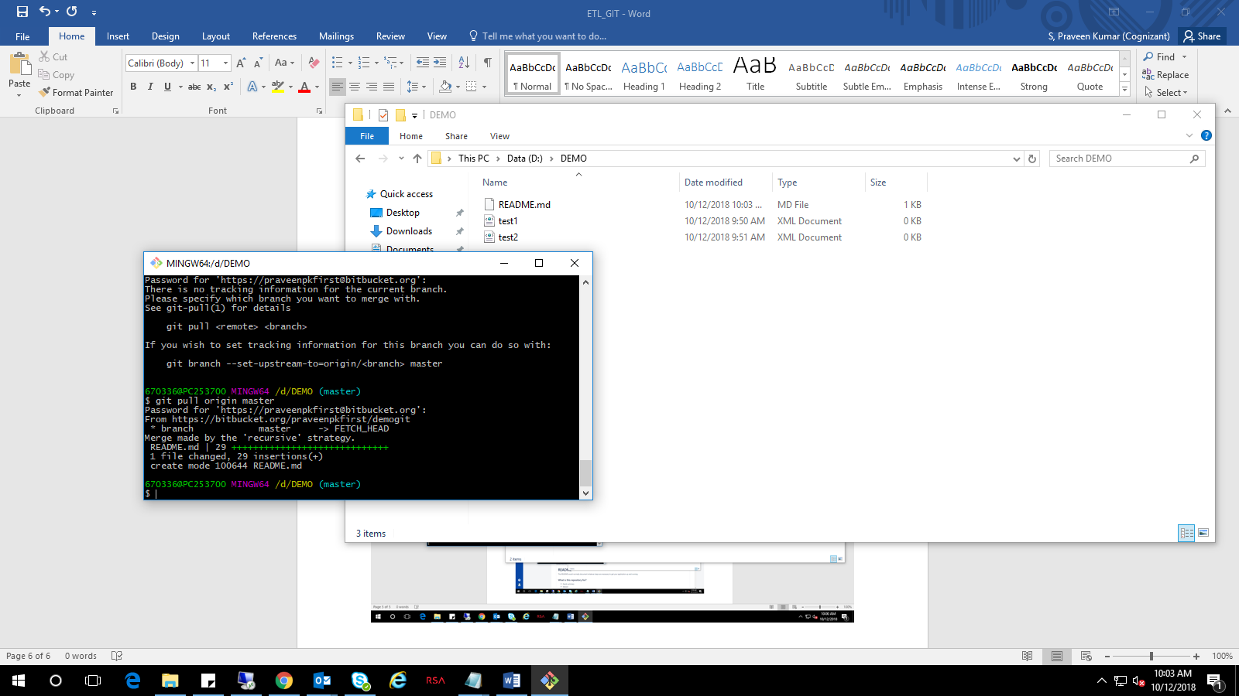

Step12:

After that we have to give < git push –u origin master > command to upload all the changes from git to bitbucket.

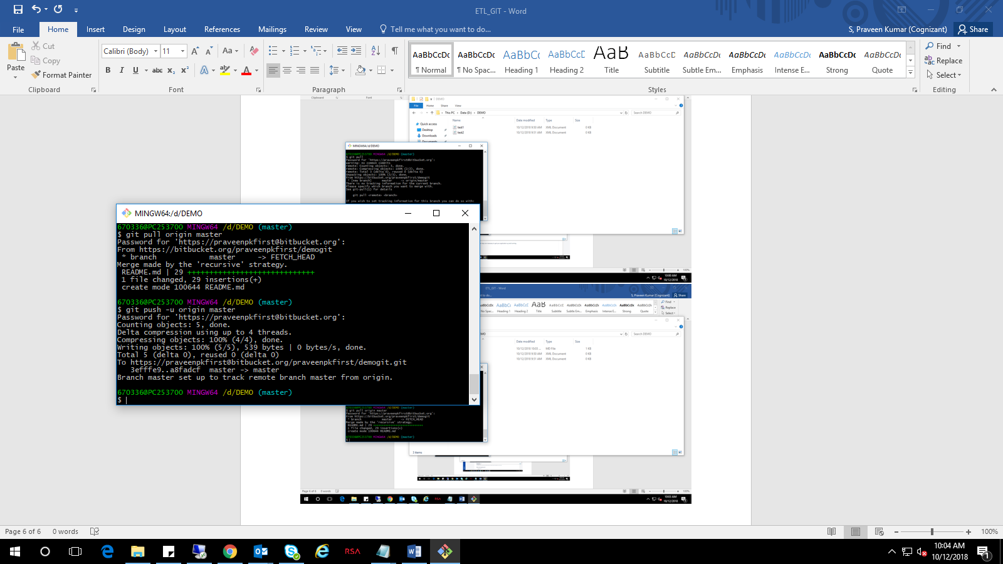

Step13:

Once we refreshing here , we can get the changes in Bitbucket.

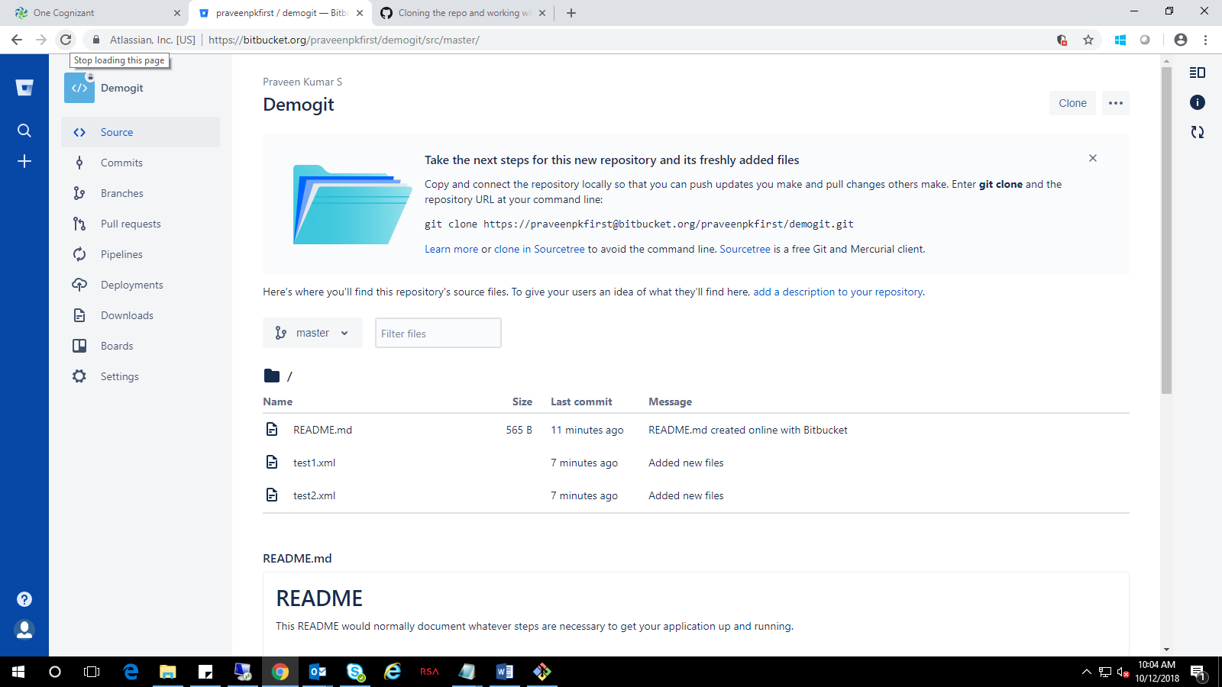

Step14:

* Create a new branch ETL_INT by giving < git branch ETL_INT >
* To check the branch < git branch >
* To swap branch < git checkout ETL_INT >

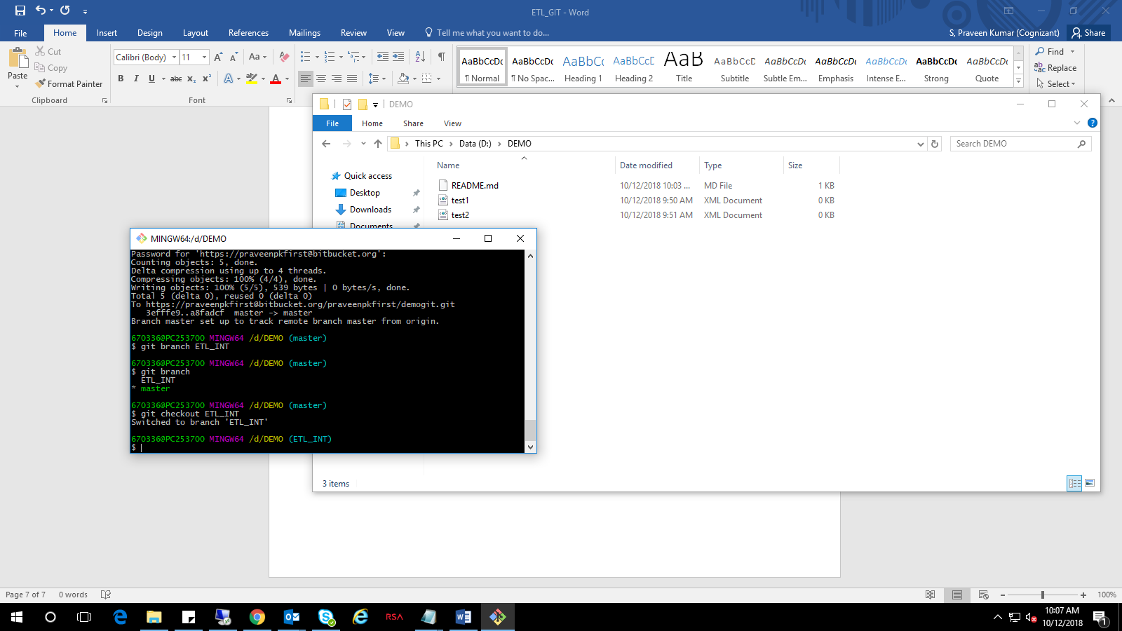

Step15:

* Give < git push –set-upstream origin ETL_INT > to make the changes have been uploaded to bitbucket.

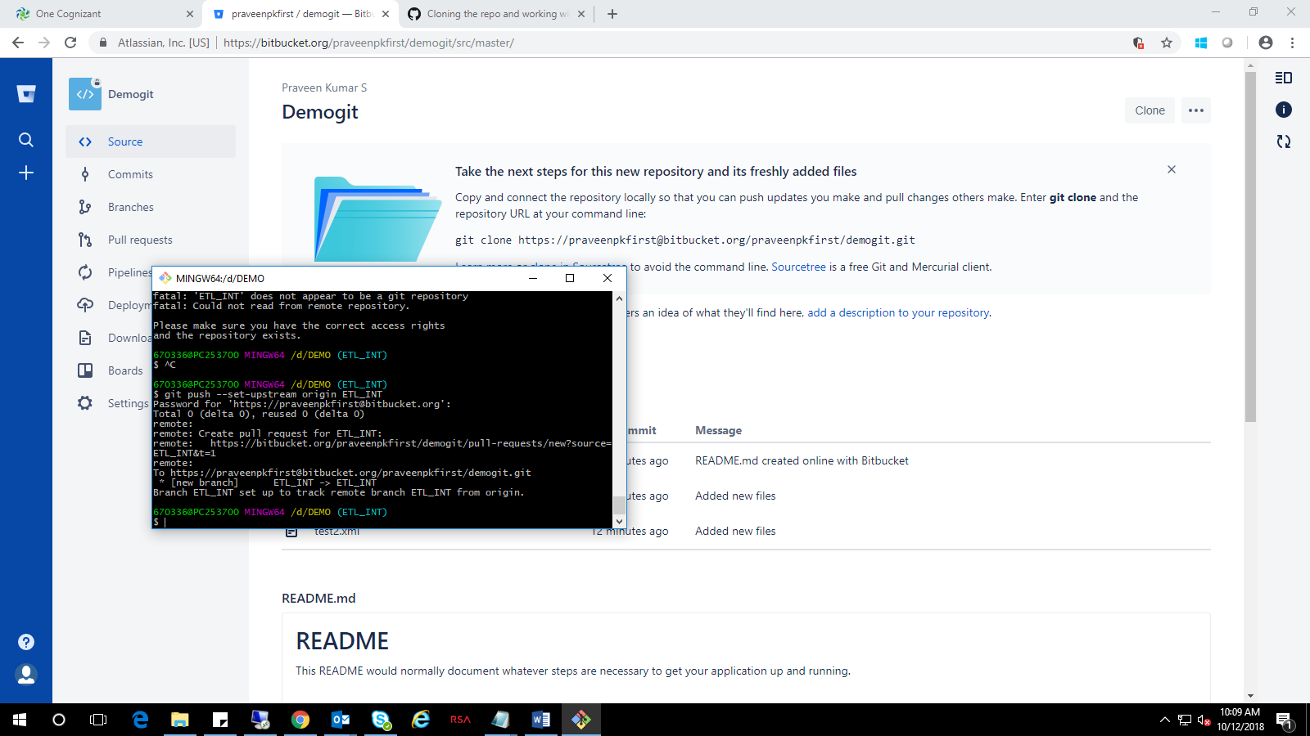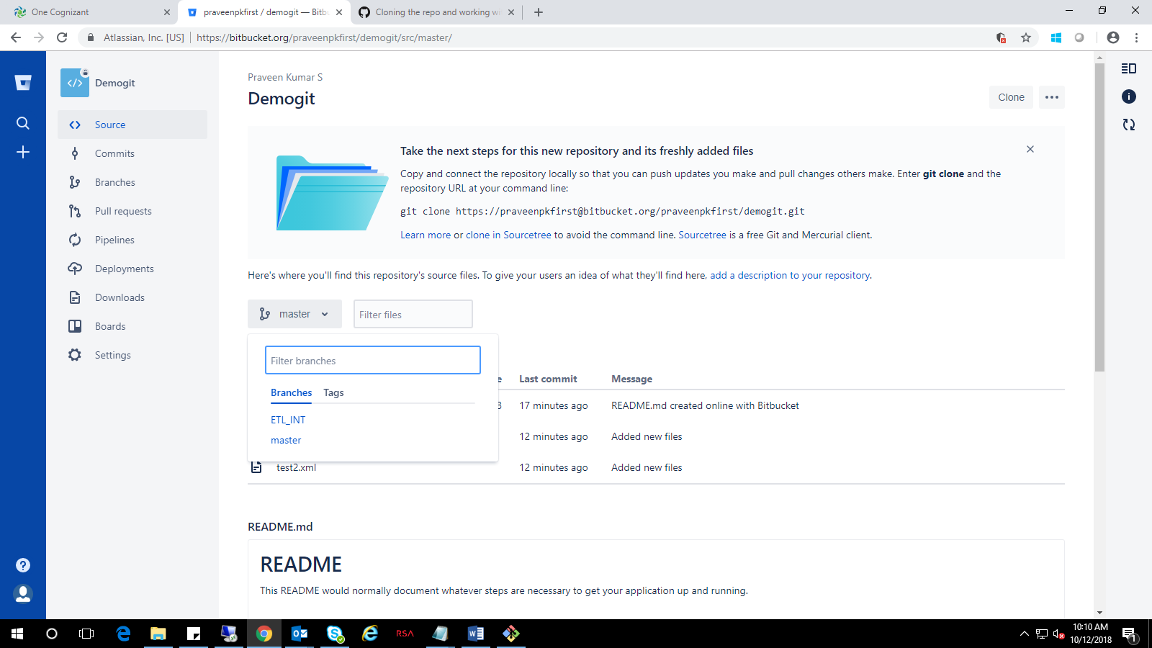

Step16:

Now removing files in ETL_INT branch by < git rm –r * > command.

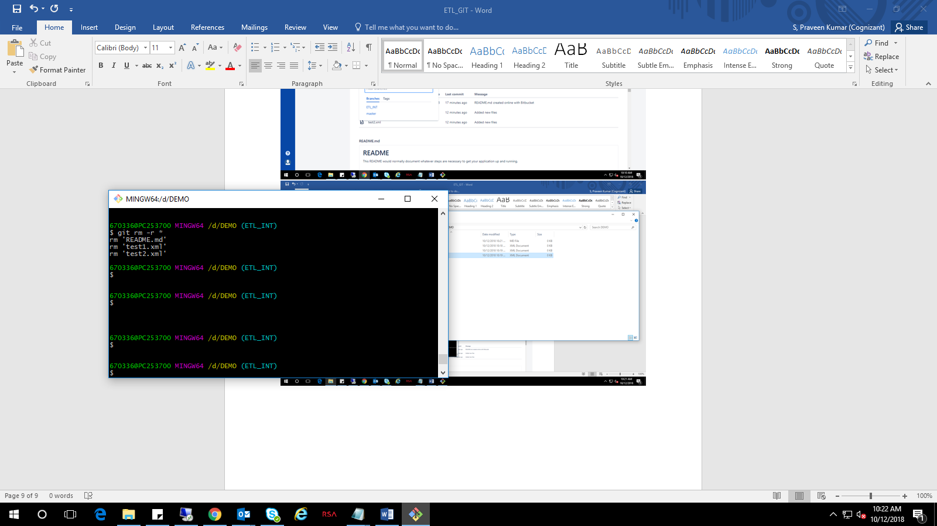

Step17:

* Add the new files in local sharepath.
* Follow the below steps

< git status >

< git add . >

< git status >

< git commit –m “msg” >

< git push origin ETL_INT >

NOTE: Above steps should follow only in ETL_INT branch.

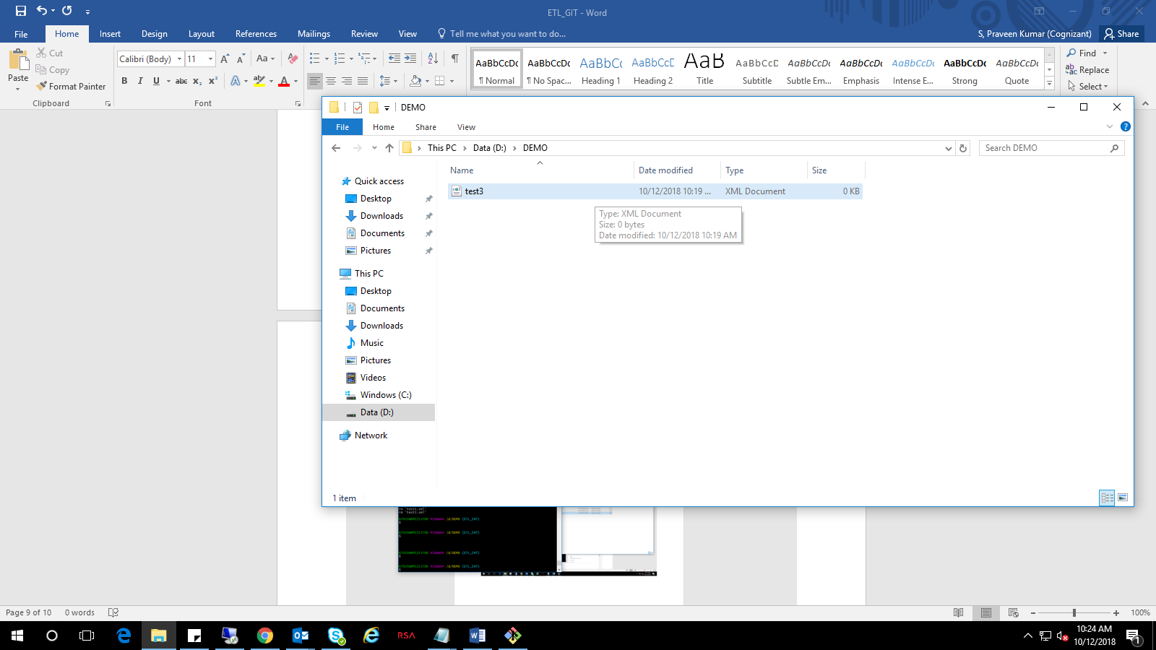

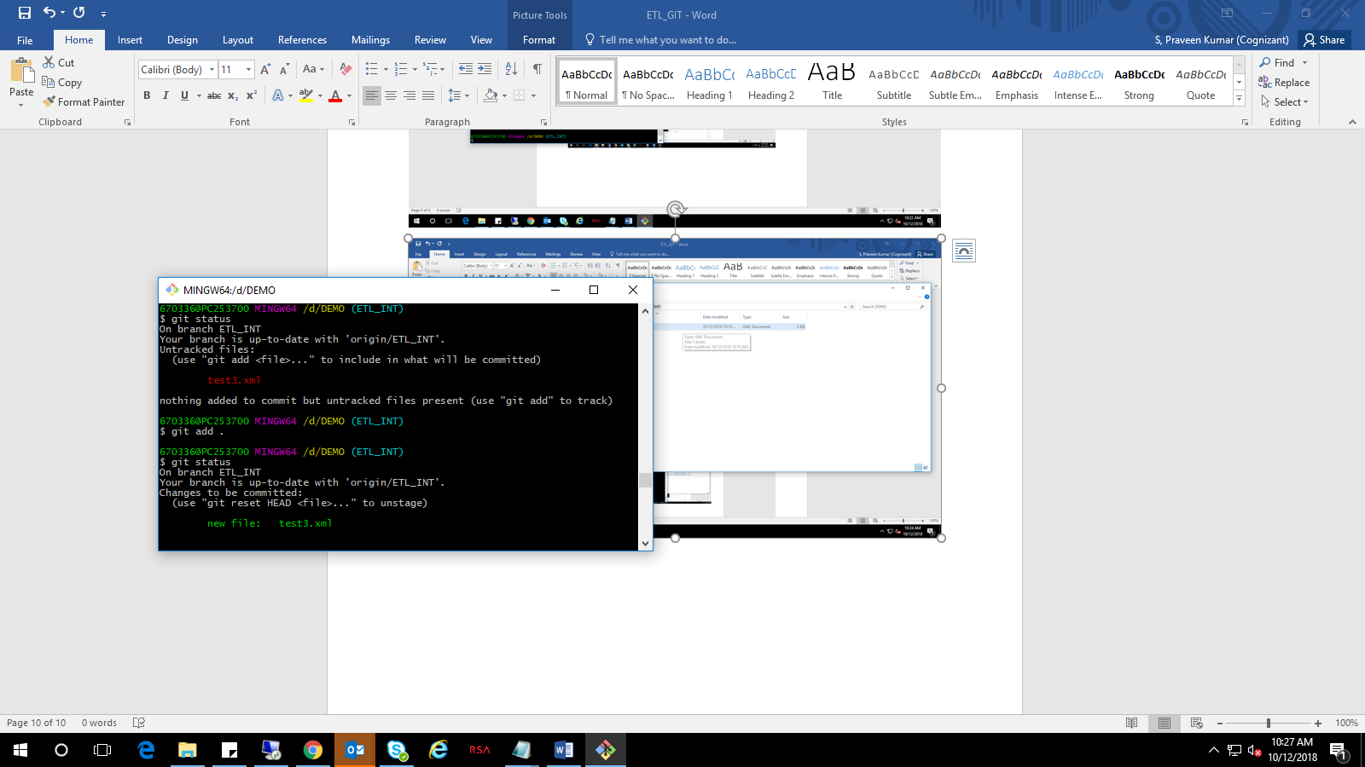

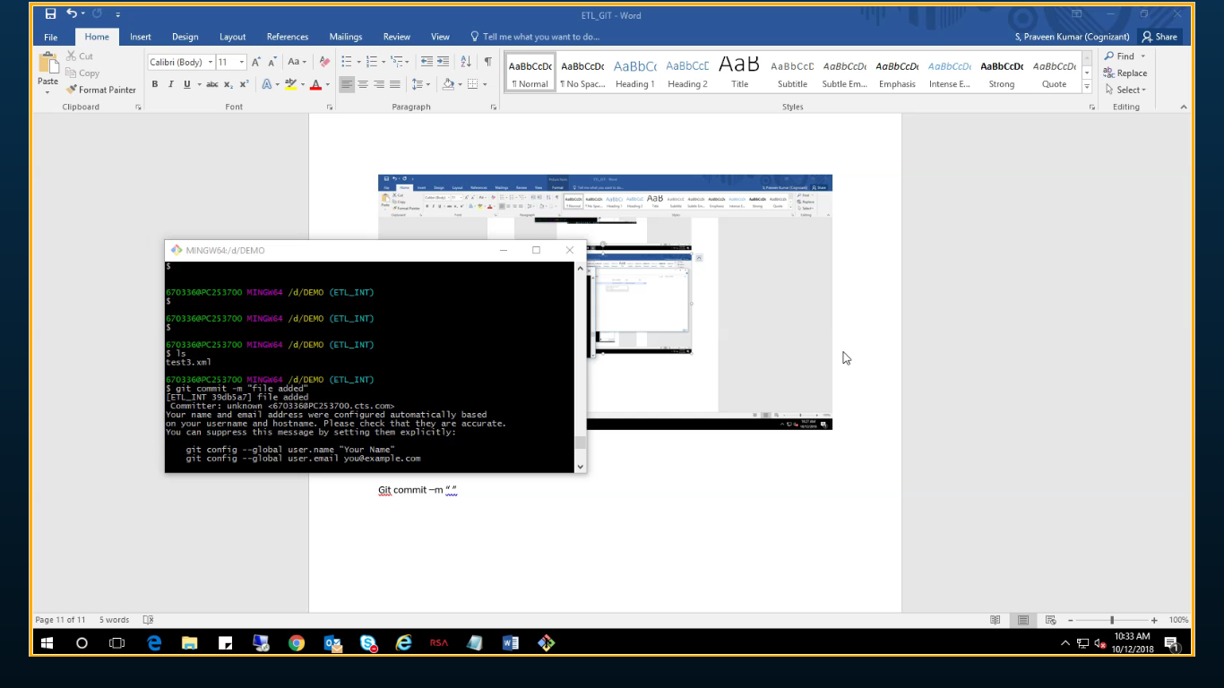

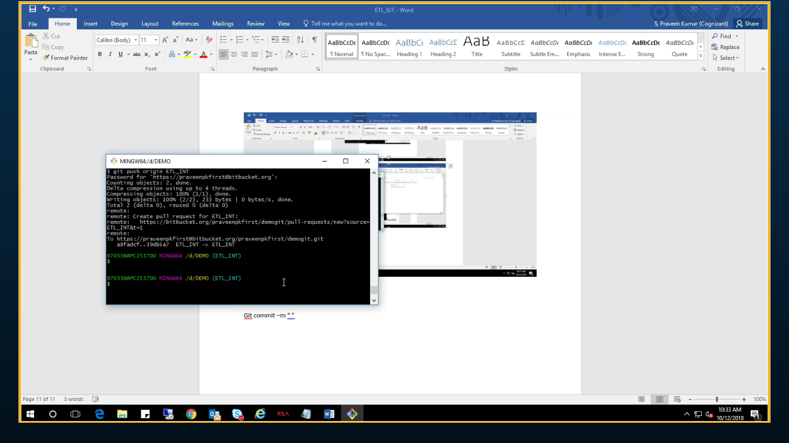

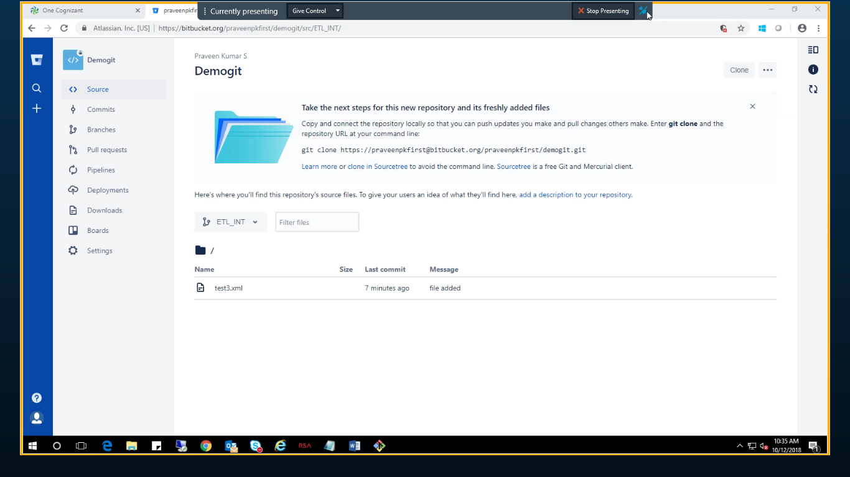

Step18:

* Now we have to push changes to master to save all the files,
* Our plan is to keep latest file in ETL_INT.
* Here, In ETL_INT branch Praveen.txt file only found and in Master branch ,different other files are there.
* So before deleting the file in ETL_INT branch ,we have to push the file to master.

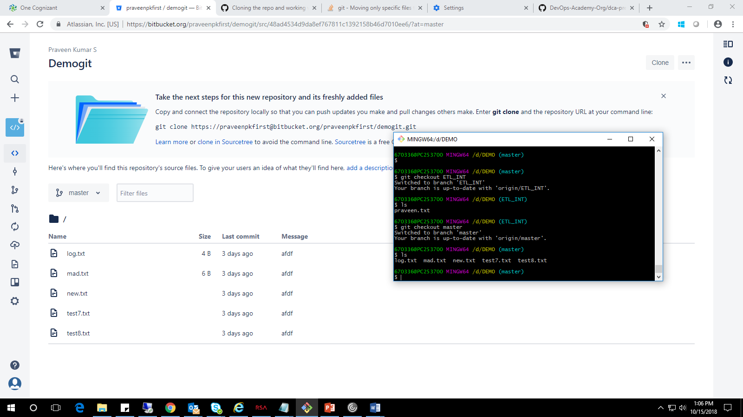

Step19:

Give < git checkout ETL_INT . > in master branch to add files in ETL_INT to master.

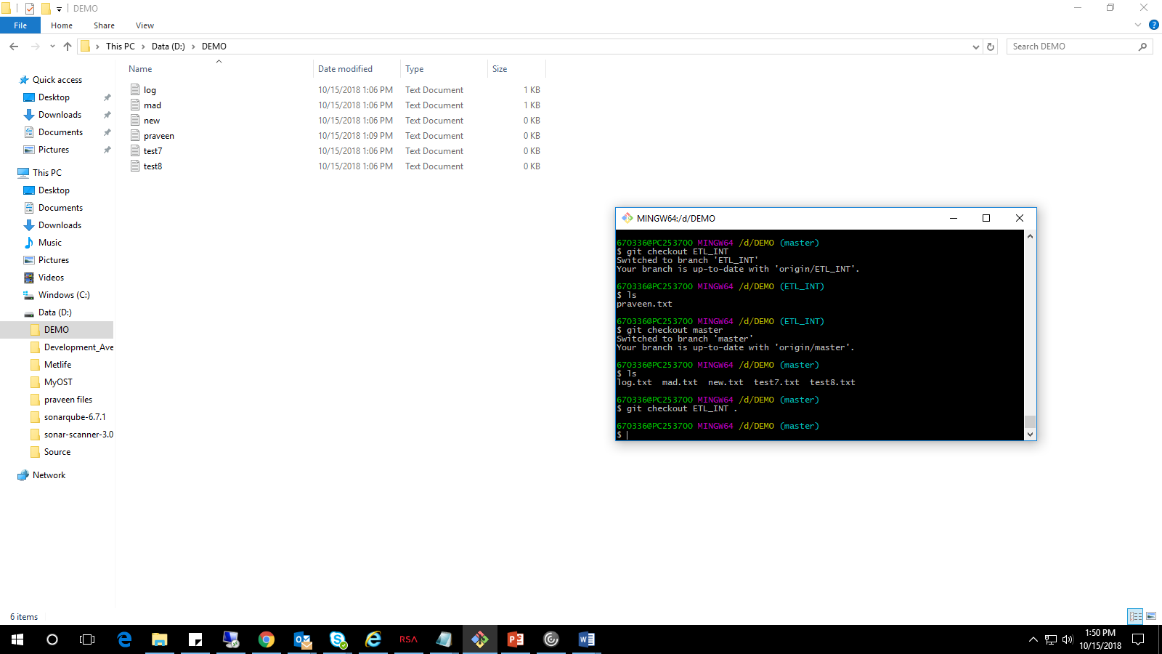

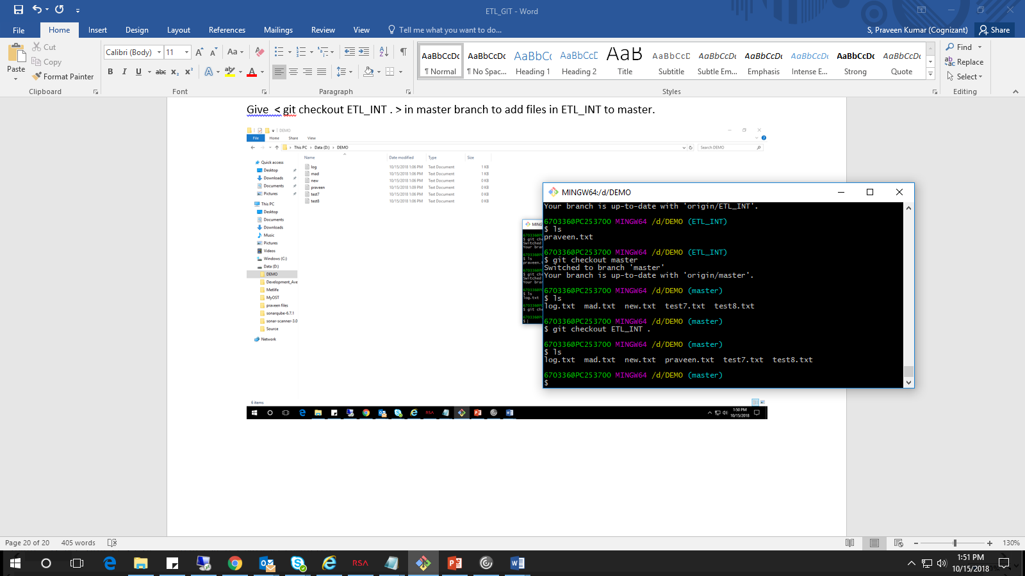

Step20:

* Now commit the changes
* Pull the code and push into master.

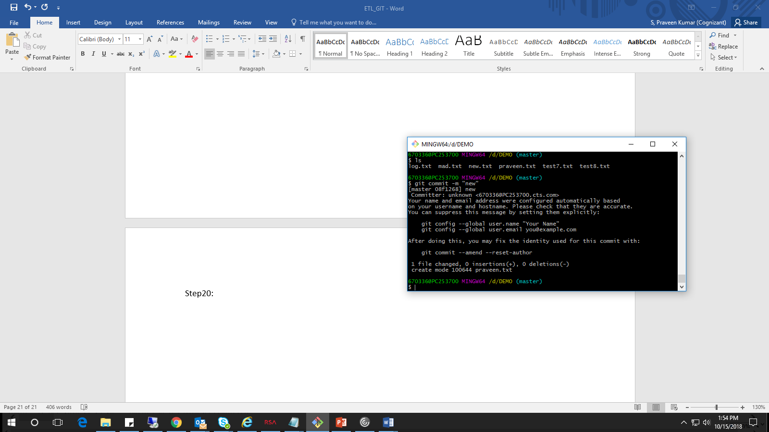

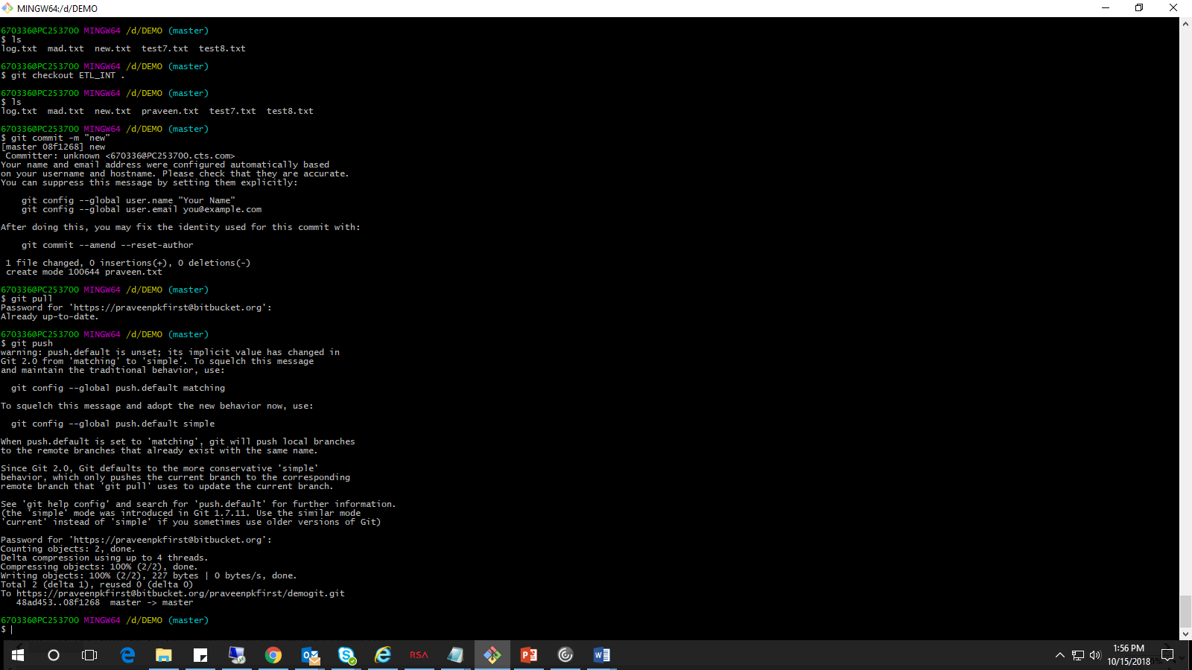

Step21:

* Refresh the bitbucket repository to see the changes.
* Here Praveen.txt file is added in master.

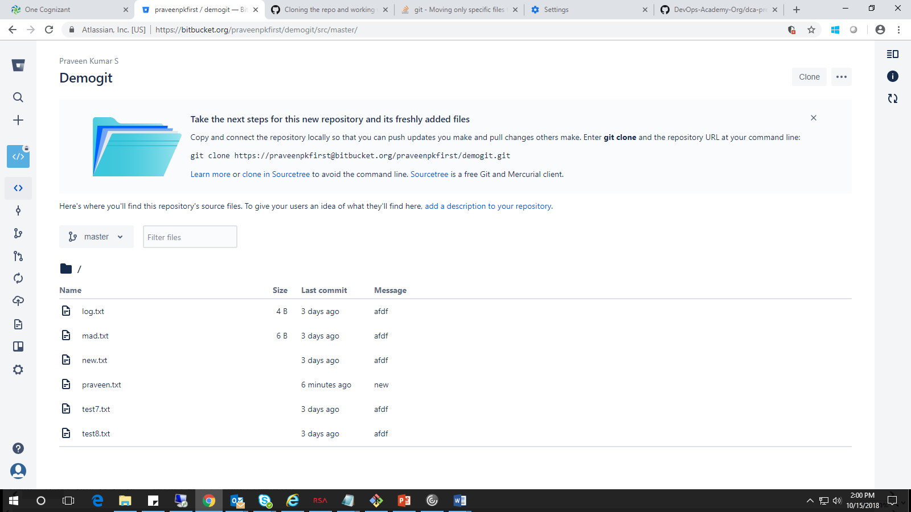

NOTE:

* Before deleting file in ETL_INT branch, we have to push the file into master.