Step 1: npm install gh-pages --save-dev

Step 2: Create new Repository in GIT HUB <https://github.com/new>

Step 3:

"homepage": "http://sankarsai8686.github.io/ReactApp",

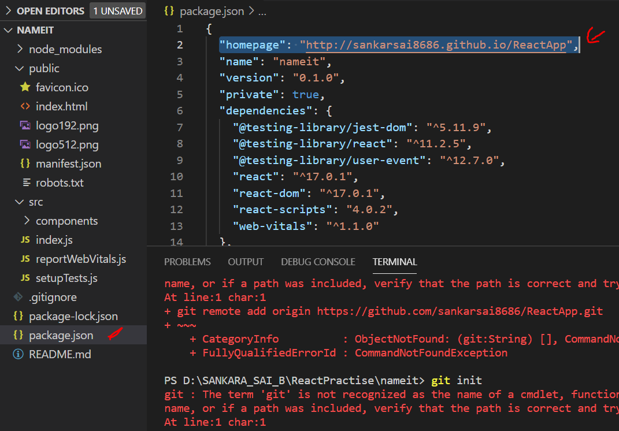

"predeploy": "npm run build",

    "deploy": "gh-pages -d build",

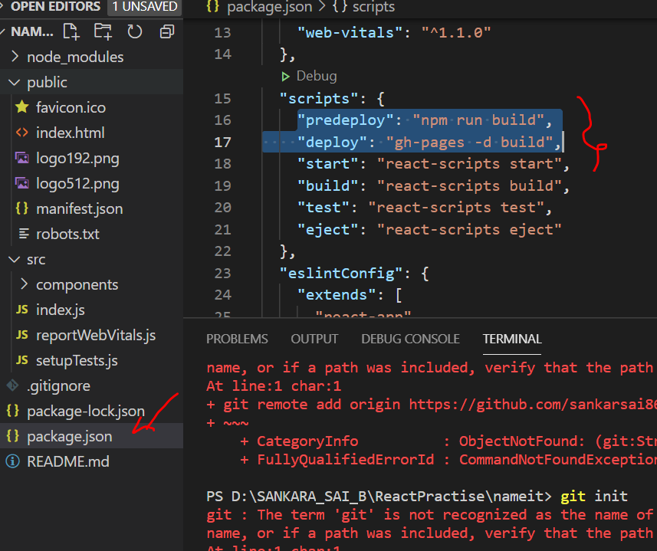

Step 4: Using Git bash login to your account

Step 5: git init

Step 6:

Copy URL from GIT

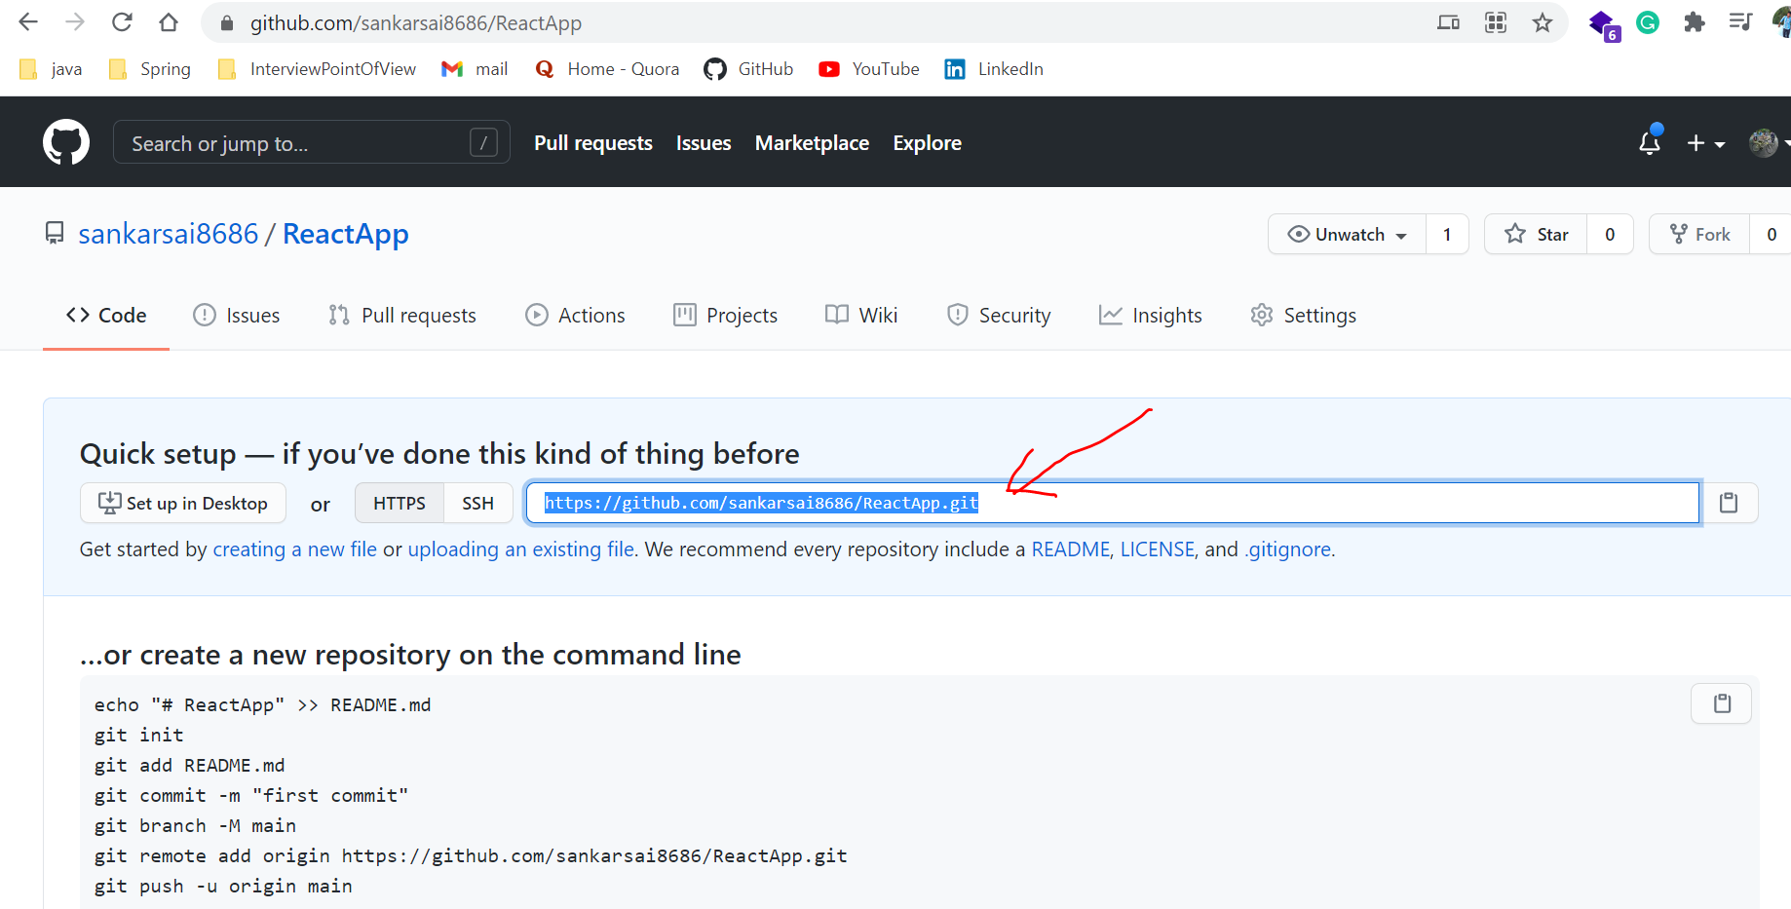

Execute in terminal

git remote add origin https://github.com/sankarsai8686/ReactApp.git

Step 7:

npm run deploy

Step 8:

