**Redis**, which stands for **R**emote **D**ictionary **S**erver, is a fast, open-source (BSD licensed), NoSQL, in-memory key-value data store use as a database, cache, message broker, and queue.

Redis is an Open source in-memory data structure store, used as a database, cache and message broker, this lesson will demonstrate only the caching integration.

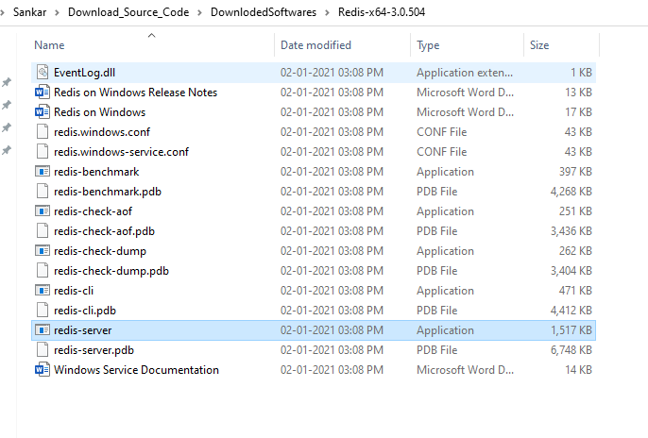

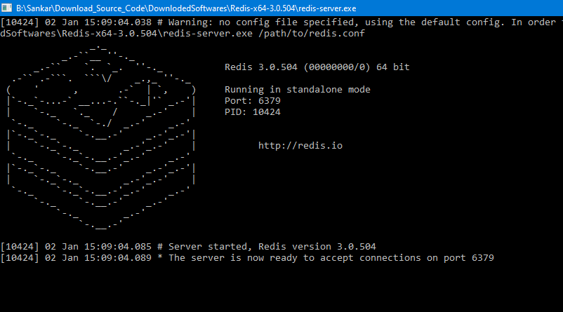

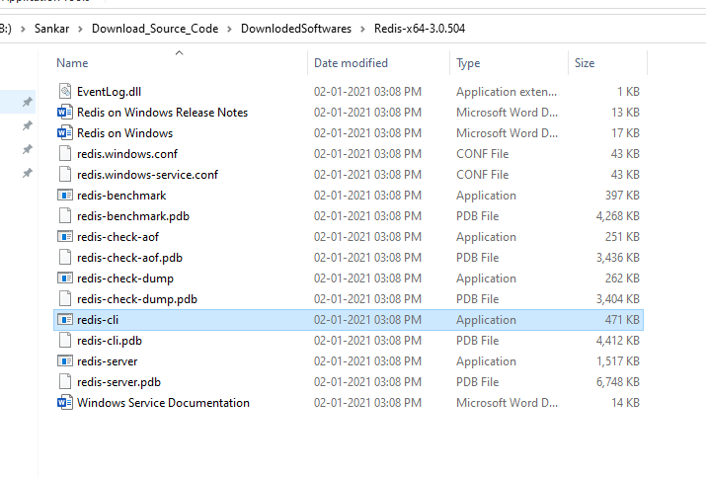

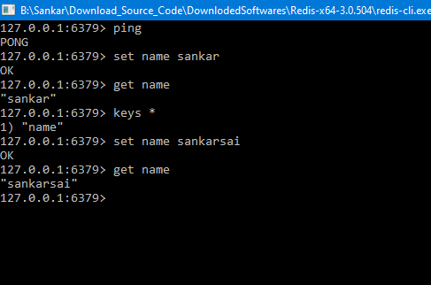

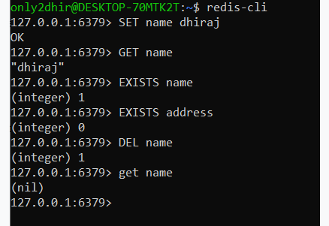

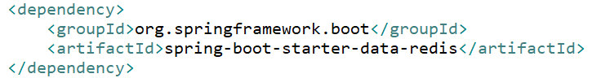

We require to define 2 Spring beans, [JedisConnectionFactory](https://docs.spring.io/spring-data/data-redis/docs/current/api/org/springframework/data/redis/connection/jedis/JedisConnectionFactory.html) and [RedisTemplate](https://docs.spring.io/spring-data/redis/docs/current/api/org/springframework/data/redis/core/RedisTemplate.html) to configure Redis with Spring Boot.

