* + - 1. **Code samples – best practices**

**Promise.All**

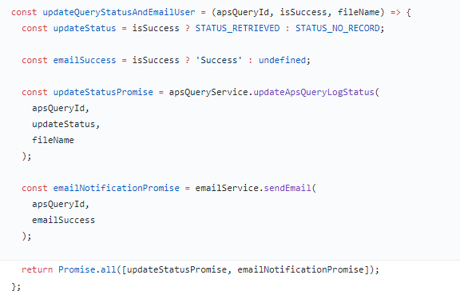

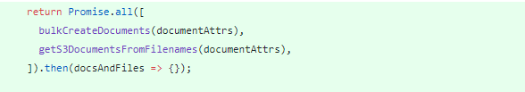

const processDocumentAndFileData = (sampleId, filename) => {

return docsAndFiles => {

const [docs, files] = docsAndFiles;

return Promise.all([

docs.map((doc, idx) => {

const { xml, fileName } = files[idx];

const convertedXml = convertAndUploadXml(

sampleId,

doc.documentId,

xml

);

const transform = transformAndUploadBBDAXml(

sampleId,

doc.documentId,

xml,

fileName

).then(transformed => {

return proxigramService.callToProxygramService(

transformed,

doc.documentId,

sampleId

);

});

return Promise.all([convertedXml, transform]);

}),

]).then(() => {

return gpsQuarService.updateGpsQuarLogStatus(

sampleId,

STATUS_COMPLETED,

filename

);

});

};

};

NotNull check

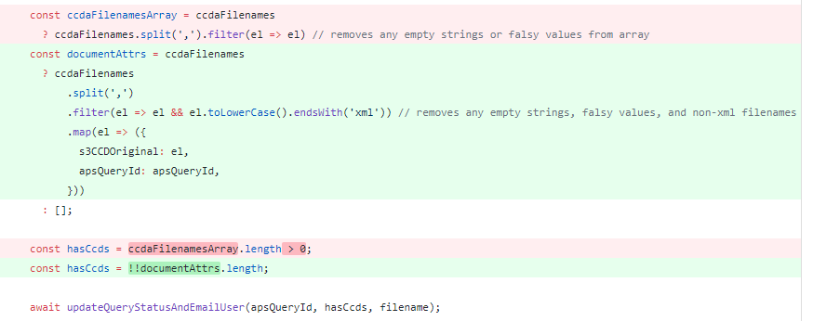

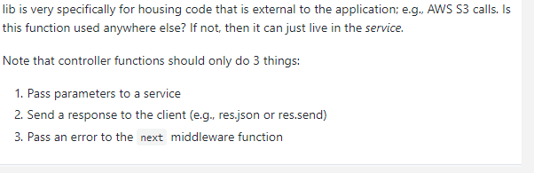

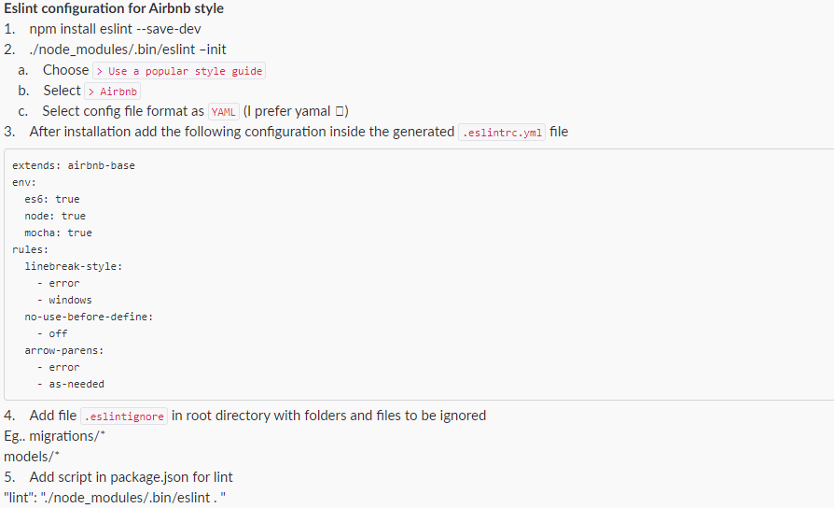

<https://github.com/craftninja/exp-starter-api>