**1.Problems and Solutions**

Problem:

1. Console error:

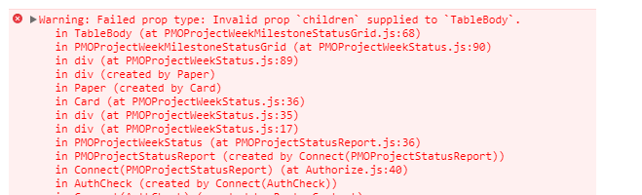

Solution:

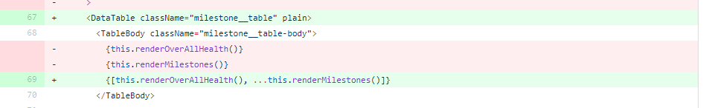

1. There is a previous and next button in a page. But flickering issue with button click.

Cause: Sate was getting cleaned and reloaded again.

Solution:

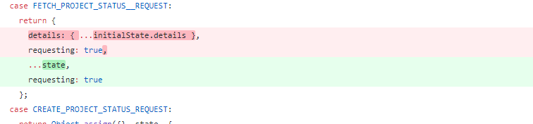

**2. PR review comments**

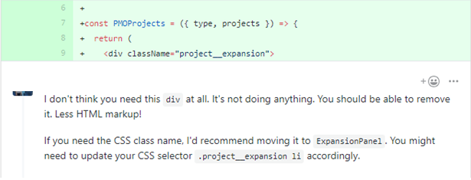

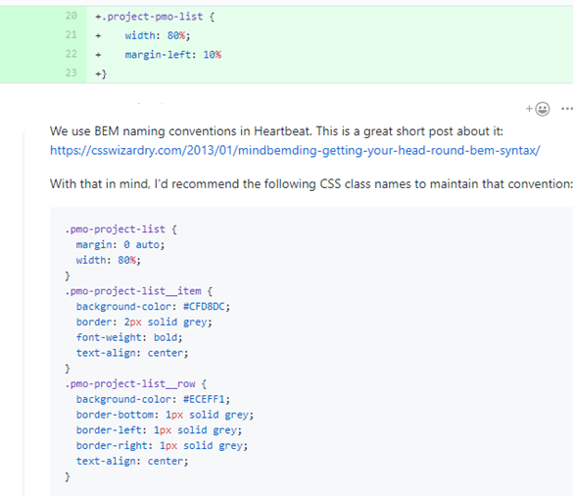



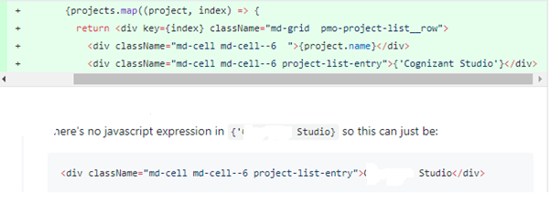

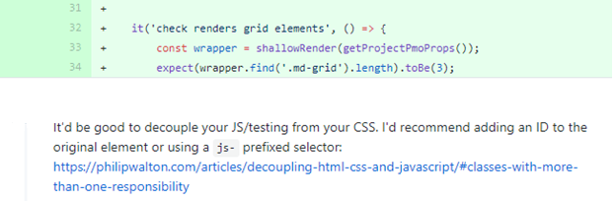

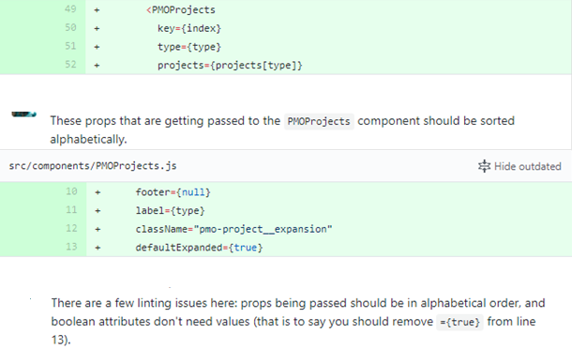



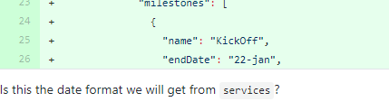

Overall looks great, but please make some changes per my feedback:  
• Don't use a <div> for everything. Use <table> for tabular data, and please follow the best practices here:  
<https://developer.mozilla.org/en-US/docs/Learn/CSS/Styling_boxes/Styling_tables>  
<https://css-tricks.com/accessible-simple-responsive-tables/>  
• Never use pt in CSS unless it's for print-specific styles  
• Always use 2-spaced tabs in Heartbeat  
• Be consistent in how your write your JS and CSS. Include a space before { in your CSS and between your property names and values in both your CSS and JS.

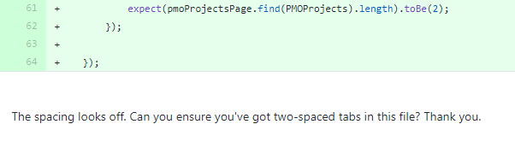

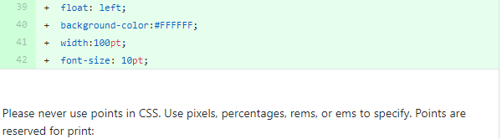

<https://css-tricks.com/css-font-size/#article-header-id-4>

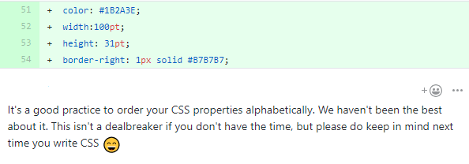

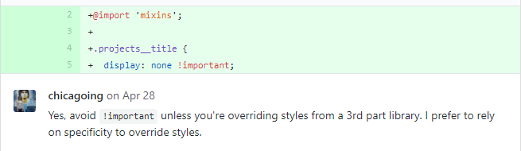

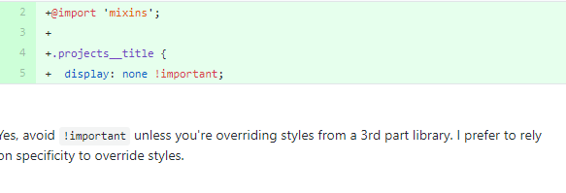



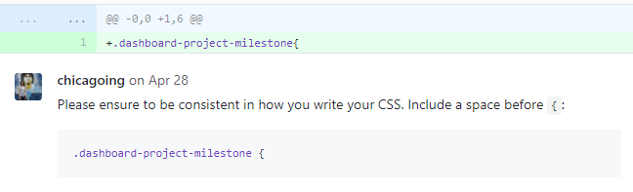

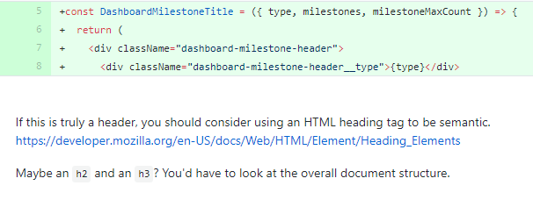

<https://developer.mozilla.org/en-US/docs/Web/HTML/Element/Heading_Elements>

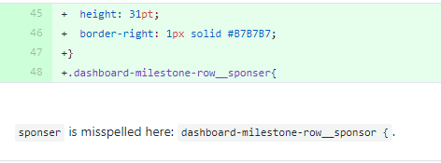

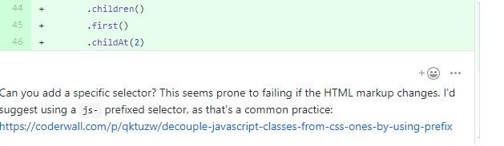

<https://coderwall.com/p/qktuzw/decouple-javascript-classes-from-css-ones-by-using-prefix>

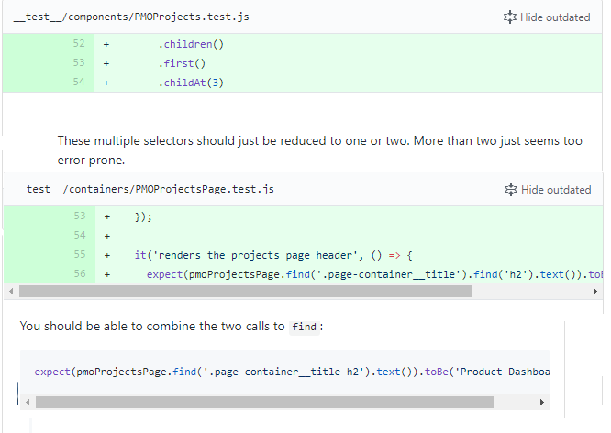

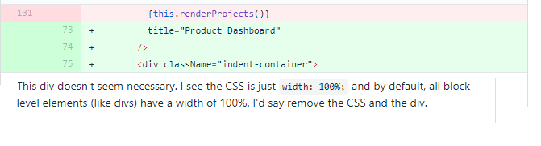

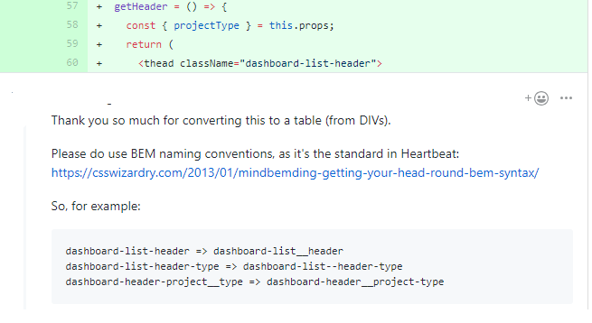

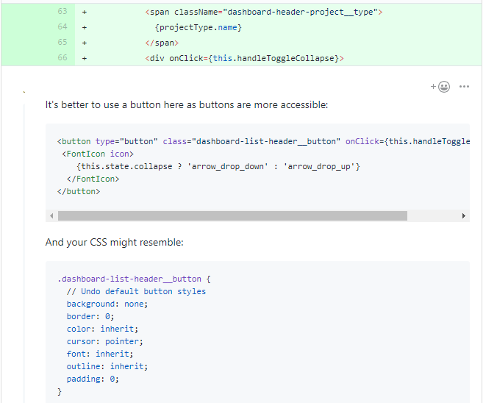

**3. Code samples – best practices**