**Environment**

**Cloud (Azure)**

Did complete setup of Azure cloud environment from the scratch for this demo using a free account.

Access:

<https://portal.azure.com/#@sankartechieprotonmail.onmicrosoft.com/dashboard/private/d05e417d-480c-47ea-bc3a-5117c3013733>

User credentials for guests:

[sankardemoclient@sankartechieprotonmail.onmicrosoft.com](mailto:sankardemoclient@sankartechieprotonmail.onmicrosoft.com)

Ping me for password

Resources used:

Azure functions, APIM, Azure SQL server, App insights, Storage

**Code repo/deployment:**

<https://github.com/sankartechie/AzureDemos> (public access, just need github account)

**Branches:**

WTT:

Has project (WTT.csproj) with 3 Azure functions ([CreateMatch.cs](https://github.com/sankartechie/AzureDemos/blob/WTT/WTT/CreateMatch.cs), GetPlayerInfo.cs, [UpdatePlayerStats.cs](https://github.com/sankartechie/AzureDemos/blob/WTT/WTT/UpdatePlayerStats.cs))

[sanazr.postman_collection.json](https://github.com/sankartechie/AzureDemos/blob/WTT/sanazr.postman_collection.json) - [fetch player thru api call from func endpoint](https://github.com/sankartechie/AzureDemos/commit/bd28beae7d5772141b01ff0d9eee03df1e69b853)

WTT_bkup:

Has the API and its associated test projects (to connect to function endpoints).

Works from Postman, test result screenshot

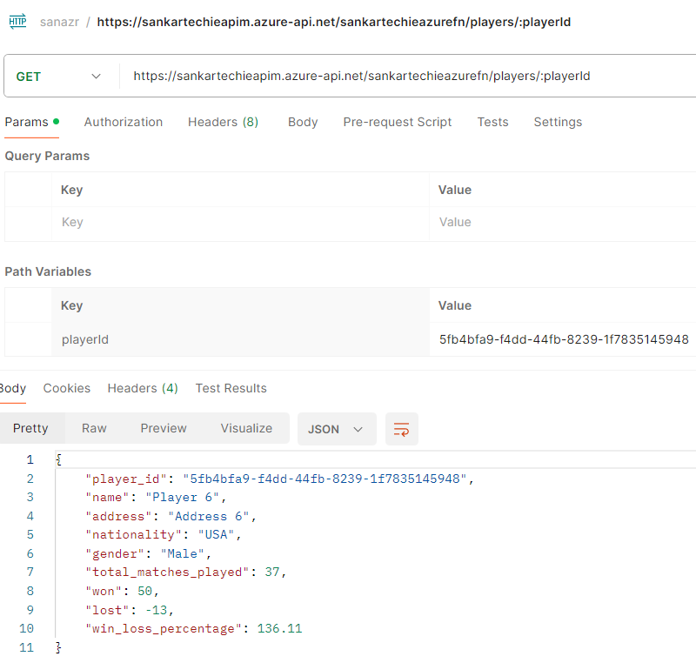

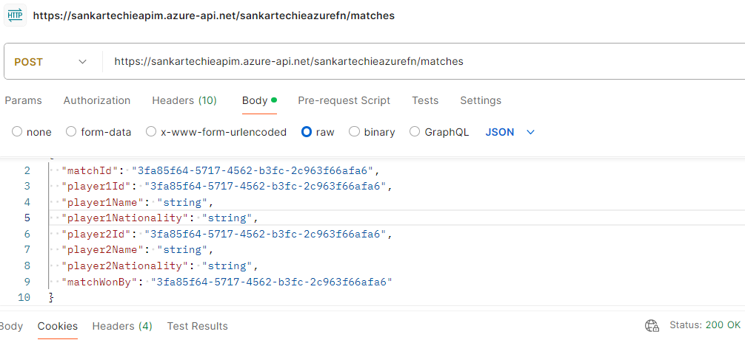

**Known error: (when accessing from Swagger API)**

Access denied

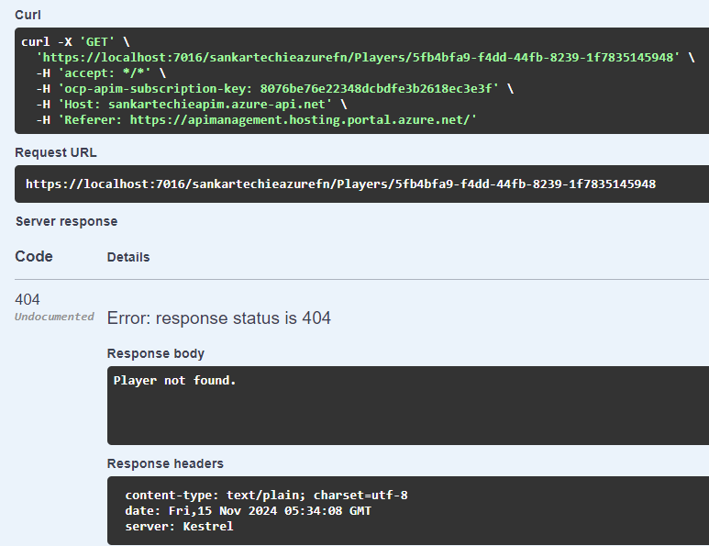

Seems like network related/auth issue, due to CORS/Custom domain;

Need completely setup environment and resources to continue (or) need more time