BUSINESS REQUIREMENT STATEMENT
Data Center Infrastructure Management (DCIM)

AI-Powered Rack Discovery, Configuration & Server Onboarding
Sunbird dcTrack with MCP Server Integration

Document ID | BRS-DCIM-2026-001
Version | 1.0
Date | April 2026
Prepared By | International Integrated Solutions Ltd.

1. Executive Summary
The data center operations team requires a modern, AI-assisted approach to manage the full lifecycle of rack cabinet infrastructure in Sunbird dcTrack. This includes discovering existing physical equipment using visual AI, configuring power and network connectivity, and onboarding new servers — all governed through formal change management.
This document defines the business requirements for a solution that transforms manual, error-prone data center documentation into an automated, AI-driven workflow powered by Sunbird dcTrack and a custom MCP (Model Context Protocol) server integration.

2. Business Context
Data center infrastructure documentation is frequently outdated, incomplete, or maintained through manual spreadsheets. When new equipment is installed or changes are made, the gap between physical reality and digital records widens. This leads to:
- Inaccurate capacity planning and stranded resources
- Untracked power and network connections creating compliance risks
- Time-consuming audits when onboarding new equipment
- No single system of record linking physical infrastructure to change management
- Inability to rapidly onboard new servers with full connectivity documentation

3. Scope of Requirement

3.1 Location
AI-DEMO-DC > AI-ROOM-01 — A single rack cabinet (AI-CAB-01) containing existing compute, network, and KVM infrastructure.

3.2 Existing Infrastructure
The following photograph shows the current state of the rack cabinet that must be documented in dcTrack:
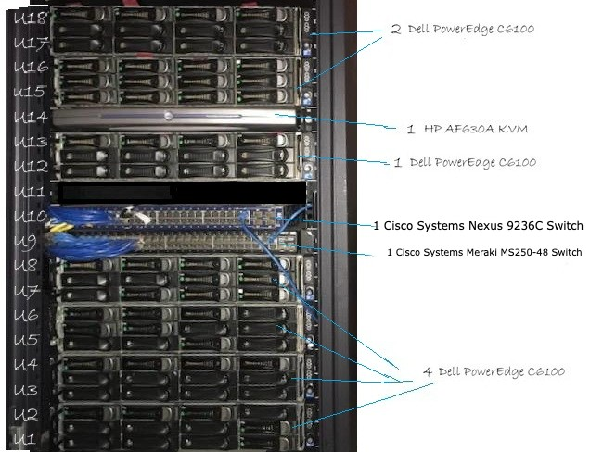
Figure 1: Existing Rack Cabinet AI-CAB-01 in AI-ROOM-01

Current Equipment Inventory
Qty | Equipment | Make | Position | Class
7 | PowerEdge C6100 | Dell | U1–U18 | Device (2U each)
1 | AF630A KVM | HP | U14 | Device (1U)
1 | Nexus 9236C Switch | Cisco | U10 | Network (36 QSFP28)
1 | Meraki MS250-48 Switch | Cisco | U9 | Network (48-port)

No PDU is currently documented. No power or network connections are recorded in dcTrack.

4. Functional Requirements
The solution must support three distinct operational phases, each governed by a formal change request:

4.1 Phase 1 — Rack Discovery (CR-1)
Requirement: Automatically discover and document existing rack equipment using visual AI.
- Photograph the physical rack cabinet
- AI vision identifies all equipment: servers, switches, KVM, blanking panels
- Detected equipment is presented in an editable table for human review
- One-click push to Sunbird dcTrack creates the cabinet and all items with correct U-positions
- Make and model are matched against the dcTrack model library using fuzzy search

4.2 Phase 2 — Configure Existing Infrastructure (CR-2)
Requirement: Install a PDU and configure all power and network connections via natural language.
- Create and mount a Rack PDU (CPI Orsted EA-3019-C, ZeroU side-mount)
- Set all items to Installed status
- Wire 10 power connections: PDU outlets to all device power supplies
- Create data ports on servers and switches
- Wire 9 network connections: 7 servers + KVM to Meraki, Meraki uplink to Nexus
- All configuration through conversational AI — no manual dcTrack navigation required

4.3 Phase 3 — New Server Onboarding (CR-3)
Requirement: Onboard 4 new Dell VxRail S670 servers with full connectivity.
- Create work orders for racking, network, power, and validation
- Mount 4 Dell VxRail S670 servers at U20, U22, U24, U26 (2U each)
- Connect network via QSFP28 100GbE ports to the Nexus 9236C switch
- Connect power to the existing PDU (outlets 11–14)
- Close work orders and change request with full audit trail

5. Desired Outcome
dcTrack should function as the single system of record for this infrastructure, providing visibility into:
Area | What dcTrack Must Show
Asset Discovery | All rack items with correct make, model, and U-position from AI scan
Rack Visualization | Cabinet front/back view with all items, side-mounted PDU visible
Power Connectivity | Complete power chain from UPS through Floor PDU to Rack PDU to device PS
Network Connectivity | Server eth0 to Meraki access ports, Meraki uplink to Nexus, VxRail qsfp0 to Nexus
Change Management | Project, 3 tickets (CR-1/CR-2/CR-3), tracked in Change > Tickets
Capacity Planning | Available U-space, free ports, and power outlet utilization
Audit Trail | Full history from discovery through configuration to expansion

6. Solution Architecture
The solution leverages three integrated components:

6.1 Rack Discovery AI
A browser-based chatbot that accepts rack cabinet photographs. The AI vision model (Claude) analyzes the image to identify all visible equipment, extract make/model/position, and present an editable inventory table. One-click push creates the cabinet and all items in dcTrack via the MCP server.

6.2 Sunbird DCIM AI Assistant
A conversational chat interface that translates natural language commands into dcTrack API operations. Operators can create items, configure connections, manage tickets, and query rack status using plain English. The assistant dynamically discovers available MCP tools and selects the appropriate one.

6.3 MCP Server (Model Context Protocol)
A Node.js server deployed on OpenShift that exposes 190+ dcTrack and PowerIQ operations as standardized tools. The MCP server handles item name resolution, model library fuzzy matching, power port discovery, and connection creation — abstracting the complexity of the dcTrack REST API.

7. Demo Execution Plan
The following phases demonstrate the complete lifecycle:
# | Phase | Tool | Key Actions
1 | Rack Discovery via Visual AI | Rack AI | Upload photo, AI identifies 10 items, push to dcTrack
2 | Project & Change Requests | Chat UI | Create project + 3 tickets as change requests
3 | Install PDU & Set Status | Chat UI | Create PDU (side-mount), install all items
4 | Power Connections | UI/Chat | 14 power circuits: PDU outlets to all devices
5 | Network Connections | Chat UI | 13 data connections: servers to Meraki to Nexus
6 | Work Orders | Chat UI | 4 WOs for racking, network, power, closeout
7 | New Server Onboarding | Chat UI | 4 VxRail S670 servers + network + power
8 | Validation & Closeout | Chat UI | Rack summary, audit trail, close project

8. Success Criteria
The solution is considered successful when:
- A rack photo is scanned and all 10 items appear in dcTrack at correct U-positions
- PDU is visible as a side-mounted red bar in the rack visualization
- All power circuits trace from device PS through PDU to upstream power
- Network connections are documented: servers to Meraki, Meraki to Nexus, VxRail to Nexus
- 4 new VxRail S670 servers are onboarded with full connectivity in a single session
- All operations are performed through natural language prompts (no manual dcTrack navigation)
- Complete audit trail exists from project creation through closeout

9. Constraints & Dependencies
- Sunbird dcTrack 9.2.3-85 with REST API v2 enabled
- Power circuit creation requires upstream chain (Floor PDU to Rack PDU inlet) configured via dcTrack UI
- dcTrack Change Management request types must be configured per item class; demo uses Tickets as lightweight change tracking
- Equipment make/model must exist in dcTrack model library; fuzzy matching selects closest
- OpenShift cluster hosting MCP server, n8n workflows, and Portkey LLM gateway
- Anthropic Claude API access for vision analysis and natural language processing

End of Document

