Capstone Project

**Course code:** CSA4385

**Course:** Internet Programming for Green App

**Team:** 02

**Name:**

S.vaishnavi

B.V.Bavana

**Registration no:**

192211575

192211331

**Slot:** B

**Title:** Travel Agency by using Icdi code

**Guided by:** Venkatesan sir

**Department:** CSE

**College:** Saveetha School of Engineering



**Objectives**

1. **Creating a niche**: Specializing in a specific area of travel expertise.
2. **Selling expertise**: Providing valuable knowledge and insider information to clients.
3. **Making travel planning and booking easier**: Offering convenience and access to exclusive deals.
4. **Building customer relationships**: Focusing on repeat business and customer satisfaction.
5. **Serving as a link between clients and suppliers**: Facilitating travel services and providing reliable information.
6. **Database Management with MySQL:**
   * Design a relational database in MySQL to store information about pets, adopters, and adoption applications.
   * Implement CRUD (Create, Read, Update, Delete) operations to manage data effectively.
7. **Ensure Data Security and Validation:**

Different types of travel agency objectives exist. The particular objectives you choose depend on the goals and focus of your agency. Creative and innovative objectives give a travel agency exciting, new options to increase the value of products and services to customers.

* + Create distinct interfaces and functionalities for admin users and regular users.
  + Allow admins to add, update, or remove pets from the adoption list, manage user accounts, and review adoption applications.

1. **Provide Responsive and Accessible Design:**
   * Ensure the platform is accessible across various devices by implementing responsive design principles.
   * Adhere to web accessibility standards to make the platform usable for people with disabilities.
2. **Integrate External APIs and Services:**
   * Utilize APIs for additional features such as location-based pet searches or integration with social media for sharing adoptable pets.
   * Include features like email notifications for adoption updates or reminders.

**Keywords**

• Travel Agency

• Travel Agent

• Book Travel

• Vacation Packages

• Holiday Packages

• Travel Deals

• Travel Offers

• Travel Planner

• Travel Services

* **Introduction**

At [Your Travel Agency Name], we believe that travel is more than just visiting new places; it's about creating memories that last a lifetime. Whether you're dreaming of sun-soaked beaches, thrilling adventures, cultural explorations, or tranquil escapes, we are here to make those dreams a reality.

With years of experience and a passion for discovering the world's most captivating destinations, our team of dedicated travel experts is committed to providing personalized service and bespoke travel experiences. From the moment you contact us to the day you return home, we ensure every detail is meticulously planned and executed, so you can travel with confidence and peace of mind. **Tailored Itineraries:** We understand that every traveler is unique. That's why we offer customized travel plans that cater to your specific interests, preferences, and budget.

**Exclusive Deals:** Take advantage of our exclusive travel deals and packages, designed to give you the best value for your money without compromising on quality.

**Expert Guidance:** Our knowledgeable travel consultants are passionate about travel and are always on hand to offer expert advice and insider tips to enhance your travel experience.

**Comprehensive Services:** From flight bookings and hotel reservations to car rentals, guided tours, and travel insurance, we provide a full range of travel services to meet all your needs.

**24/7 Support:** Travel with peace of mind knowing that our support team is available around the clock to assist you with any questions or concerns during your trip. Discover the wonders of Europe, the exotic charm of Asia, the vibrant cultures of South America, the breathtaking landscapes of Africa, and the endless adventures awaiting you in every corner of the globe. Whether you're planning a romantic getaway, a family vacation, a solo adventure, or a group tour, [Your Travel Agency Name] is your trusted partner in crafting extraordinary travel experiences.

* **Pets Adoption (HTML):**

<!DOCTYPE html>

<html lang="en">

<head>

  <meta charset="UTF-8">

  <meta name="viewport" content="width=device-width, initial-scale=1.0">

  <title>View Pets</title>

  <link rel="stylesheet" href="styles.css">

</head>

<body>

  <header>

    <h1>Pet Adoption</h1>

    <nav>

      <ul>

        <li><a href="index.html">Home</a></li>

        <li><a href="pets.html">View Pets</a></li>

        <li><a href="contact.html">Contact</a></li>

      </ul>

    </nav>

  </header>

  <div id="pets-container">

    <!-- Pets will be dynamically added here -->

    <h1>pets</h1>

  </div>

  <footer>

    <p>&copy; 2024 Pet Adoption</p>

  </footer>

  <script src="script.js"></script>

</body>

</html>

* **OUTPUT:**

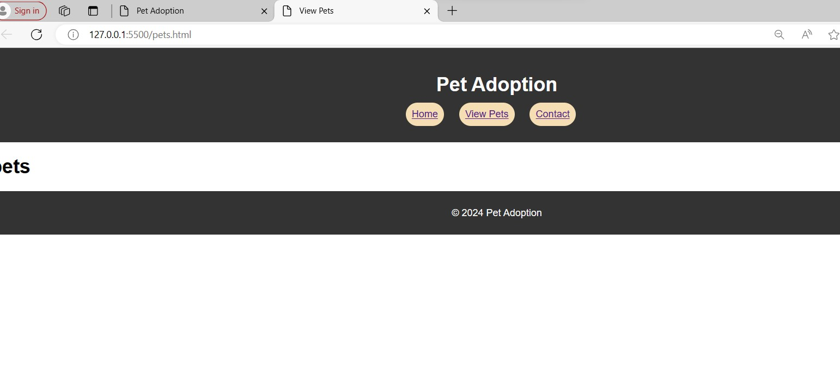

* **PET ADOPTION WEBSITE**

<!DOCTYPE html>

<html lang="en">

<head>

  <meta charset="UTF-8">

  <meta name="viewport" content="width=device-width, initial-scale=1.0">

  <title>Pet Adoption</title>

  <link rel="stylesheet" href="styles.css">

</head>

<body>

  <header>

    <h1>Pet Adoption</h1>

    <nav>

      <ul>

        <li><a href="index.html">Home</a></li>

        <li><a href="pets.html">View Pets</a></li>

        <li><a href="contact.html">Contact</a></li>

      </ul>

    </nav>

  </header>

  <div class="hero">

    <img src="cat.jpeg" alt="Pet Adoption" class="hero-image">

    <img src="pet1.jpeg" alt="Pet Adoption" class="hero-image">

    <h2>Welcome to our Pet Adoption Website</h2>

    <p>Find your new furry friend today!</p>

  </div>

  <footer>

    <p>&copy; 2024 Pet Adoption</p>

  </footer>

</body>

</html>

* **OUTPUT:**

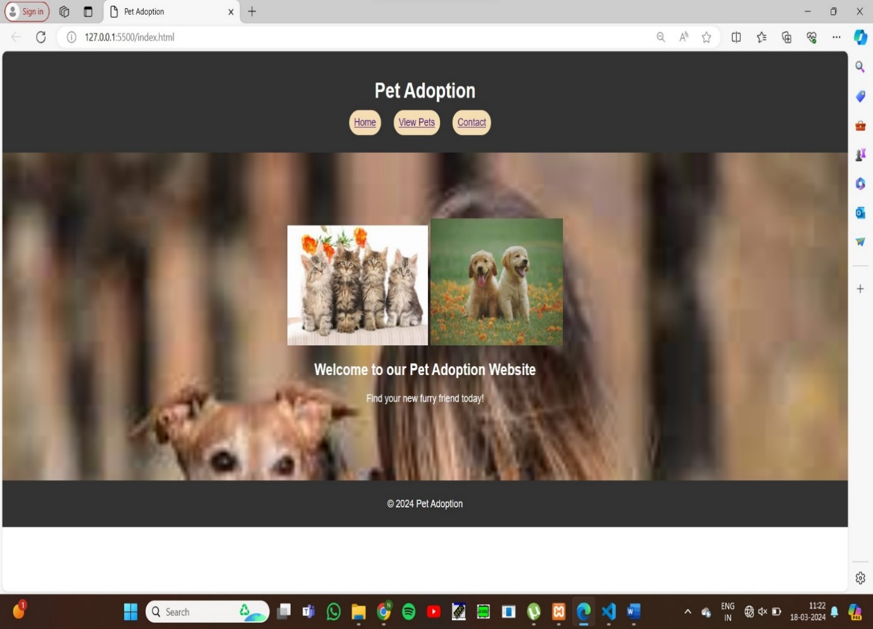

* **CONTACT HTML:**

<!DOCTYPE html>

<html>

<head>

    <title>Registration Form</title>

</head>

<body>

    <center>

    <h2>Registration Form</h2>

    <form method="post" action="<?php echo htmlspecialchars($_SERVER["PHP_SELF"]); ?>">

        <input type="hidden" name="action" value="submit_registration">

        <label for="firstname">First Name:</label><br>

        <input type="text" id="firstname" name="firstname"><br><br>

        <label for="lastname">Last Name:</label><br>

        <input type="text" id="lastname" name="lastname"><br><br>

        <label for="phonenumber">Phone Number:</label><br>

        <input type="text" id="phonenumber" name="phonenumber"><br><br>

        <label for="username">Username:</label><br>

        <input type="text" id="username" name="username"><br><br>

        <label for="email">Email:</label><br>

        <input type="email" id="email" name="email"><br><br>

        <label for="password">Password:</label><br>

        <input type="password" id="password" name="password"><br><br>

        <label for="gender">Gender:</label><br>

        <select id="gender" name="gender">

            <option value="male">Male</option>

            <option value="female">Female</option>

            <option value="other">Other</option>

        </select><br><br>

        <input type="submit" value="Submit">

    </form>

    </center>

* **OUTPUT:**

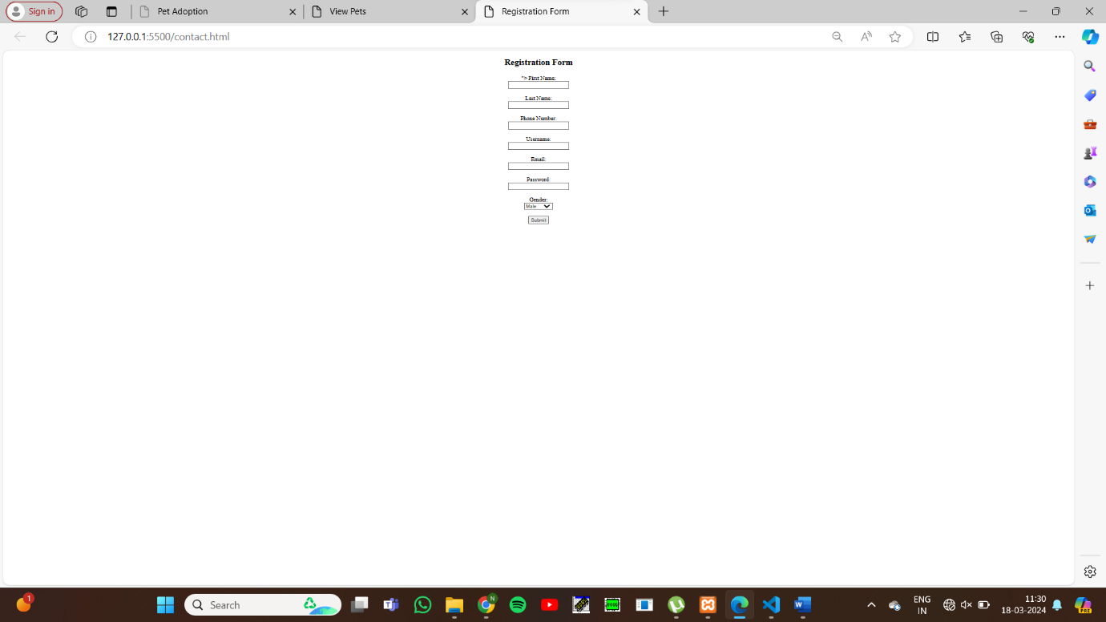

* **PHP DATA BASE CODE:**

<!DOCTYPE html>

<html>

<head>

    <title>Registration Form</title>

</head>

<body>

    <center>

    <h2>Registration Form</h2>

    <form method="post" action="<?php echo htmlspecialchars($_SERVER["PHP_SELF"]); ?>">

        <input type="hidden" name="action" value="submit_registration">

        <label for="firstname">First Name:</label><br>

        <input type="text" id="firstname" name="firstname"><br><br>

        <label for="lastname">Last Name:</label><br>

        <input type="text" id="lastname" name="lastname"><br><br>

        <label for="phonenumber">Phone Number:</label><br>

        <input type="text" id="phonenumber" name="phonenumber"><br><br>

        <label for="username">Username:</label><br>

        <input type="text" id="username" name="username"><br><br>

        <label for="email">Email:</label><br>

        <input type="email" id="email" name="email"><br><br>

        <label for="password">Password:</label><br>

        <input type="password" id="password" name="password"><br><br>

        <label for="gender">Gender:</label><br>

        <select id="gender" name="gender">

            <option value="male">Male</option>

            <option value="female">Female</option>

            <option value="other">Other</option>

        </select><br><br>

        <input type="submit" value="Submit">

    </form>

    </center>

    <?php

    $servername = "localhost";

    $username = "root";

    $password = "";

    $dbname = "pet";

    $conn = new mysqli($servername, $username, $password, $dbname);

    if ($conn->connect_error) {

        die("Connection failed: " . $conn->connect_error);

    }

    if (isset($_POST['action']) && $_POST['action'] == 'submit_registration') {

        $firstname = isset($_POST['firstname']) ? $conn->real_escape_string($_POST['firstname']) : '';

        $lastname = isset($_POST['lastname']) ? $conn->real_escape_string($_POST['lastname']) : '';

        $phonenumber = isset($_POST['phonenumber']) ? $conn->real_escape_string($_POST['phonenumber']) : '';

        $username = isset($_POST['username']) ? $conn->real_escape_string($_POST['username']) : '';

        $email = isset($_POST['email']) ? $conn->real_escape_string($_POST['email']) : '';

        $password = isset($_POST['password']) ? $conn->real_escape_string($_POST['password']) : '';

        $gender = isset($_POST['gender']) ? $conn->real_escape_string($_POST['gender']) : '';

        $sql = "INSERT INTO details(firstname, lastname, phonenumber, username, email, password, gender)

                VALUES ('$firstname', '$lastname', '$phonenumber', '$username', '$email', '$password', '$gender')";

        if ($conn->query($sql) === TRUE) {

            echo "Records inserted successfully.";

        } else {

            echo "ERROR: Could not able to execute $sql. " . $conn->error;

        }

    }

    $conn->close();

    ?>

</body>

</html>

* **OUTPUT:**

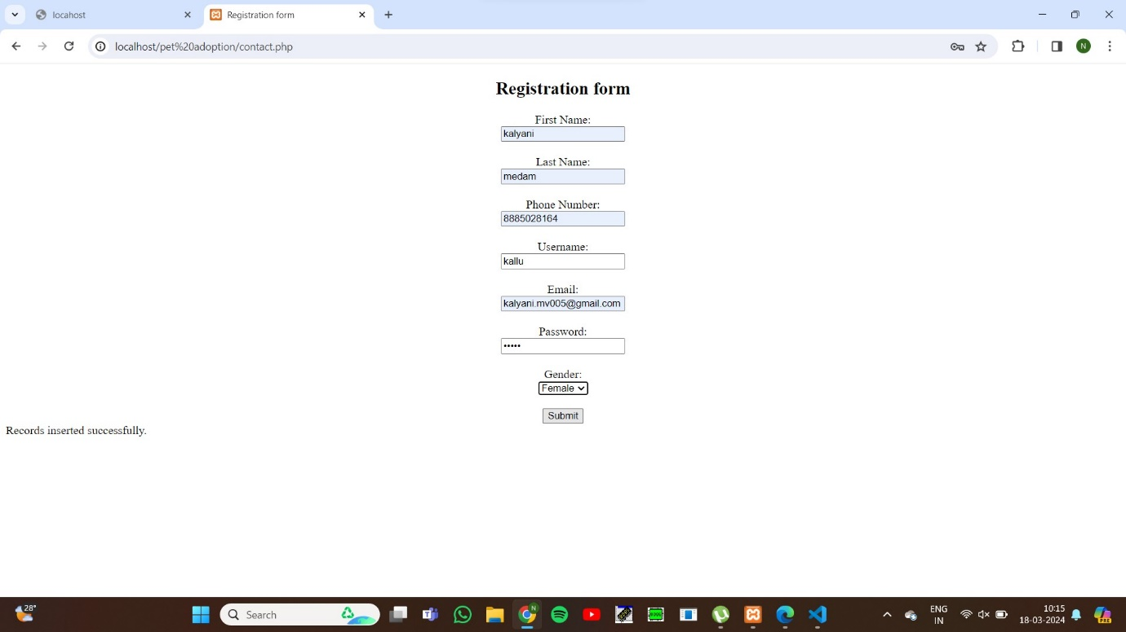

* **STYLE SHEET CSS:**

body {

    font-family: Arial, sans-serif;

    margin: 0;

    padding: 0;

  }

  header {

    background-color: #333;

    color: white;

    padding: 20px;

    text-align: center;

  }

  nav ul {

    list-style-type: none;

    padding: 0;

  }

  nav ul li {

    display: inline;

    margin-right: 20px;

    background-color:wheat;

    padding: 10px;

    border-radius: 20px;

    text-decoration-color: black;

  }

  .hero {

    background-image: url('background.jpeg');

    background-size: cover;

    color: white;

    text-align: center;

    padding: 100px 0;

  }

  footer {

    background-color: #333;

    color: white;

    padding: 10px 0;

    text-align: center;

  }

  .contact-form {

    margin: 20px auto;

    width: 50%;

  }

  .contact-form form {

    border: 1px solid #ccc;

    padding: 20px;

  }

  .contact-form label {

    display: block;

    margin-bottom: 5px;

  }

  .contact-form input[type="text"],

  .contact-form input[type="email"],

  .contact-form textarea {

    width: 100%;

    margin-bottom: 10px;

  }

  .contact-form button {

    background-color: #333;

    color: white;

    border: none;

    padding: 10px 20px;

    cursor: pointer;

  }

  .contact-form button:hover {

    background-color: #555;

  }

* **OUTPUT:**



* **CONCLUSION:**

Explore our diverse range of travel packages and services, designed to suit every taste and budget. Our team of passionate travel consultants is ready to provide you with expert advice and ensure that every detail of your trip is flawlessly executed.Join the countless travelers who have experienced the world with [Your Travel Agency Name] and discovered the true joy of travel. Your next adventure is just a call or click away.