AI CAPSTONE PROJECT — CAPSTONE 20
AI Social Media Content Calendar for a Small Business
Project Brand: CAKE CORNER
A fictional cake shop concept
Student Name: __________________________ Class/Department: __________________________
Date: __________________________

1. Project Overview
This project uses AI tools to plan and prepare a 30-day social media content calendar for Cake Corner, a fictional small cake shop. The package includes content themes, post types, hashtags, 12 drafted captions, six matching visuals, a short Reel storyboard, and a simple spreadsheet automation workflow.

2. Business and Target Audience
Cake Corner is a fictional bakery concept offering birthday cake inspiration, cupcakes, brownies, custom cake ideas and wedding cake inspiration. The intended audience is families, students and working adults planning birthdays, celebrations and small events. The brand tone is warm, cheerful, friendly and clear.

3. Objectives
- Prepare a 30-day social media content calendar.
- Draft 12 social media posts with captions and hashtags.
- Create six matching visual designs.
- Plan a short vertical Reel/video.
- Automate one step by moving READY calendar rows into a Draft Queue in Google Sheets.
- Compare AI-assisted and manual workflow time, including review and correction.

4. AI Tools and Their Uses
Tool | Use in project | Output
ChatGPT / Gemini | Idea generation, calendar planning, caption drafting, review prompts | Calendar ideas and caption drafts
Canva | Create or edit branded poster layouts | Six matching visuals
CapCut | Arrange visuals/video clips, add captions and transitions | Short Reel
Google Sheets | Organise calendar and demonstrate automation | Calendar and Draft Queue
Use free-tier options where available. Tool features and free limits can change; no paid plan is required for this project package.

5. Content Calendar
The attached CSV and Excel files contain all 30 days, including theme, post type, content idea and suggested hashtags. The plan mixes static posts, carousels, stories and Reels to keep the content varied.

6. Twelve Social Media Post Drafts
01 - Brand introduction
Every celebration deserves a little sweetness! Welcome to Cake Corner, your fictional neighbourhood-inspired cake shop for birthday cakes, cupcakes, brownies and custom cake ideas. What would you love to celebrate next? #CakeCorner #CelebrationTime #CakeLovers
02 - Birthday cake
Big wishes call for a cake made to match the moment. Explore this birthday cake inspiration and tell us which flavour you would choose! #BirthdayCake #CakeCorner #PartyIdeas
03 - Cupcake spotlight
A little treat, a lot of joy. Our cupcake inspiration is ready for your next get-together. Which topping would you pick: sprinkles or chocolate? #Cupcakes #SweetTreats #CakeCorner
04 - Flavour poll
Help us choose a flavour for our next cake idea! Are you team chocolate, vanilla, or strawberry? Vote in the comments or story poll. #FlavourPoll #CakeLovers #CakeCorner
05 - Brownie moment
Chocolate fans, this one is for you. Save this brownie serving idea for your next movie night or friendly get-together. #BrownieTime #ChocolateLovers #CakeCorner
06 - Custom cake
Your idea can inspire a special cake design. Share a theme, colour palette, or celebration idea, and explore the possibilities with Cake Corner. #CustomCake #CakeDesign #CakeCorner
07 - Weekend treat
Weekend plans: good company and a sweet little treat. Which would you choose today—cupcakes, brownies, or a slice of cake? #WeekendTreat #DessertIdeas #CakeCorner
08 - Cake care
Planning to serve a cake later? Follow the storage instructions provided with the cake and check ingredient-specific guidance. When in doubt, ask the baker. #CakeCare #HelpfulTips #CakeCorner
09 - Wedding inspiration
A celebration design can be simple, elegant, colourful, or completely personal. Which wedding cake style inspires you most? #WeddingCake #CakeInspiration #CakeCorner
10 - Party checklist
A little planning makes celebration day easier: choose a theme, estimate guest numbers, discuss serving size, and confirm collection details with your baker. #PartyPlanning #BirthdayIdeas #CakeCorner
11 - Behind the scenes
From an idea to a finished design, every cake begins with a plan. Here is a short look at our fictional decorating process. #BehindTheScenes #CakeDecorating #CakeCorner
12 - Month highlights
Thirty days of sweet ideas! Thank you for exploring cake designs, cupcakes, brownies and celebration inspiration with Cake Corner. Which post was your favourite? #MonthlyHighlights #CakeCorner #CakeLovers

7. Six Visual Designs
Six coordinated poster designs are included in the posters folder: birthday cake, cupcakes, brownies, custom cake, wedding cake inspiration and weekend treats. They use a consistent pastel bakery style. The designs are sample graphics for a fictional brand.
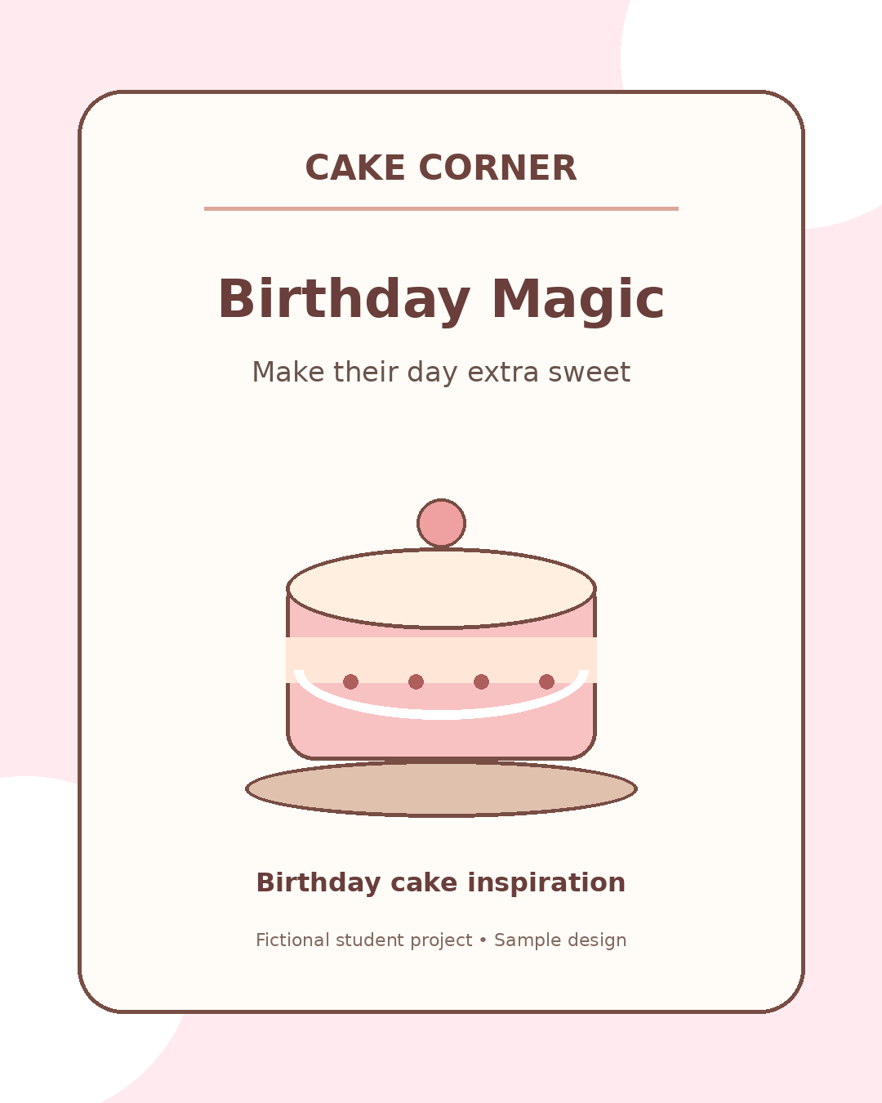
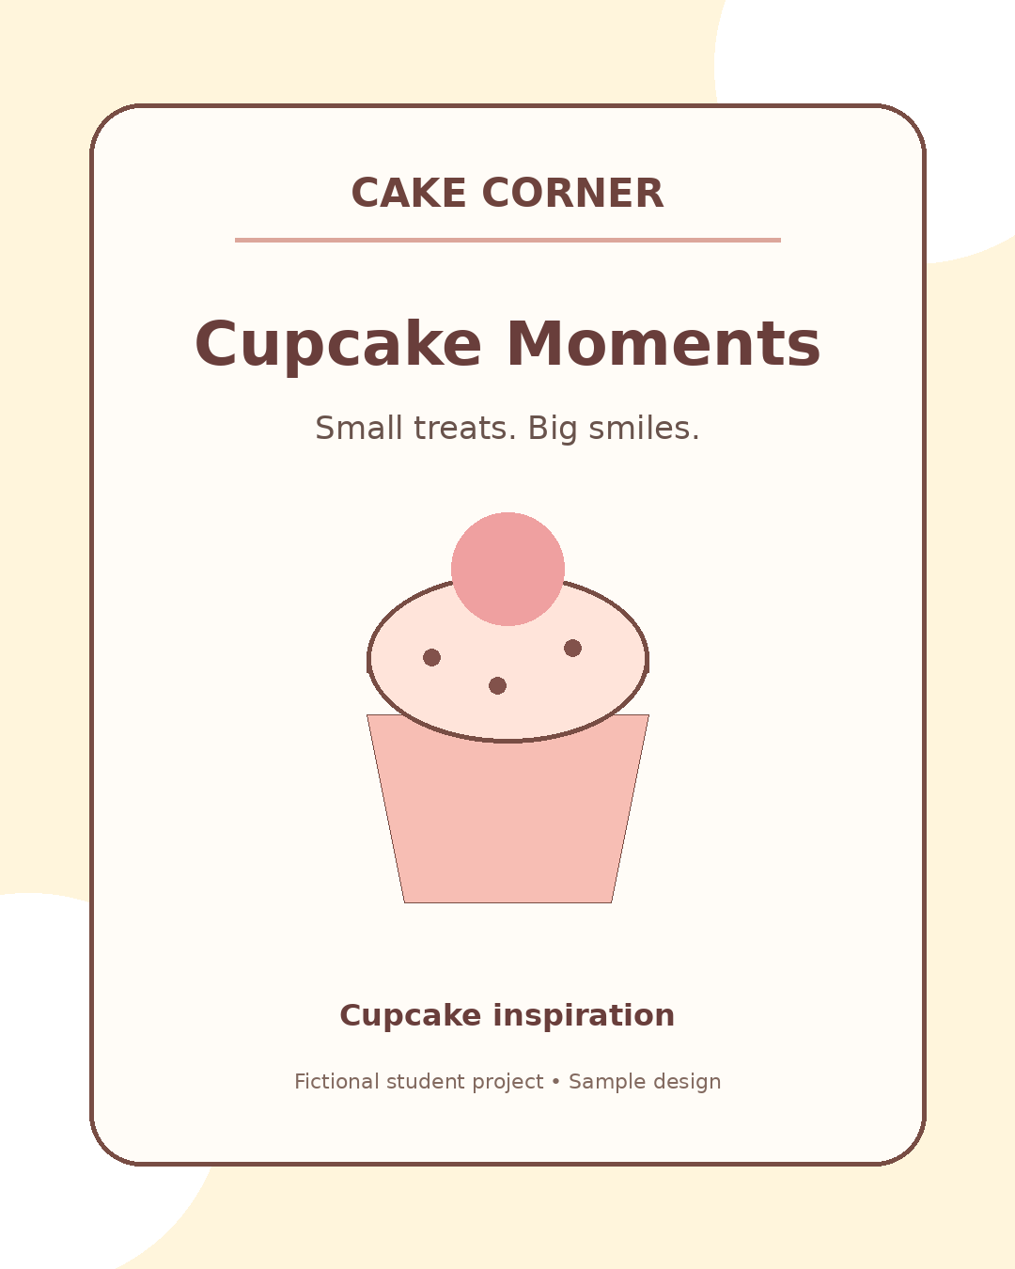
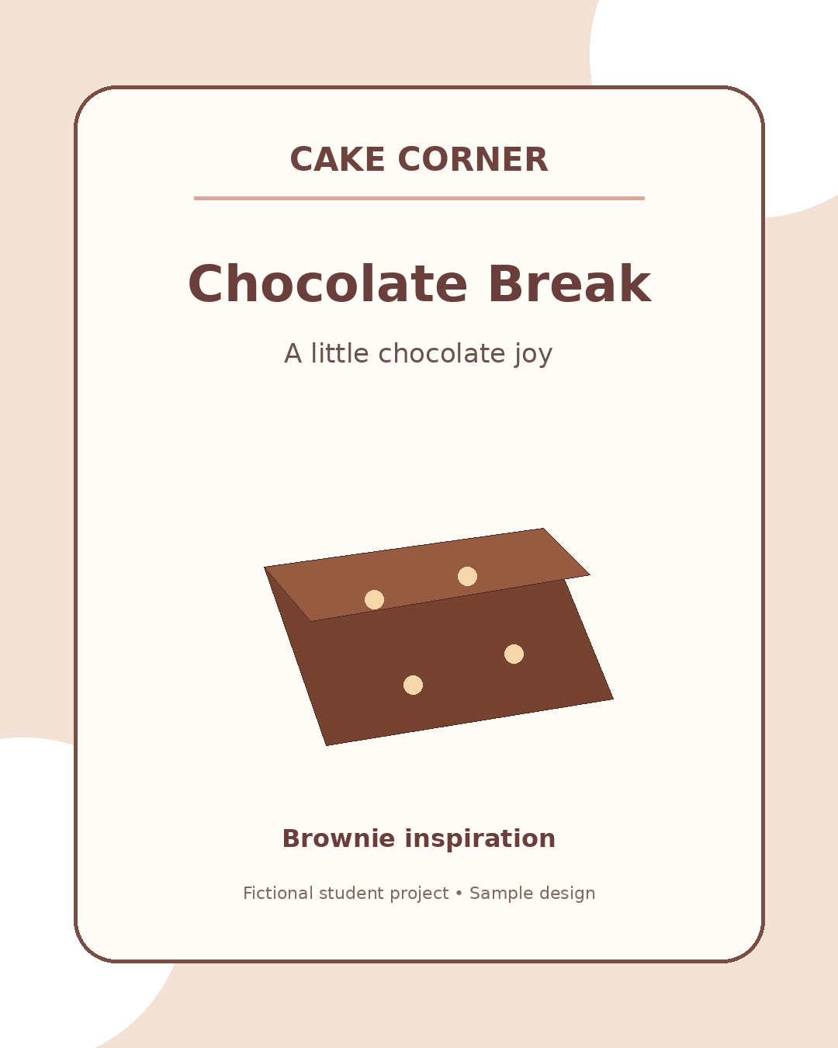
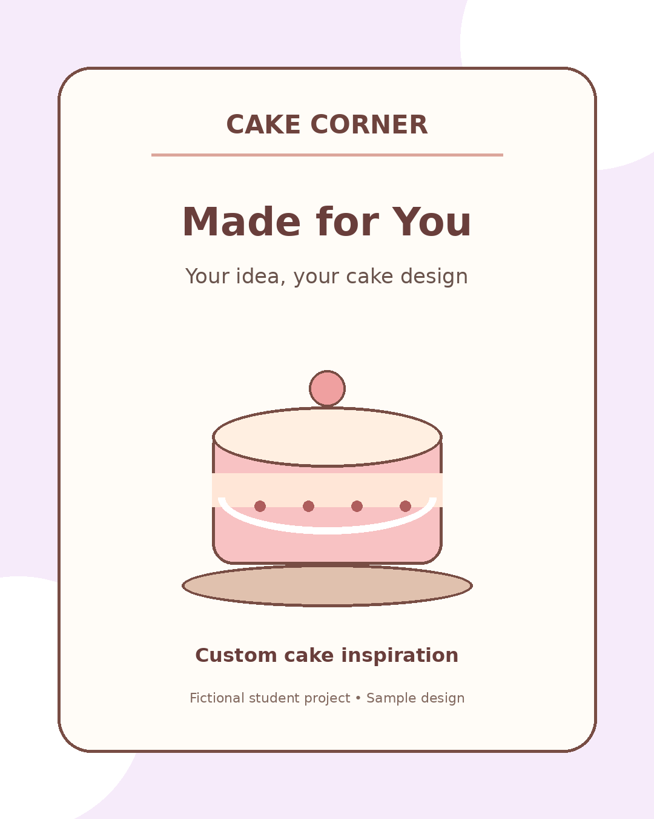
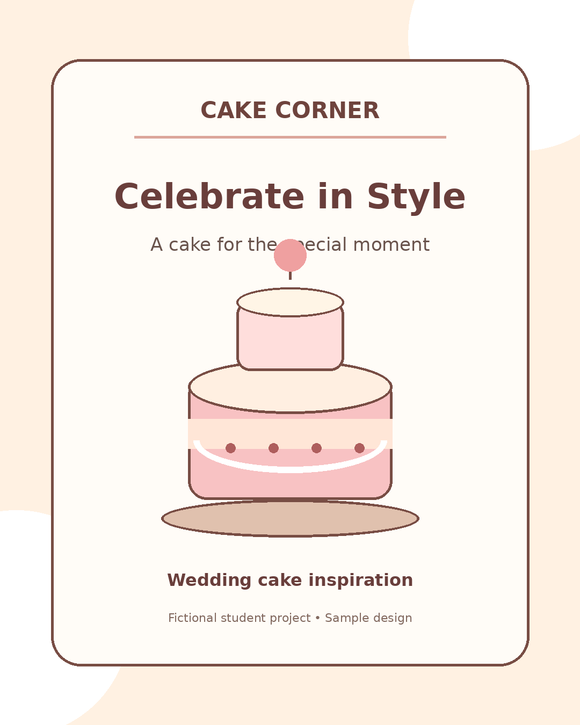
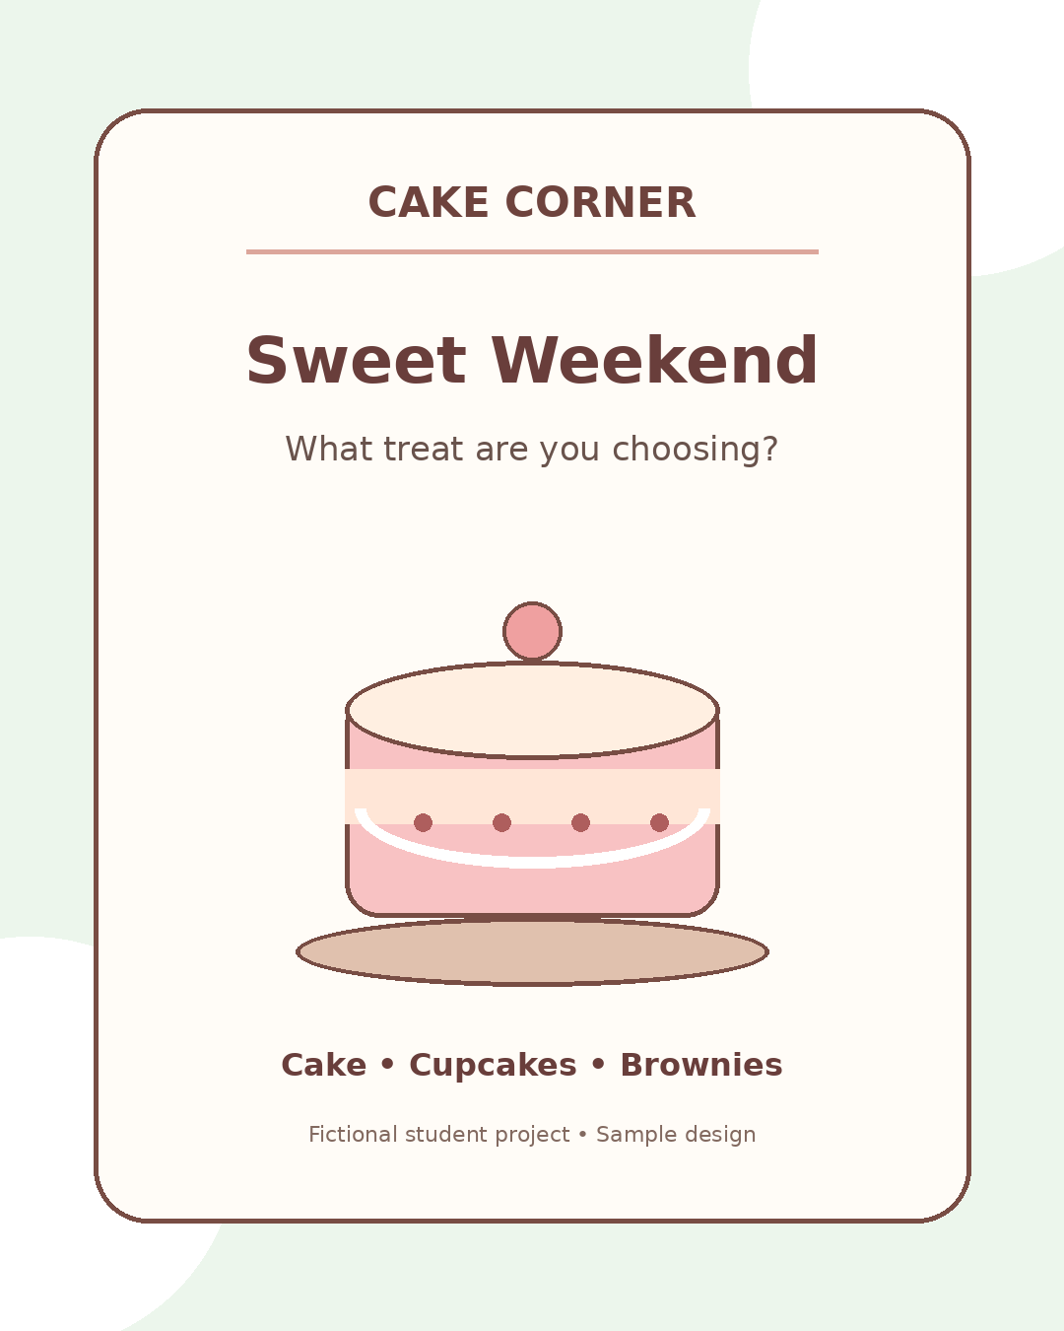

8. Reel / Short Video
A 20–25 second vertical Reel storyboard is included in video/reel_script_and_storyboard.txt. It contains six scenes, suggested on-screen text and voiceover. Assemble it in CapCut using original footage or properly licensed assets.

9. Automation Workflow
The Google Sheets automation guide includes a script that copies rows marked READY from the Calendar sheet into a Draft Queue sheet, then marks the original row COPIED. It does not publish content or contact users. Test it with sample data only.

10. AI vs Manual Comparison
An illustrative comparison file is included. The sample estimates are not measured results. For a fair comparison, time the manual and AI-assisted workflows, including prompting, editing, fact-checking and final review, then replace the estimates with actual observations.

11. Research, Verification and Responsible AI
The project uses a fictional business and clearly stated audience assumptions. No real customer survey, sales data or competitor research is claimed. Before public use, verify product availability and any food-related advice. Remove unsupported prices, testimonials, contact details and claims. Use original or licensed images and music, check cultural relevance, and do not upload private customer data.

12. AI Skills Demonstrated
- Prompt engineering and iterative prompting
- Research planning and audience definition
- Text generation and content adaptation
- Multimodal visual content creation
- Workflow design and basic automation
- Verification, error analysis and fact-checking
- Responsible AI and copyright awareness
- Comparative evaluation of AI-assisted and manual work

13. Conclusion
This capstone demonstrates how AI can support a small-business social media workflow, from planning and drafting to visual design and spreadsheet organisation. Human review remains necessary for accuracy, originality, cultural sensitivity and responsible publication.

14. Submission Checklist
☐ 30-day calendar file included
☐ 12 post drafts included
☐ Six matching visuals included
☐ Short Reel storyboard included
☐ One automation workflow and test steps included
☐ AI/manual comparison method included
☐ Research assumptions, verification and responsible AI notes included
☐ Final proofreading and teacher-specific formatting completed

