**Phase2: NFT FOR CAR RESALE VALUE**

**Team Members:**

Shreya Reddy Katipelly (50465203)

[skatipel@buffalo.edu](mailto:skatipel@buffalo.edu)

Sai Sankeerthana Desireddy(50465523)

[saisanke@buffalo.edu](mailto:saisanke@buffalo.edu)

**Issues Addressed:**

Usage of NFT’s for car resale value can address many of the issues which the traditional car resale markets cannot address:

1)**Lack of Transparency**: In traditional markets while buying or selling a car it could be difficult to know the actual value of the car as factors like mileage, condition and previous accidents can impact its resale value.

By using NFT’s the Dapp can provide a transparent and immutable record of a car’s value. The NFT could include information about the car on the block chain making it more transparent and accessible.

2)**Fraud Prevention**: NFTs can help prevent fraud by verifying the authenticity of the car and ensuring that only the rightful owner is able to sell the car. This can help reduce the risk of scams and fraudulent activities in car resale markets.

3)**Security**: Using blockchain technology and NFT we can provide a secure platform to store and manage the car details. Which reduces the risk of hacking.

4)**Liquidity**: NFT’s make it easier for car owners to sell their car by providing a trusted platform for car resale. This can help increase the liquidity in the car resale market and reduce transaction costs.

**Abstract**

The traditional car resale market faces daily several challenges like lack of transparency regarding a car’s history, condition etc. which leads to difficulty in verifying the authenticity of the car. Furthermore fraudulent activities occur in the market by tampering with the prices that affects both the buyer and the seller.

Blockchain technology and NFT’s can provide a solution addressing all these issues. NFT’s can represent the car’s make ,model, year ,resale value and condition with the help of a unique identifier can we verified on the blockchain which boosts the confidence of the buyer or selling while purchasing a car. Blockchain technology provides high security which helps prevent fraud and only the rightful owner can sell the car.

Blockchain Technology and NFT’s for car resale value provide a more transparent, efficient and secure way of managing the car details and transactions which the traditional car resale market cannot solve.

**Digital Asset and Token and the Reasoning:**

In the NFT for car resale value the digital asset is the NFT that represents the resale value of the specific car and this would be stored in the blockchain as an unique digital asset. The NFT would include information of the car’s make, model, year ,condition and other details that would determine the value of the NFT. And this could be bought and sold like any other asset.

After deploying the smart contract code for car resale value, the contract will be available on the Ethereum blockchain for use. Users will be able to interact with the contract and create new tokens representing the resale value of cars by calling the "createCarResaleValue" function and providing the necessary parameters such as make, model, year, condition, and resale value.

Once a new token is created, it will be owned by the address specified in the "owner" parameter of the "createCarResaleValue" function. This address can later transfer ownership of the token to another address by calling the "transferCarResaleValue" function.

The tokens generated in the car resale value contract code act as an unique identifier for each car and its resale value. So that it becomes easy to track the ownership of the car and its resale value. The tokens can be used as a secure and reliable means for transferring ownership of the car without any difficulty providing transparency to both buyers and sellers.

**Use Case Diagram:**

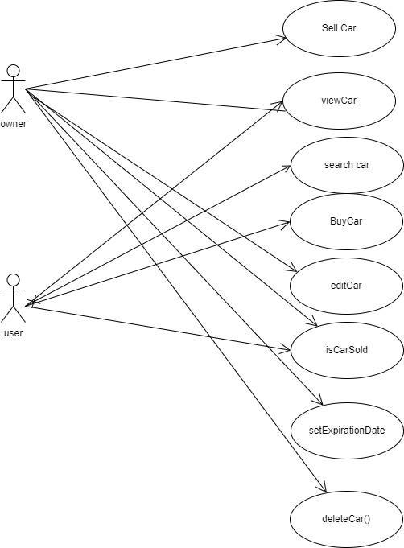

Fig1: use case for car resale value

* **Users:** from the above use case diagram are user-buyer,owner-seller.
* **Assets:** data asserts are car resale value details.
* **Roles:**

1. seller will initially create a NFT for car details to sell car and he will be act as owner initially.
2. User and owner both can view for NFT to view cars that were initially created by the owner. If user wants to search for car with specified details then he can search in search car
3. Buyer can purchase car NFT of their choice
4. Only owner of car will be able to modify details of car in editcar
5. Both owner and user can see whether car is sold or not in iscarsold
6. Only owner of car will be able setexpirationdate for car.
7. Only owner of will be able to delete car.

**UI Wireframe:**

The key features that can be included in our user interface for the car resale value NFT Dapp

Are:

* The home page with a little description about the car resale value NFT’s and how they work and a buttons with different action.

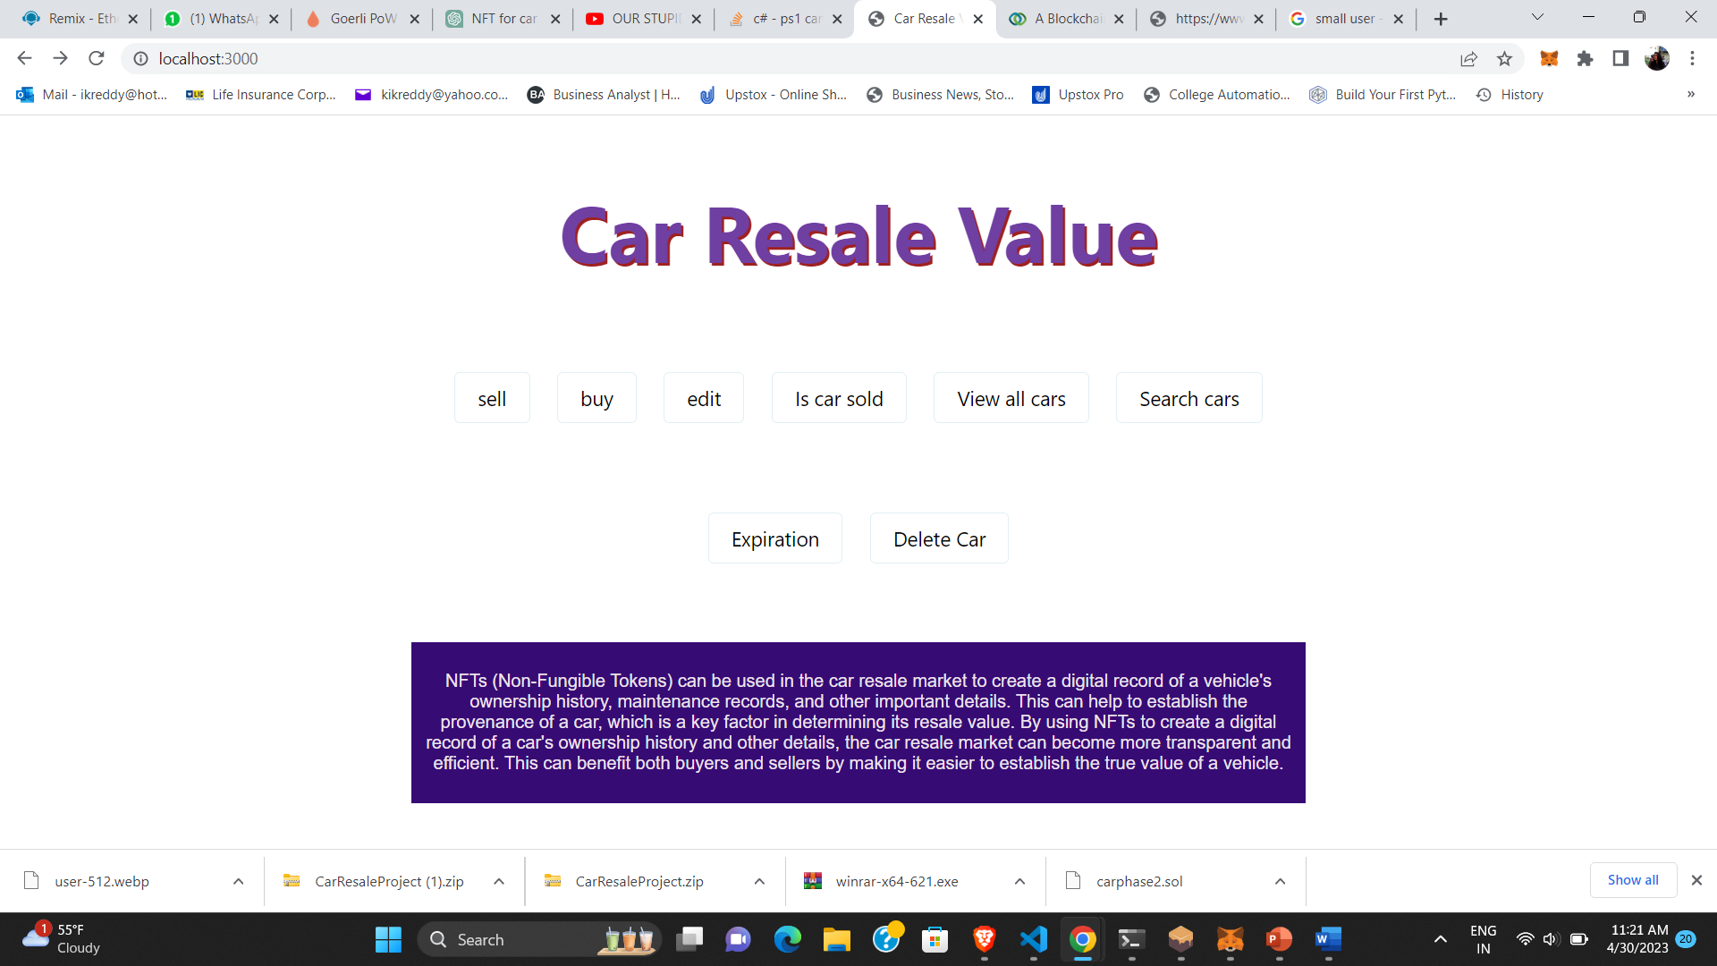

Fig2:Homepage of CarResaleValue NFT

* By Clicking on sell you will be navigating to new page where you can sell car NFT.

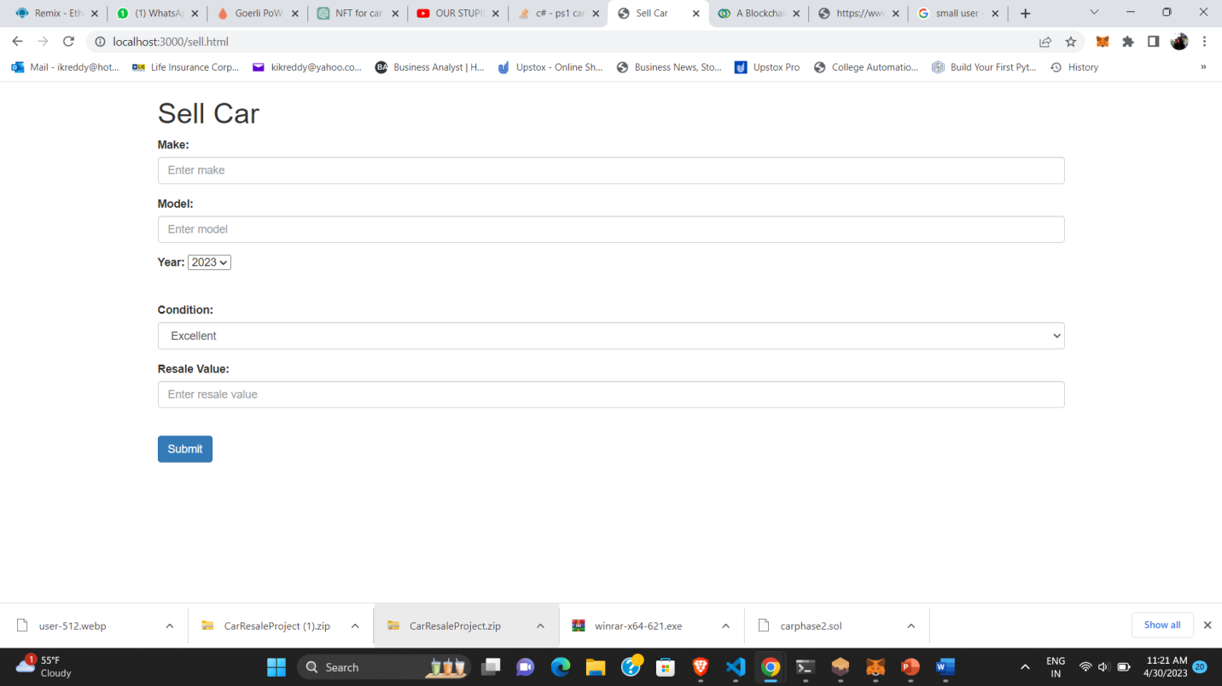

Fig3:Selling Car NFT

* By Clicking on Buy you will be navigating to new page where you can Buy car NFT of ur choice.

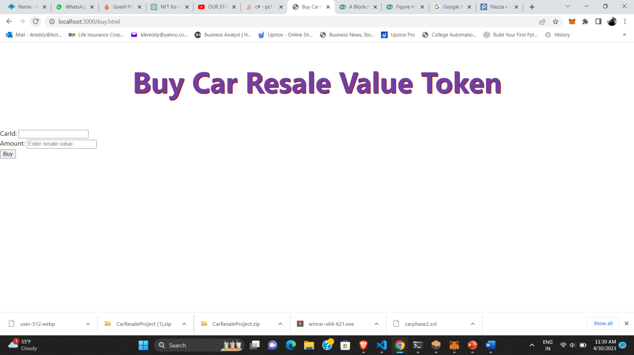

Fig4:Buy Car NFT

* By Clicking on edit you will be navigating to new page where you can edit details of car.

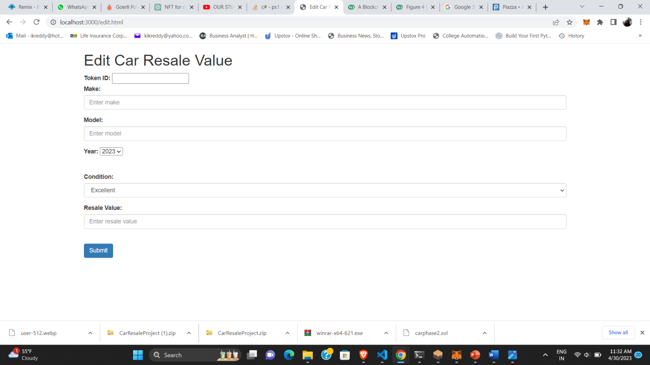

Fig5:Edit Car Details

* By Clicking on is car sold you will be navigating to new page where you can check where choice of your car is sold or still available.

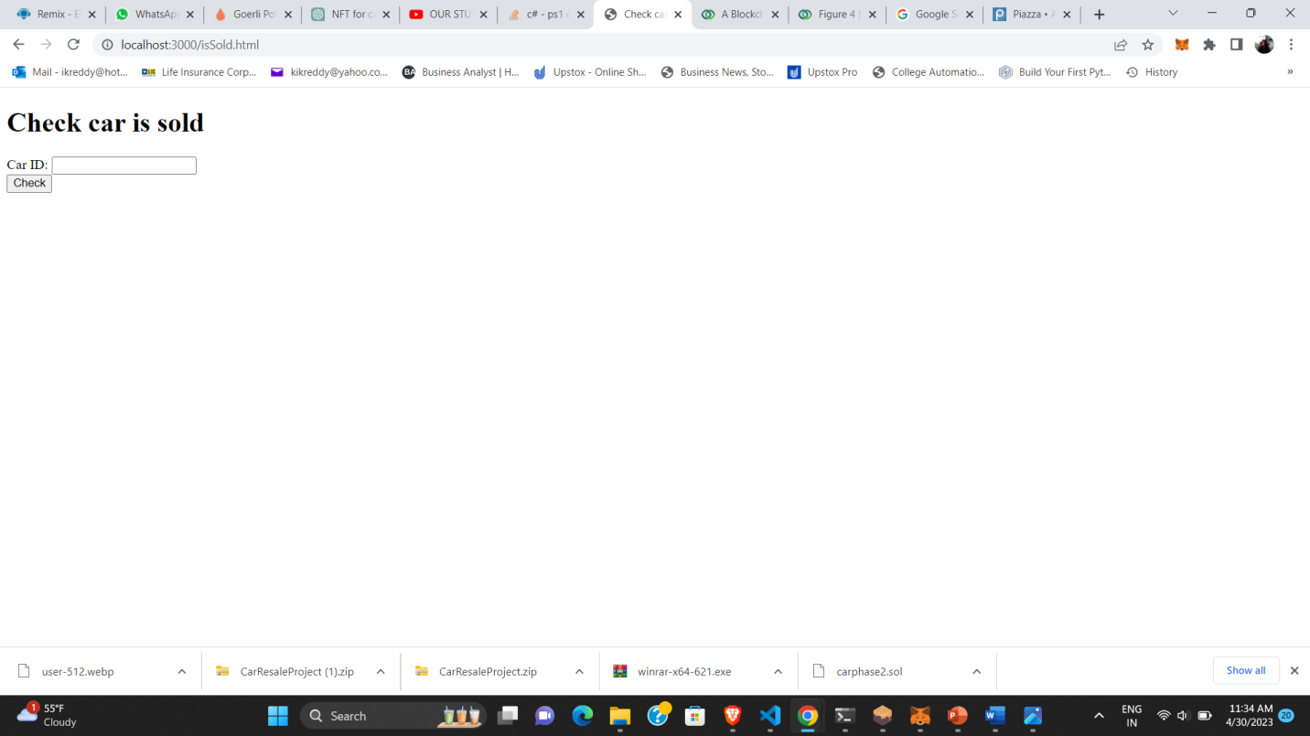

Fig6:CarSold

* By Clicking on is view cars you will be navigating to new page where you can see list of Car NFT that are available.

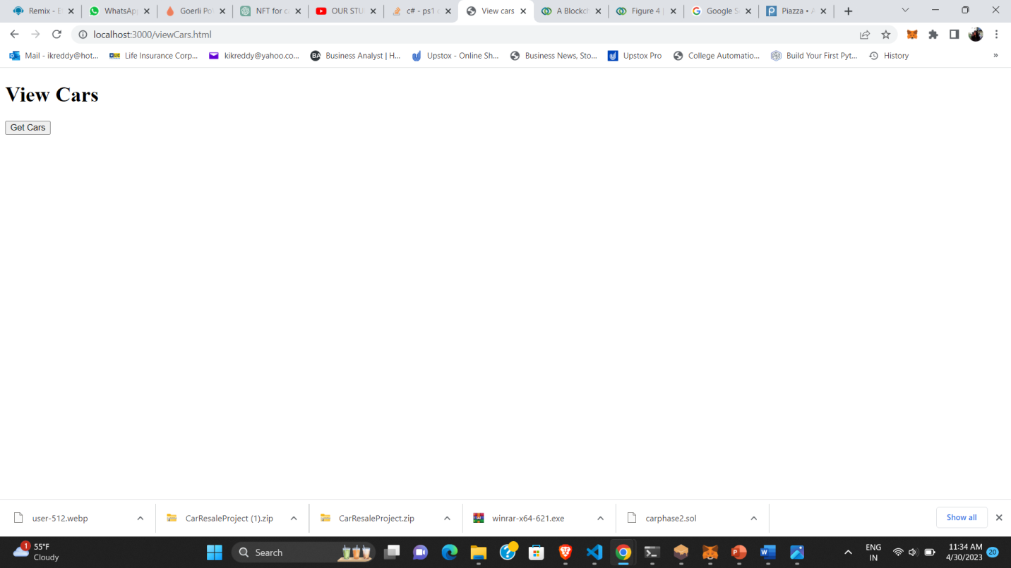

Fig7:View Car NFTS

* By Clicking on search car you will be navigating to new page where you can search for Car NFT of your choice.

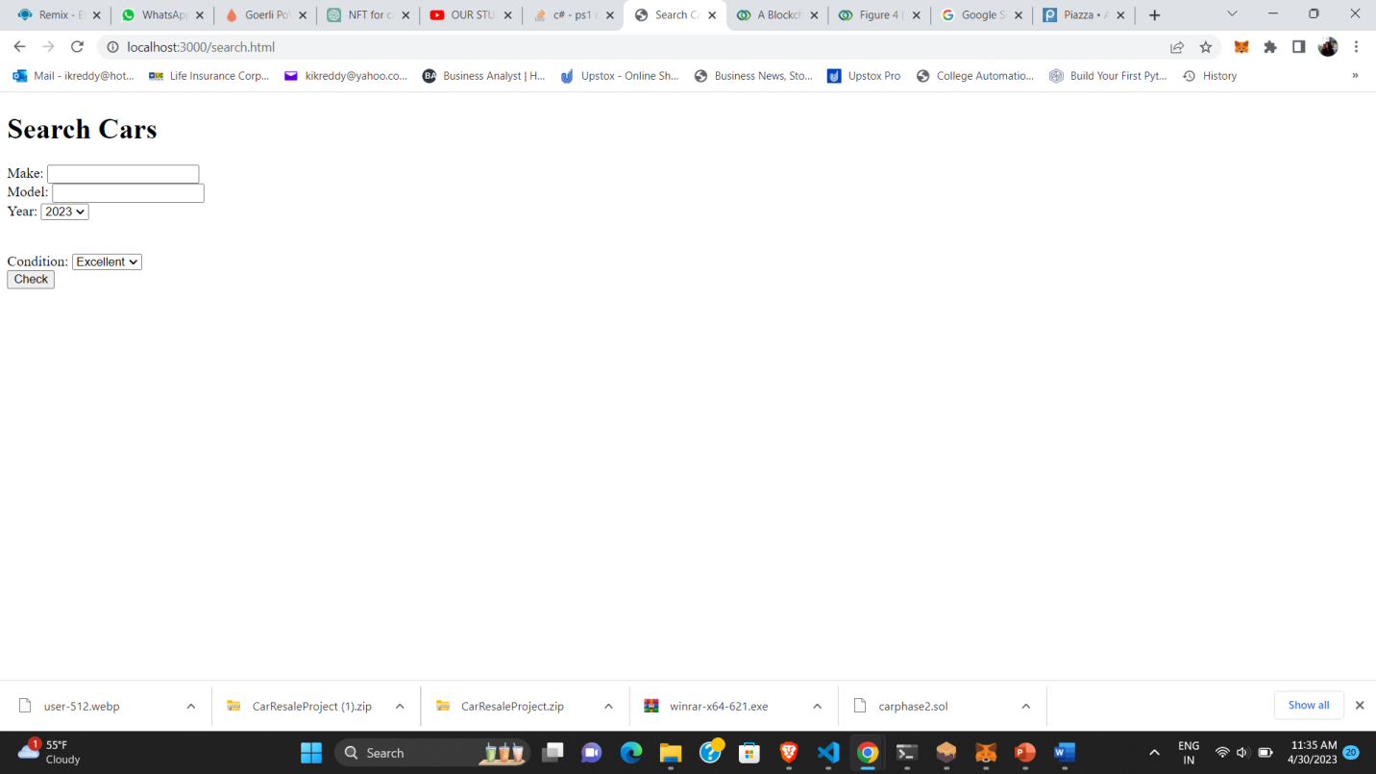

Fig8:Search for Car NFT

* By Clicking on ExpirationDate you will be navigating to new page where you can set expiration date for your car NFT.

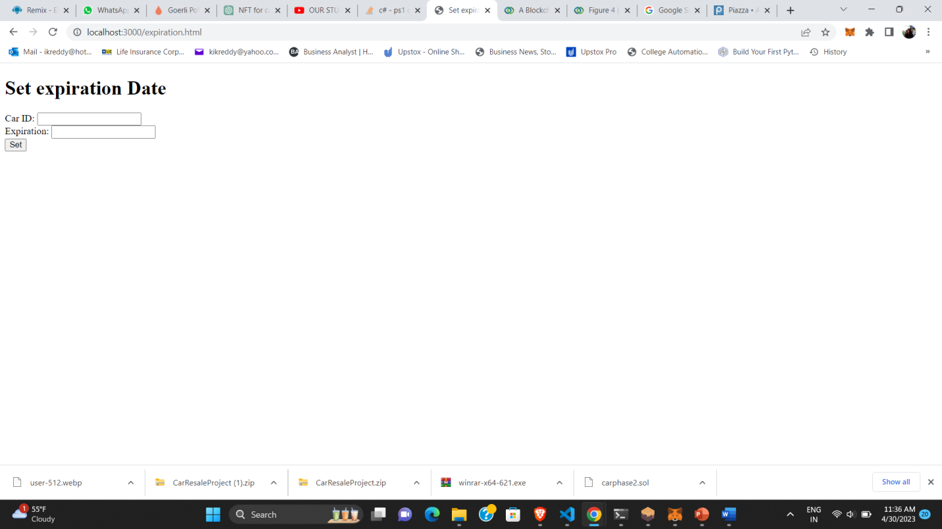

Fig 9:ExpirationDate for CarNFT

* By Clicking on DeleteCar you will be navigating to new page where you can delete your car NFT.

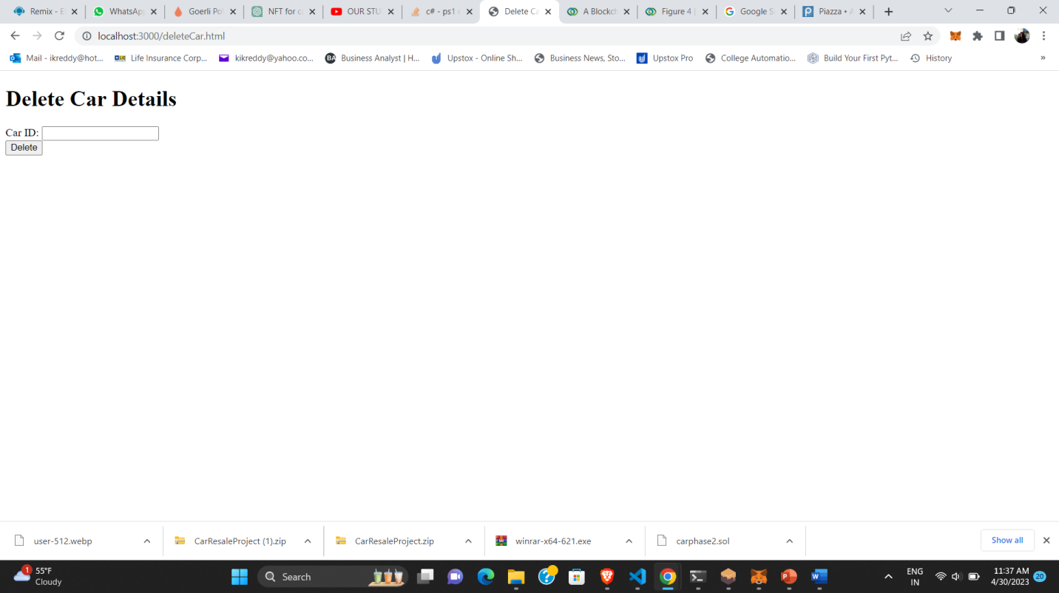

Fig10:Delete Car NFT

## Contract Diagram :

Contract diagram for above Car NFT as follows:

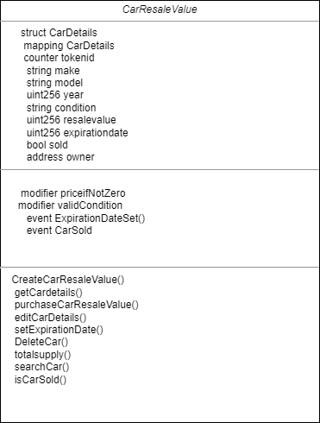

Fig 11:Contract diagram

Explanation of above:

Name of smart contract :CarResaleValue

Data:

* struct Cardetails
* Mapping CarDetails
* Counter token id
* String make
* String model
* Uint256 year
* String condition
* Uint256 resalevalue
* Uint256 expirationdate
* Bool sold
* Address owner

Rules of Validation:

* Modifier priceIfNotZero()
* Modifier ValidCondition()
* Event ExpiratonDateSet()
* Event CarSold()

Functions:

* CreateCarResaleValue()
* getCarDetails()
* purchaseCarResaleValue()
* editCarDetails()
* SetExpirationDate()
* DeleteCar()
* Totalsupply()
* searchCar()
* iscarsold()

## Sequence Diagram :

Sequence diagram for above Car NFT as follows:

Explanation:

Working of sell page:

* Initially user navigates to sell car page to sell this car NFT or to create a car NFT
* Then Car Dapp displays a form for entering details of their car
* Next user enters car details and clicks on submit button
* Then car dapp creates erc 721-token in smart contract and sends it to the user.
* Then smart contract returns a new erc 721 token id(car id) to car dapp.
* Then car dapp displays an alert box on the page saying car details successfully submitted.

Working of view page:

* User navigates to view car page
* Then car dapp retrives list of erc721 tokens owned by user from smart contract using users metamask address.
* Then smart contract returns list of cars (erc 721 tokens with token ids) to car dapp
* Then car dapp displays list of car details that were submitted.

Working of isCarSold page:

* User navigates to IsCarSold page
* User enters car id and and clicks button to check whether respective car is sold or available
* Then car dapp calls isCarSold() in smart contract by passing car id
* Smart contract first checks whether token exist or not then checks if car is sold or not and returns a boolean value to car dapp .
* Car dapp checks Boolean value if Boolean value is true then returns a alert to user saying car is sold else returns a alert saying car is not sold yet.

Working of BuyCar page:

* User navigates to buy car page
* User enters car id and amount to buy car nft to car dapp
* Car dapp calls purchase car function in smart contract with car id and amount passed by user.
* Smart contract verifies address of the user.
* Smart contract transfer amount of the car NFT to seller
* After receving amount into seller’s account seller safetransfer’s ownership to buyer and sets carsold Boolean to true
* Then returns success status to car dapp
* Then car dapp displays alert message to user saying car purchase successful

Working of SetExpiration page:

* User navigates to SetExpirationDate page .
* Only owner can set expiration date of car.
* User enters car id and year for car expiration and submits to car dapp.
* Car dapp calls SetExpirationDate () in smartcontract.
* SmartContract checks if token exits or not.
* Then smart contract checks whether token id(car id) owned by user.
* If owned then smart contract sets expiration date and emits expiration date event and returns success status to car dapp
* Then car dapp displays an alert to usr saying epiration date set successfully.

Working of DeleteCar Page:

* User navigates to delete car page.
* Only owner can delete car he owns by passing car id
* User enters car id to delete car and submits to car dapp.
* Car dapp calls deletecar() function in smart contract.
* Smartcontract checks whether token id exists or not .if exists checks whether it is owned by user .
* If owned by user then deletes car details based on car id
* Then returns success status to car dap
* Car dapp then displays a alert to user saying car deleted.

Sequence diagram follows in next page.

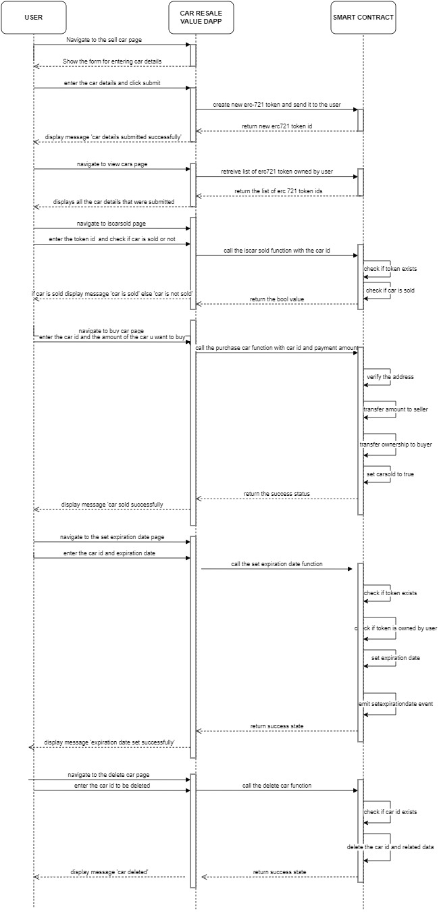

Fig 12:Sequence Diagram.

## Architecture Diagram :

Architecture diagram for above Car NFT as follows:

## Steps for Deployment:

* Running and Deploying CarResaleValue Dapp

This project is a decentralized application for CarResaleValue . I have deployed the smart contract every one of you are going to role-play as the user of the carresale smart contract.

* Prerequisites:
  + Have the following installed :
* NPM: <https://docs.npmjs.com/downloading-and-installing-node-js-and-npm>
* Truffle: <https://trufflesuite.com/docs/truffle/how-to/install/>
* Ganache network capability on Metamask with some test ethers.

## Carresalevalue Smart contract deployment (infura and Ganache):

I have deployed the carresalevalue-contract on an infura node and on Ganache network. The address of the smart contract I deployed is: 0x460ca6afE91B003Af01c7537f0Da649635662823

I have Deployed the smart contract in above address if you want you can also deploy the smartcontract in ganache and use that address by changing in app.js

## What to do? Start the application:

In the project directory, follow the steps below to start the application locally

* Navigate to **carresalevalue-contract** directory by entering the following command in the terminal, **cd carresalevalue-contract**
* Run the command : **truffle compile** and compile successfully
* After successful compilation of above command run command **truffle migate**

**--network ganache** use this command if compile first time in ganache.

* then remove above **carresalevalue-contract** directory by using command **cd..**
* Now navigate to Navigate to **carresalevalue-app** directory by entering the following command in the terminal, **cd carresalevalue-app**
* Edit app.js; Copy that address and paste it in between the quotes of line 4 in file app.js. Ex: address: "0x460ca6afE91B003Af01c7537f0Da649635662823" Then save app.js.
* Install dependencies by executing the following command: **npm install**
* Run the application by entering npm start in the terminal
* Open http://localhost:3000 to view the application in your browser(Note:open in browser where metamask is present)
* Connect to your Metamask (on Ganache network) to the application’s user interface and interact.sellcar , buy car,viewcar,setexpirationdate,iscarsold,editcar. Please understand Tx will take time.

**References**:

* NFT for car resale value: <https://www.thestar.com/autos/2022/10/08/can-nfts-and-blockchain-help-you-buy-or-sell-a-used-car.html>
* Use case diagram: <https://www.visual-paradigm.com/>
* Solidity: <https://docs.soliditylang.org/en/v0.8.11/>
* OpenZeppelin Contracts: <https://docs.openzeppelin.com/contracts/4.x/>
* ERC721 Standard: <https://eips.ethereum.org/EIPS/eip-721>
* Issues addressed in traditional car market: <https://www.wheels.ca/news/can-nfts-and-blockchain-help-you-buy-or-sell-a-used-car>

**Approved BY :** Nil Dharmecha