**SpecializationinML,SpaceScience**

**C10**



**G.NarayanammaInstituteofTechnology&Science**

**(Autonomous) (ForWomen)**

**ApprovedbyAICTE,NewDelhi&AffiliatedtoJNTUH,HyderabadAccreditedbyNBA&NAAC,anISO9001:2015CertifiedInstitution**

**Shaikpet,Hyderabad-500104**

DEPARTMENTOFCOMPUTERSCIENCEANDENGINEERING

**IIB.TechIISemMiniProject-1,2023-2024,GNR-22**

on

“EXOPLANETDETECTIONVIABRIGHTNESSDIPS”

Undertheguidance of

Ch.Radhika,AssistantProfessor

**Abstract:**

Exoplanets, planets located outside our solar system.Detecting and studying exoplanets is valuable, and the process can be significantly expedited using classical machine learning techniques.

The transit method involves a satellite observing a star continuously.When a planet passes between the star and the satellite, it causes a dip in the star’s brightness, indicating the presence of an exoplanet. First, we will preprocess the data to highlight these dips in brightness. Then, wewill usesupervised learning to train amodel on known exoplanet data, allowing.

Exoplanets, planets located outside our solar system.Detecting and studying exoplanets is valuable, and the process can be significantly expedited using classical machine learning techniques.

**S/WRequirements:**

* JupyterNotebook(Python)

**H/W Requirements:**

Processor(i7)

HardDisk

* RAM-32GB
* CloudComputingPlatform

*DeptR&D:Yes/No CompanyName/GNITS(CoE/RC):(Filledbystaff)

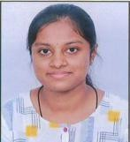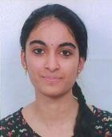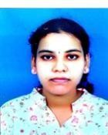

|  |  |  |  |
| --- | --- | --- | --- |
| 22251A05G6 | 22251A05E9 | 22251A05F9 | 22251A05H1 |
| DAsritha | S.Madhumitha | V.Bhavanakruthi | J Sankeerthana |

[devaramasritha6@gmail.com](mailto:devaramasritha6@gmail.com) [ssambumadhumitha@gmail.co](mailto:ssambumadhumitha@gmail.com)m bhavanaveleti@gmail. [sankeerthanajadi6@gmail.com](mailto:sankeerthanajadi6@gmail.com)

**9014241240 9640666088 9390279066** **9059125460**

InternalGuide ClassCoordinator ProjectCoordinator HeadofDepartment

**SpecializationinML,SpaceScience**

**C10**