CHAPTER 1
INTRODUCTION

Mobile Ad-hoc NETwork (MANET) is a self-configured network of mobile terminals connected by wireless links. Mobile terminals such as cell phones, portable gaming devices, personal digital assistants, (PDAs) and tablets all have wireless networking capabilities. By participating in MANETs, these terminals may reach the Internet when they are not in the range of Wi-Fi access points or cellular base stations, or communicate with each other when no networking infrastructure is available. MANETs can also be utilized in the disaster rescue and recovery described in. One primary issue with continuous participation in MANETs is the network lifetime, because the aforementioned wireless terminals are battery powered, and energy is a scarce resource. Cooperative communication (CC) is a promising technique for conserving the energy consumption in MANETs. The broadcast nature of the wireless medium (the so-called wireless broadcast advantage) is exploited in cooperative fashion. The wireless transmission between a pair of terminals can be received and processed at other terminals for performance gain, rather than be considered as an interference traditionally. CC can provide gains in terms of the required transmitting power due to the spatial diversity achieved via user cooperation. However, if we take into account the extra processing and receiving energy consumption required for cooperation, CC is not always energy efficient compared to direct transmission.
There is a tradeoff between the gains in transmitting power and the losses in extra energy consumption overhead. CC has been researched extensively from the information theoretic perspective and on the issues of relay selection. Recently, the work on CC with regard to cross-layer design by considering cooperation in both physical layer and MAC layer attracts more and more attention. Without considering the MAC layer interactions and signaling overhead due to cooperation, the performance gain through physical layer cooperation may not improve end-to-end performance. Cooperative MAC (CMAC) protocol considering the practical aspect of CC is vital. Liu et al. have proposed a CMAC protocols named CoopMAC to exploit the multi-rate capability and aimed at mitigating the throughput bottleneck caused by the low data rate nodes, so that the throughput can be increased. With the similar goal, Zhu and Cao have proposed a CMAC protocol or wireless ad hoc network. However, beneficial cooperation considering Signaling overhead is not addressed in and. A busy-tone-based cross-layer CMAC protocol has been designed to use busy tones to help avoiding collisions in the cooperative scenario at the cost on transmitting power, spectrum, and implementation complexity. A reactive network coding aware CMAC protocol has been proposed by Wang et al., in which the relay node can forward the data for the source node, while delivering its own data simultaneously. But the network lifetime is not addressed in. A distributed CMAC protocol has been proposed to improve the lifetime of wireless sensor networks, but it is based on the assumption that every node can connect to the base station within one hop, which is impractical for most applications. A CMAC protocol for vehicular networks, particularly for gateway downloading scenarios, has been designed by Zhang et al. A drawback in is that it can only be utilized in the scenario that all the vehicles are interested in the same information. Moreover, Moh and Yu have designed a CMAC protocol named CD-MAC which lets the relay transmit simultaneously with the source using space-time coding technique. Shan et al. have explored a concept of cooperation region, whereby beneficial cooperative transmissions can be identified. However, energy consumption is not evaluated for both of them.

1.1 Modules
- Network Formation
- Utility-Based Best Relay Selection
- Data Transmission
Network formation:
In this module, a multi-hop MANET with randomly deployed mobile terminals is considered, where all terminals have the capability to relay. First these all terminals are connected with network controller. Network Controller contains all terminals location and distance information.
Utility-based best relay selection:
A source node wants to find the best relay for data transmission. So our proposed work using a distributed energy-aware location-based best relay selection strategy is incorporated, which is more reasonable for MANETs comparing with the existing schemes based on channel condition. Selecting the best relay terminal based on the instantaneous location instead of instantaneous channel condition may be more reasonable for MANETs. The location information of individual wireless devices can be obtained through GPS or other localization algorithms. The required location information of source and destination is carried by RTS and CTS frames. Thus no additional communication over heads is involved. DEL-CMAC chooses the best relay based on a utility-based back off, which depends on the required transmitting power to meet certain outage probability (related to individual location) and the residual energy of individual terminals. It is carried out in a distributed, lightweight and energy-efficient fashion, in which the back off of the relay that has the minimum utility value expires first.

Data transmission:
In this module, source node packet was transmitted to destination node through intermediate relay nodes. Compare with existing direct transmission phase our cooperative transmission phase significantly prolongs the network lifetime.

  - Process Diagram

Fig: 1.2.1-Process Diagram

CHAPTER 2
SYSTEM ANALYSIS
  - Existing System
Cooperative MAC (CMAC) protocol considering the practical aspect of CC is vital. Liu et al. have proposed a CMAC protocols named CoopMAC to exploit the multi-rate capability and aimed at mitigating the throughput bottleneck caused by the low data rate nodes, so that the throughput can be increased. With the similar goal, Zhu and Cao have proposed a CMAC protocol or wireless ad hoc network. However, beneficial cooperation considering signaling overhead is not addressed. A busy-tone-based cross-layer CMAC protocol has been end signed to use busy tones to help avoiding collisions in the cooperative scenario at the cost on transmitting power, spectrum, and implementation complexity. A reactive network coding aware CMAC protocol has been proposed by Wang et al. in which the relay node can forward the data for the source node, while delivering its own data simultaneously. But the network lifetime is not addressed. A distributed CMAC protocol has been proposed to improve the lifetime of wireless sensor networks, but it is based on the assumption that every node can connect to the base station within one hop, which is impractical for most applications. A CMAC protocol for vehicular networks, particularly for gateway downloading scenarios, has been designed by Zhang et al. A drawback is that it can only be utilized in the scenario that all the vehicles are interested in the same information. Moreover, Moh and Yu have designed a CMAC protocol named CD-MAC which lets the relay transmit simultaneously with the source using space-time coding technique. Shan et al. have explored a concept of cooperation region, whereby beneficial cooperative transmissions can be identified. However, energy consumption is not evaluated for both of them.
Disadvantages: The existing CMAC protocols mainly focus on the throughput enhancement while failing to investigate the energy efficiency or network lifetime.

  - Proposed System
In this paper, we propose a novel distributed energy-adaptive location-based CMAC protocol, namely DEL-CMAC, for MANETs. DEL-CMAC is designed based on the IEEE 802.11 distributed coordination function (DCF), which is a widely used standard protocol for most of wireless net-works. DEL-CMAC comprises a relay-involved handshaking process, a cross-layer power allocation scheme, a distributed utility-based best relay selection strategy, and an innovative Network Allocation Vector (NAV) setting. From the perspective of information theory, higher diversity gain can be obtained by increasing the number of relay terminals. From a MAC layer point of view, however, more relays lead to the enlarged interference ranges and additional control frame overheads. We employ single relay terminal in this paper to reduce the additional communication overhead. DEL-CMAC initiates the cooperation proactively, and utilizes the decode and forward (DF) protocol in the physical layer. We propose DEL- CMAC that focuses on the net-work lifetime extension, which is a less explored aspect in the related work. By considering the overheads and interference due to cooperation, as well as the energy consumption on both transceiver circuitry and transmit amplifier, DEL-CMAC can significantly prolong the network lifetime. A distributed energy-aware location-based best relay selection strategy is incorporated, which is more reasonable for MANETs comparing with the existing schemes based on channel condition. For a desired outage probability requirement, a cross-layer optimal transmitting power allocation scheme is designed to conserve the energy while maintaining certain throughput level. To deal with the presence of relay terminals and dynamic transmitting power, we provide an innovative NAV setting to avoid the collisions and enhance the spatial reuse.
Advantages: Our proposed results reveal that DEL-CMAC can significantly extend the network lifetime under various scenarios at the cost of relatively low throughput and delay degradation, compared with IEEE standard DCF and throughput-aimed scheme CoopMAC.
2.3 Feasibility Study
Feasibility Study is a high level capsule version of the entire process intended to answer a number of questions like: What is the problem? Is there any feasible solution to the given problem? Is the problem even worth solving? Feasibility study is conducted once the problem clearly understood. Feasibility study is necessary to determine that the proposed system is Feasible by considering the technical, Operational, and Economical factors. By having a detailed feasibility study the management will have a clear-cut view of the proposed system.
The following feasibilities are considered for the project in order to ensure that the project is variable and it does not have any major obstructions. Feasibility study encompasses the following things:
- Technical Feasibility
- Economical Feasibility
- Operational Feasibility

In this phase, we study the feasibility of all proposed systems, and pick the best feasible solution for the problem. The feasibility is studied based on three main factors as follows.

2.3.1 Technical Feasibility
In this step, we verify whether the proposed systems are technically feasible or not. i.e., all the technologies required to develop the system are available readily or not.
Technical Feasibility determines whether the organization has the technology and skills necessary to carry out the project and how this should be obtained. The system can be feasible because of the following grounds.
- All necessary technology exists to develop the system.
- This system is too flexible and it can be expanded further.
- This system can give guarantees of accuracy, ease of use, reliability and the data security.
- This system can give instant response to inquire.
- Our project is technically feasible because, all the technology needed for our project is readily available.

    - Economical Feasibility
In this step, we verify which proposal is more economical. We compare the financial benefits of the new system with the investment. The new system is economically feasible only when the financial benefits are more than the investments and expenditure. Economical Feasibility determines whether the project goal can be within the resource limits allocated to it or not. It must determine whether it is worthwhile to process with the entire project or whether the benefits obtained from the new system are not worth the costs. Financial benefits must be equal or exceed the costs. In this issue, we should consider:
- The cost to conduct a full system investigation.
- The cost of h/w and s/w for the class of application being considered.
- The development tool.
- The cost of maintenance etc.,
Our project is economically feasible because the cost of development is very minimal when compared to financial benefits of the application.

    - Operational Feasibility
In this step, we verify different operational factors of the proposed systems like man-power, time etc., whichever solution uses less operational resources, is the best operationally feasible solution. The solution should also be operationally possible to implement. Operational Feasibility determines if the proposed system satisfied user objectives could be fitted into the current system operation. The present system Enterprise Resource Information System can be justified as Operationally Feasible based on the following grounds.
- The methods of processing and presentation are completely accepted by the clients since they can meet all user requirements.
- The clients have been involved in the planning and development of the system.
- The proposed system will not cause any problem under any circumstances.
Our project is operationally feasible because the time requirements and personnel requirements are satisfied. We are a team of four members and we worked on this project for three working months.
Project Instructions:
- Based on the solution requirements, conceptualize the Solution Architecture. Depict the various architectural components, show interactions and connectedness and show internal and external elements. Discuss suitability of typical architectural types like Pipes, Filters, Event Handlers, and Layers etc.
- Identify the significant class entities and carry out class modeling.
- Carry out Detailed design of Classes, Database objects and other solution components.
- Distribute work specifications and carry out coding and testing.

2.4 Architecture Diagram
Three Tier Architecture
3-tier application is a program which is organized into three major disjunctive tiers on layers. Here we can see that how these layers increase the reusability of codes. These layers are described below.
1. Application layer or Presentation layer
2. Business layer
a. Property layer (Sub layer of business layer)
3. Data layer

Advantages of Three Tier Architecture.
The main characteristic of a Host Architecture is that the application and databases reside on the same host computer and the user interacts with the host using an unfriendly and dump terminal. This architecture does not support distributed computing (the host applications are not able to connect a database of a strategically allied partner). Some managers found that developing a host application take too long and it is expensive. Consequently led these disadvantages to Client-Server architecture.
Client-Server architecture is 2-Tier architecture because the client does not distinguish between Presentation layer and business layer. The increasing demands on GUI controls caused difficulty to manage the mixture of source code from GUI and Business Logic (Spaghetti Code). Further, Client Server Architecture does not support enough the Change Management. Let suppose that the government increases the Entertainment tax rate from 4% to 8 %, then in the Client-Server case, we have to send an update to each clients and they must update synchronously on a specific time otherwise we may store invalid or wrong information. The Client-Server Architecture is also a burden to network traffic and resources. Let us assume that about five hundred clients are working on a data server then we will have five hundred ODBC connections and several ruffian record sets, which must be transported from the server to the clients (because the Business layer is stayed in the client side). The fact that Client-Server does not have any caching facilities caused additional traffic in the network. Normally, a server has a better hardware than client therefore it is able compute algorithms faster than a client, so this fact is also an additional pro argument for the 3.Tier Architecture. This categorization of the application makes the function more reusable easily and it becomes too easy to find the functions which have been written previously. If programmer wants to make further update in the application then he easily can understand the previous written code and can update easily.
1. Application layer or Presentation layer
Application layer is the form which provides the user interface to either programmer of end user. Programmer uses this layer for designing purpose and to get or set the data back and forth.

2. Business layer
This layer is a class which we use to write the function which works as a mediator to transfer the data from Application or presentation layer data layer. In the three tier architecture we never let the data access layer to interact with the presentation layer.

a. Property Layer
This layer is also a class where we declare the variable corresponding to the fields of the database which can be required for the application and make the properties so that we can get or set the data using these properties into the variables. These properties are public so that we can access its values.

3. Data Access Layer
This layer is also a class which we use to get or set the data to the database back and forth. This layer only interacts with the database. We write the database queries or use stored procedures to access the data from the database or to perform any operation to the database.

Summary
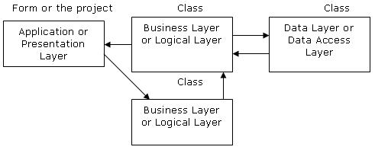

Fig: 2.4.1- Three Tier Architecture

- Application layer is the form where we design using the controls like textbox, labels, command buttons etc.
- Business layer is the class where we write the functions which get the data from the application layer and passes through the data access layer.
- Data layer is also the class which gets the data from the business layer and sends it to the database or gets the data from the database and sends it to the business layer.
- Property layer is the sub layers of the business layer in which we make the properties to sent or get the values from the application layer. These properties help to sustain the value in an object so that we can get these values till the object destroys.

Data flow from application layer to data layer
Here we are passing the code of the student to the business layer and on the behalf of that getting the data from the database which is being displayed on the application layer.
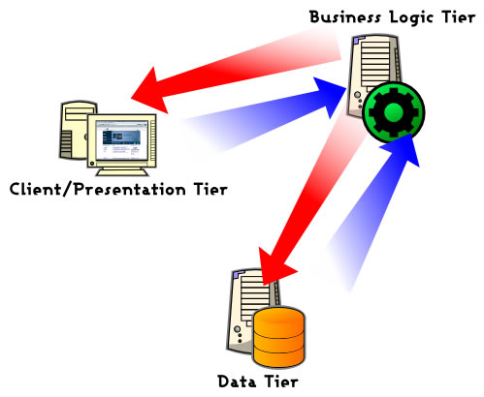

Fig: 2.4.2- Data flow from application layer to data layer

2.5 Analysis Model
The model that is basically being followed is the WATER FALL MODEL, which states that the phases are organized in a linear order. First of all the feasibility study is done. Once that part is over the requirement analysis and project planning begins. If system exists one and modification and addition of new module is needed, analysis of present system can be used as basic model.
The design starts after the requirement analysis is complete and the coding begins after the design is complete. Once the programming is completed, the testing is done. In this model the sequence of activities performed in a software development project are: -
Requirement Analysis, Project Planning, System design, Detail design, Coding, Unit testing, System integration & testing

Here the linear ordering of these activities is critical. End of the phase and the output of one phase is the input of other phase. The output of each phase is to be consistent with the overall requirement of the system. Some of the qualities of spiral model are also incorporated like after the people concerned with the project review completion of each of the phase the work done.
WATER FALL MODEL was being chosen because all requirements were known beforehand and the objective of our software development is the computerization/automation of an already existing manual working system.

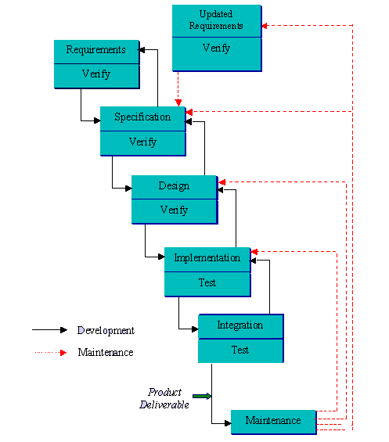
Fig: 2.5.1-water fall model

CHAPTER 3
SYSTEM REQUIREMENT SPECIFICATION
Software Requirements Specification plays an important role in creating quality software solutions. Specification is basically a representation process. Requirements are represented in a manner that ultimately leads to successful software implementation.
Requirements may be specified in a variety of ways. However there are some guidelines worth following: -
• Representation format and content should be relevant to the problem
• Information contained within the specification should be nested
• Diagrams and other notational forms should be restricted in number and consistent in use.
• Representations should be revisable.

The software requirements specification is produced at the culmination of the analysis task. The function and performance allocated to the software as a part of system engineering are refined by establishing a complete information description, a detailed functional and behavioral description, and indication of performance requirements and design constraints, appropriate validation criteria and other data pertinent to requirements.

  - Functional Requirements
REQ_NO | REQUIREMENT NAME
REQ_01 | System should provide provision for network controller to get IP address
REQ_02 | System should provide provision for network controller to view mobile node details
REQ_03 | System should provide provision for network controller to get distances between mobile nodes
REQ_04 | System should provide provision for mobile node to connect with network controller
REQ_05 | System should provide provision for mobile node to get IP address
REQ_06 | System should provide provision for mobile node to view neighbor details
REQ_07 | System should provide provision for mobile node to calculate energy
REQ_08 | System should provide provision for mobile node to calculate back-off time
REQ_09 | System should provide provision for mobile node to view relay nodes
REQ_10 | System should provide provision for mobile node to select best relay nodes
REQ_11 | System should provide provision for mobile node to calculate residual energy
REQ_12 | System should provide provision for mobile node to send data to neighbor node
REQ_13 | System should provide provision for mobile node to view routing table
REQ_14 | System should provide provision for mobile node to select  routing path
Table: 3.1-Functional Requirements
  - Non- Functional Requirements

Performance Requirements:
Good band width, less congestion on the network. Identifying the shortest route to reach the destination will all improve performance.

Safety Requirements:
No harm is expected from the use of the product either to the OS or any data.

Product Security Requirements:
The product is protected from un-authorized users from using it. The system allows only authenticated users to work on the application. The users of this system are organization and ISP administrator.

Software Quality Attributes:
The product is user friendly and its accessibility is from the client. The application is reliable and ensures its functioning maintaining the ISP web service is accessible to the various organizations. As it is developed in .Net it is highly interoperable with OS that have provided support for MSIL (Server side). The system requires less maintenance as it is not installed on the client but hosted on the ISP. The firewall, antivirus protection etc is provided by the ISP.

  - System Requirements
Software Requirements Specification plays an important role in creating quality software solutions. Specification is basically a representation process. Requirements are represented in a manner that ultimately leads to successful software implementation.
Requirements may be specified in a variety of ways. However there are some guidelines worth following: -
- Representation format and content should be relevant to the problem
- Information contained within the specification should be nested
- Diagrams and other notational forms should be restricted in number and consistent in use.
- Representations should be revisable.

    - Software Requirements

  - Operating System : Windows 7
  - Programming Package : Net Beans IDE 7.3.1
  - Coding Language : JDK 1.7

    - Hardware Requirements

  - Processor Type : Pentium IV
  - Speed : 2.4 GHZ
  - RAM : 1 GB
  - Hard disk : 80 GB

CHAPTER 4
SYSTEM DESIGN
Software design sits at the technical kernel of the software engineering process and is applied regardless of the development paradigm and area of application. Design is the first step in the development phase for any engineered product or system. The designer’s goal is to produce a model or representation of an entity that will later be built. Beginning, once system requirement have been specified and analyzed, system design is the first of the three technical activities -design, code and test that is required to build and verify software.
The importance can be stated with a single word “Quality”. Design is the place where quality is fostered in software development. Design provides us with representations of software that can assess for quality. Design is the only way that we can accurately translate a customer’s view into a finished software product or system. Software design serves as a foundation for all the software engineering steps that follow. Without a strong design we risk building an unstable system – one that will be difficult to test, one whose quality cannot be assessed until the last stage.
During design, progressive refinement of data structure, program structure, and procedural details are developed reviewed and documented. System design can be viewed from either technical or project management perspective. From the technical point of view, design is comprised of four activities – architectural design, data structure design, interface design and procedural design.

4.1 High level Design
System Design:
Understanding bigger application with its external interfaces is called System Design.

Improving network lifetime of MANETs

MANETs

Fig: 4.1.1-System Design
Subsystem Design:
Understanding bigger system into smaller independent working systems is called subsystem design.

Improving network lifetime of MANETs business logic sub system

Improving network lifetime of MANETs UI subs system

Fig: 4.1.2-Subsystem Design
Block Design:
Path Selector
Mobile Node
Network controller

IP Manager
Sender
Relay node Handler
Time Scheduler
Energy Manager
Distance Handler

Fig: 4.1.3-Block Design

  - Low level Design
Unified Modeling Language
The unified modeling language allows the software engineer to express an analysis model using the modeling notation that is governed by a set of syntactic semantic and pragmatic rules. A UML system is represented using five different views that describe the system from distinctly different perspective. Each view is defined by a set of diagram, which is as follows.

User Model View
This view represents the system from the user’s perspective. The analysis representation describes a usage scenario from the end-users perspective.
Structural model view
In this model the data and functionality are arrived from inside the system. This model view models the static structures.
Behavioral Model View
It represents the dynamic of behavioral as parts of the system, depicting the interactions of collection between various structural elements described in the user model and structural model view.
Implementation Model View
In this the structural and behavioral as parts of the system are represented as they are to be built.
Environmental Model View
In this the structural and behavioral aspects of the environment in which the system is to be implemented are represented.UML is specifically constructed through two different domains they are UML Analysis modeling, which focuses on the user model and structural model views of the system UML design modeling, which focuses on the behavioral modeling, implementation modeling and environmental model views.

4.3 Introduction to the unified modified language

Building a model for a software system prior to its construction is as essential as having a blueprint for building a large building. Good models are essential for communication among project teams. As the complexity of the systems increases, so does the importance of good modeling techniques.

A modeling language must include:
Model elements- fundamentally modeling concepts and semantics. Notation-visual rendering of model elements Guidelines-expression of usage within trade.
The use of visual notation to represent or model a problem can provide us several benefits relating to clarity, familiarity, maintenance, and simplification. The main reason for modeling is the reduction of complexity. The Unified Modeling Language (UML) is a set of notations and conventions used to describe and model an application. The UML is intended to be a universal language for modeling systems, meaning that it can express models of many different kinds and purposes, just as a programming language or a natural language can be used in different ways. A model” is an abstract representation of a system , constructed to understand the system prior to building or modifying it. The term “system” is used here in a broad sense to include any process or structure. For example, the organizational structure of a corporation , health services, computer software, instruction of any sort (including computers) , the national economy, and so forth all would be termed “systems”. The unified modeling language is a language for specifying, constructing, visualizing, and documenting the software system and its components. The UML is a graphical language with sets of rules and semantics. The rules and semantics of a model are expressed in English, in a form known as “object constraint language”(OCL).OCL is a specification language that uses simple logic for specifying the properties of a system. The UML is not intended to be a visual programming language in the sense of having all the necessary visual and semantic support to replace programming languages. However, the UML does have a tight mapping to a family of object-oriented languages, so that you can get the best of both worlds.

The primary goals in the design of the UML were as follows:
- Provide users ready-to-use, expensive visual modeling languages so they can develop and exchange meaningful models.
- Provide extendibility and specialization mechanisms to extend the core concepts.
- Be independent of particular programming languages and development process.
- Provide a formal basis for understanding the modeling language.
- Encourage the growth of the OO tools market.
- Support higher level development concepts.
- Integrate best practices and methodologies.

UML is a language used to:
“Visualize” the software system well-defined symbols. Thus a developer or tool can unambiguously interpret a model written by another developer, using UML
- “Specify the software system and help building precise, unambiguous and complete models.
- “Construct” the models of the software system that can directly communicate with a variety of programming languages.
- “Document” models of the software system during its development stages.
4.3.1 UML Diagrams
The UML Meta model elements are organized into diagrams. Different diagrams are used for different purposes depending on the angle from which you are viewing the system. The different views are called “architectural views”. Architectural views facilitate the organization of knowledge, and diagrams enable the communication of knowledge. Then knowledge itself is within the model or set of models that focuses on the problem and solution. The architectural views and their diagrams are summarized below:
The “user model view” encompasses a problem and solution from the preservative of those individuals whose problem the solution addresses. The view presents the goals and objectives of the problem owners and their requirements of the solution. This view is composed of “use case diagrams”. These diagrams describe the functionality provided by a system to external integrators. These diagrams contain actors, use cases, and their relationships.
“Class diagrams” describe the static structure of a system, or how it is declared rather than how it behaves. These diagrams contain classes and associations.
“Object diagrams” describe the static structure of a system at a particular time during its life. These diagrams contain objects and links.
“Sequence diagrams” render the specification of behavior. These diagrams describes the behavior provided by a system to interactions. These diagrams contain classes that exchange messages with in an interaction arranged in time sequence. In generic form, These diagrams describe a set of message exchange sequences among a set of classes. In instance form(scenarios), these diagrams describe one actual message exchange sequence among objects of those classes.
“Collaboration diagrams” render how behavior is realized by components with in a system. These diagrams contain classes, associations, and their message exchanges with in a collaboration to accomplish a purpose. In generic form, these diagrams describe a set of classes and associations involved in message exchange sequences. In instance form(scenarios), these diagrams describe a set of objects of those classes links confirming to the associations, and one actual message exchange sequence that inconsistent with the generic form and uses those objects and links.
“State chart diagrams” render the states and responses of a class participating in behavior, and the life cycle of an object. These diagrams describe the behavior of a class in response to external stimuli.
“Activity diagrams” render the activities of a class participating in behavior. These diagrams describe the behavior of a class in response to internal processing rather than external events. Activity diagrams describe the processing activities within a class.

4.3.2 Data Flow Diagrams
A data flow diagram is graphical tool used to deMHribe and analyze movement of data through a system. These are the central tool and the basis from which the other components are developed. The transformation of data from input to output, through processed, may be deMHribed logically and independently of physical components associated with the system. These are known as the logical data flow diagrams. The physical data flow diagrams show the actual implements and movement of data between people, departments and workstations. A full deMHription of a system actually consists of a set of data flow diagrams. Using two familiar notations Yourdon, Gane and Sarson notation develops the data flow diagrams. Each component in a DFD is labeled with a deMHriptive name. Process is further identified with a number that will be used for identification purpose. The development of DFD’s is done in several levels. Each process in lower level diagrams can be broken down into a more detailed DFD in the next level. The lop-level diagram is often called context diagram. It consists a single process bit, which plays vital role in studying the current system. The process in the context level diagram is exploded into other process at the first level DFD.

The idea behind the explosion of a process into more process is that understanding at one level of detail is exploded into greater detail at the next level. This is done until further explosion is necessary and an adequate amount of detail is deMHribed for analyst to understand the process. Larry Constantine first developed the DFD as a way of expressing system requirements in a graphical from, this lead to the modular design.
A DFD is also known as a “bubble Chart” has the purpose of clarifying system requirements and identifying major transformations that will become programs in system design. So it is the starting point of the design to the lowest level of detail. A DFD consists of a series of bubbles joined by data flows in the system.

DFD SYMBOLS:
In the DFD, there are four symbols
- A square defines a source(originator) or destination of system data
- An arrow identifies data flow. It is the pipeline through which the information flows
- A circle or a bubble represents a process that transforms incoming data flow into outgoing data flows.
- An open rectangle is a data store, data at rest or a temporary repository of data
Process that transforms data flow.

Symbol: 4.3.2.1- Process that transforms data flow.

Source or Destination of data Symbol: 4.3.2.2- Source or Destination of data

Data flow
Symbol: 4.3.2.3- Data flow

Data Store

Symbol: 4.3.2.4- Data Store

CONSTRUCTING A DFD:
Several rules of thumb are used in drawing DFD’s:
- Process should be named and numbered for an easy reference. Each name should be representative of the process.
- The direction of flow is from top to bottom and from left to right. Data traditionally flow from source to the destination although they may flow back to the source. One way to indicate this is to draw long flow line back to a source. An alternative way is to repeat the source symbol as a destination. Since it is used more than once in the DFD it is marked with a short diagonal.
- When a process is exploded into lower level details, they are numbered.
- The names of data stores and destinations are written in capital letters. Process and dataflow names have the first letter of each work capitalized

A DFD typically shows the minimum contents of data store. Each data store should contain all the data elements that flow in and out. Questionnaires should contain all the data elements that flow in and out. Missing interfaces redundancies and like is then accounted for often through interviews.

SAILENT FEATURES OF DFD’s:
- The DFD shows flow of data, not of control loops and decision are controlled considerations do not appear on a DFD.
- The DFD does not indicate the time factor involved in any process whether the data flows take place daily, weekly, monthly or yearly.
- The sequence of events is not brought out on the DFD.

TYPES OF DATA FLOW DIAGRAMS:
- Current Physical
- Current Logical
- New Logical
- New Physical

Current physical:
In Current Physical DFD process label include the name of people or their positions or the names of computer systems that might provide some of the overall system-processing label includes an identification of the technology used to process the data. Similarly data flows and data stores are often labels with the names of the actual physical media on which data are stored such as file folders, computer files, business forms or computer tapes.

- Current logical:
The physical aspects at the system are removed as much as possible so that the current system is reduced to its essence to the data and the processors that transforms them regardless of actual physical form.

- New logical:
This is exactly like a current logical model if the user were completely happy with the user were completely happy with the functionality of the current system but had problems with how it was implemented typically through the new logical model will differ from current logical model while having additional functions, absolute function removal and inefficient flows recognized.

- New physical:
The new physical represents only the physical implementation of the new system.

RULES GOVERNING THE DFD’S:

PROCESS:
- No process can have only outputs.
- No process can have only inputs. If an object has only inputs than it must be a sink.
- A process has a verb phrase label.
DATA STORE:
- Data cannot move directly from one data store to another data store, a process must move data.
- Data cannot move directly from an outside source to a data store, a process, which receives, must move data from the source and place the data into data store
- A data store has a noun phrase label.

SOURCE OR SINK:
The origin and /or destination of data.
- Data cannot move direly from a source to sink it must be moved by a process
- A source and /or sink has a noun phrase land

DATA FLOW:
- A Data Flow has only one direction of flow between symbols. It may flow in both directions between a process and a data store to show a read before an update. The later is usually indicated however by two separate arrows since these happen at different type.
- A join in DFD means that exactly the same data comes from any of two or more different processes data store or sink to a common location.
- A data flow cannot go directly back to the same process it leads. There must be at least one other process that handles the data flow produce some other data flow returns the original data into the beginning process.
- A Data flow to a data store means update (delete or change).
- A data Flow from a data store means retrieve or use.
A data flow has a noun phrase label more than one data flow noun phrase can appear on a single arrow as long as all of the flows on the same arrow move together as one package.
LEVELS OF DFD:
The complexity of the business system means that it is a responsible to represent the operations of any system of single data flow diagram. At the top level, an Overview of the different systems in an organization is shown by the way of context analysis diagram. When exploded into DFD
They are represented by:
- LEVEL-1:SUBSYSTEM LEVEL DATAFLOW FUNCTIONAL
- LEVEL-2: FILE LEVEL DETAIL DATA FLOW.
The input and output data shown should be consistent from one level to the next.

LEVEL-1: SUBSYSTEM LEVEL DATA FLOW
A level-1 DFD deMHribes the next level of details within the system, detailing the data flows between subsystems, which make up the whole.
LEVEL-2: FILE LEVEL DETAIL DATA FLOW
All the projects are feasible given unlimited resources and infinite time. It is both necessary and prudent to evaluate the feasibility of the project at the earliest possible time. Feasibility and the risk analysis are pertained in many ways. If project risk is great.

CHAPTER 5
CODING
5.1 Software Description (Technology Description)

Java Technology
Java technology is both a programming language and a platform.

The Java Programming Language

The Java programming language is a high-level language that can be characterized by all of the following buzzwords:
    - Simple
    - Architecture neutral
    - Object oriented
    - Portable
    - Distributed
    - High performance
    - Interpreted
    - Multithreaded
    - Robust
    - Dynamic
    - Secure

With most programming languages, you either compile or interpret a program so that you can run it on your computer. The Java programming language is unusual in that a program is both compiled and interpreted. With the compiler, first you translate a program into an intermediate language called Java byte codes —the platform-independent codes interpreted by the interpreter on the Java platform. The interpreter parses and runs each Java byte code instruction on the computer. Compilation happens just once; interpretation occurs each time the program is executed. The following figure illustrates how this works.

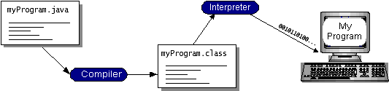
Fig: 5.1.1-Java Programming Language

You can think of Java byte codes as the machine code instructions for the Java Virtual Machine (Java VM). Every Java interpreter, whether it’s a development tool or a Web browser that can run applets, is an implementation of the Java VM. Java byte codes help make “write once, run anywhere” possible. You can compile your program into byte codes on any platform that has a Java compiler. The byte codes can then be run on any implementation of the Java VM. That means that as long as a computer has a Java VM, the same program written in the Java programming language can run on Windows 2000, a Solaris workstation, or on an iMac.

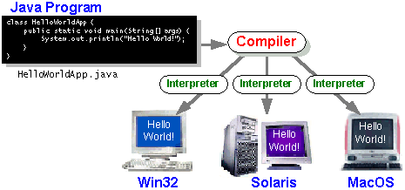
Fig: 5.1.2-Java Program

The Java Platform
A platform is the hardware or software environment in which a program runs. We’ve already mentioned some of the most popular platforms like Windows 2000, Linux, Solaris, and MacOS. Most platforms can be described as a combination of the operating system and hardware. The Java platform differs from most other platforms in that it’s a software-only platform that runs on top of other hardware-based platforms.
The Java platform has two components:
- The Java Virtual Machine (Java VM)
- The Java Application Programming Interface (Java API)
You’ve already been introduced to the Java VM. It’s the base for the Java platform and is ported onto various hardware-based platforms. The Java API is a large collection of ready-made software components that provide many useful capabilities, such as graphical user interface (GUI) widgets. The Java API is grouped into libraries of related classes and interfaces; these libraries are known as packages. The next section, What Can Java Technology Do? Highlights what functionality some of the packages in the Java API provide.
The following figure depicts a program that’s running on the Java platform. As the figure shows, the Java API and the virtual machine insulate the program from the hardware.

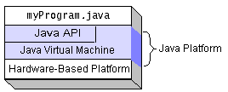
Fig: 5.1.3-Java Platform
Native code is code that after you compile it, the compiled code runs on a specific hardware platform. As a platform-independent environment, the Java platform can be a bit slower than native code. However, smart compilers, well-tuned interpreters, and just-in-time byte code compilers can bring performance close to that of native code without threatening portability.

The Java platform gives you the following features:
- The essentials: Objects, strings, threads, numbers, input and output, data structures, system properties, date and time, and so on.
- Applets: The set of conventions used by applets.
- Networking: URLs, TCP (Transmission Control Protocol), UDP (User Data gram Protocol) sockets, and IP (Internet Protocol) addresses.
- Internationalization: Help for writing programs that can be localized for users worldwide. Programs can automatically adapt to specific locales and be displayed in the appropriate language.
- Security: Both low level and high level, including electronic signatures, public and private key management, access control, and certificates.
- Software components: Known as JavaBeans, can plug into existing component architectures.
- Object serialization: Allows lightweight persistence and communication via Remote Method Invocation (RMI).
- Java Database Connectivity (JDBCTM): Provides uniform access to a wide range of relational databases.

  - Sample Code
/*
* To change this license header, choose License Headers in Project Properties.
* To change this template file, choose Tools | Templates
* And open the template in the editor.
*/
package improvingnode;
import java.net.DatagramPacket;
import java.net.DatagramSocket;
import java.net.InetAddress;
import java.util.ArrayList;
import java.util.Vector;
import javax.swing.JFrame;
import javax.swing.JOptionPane;
import javax.swing.table.DefaultTableModel;
/**
*
* @author Elcot
*/

public class NodeReceiver extends Thread
{
NodeFrame nf;
int nid,port;
String neighbors,src;
ArrayList norepeat=new ArrayList();
public static String distance,srcdistance;
public static ArrayList fordist=new ArrayList();
public static int transmittingpower=0,direct=0;
NodeReceiver(NodeFrame f,int id)
{
nf=f;
nid=id;
port=nid+6000;
}

public void run()
{
try
{
DatagramSocket ds=new DatagramSocket(port);
while(true)
{
byte data[]=new byte[10000];
DatagramPacket dp=new DatagramPacket(data,0,data.length);
ds.receive(dp);
String str=new String(dp.getData()).trim();
System.out.println("str is "+str);
String req[]=str.split("#");
if(req[0].equals("DistanceDetails"))
{
distance=req[1].trim();
}
if(req[0].equals("NeighborDetails"))
{
String nei[]=req[1].trim().split(",");
String nei1="";
for(int i=0;i<nei.length;i++)
{
if(!((""+nid).equals(nei[i].trim())))
{
if(!(norepeat.contains(nei[i].trim())))
{
nei1=nei1+nei[i].trim()+",";
DefaultTableModel dm=(DefaultTableModel)nf.jTable1.getModel();
Vector v=new Vector();
v.add(nei[i].trim());
dm.addRow(v);
norepeat.add(nei[i].trim());
}
}
}
if(!(nei1.equals("")))
{
neighbors=nei1.substring(0,nei1.lastIndexOf(','));
}
}
if(req[0].equals("RTS"))
{
JOptionPane.showMessageDialog(new JFrame(), "RTS Message has been received successfully!");
src=req[1].trim();
String dst=""+nid;
srcdistance=req[3].trim();
String dstdistance=distance.trim();

String msg="FLAG_PRequest#"+src+"#"+dst+"#"+srcdistance+"#"+dstdistance;
int pt=5000;
packetTransmission(msg,pt);
}
if(req[0].equals("FLAG_PResponse"))
{
String FLAG_P=req[1].trim();
String msg="CTS#"+FLAG_P;
int pt=Integer.parseInt(src.trim())+6000;
packetTransmission(msg,pt);
JOptionPane.showMessageDialog(new JFrame(), "CTS Message has been sent to source node-"+src+" successfully!");

if(FLAG_P.equals("1"))
{
String msg1="CTSforBU#"+src+"#"+srcdistance+"#"+nid;
for(int i=0;i<nf.jTable1.getRowCount();i++)
{
String nei=nf.jTable1.getValueAt(i,0).toString();
if(!(nei.trim().equals(src.trim())))
{
int pt1=Integer.parseInt(nei.trim())+6000;
packetTransmission(msg1,pt1);
}
}
JOptionPane.showMessageDialog(new JFrame(), "CTS Message has been sent to all neighbor nodes for compute Backoff Utility successfully!");
}
}
if(req[0].equals("CTS"))
{
System.out.println("FLAG_P: "+req[1].trim());
String FLAG_P=req[1].trim();
if(FLAG_P.equals("0"))
{
JOptionPane.showMessageDialog(new JFrame(), "FLAG_P values is 0.");
JOptionPane.showMessageDialog(new JFrame(), "Destination is located nearest from source!");
JOptionPane.showMessageDialog(new JFrame(), "So Direct Transmission Executed!");
JOptionPane.showMessageDialog(new JFrame(), "Now you can Transmit Data!");
direct=1;
transmittingpower=10;
nf.jTextField2.setText("-");
}
else
{
JOptionPane.showMessageDialog(new JFrame(), "FLAG_P values is 1.");
JOptionPane.showMessageDialog(new JFrame(), "Destination is located faraway from source!");
JOptionPane.showMessageDialog(new JFrame(), "So Cooperative Transmission Selected!");
JOptionPane.showMessageDialog(new JFrame(), "Please Wait for ETH Message Comming from neighbor nodes!");
direct=0;
transmittingpower=2;
}
}
if(req[0].equals("CTSforBU"))
{
//Compute Backoff utility

String src1=req[1].trim();
String srcdistance1=req[2].trim();
String currentnodedistance=distance.trim();

int distbetweensrccurrentnode=Math.abs(Integer.parseInt(srcdistance1.trim())-Integer.parseInt(currentnodedistance.trim()));
String residualenergy=nf.jLabel3.getText().trim().replaceAll("Energy: ", "").replaceAll(" J", "");
String backoffUtility=distbetweensrccurrentnode+"#"+residualenergy;
String msg="ETH#"+nid+"#"+backoffUtility;
int pt=Integer.parseInt(src1.trim())+6000;
packetTransmission(msg,pt);
}
if(req[0].equals("ETH"))
{
DefaultTableModel dm=(DefaultTableModel)nf.jTable2.getModel();
Vector v=new Vector();
v.add(req[1].trim());
v.add(req[2].trim());
v.add(req[3].trim());
dm.addRow(v);
fordist.add(Integer.parseInt(req[2].trim()));
}
if(req[0].equals("Packets"))
{
String src1=req[1].trim();
String dst=req[2].trim();
String path=req[3].trim();
String message=req[4].trim();

System.out.println("Path is: "+path);
if(path.equals("-"))
{
String msg="DestiPackets#"+src1+"#"+dst+"#"+message;
int pt=Integer.parseInt(dst.trim())+6000;
packetTransmission(msg,pt);
JOptionPane.showMessageDialog(new JFrame(), "Packet has been sent to Destination node - "+dst.trim()+" Successfully!");

DefaultTableModel dm=(DefaultTableModel)nf.jTable3.getModel();
Vector v=new Vector();
v.add(nid);
v.add(src1.trim());
v.add(dst.trim());
v.add(dst.trim());
v.add(message);
dm.addRow(v);

transmittingpower=2;
int totalenergy=Integer.parseInt(nf.jLabel3.getText().trim().replaceAll("Energy: ", "").replaceAll(" J", "").trim());
int energyconsume=totalenergy-transmittingpower;
nf.jLabel3.setText("Energy: "+energyconsume+" J");
}
else
{
if(path.contains("-"))
{
String node[]=path.trim().split("-");
String nxtnode=node[0].trim();
String rem="";
for(int i=1;i<node.length;i++)
{
rem=rem+node[i]+"-";
}
String remainode=rem.substring(0,rem.lastIndexOf('-'));

String msg="Packets#"+src1+"#"+dst+"#"+remainode+"#"+message;
int pt=Integer.parseInt(nxtnode.trim())+6000;
packetTransmission(msg,pt);
JOptionPane.showMessageDialog(new JFrame(), "Packet has been sent to next node - "+nxtnode.trim()+" Successfully!");

DefaultTableModel dm=(DefaultTableModel)nf.jTable3.getModel();
Vector v=new Vector();
v.add(nid);
v.add(src1.trim());
v.add(dst.trim());
v.add(nxtnode+"-"+remainode);
v.add(message);
dm.addRow(v);

transmittingpower=2;
int totalenergy=Integer.parseInt(nf.jLabel3.getText().trim().replaceAll("Energy: ", "").replaceAll(" J", "").trim());
int energyconsume=totalenergy-transmittingpower;
nf.jLabel3.setText("Energy: "+energyconsume+" J");
}
else
{
String nxtnode=path.trim();
String remainode="-";
String msg="Packets#"+src1+"#"+dst+"#"+remainode+"#"+message;
int pt=Integer.parseInt(nxtnode.trim())+6000;
packetTransmission(msg,pt);
JOptionPane.showMessageDialog(new JFrame(), "Packet has been sent to next node - "+nxtnode.trim()+" Successfully!");

DefaultTableModel dm=(DefaultTableModel)nf.jTable3.getModel();
Vector v=new Vector();
v.add(nid);
v.add(src1.trim());
v.add(dst.trim());
v.add(nxtnode);
v.add(message);
dm.addRow(v);

transmittingpower=2;
int totalenergy=Integer.parseInt(nf.jLabel3.getText().trim().replaceAll("Energy: ", "").replaceAll(" J", "").trim());
int energyconsume=totalenergy-transmittingpower;
nf.jLabel3.setText("Energy: "+energyconsume+" J");
}
}
}
if(req[0].equals("DestiPackets"))
{
String src1=req[1].trim();
String dst=req[2].trim();
String message=req[3].trim();

JOptionPane.showMessageDialog(new JFrame(), "Packet has been received Successfully!");

DefaultTableModel dm=(DefaultTableModel)nf.jTable3.getModel();
Vector v=new Vector();
v.add(nid);
v.add(src1.trim());
v.add(dst.trim());
v.add("-");
v.add(message);
dm.addRow(v);

transmittingpower=1;
int totalenergy=Integer.parseInt(nf.jLabel3.getText().trim().replaceAll("Energy: ", "").replaceAll(" J", "").trim());
int energyconsume=totalenergy-transmittingpower;
nf.jLabel3.setText("Energy: "+energyconsume+" J");
}
}
}
catch(Exception e)
{
e.printStackTrace();
}
}

private void packetTransmission(String msg, int pt) {
try
{
byte data1[]=msg.getBytes();
DatagramSocket ds1=new DatagramSocket();
DatagramPacket dp1=new DatagramPacket(data1,0,data1.length,InetAddress.getByName("127.0.0.1"),pt);
ds1.send(dp1);
System.out.println("Port is "+pt+"\n");
}
catch(Exception e)
{
e.printStackTrace();
}
}
}

CHAPTER 6
TESTING
Software testing is a critical element of software quality assurance and represents the ultimate review of specification, design and coding. The increasing visibility of software as a system element and attendant costs associated with a software failure are motivating factors for we planned, through testing. Testing is the process of executing a program with the intent of finding an error. The design of tests for software and other engineered products can be as challenging as the initial design of the product itself.
There of basically two types of testing approaches.
One is Black-Box testing – the specified function that a product has been designed to perform, tests can be conducted that demonstrate each function is fully operated.
The other is White-Box testing – knowing the internal workings of the product ,tests can be conducted to ensure that the internal operation of the product performs according to specifications and all internal components have been adequately exercised.
White box and Black box testing methods have been used to test this package. The entire loop constructs have been tested for their boundary and intermediate conditions. The test data was designed with a view to check for all the conditions and logical decisions. Error handling has been taken care of by the use of exception handlers.
Testing strategies:
Testing is a set of activities that can be planned in advanced and conducted systematically. A strategy for software testing must accommodation low-level tests that are necessary to verify that a small source code segment has been correctly implemented as well as high-level tests that validate major system functions against customer requirements.
Software testing is one element of verification and validation. Verification refers to the set of activities that ensure that software correctly implements as specific function. Validation refers to a different set of activities that ensure that the software that has been built is traceable to customer requirements.
The main objective of software is testing to uncover errors. To fulfill this objective, a series of test steps unit, integration, validation and system tests are planned and executed. Each test step is accomplished through a series of systematic test technique that assist in the design of test cases. With each testing step, the level of abstraction with which software is considered is broadened. Testing is the only way to assure the quality of software and it is an umbrella activity rather than a separate phase. This is an activity to be preformed in parallel with the software effort and one that consists of its own phases of analysis, design, implementation, execution and maintenance.

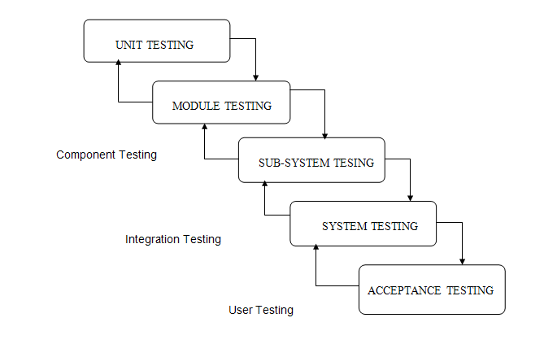

Fig: 6.1-Testing Strategies

UNIT TESTING:

This testing method considers a module as single unit and checks the unit at interfaces and communicates with other modules rather than getting into details at statement level. Here the module will be treated as a black box, which will take some input and generate output. Outputs for a given set of input combination are pre-calculated and are generated by the module.

SYSTEM TESTING:

Here all the pre tested individual modules will be assembled to create the larger system and tests are carried out at system level to make sure that all modules are working in synchronous with each other. This testing methodology helps in making sure that all modules which are running perfectly when checked individually are also running in cohesion with other modules. For this testing we create test cases to check all modules once and then generated test combinations of test paths throughout the system to make sure that no path are making its way into chaos.

INTEGRATED TESTING:

Testing is a major quality control measure employed during software development. Its basic function is to detect errors. Sub functions when combined may not produce than it is desired. Global data structures can represent the problems. Integrated testing is a systematic technique for constructing the program structure while conducting the tests. To uncover errors that are associated with interfacing the objective is to make unit test modules and built a program structure that has been detected by design. In a non - incremental integration all the modules are combined in advance and the program is tested as a whole. Here errors will appear in an endless loop function. In incremental testing the program is constructed and tested in small segments where the errors are isolated and corrected. Different incremental integration strategies are top – down integration, bottom – up integration, regression testing.

TOP-DOWN INTEGRATION TEST:

Modules are integrated by moving downwards through the control hierarchy beginning with main program. The subordinate modules are incorporated into structure in either a breadth first manner or depth first manner. This process is done in five steps:

Main control module is used as a test driver and steps are substituted or all modules directly to main program.

Depending on the integration approach selected subordinate is replaced at a time with actual modules.

Tests are conducted.

On completion of each set of tests another stub is replaced with the real module

Regression testing may be conducted to ensure trha6t new errors have not been introduced.

This process continuous from step 2 until entire program structure is reached. In top down integration strategy decision making occurs at upper levels in the hierarchy and is encountered first. If major control problems do exists early recognitions is essential.

If depth first integration is selected a complete function of the software may be implemented and demonstrated. Some problems occur when processing at low levels in hierarchy is required to adequately test upper level steps to replace low-level modules at the beginning of the top down testing. So no data flows upward in the program structure.

BOTTOM-UP INTEGRATION TEST:

Begins construction and testing with atomic modules. As modules are integrated from the bottom up, processing requirement for modules subordinate to a given level is always available and need for stubs is eliminated. The following steps implements this strategy.

Low-level modules are combined in to clusters that perform a specific software sub function.

A driver is written to coordinate test case input and output.

Cluster is tested.

Drivers are removed and moving upward in program structure combines clusters.

Integration moves upward, the need for separate test driver’s lesions.

If the top levels of program structures are integrated top down, the number of drivers can be reduced substantially and integration of clusters is greatly simplified.

REGRESSION TESTING:

Each time a new module is added as a part of integration as the software changes. Regression testing is an actually that helps to ensure changes that do not introduce unintended behavior as additional errors.

Regression testing maybe conducted manually by executing a subset of all test cases or using automated capture play back tools enables the software engineer to capture the test case and results for subsequent playback and compression. The regression suit contains different classes of test cases. A representative sample to tests that will exercise all software functions.
Additional tests that focus on software functions that are likely to be affected by the change.

Validation Testing:

Validation testing demonstrates the traces the requirements of the software. This can be achieved through a series of black box tests.

CHAPTER 7
results
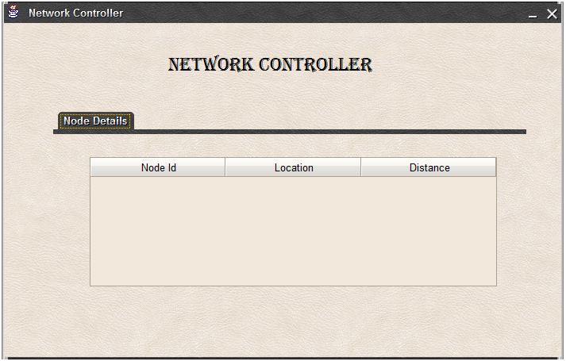

Fig: 7.1-creation of network controller

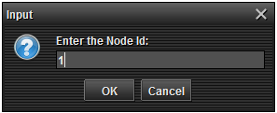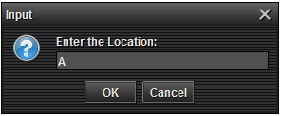

Fig: 7.2-entering node1 details

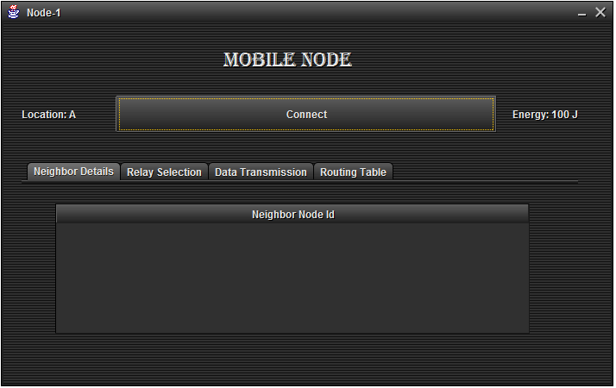

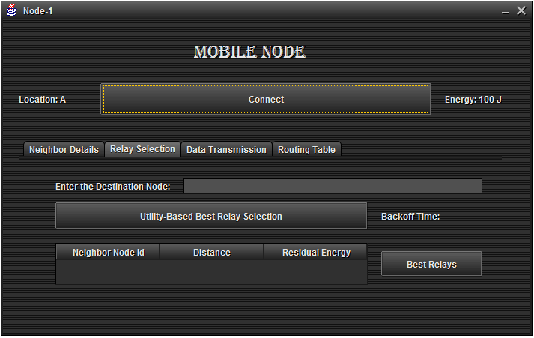

Fig: 7.3-node1 connected to network controller

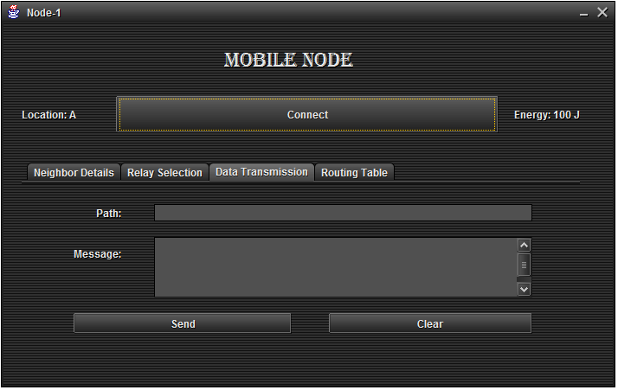

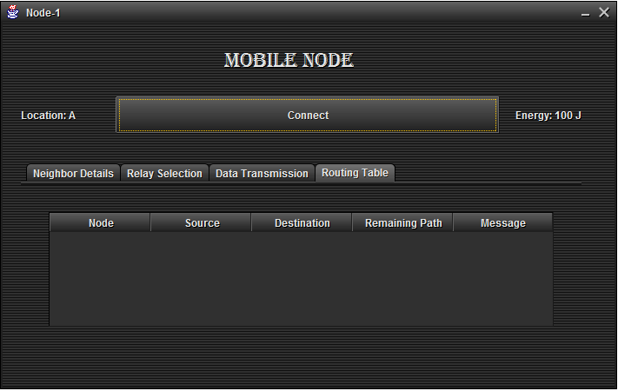

Fig: 7.4- node1 details
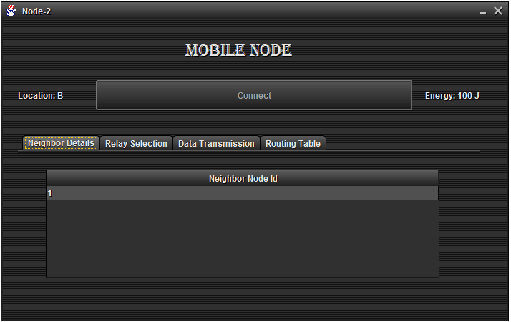

Fig: 7.5-creating node2 and connects to the network controller

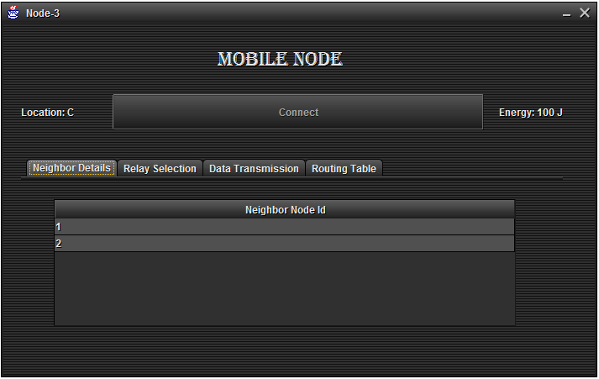

Fig: 7.6-creating node3 and connects to the network controller

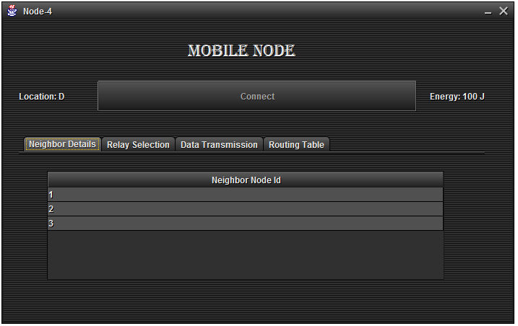

Fig: 7.7-creating node4 and connects to the network controller

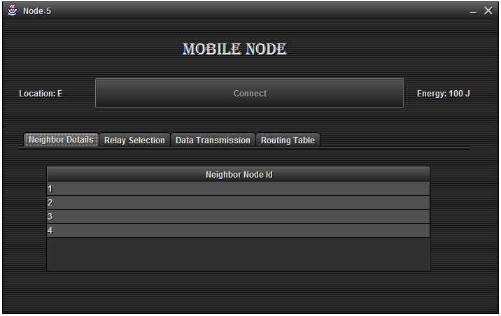

Fig: 7.8-creating node5 and connects to the network controller
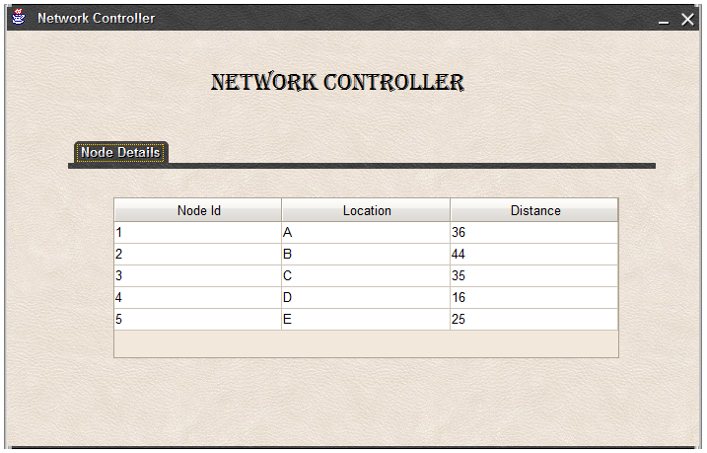

Fig: 7.9-all nodes connected to network controller

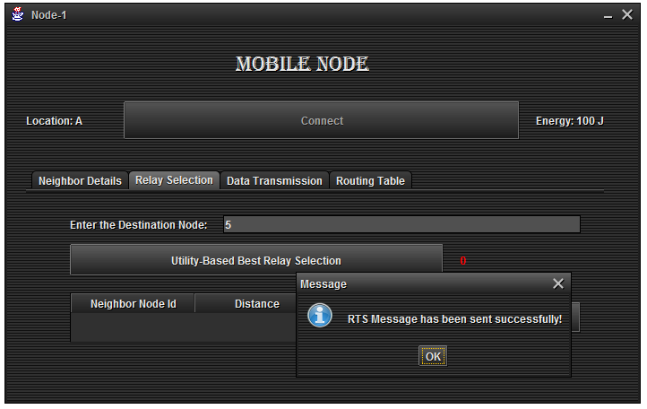

Fig: 7.10-entering the destination node details and RTS message send to destination node

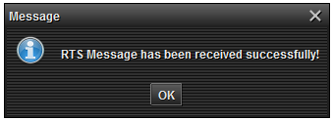

Fig: 7.11-at destination node RTS message has been received

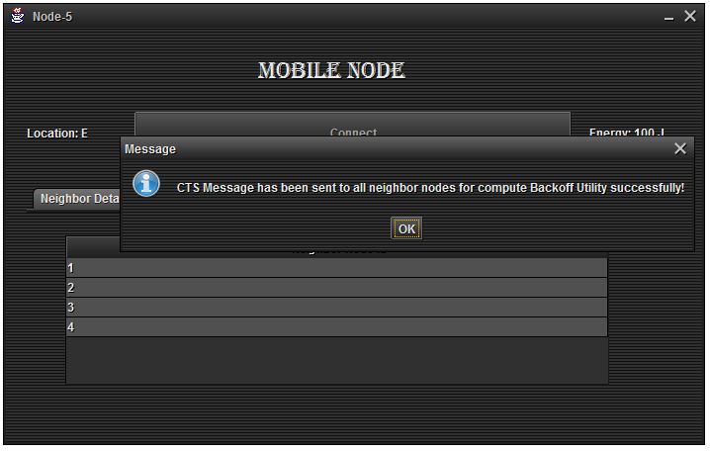

Fig: 7.12-from destination node CTS message has send to all neighbor nodes

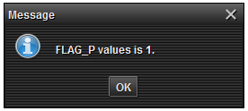

Fig: 7.13-caluculating flag value

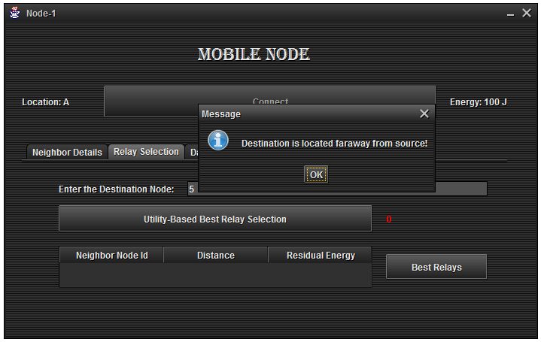

Fig: 7.14- destination is far away from source

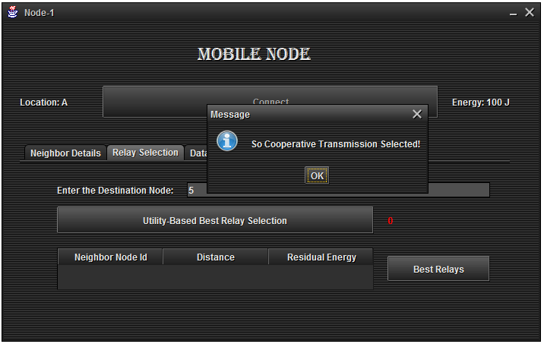

Fig: 7.15- cooperative transmission selected
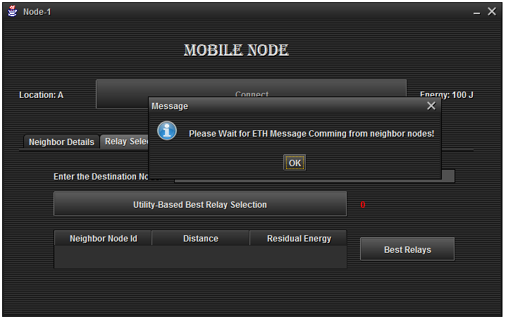

Fig: 7.16- the message coming from neighbor nodes

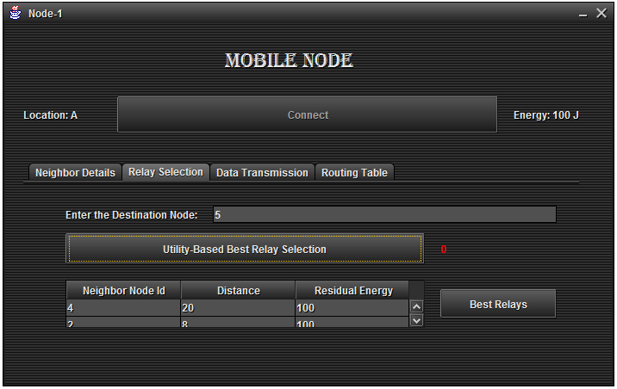

Fig: 7.17-caluculating utility-based relay selection
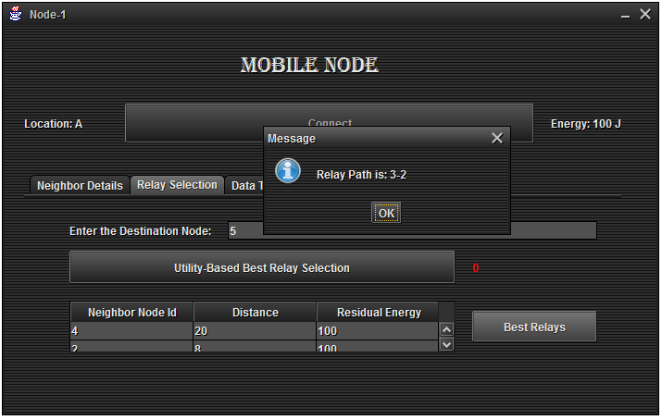

Fig: 7.18-relay path is calculated

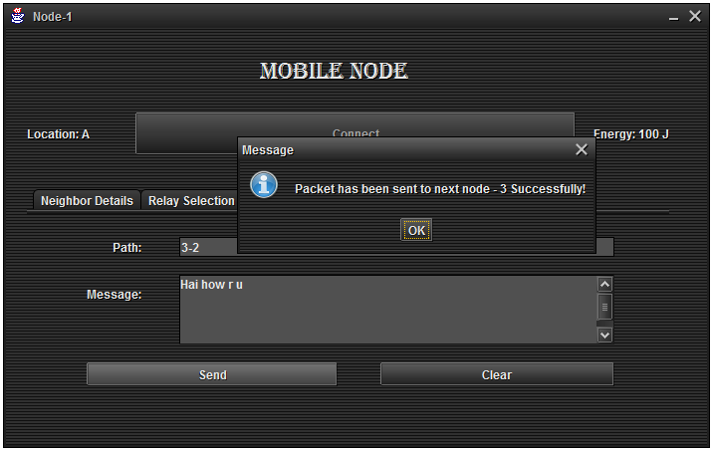

Fig: 7.19-packet has been sent from node1 to node3
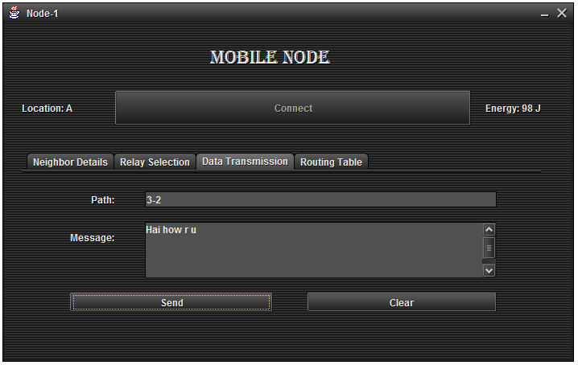

Fig: 7.20-checking data transmission at node1

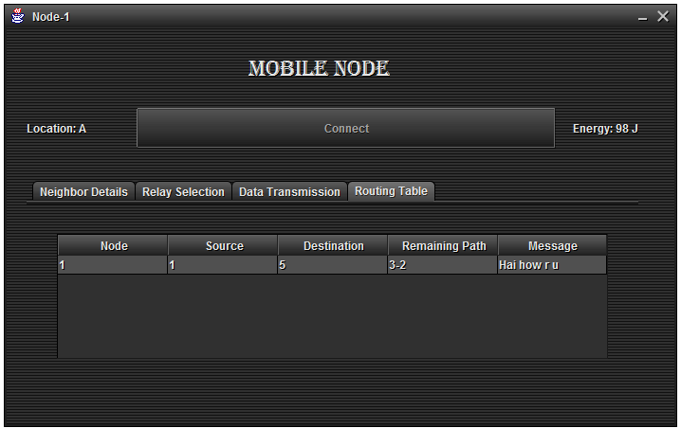

Fig: 7.21-checking routing table at node1
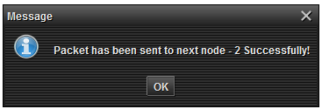

Fig: 7.22-packet has been sent from node3 to node2

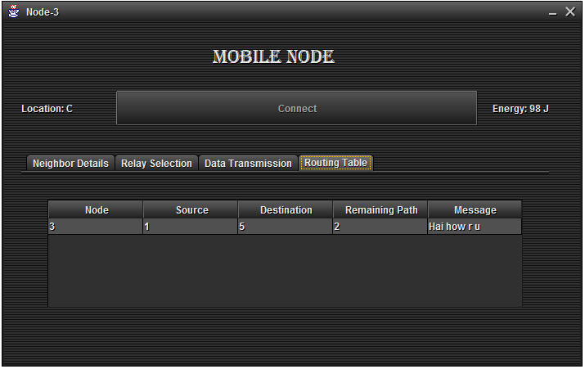

Fig: 7.23-checking routing table at node3

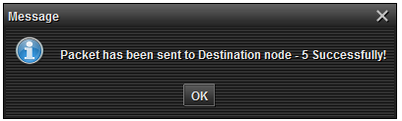

Fig: 7.24-packet has been sent from node2 to node5
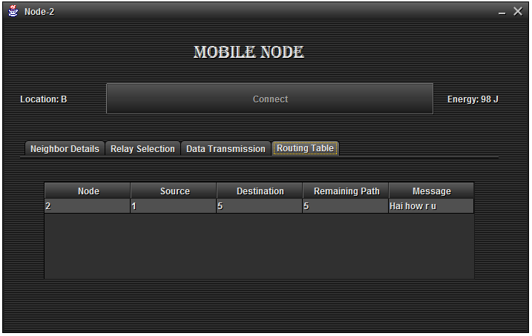

Fig: 7.25-checking routing table at node2

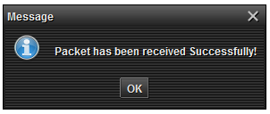

Fig: 7.26-packet has been sent to node5

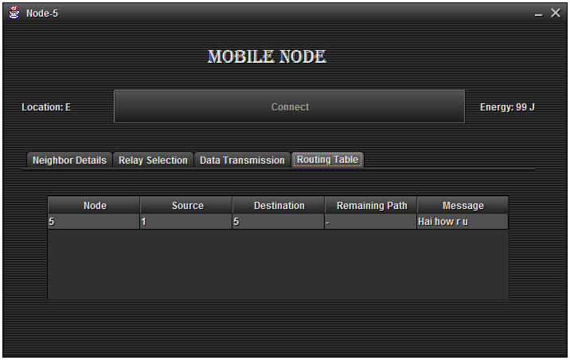

Fig: 7.27-checking routing table at node5

CHAPTER 8
REFERENCES
[1] J.N. Laneman, D.N.C. Tse, and G.W. Wornell, “Cooperative Diversity in Wireless Networks: Efficient Protocols and Outage Behaviour,” IEEE Trans. Information Theory, vol. 50, no. 12,
pp. 3062-3080, Dec. 2004.
[2] A. Sendonaris, E. Erkip, and B. Aazhang, “User Cooperation Diversity-Part I: System Description,” IEEE Trans. Comm., vol. 51, no. 11, pp. 1927-1938, Nov. 2003.
[3] J.N. Laneman and G.W. Wornell, “Distributed Space-Time-Coded Protocols for Exploiting Cooperative Diversity in Wireless Networks,” IEEE Trans. Information Theory, vol. 49, no. 10,
pp. 2415-2425, Oct. 2003.
[4] J. Wu, M. Cardei, F. Dai, and S. Yang, “Extended Dominating Set and Its Applications in Ad Hoc Networks Using Cooperative Communication,” IEEE Trans. Parallel and Distributed Systems,vol. 17, no. 8, pp. 851-864, Aug. 2006.
[5] Y. Zhu, M. Huang, S. Chen, and Y. Wang, “Energy-EfficientTopology Control in Cooperative Ad Hoc Networks,” IEEE Trans.Parallel and Distributed Systems, vol. 23, no. 8, pp. 1480-1491, Aug.2011.
[6] S. Cui, A.J. Goldsmith, and A. Bahai, “Energy-Efficiency of MIMO and Cooperative MIMO in Sensor Networks,” IEEE J. Selected Areas in Comm., vol. 22, no. 6, pp. 1089-1098, Aug. 2004.
[7] P. Liu, Z. Tao, S. Narayanan, T. Korakis, and S.S. Panwar,“CoopMAC: A Cooperative MAC for Wireless LANs,” IEEE J. Selected Areas in Comm., vol. 25, no. 2, pp. 340-354, Feb. 2007.
[8] H. Zhu and G. Cao, “rDCF: A Relay-Enabled Medium AccessControl Protocol for Wireless Ad Hoc Networks,” IEEE Trans.Mobile Computing, vol. 5, no. 9, pp. 1201-1214, Sept. 2006.
[9] H. Shan, P. Wang, W. Zhuang, and Z. Wang, “Cross-Layer Cooperative Triple Busy Tone Multiple Access for Wireless Networks,”Proc. IEEE GLOBECOM, pp. 1-5, Dec. 2008.
[10] X. Wang, J. Li, and M. Guizani, “NCAC-MAC: Network Coding Aware Cooperateive Medium Access Control for Wireless Networks,” Proc. IEEE Wireless Comm. and Networking Conf.(WCNC ’12), pp. 1646-1651, Apr. 2012.
[11] C. Zhai, J. Liu, L. Zheng, and H. Xu, “Lifetime Maximization via a New Cooperative MAC Protocol in Wireless Sensor Networks,”Proc. IEEE GLOBECOM, pp. 1-6, Dec. 2009.
[12] J. Zhang, Q. Zhang, and W. Jia, “VC-MAC: A Cooperative MAC Protocol in Vehicular Networks,” IEEE Trans. Vehicular Technology,vol. 58, no. 3, pp. 1561-1571, Mar. 2009.
[13] S. Moh and C. Yu, “A Cooperative Diversity-Based Robust MAC Protocol in Wireless Ad Hoc Networks,” IEEE Trans. Parallel and Distributed Systems, vol. 22, no. 3, pp. 353-363, Mar. 2011.
[14] H. Shan, H. Cheng, and W. Zhuang, “Cross-Layer Cooperative MAC Protocol in Distributed Wireless Networks,” IEEE Trans.Wireless Comm., vol. 10, no. 8, pp. 2603-2615, Aug. 2011.
[15] http://www.scalable-networks.com/products/qualnet/, 2013.
[16] C.E. Perkins and E. Royer, “Ad-hoc On-demand Distance VectorRouting,” Proc. IEEE Workshop Mobile Computing Systems and Applications, 1999.
[17] J. Broch, D.A. Maltzn, D.B. Johnsonn, Y. Hun, and J. Jetcheva, “A Performance Comparision of Multi-hop Wireless Ad Hoc Network Routing Protocols,” Proc. ACM MobiCom, Oct. 1998.
[18] Wireless LAN Medium Access Control (MAC) and Physical Layer (PHY) Spec, IEEE 802.11 Standard, 1999.
[19] T. Himsoon, W.P. Siriwongpairat, Z. Han, and K.J.R. Liu,“Lifetime Maximization via Cooperative Nodes and Relay Deployment in Wireless Networks,” IEEE J. Selected Areas in Comm., vol. 25, no. 2, pp. 307-317, Feb. 2007.

CHAPTER 9
CONCLUSION AND FUTURE ENHANCEMENT

In this paper, we have proposed a novel distributed energy adaptive location-based cooperative MAC protocol for MANETs. By introducing DEL-CMAC, both energy advantage and location advantage can be exploited thus the network lifetime is extended significantly. We have also proposed an effective relay selection strategy to choose the best relay terminal and a cross-layer optimal power allocation scheme to set the transmitting power. Moreover, we have enhanced the spatial reuse to minimize the interference among different connections by using novel NAV settings. We have demonstrated that DEL-CMAC can significantly prolong the network lifetime comparing with the IEEE 802.11 DCF and CoopMAC, at relatively low throughput and delay degradation cost.

As a future work, we will investigate our DEL-CMAC for larger scale network size and with high mobility. We will also consider developing an effective cross-layer cooperative diversity-aware routing algorithm together with our DEL-CMAC to conserve energy while minimizing the throughput and delay degradation.

